Additional file
CONTENTS

Tables
Table S1. Definition of index squamous cell carcinoma of head and neck used in the present study
Table S2. Definition of second primary malignancy used in the present study
Table S3. Observed number, SIRs, and RRs between surgery and RT for overall and specific SPMs, stratified by the treatment method and the subsites of head and neck among 5-year survivors.

Figures
Figure S1. Kaplan-Meier curves of overall survival according to the treatment modality (left panel) and the combination of treatment modality and SPM development (right panel) stratified by subsites of index HNSCC. OSCC (A), OPSCC (B), HPSCC (C), LSCC (D).
Figure S2. Kaplan-Meier curves of cancer-specific survival according to the treatment modality (left panel) and the combination of treatment modality and SPM development (right panel) stratified by subsites of index HNSCC. OSCC (A), OPSCC (B), HPSCC (C), LSCC (D).

Table S1. Definition of index squamous cell carcinoma of head and neck used in the present study
ICD-O-3 Histology Code | Subsite | ICD-O-3 Site Code | SITE
Squamous cell carcinoma  8070/3  8071/3  8072/3  8073/3  8074/3  8075/3  8076/3  8077/3  8078/3 | Oral Cavity | C00.0-00.9 | Lip
 | Oral Cavity | C02.0-02.3  C02.8-02.9 | Tongue (Excluding base of tongue and lingual tonsil)
 | Oral Cavity | C03.0-05.0  C05.8-06.9 | Gum, floor of mouth, & other mouth (Excluding soft palate and uvula)
 | Oropharynx | C01.9 | Base of tongue, NOS
 | Oropharynx | C02.4 | Lingual tonsil
 | Oropharynx | C05.1-05.2 | Soft palate, NOS, & Uvula
 | Oropharynx | C09.0-10.9 | Oropharynx
 | Larynx | C32.0-32.9 | Larynx
 | Hypopharynx | C12.9-13.9 | Hypopharynx
 | Other sites in the lip, oral cavity and pharynx | C14.0-14.8 | Other and ill-defined sites in the lip, oral cavity and pharynx

Table S2. Definition of second primary malignancy used in the present study
 | ICD-O-3 Site Code
All Sites | All sites
All Solid Tumors | All excluding C42.0-42.4
Head and Neck (all sites) | C00.0-06.9  C09.0-10.9  C12.9-13.9  C14.0-14.8  C32.0-32.9
Oral Cavity | C00.0-00.9
Oral Cavity | C02.0-02.3  C02.8-02.9
Oral Cavity | C03.0-05.0  C05.8-06.9
Oropharynx | C01.9
Oropharynx | C02.4
Oropharynx | C05.1-05.2
Oropharynx | C09.0-10.9
Larynx | C32.0-32.9
Hypopharynx | C12.9-13.9
Other sites in the lip, oral cavity and pharynx | C14.0-14.8
Non-Head and Neck Site | All solid tumors excluding head and neck site
Esophagus | C15.0-15.9
Liver | C22.0
Breast | C50.0-50.9
Thyroid | C73.9
CNS | C70.0-72.9
Lung, bronchus and trachea | C34.0-34.9
Kidney | C64.9
Bladder | C67.0-67.9
Skin | C44.0-44.9
Hematopoietic system | C42.0-42.4
CNS: central nervous system.

Table S3. Observed number, SIRs, and RRs between surgery and RT for overall and specific SPMs, stratified by the treatment method and the subsites of head and neck among 5-year survivors.
 | Surgery |  | RT |  | Surgery vs. RT
Site of SPM | No. of SPMs | SIR (95% CI) | No. of SPMs | SIR (95% CI) | RR (95% CI)
OSCC
All Sites | 606 | 2.22(2.04-2.40) | 21 | 2.64(1.63-4.03) | 0.77(0.50-1.18)
All Solid Tumors | 593 | 2.34(2.16-2.54) | 21 | 2.85(1.77-4.36) | 0.75(0.49-1.16)
Head and Neck | 298 | 34.13(30.36-38.23) | 8 | 30.70(13.25-60.49) | 0.99(0.49-2.00)
Oral Cavity | 240 | 85.41(74.94-96.92) | 6 | 71.93(26.40-156.56) | 1.06(0.47-2.39)
Oropharynx | 39 | 11.53(8.20-15.76) | 2 | 19.75(2.39-71.36) | 0.52(0.13-2.14)
Hypopharynx | 5 | 13.38(4.34-31.23) | 0 | 0(0-330.08) | NA
Larynx | 10 | 4.99(2.39-9.17) | 0 | 0(0-61.75) | NA
Non-Head and Neck | 295 | 1.21(1.07-1.35) | 13 | 1.83(0.97-3.13) | 0.60(0.35-1.05)
Esophagus | 10 | 3.04(1.46-5.59) | 0 | 0(0-37.47) | NA
Liver | 5 | 0.92(0.30-2.16) | 0 | 0(0-22.67) | NA
Breast | 25 | 0.95(0.61-1.40) | 0 | 0(0-5.32) | NA
Thyroid | 2 | 0.52(0.06-1.87) | 0 | 0(0-38.33) | NA
CNS | 6 | 1.87(0.69-4.08) | 0 | 0(0-40.08) | NA
Lung, bronchus and trachea | 83 | 2.25(1.79-2.79) | 1 | 0.93(0.02-5.17) | 2.20(0.31-15.83)
Bladder | 13 | 0.78(0.42-1.34) | 1 | 2.02(0.05-11.23) | 0.35(0.05-2.64)
Kidney | 7 | 0.75(0.30-1.54) | 2 | 7.40(0.90-26.75) | 0.09(0.02-0.45)
Skin | 18 | 0.98(0.58-1.55) | 2 | 3.72(0.45-13.43) | 0.24(0.06-1.03)
Hematopoietic system | 13 | 0.64(0.34-1.10) | 0 | 0(0-6.13) | NA
OPSCC
All Sites | 46 | 1.76(1.29-2.34) | 67 | 2.69(2.09-3.42) | 0.56(0.39-0.82)
All Solid Tumors | 45 | 1.85(1.35-2.47) | 66 | 2.86(2.21-3.64) | 0.56(0.38-0.82)
Head and Neck | 18 | 19.48(11.54-30.78) | 25 | 27.78(17.98-41.01) | 0.59(0.32-1.09)
Oral Cavity | 8 | 30.44(13.14-59.97) | 9 | 35.64(16.30-67.66) | 0.73(0.28-1.90)
Oropharynx | 7 | 18.26(7.34-37.63) | 14 | 38.07(20.82-63.88) | 0.41(0.17-1.02)
Hypopharynx | 0 | 0(0-90.02) | 1 | 24.27(0.61-135.24) | NA
Larynx | 0 | 0(0-16.73) | 1 | 4.51(0.11-25.12) | NA
Non-Head and Neck | 27 | 1.15(0.76-1.68) | 41 | 1.85(1.33-2.50) | 0.54(0.33-0.88)
Esophagus | 1 | 2.98(0.08-16.61) | 5 | 14.40(4.68-33.60) | 0.16(0.02-1.41)
Liver | 2 | 3.41(0.41-12.31) | 1 | 1.76(0.04-9.82) | 1.65(0.15-18.15)
Breast | 1 | 0.49(0.01-2.73) | 3 | 2.43(0.50-7.11) | 0.27(0.03-2.64)
Thyroid | 0 | 0(0-10.57) | 0 | 0(0-12.92) | NA
CNS | 0 | 0(0-12.06) | 1 | 3.45(0.09-19.21) | NA
Lung, bronchus and trachea | 8 | 2.32(1-4.57) | 12 | 3.58(1.85-6.25) | 0.55(0.22-1.34)
Bladder | 0 | 0(0-2.44) | 1 | 0.61(0.02-3.39) | NA
Kidney | 2 | 2.04(0.25-7.38) | 0 | 0(0-3.97) | NA
Skin | 0 | 0(0-2.18) | 1 | 0.58(0.01-3.25) | NA
Hematopoietic system | 1 | 0.54(0.01-3.03) | 1 | 0.56(0.01-3.10) | 0.82(0.05-13.16)
HPSCC
All Sites | 1 | 1.74(0.04-9.69) | 11 | 3.18(1.59-5.69) | 0.59(0.08-4.60)
All Solid Tumors | 1 | 1.89(0.05-10.55) | 11 | 3.44(1.72-6.16) | 0.59(0.08-4.60)
Head and Neck | 0 | 0(0-224.71) | 3 | 24.71(5.10-72.20) | NA
Oral Cavity | 0 | 0(0-661.25) | 0 | 0(0-108.81) | NA
Oropharynx | 0 | 0(0-764.77) | 0 | 0(0-77.8) | NA
Hypopharynx | 0 | 0(0-3,745.47) | 2 | 349.39(42.31-1,262.13) | NA
Larynx | 0 | 0(0-788.97) | 1 | 31.21(0.79-173.89) | NA
Non-Head and Neck | 1 | 1.95(0.05-10.88) | 8 | 2.6(1.12-5.13) | 0.81(0.08-6.60)
Esophagus | 0 | 0(0-491.19) | 2 | 40.76(4.94-147.22) | NA
Liver | 0 | 0(0-272.47) | 0 | 0(0-49.81) | NA
Breast | 0 | 0(0-152.99) | 0 | 0(0-28.83) | NA
Thyroid | 0 | 0(0-717.32) | 0 | 0(0-114.11) | NA
CNS | 0 | 0(0-602.02) | 0 | 0(0-97.13) | NA
Lung, bronchus and trachea | 0 | 0(0-40.40) | 3 | 6.31(1.3-18.43) | NA
Bladder | 0 | 0(0-79.18) | 0 | 0(0-14.9) | NA
Kidney | 0 | 0(0-206.41) | 0 | 0(0-28.84) | NA
Skin | 0 | 0(0-106.44) | 0 | 0(0-15.32) | NA
Hematopoietic system | 0 | 0(0-78.45) | 0 | 0(0-13.92) | NA
LSCC
All Sites | 39 | 1.57(1.12-2.15) | 511 | 1.79(1.64-1.95) | 0.80(0.57-1.10)
All Solid Tumors | 37 | 1.61(1.13-2.22) | 488 | 1.85(1.69-2.02) | 0.79(0.57-1.10)
Head and Neck | 8 | 8.86(3.83-17.46) | 99 | 9.93(8.07-12.10) | 0.84(0.41-1.73)
Oral Cavity | 1 | 4.04(0.1-22.49) | 12 | 4.32(2.23-7.54) | 0.87(0.11-6.68)
Oropharynx | 0 | 0(0-10.12) | 15 | 3.94(2.20-6.49) | NA
Hypopharynx | 0 | 0(0-86.19) | 17 | 34.87(20.31-55.84) | NA
Larynx | 7 | 30.28(12.17-62.39) | 49 | 18.15(13.43-24.00) | 1.49(0.67-3.29)
Non-Head and Neck | 29 | 1.31(0.88-1.88) | 390 | 1.54(1.39-1.70) | 0.78(0.53-1.13)
Esophagus | 1 | 2.82(0.07-15.74) | 18 | 4.43(2.63-7.01) | 0.58(0.08-4.34)
Liver | 2 | 3.53(0.43-12.76) | 9 | 1.43(0.65-2.72) | 2.32(0.50-10.73)
Breast | 1 | 1.07(0.03-5.96) | 6 | 0.68(0.25-1.47) | 1.74(0.21-14.44)
Thyroid | 0 | 0(0-13.36) | 2 | 0.75(0.09-2.72) | NA
CNS | 0 | 0(0-12.95) | 2 | 0.64(0.08-2.31) | NA
Lung, bronchus and trachea | 14 | 4.15(2.27-6.96) | 177 | 4.44(3.81-5.14) | 0.82(0.48-1.42)
Bladder | 4 | 2.34(0.64-5.99) | 20 | 0.96(0.59-1.48) | 2.09(0.71-6.10)
Kidney | 0 | 0(0-3.95) | 5 | 0.48(0.16-1.11) | NA
Skin | 1 | 0.59(0.01-3.27) | 14 | 0.72(0.39-1.21) | 0.75(0.10-5.67)
Hematopoietic system | 2 | 1.1(0.13-3.96) | 23 | 1.04(0.66-1.56) | 0.91(0.21-3.85)

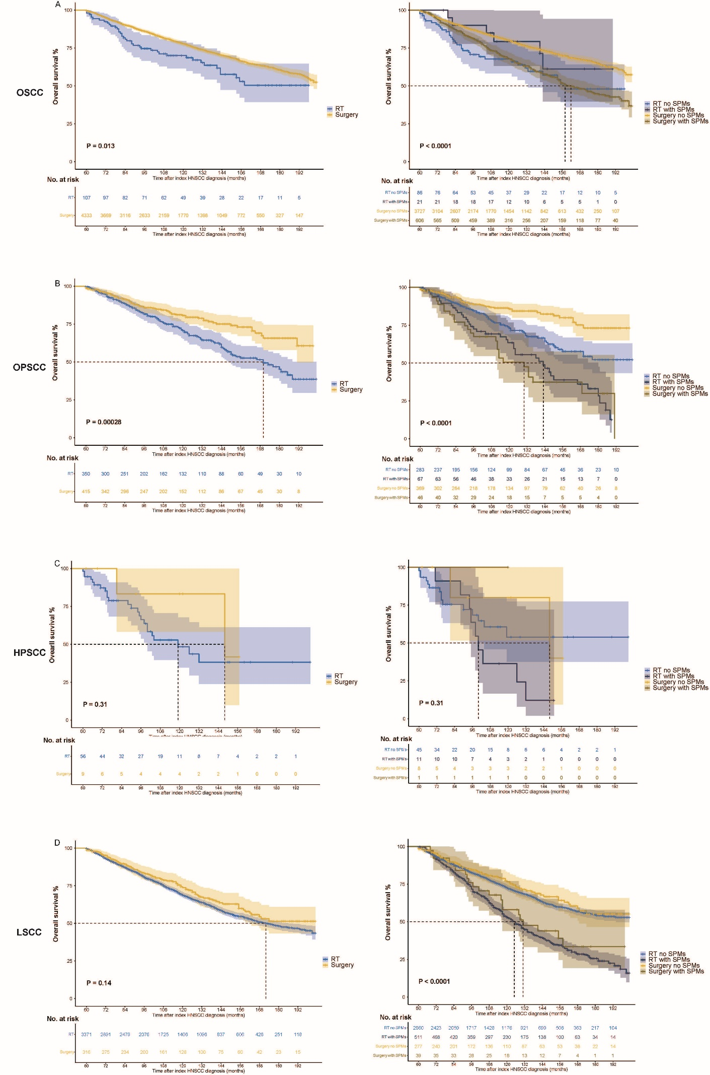
Figure S1. Kaplan-Meier curves of overall survival according to the treatment modality (left panel) and the combination of treatment modality and SPM development (right panel) stratified by subsites of index HNSCC. OSCC (A), OPSCC (B), HPSCC (C), LSCC (D).

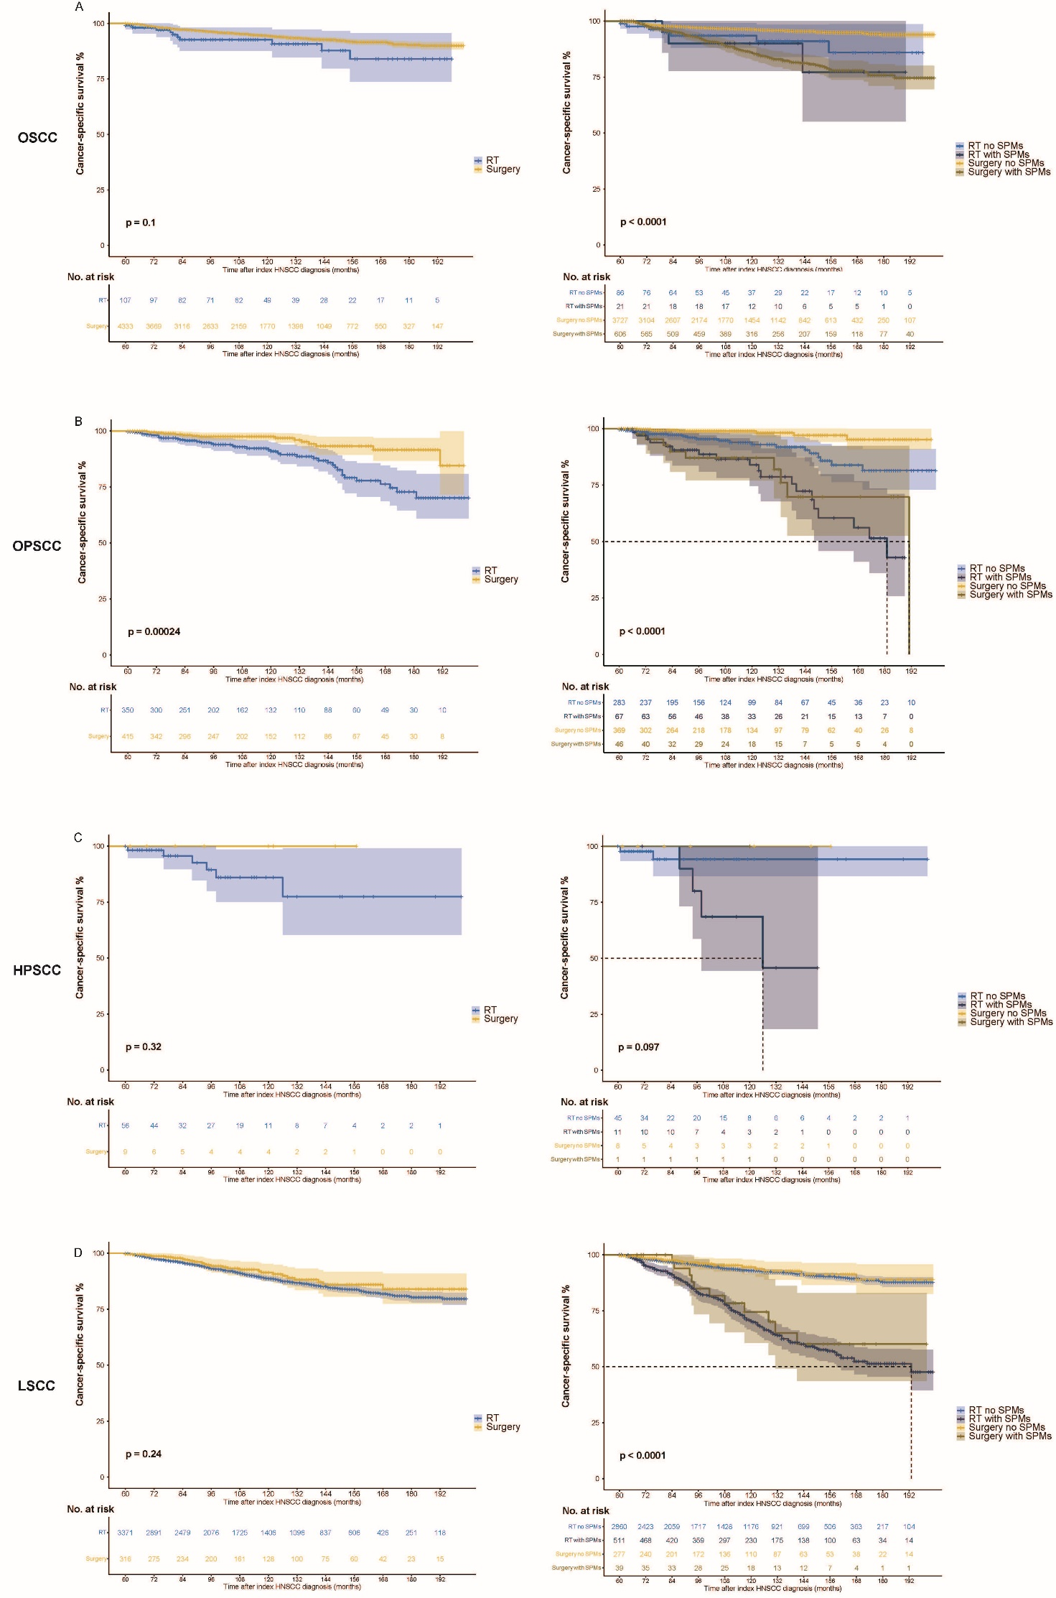
Figure S2. Kaplan-Meier curves of cancer-specific survival according to the treatment modality (left panel) and the combination of treatment modality and SPM development (right panel) stratified by subsites of index HNSCC. OSCC (A), OPSCC (B), HPSCC (C), LSCC (D).

