Supplement
Oceanographic background
The oceanographic background of the Sea of Japan (SOJ) is described in Hirose and Povinec¹. The SOJ is a unique marginal sea characterized by a semi-closed feature with maximum depth of 3742 m, connecting to the East China Sea, the North Pacific Ocean and the Okhotsk Sea through shallow straits (Tsushima, Tsugaru, Soya, and Tatarskiy (Mamiya)) with less than 150 m water depth. The warm Tsushima Current, characterized as a branch of the Kuroshio Current, inflows into the SOJ, while the Liman Current, associated with cold and low saline water from the Tatarskiy Strait is present in the northern SOJ as a cyclonic circulation². The deeper water layers in the SOJ (more than a few hundred meters) are occupied by an almost homogeneous cold-water mass, characterized as Japan Sea Proper Water (JSPW), which is strongly homogeneous in salinity (34.04 - 34.10), low temperature (0.2 - 0.5 °C), and higher concentrations of dissolved oxygen (220-250 µmol kg-1)³. In this work, the overlying waters at stations 1- 5 correspond to the JSPW, which is formed by deep convection offshore Vladivostok during the winter monsoon period⁴. Furthermore, bottom water (BW) below benthic front of 2000 – 2500 m depth exists in the Japan Basin, characterized as a vertically homogeneous layer with fluctuation of potential temperature < 0.001 °C⁵. In this work, the overlying waters at stations 6 - 8 correspond to BW. Other interesting features are large seasonal variations of sea surface temperature (SST) by more than 15 °C, the presence of active biological processes and of polar (or sub-polar) front between the northern cold (subpolar) and southern warm (subtropical) water masses. The polar front showed interannual changes: It migrates more widely (36°N – 41°N) in the western part of the SOJ than in the eastern part⁶. The SOJ is also one of the most eddy active seas. Anticyclonic (warm) eddies are formed in the Tsushima Current region⁷⁻¹⁰.
The SOJ has been affected by global warming¹, where the SST in the central SOJ has shown high increase rates of 1.75 °C/100 y¹¹, which exceeds the SST increase rates of all oceans (0.55 °C/100 y), as well as of the surface air temperature (1.26 °C/100 y) during the past about 100 years. In particular, SST in the central SOJ during the winter season (January – March) exhibits the highest rate of increase (2.40 °C/100 y) within the sea areas surrounding the Japan islands. The potential temperature of the upper JSPW (800 m depth) has also been increasing with a rate of 0.16 ± 0.09 °C/100 y during the period 1958 – 1966 (ref. 12). There are current temporal changes in the water column of the SOJ. Figure S1 shows temporal changes in temperature in subsurface water (around 200 m depth), JSPW (1300 – 2000 m depth) and BW (2600 – 3670 m depth) during the period of 1998 - 2021. In 2000, a small decrease in water temperature was observed in the JSPW and BW, which corresponds to deep water formation in the 2000 winter^{13,14}. An increase of water temperatures was observed in all water masses in the SOJ, except for 2000¹⁵. The increase rates of water temperature were calculated based on exponential change; increase rates in JSPW were 0.28 °C/100 y (St. 1) and 0.43 °C/100 y (St. 5), and in BW 0.4 °C/100 y (St. 4), 0.25 °C/100 y (St. 6), 0.23 °C/100 y (St. 7) and 0.23 (St. 8). This finding reveals that after the 2000-2001 event, a distinct formation of JSPW and BW did not occur in the SOJ, which may reflect the effects of global warming¹⁶.
The Okhotsk Sea is a marginal sea in the western North Pacific Ocean, with a mean depth of 859 m and a maximum depth of 3372 m. The Okhotsk Sea is connected with the North Pacific Ocean by passes through the Kuril Island Chain; two straits are deeper than 1000 m. In winter, a significant part of the Okhotsk Sea is covered by ice floes, formed due to large amounts of fresh water from the Amur River, which is lowering the salinity of the upper water. The Okhotsk Sea is a unique sea, in which Okhotsk Sea Intermediate Water (OSIW) is formed from the Dense Shelf Water, occurring in the northwest shelf region, Western Subarctic Water originating from the North Pacific, and Soya Warm Current, which has warm and saline properties, originating from the Sea of Japan. OSIW flows from the Okhotsk Sea to the western North Pacific and contributes to Oyashio Intermediate Water¹⁷. Therefore, in contrast to SOJ, the Okhotsk Sea cannot accumulate contaminants, including anthropogenic radionuclides, because a significant part of Okhotsk Sea Water is continuously replaced by Western Subarctic Water with lower ¹³⁷Cs derived from global fallout¹⁸, although a part of the western subarctic water was affected by the deposition of FDNPP-derived radionuclides¹⁹.

References
- Hirose, K., Povinec, P.P. Temporal variability of plutonium in surface waters of the Sea of Japan. J. Environ. Radioact. 248, 106890 (2022).
- Martin, S., Kawase, M. The southern flux of sea ice in the Tatarskiy Strait, Japan Sea and the generation of the Liman Current. J. Marine Res. 56, 141-155.(1998).
- Sudo, H. A note on the Japan Sea Proper Water. Prog. Oceanogr. 17, 313–336 (1986).
- Kawamura, H., Wu, P. Formation mechanism of Japan Proper Water in the flux center off Vladivostok. J. Geophys. Res. 103, 21611-21622 (1998).
- Gamo, T., Horibe, Y. Abyssal circulation in the Japan Sea. J. Oceanogr. Soc. Japan. 39, 220-230 (1983).
- Choi, B.-J., Haidvogel, D.B., Cho, Y.-K. Interannual variation of the Poler Front in the Japan/East Sea from summertime hydrography and sea level data. J. Mar. Sys. 78, 351-362 (2009).
- Gordon, A.L. et al. Japan/East Sea thermocline eddies. J. Phys. Oceanogr. 32, 1960-1974 (2002).
- Hogan, P.J., Hurlburt, H.E. Why do intrathermocline eddies form in the Japan/East Sea? A modeling perspective. Oceanogr. 19, 134-143 (2006).
- Isoda, Y. Warm eddy movements in the eastern Japan Sea. J. Oceanogr. 50, 1-15 (1994).
- Jacobs, G.A., Hogan, P.J., Whitmer, K.R. Effects of eddy variability on the circulation of the Japan/East Sea. J. Oceanogr. 55, 247-259 (1999).
- JMA, Japan Meteorological Agency (2021). https://www.data.jma.go.jp/gmd/kaiyo/data/shindan/a_1/japan_warm/japan_warm.html.
- Minami, H., Kano, K., Ogawa, K. Long-term variations of potential temperature and dissolved oxygen of the Japan Sea Proper Water. J. Oceanogr. 55, 197-205 (1999).
- Senjyu, T. et al. Renewal of the bottom water after the winter 2000–2001 may spin-up the thermohaline circulation in the Japan Sea. Geophys. Res. Lett. 29, 10.1029/2001GL014093 (2002).
- Talley, L.D. et al. Deep convection and brine rejection in the Japan Sea. Geophys. Res. Lett. 30, 1159 (2003).
- JCG, Japan Coastal Guard. Annual reports of Radioactivity survey for 2001 – 2021 (2022) (in Japanese). http://www1.kaiho.mlit.go.jp/KANKYO/OSEN/housha.html.
- Kim, K. et al. Warming and structural changes in the East (Japan) Sea: A clue to future changes in global oceans? Geophys. Res Lett. 28, 3293-3296 (2001).
- Itoh, M., Ohshima, K.I., Wakatsuki, M. Distribution and formation of Okhotsk Sea Intermediate Water: An analysis of isopycnal climatological data. J. Geophys. Res., 108, C8, 3258 (2003).
- Aoyama, M., K. Hirose, K. Igarashi, Y. Re-construction and updating our understanding on the global weapons tests ¹³⁷Cs fallout. J. Environ. Monitoring 8, 431-438 (2006).
- Honda, M.C. et al. Dispersion of artificial caesium-134 and -137 in the western North Pacific one month after the Fukushima accident. Geochem. J. 46, 1-9 (2012).

Figure captions

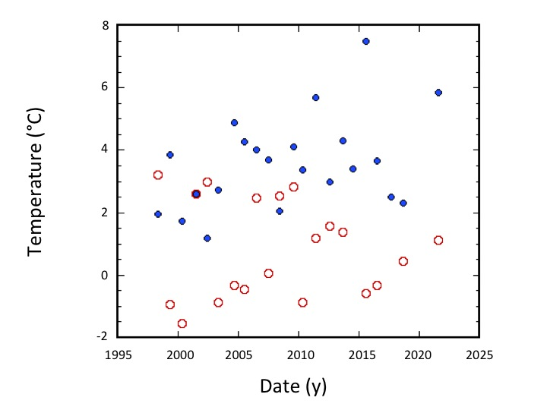
Fig. S1A. Temperature change of shallow waters (St. 8: closed circles, St. 9: open circles).

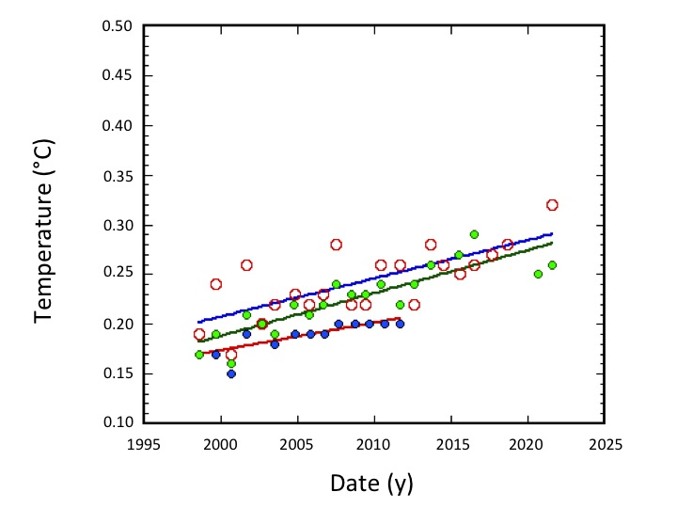
Fig. S1B. Temperature change of Japan Sea Proper Water (St.1: blue closed circles, St. 4: red open circles, St. 5: green open circles)

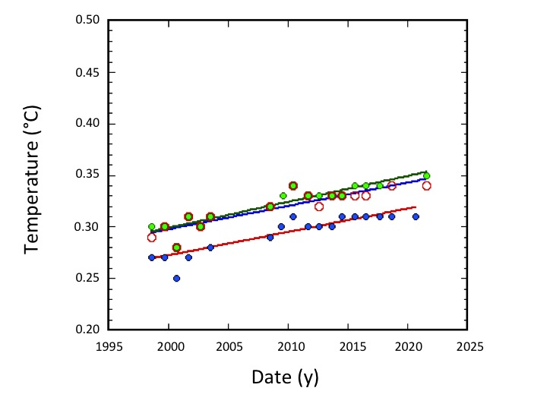
Fig. S1C. Temperature change of bottom waters (St. 6: green closed circles, St. 7: red open circles, St. 8: blue closed circles)

Tables
Table S1 Location of sampling sites in the Sea of Japan and Okhotsk Sea

Station No. Latitude (N) Longitude (E) depth(m)
1 36.59 132.50 1981 TB/UB
2 37.00 131.00 1680 TB/UB
3 38.72 132.93 2851 TB/UB
4 40.00 134.56 1309 YR
5 40.00 136.00 1433 YR
6 41.00 136.34 3363 JB
7 41.45 137.43 3635 JB
8 43.01 137.49 3674 JB
9 44.34 140.82 253
10 44.80 144.00 186 OS

TB/UB: Tsushima Basin/Ulleung Basin, YR: Yamato Ridge, JB: Japan Basin,
OS: Okhotsk Sea

Table S2. Sampling results of ten stations in the SOJ/ES and OS in each year. Open circles: overlying water and sediment, triangles: only overlying water (sediment: less than detection limit), closed circles: only sediment, blank: no observation

Year Sampling station number
 |  | 1 | 2 | 3 | 4 | 5 | 6 | 7 | 8 | 9 | 10
1998 |  | ○ | ○ | ○ | ○ | ○ | ○ | ○ | ○ | ○ | ○
1999 |  | ○ | ○ | ○ | ○ | ○ | ○ | ○ | ○ | ○ | ○
2000 |  | ○ | ● | ○ | ○ | ○ | ○ | ○ | ○ | ○ | ○
2001 |  | ○ | ○ | ○ | ○ | ○ | ○ | △ | △ | ● | ○
2002 |  | ○ | ○ | ○ | ○ | ○ | ○ | △ | △ | ○ | ○
2003 |  | ○ | ○ | ○ | ○ | ○ | ○ | ○ | ○ | ○ | ○
2004 |  | ○ |  |  | ○ | ○ |  |  |  | ○ | ○
2005 |  | ○ |  |  | ○ | ○ |  |  |  | ○ | ○
2006 |  | ○ | ○ | ○ | ○ | ○ |  |  |  | ○ | ○
2007 |  | ○ | ○ | △ | ○ | ○ |  |  |  | ○ | ○
2008 |  | ○ | ○ | △ | ○ | ○ | ○ | ○ | △ | ○ | ○
2009 |  | ○ | ○ | ○ | ○ | ○ | ○ |  | △ | ○ | ○
2010 |  | ○ | ○ | △ | ○ | ○ | ○ | ○ | △ | ○ | ○
2011 |  | ○ | ○ | ○ | ○ | ○ | ○ | ○ | ○ | ○ | ○
2012 |  |  |  |  | ○ | ○ | ○ | ○ | ○ | ○ | ○
2013 |  |  |  |  | ○ | ○ | ○ | ○ | ○ | ○ | ○
2014 |  |  |  |  | ○ |  | ○ | ○ | ○ | ○
2015 |  |  |  |  | ○ | ○ | ○ | ○ | ○ | ○ | ○
2016 |  |  |  |  | ○ | ○ | ○ | ○ | ○ | ○ | ○
2017 |  |  |  |  | ○ |  | ○ |  | △ | ○
2018 |  |  |  |  | ○ |  | ○ | ○ |  | ○ | ○
2019
2020 |  |  |  |  |  | ○ | ○
2021 |  |  |  |  | ○ | ○ |  | ○ | △ | ○ | ○

Table S3. Activity concentrations of ¹³⁷Cs in overlying waters of the SOJ and OS

Sampling station Sample No Activity concentration (Bq m⁻³)
Range Mean SD
1 |  | 14 |  | 0.25 | - | 0.61 | 0.35 | 0.09
2 |  | 11 |  | 0.34 | - | 0.73 | 0.58 | 0.1
3 |  | 12 |  | 0.23 | - | 0.54 | 0.33 | 0.08
4 |  | 23 |  | 0.59 | - | 1.15 | 0.83 | 0.18
5 |  | 19 |  | 0.44 | - | 1.17 | 0.76 | 0.16
6 |  | 18 |  | 0.11 | - | 0.6 | 0.34 | 0.11
7 |  | 16 |  | 0.13 | - | 0.51 | 0.29 | 0.1
8 |  | 16 |  | 0.14 | - | 0.82 | 0.35 | 0.18
9 |  | 21 |  | 1.5 | - | 2.3 | 1.83 | 0.26
10 |  | 20 |  | 0.71 | - | 2.31 | 1.32 | 0.34

Table S4. Activity concentrations of ¹³⁷Cs in sediments of the SOJ and OS

Sampling station Sample No Activity concentration (Bq kg⁻³)
Range Mean SD
1 |  | 14 |  | 1 | - | 4.8 | 2.38 | 0.97
2 |  | 12 |  | 0.91 | - | 3.23 | 2.17 | 0.61
3 |  | 9 |  | 0.01 | - | 0.54 | 0.22 | 0.16
4 |  | 22 |  | 0.58 | - | 2.8 | 2.14 | 0.54
5 |  | 19 |  | 1.1 | - | 3.2 | 2.1 | 0.53
6 |  | 18 |  | 1.1 | - | 6 | 3.14 | 1.2
7 |  | 16 |  | 0.18 | - | 3.7 | 2.34 | 0.89
8 |  | 10 |  | 0.02 | - | 0.35 | 0.14 | 0.12
9 |  | 22 |  | 1.3 | - | 3.35 | 2.47 | 0.57
10 |  | 20 |  | 1.2 | - | 2.9 | 1.87 | 0.42

Table S5. ¹³⁷Cs activity concentrations in overlying water on January 1998, apparent change rates and physical change rates of ¹³⁷Cs in overlying waters

Station No. Depth C_{137Cs,OW,o} (Bq m⁻³) k_{aw} (y⁻¹) k_{pw} (y⁻¹)
1 |  | 1981 |  | 0.26 | ± | 0.04 |  | 0.038 | ± | 0.014 |  | 0.061 | ± | 0.014
2 |  | 1680 |  | 0.6 | ± | 0.06 |  | -0.051 | ± | 0.012 |  | 0.018 | ± | 0.012
3 |  | 2851 |  | 0.21 | ± | 0.04 |  | 0.028 | ± | 0.01 |  | 0.051 | ± | 0.01
4 |  | 1309 |  | 0.91 | ± | 0.07 |  | -0.008 | ± | 0.006 |  | 0.015 | ± | 0.0062
5 |  | 1433 |  | 0.66 | ± | 0.06 |  | 0.013 | ± | 0.007 |  | 0.036 | ± | 0.007
6 |  | 3373 |  | 0.23 | ± | 0.04 |  | 0.03 | ± | 0.011 |  | 0.053 | ± | 0.011
7 |  | 3635 |  | 0.28 | ± | 0.04 |  | 0.024 | ± | 0.016 |  | 0.047 | ± | 0.016
8 |  | 3674 |  | 0.2 | ± | 0.04 |  | 0.05 | ± | 0.02 |  | 0.073 | ± | 0.02
9 |  | 235 |  | 2.17 | ± | 0.09 |  | -0.015 | ± | 0.004 |  | 0.008 | ± | 0.004
10 |  | 186 |  | 1.7 | ± | 0.14 |  | -0.026 | ± | 0.008 |  | -0.003 | ± | 0.008

Table S6. ¹³⁷Cs activity concentrations in sediments on January 1998, apparent change rates and physical change rates of ¹³⁷Cs in sediments

Station No. Depth C_{137Cs,SS,o} (Bq m⁻³) k_{aS} (y⁻¹) k_{pS} (y⁻¹)
1 |  | 1981 |  | 1.74 | ± | 0.44 |  | 0.039 | ± | 0.026 |  | 0.062 | ± | 0.026
2 |  | 1680 |  | 2.11 | ± | 0.35 |  | 0.004 | ± | 0.002 |  | 0.027 | ± | 0.002
3 |  | 2851 |  | 0.11 | ± | 0.41 |  | 0.104 | ± | 0.034 |  | 0.167 | ± | 0.034
4 |  | 1309 |  | 2.32 | ± | 0.24 |  | -0.007 | ± | 0.008 |  | 0.016 | ± | 0.008
5 |  | 1433 |  | 2.41 | ± | 0.24 |  | -0.015 | ± | 0.009 |  | 0.008 | ± | 0.009
6 |  | 3373 |  | 1.9 | ± | 0.38 |  | -0.014 | ± | 0.013 |  | 0.009 | ± | 0.013
7 |  | 3635 |  | 3.67 | ± | 0.58 |  | 0.017 | ± | 0.013 |  | 0.04 | ± | 0.013
8 |  | 3674 |  | 0.06 | ± | 0.04 |  | 0.074 | ± | 0.049 |  | 0.097 | ± | 0.049
9 |  | 235 |  | 3.01 | ± | 0.24 |  | -0.02 | ± | 0.007 |  | 0.003 | ± | 0.007
10 |  | 186 |  | 2.39 | ± | 0.15 |  | -0.025 | ± | 0.006 |  | -0.002 | ± | 0.006

Table S7. Practical partition coefficients of ¹³⁷Cs between overlying water and sediment

Sampling station Sample No Practical partition coefficient (×10³ L kg⁻¹)
Range Mean SD
1 |  | 14 |  | 3.3 | - | 14.5 | 7 | 3.1
2 |  | 12 |  | 1.6 | - | 6.2 | 3.9 | 1.4
3 |  | 9 |  | 0.31 | - | 1.45 | 0.66 | 0.46
4 |  | 22 |  | 0.88 | - | 4.51 | 2.61 | 0.92
5 |  | 19 |  | 1.51 | - | 4.21 | 2.88 | 0.88
6 |  | 18 |  | 3 | - | 47.2 | 11.5 | 10
7 |  | 16 |  | 0.69 | - | 14.9 | 8.6 | 3.5
8 |  | 10 |  | 0.12 | - | 0.85 | 0.34 | 0.26
9 |  | 22 |  | 0.76 | - | 2 | 1.33 | 0.34
10 |  | 20 |  | 0.86 | - | 2.1 | 1.41 | 0.38

Table S8. Practical partition coefficients in 1998 and apparent change rates of K_{d} values

Station No. Depth K_{d,o} (L kg⁻¹) k_{kd} (y⁻¹) correlation factor
1 |  | 1981 |  | 7.47 | ± | 1.78 |  | -0.0092 | ± | 0.03 |  | 0.079
2 |  | 1680 |  | 3.69 | ± | 0.86 |  | 0.006 | ± | 0.026 |  | 0.072
3 |  | 2851 |  | 0.42 | ± | 0.18 |  | 0.07 | ± | 0.044 |  | 0.535
4 |  | 1309 |  | 2.71 | ± | 0.4 |  | -0.0028 | ± | 0.012 |  | 0.056
5 |  | 1433 |  | 3.65 | ± | 0.39 |  | -0.025 | ± | 0.011 |  | 0.513
6 |  | 3373 |  | 22.1 | ± | 5.3 |  | -0.067 | ± | 0.029 |  | 0.525
7 |  | 3635 |  | 10.7 | ± | 1.7 |  | -0.021 | ± | 0.014 |  | 0.373
8 |  | 3674 |  | 0.19 | ± | 0.13 |  | 0.048 | ± | 0.043 |  | 0.456
9 |  | 235 |  | 1.36 | ± | 0.15 |  | -0.0023 | ± | 0.009 |  | 0.06
10 |  | 186 |  | 1.45 | ± | 0.2 |  | -0.001 | ± | 0.012 |  | 0.019

