Supplementary Figure 1
A. Boxplot of differential expression of prognostic m⁶A-lncRNAs between normal and tumor tissues; B. Boxplot of the risk index of m⁶A-lncRNAs for clinical diagnosis. Red represents unfavorable prognosis, and green represents favorable prognosis.

A
B
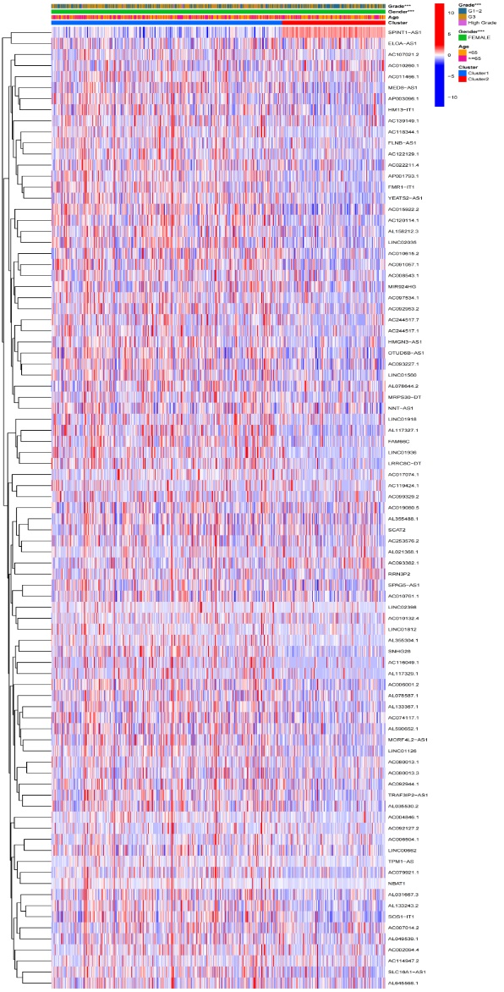

A
B

Supplementary Figure 2
A. Boxplot of analysis for M1 Macrophages in different clusters, p < 0.05; B-D. Boxplot analysis of tumor microenvironment in different clusters. The higher the stroma score, the lower was the purity of the tumor cells.

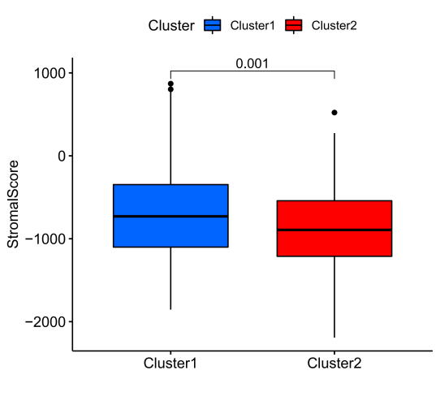

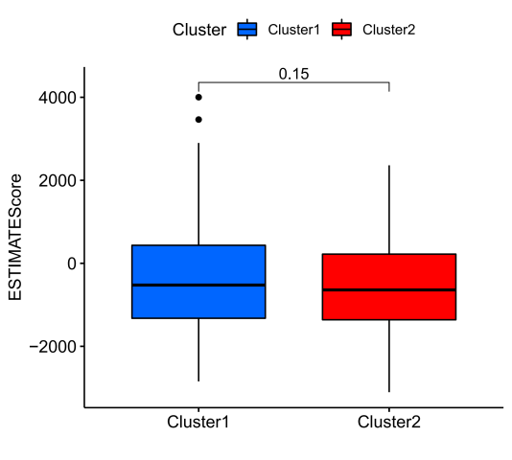
D
C
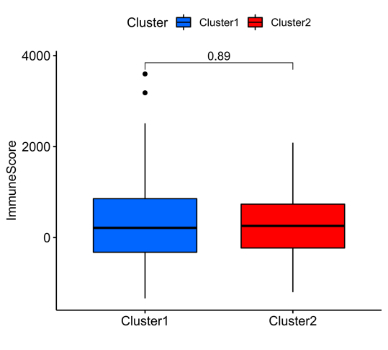

Supplementary Figure 3. Validation of the prognostic analysis.
A. Age, grade, and risk score were the risk factors affecting CC prognosis in the training group; B. Grade was the risk factor affecting CC prognosis in the testing group.
