Fig. S1 (a) Activity stability of free enzyme and immobilized enzyme; (b) Comparison of operational stability of immobilized enzyme; (c) Effects of immobilization time on activity of immobilized enzyme; (d) Effects of immobilization temperature on activity of immobilized enzyme; (e) Effects of pH on activity of immobilized enzyme; (f) Effects of the amount of laccase on activity of immobilized enzyme.

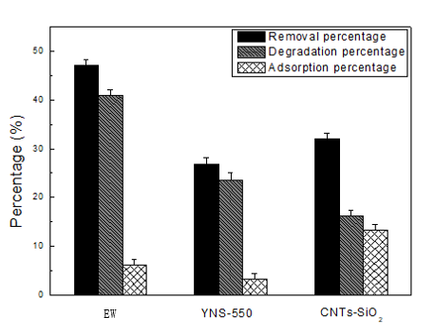

Fig. S2 Effect of carriers on MXC degraded by immobilized laccase

Fig. S3 The IR spectura of carrier and immobilized laccase

Fig. S4 First-order kinetic model

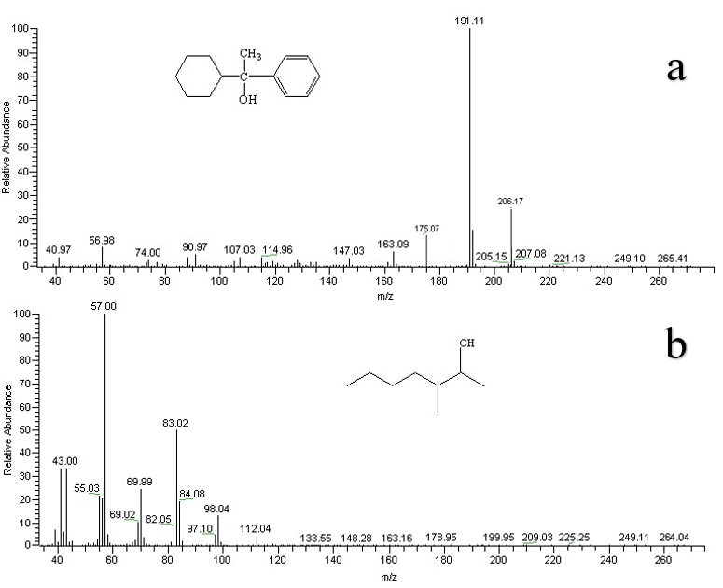

Fig. S5 GC/MS analysis of degradation products

Figure S6. Standard curve for MXC concentration determination using internal standard method

Fig.S7 The comparison of theoretical and actual concentration of released chloride ions during the catalytic degradation of MXC

Products | Mass spectrum m/z (relative intensity)
1-cyclohexyl-1-phenyl ethanol | 206(24.1), 191(100), 175(14.7)
3-methyl-2-heptanol | 112(5.2), 98(13.6), 84(19.8), 83(50.1), 70(24.3), 43(33.4), 57(100)

Table S1 Mass spectra data of products after degradation of MXC

