Supporting Information

Effect of sodium chloride on the enhanced performance of chitosan-based ion actuators

Zhaoyang Cuiª, Xiaoli Zhao^{b}, Weikun Jia^{b}, Yueming Renª, Yan Xu^{b ,}∗, Yanzhuo Lv ^{a,} ∗
ª College of Material Science and Chemical Engineering, Harbin Engineering University, Harbin, 150001, China
^{b} College of Mechanical and Electrical Engineering, Harbin Engineering University, Harbin, China

Text S1. Preparation of experimental materials
Force measurement software (FA1004) was produced by Shanghai Shangping Instrument Co., Ltd (Shanghai, China). Vacuum drying oven (DZF-6050) was produced by Shanghai sead Instrument Co., Ltd (Shanghai, China). Electrochemical workstation (CHI760E) was produced by Shanghai Chenhua Instrument Co., Ltd. Infrared spectroscopy (FT-IR200) was produced by Tianjin Gangdong Technology Development Co., Ltd. Scanning electron microscope (S-240) was produced by Cambridge Instrument Company.
Chitosan (CS), sodium chloride (Nacl), acetic acid (HAC), Multi-walled carbon nanotubes (MCNT), Glycerol were provided by Shanghai Aladdin Bio-Chem Technology Co., Ltd (Shanghai, China). All chemicals were of analytic grade and used without treating further for purification and the deionized water was self-restraint.

Figure S1. Preparation of chitotan-based ion actuator.
In this experiment the ion actuator investigation was a new type of responsive electronic material, which was composed of electrode membranes and actuate membranes, in which the actuate membranes were mainly composed of multi-walled carbon nanotubes and chitosan, and the actuate membranes were composed of sodium chloride with different doping ratios and chitosan, acetic acid. Sodium chloride doped CSIA were prepared by sol-gel method^{[1]}. Preparation of chitotan-based ion actuator as shown in Figure S1. The CSIA preparation process consists of the following steps. First of all, 40 mL of acetic acid solution with a volume fraction of 2 % was poured into six 250 mL beakers in a water bath at 50 °C to keep warm. Secondly, added 1.2 g chitosan to the beaker slowly and dissolved the solution thoroughly with magnetron stirring. Thirdly, different amounts of Nacl were added to different beakers in turn when the chitosan was completely dissolved. According to the experimental design, the doping ratios of Nacl added to the actuate membrane mixtures were detailed in Table 1. When mixtures completely dissolved, injected 2 mL of glycerol into the solution to obtain actuate membrane mixtures. Eventually, after ultrasonic defoaming for 15 min, the hydrogel was poured into a 50×50 mm mold, placed in a drying oven, and dried at 50 °C for 12 h.

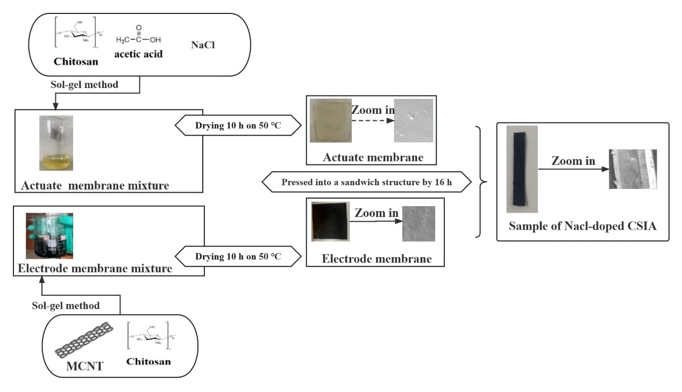

According to the experimental design, the doping ratio of Nacl added to the actuate membrane mixture was detailed in Table 1 Samples of CSIA of different Nacl qualities were numbered.
Table S1. Ratio table of different CSIA raw materials.
Sample` | S0 | S1 | S2 | S3 | S4 | S5
Nacl (%) | 0.0 | 0.1 | 0.2 | 0.3 | 0.4 | 0.5
Notes:
The doping ratios of Nacl were the mass ratio of the chitosan solution of Nacl.
For all groups, the chitosan ingredient was 1.2 g, glycerol was 2 mL and deionized water was 40 mL.

Figure S2. (a) Output force test platform, and (b) the deflection of CSIA on electrical stimulation.
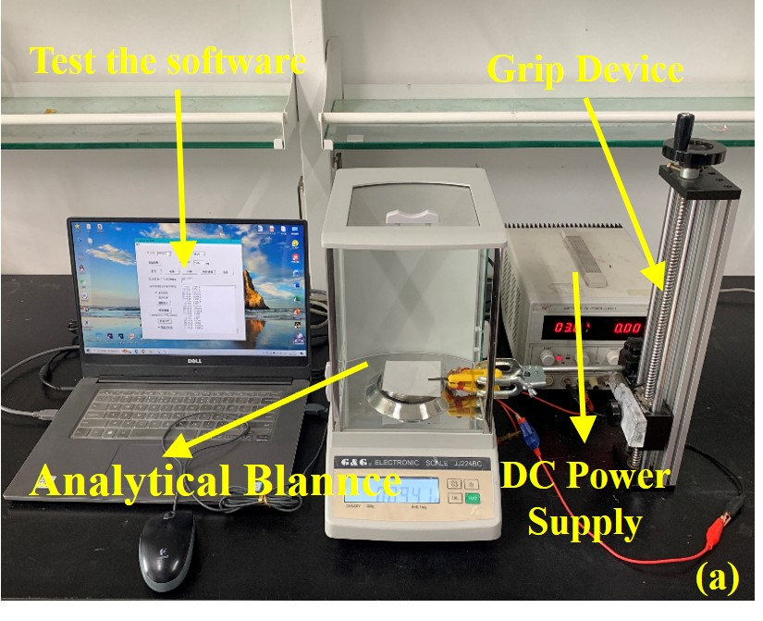

Text S2. Computational details.
(1) Porosity calculation
Since the ion channel could improve the transmission ratio of charged ions inside the actuate membrane of CSIA, its mechanochemical characteristics and the porosity of the actuate membrane^{[2]}. The formula for calculating porosity was shown below.

$$P=\frac{m_{1}-m_{0}}{ρ×V}×100\% (1)$$
Where $m_{0}$ (g) was the constant mass of the actuate membrane, $m_{1}$ (g) was the mass weight, ρ (g.cm⁻³) was the density of absolute ethanol and $V$ (cm³) was the volume of the sample.
(2) Specific capacitance calculation
Calculating the area enclosed by the plotted figure, which was approximately the value of the integral part, and then it was brought into the specific capacitance formula to calculate the specific capacitance of the material. The specific capacitance was calculated as follows.
$$Cp=\frac{A}{2(V_{2}-V_{1}×m×k)} \left(2\right)$$
Among them, Cp was the specific capacitance. A was the scanning area. $V_{1}$ and $V_{2}$ were low and high potential, respectively. m was the sample quality and k was the scanning speed.

Figure S3. (a) Electrochemical workstation, (b) three-electrode system, and (c) Z-View analog circuitry.
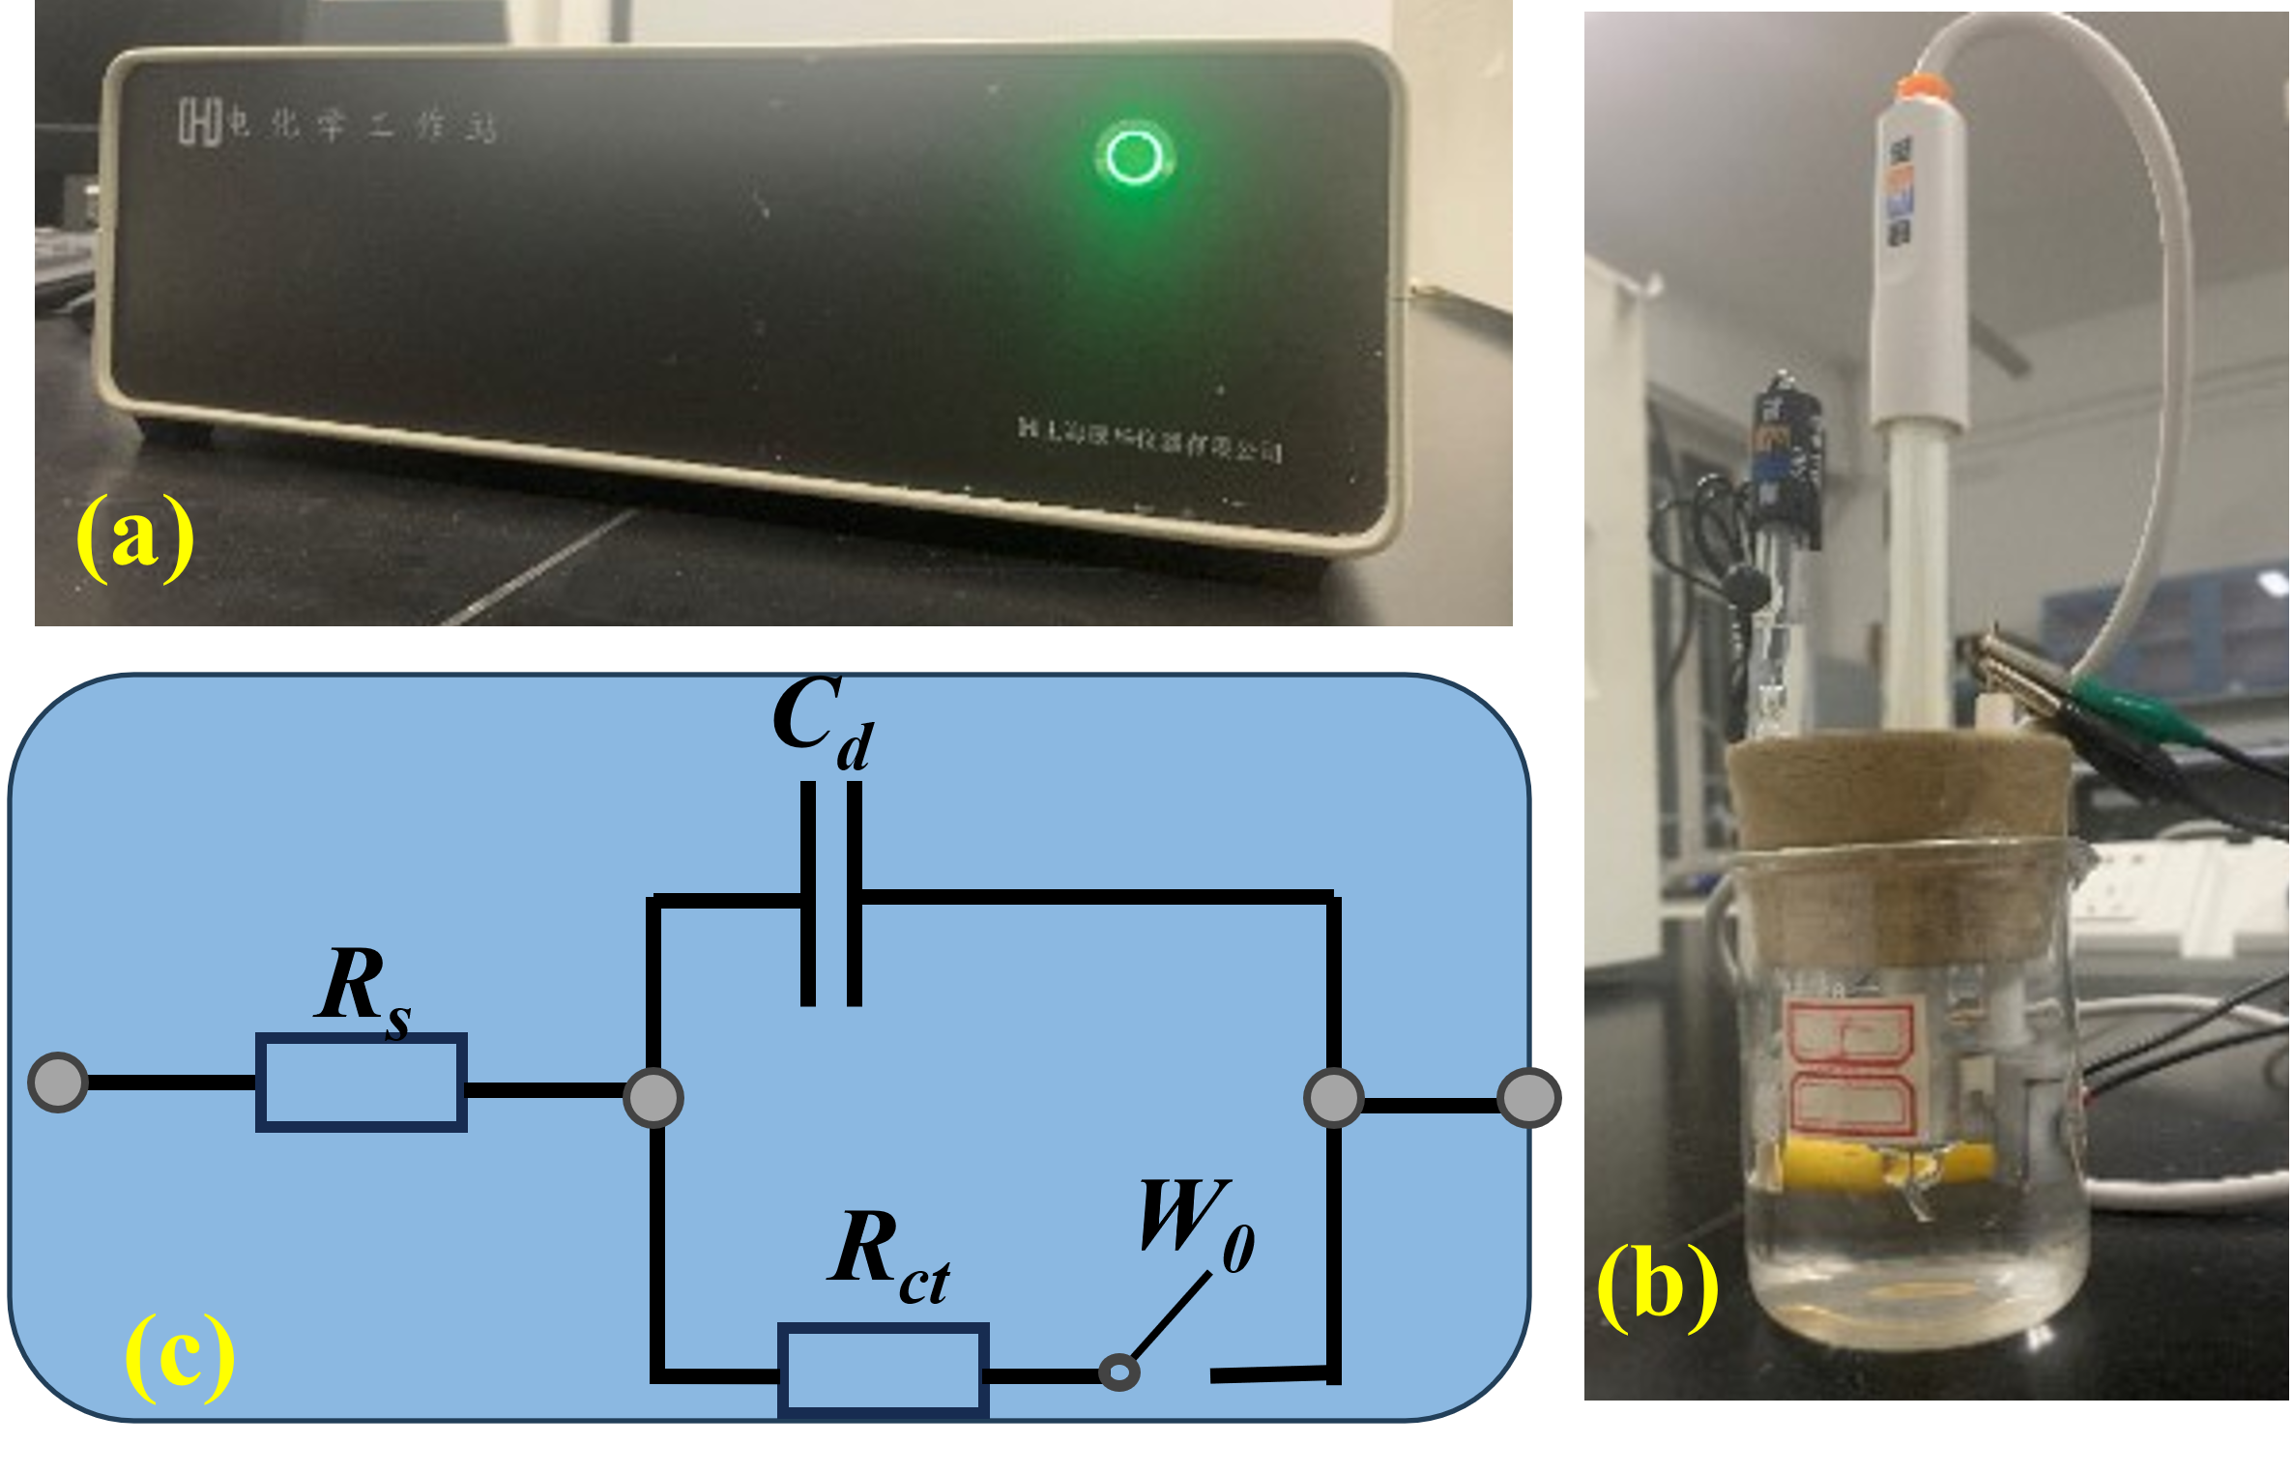
The electrochemical tests were tested by the electrochemical workstation, as shown in Figure S3 (a). The three-electrode system (Figure S3 (b)) was formed by using saturated calomel electrode as reference electrode and platinum electrode as auxiliary electrode and working electrode.
The equivalent circuit model was indicated in Figure S3 (c). It was used to study the electrochemical impedance data^{[3]}.This analog circuit used $R_{s}$ to represent the resistance of the electrolyte solution, $R_{ct}$ to denote the charge transfer resistance, $C_{d}$ to show the electric double-layer capacitance, and $W_{o}$ to represent the open potential. Data fitting was performed using Z-view software. The reverse extension of the data in the figure was connected to the x-axis, and its intercept was the measured resistance value.

Table S2. Performance parameters of the sample.
Sample number | S0 | S1 | S2 | S3 | S4 | S5
Maximum output force（mN） | 0.667 | 0.814 | 1.077 | 1.753 | 2.939 | 0.302
Specific capacitance (50 mV s⁻¹, F g⁻¹） | 0.0299 | 0.04576 | 0.04245 | 0.06941 | 0.07719 | 0.05994
Resistance (0.1 Hz, Ω) | 14.18 | 14.29 | 14.47 | 14.34 | 13.48 | 14.35
Porosity (%) | 2.704 | 3.018 | 4.447 | 5.173 | 12.98 | 1.531

References
- D. Bokov, A. T. Jalil, S Chupradit, Nanomaterial by Sol-Gel Method: Synthesis and Application, J. Advances in Materials Science and Engineering, 2021(2021) 5102014.
- M. Antonietti, N. Fechler, T. P. Fellinger, Carbon aerogels and monoliths: control of porosity and nanoarchitecture via sol-gel routes, J. Chemistry of Materials, 26(2013) 196-210.
- V. Panwar, S.Y. K, J. Park, S. Park, Enhanced and fast actuation of fullerenol/PVDF/PVP/PSSA based ionic polymer metal composite actuators, J. Sensors and Actuators B, 183(2013) 504-517.

∗ Corresponding author. Tel. /Fax: +86-18845592773 Email: xychangke@163.com (Y. Xu).

