 | Surbhi Kapoor received a B.Tech degree from GNDEC, Punjab, India in 2014, and an M.Tech degree from LPU in 2016. She was awarded the UGC Junior Research Fellow in 2018 and is currently pursuing a Ph.D. in Computer Science and Engineering at University Institute of Engineering and Technology, Chandigarh, India. Her research focuses on object detection, image, and video analytics.
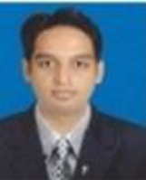 | Akashdeep is an assistant professor in Computer Science and Engineering at University Institute of Engineering & Technology, Panjab University, Chandigarh, India. He has published over 22 papers in international journals and conferences, and specializes in wireless networks, soft computing, video analytics, and traffic sensing/classification.
 | Amandeep Verma is an associate professor of Information Technology at University Institute of Engineering & Technology, Panjab University, Chandigarh, India. She earned a Ph.D. in Computer Science & Engineering in 2016 and focuses her research on parallel/distributed computing, computer networks, workflow scheduling in cloud computing, and IoT.

