Supporting Information for Publication
Tunable magnetism and electron correlation in titanium-based Kagome metals RETi₃Bi₄ (RE = Yb, Pr, and Nd) by rare-earth engineering

Long Chen^{1, 2, #}, Ying Zhou^{1, 2, #}, He Zhang^{1, 2, #}, Xuecong Ji^{1, 2, #}, Ke Liao^{1, 2}, Yu Ji^{1, 2}, Ying Li¹, Zhongnan Guo³, Xi Shen¹, Richeng Yu^{1, 2, 4}, Xiaohui Yu^{1, 2, 4, *}, Hongming Weng^{1, 2, 4, *}, Gang Wang^{1, 2, 4, *}

¹ Beijing National Laboratory for Condensed Matter Physics, Institute of Physics, Chinese Academy of Sciences, Beijing 100190, China
² University of Chinese Academy of Sciences, Beijing 100049, China
³ Department of Chemistry, School of Chemistry and Biological Engineering, University of Science and Technology Beijing, Beijing 100083, China
⁴ Songshan Lake Materials Laboratory, Dongguan, Guangdong 523808, China
# These authors contributed equally to this work.
*Corresponding author. Email: yuxh@iphy.ac.cn; hmweng@iphy.ac.cn; gangwang@iphy.ac.cn.

Table S1. Crystallographic data and structure refinement of RETi₃Bi₄ (RE = Yb, Pr, and Nd).
Empirical formula |  | YbTi₃Bi₄** | PrTi₃Bi₄ | NdTi₃Bi₄
f.u. weight (g/mol) |  | 1152.7 | 1120.6 | 1120.6
Space group / Z |  | Fmmm (No.69) / 4
Unit cell parameter | a (Å) | 24.9(4) | 24.9668(114) | 24.9523(87)
Unit cell parameter | b (Å) | 10.3(4) | 10.3248(49) | 10.3327(27)
Unit cell parameter | c (Å) | 5.9(2) | 5.9125(26) | 5.9009(18)
Unit cell parameter | α, β, γ (°) | 90 | 90 | 90
Unit cell parameter | V (Å³) | 1513.17(3) | 1524.108(2.0) | 1521.4 (1.9)
d_{cal} (g/cm³) |  | -- | 4.883 | 4.883
Refl. Collectd / unique |  | -- | 2477 / 364 | 2013 / 346
R_{int} |  | -- | 0.0723 | 0.0623
Goodness-of-fit |  | -- | 1.5212 | 1.435
R₁ / wR₂ (I > 2σ(I)) |  | -- | 0.0473 / 0.0887 | 0.0461 / 0.0884
R₁ / wR₂ (all) |  | -- | 0.0723 / 0.0989 | 0.0644 / 0.0963
** Due to the two-dimensional feature of YbTi₃Bi₄, the collected single crystal X-ray diffraction data cannot be used to do the refinement. Here we present the indexed unit cell parameters. The crystal structure of YbTi₃Bi₄ is determined by scanning transmission electron microscopy as shown in the manuscript.

Table S2. Atomic coordinates and equivalent isotropic displacement parameters for PrTi₃Bi₄.
Atom | Wyck. | Sym. | x/a | y/b | z/c | Occ. | U(eq)(Å²)
Pr | 8g | 2mm | 0.6954(1) | 0 | 0 | 1.0 | 0.0262(8)
Ti1 | 8g | m | 0.5926(3) | 0 | -0.5000 | 1.0 | 0.0250(2)
Ti2 | 16l | m | 0.5933(3) | 0.2500 | -0.2500 | 1.0 | 0.0290(2)
Bi1 | 8h | m | 0.5000 | 0.1693(1) | -0.5000 | 1.0 | 0.0263(6)
Bi2 | 16o | m | 0.6877(1) | 0.1613(1) | -0.5000 | 1.0 | 0.0263(4)
Bi3 | 8g | m | 0.5682(1) | 0.5000 | 0.5000 | 1.0 | 0.0271(6)

Table S3. Anisotropic displacement parameters for PrTi₃Bi₄. The anisotropic displacement factor exponent takes the form: -2π²[h²a²U₁₁ + ... + 2hkabU₁₂].
Atom | U₁₁ (Å²) | U₂₂ (Å²) | U₃₃ (Å²) | U₂₃ (Å²) | U₁₃ (Å²) | U₁₂ (Å²)
Pr | 0.0480(18) | 0.0076(7) | 0.0230(13) | 0 | 0 | 0
Ti1 | 0.0400(60) | 0.0080(20) | 0.0280(40) | 0 | 0 | 0
Ti2 | 0.0630(50) | 0.0083(17) | 0.0160(30) | 0 | 0 | -0.0021(14)
Bi1 | 0.0462(13) | 0.0080(50) | 0.0246(10) | 0 | 0 | 0
Bi2 | 0.0493(10) | 0.0071(4) | 0.0226(7) | -0.0002(3) | 0 | 0
Bi3 | 0.0568(14) | 0.0053(5) | 0.0192(8) | 0 | 0 | 0

Table S4. Atomic coordinates and equivalent isotropic displacement parameters for NdTi₃Bi₄.
Atom | Wyck. | Sym. | x/a | y/b | z/c | Occ. | U(eq)(Å²)
Nd | 8g | 2mm | 0.30408(8) | 0 | 0.5000 | 1.0 | 0.0142(6)
Ti1 | 8g | m | 0.4071(3) | 0.5000 | 0.5000 | 1.0 | 0.0140(20)
Ti2 | 16l | m | 0.4053(2) | 0.7500 | 0.7500 | 1.0 | 0.0192(17)
Bi1 | 8h | m | 0.5000 | 0.6694(1) | 0.5000 | 1.0 | 0.0143(5)
Bi2 | 16o | m | 0.3118(1) | 0.6606(1) | 0.5000 | 1.0 | 0.0139(4)
Bi3 | 8g | m | 0.43123(5) | 0 | 0.5000 | 1.0 | 0.0144(5)

Table S5. Anisotropic displacement parameters for NdTi₃Bi₄. The anisotropic displacement factor exponent takes the form: -2π²[h²a²U₁₁ + ... + 2hkabU₁₂].
Atom | U₁₁ (Å²) | U₂₂ (Å²) | U₃₃ (Å²) | U₂₃ (Å²) | U₁₃ (Å²) | U₁₂ (Å²)
Nd | 0.0202(12) | 0.0104(8) | 0.0119(12) | 0 | 0 | 0
Ti1 | 0.029(5) | 0.011(3) | 0.003(4) | 0 | 0 | 0
Ti2 | 0.047(4) | 0.0047(17) | 0.006(3) | 0 | 0 | 0.0013(17)
Bi1 | 0.0214(9) | 0.0076(5) | 0.0138(9) | 0 | 0 | 0
Bi2 | 0.0215(8) | 0.0006(2) | 0.0072(5) | 0.0131(7) | 0 | 0
Bi3 | 0.0253(9) | 0.0051(5) | 0.0127(9) | 0 | 0 | 0

Table S6. Quantitative analysis of elemental composition for YbTi₃Bi₄ single crystals. For each sample, the molar ratio of composed elements is measured at three different locations. The stoichiometry of YbTi₃Bi₄ is determined to be Yb : Ti : Bi = 0.85(3) : 3.00(5) : 4.04(3) by the statistical average and standard deviation (SD) of the overall energy-dispersive spectroscopy (EDS) data.
Atom | Yb (Mol.%) | Ti (Mol.%) | Bi (Mol.%)
SA#-1 | 10.62 | 38.02 | 51.36
SA#-2 | 11.37 | 37.37 | 51.26
SA#-3 | 10.74 | 37.74 | 51.51
SB#-1 | 11.07 | 37.03 | 51.90
SB#-2 | 10.30 | 39.07 | 50.63
SB#-3 | 10.74 | 37.90 | 51.36
SC#-1 | 11.39 | 37.78 | 50.83
SC#-2 | 10.26 | 38.65 | 51.08
SC#-3 | 10.79 | 38.29 | 50.93
Average | 10.81 | 37.98 | 51.21
SD | 0.41 | 0.62 | 0.39

Table S7. Quantitative analysis of elemental composition for PrTi₃Bi₄ single crystals. The final stoichiometry of PrTi₃Bi₄ is determined to be Pr : Ti : Bi = 1.00(3) : 3.06(7) : 3.99(8).
Atom | Pr (Mol.%) | Ti (Mol.%) | Bi (Mol.%)
SA#-1 | 12.82 | 37.61 | 49.57
SA#-2 | 11.79 | 38.65 | 49.56
SA#-3 | 12.33 | 36.42 | 51.25
SB#-1 | 12.28 | 36.98 | 50.74
SB#-2 | 12.87 | 38.66 | 48.47
SB#-3 | 12.72 | 39.03 | 48.25
SC#-1 | 11.99 | 38.99 | 49.02
SC#-2 | 12.92 | 37.49 | 49.59
SC#-3 | 12.12 | 38.28 | 49.60
Average | 12.43 | 38.01 | 49.56
SD | 0.42 | 0.93 | 0.97

Table S8. Quantitative analysis of elemental composition for NdTi₃Bi₄ single crystals. The final stoichiometry of NdTi₃Bi₄ is determined to be Nd : Ti : Bi = 1.00(4) : 3.02(5) : 3.92(5).
Atom | Nd (Mol.%) | Ti (Mol.%) | Bi (Mol.%)
SA#-1 | 13.14 | 37.81 | 49.05
SA#-2 | 11.69 | 37.96 | 50.35
SA#-3 | 12.27 | 38.72 | 49.01
SB#-1 | 12.53 | 37.20 | 50.27
SB#-2 | 11.94 | 38.58 | 49.48
SB#-3 | 12.55 | 37.93 | 49.52
SC#-1 | 12.93 | 38.57 | 48.50
SC#-2 | 13.18 | 38.41 | 48.41
SC#-3 | 13.10 | 37.24 | 49.66
Average | 12.59 | 38.05 | 49.36
SD | 0.54 | 0.57 | 0.69

Table S9. Fitted parameters of magnetic susceptibility for RETi₃Bi₄ using Curie-Weiss law.
RE | Yb |  | Pr |  | Nd
Field configuration | H // bc | H ⊥ bc | H // bc | H ⊥ bc | H // bc | H ⊥ bc
χ₀ (10⁻⁴ emu mol⁻¹ Oe⁻¹) | 0.36(1) | 2.29(6) | -6.50(4) | -32.2(1) | 0.21(4) | 2.17(2)
C (10⁻³ emu mol⁻¹ Oe⁻¹ K⁻¹) | 9.59(5) | 3.11(2) | 1.68(5) | 2.78(8) | 1.58(3) | 1.70(1)
θ (K) | 0.55(1) | 0.55(1) | 2.50(1) | -100(1) | -3.62(3) | -36.7(3)
μ_{eff} (μ_{B}/f.u.) | 0.28(1) | 0.16(1) | 3.66(5) | 4.72(7) | 3.58(6) | 3.69(1)
μ_{sat} at 7 T (μ_{B}/ f.u.) | 0.016 | 0.006 | 1.620 | 0.855 | 1.426 | 0.587

Table S10. Fitted parameters of resistivity using Power law and those of specific heat capacity using Debye model for RETi₃Bi₄.
RE | Yb | Pr | Nd | Nd
T_{anomaly} or T_{c} | - | ~8.2 K | 8.5 K | 8.5 K
T_{min} - T_{max} | 2 K - 45 K | 10 K - 45 K | 10 K - 45 K | 2 K - 9 K
ρ₀ (10⁻⁵ Ω cm) | 2.62(1) | 3.68(3) | 3.79(1) | 3.45(1)
A (10⁻⁹ Ω cm K^{-α}) | 2.36(29) | 8.07(1.02) | 2.56(28) | 0.00329(6)
α | 2.00(3) | 1.64(3) | 1.51(2) | 5.35(8)
T_{min} - T_{max} | 2 K - 7 K | 12 K - 18 K | 12 K - 18 K
γ (mJ mol⁻¹ K⁻²) | 20.7(7) | 762.6(8.9) | 809.6(7.5)

Table S11. Fitted parameters of resistance for NdTi₃Bi₄ under high pressure using Power law (10 K - 45 K).
Pressure (GPa) | R₀ (Ω) | A (10⁻⁵ Ω K^{-α}) | α
1.5 | 0.06853(4) | 3.65(17) | 1.539(12)
2.6 | 0.06900(2) | 3.75(9) | 1.530(6)
3.8 | 0.06924(2) | 3.09(7) | 1.546(6)
5.4 | 0.07044(2) | 3.12(10) | 1.544(8)
7.7 | 0.07141(3) | 2.97(13) | 1.554(11)
10.2 | 0.07180(3) | 2.89(13) | 1.556(12)
12.4 | 0.07111(4) | 2.48(15) | 1.594(16)
15.4 | 0.07237(4) | 2.03(14) | 1.640(18)
18.9 | 0.07585(4) | 1.07(10) | 1.802(26)
23.3 | 0.07975(4) | 1.12(11) | 1.794(26)
28.1 | 0.08467(4) | 1.02(10) | 1.818(25)
32.4 | 0.08675(5) | 9.21(10) | 1.854(28)
37.0 | 0.08938(5) | 1.19(13) | 1.810(28)
41.9 | 0.09137(6) | 1.42(15) | 1.786(27)

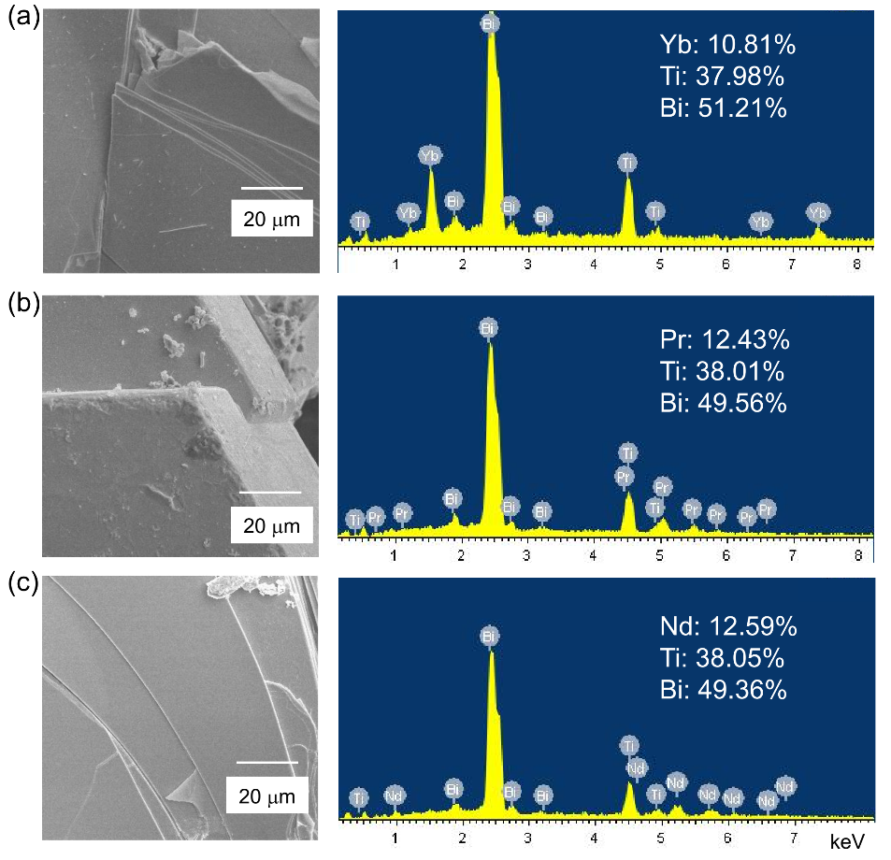
Figure S1. Scanning electron microscope images and typical EDSs collected on the flat clean surface of (a) YbTi₃Bi₄, (b) PrTi₃Bi₄, and (c) NdTi₃Bi₄ single crystals, showing clean surface with hexagonal shape and two-dimensional feature.

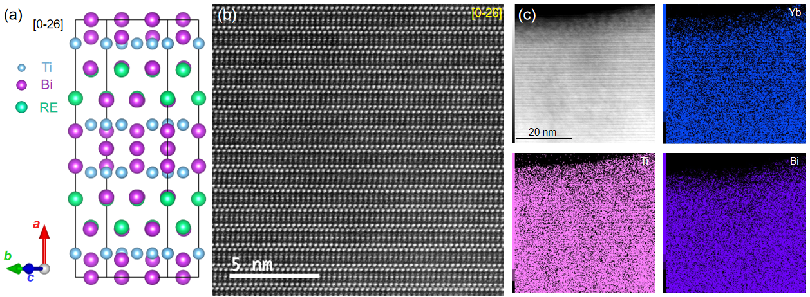
Figure S2. (a) Crystal structure and (b) high-angle annular dark-field image of YbTi₃Bi₄ along the [0-26] zone axis. (c) EDS mapping of YbTi₃Bi₄ collected on a 20 nm scale bar, showing the homogenous distribution of Yb, Ti, and Bi elements

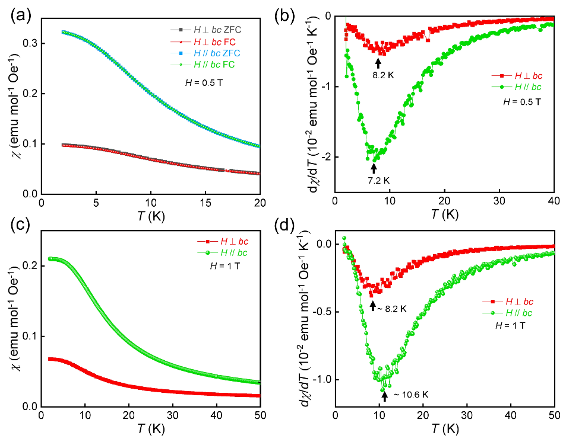
Figure S3. (a) Magnetic susceptibility and (b) first derivative of magnetic susceptibility (dχ/dT) for PrTi₃Bi₄ at low temperature under 0.5 T. (c) Magnetic susceptibility and (d) first derivative of magnetic susceptibility (dχ/dT) for PrTi₃Bi₄ at low temperature under 1 T.

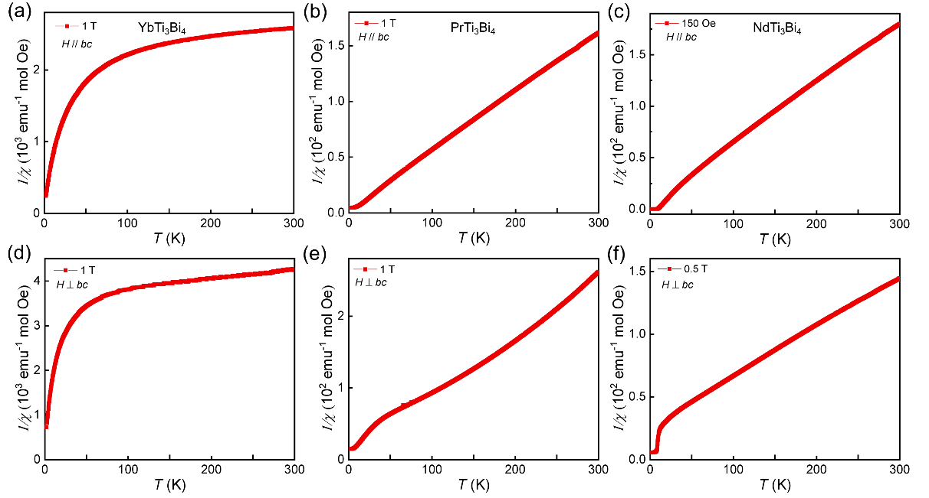
Figure S4. 1/χ vs. T plot with magnetic field parallel to the bc plane of (a) YbTi₃Bi₄, (b) PrTi₃Bi₄, and (c) NdTi₃Bi₄ single crystal. 1/χ vs. T plot with magnetic field perpendicular to the bc plane of (a) YbTi₃Bi₄, (b) PrTi₃Bi₄, and (c) NdTi₃Bi₄ single crystal.

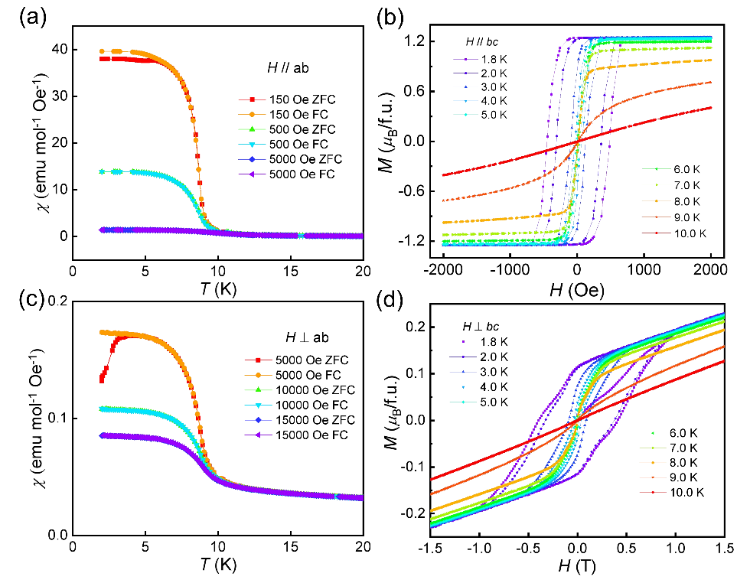
Figure S5. Magnetic susceptibility of NdTi₃Bi₄ under different magnetic field (a) parallel and (c) perpendicular to the bc plane. Field-dependent magnetization of NdTi₃Bi₄ at different temperature under magnetic field (b) parallel and (d) perpendicular to the bc plane.
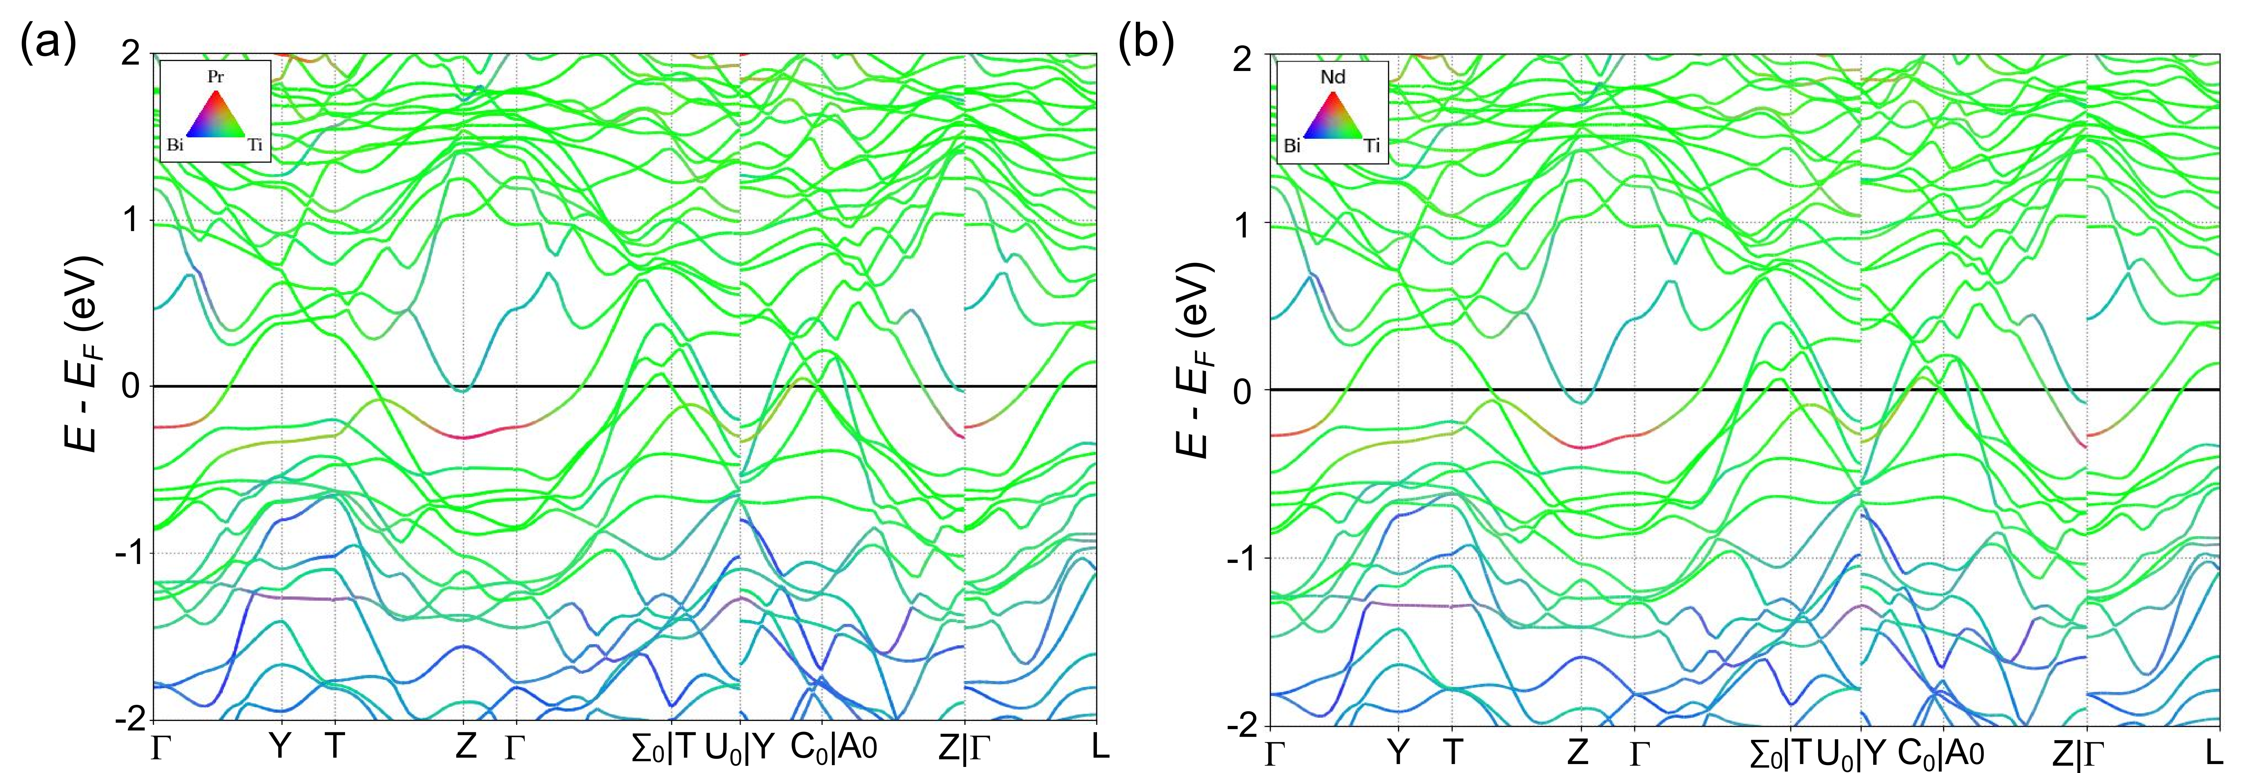
Figure S6. Electronic structure of (a) PrTi₃Bi₄ and (b) NdTi₃Bi₄. The bands with different color represent the contribution coming from Pr or Nd (red), Ti (green), and Bi (blue).

First principles calculations were carried out with the projector augmented wave method as implemented in the Vienna ab initio simulation package [1-3]. The generalized gradient approximation [4] of the Perdew-Burke-Ernzerhof [2] type was adopted for the exchange-correlation function. The cutoff energy of the plane-wave basis was 500 eV and the energy convergence standard was set to 10⁻⁸ eV. The 3 × 11 × 4 Monkhorst-Pack K-point mesh was employed for the Brillouin zone sampling of the 1 × 1 × 1 unit cell. Since Bi is a quite heavy element, spin-orbit coupling effect was taken into account by treating core electrons in fully relativistic method and valance electrons in second-variation method.

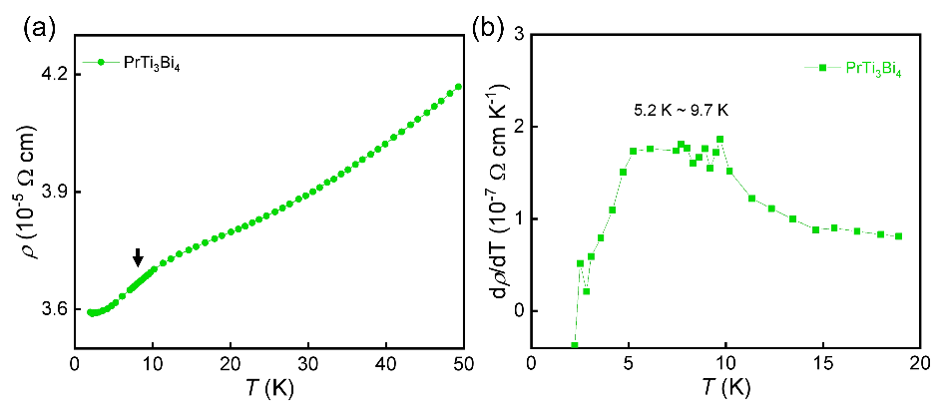
Figure S7. (a) Zoomed temperature-dependent resistivity of PrTi₃Bi₄ at low temperature. The arrow denotes the abnormal enhancement around 10 K. (b) First derivate of resistivity at low temperature.

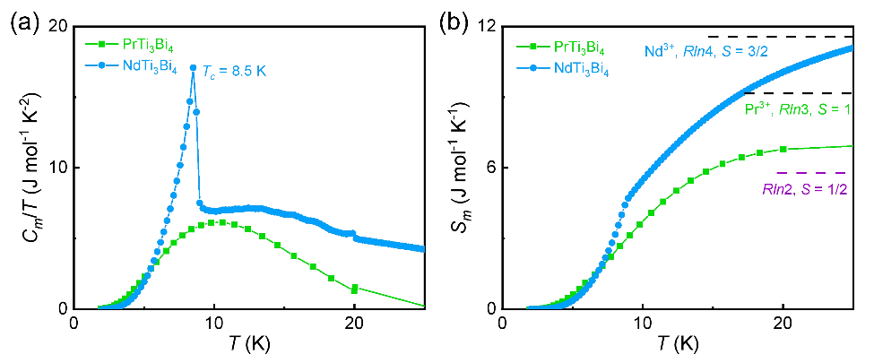
Figure S8. (a) C_{mag}/T vs T and (b) calculated magnetic entropy S_{mag} of PrTi₃Bi₄ and NdTi₃Bi₄ single crystal. The dashed lines show the theoretical value Rln(2S + 1) with S = 1/2, 1, and 3/2.
To obtain the specific heat capacity contributed by magnon (C_{mag}) associated with the broad anomaly of PrTi₃Bi₄ and FM phase transition of NdTi₃Bi₄, the specific heat capacity of nonmagnetic YbTi₃Bi₄ is taken as the sum of phonon contribution (C_{ph}) and electron contribution (C_{e}), C_{Yb}= C_{ph} + C_{e}. By subtracting the specific heat capacity of YbTi₃Bi₄ from the total specific heat capacity (C_{p}) of PrTi₃Bi₄ and NdTi₃Bi₄, the specific heat capacity contributed by magnon is calculated using C_{mag} = C_{p} - C_{Yb} = C_{p} - C_{ph} - C_{e}. The magnetic entropy is further calculated following${ S}_{mag}(T)=\int_{0}^{T}{C_{mag}/TdT}$. For PrTi₃Bi₄, the specific heat capacity contributed by magnon show a broad peak around 10 K. The magnetic entropy tends to saturated at 25 K and exceeds Rln2 = 5.78 J mol⁻¹ K⁻¹ with S = 1/2, possibly indicating a Pr³⁺ state with S = 1. For NdTi₃Bi₄, a sharp peak at 8.5 K can be observed in its specific heat capacity being contributed by magnon and the saturated magnetic entropy approaches the theoretical value Rln(2S+1) = 11.56 J mol⁻¹ K⁻¹ for S = 3/2, suggesting a Nd³⁺ state.

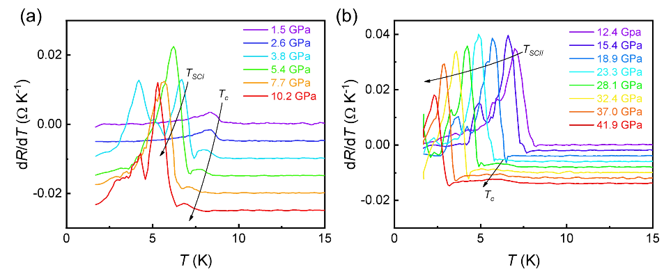
Figure S9. The first derivative curves of resistance (dR/dT) for NdTi₃Bi₄ under pressure ranging from (a) 1.5 GPa to 10.2 GPa and (b) 12.4 GPa to 41.9 GPa. The arrows show the suppression trend of ferromagnetic ordering temperature (T_{c}) and superconducting transition temperature (T_{SCI} or T_{SCII}).

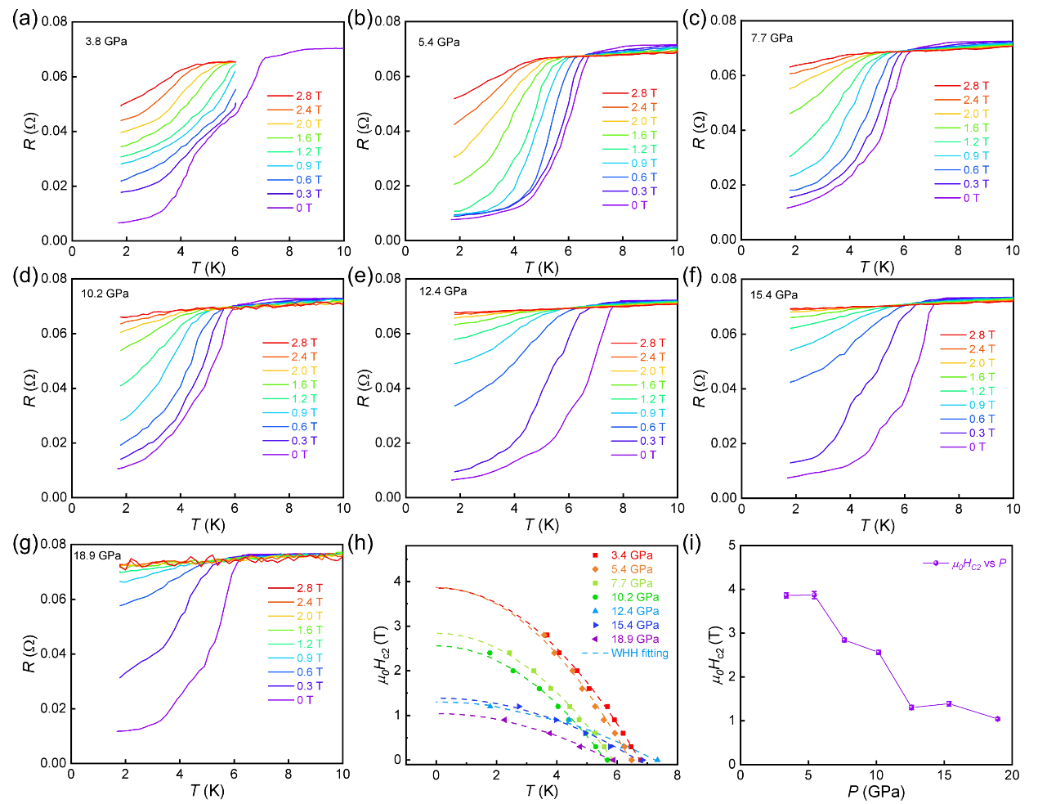
Figure S10. Resistance under different magnetic field for NdTi₃Bi₄ under (a) 3.8 GPa, (b) 5.4 GPa, (c) 7.7 GPa, (d) 10.2 GPa, (e) 12.4 GPa, (f) 15.4 GPa, and (g) 18.9 GPa. (h) Plots of superconducting transition temperature (T_{SC}) vs upper critical field (μ₀H_{c2}) for NdTi₃Bi₄ under different pressure. The dashed lines represent the WHH fittings to the data of μ₀H_{c2}. (i) Pressure dependence of upper critical field for NdTi₃Bi₄.
Owing to the non-zero resistance, the pressure-induced superconducting transition may not be the intrinsic properties of NdTi₃Bi₄. To determine this issue, the resistance under different magnetic field (0 T - 2.8 T) have been measured. As shown in Figure S10a-g, the drop in resistance is suppressed with applied magnetic field. Under 3.8 GPa, without magnetic field, the superconducting transition shows a step-like feature with T_{SC1} = 4.2 K and T_{SC2} = 6.3 K, which are quite close to the reported pressure-induced superconducting transition of Bi-II (T_{SC} = 3.92 K) and Bi-III (T_{SC} = 7 K) under 2.8 GPa [5], respectively. A small magnetic field (< 0.3 T) would fully suppress the lower superconducting transition, but the higher superconducting transition would survive beyond 2.8 T. According to the Werthamer–Helfand–Hohenberg (WHH) theory [6], the upper critical field of the higher superconducting transition under 3.8 GPa is calculated to be 3.8 T, quite close to the reported upper critical field (3.71 T) of Bi-III phase [5]. For the pressure ranging from 5.4 GPa to 10.2 GPa, there only exists one superconducting transition, where both the superconducting transition temperature T_{SC} and upper critical field slightly decrease with increasing pressure (Figure S10i), similar to the reported behavior of Bi-III phase [5]. When the pressure further increases to 12.4 GPa, another superconducting transition with higher T_{SC} and lower upper critical field appears, which should be attributed to the reported Bi-V phase under high pressure [5].

[1] G. Kresse, J. Hafner, Abinitio molecular-dynamics for liquid-metals, Phys. Rev. B, 47 (1993) 558-561.
[2] G. Kresse, J. Furthmuller, Efficiency of ab-initio total energy calculations for metals and semiconductors using a plane-wave basis set, Comp. Mater. Sci., 6 (1996) 15-50.
[3] G. Kresse, J. Furthmuller, Efficient iterative schemes for ab initio total-energy calculations using a plane-wave basis set, Phys. Rev. B, 54 (1996) 11169-11186.
[4] J.P. Perdew, K. Burke, M. Ernzerhof, Generalized gradient approximation made simple, Phys. Rev. Lett., 78 (1997) 1396.
[5] Y. Li, E. Wang, X. Zhu, H.-H. Wen, Pressure-induced superconductivity in Bi single crystals, Phys. Rev. B, 95 (2017) 024510.
[6] N.R. Werthamer, E. Helfand, P.C. Hohenberg, Temperature and purity dependence of the superconducting critical field, H_{c2}. III. Electron spin and spin-orbit effects, Phys. Rev., 147 (1966) 295-302.

