Supplementary Table 1: Major phytocompounds identified in GC-MS profiling of methanolic extracts of roots (MR) of P. nepalensis
Sl. No | Compounds | Chemical formula | SMILES format | PubChem ID | 2D Structures
1a | Tetradecanoic acid, 10,13-dimethyl-, methyl ester | C₁₇H₃O₄ | CC(C)CCC(C)CCCCCCCCC(=O)OC | 554145 | 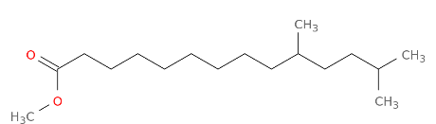
1b | Heptadecanoic acid, 16-methyl-, methyl ester | C₁₉H₃₈O₂ | CC(C)CCCCCCCCCCCCCCC(=O)OC | 110444 | 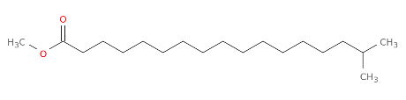
1c | 1,1,1,5,7,7,7-Heptamethyl-3,3-bis(trimethylsiloxy) tetrasiloxane | C₁₃H₄₀O₅Si₆ | C[Si](O[Si](C)(C)C)O[Si](O[Si](C)(C)C)(O[Si](C)(C)C)O[Si](C)(C)C | 6329081 | 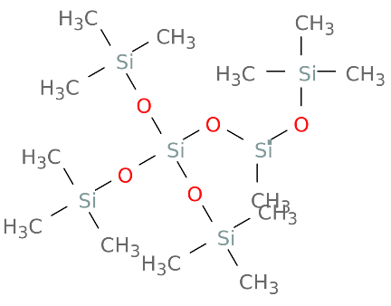
1d | Phthalic acid, butyl hept-4-yl | C₁₉H₂₈O₄ | CCCCOC(=O)C1=CC=CC=C1C(=O)OC(CCC)CCC | 91720764 | 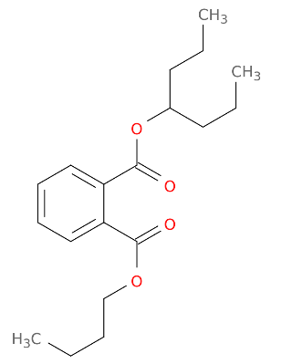
1e | 1,1,1,3,5,5,7,7,7-Nonamethyl-3-(trimethyl siloxy) tetrasiloxane | C₁₂H₃₆O₄Si₅ | C[Si](C)(C)O[Si](C)(C)O[Si](C)(C)O[Si](C)(C)O[Si](C)(C)C | 8853 | 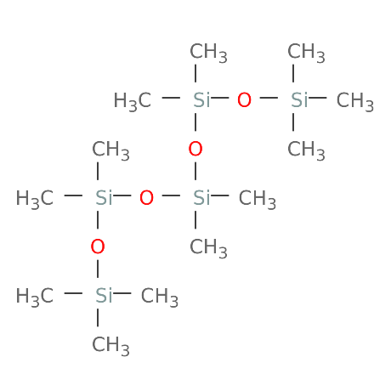
1f | Norepinephrine, (R)-, 4TMS derivative | C₂₀H₄₃NO₃Si₄ | CCOC1=CC=CC=C1O[C@@H]([C@H]2CNCCO2)C3=CC=CC=C3 | 12751 | 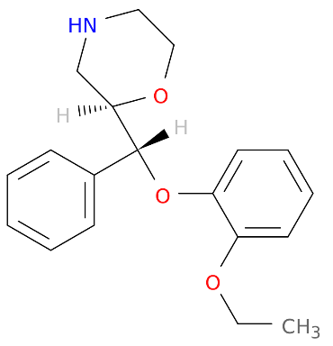
1g | 2-Isopropyl-6- phenylnicotinonitrile | C₁₅H₁₄N₂ | CC(C)C1=C(C=CC(=N1)C2=CC=CC=C2)C#N | 610213 | 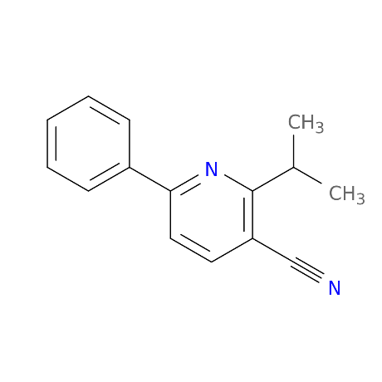
1h | Cyclononasiloxane, octadecamethyl | C₁₈H₅₄O₉Si₉ | C[Si]1(O[Si](O[Si](O[Si](O[Si](O[Si](O[Si](O[Si](O[Si](O1)(C)C)(C)C)(C)C)(C)C)(C)C)(C)C)(C)C)(C)C)C | 11172 | 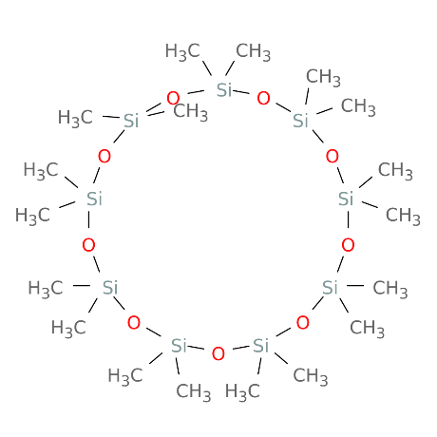
1i | Oxalic acid, 2TMS derivative | C₈H₁₈O₄Si₂ | C[Si](C)(C)OC(=O)C(=O)O[Si](C)(C)C | 519543 | 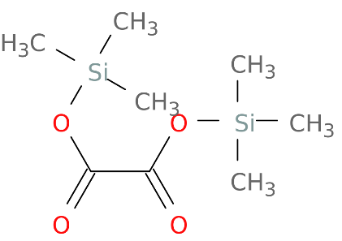
1j | 2-Tetradecanol | C₁₄H₃₀O | CCCCCCCCCCCCC(C)O | 20831 | 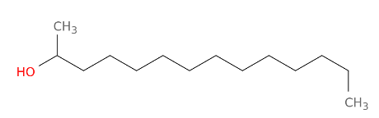

Supplementary Table 2: Major phytocompounds identified in GC-MS profiling of methanolic extracts of shoots (MS) of P. nepalensis.
Sl. No | Compounds | Chemical formula | SMILES format | PubChem ID | 2D Structures
2a | Hexadecanoic acid,methyl ester | C17H34O2 | CCCCCCCCCCCCCCCC(=O)OC | 8181 | 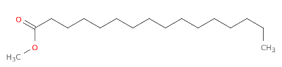
2b | 1,1,1,5,7,7,7-Heptamethyl-3,3- bis(trimethylsiloxy)tetrasiloxane | C13H40O5Si6 | C[Si](O[Si](C)(C)C)O[Si](O[Si](C)(C)C)(O[Si](C)(C)C)O[Si](C)(C)C | 6329081 | 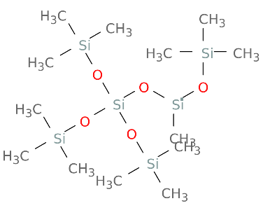
2c | Oxalic acid, 2TMS derivative | C8H18O4Si2 | C[Si](C)(C)OC(=O)C(=O)O[Si](C)(C)C | 519543 | 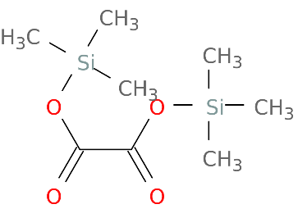
2d | Cyclooctasiloxane, hexadecamethyl- | C16H48O8Si8 | C[Si]1(O[Si](O[Si](O[Si](O[Si](O[Si](O[Si](O[Si](O1)(C)C)(C)C)(C)C)(C)C)(C)C)(C)C)(C)C)C | 11170 | 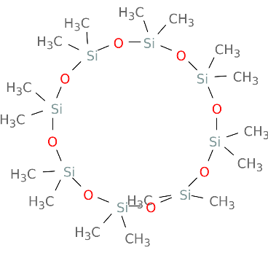
2e | 3-Ethyl-7-hydroxyphthalide | C10H10O3 | CCC1C2=C(C(=CC=C2)O)C(=O)O1 | 591119 | 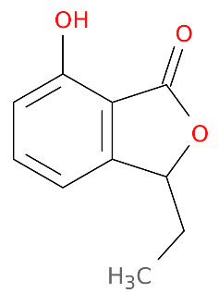
2f | Phthalic acid, butyl hex-3-yl ester | C18H26O4 | CCCCOC(=O)C1=CC=CC=C1C(=O)OC(CC)CCC | 91720282 | 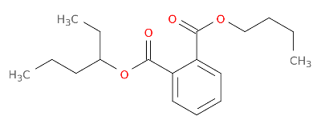
2g | 1,1,1,3,5,5,7,7,7-Nonamethyl-3-  (trimethylsiloxy)tetrasiloxane | C12H36O4Si5 | C[Si](C)(C)O[Si](C)(C)O[Si](C)(O[Si](C)(C)C)O[Si](C)(C)C | 553706 | 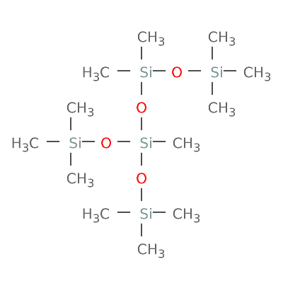
2h | 1-Hexyl-1-nitrocyclohexane | C12H23NO2 | CCCCCCC1(CCCCC1)[N+](=O)[O-] | 544063 | 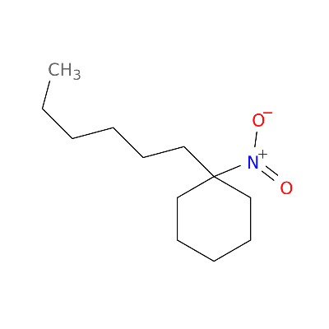
2i | Isobutyl 4-hydroxybenzoate | C11H14O3 | CC(C)COC(=O)C1=CC=C(C=C1)O | 20240 | 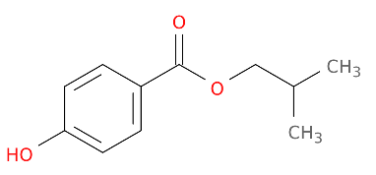
2j | Octanoic acid, 5-(acetyloxy)-, methyl ester | C11H20O4 | CCCC(CCCC(=O)OC)OC(=O)C | 539496 | 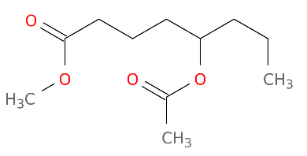

Supplementary Table 3: Major phytocompounds identified in GC-MS profiling of n-hexane extracts of roots (NR) of P. nepalensis.
Sl. No | Compounds | Chemical formula | SMILES format | PubChem ID | 2D Structures
3a | Trichloromethyl 9-anthracenecarbodithioate | C16H9Cl3S2 | C1=CC=C2C(=C1)C=C3C=CC=CC3=C2C(=S)SC(Cl)(Cl)Cl | 613595 | 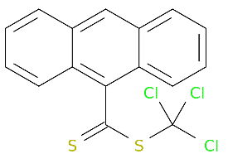
3b | Heptane, 3,3-dimethyl- | C9H20 | CCCCC(C)(C)CC | 520991 | 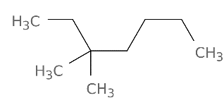
3c | Hexadecane | C16H34 | CCCCCCCCCCCCCCCC | 11006 | 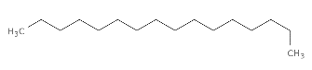
3d | 1,1,1,5,7,7,7-Heptamethyl-3, 3- bis(trimethylsiloxy)tetrasiloxane | C13H40O5Si6 | C[Si](O[Si](C)(C)C)O[Si](O[Si](C)(C)C)(O[Si](C)(C)C)O[Si](C)(C)C | 6329081 | 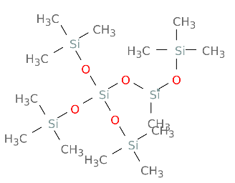
3e | Dodecane | C12H26 | CCCCCCCCCCCC | 8182 | 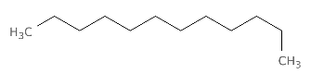
3f | Eicosane | C20H42 | CCCCCCCCCCCCCCCCCCCC | 8222 | 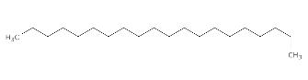
3g | 1,1,1,3,5,5,7,7,7-Nonamethyl-3-(trimethylsiloxy) tetrasiloxane Propanoicacid, | C12H36O4Si5 | C[Si](C)(C)O[Si](C)(C)O[Si](C)(C)O[Si](C)(C)O[Si](C)(C)C | 8853 | 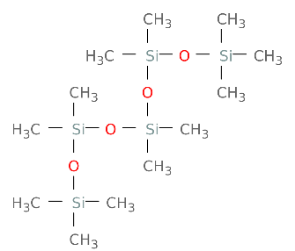
3h | 2-oxo-3-(trimethylsilyl)-, trimethylsilyl ester | C9H20O3Si2 | CCOC(=O)C1(CC2C(=C(C(=O)O2)[Si](C)(C)C)C1)C(=O)OCC | 102119459 | 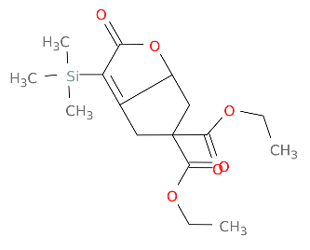
3i | 1,1,1,3,5,7,7,7-Octamethyl-3,5- bis(trimethylsiloxy) tetrasiloxane | C14H42O5Si6 | C[Si](C)(C)O[Si](C)(O[Si](C)(C)C)O[Si](C)(O[Si](C)(C)C)O[Si](C)(C)C | 553110 | 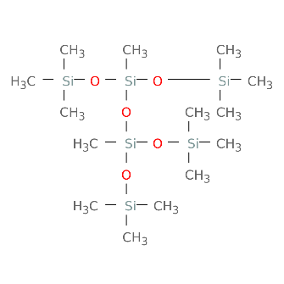
3j | 2,4,6,9-Dehydroadamantane | C10H12 | C1C2CC3C4C1C5C2C5C34 | 562325 | 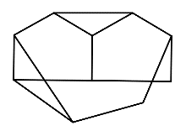

Supplementary Table 4: Major phytocompounds identified in GC-MS profiling of n-hexane extracts of shoots (NS) of P. nepalensis
Sl. No | Compounds | Chemical formula | SMILES format | PubChem ID | 2D Structures
4a | Benzene, 1,3,5-tri-tert-butyl- | C18H30 | CC(C)(C)C1=CC(=CC(=C1)C(C)(C)C)C(C)(C)C | 15089 | 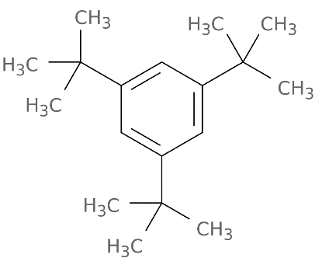
4b | 1,1,1,3,5,5,5-Heptamethyltrisiloxane 4H-1-Benzopyran-2-carboxylic acid | C7H22O2Si3 | C[Si](O[Si](C)(C)C)O[Si](C)(C)C | 6327366 | 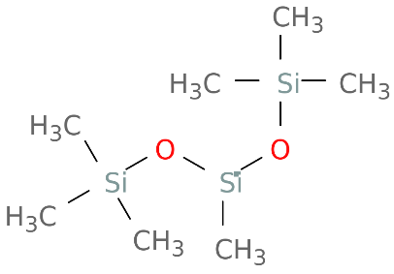
4c | 5-amino-6-hydroxy-4-oxo-, ethyl ester | C12H11NO5 | CCOC(=O)C1=CC(=O)C2=C(O1)C=CC(=C2N)O | 619354 | 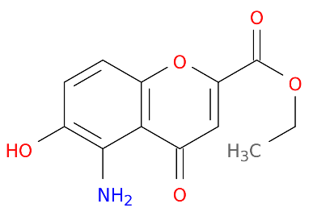
4d | 1-Propene, 3-methoxy- | C4H8O | COCC=C | 69392 | 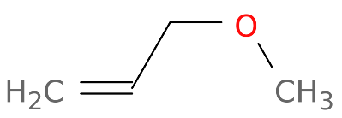
4e | Phthalic acid, butyl hept-4-yl ester | C19H28O4 | CCCCOC(=O)C1=CC=CC=C1C(=O)OC(CCC)CCC | 91720764 | 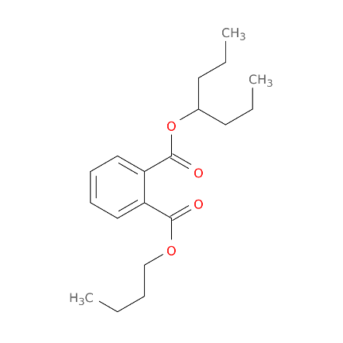
4f | Heptane, | C9H20 | CCCCCCC | 8900 | 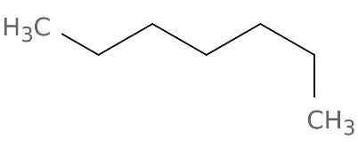
4g | 3,3-dimethyl- N- (Methyl sulfonyl)-N, O-bis (trimethyl silyl) hydroxylamine | C7H21NO3SSi2 | CN([Si](C)(C)C)S(=O)(=O)O[Si](C)(C)C | 155620124 | 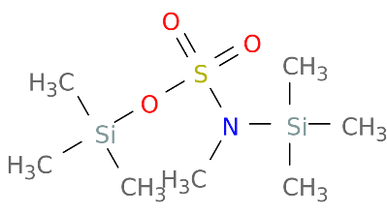
4h | Dodecanoic acid, 2-methyl- | C13H26O2 | CCCCCCCCCC[C@@H](C)C(=O)O | 5312339 | 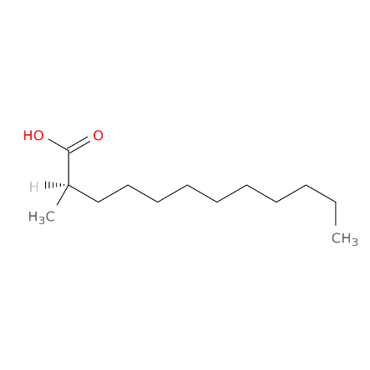
4i | 2-Acetyl-3-ethylpyrazine | C8H10N2O | CCC1=NC=CN=C1C(=O)C | 61918 | 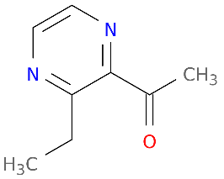
4j | Eicosane | C20H42 | CCCCCCCCCCCCCCCCCCCC | 8222 | 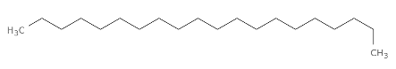

Supplementary Table 5: The binding affinities (B.A.) kcal/mol values of TP53, NFKB1, and HSPCB with the PCs of of p.nepalensis (1a – 4j)
TP53
PCs | B.A. | PCs | B.A. | PCs | B.A. | PCs | B.A.
1a | -6.1 | 2a | *-8.0 | 3a | -7.5 | 4a | -6.4
1b | *-8.6 | 2b | -6.3 | 3b | -5.2 | 4b | -6.1
1c | -6.4 | 2c | -5.6 | 3c | -7.2 | 4c | -7.0
1d | -5.0 | 2d | -3.9 | 3d | -7.0 | 4d | -3.8
1e | -6.9 | 2e | -6.2 | 3e | -7.3 | 4e | -6.0
1f | -6.2 | 2f | -5.8 | 3f | -4.2 | 4f | -5.6
1g | -5.8 | 2g | -6.4 | 3g | -6.7 | 4g | -5.4
1h | -7.2 | 2h | -5.9 | 3h | -6.3 | 4h | -5.9
1i | -6.1 | 2i | -7.1 | 3i | -5.9 | 4i | -4.9
1j | -7.8 | 2j | -5.6 | 3j | -5.6 | 4j | -3.9
NFKB1
1a | -5.2 | 2a | -5.0 | 3a | -6.8 | 4a | -5.3
1b | -4.9 | 2b | -4.4 | 3b | -4.3 | 4b | -5.0
1c | -4.9 | 2c | -4.9 | 3c | -3.8 | 4c | -6.4
1d | -4.9 | 2d | -4.9 | 3d | -4.9 | 4d | -4.9
1e | -4.9 | 2e | -6.5 | 3e | -4.3 | 4e | -4.9
1f | -5.0 | 2f | -5.1 | 3f | -3.8 | 4f | -3.8
1g | -4.4 | 2g | -4.9 | 3g | -4.9 | 4g | -5.0
1h | -5.0 | 2h | -5.0 | 3h | -4.4 | 4h | -4.4
1i | -4.4 | 2i | -5.5 | 3i | -5.0 | 4i | -4.9
1j | -4.0 | 2j | -4.9 | 3j | -4.3 | 4j | -4.9
HSPCB
1a | -6.3 | 2a | -5.7 | 3a | *-9.6 | 4a | *-8.7
1b | -6.3 | 2b | -6.2 | 3b | -5.3 | 4b | -5.6
1c | -6.1 | 2c | -5.2 | 3c | -6.3 | 4c | *-8.2
1d | -7.5 | 2d | -7.4 | 3d | -5.3 | 4d | -3.4
1e | -7.2 | 2e | -7.5 | 3e | -5.9 | 4e | -7.8
1f | -6.8 | 2f | -7.7 | 3f | -6.1 | 4f | -4.5
1g | -5.8 | 2g | -6.2 | 3g | -5.8 | 4g | -6.8
1h | -3.4 | 2h | -4.5 | 3h | -6.6 | 4h | -6.4
1i | -5.6 | 2i | -6.6 | 3i | -7.4 | 4i | -5.8
1j | -6.4 | 2j | -6.1 | 3j | -5.9 | 4j | -5.8

*Higher binding score exhibited ligands

Supplementary Table 6: Results from t-test analysis for p53 complexes.
T-test
Unpaired t test
P value | <0.0001
P value summary | ****
Significantly different (P < 0.05)? | Yes
One- or two-tailed P value? | Two-tailed
t, df | t=139.0, df=3600
Mean of column A p53 + 1b | -47.37
Mean of column B p53 + 2a | -27.3
Difference between means (B - A) ± SEM | 20.06 ± 0.1443
95% confidence interval | 19.78 to 20.34
R squared (eta squared) | 0.8429
F, DFn, Dfd | 1.859, 1800, 1800
P value | <0.0001
P value summary | ****
Significantly different (P < 0.05)? | Yes
Sample size, column A | 1801
Sample size, column B | 1801

Supplementary Table 7: Results from One-way ANOVA test for HSPCB complexes.
One way Anova
Tukey's multiple comparisons test | Mean Difference | 95.00% CI of Difference | Significant | Summary | Adjusted P-Value
HSPCB + 3a vs. HSPCB + 4a | -1.407 | -1.574 to -1.239 | Yes | **** | <0.0001
HSPCB + 3a vs. HSPCB + 4c | -1.543 | -1.710 to -1.376 | Yes | **** | <0.0001
HSPCB + 4a vs. HSPCB + 4c | -0.1366 | -0.3038 to 0.03071 | No | ns | 0.1348
ns: Non-significant.

Supplementary Figure 1: Root methanolic extract PCs enrichment analysis, A. Biological process, B. Molecular function, C. Cellular components, D. Pathways, E. Diseases, F. Drugs

Supplementary Figure 2: Stem methanolic extract PCs enrichment analysis, A. Biological process, B. Molecular function, C. Cellular components, D. Pathways, E. Diseases, F. Drugs
Supplementary Figure 3: Root n-hexane extract PCs enrichment analysis, A. Biological process, B. Molecular function, C. Cellular components, D. Pathways, E. Diseases, F. Drugs
Supplementary Figure 4: Stem n-hexane extract PCs enrichment analysis, A. Biological process, B. Molecular function, C. Cellular components, D. Pathways, E. Diseases, F. Drugs

