Method Development and Validation for the Analysis of Coumarin-based Phototoxins in Citrus-derived Essential Oils Using Liquid Chromatography-Mass Spectrometry
Siheng Li*^{,a}, Colleen Kelly^{b}, Radim Knobª, Kent McConnellª, Justin Barrettª
ªdōTERRA International, Pleasant Grove, UT, USA
^{b}dōTERRA Global, Cork, Ireland
*Corresponding author: Siheng Li; sli1@doterra.com; 389 S 1300 W, Pleasant Grove, UT, 84062, USA

Table S1. The summary of method linearity determined from calibration curves established by a set of five calibration standards in the method validation study.
Analyte | Linear correlation coefficient (r) of calibration curves
Analyte | Run 1 | Run 2 | Run 3
Trioxsalen | 0.99796 | 0.99897 | 0.99991
Sphondin | 0.99621 | 0.99629 | 0.99932
Psoralen | 0.99859 | 0.99919 | 0.99986
Pimpinellin | 0.99835 | 0.99858 | 0.99989
Phellopterin | 0.99846 | 0.99925 | 0.99987
Oxypeucednin hydrate | 0.99864 | 0.99901 | 0.99907
Oxypeucedanin | 0.99825 | 0.99848 | 0.99978
Oxyimperatorin | 0.99882 | 0.99943 | 0.99964
Isopimpinellin | 0.99913 | 0.99942 | 0.99989
Isoimperatorin | 0.99711 | 0.99729 | 0.99974
Isobergapten | 0.99818 | 0.99882 | 0.99961
Imperatorin | 0.99830 | 0.99828 | 0.99987
Epoxybergamottin | 0.99780 | 0.99937 | 0.99933
Citropten | 0.99920 | 0.99902 | 0.99978
Byakangelicol | 0.99873 | 0.99919 | 0.99984
Byakangelicin | 0.99873 | 0.99910 | 0.99937
Bergaptol | 0.99649 | 0.99835 | 0.99912
Bergapten | 0.99922 | 0.99931 | 0.99990
Bergamottin | 0.99802 | 0.99872 | 0.99982
Angelicin | 0.99860 | 0.99899 | 0.99974
Methoxsalen (8-MOP) | 0.99926 | 0.99928 | 0.99984
8-Geranyloxypsoralen | 0.99653 | 0.99751 | 0.99966
7-Methoxycoumarin | 0.99943 | 0.99838 | 0.99991
6-Methylcoumarin | 0.99814 | 0.99884 | 0.99955
5-geranoxy-7-methoxycoumarin | 0.99769 | 0.99833 | 0.99929

Table S2. The summary of method accuracy (determined from mean % spike recovery) and precision (in parentheses as % RSD) from yuzu oil fortified at 5, 20, 40, and 48 µg/g in the method validation study.
Analyte | Fortified level on sample
Analyte | 5 µg/g | 20 µg/g | 40 µg/g | 48 µg/g
Trioxsalen | 97 (4.6) | 101 (0.9) | 99 (2.3) | 95 (1.5)
Sphondin | 106 (5.9) | 96 (1.1) | 96 (3.5) | 93 (1.8)
Psoralen | 108 (7.9) | 105 (1.2) | 101 (1.3) | 100 (1.8)
Pimpinellin | 97 (8.1) | 99 (0.6) | 96 (1.0) | 93 (1.8)
Phellopterin | 104 (6.7) | 101 (1.0) | 98 (0.9) | 95 (1.8)
Oxypeucednin hydrate | 112 (7.4) | 106 (1.2) | 100 (0.9) | 97 (1.3)
Oxypeucedanin | 97 (6.7) | 97 (1.0) | 98 (2.2) | 96 (1.5)
Oxyimperatorin | 103 (7.7) | 104 (1.0) | 104 (0.7) | 103 (1.5)
Isopimpinellin | 105 (6.3) | 102 (2.9) | 98 (2.2) | 96 (2.3)
Isoimperatorin | 91 (7.1) | 96 (1.7) | 89 (2.2) | 84 (1.0)
Isobergapten | 102 (6.5) | 104 (1.5) | 98 (1.6) | 96 (1.6)
Imperatorin | 110 (7.4) | 110 (0.6) | 106 (1.4) | 103 (0.5)
Epoxybergamottin | 95 (5.1) | 94 (1.2) | 96 (1.0) | 93 (1.6)
Citropten | 104 (7.1) | 97 (2.1) | 99 (1.9) | 94 (1.2)
Byakangelicol | 105 (4.4) | 103 (1.4) | 102 (0.8) | 99 (0.9)
Byakangelicin | 110 (9.3) | 105 (1.5) | 102 (1.2) | 101 (3.3)
Bergaptol | 111 (7.2) | 107 (1.5) | 99 (1.3) | 95 (1.1)
Bergapten | 102 (5.4) | 100 (1.9) | 99 (1.6) | 96 (3.0)
Bergamottin | 78 (4.1) | 78 (1.2) | 73 (1.2) | 71 (0.9)
Angelicin | 108 (5.0) | 102 (4.7) | 98 (2.7) | 96 (2.9)
8-MOP | 107 (7.5) | 102 (2.0) | 102 (1.4) | 100 (1.6)
8-Geranyloxypsoralen | 90 (6.0) | 95 (1.7) | 88 (2.0) | 85 (1.9)
7-Methoxycoumarin | 107 (6.7) | 103 (0.1) | 97 (0.8) | 94 (1.1)
6-Methylcoumarin | 106 (5.5) | 96 (2.1) | 100 (1.4) | 98 (1.9)
5-geranoxy-7-methoxycoumarin | 61 (5.0) | 71 (2.0) | 67 (1.5) | 66 (1.2)

Table S3. The summary of lowest S/N of each analyte peak from yuzu oil fortified at LOQ level (5 µg/g) in the method validation study.
Analyte | Lowest S/N
Trioxsalen | 52
Sphondin | 115
Psoralen | 377
Pimpinellin | 437
Phellopterin | 411
Oxypeucednin hydrate | 486
Oxypeucedanin | 699
Oxyimperatorin | 618
Isopimpinellin | 759
Isoimperatorin | 127
Isobergapten | 601
Imperatorin | 39
Epoxybergamottin | 68
Citropten | 396
Byakangelicol | 166
Byakangelicin | 547
Bergaptol | 25
Bergapten | 585
Bergamottin | 131
Angelicin | 102
8-MOP | 390
8-Geranyloxypsoralen | 22
7-Methoxycoumarin | 80
6-Methylcoumarin | 217
5-geranoxy-7-methoxycoumarin | 369

A
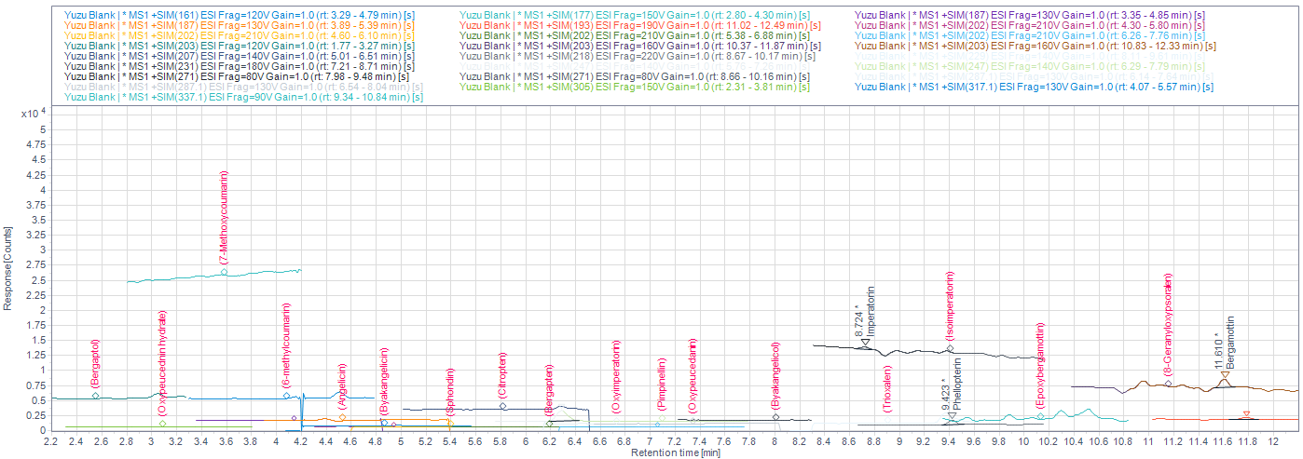
B
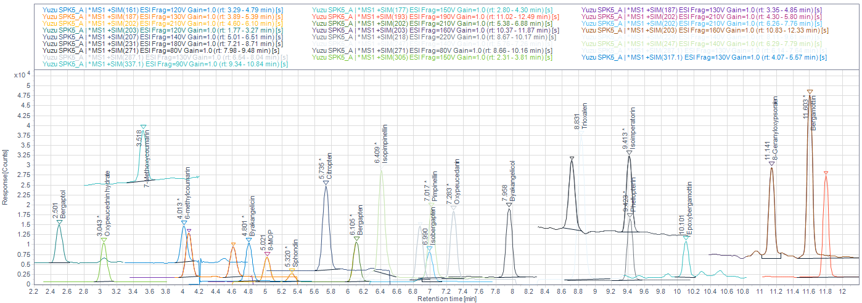
Figure S1. The overlaid extracted-ion chromatograms of blank yuzu oil (A) and yuzu oil fortified with 5 µg/g targeted coumarin derivatives (B).

