Polydatin combined with hawthorn flavonoids alleviate high fat diet induced atherosclerosis by remodeling the gut microbiota and glycolipid metabolism
Dan Li et.al.
Data Supplementary
Table S1. Realtime PCR reaction condition
procedure | temperature | time | cycle number
predegeneration | 95℃ | 5 min | 1
denaturation | 95℃ | 10 sec | 40
anneal | 58℃ | 20 sec | 40
extend | 72℃ | 20 sec | 40
melting curve | 95℃ | 15 sec | 1
melting curve | 60℃ | 60 sec | 1
melting curve | 95℃ | 15 sec | 1

Table S2. Primer sequences
Primer sequences |  | 5’-3’
FMO3 | F | TACTGGCAAATGGGAAGTCAC
 | R | CCTTTAAAACGGTTCAGTCCT
β-actin | F | CTCCTGAGCGCAAGTACTCT
 | R | TACTCCTGCTTGCTGATCCAC

Table S3. Mobile phase gradient condition
The mobile phase was water (A containing 0.1 % formic acid) and acetonitrile (B containing 5 mmol/l ammonium formate, 0.1 % formic acid, Acetonitrile: Water 95:5).
Time（min） | A% | B%
0 | 10 | 90
1 | 10 | 90
3.5 | 50 | 50
3.6 | 10 | 90
5 | 10 | 90

Table S4. Mass spectrum condition
Ion source voltage | Cone-hole voltage | Ion source temperature | Desolvation temperature | Cone-hole gas flow rate | Desolvation gas flow rate
2.0 kV | 10 V | 150℃ | 450℃ | 10 L/h | 900L/h

Table S5. Alpha diversity index comparison among groups
Estimators | Control-Mean | Control-Sd | PHH-Mean | PHH-Sd | P-value | Q-value
sobs | 413.83 | 21.451 | 296.67 | 46.638 | 0.0002306 | 0.000745
shannon | 4.0461 | 0.16123 | 3.3894 | 0.50054 | 0.01206 | 0.02413
simpson | 0.045524 | 0.0099807 | 0.081402 | 0.03517 | 0.03707 | 0.05146
chao | 492.66 | 35.123 | 369.84 | 41.447 | 0.0002483 | 0.000745
shannoneven | 0.67155 | 0.023577 | 0.59539 | 0.076927 | 0.04288 | 0.05146
simpsoneven | 0.055359 | 0.013055 | 0.052466 | 0.032931 | 0.8455 | 0.8455

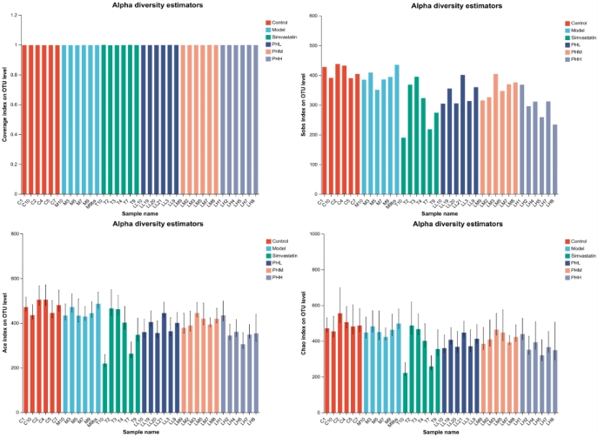
Figure S1. The distribution of coverage index and abundance index Sobs, Ace and Chao

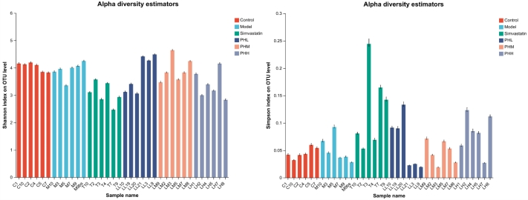
Figure S2. The distribution of diversity index Shannon and Simpson

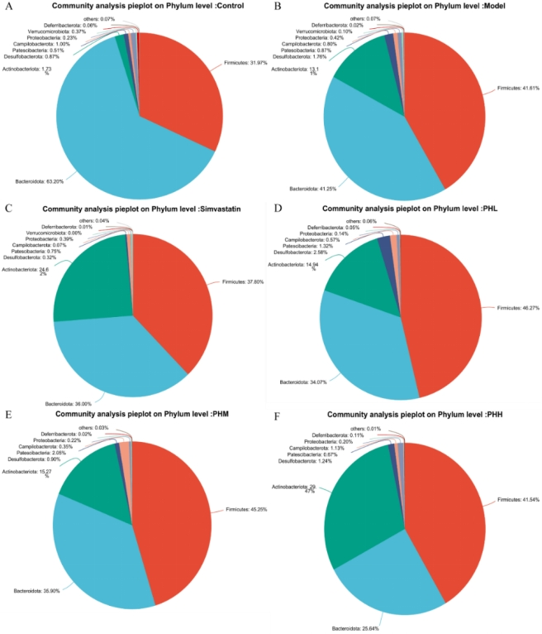
Figure S3. Venn analysis pie plot at phylum level
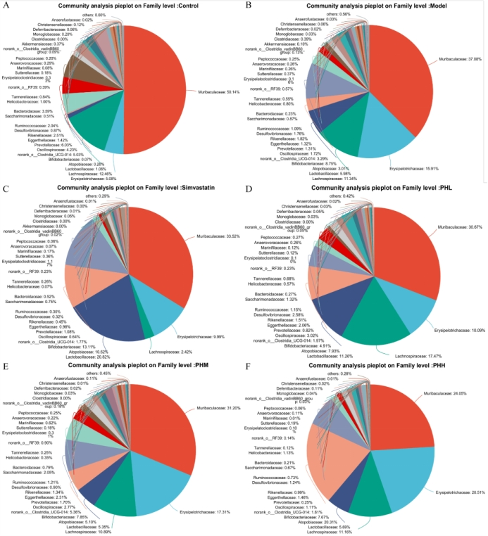
Figure S4. Venn analysis pie plot at family level
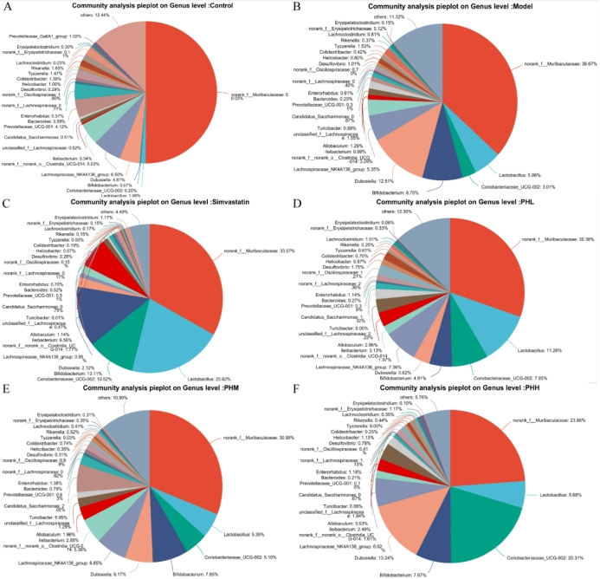
Figure S5. Venn analysis pie plot at genus level

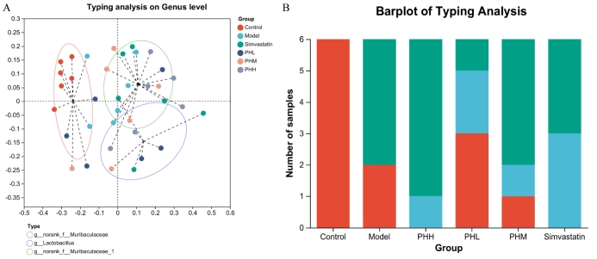
Figure S6. PCoA and barplot of typing analysis

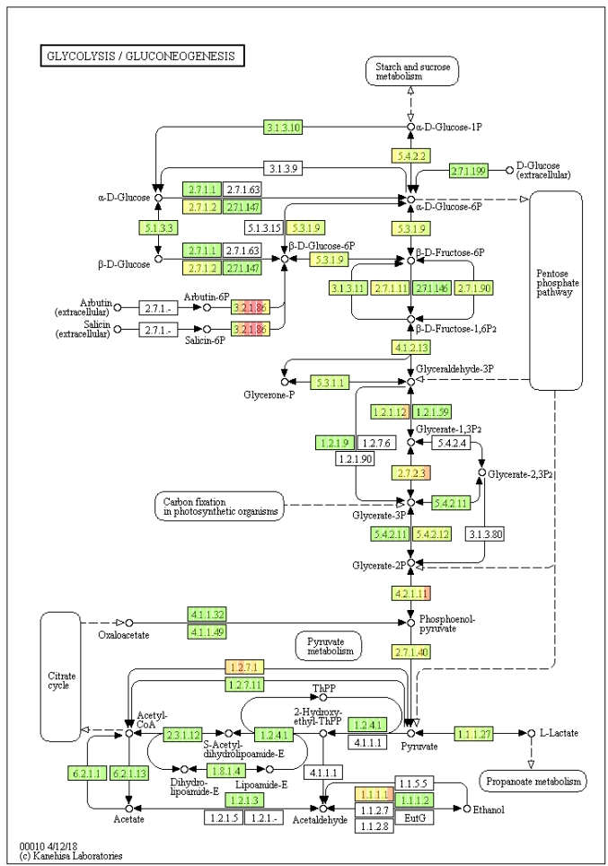
Figure S7. Glycolysis/Gluconeogenesis pathway
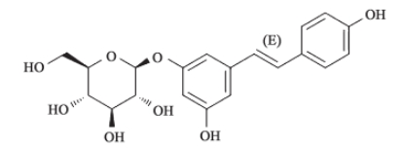
Figure S8. Chemical structure of polydatin
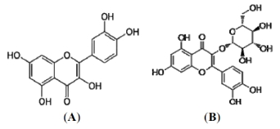
Figure S9. Chemical structure of the predominant hawthorn leaf flavonoids. (A) quercetin and (B) isoquercetin

