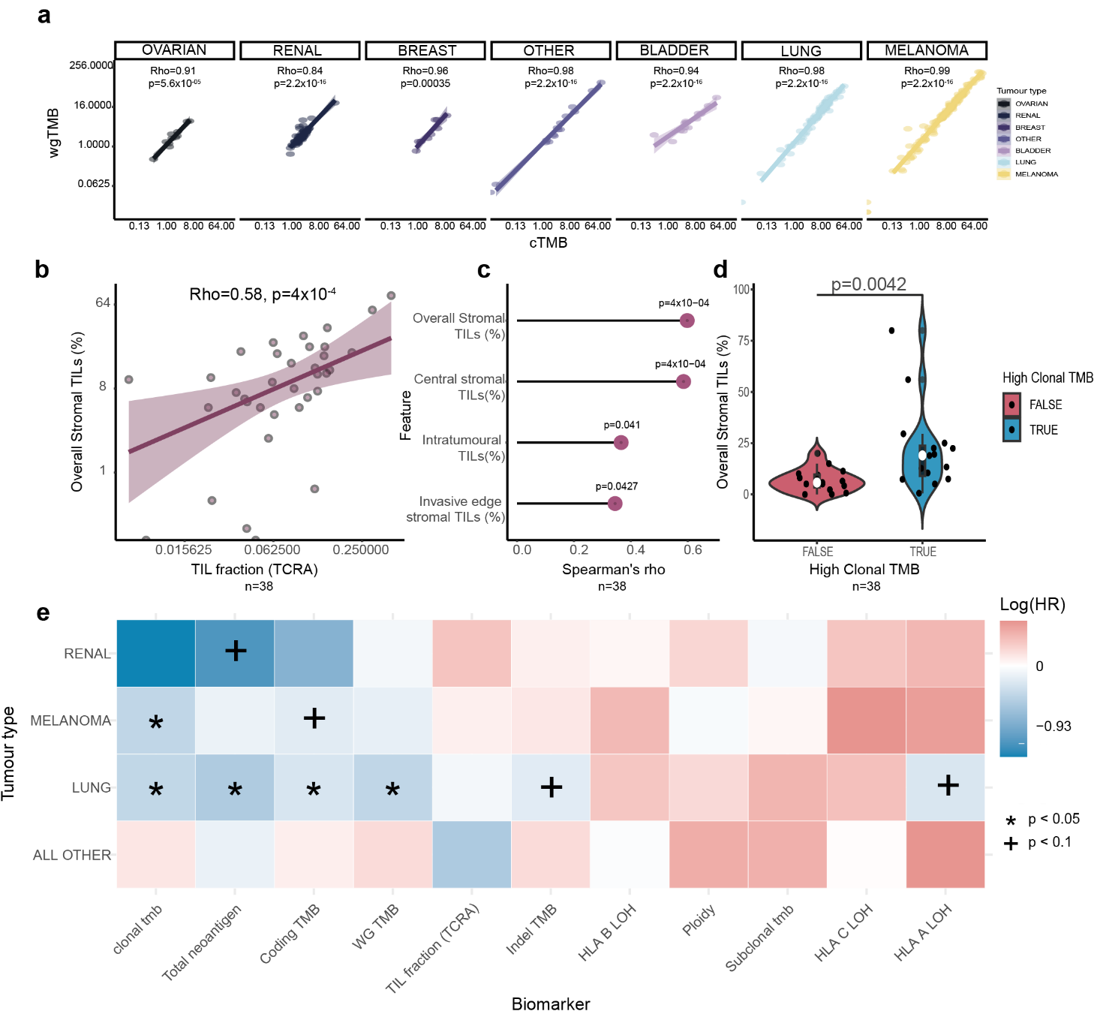
Extended data fig.1: Tumour type-specific differences in published markers. a, Correlation between coding TMB and whole-genome (WG) TMB by tumour type. Rho values indicate Spearman’s correlation coefficient and associated p-value. b, Correlation between mean overall stromal TIL % and TIL fraction derived from genomics. Spearman’s rho and p value are shown. d, Spearmans correlation coefficients for various spatial TIL measures derived from H&E and genomic TIL fraction (TCRA). d, The average overall stromal TIL (%) is shown for patients with high and low clonal TMB (discretised by median). e, Heatmap showing hazard ratios from univariate Cox regression analyses for each biomarker in individual tumour types. Colour shows the size and direction of the hazard ratio, significant variables (p < 0.05) are indicated by an asterisk and those reaching nominal significance with a plus.

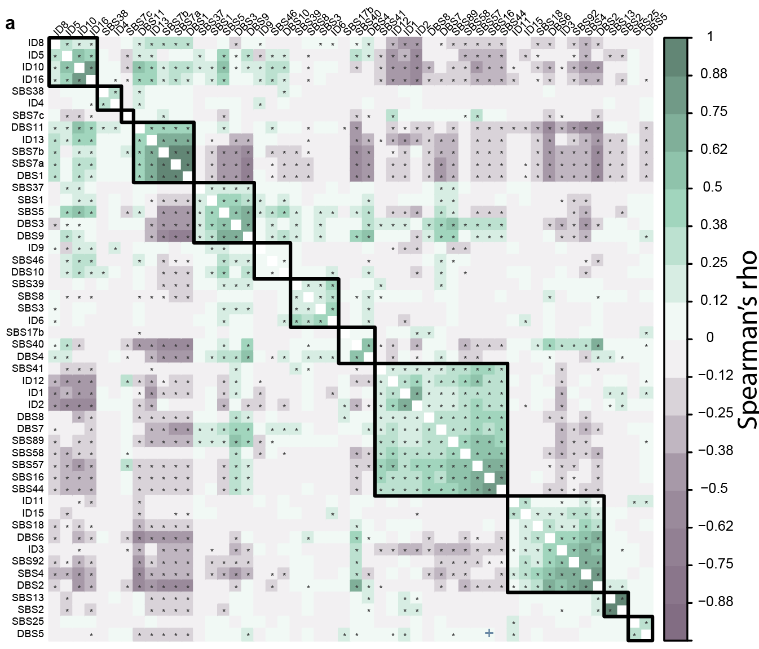
Extended data Fig.2: Interconnection of mutational signatures. a, Correlation heatmap showing the correlation between mutational signatures fitted to the pan-cancer cohort. Significant correlations (p<0.05) are indicated with an asterisk. Only signatures present in more than three patients are shown. Signatures were scaled and centred before correlation. Rows and columns are ordered using hierarchical clustering.

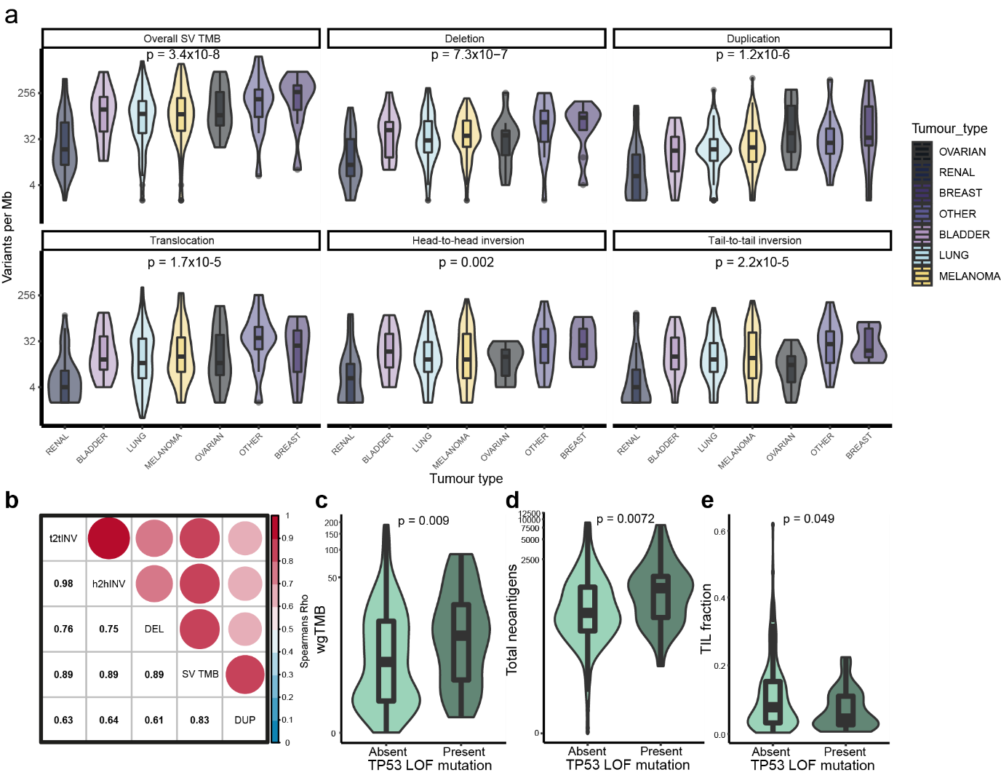
Extended data Fig.3: Properties of structural variants. a, SV counts by class across tumour type. P-values indicate the results of a Kruskal-Wallis test. b, correlation bubble grid showing Spearman’s correlation between counts of each SV class across the pan-cancer cohort. Colour indicates effect direction, bubble size indicates effect size. c, wgTMB for patients with or without TP53 loss-of-function mutations. d, as in (c) however, showing differences in total neoantigen burden. e, as in (c) however, showing differences in TIL fraction (TCRA).

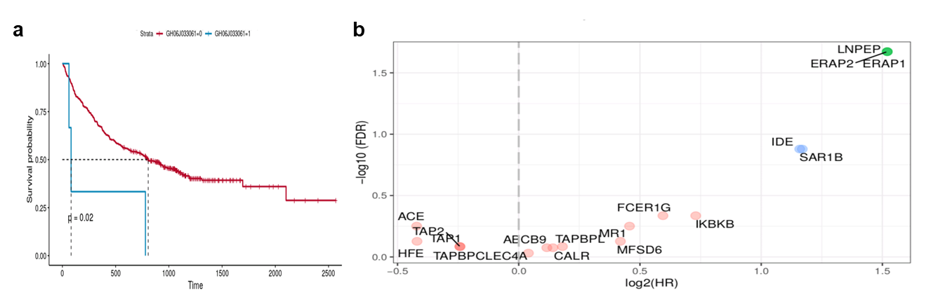

Extended data fig.4: Alterations in key MHC class I antigen presentation genes predict reduced survival after CPI. a, overall survival after CPI treatment in patients with or without a mutation in GH06J033061. b, loss-of-heterozygosity in class I antigen presentation genes and their association with OS after CPI. X-axis shows the log2 HR and y-axis shows the -log10 FDR value for each alteration.

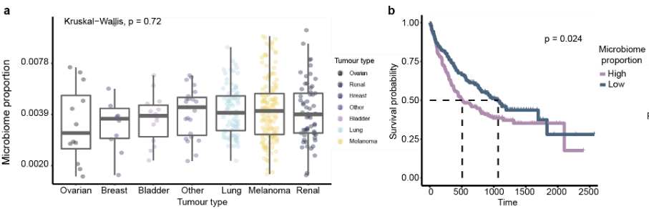
Extended data Fig.5: Increased intratumoral microbial load is associated with reduced CPI response. a, distribution of total microbial proportion by tumour type. b, the association of microbial proportion (low vs high, segregated by median) and overall survival after CPI therapy. P-value indicates result of a two-way Log-Rank test.

