Host-Directed anti-fusion aptamers and small molecules as Respiratory Syncytial Virus (RSV) inhibitors: An Insilco-based study.
Ssemuyiga Charlesª ^{ID}
Ssemuyigacharles11@gmail.com
a School of Biotechnology, KIIT Deemed to be University, Bhubaneswar, Odisha, India.
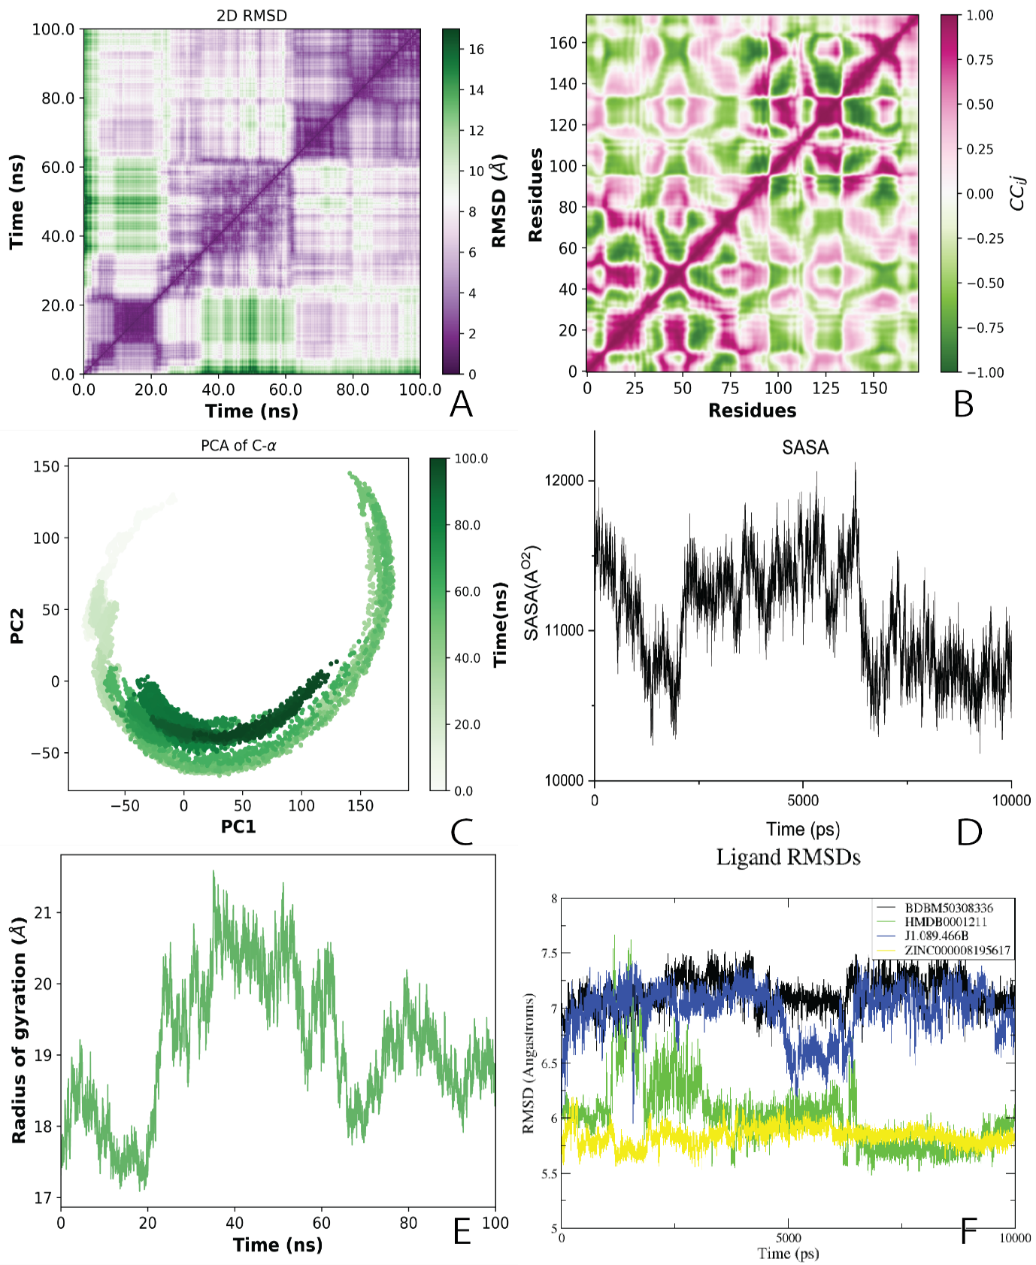

Figure S1: (A) Shows the ApoProtein 2DRMSD Plot. (B) Shows the ApoProtein Global motion analysis. The cross-correlation values are represented by a color range from pink (positive correlation, +1) to green (negative correlation, −1). (C) Shows ApoProtein PCA results for C-α energy conformational space and (D) Shows the SASA variation of the apoprotein over 100ns. (E) Shows variation of radius of gyration of the ApoProtein over simulation. (F) Shows the variation of Ligand RMSDs from small molecule complexes.

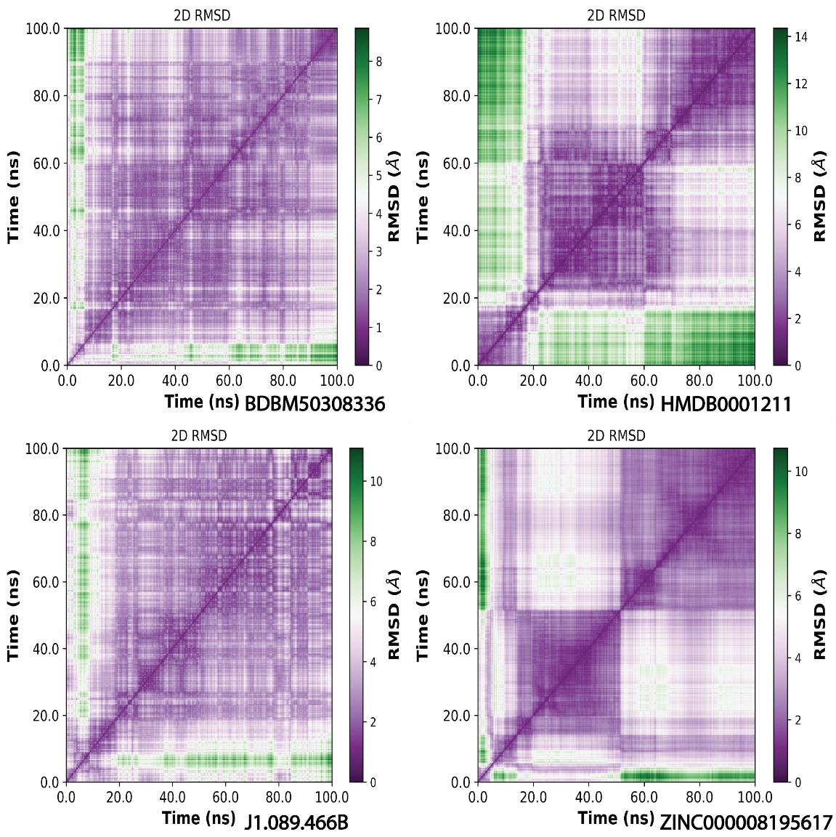

Figure S2:The all to all RMSDs of all small molecule complexes. Color scale is the RMSD in Aº.

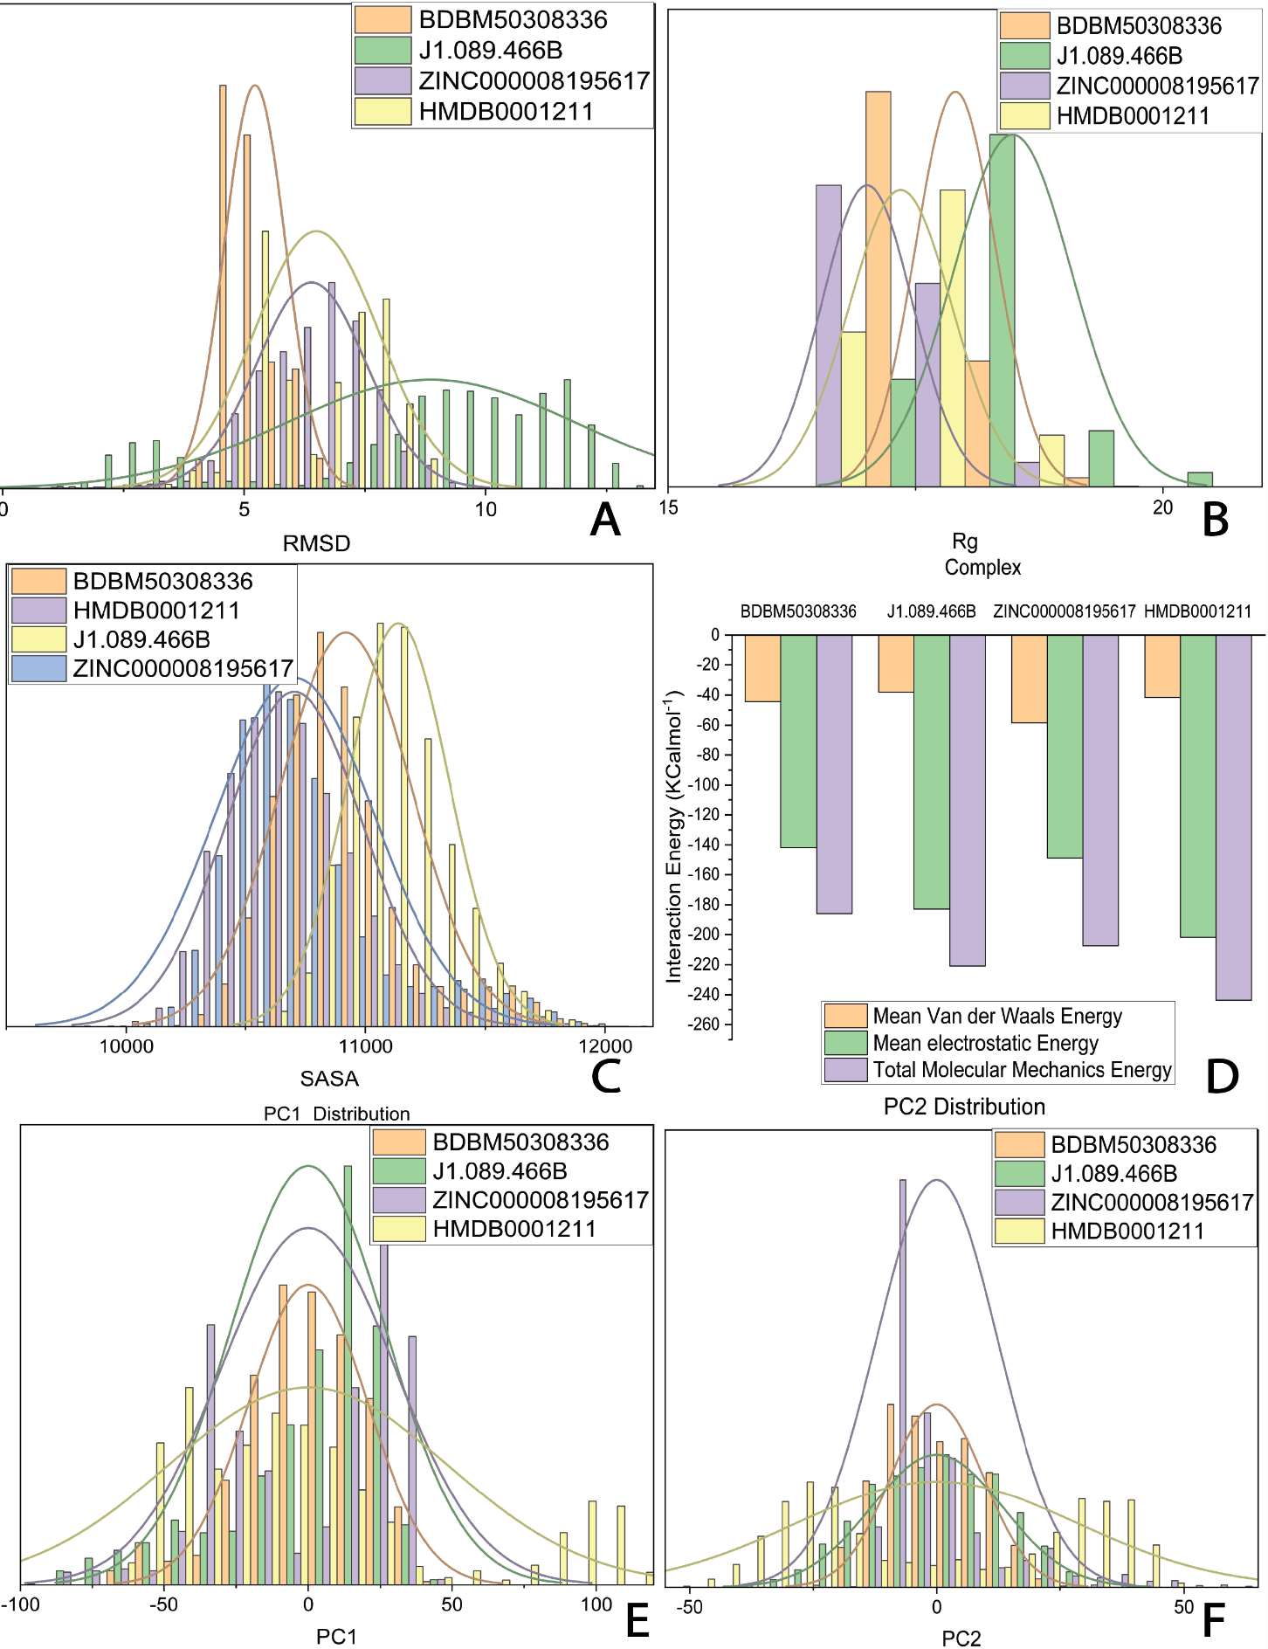

Figure S3: (A) The small molecule complex RMSD distribution. (B) Shows the Distribution of Rg for small molecule complexes over 100ns simulation time. (C) Shows the distribution of SASA for small molecule complexes. (D) A summary of MM energy of the simulated complexes. (E) PC1 Distribution for small molecule complexes. (F) PC2 Distribution for small molecule complexes.

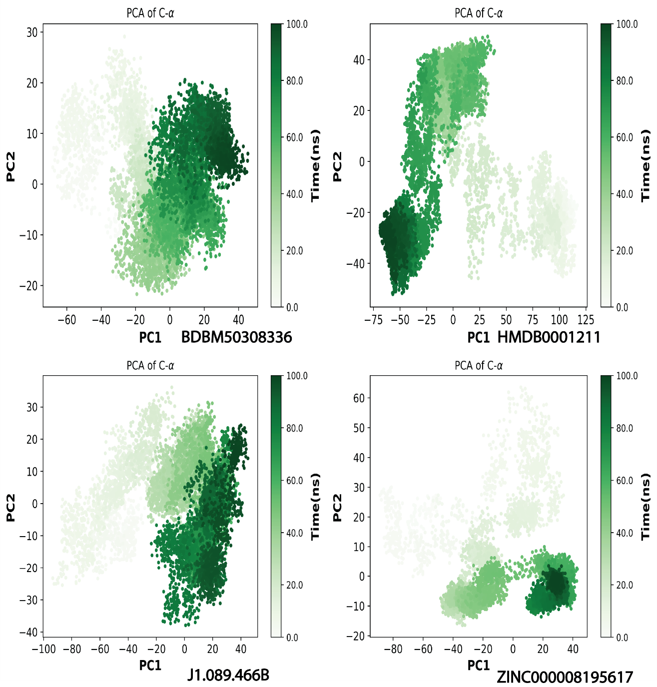

Figure S4: The results of PCA analysis for complexes of small molecules showing the dynamic energy fluctuation plotted between two eigenvectors 1 and 2 generated for the docked complexes showing conformational space of Cα-atoms.
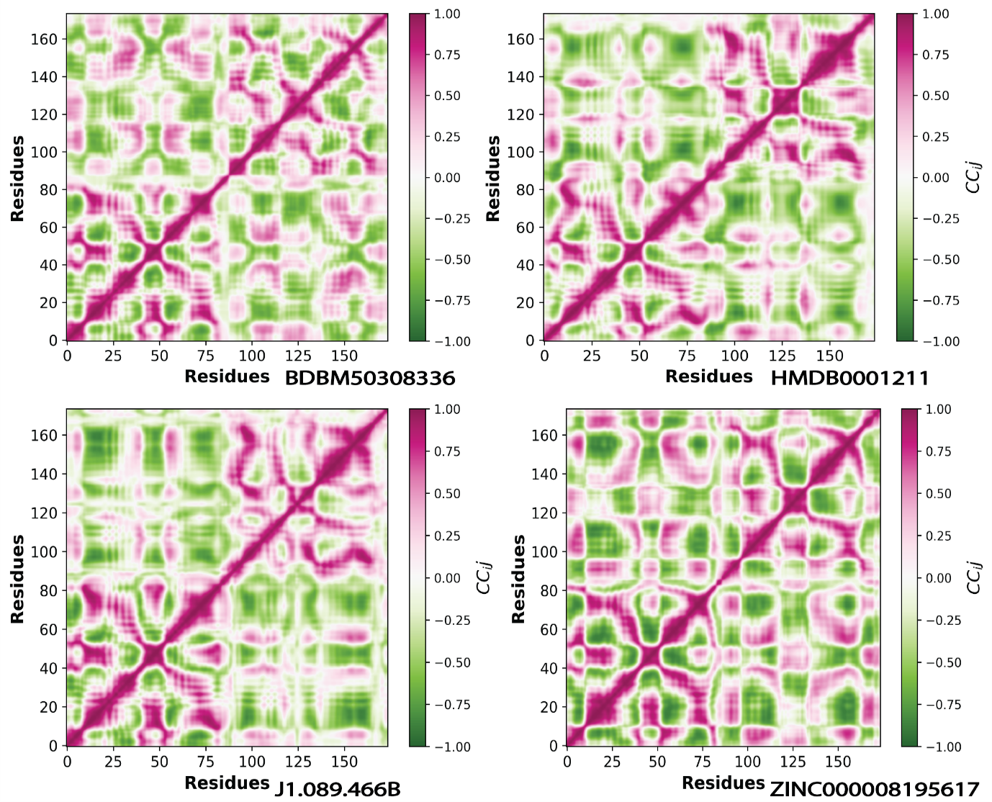

Figure S5: Global motion analysis results for small molecule simulated complexes. The cross-correlation values are represented by a color range from Red (positive correlation, +1) to green (negative correlation, −1).
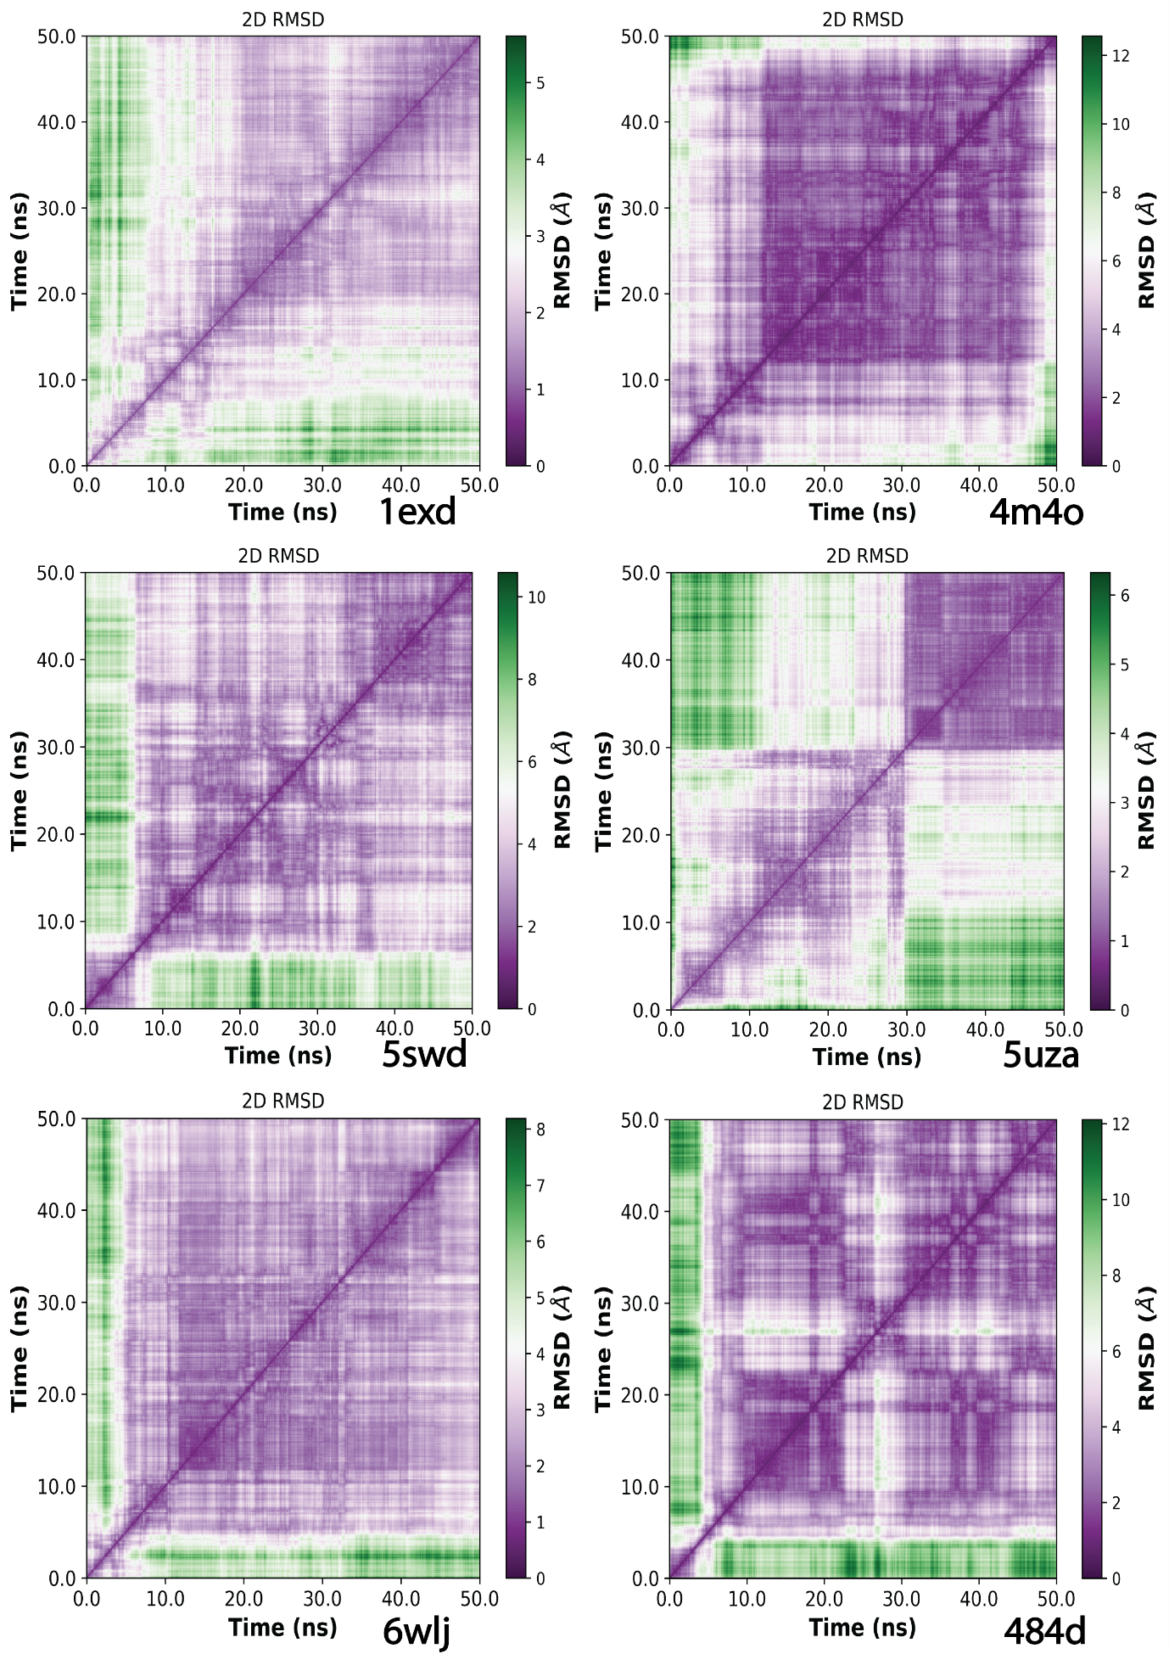

Figure S6: The all to all RMSDs of aptamer complexes. Color scale is the RMSD in Aº.

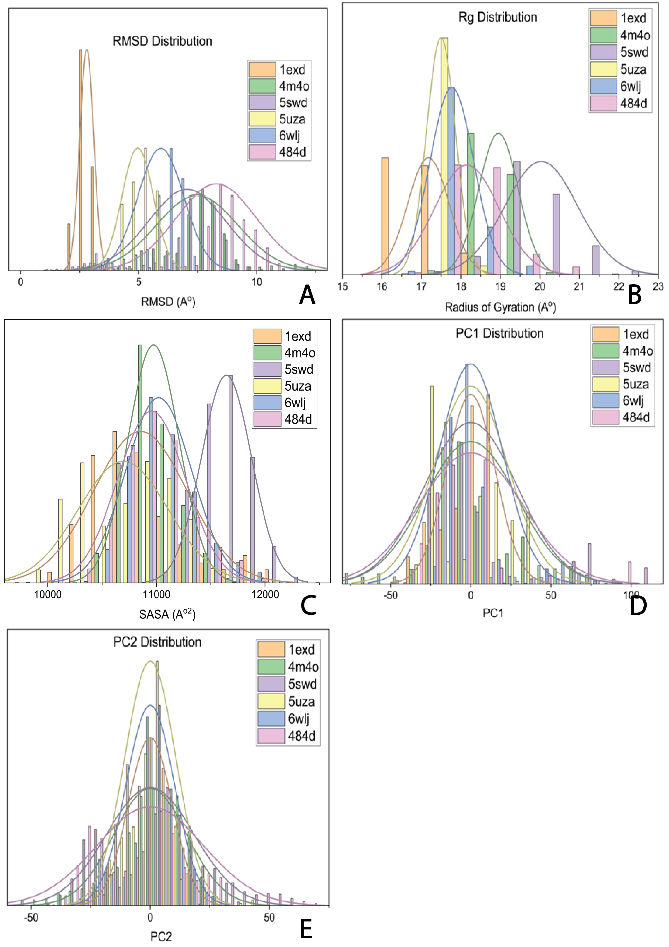

Figure S7: (A) Shows the aptamer complex RMSD distribution. (B) Shows the Distribution of Rg for aptamer complexes over 50ns simulation time. (C) Shows the distribution of SASA for aptamer complexes. (D) PC1 Distribution for aptamer complexes. (F) PC2 Distribution for aptamer complexes.

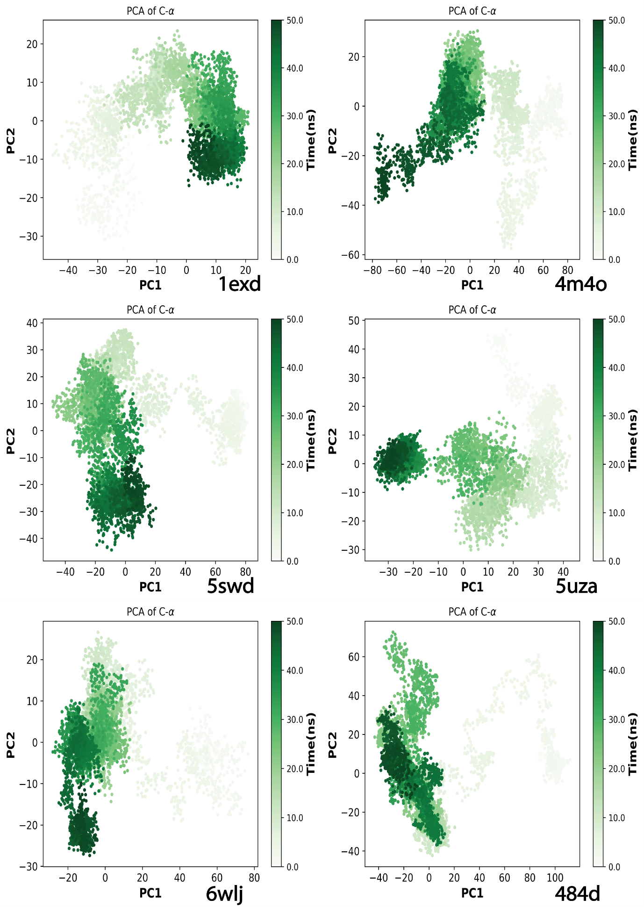

Figure S8: The results of PCA analysis for complexes of aptamers showing the dynamic energy fluctuation plotted between two eigenvectors 1 and 2 generated for the docked complexes showing conformational space of Cα-atoms.

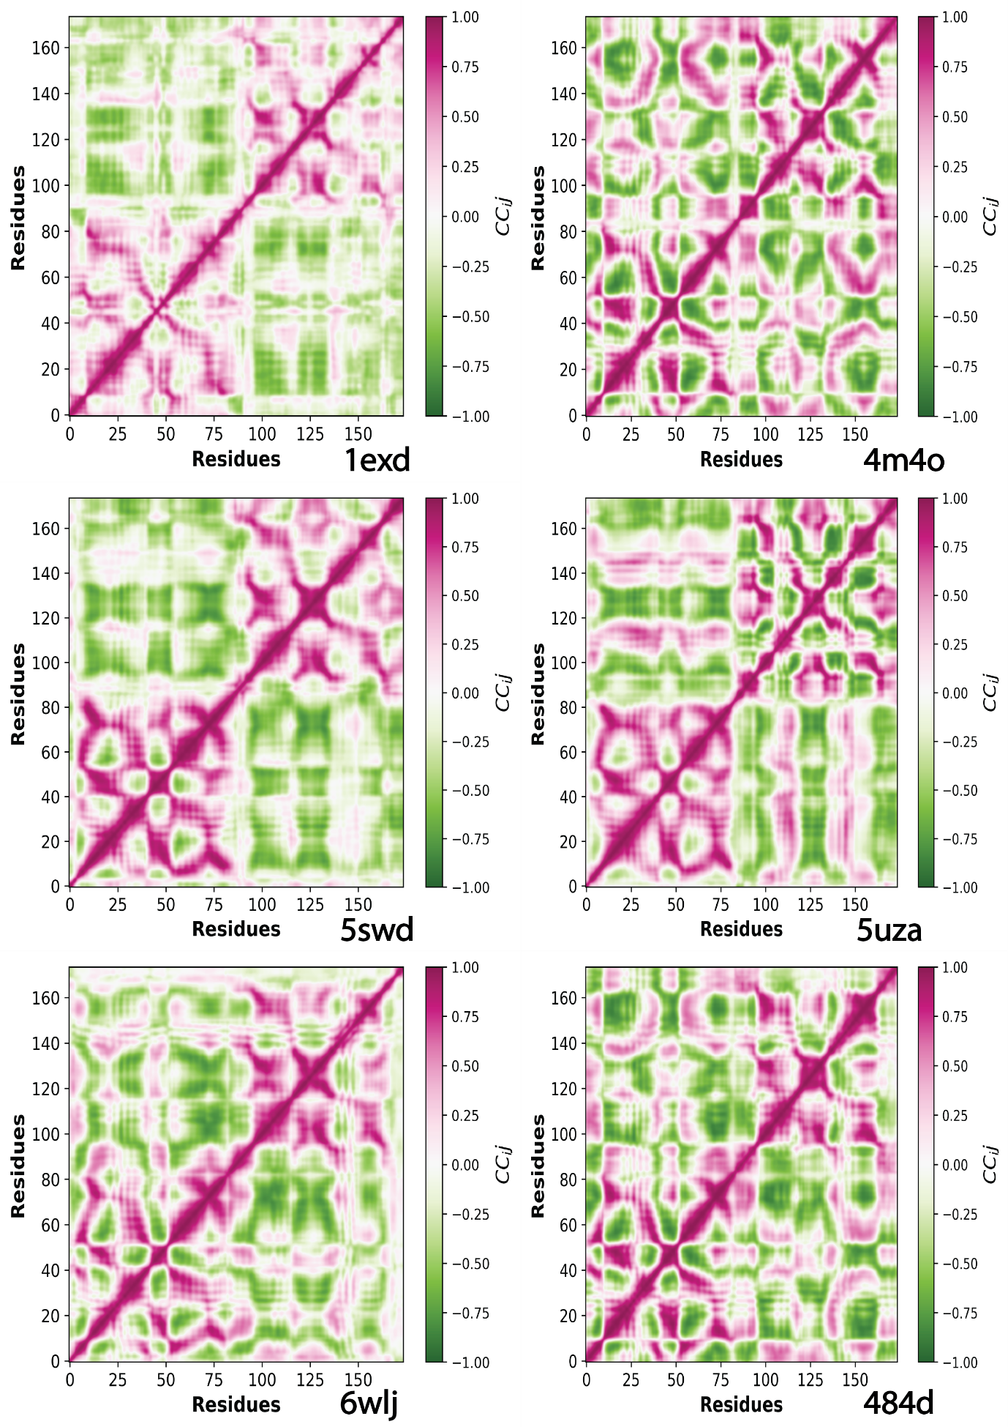
Figure S9: Global motion analysis results for aptamer simulated complexes. The cross-correlation values are represented by a color range from Red (positive correlation, +1) to green (negative correlation, −1).
.

