Table II: Results of small molecule docking with NCL; ligand efficiency sa is (docking score) / (number of heavy atoms)^{2/3}, and ligand efficiency ln is (docking score) / (1 + ln (number of heavy atoms)).
Ligand structure and Database ID | Glide XP Docking  score (KCalmol⁻¹) | ligand efficiency sa | ligand efficiency ln | Glide gscore | Prime MMGBSA dG Bind | Binding Affinity  MolDock Score (KCalmol⁻¹) | Rerank Score  (KCalmol⁻¹) | HBond Energy  (KCalmol⁻¹) | Database
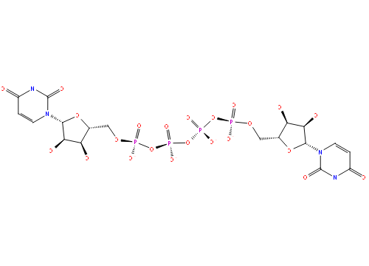  DB15919 | -10.557 | -0.788 | -2.158 | -10.561 | -55.02 | -176.367 | -105.605 | -9.221 | Drug Bank
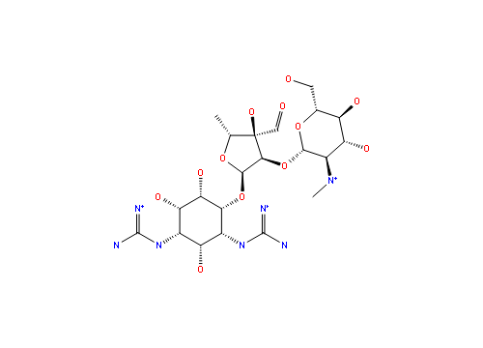  CHEMBL4087771 | -10.404 | -0.890 | -2.219 | -10.573 | -36.01 | -176.561 | -82.401 | -14.688 | CHEMBL
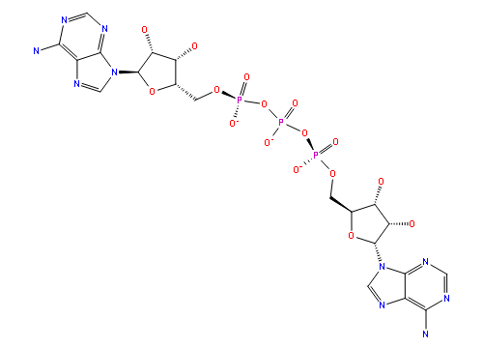  BDBM50308336 | -10.405 | -0.777 | -2.127 | -10.405 | -50.13 | -204.404 | -109.469 | -10.848 | Binding Database
DB03495  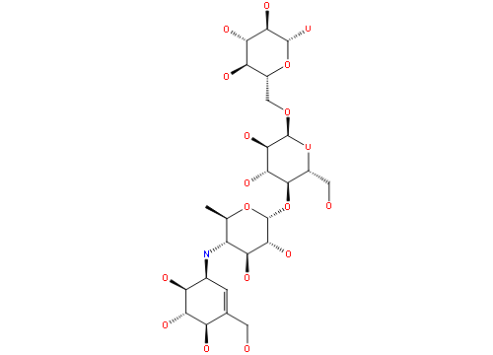 | -10.064 | -0.808 | -2.104 | -10.571 | -33.18 | -155.559 | -89.801 | -5.305 | Drug Bank
DB04158  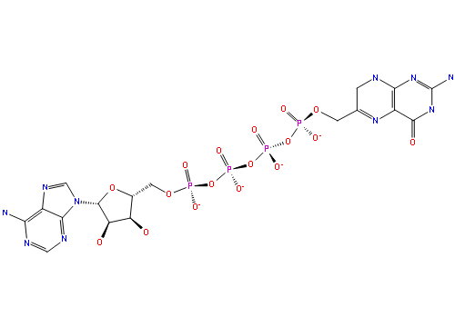 | -10.045 | -0.761 | -2.062 | -10.078 | -28.82 | -208.69 | -133.163 | -14.665 | Drug Bank
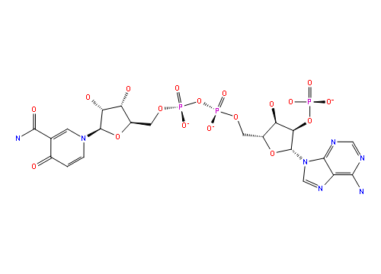  DB01753 | -10.027 | -0.749 | -2.050 | -11.419 | -24.92 | -189.425 | -109.374 | -7.478 | Drug Bank
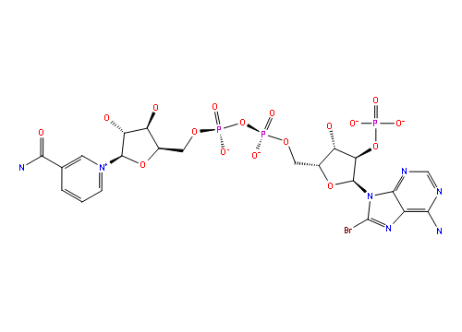  118753825 | -9.891 | -0.739 | -2.022 | -9.951 | -54.50 | -191.742 | -138.468 | -15.883 | PubChem
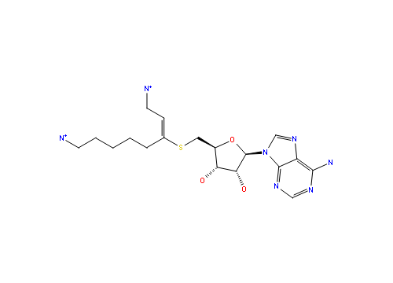  DB02844 | -9.744 | -1.032 | -2.231 | -9.754 | -45.09 | -151.691 | -107.938 | -9.629 | Drug Bank
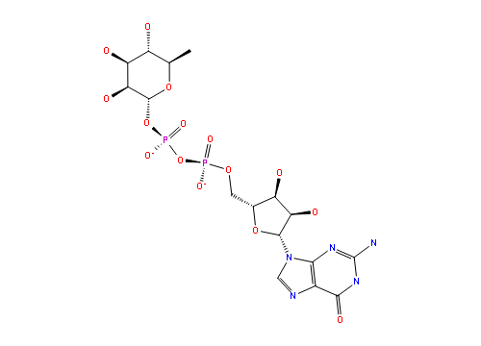  DB02547 | -9.470 | -0.838 | -2.042 | -9.470 | -49.52 | -170.373 | -125.792 | -12.355 | Drug Bank
4532  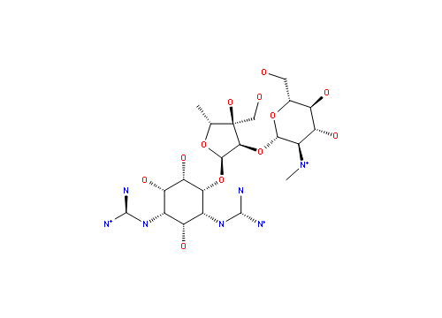 | -9.461 | -0.809 | -2.018 | -9.614 | -53.85 | -176.824 | -76.104 | -7.305 | Brenda
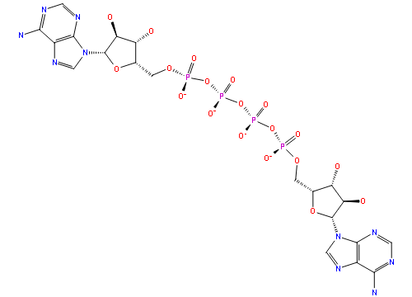  ZINC000008195617 | -9.383 | -0.665 | -1.888 | -9.384 | -41.93 | -216.941 | -126.304 | -10.445 | ZINC20
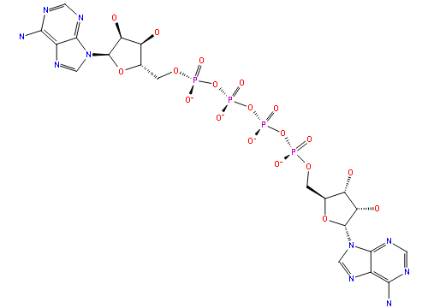  6603812 | -9.279 | -0.658 | -1.867 | -9.280 | -48.46 | -218.826 | -95.790 | -8.656 | PubChem
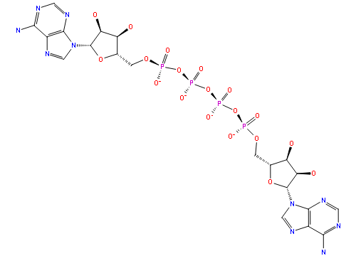  ZINC000169357919 | -9.253 | -0.656 | -1.862 | -9.254 | -52.08 | -216.941 | -126.304 | -10.645 | ZINC20
J1.089.466B  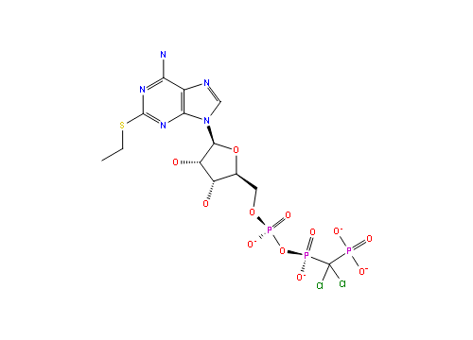 | -9.231 | -0.847 | -2.014 | -9.290 | -35.42 | -189.573 | -85.697 | -12.548 | ZINC20
DB04983  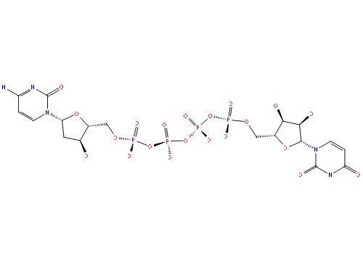 | -9.076 | -0.687 | -1.863 | -10.245 | -54.79 | -170.547 | -100.568 | -8.435 | Drug Bank
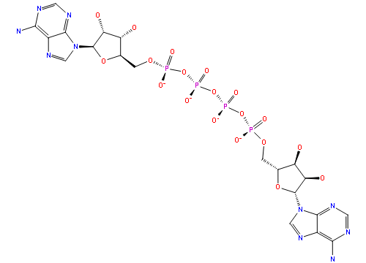  HMDB0001211 (Diadenosine tetraphosphate) | -9.053 | -0.642 | -1.821 | -10.090 | -58.06 | -215.036 | -139.818 | -9.548 | Human Metabolome Database

