Supporting Information

LiOtBu-Promoted Synthesis of Bis(3-indolyl)methanes by the Alkylation of Indoles with Alcohols under Air: An Investigation about Mechanism Insights via Chemical Intermediates
Hai Yen Nguyen,^{#[a]} Thu Hue Tran,^{#[a]} Ha Nam Do,^{[a]} Dang Van Do,^{[a]} Quoc-Anh Ngo,^{[b][c]} Nguyen Quyet Tien,^{[b]} Truong Thi Thanh Nga,^{[b]} Hien Nguyen,^{[c]} Tran Quang Hung,*^{[b][c]} Tuan Thanh Dang*^{[a]}

[a] H.Y. Nguyen; T. H. Tran; H.N. Do; Dr. D. V., Do; Dr. T.T., Dang
Faculty of Chemistry
University of Science, Vietnam National University Hanoi
Address: 19 Le Thanh Tong, Hoan Kiem, Hanoi, Vietnam
E-mail: dangthanhtuan@hus.edu.vn
[b] Assoc. Prof. N. Quoc-Anh; Dr. N.Q., Tien; Dr. T. T. T., Nga; Dr. T.Q. Hung
Insitute of Chemistry
Vietnam Academy of Science and Technology (VAST)
Address: 18 Hoang Quoc Viet, Cau Giay, Hanoi, Vietnam
E-mail: tqhung@ich.vast.vn
[c] Assoc. Prof. N. Quoc-Anh; Dr. T.Q., Hung
Graduate University of Science and Technology
Vietnam Academy of Science and Technology (VAST)
Address: 18 Hoang Quoc Viet, Cau Giay, Hanoi, Vietnam
[d] Assoc. Prof. H. Nguyen
Faculty of Chemistry
Hanoi National University of Education
Address: 136 Xuan Thuy, Cau Giay, Hanoi, Vietnam
# Both authors contributed equally to this work.

CONTENTS:
- General information
- Experimental section
- Results of control experiments were analyzed by GC MS method.
- NMR spectra

- General information
All chemicals were purchased from Sigma-Aldrich, Ak-Sci and used without further purification. Mass spectra were obtained with a Hewlett–Packard HPGC–MS 5890/5972 instrument (EI, 70 eV) by using a GC inlet or with an MX-1321 instrument (EI, 70 eV) by using a direct inlet. Column chromatography was performed on silica gel (200 mesh, Merck), and silica gel Merck 60 F254 plates were used for TLC. Commercially available solvents were distilled for column chromatography. All other solvents were purified and dried by standard methods. Crystallographic data were deposited with the CCDC.

- Experimental section
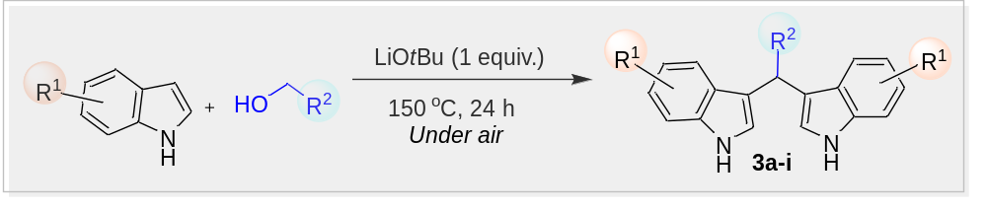
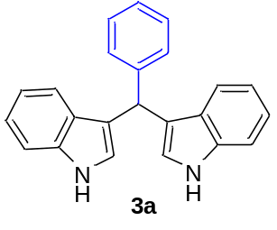
3,3'-(phenylmethylene)bis(1H-indole): Indole (35.1 mg, 0.3 mmol, 1eq) was added to a pressure tube that was charged with benzyl alcohol (130 mg, 1.2 mmol, 4eq)), LiOtBu (24 mg, 0,3 mmol, 1eq) under air. The reaction mixture was stirred with a magnetic stirrer and heated at 150°C for 24 hours. After cooling, the reaction mixture was filtered through a pad of Celite, which was washed three times with hot water (200 mL) to eliminate benzyl alcohol and three times with EtOAc to have the final filtrate. The filtrate was concentrated in vacuo. The crude product was further purified on Silica gel column chromatography with a 5:1 elution system of hexane/ ethyl acetate to yield 3a (38.6 mg, 80%) as pale-yellow solid; mp = 86-87 ℃; ¹H NMR (600 MHz, Chloroform-d) δ 7.87 (s, 1H), 7.40 (dd, J = 8.0, 1.1 Hz, 1H), 7.38 – 7.33 (m, 2H), 7.28 (dd, J = 8.4, 6.8 Hz, 1H), 7.25 – 7.20 (m, 0H), 7.17 (ddd, J = 8.2, 7.0, 1.2 Hz, 1H), 7.01 (ddd, J = 8.0, 7.0, 1.0 Hz, 1H), 6.65 (dd, J = 2.4, 1.0 Hz, 1H), 5.90 (s, 1H). ¹³C NMR (151 MHz, CDCl₃) δ 144.03, 136.72, 128.74, 128.22, 127.12, 126.14, 123.61, 121.94, 119.96, 119.77, 119.25, 111.02, 77.24, 77.03, 76.82, 40.23.

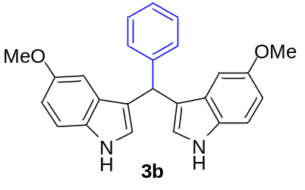
3,3'-(phenylmethylene)bis(5-methoxy-1H-indole):¹ Following the general procedure and using compound 2 (130 mg, 1.2 mmol) and 5-methoxy indole (44 mg, 0.3 mmol) gave a crude product, which was purified by preparative thin-layer chromatography (silica gel; hexane) to yield 3b (47.2 mg, 82%) as pale-yellow solid; mp = 215-216 ℃; ¹H NMR (600 MHz, DMSO-d₆) δ 10.65 (s, 2H), 7.40 – 7.36 (m, 2H), 7.30 – 7.24 (m, 5H), 7.20 – 7.15 (m, 1H), 6.84 (t, J = 2.3 Hz, 2H), 6.76 (t, J = 2.3 Hz, 3H), 6.72 (dt, J = 8.7, 2.1 Hz, 2H), 5.77 (s, 1H). ¹³C NMR (126 MHz, DMSO) δ 152.67, 145.02, 131.80, 128.31, 127.97, 127.02, 125.70, 124.28, 117.68, 111.99, 110.55, 101.47, 55.24, 40.01, 39.84, 39.67, 39.51, 39.34, 39.17, 39.01.
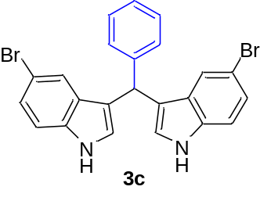
3,3'-(phenylmethylene)bis(5-bromo-1H-indole):² Following the general procedure and using compound 2 (130 mg, 1.2 mmol) and 4-bromoindole (59 mg, 0.3 mmol) gave a crude product, which was purified by preparative thin-layer chromatography (silica gel; hexane/ ethyl acetate, 30:1) to yield 3c (51.8 mg, 72%) as pale-yellow solid; mp = 230-232 ℃; ¹H NMR (600 MHz, Chloroform-d) δ 7.95 (s, 4H), 7.50 – 7.39 (m, 3H), 7.28 – 7.25 (m, 6H), 7.24 – 7.20 (m, 7H), 6.61 (dd, J = 2.5, 1.1 Hz, 3H), 5.72 (s, 1H). ¹³C NMR (151 MHz, Chloroform-d) δ 143.07, 135.37, 128.70, 128.54, 128.43, 126.53, 124.99, 124.76, 122.30, 119.10, 112.70, 112.57, 77.22, 77.01, 76.80, 39.92.
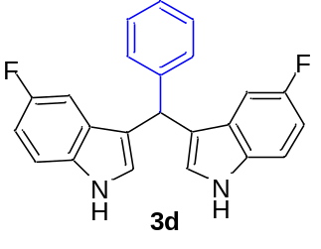
3,3'-(phenylmethylene)bis(5-fluoro-1H-indole):¹ Following the general procedure and using compound 2 (130 mg, 1.2 mmol) and 4-fluoroindole (41 mg, 0.3 mmol) gave a crude product, which was purified by preparative thin-layer chromatography (silica gel; hexane) to yield 3d (25.5 mg, 48%) as pale-yellow solid; mp = 169-171 °C;. ¹H NMR (600 MHz, DMSO-d₆) δ 10.97 (d, J = 2.6 Hz, 2H), 7.42 – 7.35 (m, 4H), 7.29 (t, J = 7.7 Hz, 2H), 7.21 – 7.14 (m, 1H), 7.02 – 6.96 (m, 4H), 6.90 (td, J = 9.1, 2.6 Hz, 2H), 5.82 (s, 1H). ¹³C NMR (126 MHz, DMSO-d6) δ 156.43 (d, J = 231.1 Hz), 144.46, 133.27, 128.25, 128.14, 126.80 (d, J = 9.9 Hz), 125.95, 125.64, 118.04 (d, J = 4.7 Hz), 112.45 (d, J = 9.7 Hz), 109.05 (d, J = 26.1 Hz), 103.63 (d, J = 23.2 Hz).
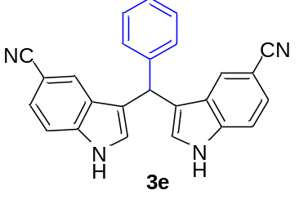
3,3'-(phenylmethylene)bis(1H-indole-6-carbonitrile): Following the general procedure and using compound 2 (130 mg, 1.2 mmol) and 4-cyanodindole (47 mg, 0.3 mmol) gave a crude product, which was purified by preparative thin-layer chromatography (silica gel; hexane) to yield 3e (42.5 mg, 76%) as pale-yellow solid; mp = 240-242 °C; ¹H NMR (600 MHz, DMSO-d₆) δ 11.47 (s, 1H), 7.89 (d, J = 1.5 Hz, 2H), 7.41 (d, J = 8.3 Hz, 2H), 7.34 (d, J = 7.3 Hz, 2H), 7.28 (t, J = 7.6 Hz, 2H), 7.24 – 7.14 (m, 6H), 5.96 (s, 1H). ¹³C NMR (126 MHz, DMSO) δ 143.84, 135.41, 129.45, 128.34, 128.23, 128.21, 126.23, 121.07, 120.67, 120.09, 118.69, 116.55, 102.46, 79.16, 40.01, 39.84, 39.67, 39.51, 39.34, 39.17, 39.01.
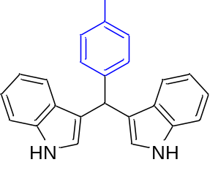
3,3'-((4-methylphenyl)methylene)bis(1H-indole):¹ Following the general procedure and using compound 1 (35 mg, 0.3 mmol) and 2-methylbenzyl alcohol (146 mg, 1.2 mmol) gave a crude product, which was purified by preparative thin-layer chromatography (silica gel; hexane) to yield 3f (42.9 mg, 85%) as pale-yellow solid. ¹H NMR (600 MHz, Chloroform-d) δ 7.91 (s, 2H), 7.40 (dq, J = 7.9, 0.9 Hz, 2H), 7.34 (dt, J = 8.1, 0.9 Hz, 2H), 7.23 (d, J = 8.0 Hz, 2H), 7.16 (ddd, J = 8.2, 7.0, 1.2 Hz, 2H), 7.11 – 7.07 (m, 2H), 7.00 (ddd, J = 8.0, 7.1, 1.0 Hz, 2H), 2.32 (s, 3H). ¹³C NMR (151 MHz, CDCl₃) δ 141.02, 136.73, 135.47, 128.91, 128.58, 127.14, 123.54, 121.87, 119.98, 119.94, 119.19, 110.99, 77.24, 77.03, 76.82, 39.80.
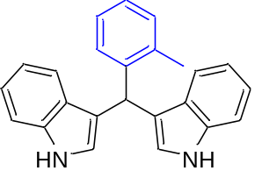
3,3'-((2-methylphenyl)methylene)bis(1H-indole):¹ Following the general procedure and using compound 1 (35 mg, 0.3 mmol) and 2-methylbenzyl alcohol (146 mg, 1.2 mmol) gave a crude product, which was purified by preparative thin-layer chromatography (silica gel; hexane) to yield 3g (41.4 mg, 82%) as pale-yellow solid. ¹H NMR (600 MHz, Chloroform-d) δ 7.85 (s, 2H), 7.36 (ddd, J = 13.6, 8.1, 1.0 Hz, 3H), 7.24 – 7.09 (m, 5H), 7.08 – 6.99 (m, 3H), 6.54 (dd, J = 2.5, 1.0 Hz, 2H), 6.04 (s, 1H), 2.40 (s, 3H). ¹³C NMR (151 MHz, CDCl3) δ 207.07, 142.11, 136.77, 136.08, 130.20, 128.43, 127.23, 126.09, 125.84, 123.89, 121.90, 119.80, 119.21, 119.16, 111.06, 77.27, 77.05, 76.84, 36.25.
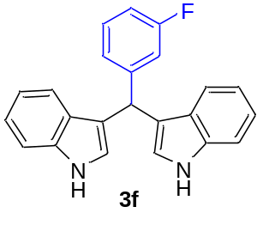
3,3'-((3-fluorophenyl)methylene)bis(1H-indole):¹ Following the general procedure and using compound 1 (35 mg, 0.3 mmol) and 3-fluorobenzyl alcohol (151 mg, 1.2 mmol) gave a crude product, which was purified by preparative thin-layer chromatography (silica gel; hexane) to yield 3h (40,2 mg, 79%) as pale-yellow solid; mp = ¹H NMR (600 MHz, Chloroform-d) δ 7.91 (s, 2H), 7.43 – 7.33 (m, 4H), 7.30 – 7.22 (m, 2H), 7.22 – 7.12 (m, 3H), 7.08 – 6.98 (m, 3H), 6.91 (tdd, J = 8.4, 2.6, 1.0 Hz, 1H), 6.66 (dd, J = 2.5, 1.0 Hz, 2H), 5.89 (s, 1H). ¹³C NMR (151 MHz, Chloroform-d) δ 163.84, 162.21, 146.86, 146.81, 136.72, 129.60, 129.55, 126.95, 124.43, 124.41, 123.58, 122.09, 119.80, 119.38, 119.10, 115.67, 115.52, 113.16, 113.02, 111.11, 77.24, 77.03, 76.82, 29.72.

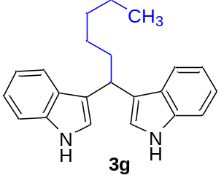

3,3'-(hexane-1,1-diyl)bis(1H-indole):¹ Following general procedure and using compound 1 (35 mg, 0.3 mmol) and n-hexanol (123 mg, 1.2 mmol) gave a crude product, which was purified by preparative thin-layer chromatography (silica gel; hexane) to yield 3i (35.6 mg, 75%) as pale-yellow solid; mp = 67-69 °C; ¹H NMR (600 MHz, Chloroform-d) δ 7.86 (s, 1H), 7.61 (d, J = 8.0 Hz, 1H), 7.33 (d, J = 8.1 Hz, 1H), 7.16 (ddd, J = 8.1, 6.9, 1.2 Hz, 1H), 7.10 – 7.01 (m, 1H), 6.98 (d, J = 2.4 Hz, 1H), 4.49 (s, 1H), 2.23 (qd, J = 7.4, 1.4 Hz, 1H), 1.44 (ddd, J = 15.2, 8.3, 6.4 Hz, 1H), 1.36 (dddd, J = 13.4, 7.7, 6.4, 2.9 Hz, 1H), 1.33 – 1.26 (m, 1H), 0.87 (t, J = 7.2 Hz, 1H).¹³C NMR (151 MHz, Chloroform-d) δ 136.64, 127.23, 121.72, 121.38, 120.64, 119.70, 119.00, 111.04, 77.24, 77.03, 76.82, 35.84, 34.04, 32.04, 28.04, 22.68, 14.13.

- Results of control experiments were analyzed by GC MS method.
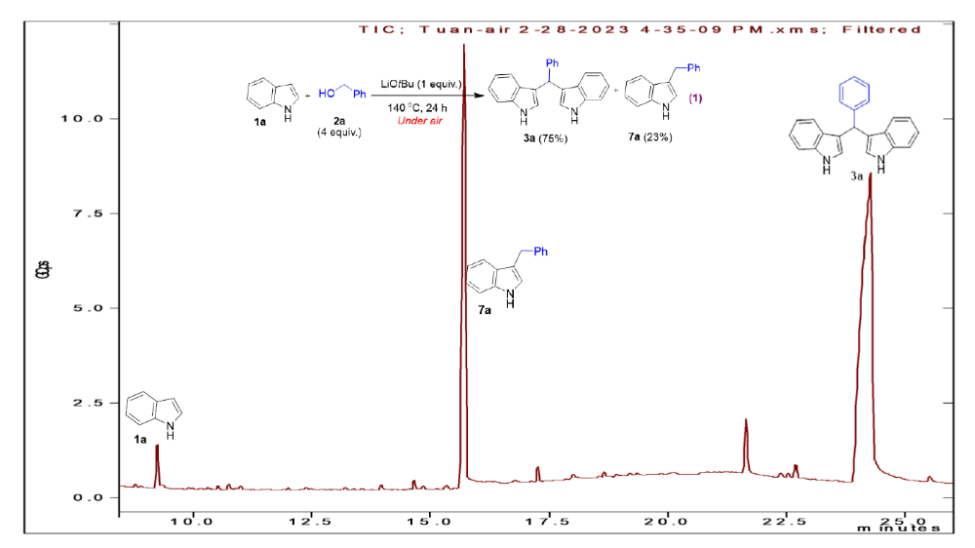

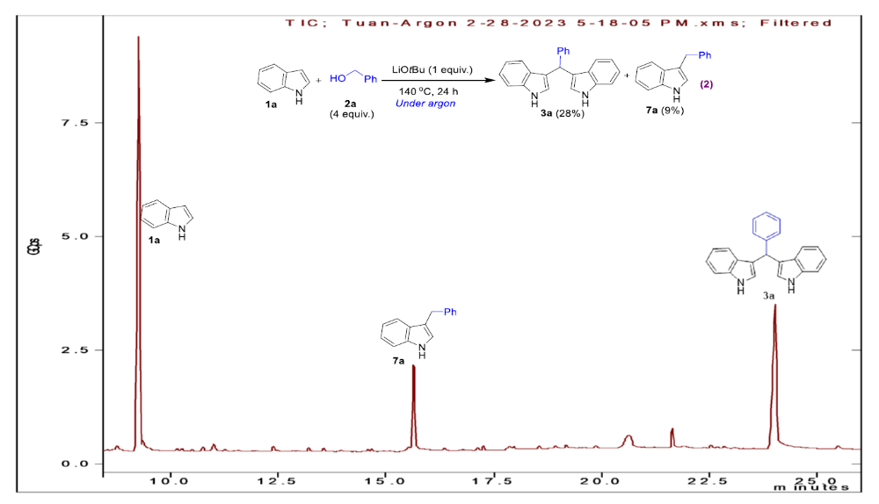

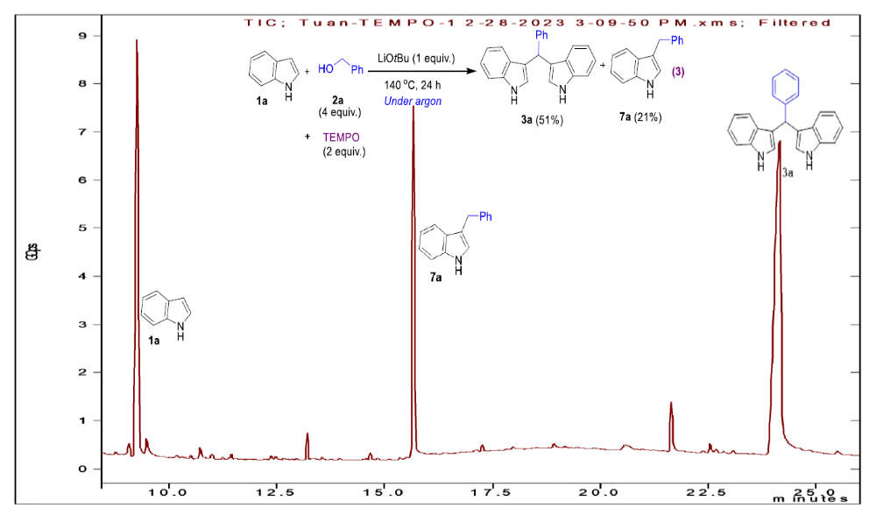

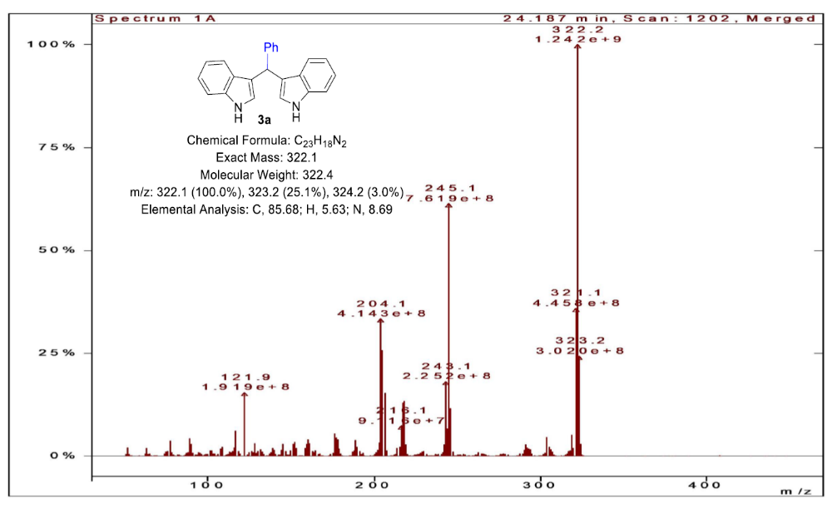

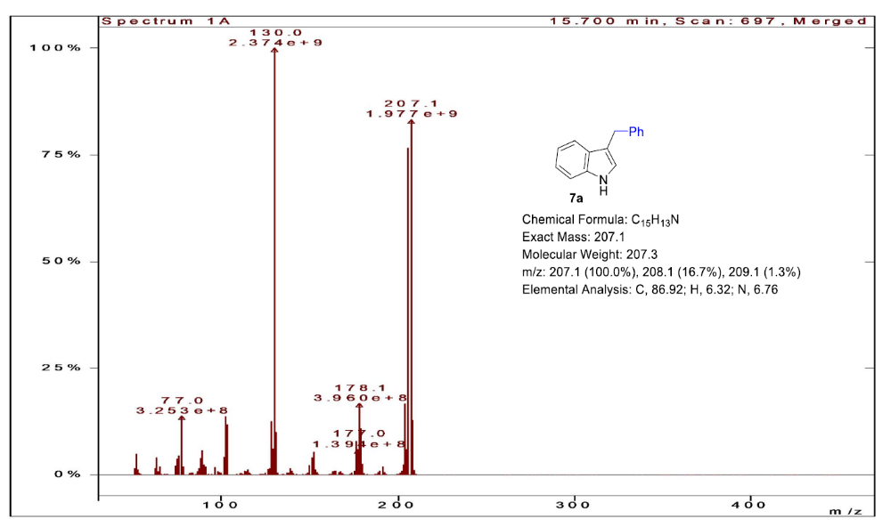

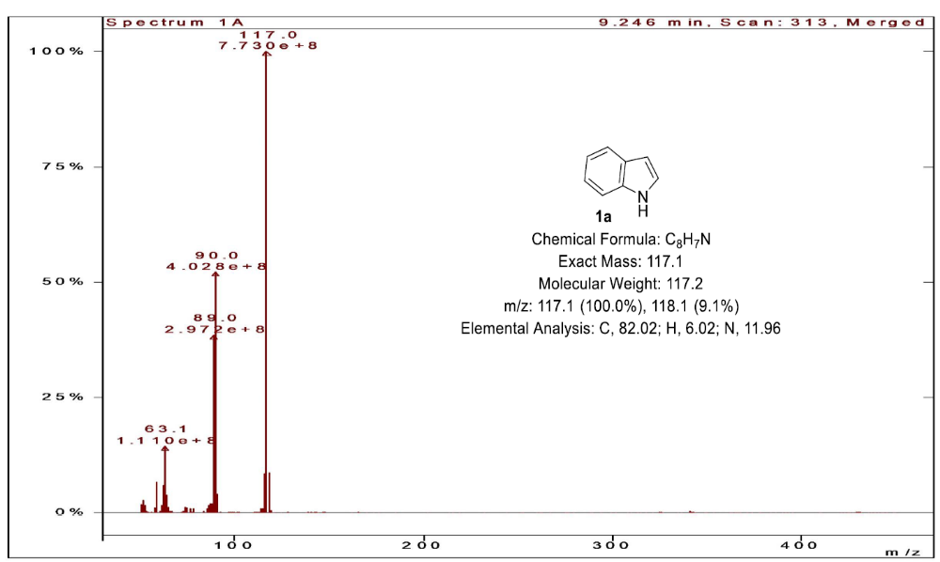

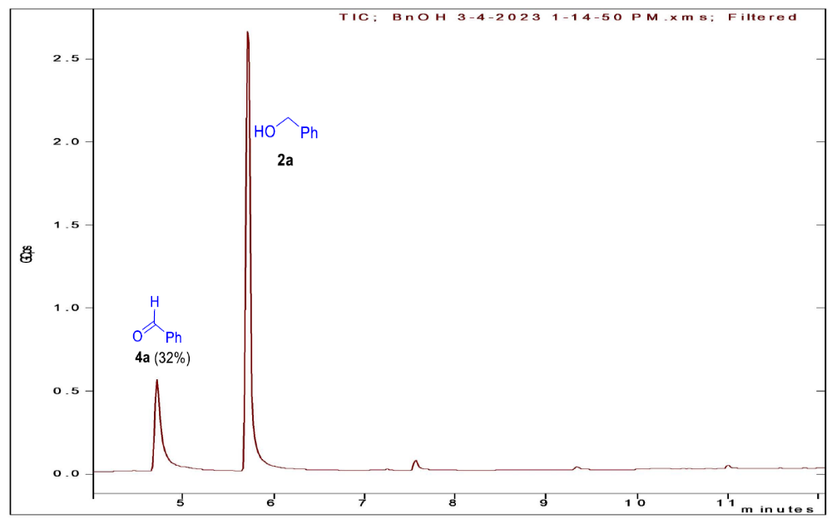

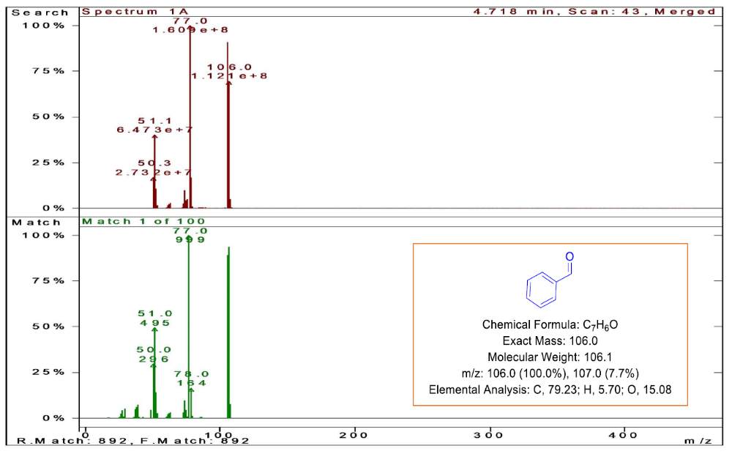
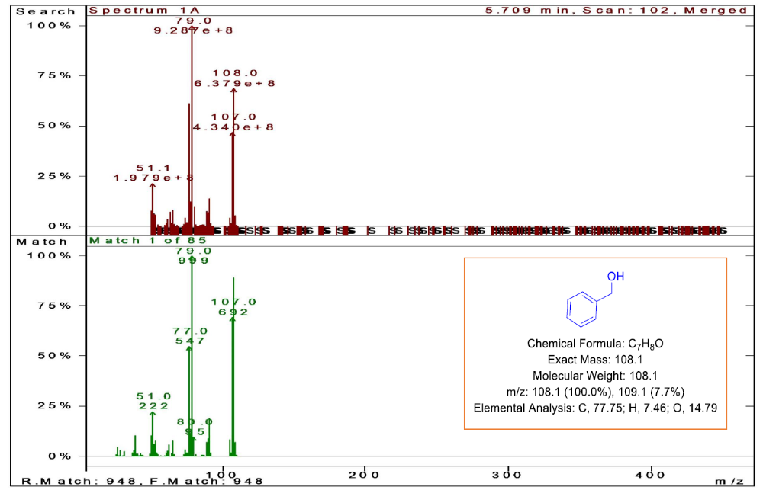
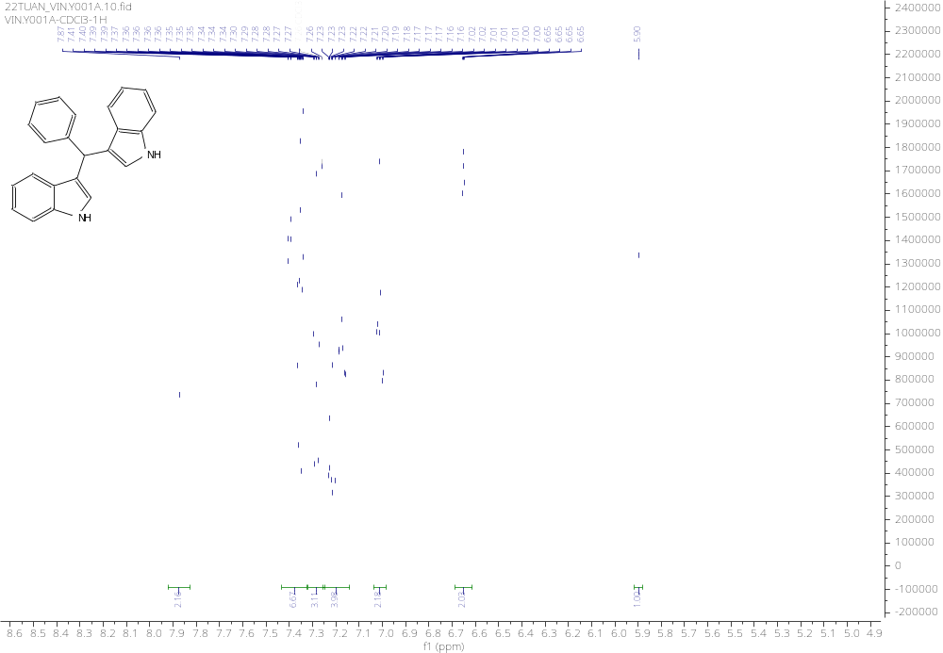
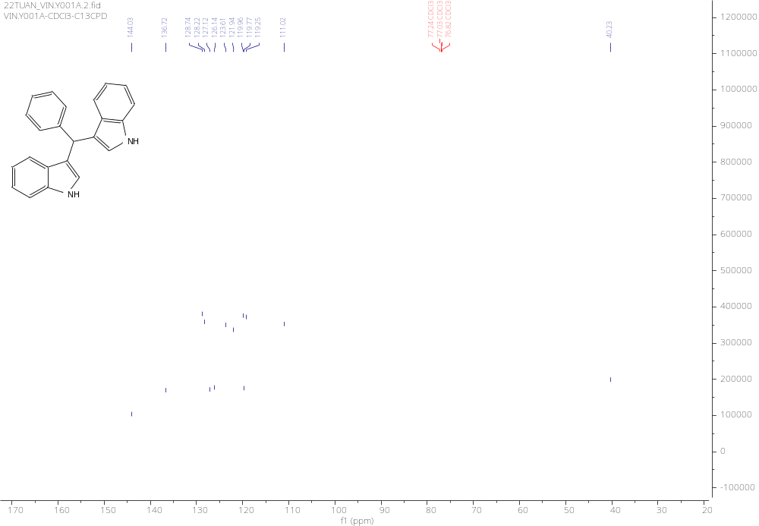

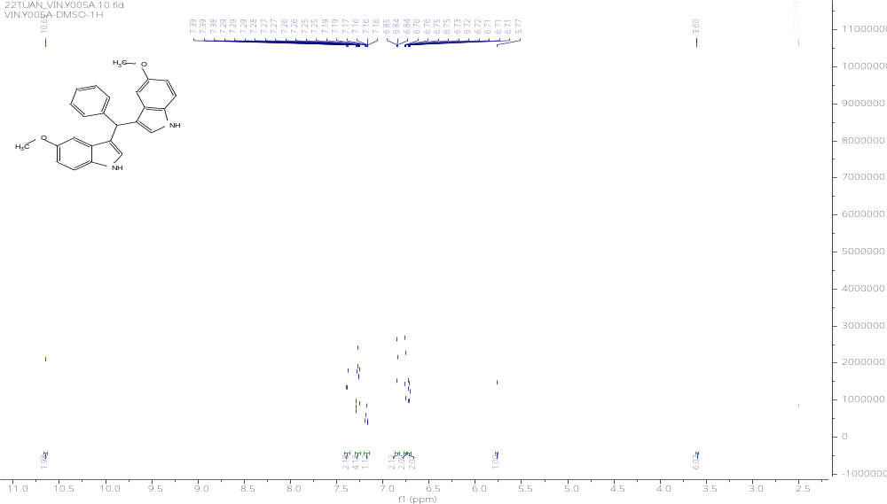

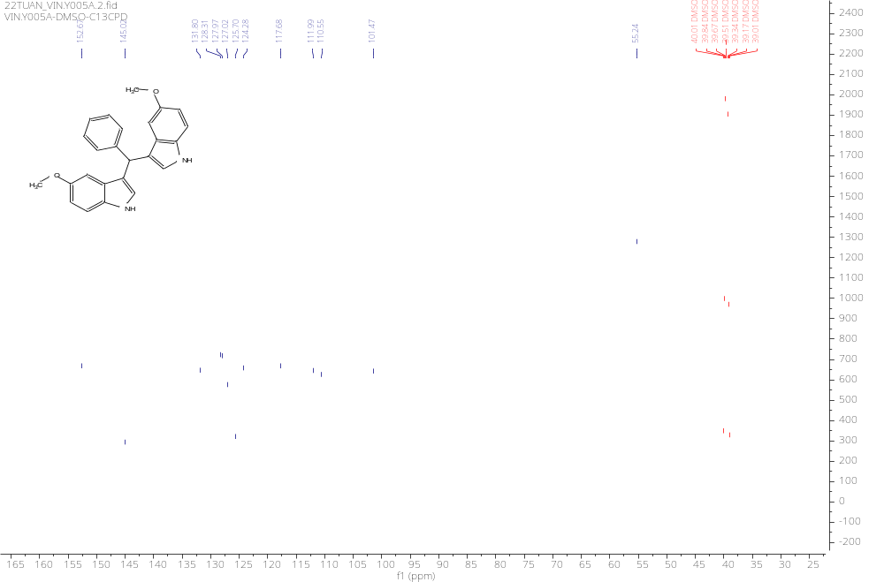
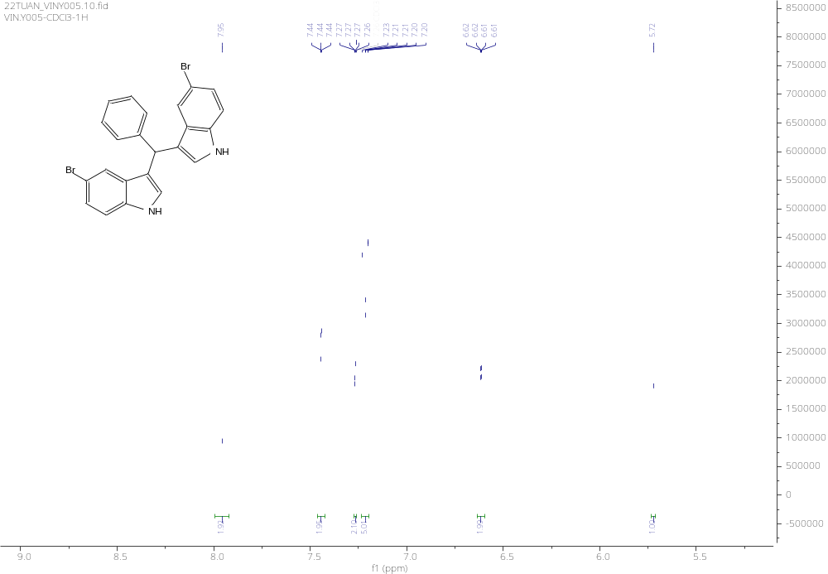
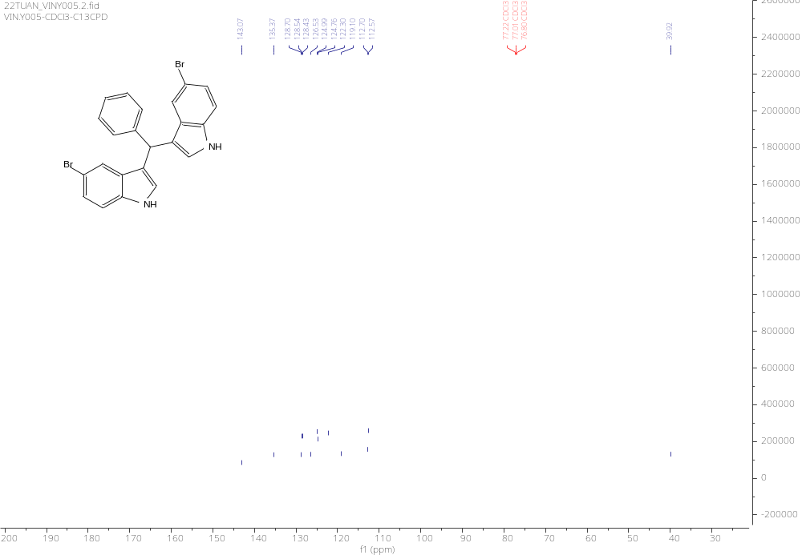
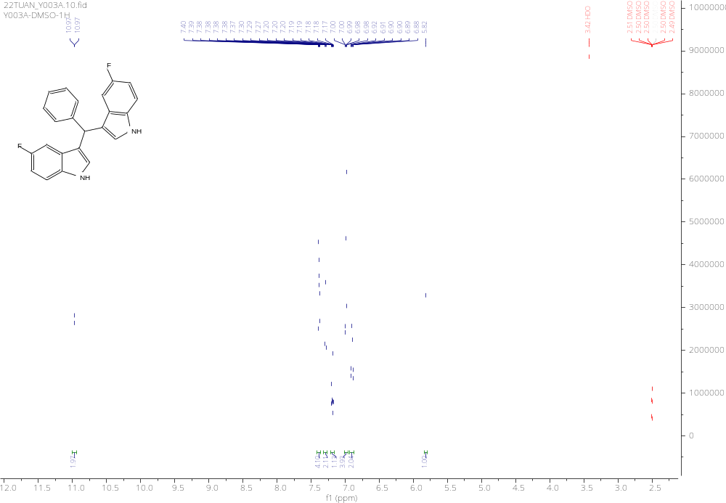

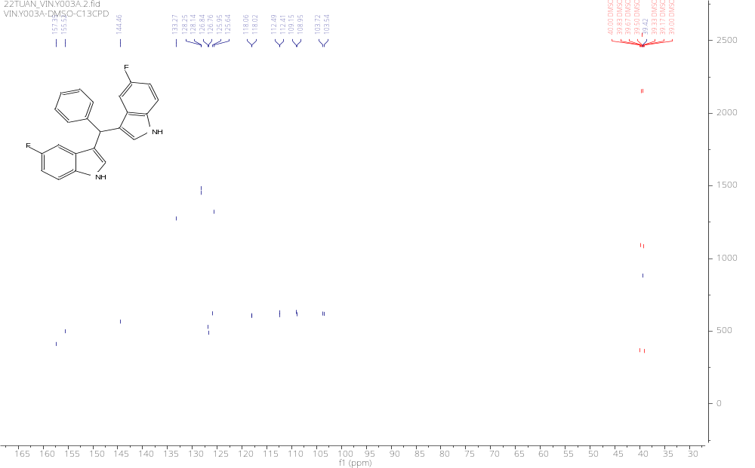
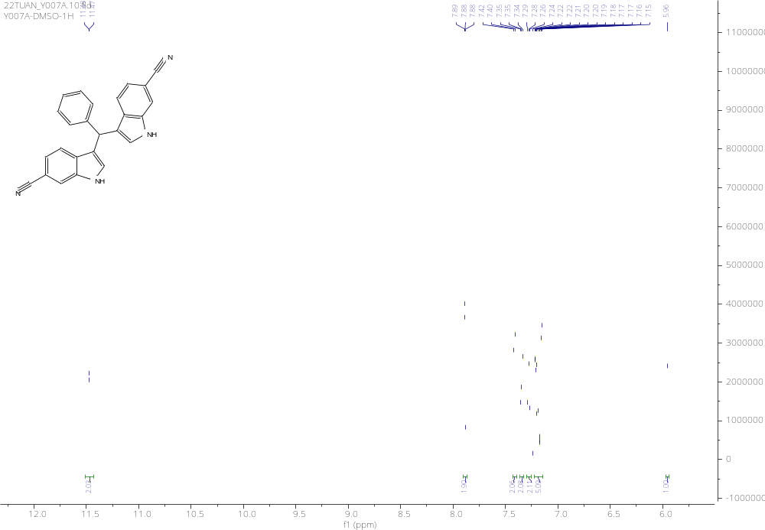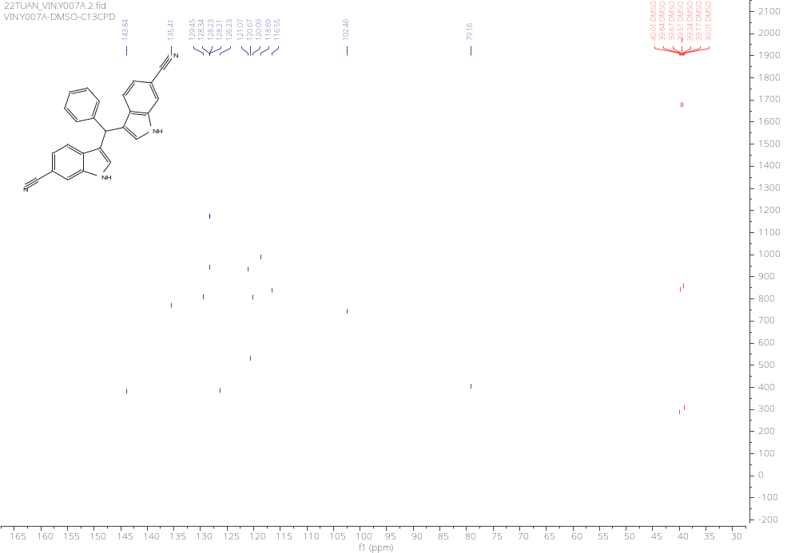
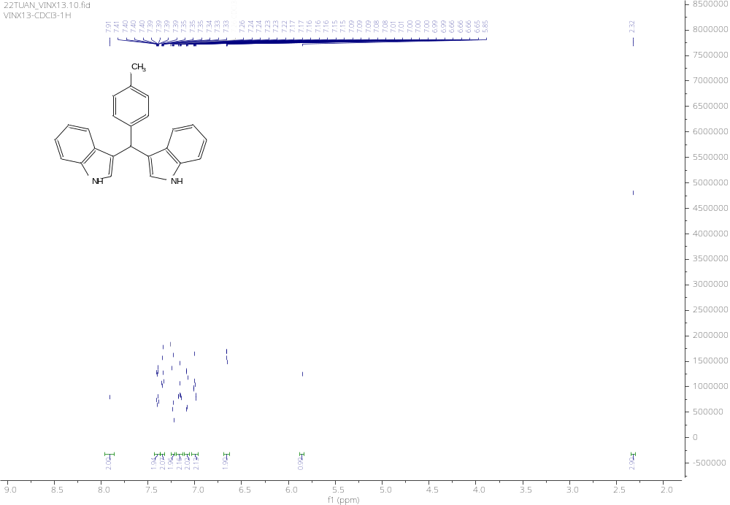
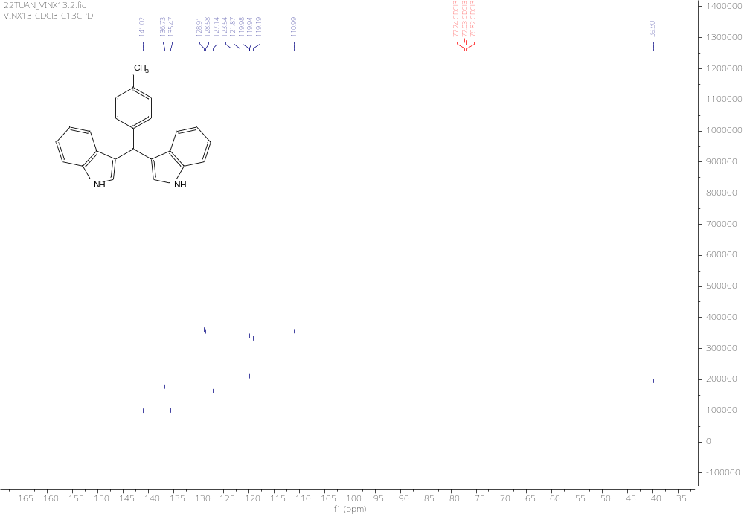
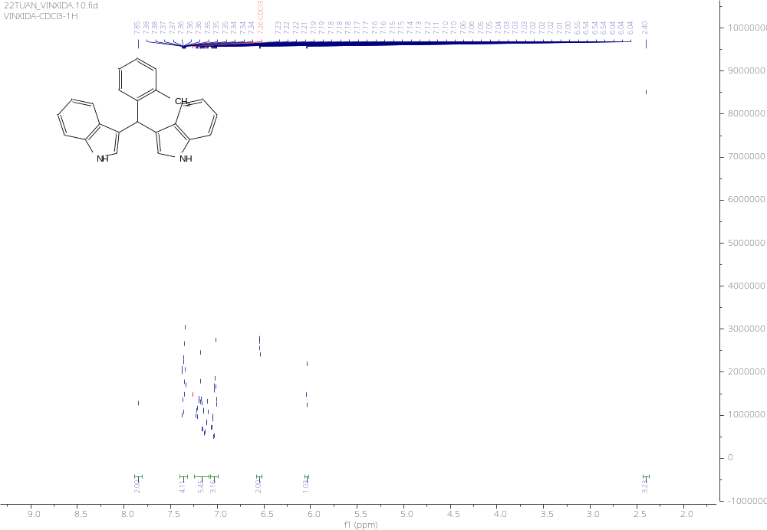
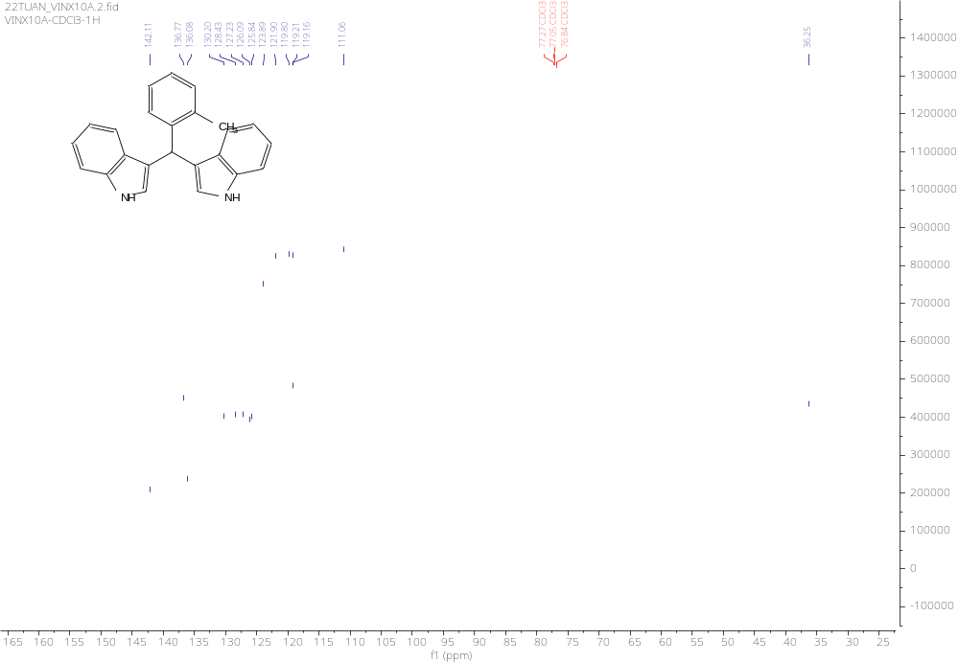
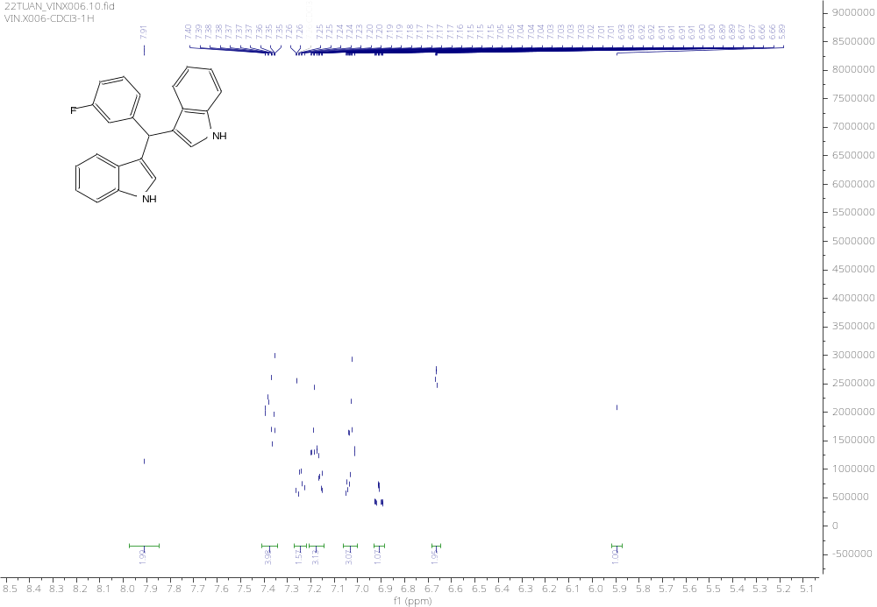
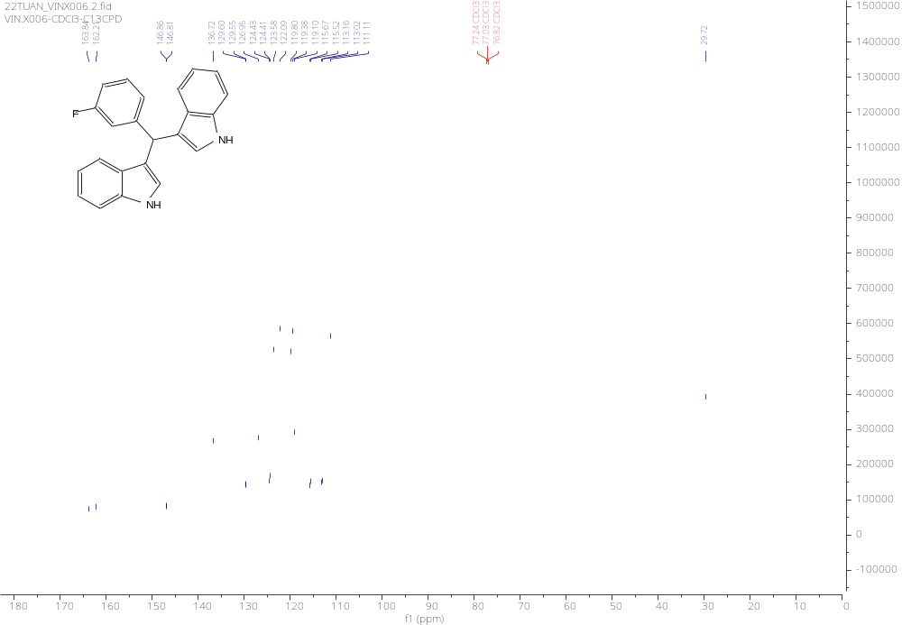
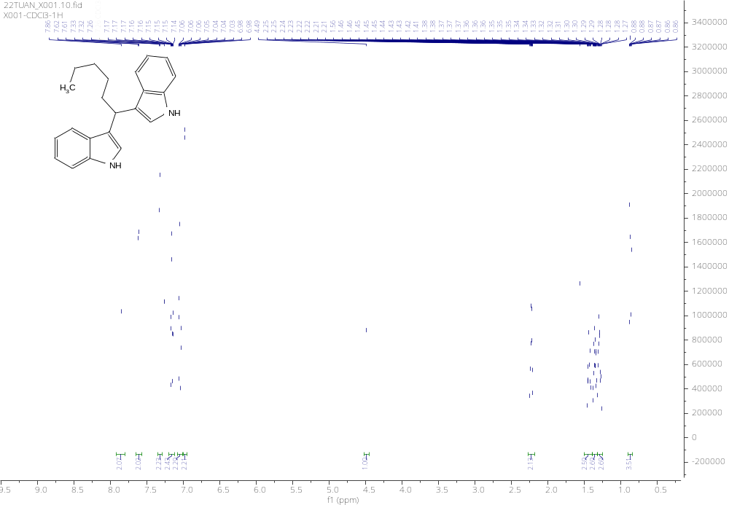
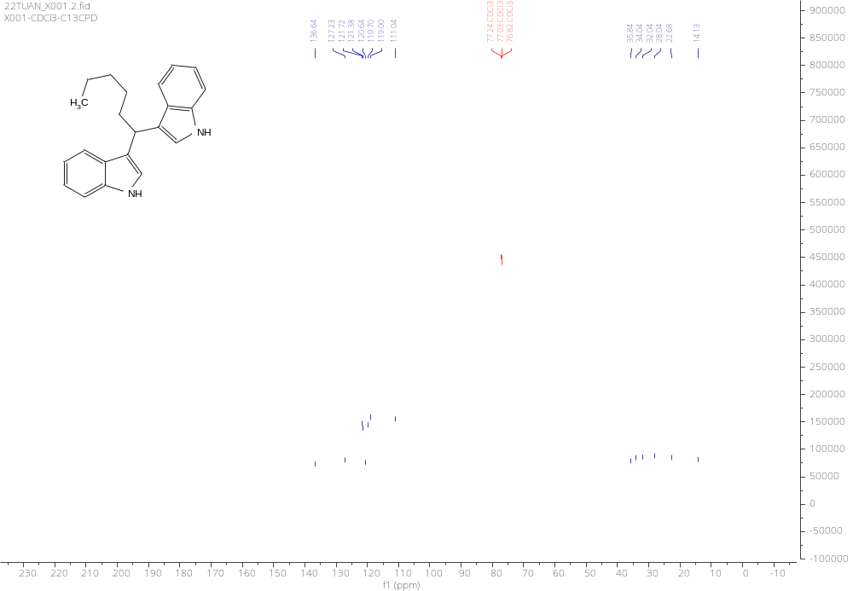

N. K. Nguyen, D. L. Tran, T. Q. Hung, T. M. Le, N. T. Son, Q. T. Trinh, T. T. Dang, P. Langer, Tetrahedron Lett. 2021, 68, 152936.
N. Biswas, R. Sharma, D. Srimani, Adv. Synth. Catal. 2020, 362, 2902–2910.

