Supplementary Table 1 – Analysis of risk factors for 30-day clinical failure in patients with ESBL-KP bacteremia
Characteristics | 30-day success  n = 61 | 30-day failure  n = 49 | Univariate analysis |  | Adjusted analysis
Characteristics | 30-day success  n = 61 | 30-day failure  n = 49 | HR (95%CI) | p value | aHR (95%CI) | p value
Age, year | 57 [45-67] | 64 [55-69] | 1.0 (1.0-1.0) | .102 | 1.0 (1.0-1.0) | .134
Male | 40 (66) | 33 (67) | 1.0 (0.6-1.9) | .938
Body-mass index | 25 [22-29] | 26 [24-30] | 1.0 (1.0-1.1) | .780
Charlson comorbidity index | 3 (1-5) | 4 (2-5) | 1.1 (1.0-1.2) | .263
Sickle cell disease | 1 (2) | 3 (6) | 1.7 (0.5-5.4) | .385
Surgery, previous 30 days | 16 (27) | 18 (37) | 1.4 (0.8-2.4) | .301
Type of surgery:  Cardiovascular  Thoraco-abdomino-pelvic  Orthopedic  Neurosurgery  Plastic | 1 (6)  7 (44)  4 (25)  3 (19)  1 (6) | 1 (5)  9 (50)  3 (17)  3 (17)  2 (11) | 1.3 (0.2-10.1)  1.3 (0.5-3.3)  0.7 (0.2-2.6)  0.8 (0.2-2.6)  1.0 (0.2-4.6) | .778  .554  .636  .664  .944
Immunosuppressive therapy | 5 (8) | 5 (10) | 1.2 (0.5-3.0) | .731
Origin:  Community-acquired  Nosocomial infection | 6 (10)  55 (90) | 3 (6)  46 (94) | Reference variable  1.3 (0.4-4.3) | .625
Source of bacteremia:  Central line associated  With thrombophlebitis  Pneumonia  Urinary tract  Intra abdominal  Others*  Unknown | 30 (49)  8 (13)  4 (7)  10 (16)  3 (5)  3 (5)  11 (18) | 6 (12)  4 (8)  17 (35)  6 (12)  9 (19)  5 (10)  6 (12) | 0.2 (0.1-0.5)  0.7 (0.2-1.9)  3.5 (1.9-6.4)  0.7 (0.3-1.6)  2.3 (1.1-4.8)  1.8 (0.7-4.5)  0.7 (0.3-1.6) | .001  .473  <.001  .391  .023  .227  .420 | 3.3 (1.7-6.4)  2.4 (1.0-5.6) | .001  .044
Time between admission to ICU and bacteremia, days | 11 [6-19] | 9 [5-15] | 1.0 (1.0-1.0) | .337
SAPS II admission score | 47 [32-57] | 48 [34-61] | 1.0 (1.0-1.0) | .558
SOFA score | 7 [5-11] | 13 [10-16] | 1.2 (1.1-1.3) | <.001 | 1.1 (1.1-1.2) | <.001
Pitt bacteremia score | 6 [3-8] | 8 [7-9] | 1.2 (1.1-1.3) | <.001
Septic shock | 12 (20) | 32 (65) | 4.1 (2.2-7.4) | <.001
Mechanical ventilation | 40 (66) | 41 (84) | 2.1 (1.0-4.5) | .057
Duration of empirical therapy, days | 0 (0-2) | 1 (0-2) | 1.0 (0.9-1.2) | .719
Appropriate empirical therapy | 31 (58) | 28 (62) | 1.1 (0.6-2.0) | .785
Co-infections | 10 (17) | 11 (23) | 1.4 (0.7-2.7) | .349
Other antibiotic therapy | 11 (22) | 11 (25) | 1.3 (0.7-2.6) | .391
Time to effective antibiotic therapy, hours | 20 [5-44] | 16 [5-32] | 1.0 (1.0-1.0) | .706
Definitive antibiotic therapy with cefoxitin (versus carbapenem) | 36 (59) | 27 (55) | 0.9 (0.5-1.6) | .823
Data are presented as median [IQR] or count (%). P values in bold are statistically significant. Abbreviation as in Table 1. NA= not applicable
*Due to low patient numbers, infections related to liver abscess, skin and soft tissue, and neuromeningeal etiology were merged for the analysis.

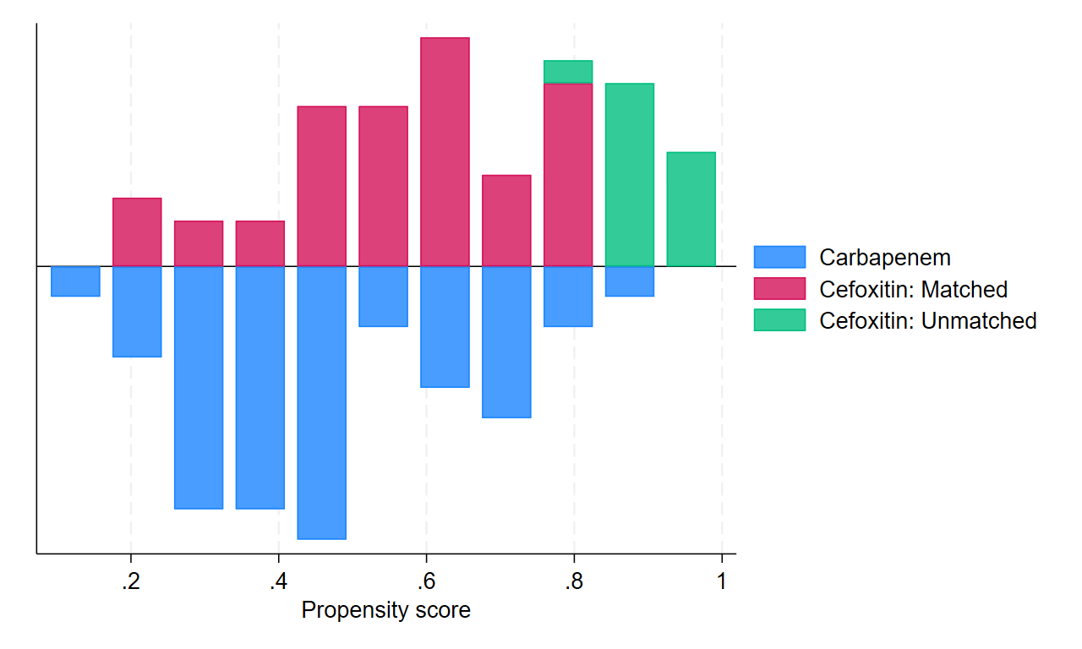
Supplementary Figure 1 - Matching graph of the propensity score

