Table 1. Baseline characteristics
 | WHR>=0.9, N = 388¹ | WHR<0.9, N = 161¹ | p-value²
Patient Related Variables
Age | 56 +9 | 55 +8 | 0.5
Race |  |  | 0.019
African American | 63 (61) | 40 (39)
White | 325 (73) | 121 (27)
Gender |  |  | <0.001
Male | 290 (87) | 42 (13)
Female | 98 (45) | 119 (55)
KPS Score |  |  | 0.3
90-100 | 69 (69) | 31 (31)
80-90 | 190 (68) | 90 (32)
70-80 | 107 (76) | 34 (24)
<70 | 22 (79) | 6 (21)
Disease Related Variables
Disease risk |  |  | 0.2
High risk | 85 (66) | 43 (34)
Standard risk | 303 (72) | 118 (28)
Number of lines of treatment |  |  | 0.6
1 | 331 (70) | 140 (30)
2 | 53 (72) | 21 (28)
3 | 4 (100) | 0(0)
Initial therapy |  |  | 0.4
VRD (alone or with others) | 211 (68) | 99 (32)
VCD (alone or with others) | 62 (74) | 22 (26)
RD (alone) | 38 (76) | 12 (24)
VD (alone) | 55 (77) | 16 (23)
Other | 22 (65) | 12 (35)
Received second intervention² | 203 (70) | 88 (30) | 0.6
Started maintenance therapy | 349(70) | 151(30) | 0.2
1. n(%); Mean +SD; 2. Second intervention includes Auto/Auto arm pt received 2nd txp or Auto/RVD pt started RVD cycles
- 17% African American
- Median follow up time: 6 years (range 0.4-8.5)
- More white patients were seen in the high WHR group
- More males were seen in high WHR compared to female

Table1.Sup: Obesity classification based on race
 | Race
 | Black/Africa-American | White | Total
BMI>30 & WHR>0.9 | 34(19.43%) | 141(80.57%) | 175
BMI>30 & WHR<0.9 | 14(29.17%) | 34(70.83%) | 48
BMI<30 & WHR>0.9 | 25(13.51%) | 160(86.49%) | 185
BMI<30 & WHR<0.9 | 26(23.01%) | 87(76.99%) | 113
Total | 103(18.76%) | 446(81.24%) | 549

Table-2:
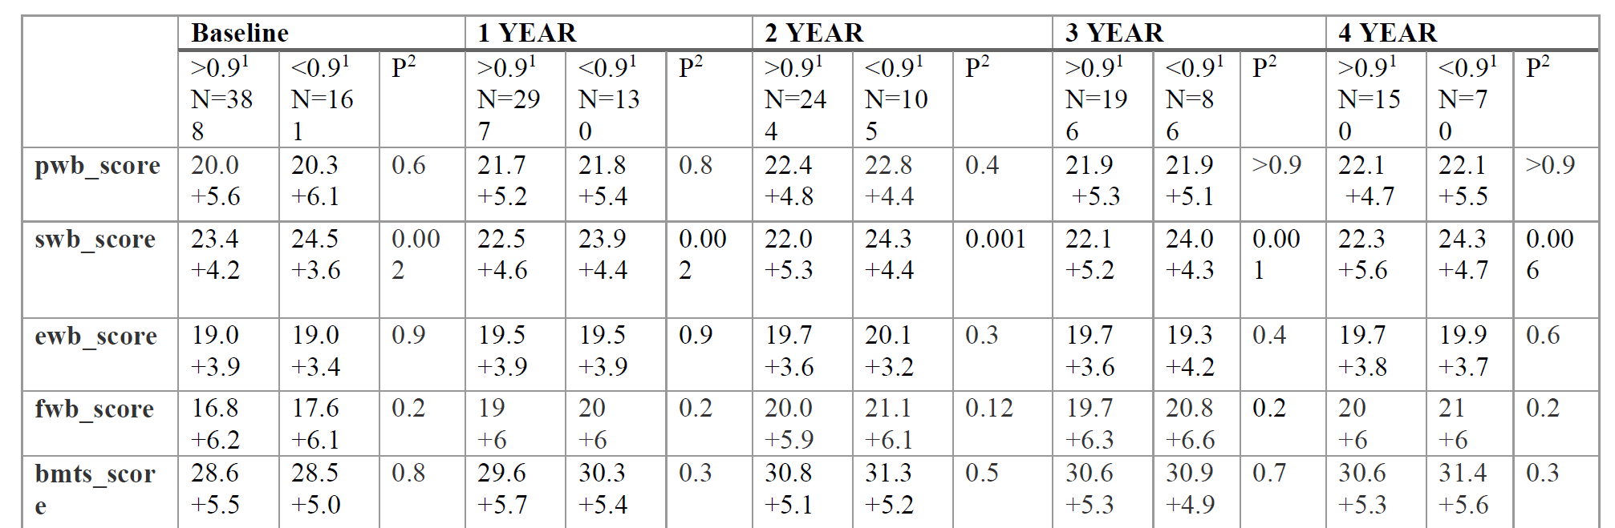
- Physical well-being (PWB)
- Emotional well-being (EMB)
- Functional well-being (FWB)
- Bone marrow transplant score (BMTS)

