Supplementary Figures
Crossing host boundaries: the evolutionary drivers and correlates of viral host jumps

Cedric C.S. Tan^{1,2}, Lucy van Dorp^{1,*}, Francois Balloux^{1,*}

¹UCL Genetics Institute, University College London, Gower St, London WC1E 6BT, UK.
²The Francis Crick Institute, 1 Midland Rd, London NW1 1AT, UK.

* These authors contributed equally.
Correspondence: C.C.S.T (cedriccstan@gmail.com)

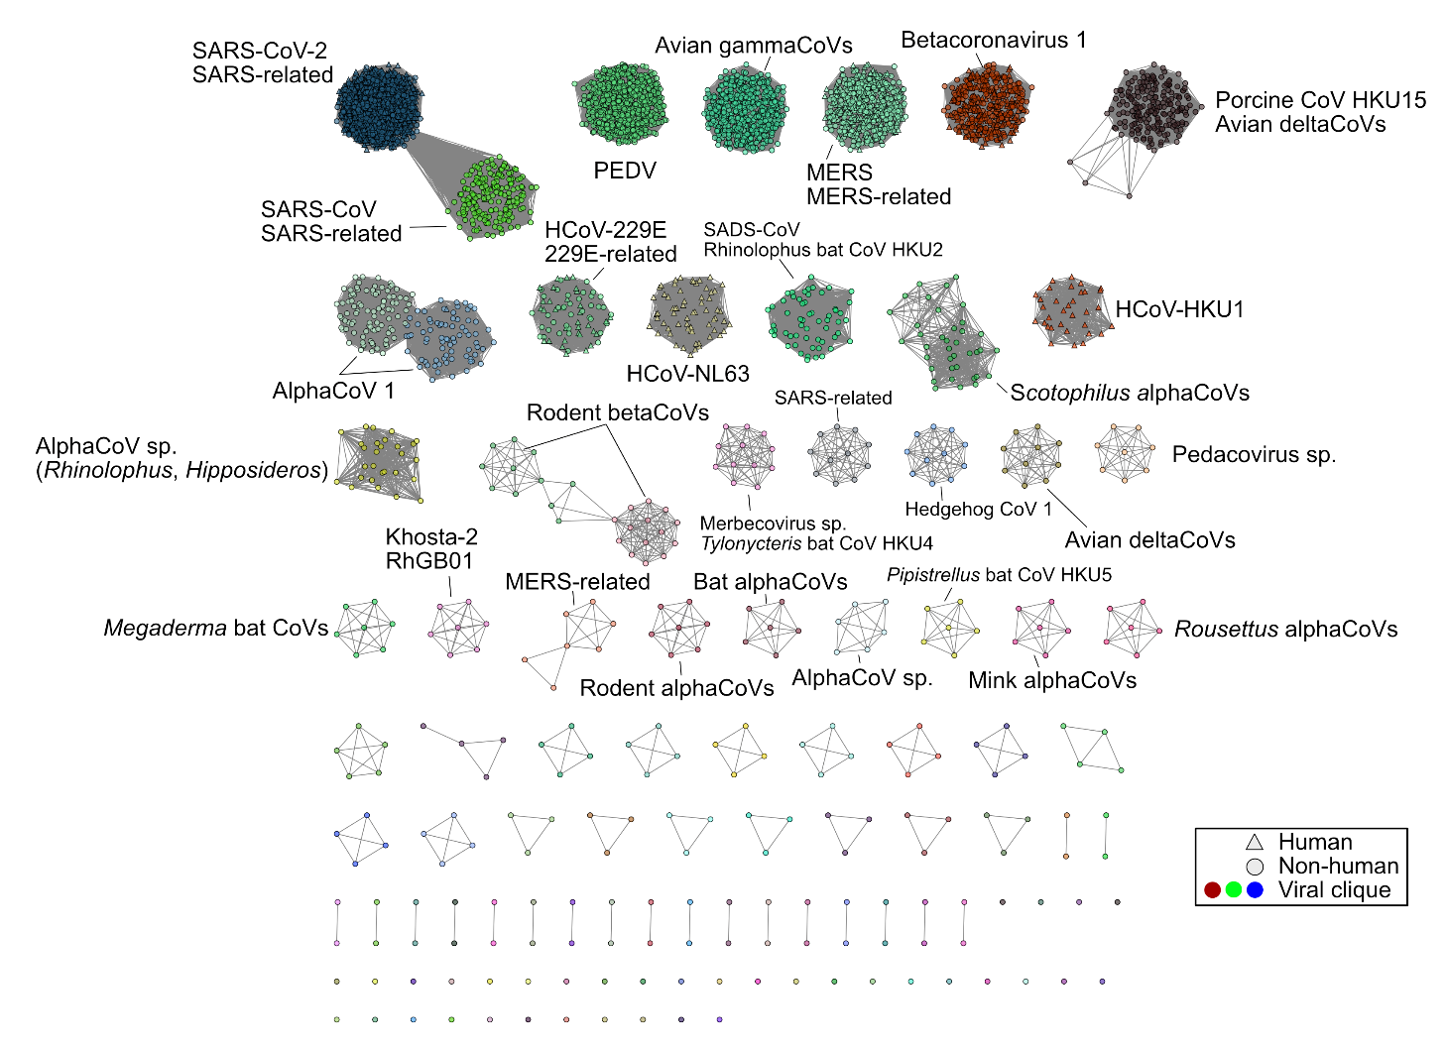
Extended Data Figure 1. Viral cliques identified and their corresponding user-submitted species names for the Coronaviridae, similar to Fig. 2. Nodes, node shapes, and edges represent individual genomes, their associated host and their pairwise Mash distances, respectively. Edges representing >0.15 Mash distance were removed (see Methods).
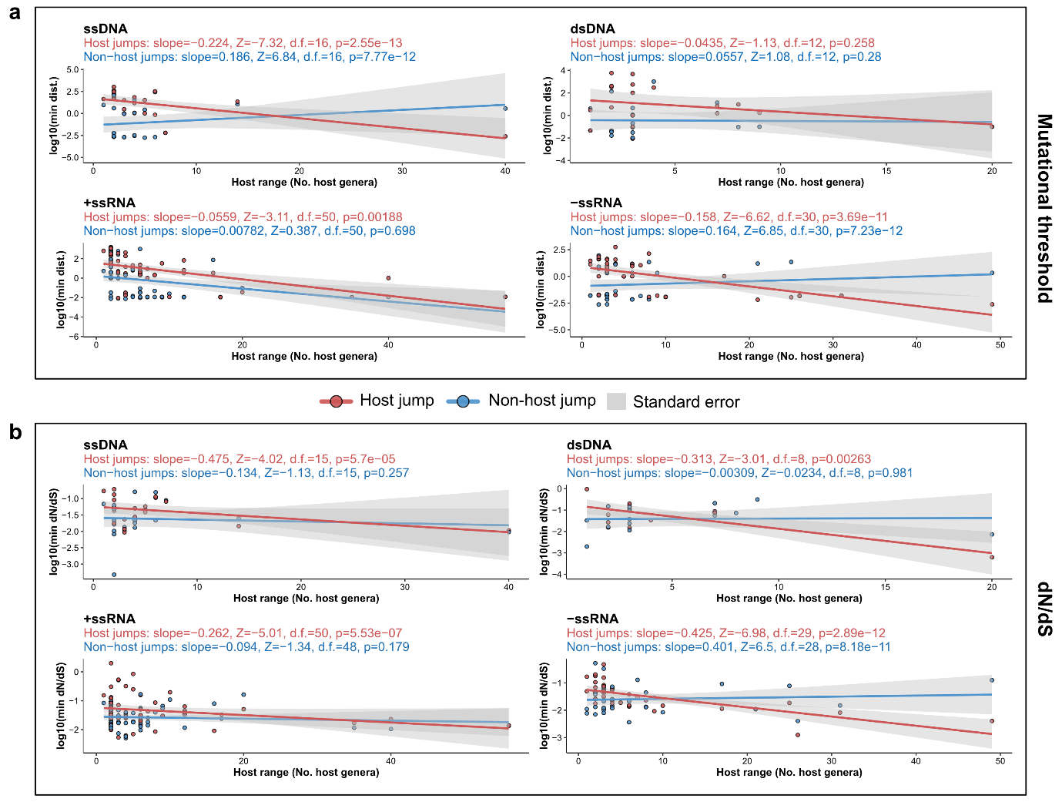
Extended Data Figure 2. Analysis of relationships between host range and adaptive thresholds, similar to Fig. 3, but only considering ssDNA, dsDNA, +ssRNA or -ssRNA viruses. Distributions of minimum (a) mutational distance and (b) dN/dS for host jump and non-host jumps on the logarithmic scale. We corrected for the effects of sequencing effort and viral family membership using Poisson regression models. The estimated effects of patristic distance on host range after these corrections are annotated. We tested whether the estimated effects were non-zero using two-tailed Z-test. For all panels, each data point represents the minimum distance or dN/dS across all host jump or randomly selected non-host jump lineages in a single clique. Lines and grey shadings represent linear regression smooths without correction and their corresponding standard errors.

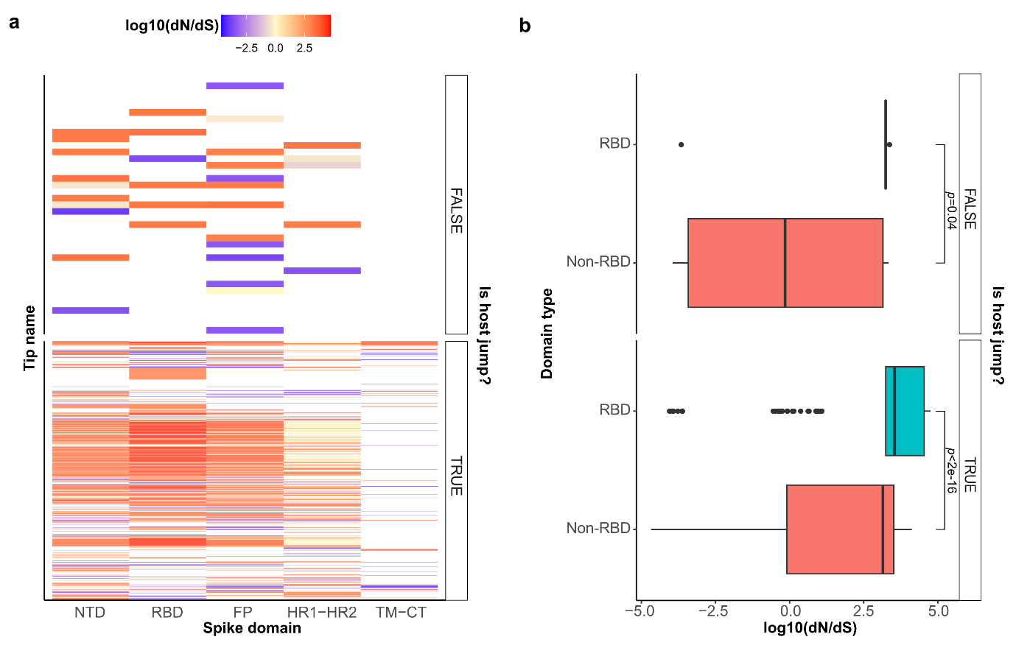
Extended Data Figure 3. Adaptive signals are region-specific. (a) dN/dS estimates of different functional domains (N-terminal domain (NTD); receptor-binding domain (RBD); fusion peptide (FP); heptad repeats 1 and 2 (HR1-HR2); transmembrane and C-terminal domains (TM-CT)) within the spike gene of the clique representing SARS-CoV-2. Spike gene sequences were aligned with gaps trimmed to that for the Wuhan-Hu-1 reference sequence (NC_045512). (b) Boxplots of log10(dN/dS) for RBD and non-RBD domains. Differences in distributions were tested for using two-sided Mann-Whitney U tests.

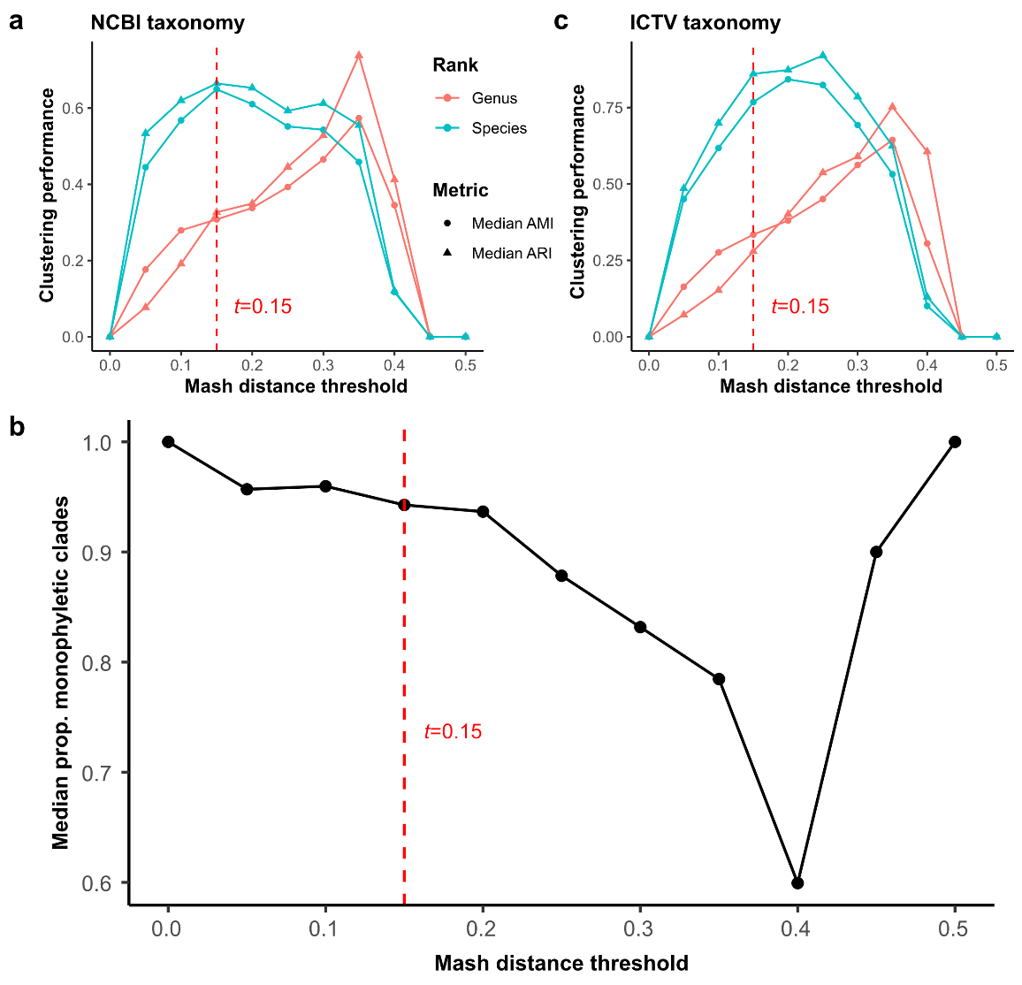
Extended Data Figure 4. Selection of Mash distance threshold. We constructed undirected, weighted bipartite graphs for each viral family with nodes and edges representing genomes and Mash distances, respectively. We then removed edges associated with values larger than the Mash distance threshold, t, before applying the community-detection algorithm, Infomap, to identify viral cliques. We then assessed the concordance of viral cliques identified against the (a) NCBI taxonomy or (c) ICTV taxonomy, using the median adjusted mutual information (AMI) or adjusted Rand index (ARI) across viral families. We also assessed (b) the median proportion of monophyletic viral cliques across all viral families. The final distance threshold selected was t=0.15.

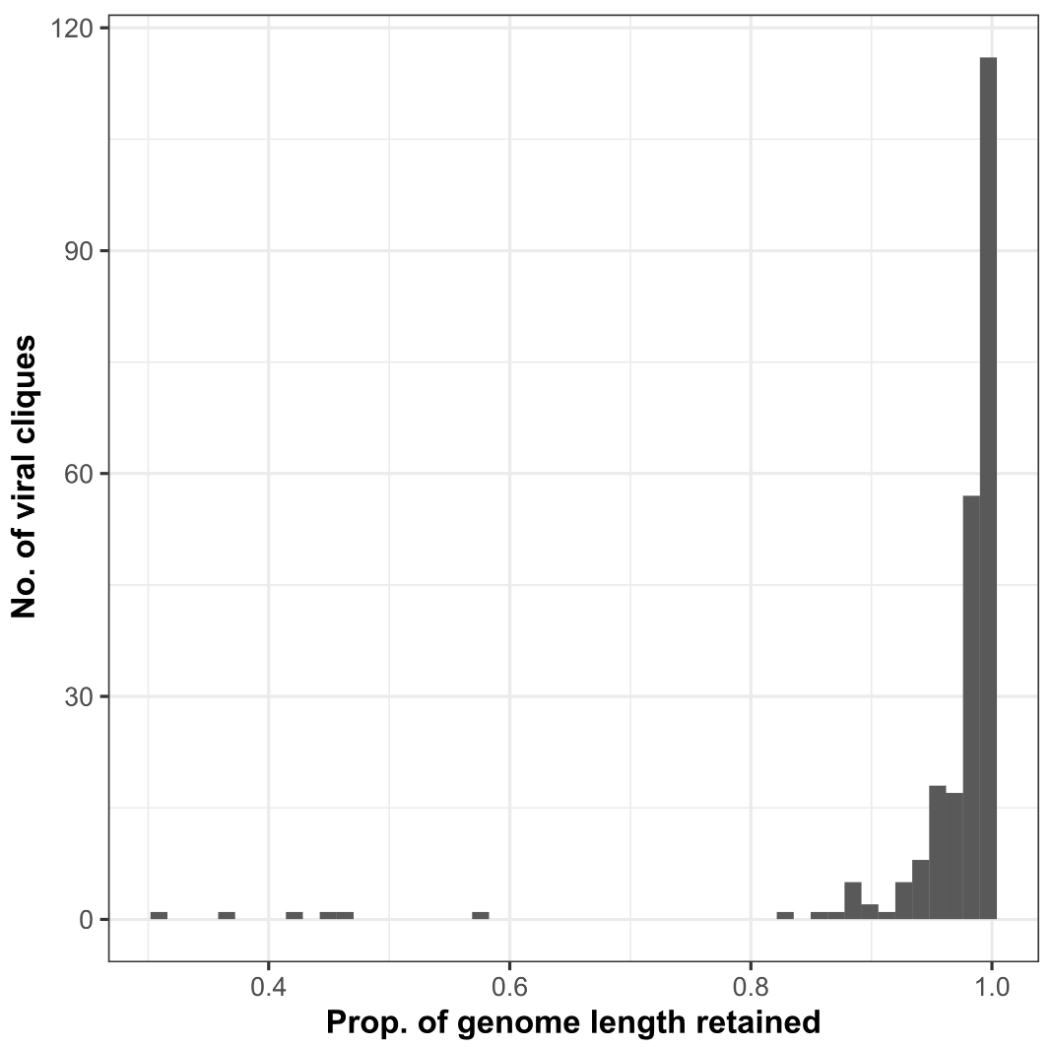
Extended Data Figure 5. Assessing the quality of clique-level genome alignments. For each viral clique, genomes were aligned and positions in these alignments were masked if more than 10% of sequences were gaps or ambiguous nucleotides. The proportion of genome length retained was calculated as the number of unmasked sites divided by the median genome length of sequences in each clique-level alignment.

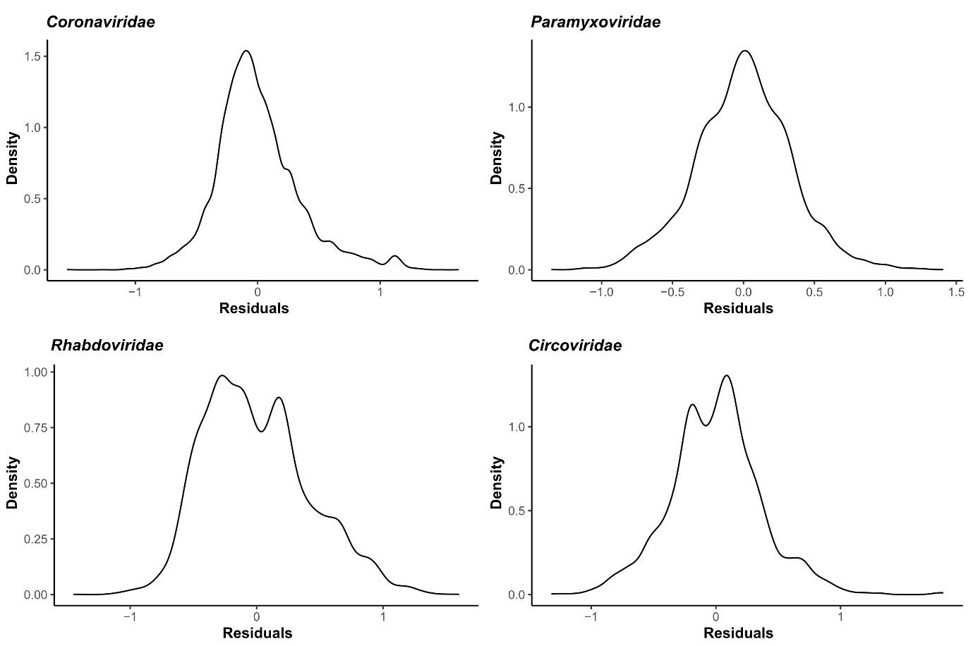
Extended Data Figure 6. Linear regression model residuals. Kernel density plots of residuals for the linear regression models implemented in Fig. 5.

