Supplementary Table 1. Comparison of alterations in H vs B/T
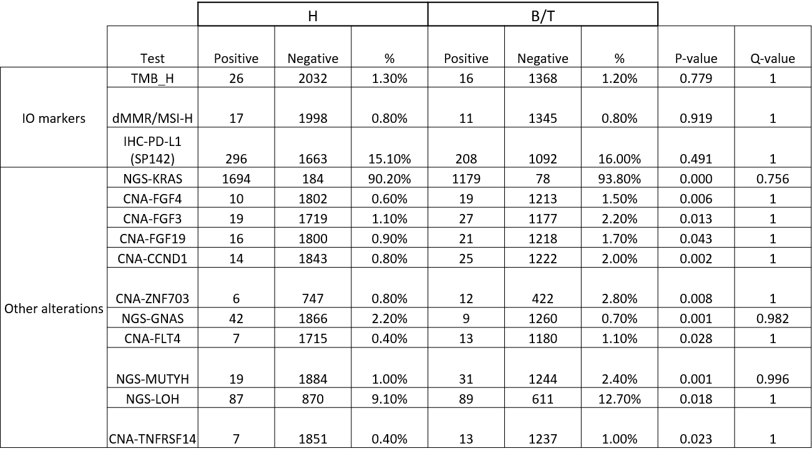

Supplementary Table 2. Median units shown for the TIME. Where median values were “0”, percent of nonzero values are shown. Red: higher median value;Blue: lower median value
