Supplementary Information
Supplementary Figures

Supplementary Fig. 1 Correlation between observed nAb titers and individual predictions. PSVN50, pseudovirus neutralizing antibody ID50 titer.

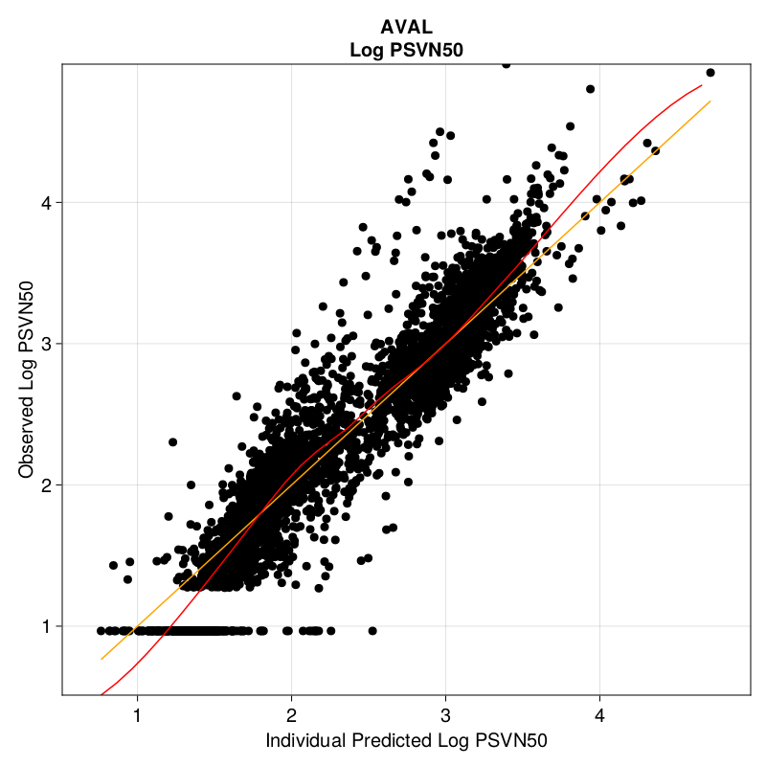

Supplementary Fig. 2 Correlation between observed nAB titers and population predictions. PSVN50, pseudovirus neutralizing antibody ID50 titer.

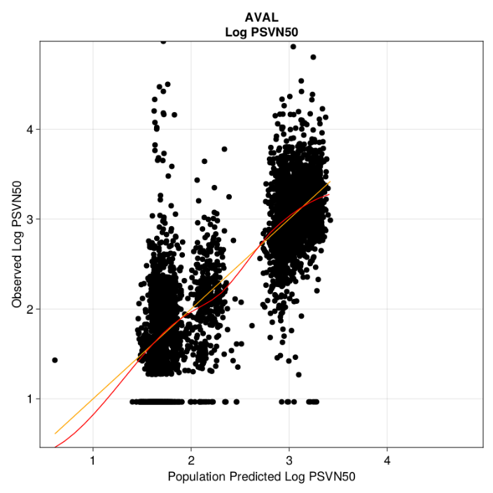

Supplementary Fig. 3 Distribution of random effect on volume scaling factor shows that the normal distribution assumption is preserved. η₁, random effect on volume scaling factor.

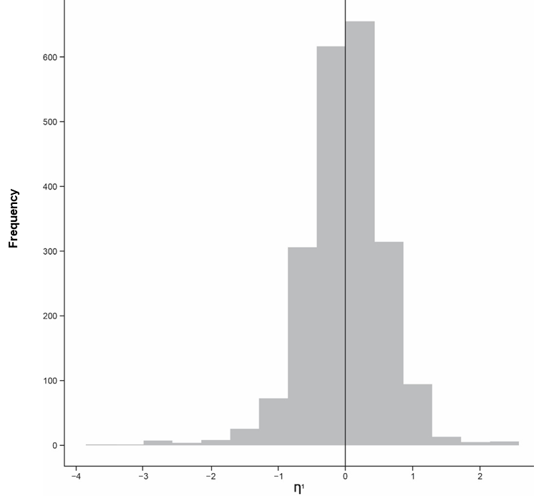

Supplementary Fig. 4 Distribution of random effect on volume scaling factor across age groups shows no bias. η₁, random effect on volume scaling factor.
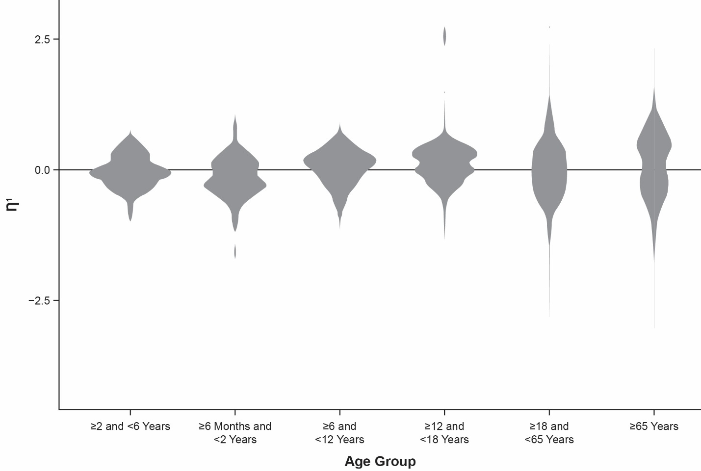

Supplementary Fig. 5 Distribution of random effect volume scaling factor across doses shows minimal to no bias. η₁, random effect on volume scaling factor.
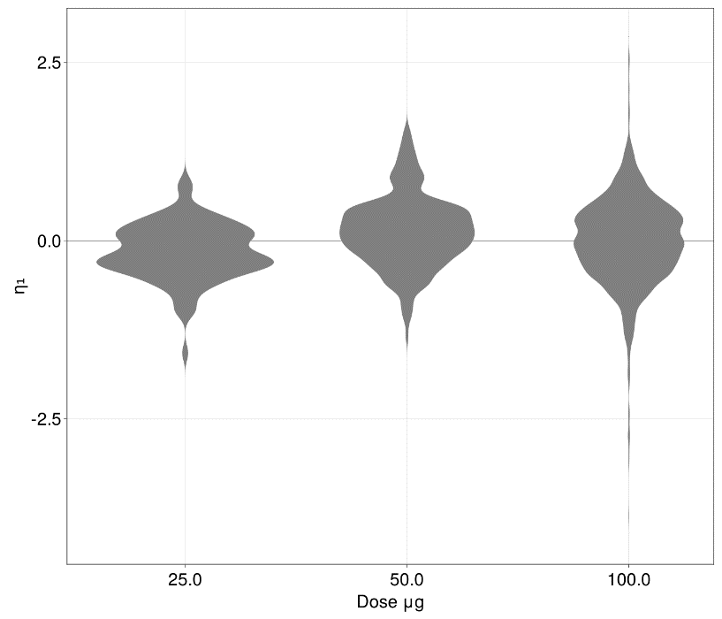

Supplementary Fig. 6 Distribution of random effect volume scaling factor across studies shows minimal to no bias. η₁, random effect on volume scaling factor.

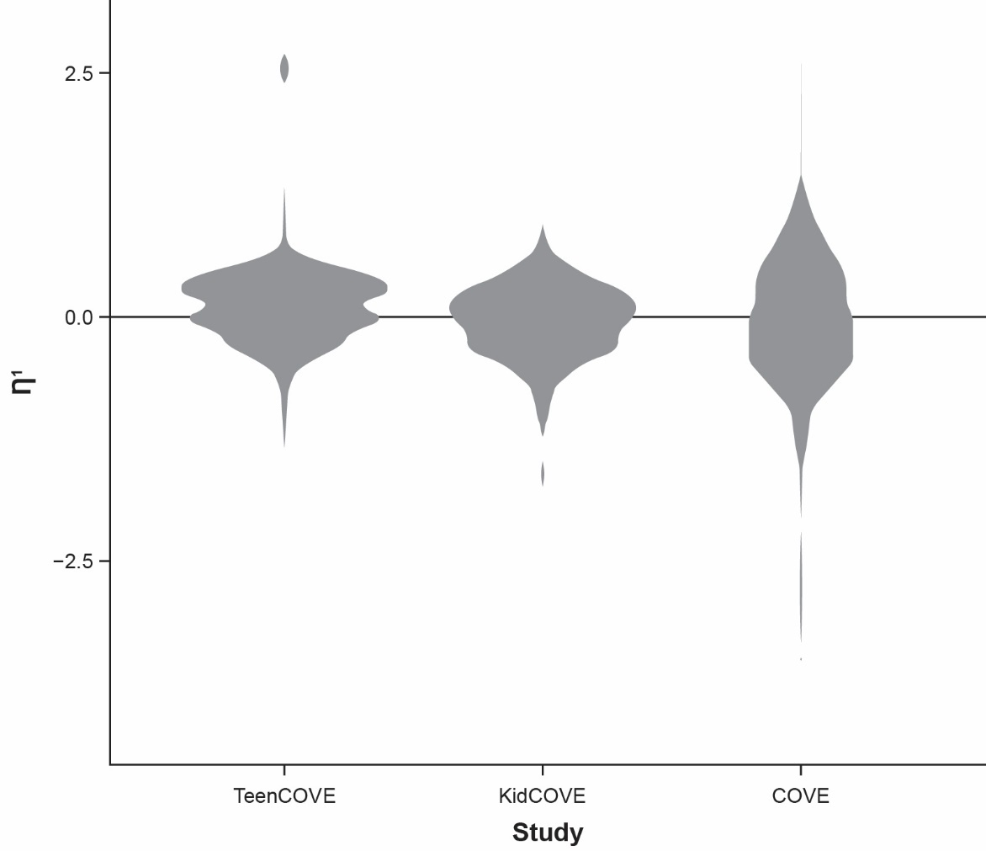

Supplementary Fig. 7 Distribution of normalized prediction distribution errors, a measure to ascertain residual distribution, shows no systematic bias over time. PSVN50, pseudovirus neutralizing antibody ID50 titer.

