Supplementary Material

Table S1. Sequencing summary statistics for the three communities inhabiting the goat rumen and distal gut. For each community, the total and the average number of raw reads, the number of samples considered, the average number and the range of reads per sample after fragment rebuilding, quality filtering, and zOTUs creation are shown.

Community | Total reads | Avg. reads | Rumen samples |  |  | Fecal samples
Community | Total reads | Avg. reads | N | Avg. after filter | Range | N | Avg. after filter | Range
Prokaryotes | 6,356,865 | 111,524 ± 31,633 | 28 | 57,629 ± 15,805 | 21,927 – 89,537 | 29 | 44,707 ± 8,649 | 28,204 – 65,840
Fungi | 2,709,239 | 75,257 ± 31,196 | 13 | 65,282 ± 29,774 | 34,297 – 128,135 | 23 | 29,480 ± 10,697 | 12,850 – 58,620
Protozoa | 5,007,343 | 185,457 ± 60,524 | 27 | 116,619 ± 46,859 | 36,480 – 223,482 | -- | -- | --

Fig. S1. Rarefaction curves of the ruminal fungal microbiota for all the samples of this study. Each line represents a sample; error bars representing the intra-diet standard deviation are also represented. (A) Samples from rumen, prokaryota community (PD whole tree metric); (B) Samples from feces, prokaryota community (PD whole tree metric); (C) Samples from rumen, fungal community (observed species metric); (D) Samples from feces, fungal community (observed species metric); (E) Samples from rumen, protozoan community (PD whole tree metric)
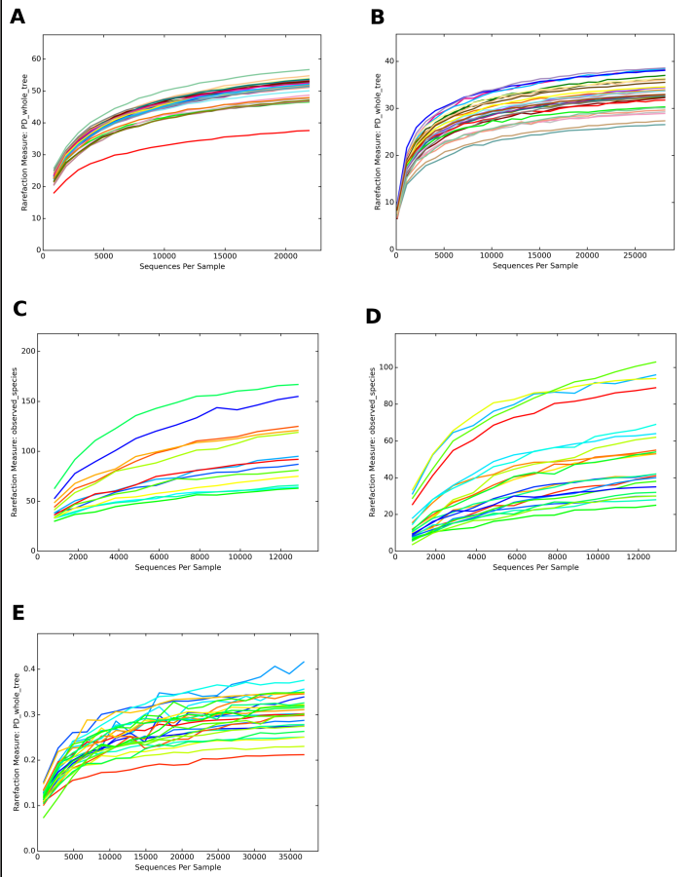

Fig. S2. (A) Rarefaction curves of the ruminal fungal microbiota according to the observed species metric for all the experimental diets assessed in this study. The line represents the average over the samples collected from goats subjected to the same diet; error bars representing the intra-diet standard deviation are also represented; (B) Rarefaction curves of the ruminal protozoan microbiota according to the PD whole tree metric for all the experimental diets; (C) Principal Coordinate Analysis (PCoA) based on the Bray-Curtis distances between samples illustrating the clustering of rumen fungal microbiota samples according to goat diet. Each point represents a sample, colored according to the diet group, centroids are the average of the coordinates and ellipses represent the SEM-based confidence interval. The first and second principal coordinates are represented; (D) PCoA based on the unweighted Unifrac distances between samples illustrating the clustering of rumen protozoan microbiota samples according to goat diet.

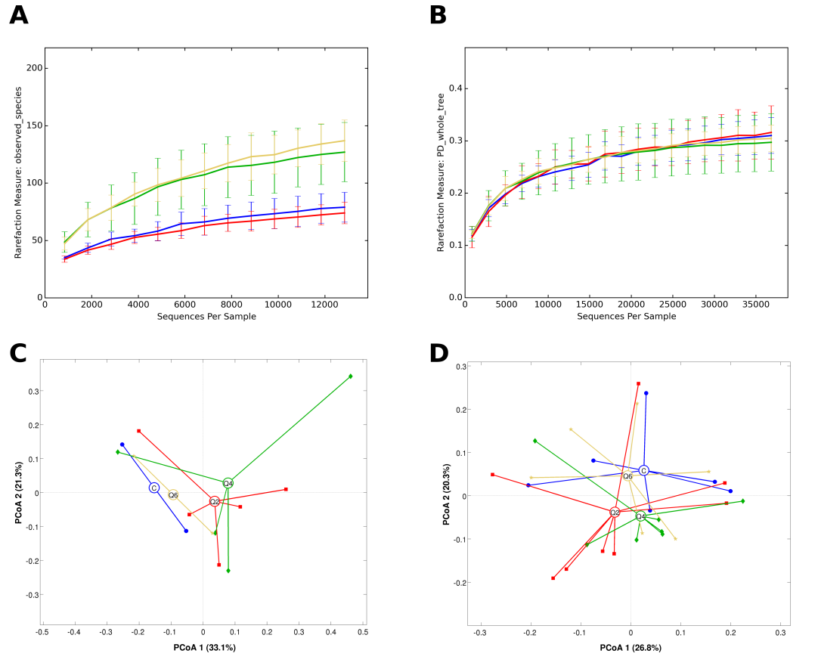

Fig. S3. (A) Rarefaction curves of the fecal fungal microbiota according to the observed species metric for all the experimental diets assessed in this study. The line represents the average over the samples collected from goats subjected to the same diet; error bars representing the intra-diet standard deviation are also represented; (B) Principal Coordinate Analysis (PCoA) based on the Bray-Curtis distances between samples illustrating the clustering of fecal fungal microbiota samples according to goat diet. Each point represents a sample, colored according to the diet group, centroids are the average of the coordinates and ellipses represent the SEM-based confidence interval. The first and second principal coordinates are represented.

