Supporting Information:
Highly Permeable and Shelf-stable Aquaporin Biomimetic Membrane Based on an Anodic Aluminum Oxide Substrate

Ahmed Fuwad¹, Hyunil Ryu², Eui Don Han³, Jun-Hee Lee⁴, Noah Malmstadt⁵, Young-Rok Kim⁴, Young Ho Seo³, Sun Min Kim^{1,2,*}, Tae-Joon Jeon^{2,5,*}

¹Department of Mechanical Engineering, Inha University, 100 Inha-ro, Michuhol-gu, Incheon 22212, Korea
²Department of Biological Sciences and Bioengineering, Inha University, 100 Inha-ro, Michuhol-gu, Incheon 22212, Korea
³Department of Mechatronics Engineering, Kangwon National University, Chuncheon 24341, Korea
⁴ Institute of Life Sciences and Resources & Department of Food Science and Biotechnology, Kyung Hee University, Yongin 17104, Korea
⁵ Mork Family Department of Chemical Engineering & Materials Science, Department of Biomedical Engineering, and Department of Chemistry, University of Southern California, Los Angeles, CA 90089, USA
⁶ Department of Biological Engineering, Inha University, 100 Inha-ro, Michuhol-gu, Incheon 22212, Korea

Corresponding Authors:
Tae-Joon Jeon: tjjeon@inha.ac.kr
Sun-Min Kim: sunmk@inha.ac.kr

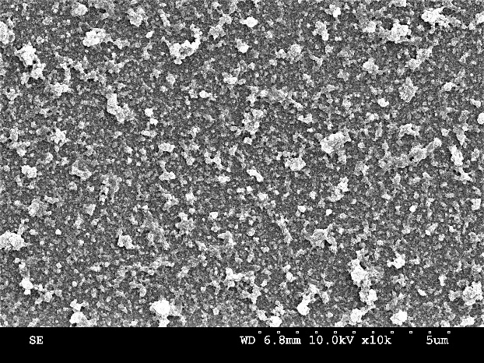
Fig. S1 Surface morphological analysis of an AQP AAO membrane after water purification.
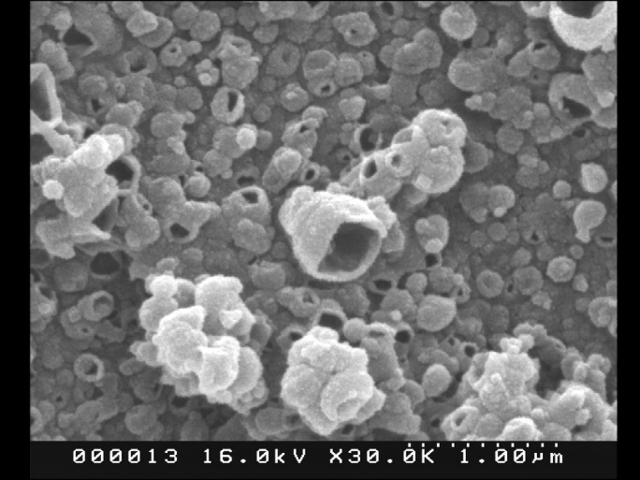

Fig. S2 Surface morphological analysis of an AQP AAO membrane after storage at room temperature and humidity conditions.

The equation used for water flux calculation was as follows:

J_{w} = ΔW/S_{m}Δt $J_{w}=\frac{∆W}{S_{m}∆t}$ (S3)
where ∆W is the increase in the DS weight with time ∆t and S_{m} is the membrane area.
The reverse solute flux was calculated using the following equation:
J_{s} = $\frac{{∆C}_{fs}}{S_{m}∆t}$ (S4)
where ΔC_{fs} is the change in the concentration of the FS.
The SRSF was calculated by
$SRSF= \frac{J_{s}}{J_{w}}$ (S5)

