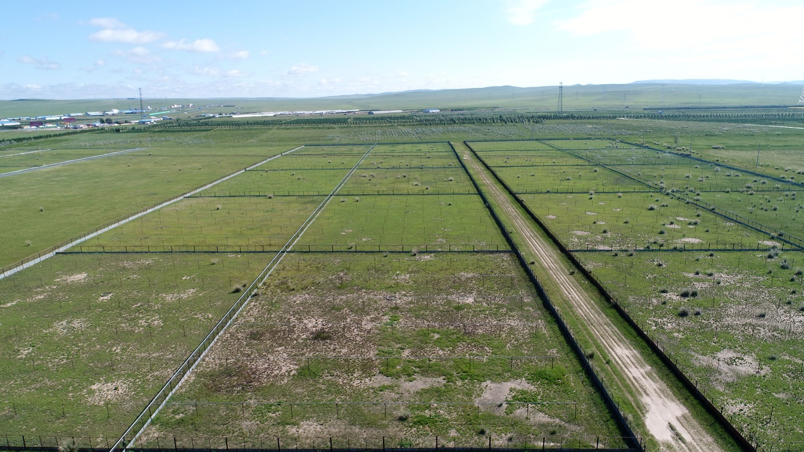
Fig. S1. Enclosures in the field (taken by Guoliang Li)

Fig. S2. Behavioral observation in high- and low-density field enclosures in 2014. (a) Difference in chasing frequency between voles from high density enclosure and low density enclosure. (b) Difference in chasing frequency per individual between high density enclosure and low density enclosure.

