Directed crystallization of a poly(3,4-ethylenedioxythiophene) film by an iron(III) dodecyl sulfate lamellar superstructure-

Feng Ma^{1†}, Sang-il Choi¹, Dooyong Lee², Sungkyun Park³, Sung-Pyo Cho^{4,5}, Jin-Hyo Boo⁶, and Sungsoo Kim^{1*}

¹Department of Materials Engineering, Paichai University, Daejeon 35345 Korea

²Department of Physics Education, Kyungpook National University, Daegu 41944, Korea

³Department of Physics, Pusan National University, Busan 46241, Korea

⁴National Center for Inter-University Research Facilities, Seoul National University, Seoul 08826, Korea

⁵Graphene Research Center, Advanced Institute of Convergence Technology, Suwon 16229, Korea

⁶Department of Chemistry, Sungkyunkwan University, Suwon 16419, Korea

†Current address: Department of Material Science and Engineering, Hunan University of Arts and Science, Changde, Hunan Province 415000, China
Table S1 Various types of trivalent Fe(Ⅲ) salts of anionic surfactants tested for the feasibility of VPP-PEDOT films
Surfactant | Fe(III) Oxidant | Solubility in alcoholic solvents | El. Conductivity of VPP-PEDOT film
CH₃(CH₂)₇CO₂Na | [CH₃(CH₂)₇CO₂]₃Fe | Soluble | < 1 S/cm
CH₃(CH₂)₇PO₃Na | Failed | - | -
CH₃(CH₂)₇PO₄Na | [CH₃(CH₂)₇PO₄]₃Fe | Marginally soluble | -
CH₃(CH₂)₁₁SO₄Na | [CH₃(CH₂)₁₁SO₄]₃Fe | Soluble | ~4,000 S/cm
CH₃(CH₂)₁₁PO₄Na | [CH₃(CH₂)₁₁PO₄]₃Fe | Insoluble | -
CH₃(CH₂)₁₁SO₃Na | [CH₃(CH₂)₁₁SO₃]₃Fe | Soluble | ~1,000 S/cm
CH₃(CH₂)₁₇SO₄Na | [CH₃(CH₂)₁₇SO₄]₃Fe | Nearly insoluble | -

Table S2 Lamellar thicknesses (d) corresponding to q values (Å⁻¹)
No. | q_{k} (Å⁻¹) | d (nm) | Group | hkl
1 | 0.168 | 3.738 | Blue | 001
2 | 0.185 | 3.395 | Red | 001
3 | 0.193 | 3.254 | Green | 001
4 | 0.212 | 2.962 | Magenta | 001
5 | 0.332 | 3.783 | Blue | 002
6 | 0.369 | 3.404 | Red | 002
7 | 0.382 | 3.288 | Green | 002
8 | 0.425 | 2.955 | Magenta | 002
9 | 0.555 | 3.395 | Red | 003

Table S3 VdW overlaps between DS-H and PEDOT-H atoms in a trench of the PEDOT crystal corresponding to the molecular modeling in Figure S17a. d denotes the distance between hydrogen atoms. VdW radius of hydrogen = 1.2 Å.¹

Table S4 VdW overlaps between DS-O and PEDOT-H atoms at the crossroad of the PEDOT trenches corresponding to the molecular modeling in Figure S17b. d denotes the distance between DS oxygen and PEDOT hydrogen atoms. VdW radius of oxygen = 1.52 Å.¹

Fig. S1 (a) TGA and (b) DSC curves of Fe(DS)₃

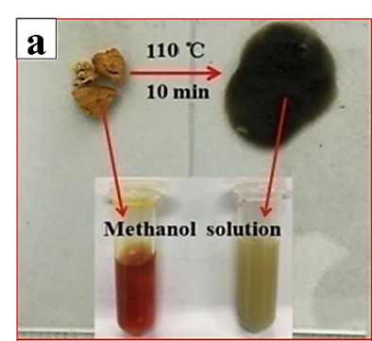
Fig. S2 (a) After heat treatment at 110 ℃, Fe(DS)₃ undergoes a permanent phase transition. (b) Micelles or vesicles do not exist on the Fe(DS)₃ film after heat treatment at 110 ℃ (200× magnification). Scale bar = 100 μm.

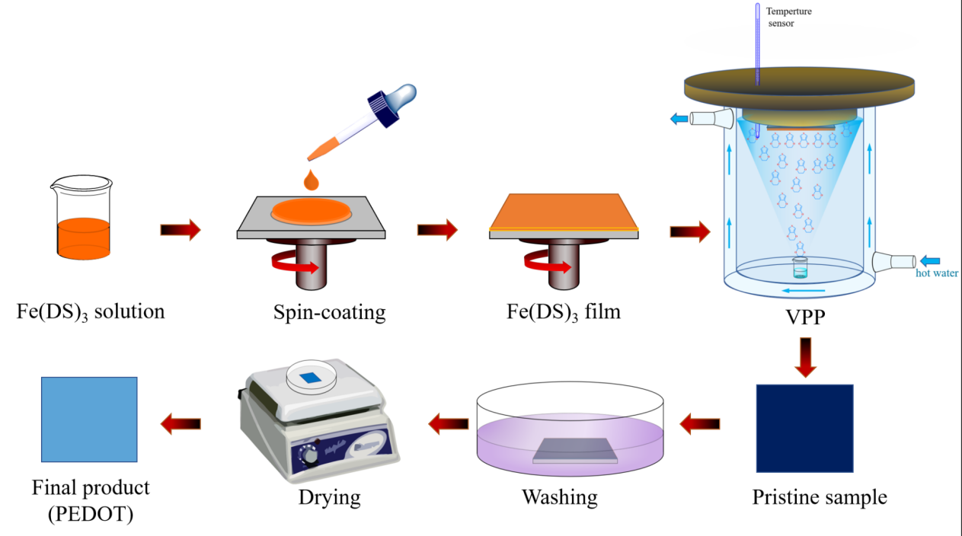
Fig. S3 Schematic representation of the preparation of the Fe(DS)₃ film on the substrate and the vapor phase polymerization (VPP) process to fabricate the PEDOT:DS film.

Optimization of the VPP process for synthesizing the PEDOT:DS film
Fig. S4 Electrical conductivities of PEDOT films prepared for several different polymerization times (a) and temperatures (b).

Fig. S5 (a) Conductivities and thicknesses of PEDOT films prepared at several different concentrations of Fe(DS)₃. (b) Transmittance (% at 550 nm) and conductivity versus film thickness of PEDOT film.

Figure S4a shows the conductivity values of PEDOT films synthesized using several different polymerization times. The polymerization time was optimized by keeping the other conditions constant (polymerization temperature: 40 ℃; concentration of oxidant: 50 wt%). The graph (black open circles) in Figure S4a shows that the film thickness increases as the polymerization time becomes longer. However, as expected, the conductivity (red filled squares) has the opposite tendency: it decreases from 4200 S cm⁻¹ to 2700 S cm⁻¹ with increasing thickness. From the graph, the optimum polymerization time was deduced to be 30 minutes and this was chosen to find the optimum polymerization temperature (polymerization time: 30 min; oxidant concentration: 50 wt%) as shown in Figure S4b. Dan et al.² systematically studied the effect of the polymerization temperature on the conductivity and chemical structure of PEDOT synthesized with Fe(Ⅲ) tosylate via VPP. According to their study, the polymerization temperature up to 50 ℃ has a great impact on the properties and quality of the PEDOT film by affecting the polymerization rate and mobility of the polymer chains. Similarly, in this study, Figure S4b shows that the polymerization rate (roughly evaluated using the film thickness divided by the reaction time (30 min)) sharply increases as the temperature increases from 30 ℃ (0.3 nm/min) to 60 ℃ (11.4 nm/min). As a result, the maximum conductivity of 8194 ± 300 S cm⁻¹ was reached at the reaction temperature of 50 ℃, showing a similar trend to that observed by Dan et al.² Thus, it is very important to emphasize that the polymerization temperature is a highly critical factor to modulate the reaction rate, and it must be optimally adjusted to ensure that the polymer chains are densely and largely stacked, i.e., for the crystallization of large domains. Ultimately, along with the two optimized conditions (30 minutes polymerization time and 50℃ as the temperature), the optimal concentration of Fe(DS)₃ was discovered to be 30 wt%. Figure S5a shows the electrical conductivities of the PEDOT films as a function of the oxidant concentration. The conductivity increases from 2700 ± 200 S cm⁻¹ to 10307 ± 500 S cm⁻¹ as the Fe(DS)₃ contents changes from 10 wt% to 30 wt%. Surprisingly, this conductivity is the highest one ever reported for bulk-sized PEDOT films. To date, the highest conductivity reported was 6259 S cm⁻¹ from a chlorine-doped and 10 nm-thick PEDOT film.³ Meanwhile, the conductivity decreases slightly to 7767 S cm⁻¹ at the film thickness of ca. 50 nm with a further increase in the oxidant concentration to 60 wt%. The trend of the two inter-dependent curves in Figure S5a is very similar to the dependence of the PEDOT film thickness and conductivity on the concentration of the FeCl₃ oxidant previously reported by Ali et al.,⁴ which is initially a proportional relation and changes to an inverse relation from a certain concentration. This tendency clearly reflects that the film quality is best at a concentration and thickness of 30 wt% and ca. 20 nm, respectively, after which it starts to slowly degrade. In fact, FESEM images of the PEDOT films prepared with an oxidant concentration above 30 wt% reveal more porous and rough surfaces as the concentration increases (Figure S6), obviously supporting the tendency of the film quality to deteriorate. This result may suggest that mobility (or diffusion) of the EDOT monomers into the oxidant layer during polymerization becomes increasingly limited as the oxidant becomes more concentrated and the film grows further from the bottom upward as previously reported elsewhere.⁵

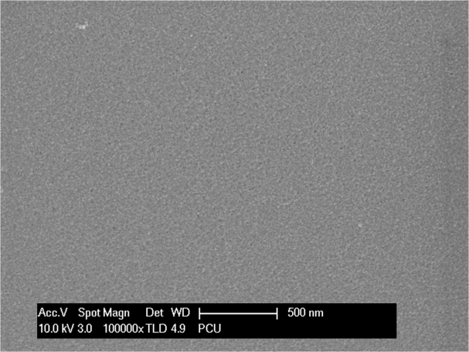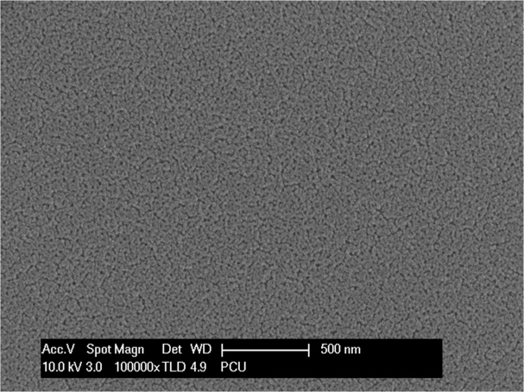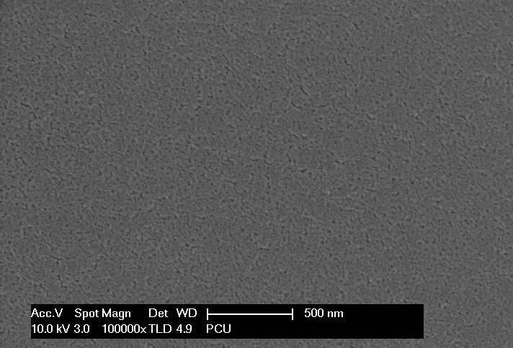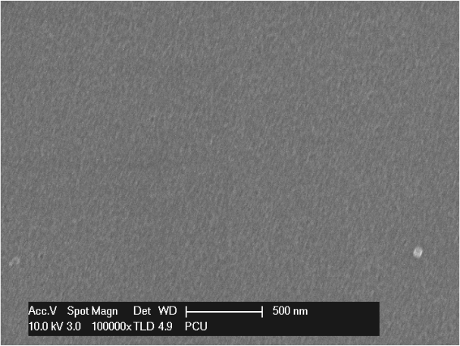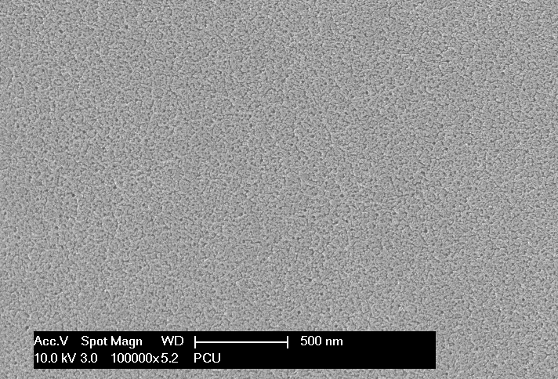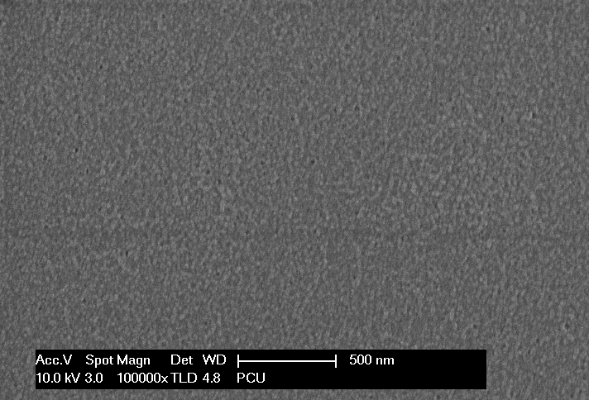
50 wt%
10 wt%
30 wt%
60 wt%
40 wt%
20 wt%
Fig. S6 FE-SEM images of PEDOT:DS films on PET. The images show more porous and rough surfaces as the concentration of Fe(DS)₃ increases except for 30 wt%. Magnification: 100k×.

Fig. S7 Visible spectrum of PEDOT:DS film on PET. A minimum of 80 % transmittance is maintained throughout the visible spectrum. (Film thickness = ~20 nm; Conductivity = ~9800 S/cm)

FT-Raman Analysis of PEDOT:DS Film
Fig. S8 Raman spectrum of PEDOT:DS film

To qualitatively verify the extent of polymerization and conjugation of the PEDOT film after VPP, a Raman study was performed, as shown in Figure S8. A thin PEDOT film was prepared on a SiO₂-wafer substrate, which is identified by the intense peak at 519 cm⁻¹ that refers to Si−O−Si stretching vibrations.⁶ On the Raman spectrum, the peaks related to symmetric and asymmetric stretching vibrations of methyl groups of the DS moiety are at 2868 cm⁻¹ and 2949 cm⁻¹, respectively. The spectrum also shows different vibrational modes, at 437, 575 and 987 cm⁻¹, which correspond to the deformation of the oxyethylene ring. The peak at 702 cm⁻¹ is pertinent to the symmetric C−S−C deformation; the C−O−C deformation gives rise to the mode appearing at 1105 cm⁻¹; the C_{α}−C_{α’} (inter-ring) stretching mode is located at 1258 cm⁻¹; the peak at 1366 cm⁻¹ is related to the C_{β}−C_{β’} stretching; particularly a very sharp symmetric stretching mode C_{α}=C_{β}(−O) appearing at 1433 cm⁻¹ is indicative of a high level of conjugation and doping in a very predominant quinoid structure of PEDOT.^{7,8} Furthermore, the peak intensity of the C_{α}=C_{β} symmetric stretching mode is in relation to those representing the deformation of the oxyethylene ring when compared to previously reported Raman spectra of PEDOT films. Finally, the existence of three very distinct peaks at 1511 cm⁻¹, 1540 cm⁻¹, and 1569 cm⁻¹ corresponds to the asymmetric stretching of C_{α}=C_{β} and it further supports the highly doped state of PEDOT.^{8,9} Based on the analysis above, it is clearly evident that the chemical structure of the resulted film is a considerably well-polymerized PEDOT with a high level of conjugation and doping.

Fig. S9 Line profiles of PEDOT crystal on the diffraction image. Two different line profiles (including four lines of each) that cross each other perpendicularly represent the average interval between PEDOT backbones (3.2 Å) and the average distance between EDOT monomers along the backbone (3.11 Å), respectively.

Fig. S10 Molecular models of PEDOT backbones in the (a) neutral, (b) bi-polaron, and (c) fully cationized states.

Fig. S11 Slightly contracted PEDOT backbone models overlaid on the TEM diffraction spot pattern. The thiophene sulfur atoms (green olive color) of the EDOT monomers correspond well with the centers of the white spots regarded as an atomic group of the EDOT monomer.

Fig. S12 Line profiles of the DS crystal on the diffraction image. The two different line profiles (including four rows of each) perpendicularly cross each other. The average interval between the DS chains is 2.22 Å and that between the centers of the ethylene groups along the chain axis is 2.27 Å, respectively. The white spots on the line profiles are regarded as the ethylene, C−O, or S=O groups of the DS molecule.

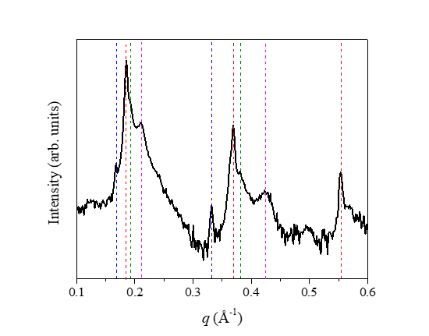
Fig. S13 XRD pattern of a ~1 μm-thick Fe(DS)₃ film. Details are in Table S2.

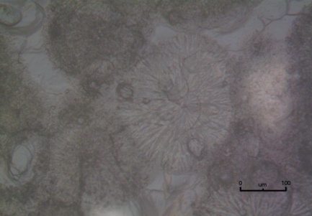
PET

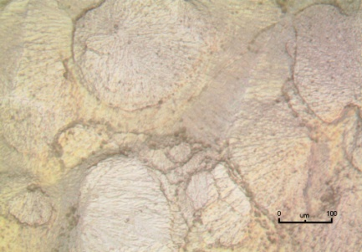
SiO₂-wafer
Fig. S14 Optical microscope images of spin-coated Fe(DS)₃ film on a (a) SiO₂-wafer substrate, and (b) PET substrate. Scale bar = 100 μm.

Fig. S15 (a) DS molecules laterally tilted by 45.5º matched with the diffraction pattern. Blue dotted circles denote un-matched spots with the DS molecules. This model shows only two DS monolayers but the image represents at least 6 or more monolayers. (b) Length of a contracted DS molecule. (c) Normal length of a DS molecule.

Fig. S16 Semi-empirical energy calculation of a DS molecule placed in the inter-lamellar space of an un-contracted PEDOT crystal. The DS was rotated clockwise in the polymer crystal and its energy was profiled at various angles.

Fig. S17 Molecular modeling of the interactions between (a) the 45.5º laterally tilted DS and PEDOT hydrogen atoms in the crystal, where the large black and gray spheres display the VdW radii of the DS and PEDOT hydrogen atoms, respectively, and (b) the sulfate and PEDOT hydrogen atoms in the crystal, where the large red and gray spheres display the VdW radii of the DS oxygen and PEDOT hydrogen atoms, respectively.

Fig. S18 Demonstration of incorrectly orientated DS molecules in the PEDOT:DS co-crystal. (a) DS molecules vertically aligned along the 2.22 Å spaced line profile and overlaid on the diffraction pattern of the PEDOT crystal. (b) A clean view of the matched crystal model in (a). The red-shaded region shows that the structures of the sulfate dopant and polymer backbone are poorly matched.

Fig. S19 Line profiles of a crystalline DS vesicle independently existing without PEDOT crystal on the diffraction image but added to un-crystallized EDOT oligomers and/or even monomers in the film as a dopant. Two different line profiles (including four rows of each) perpendicularly crossing each other represent the average lateral distance between DS chains (2.26 Å) and the average distance between the center of ethylene groups along the chain axis (2.51 Å), respectively.

Fig. S20 (a) Polymer backbones doped with DS molecules aligned exactly along the upper and lower trenches of an un-contracted PEDOT crystal. Red and blue-colored trenches formed on the upper and lower planes of the PEDOT middle layer, respectively, in an alternating mode. (b) VdW distances between the two interfacing sulfate oxygen atoms (large red spheres) as well as between two interfacing DS terminal hydrogen atoms (large gray spheres) placed along a row of DS pairs (blue shaded region in (a)).

Fig. S21 Static water contact angle measurement of the PEDOT:DS film

References
1. Bondi, A. van der Waals volumes and radii. J. Phys. Chem. 68, 441-451 (1964).
2. Wu, D. et al. Temperature dependent conductivity of vapor-phase polymerized PEDOT films. Synth. Met. 176, 86-91 (2013).
3. Wang, X. et al. High electrical conductivity and carrier mobility in oCVD PEDOT thin films by engineered crystallization and acid treatment. Sci. Adv. 4, eaat5780 (2018).
4. Ali, M. A., Kim, H. H., Lee, C. Y., Soh, H. S. & Lee, J. G. Effects of the FeCl₃ concentration on the polymerization of conductive poly(3,4-ethylenedioxythiophene) thin films on (3-aminopropyl) trimethoxysilane monolayer-coated SiO₂ surfaces. Met. Mater. Int. 15, 977-981 (2009).
5. Brooke, R., Fabretto, M., Hojati-Talemi, P., Murphy, P. & Evans, D. Evidence for ‘bottom up’ growth during vapor phase polymerization of conducting polymers. Polymer 55, 3458-3460 (2014).
6. Atanasov, P. A., Nedyalkov, N. N. & Valova, E. I. Fs-laser processing of polydimethylsiloxane. J. Appl. Phys. 116, 023104 (2014).
7. Shi, W., Yao, Q., Qu, S., Chen, H., Zhang, T. & Chen, L. Micron-thick highly conductive PEDOT films synthesized via self-inhibited polymerization: roles of anions, NPG Asia Mater. 9, 405 (2017).
8. Kondratenko, K., Guérin, D., Wallart, X., Lenfant, S. & Vuillaume, D. Thermal and electrical cross-plane conductivity at the nanoscale in poly(3,4-ethylenedioxythiophene):trifluoromethanesulfonate thin films. Nanoscale 14, 6075-6084 (2022).
9. Chiu, W. W., Travaš-Sejdić, J., Cooney, R. P. & Bowmaker, G. A. Studies of dopant effects in poly(3,4-ethylenedioxythiophene) using Raman spectroscopy. J. Raman Spectrosc. 37, 1354-1361 (2006).

