Supplementary Appendix: Uptake, effectiveness and safety of COVID-19 vaccines in the immunocompromised population: A population-based cohort study in England

Contents
Supplementary Appendix 1 – Definition and code groups of immunosuppressed patients
Supplementary Appendix 2 – List of adverse events of special interest for vaccine safety
Supplementary Appendix 3 –Vaccine uptake in immunocompromised patients: Statistical analysis plan
Supplementary Appendix 4 –Vaccine effectiveness in immunocompromised patients: Statistical analysis plan
Supplementary Appendix 5 –Vaccine safety in immunocompromised patients: Statistical analysis plan
Supplementary Figure 1 – Kaplan-Meier curves of first to fourth COVID-19 vaccine uptake in the immunocompromised and the general population
Supplementary Figure 2 – Kaplan-Meier curves of first to fourth COVID-19 vaccine uptake in the immunocompromised and general population among people aged 60 and above.
Supplementary Figure 3 – COVID-19 vaccine uptake by dose in the general and immunocompromised population
Supplementary Figure 4 – COVID-19 vaccine uptake by dose and vaccine types in the immunocompromised population
Supplementary Figure 5 – COVID-19 vaccine uptake by dose and subgroups in the immunocompromised population
Supplementary Figure 6 – COVID-19 vaccine uptake by dose and ethnicity in the immunocompromised population
Supplementary Figure 7 – COVID-19 vaccine uptake by dose and deprivation quintile in the immunocompromised population
Supplementary Figure 8 – Adjusted vaccine effectiveness against COVID-19-realted hospitalisation by vaccine types in the immunocompromised population
Supplementary Figure 9 – Adjusted vaccine effectiveness against COVID-19-realted hospitalisation in the immunocompromised population by periods of different dominant variant in the UK
Supplementary Figure 10 – Adjusted vaccine effectiveness against COVID-19-realted death in the immunocompromised population by periods of different dominant variant in the UK
Supplementary Figure 11 – Risk of serious outcomes following a first dose of ChAdOX1 or BNT162b2 vaccine in immunocompromised people relative to people who are not immunocompromised
Supplementary Figure 12 – Risk of serious outcomes following a second dose of ChAdOX1 or BNT162b2 vaccine in immunocompromised people relative to people who are not immunocompromised
Supplementary Figure 13 – Risk of serious outcomes following a third dose of BNT162b2 or mRNA-1273 vaccine in immunocompromised people relative to people who are not immunocompromised
Supplementary Table 1 – Multivariable Cox regression analyses of COVID-19 vaccine uptake in the immunocompromised population
Supplementary Table 2 – Adjusted vaccine effectiveness against COVID-19 outcomes in the immunocompromised population by vaccine types and periods of different dominant variant in the UK
Supplementary Table 3 – Demographic characteristics of the immunocompromised population according COVID-19 outcomes (n=583,541)

Supplementary Appendix 1 – Definition and code groups of immunosuppressed patients
Transplant/procedures (before 1st December 2020)
- Liver transplant
- Kidney transplant
- Solid organ transplant
- Bone marrow transplant (within 24 months)
- Renal dialysis

Drugs – taken anytime from 1st June 2020 to 1st December 2020
- Dexamethasone
- Drugs that affect the immune response
- Immune-modifying monoclonal antibodies
- Immunosuppressants for transplants
- Oral Steroids
- Other Immune Modulators
- Chemotherapy

 | Read/SNOWMED | ICD-10 | OPCS | Drug group
Transplants
Liver | 7551
Renal |  | 2772 | 2774
Solid organ |  |  | 7571
Bone marrow | 7795 |  | 7568
Dialysis and renal replacement therapy
Dialysis |  |  | 2776
Renal replacement therapy (dialysis or transplant) | 2223 | 2784 | 2777
Chemo and radiotherapy
Chemotherapy |  |  | 2878 | 15207 /  15208 /  15209
Radiotherapy |  |  | 2916
Chemo/radiotherapy |  |  | 7739
Drugs
Dexamethasone |  |  |  | 13839
Oral steroids |  |  |  | 6454
Immune-modifying monoclonal antibodies (mAbs) |  |  |  | 6467
Immunosuppressants for transplants |  |  |  | 7572
Other immune-modifying drugs |  |  |  | 6455/ 6386
Diagram of the subgroups included in the analysis (n= 583,541)
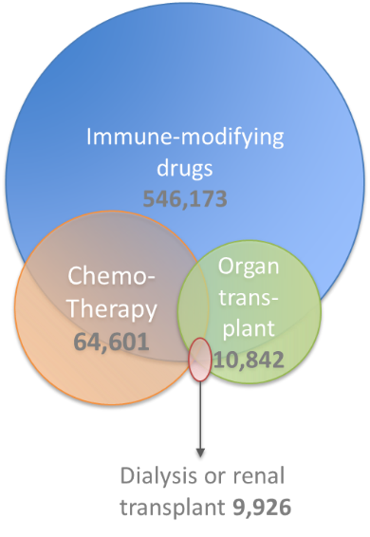
- Immune-modifying drugs
- Chemotherapy
- Organ transplant procedures
- Dialysis or renal transplant

Supplementary Appendix 2 – List of adverse events of special interest for vaccine safety
Type of outcome | Individual outcomes
Rheumatological conditions | - Rheumatoid arthritis  - Systemic lupus erythematosus  - Vasculitis  - Ankylosing spondylitis  - Inflammatory arthritis  - Scleroderma  - Sjogren's syndrome  - Goodpasture syndrome  - Myositis  - Polymyalgia
Liver disease | - Acute liver injury  - Jaundice  - Autoimmune hepatitis  - Cholangitis  - Primary biliary cirrhosis
Blood disorders | - Aplastic anaemia  - Idiopathic thrombocytopenic purpura  - Immune haemolytic anaemia
Neuroinflammatory disorders | - Bell's Palsy  - Encephalitis  - Meningitis  - Myelitis  - Guillain-Barré syndrome  - Demyelinating disorders  - Multiple sclerosis  - Optic neuritis
Cardiovascular disease | - Myocarditis  - Pericarditis  - Myocardial infarction  - Coronary heart disease  - Arrhythmia  - Atrial fibrillation or flutter  - Congestive cardiac failure  - Ischaemic stroke  - Haemorrhagic stroke  - Transient ischaemic attack  - Subarachnoid haemorrhage  - Venous thromboembolism  - Arterial thrombosis
Inflammatory skin conditions | - Pemphigus vulgaris  - Bullous pemphigoid/eruption  - Erythema nodosum  - Psoriasis
Other autoimmune disorders | - Addison's adrenal insufficiency  - Pernicious anaemia  - Multisystem inflammatory syndrome  - Inflammatory bowel disease  - Acute and chronic thyroiditis  - Coeliac disease
Allergy-related conditions | - Anaphylaxis  - Angioedema  - Asthma
Other outcomes that do not fit into above categories | - Acute renal failure  - Rhabdomyolysis  - Unplanned ICU admission  - Sudden death

Supplementary Appendix 3 –Vaccine uptake in immunocompromised patients: Statistical analysis plan
OX300 vaccine uptake in immunocompromised population: Statistical analysis plan

Objectives

Primary Objective
Determine factors associated with the uptake of COVID-19 vaccination in people with immunocompromised conditions
Secondary Objectives
Determine factors associated with the uptake of COVID-19 vaccination in:
- Immunocompromised populations
- The general population

Study Design
Cohort study

Inclusion criteria
All patients aged over 12 years with data on COVID-19 vaccination
The study period will be 1st December 2020 to the latest available data download.
Dates for each of the COVID-19 vaccine doses will start from
- Vaccine dose 1 – 1 Dec 2020
- Vaccine dose 2 – 1 March 2021
- Vaccine dose 3 (booster) - 14th Sept 2021
- Vaccine dose 4 – spring booster for most vulnerable – 1st Jan 2022

Data source
Our main analyses will be based on the QResearch database linked to the following datasets to improve ascertainment of exposures, confounders and outcomes:
- Pillar 1 and 2 testing data (PHE SGSS)
- Civil registration data (NHS Digital)
- HES care data (NHS Digital)
- Intensive Care National Audit and Research Centre Case Mix Programme (ICNARC)
- Cancer registry, SACT & Radiotherapy (PHE)
- COVID-19 Vaccine uptake data from the National Immunisation Database (NIMS, NHS Digital)
- COVID-19 vaccination adverse events (NIMS, NHS Digital)

Outcomes
Primary Outcome: Uptake of COVID-19 vaccine (one or more doses) in people with immunocompromised conditions.

Secondary Outcomes:
Uptake of 3rd vaccine dose in people with immunocompromised conditions
Uptake of 4th vaccine dose in people with immunocompromised conditions
Predictors of one of more doses of vaccine in people with immunocompromised conditions

Statistical analyses
Descriptive statistics
Tables showing uptake of each dose of vaccine (0-4 doses) by demographics (age, sex, categories of BMI (underweight, normal weight as reference, overweight, obese), ethnicity (white as reference group) and socioeconomic status, (Q1 as reference), geographic region of the UK (London as reference) and type of immunocompromised conditions (receiving immune-modifying drugs as reference).
Bar charts showing uptake of COVID-19 vaccine doses 1-4 by age, ethnicity, socioeconomic status (IMD quintile) and geographic region of the UK.
Kaplan Meyer curves showing time to vaccine uptake by age, ethnicity, socioeconomic status (IMD quintile) and geographic region of the UK.
- Townsend quintile of deprivation
  - Q1 (Most affluent) to Q5(most deprived)
- Ethnicity
  - White, Indian, Pakistani, Chinese, Bangladeshi, Other Asian, Black Caribbean, Black African, Other, Not recorded
- Regions
  - East Midlands, East of England, North East, North West, South Central, South East, South West, West Midlands, Yorkshire & Humber
- immunocompromised conditions
  - Organ transplant procedures (solid organ, liver or bone marrow),
  - Renal transplant or dialysis
  - Receiving immune-modifying drugs
  - Receiving chemotherapy

Identifying predictors of vaccine uptake in people with blood cancer and immunocompromised populations
Analyses will be restricted to the populations of interest (those with immunocompromised conditions). Cox regression will be used to identify factors associated with vaccine uptake (or non-uptake).

Cox regression to explore time to vaccine uptake reporting adjusted hazard ratios for each vaccine dose. Dates for vaccine uptake will be number of days from when the specific vaccine dose first became available. People will be censored from the analysis when they leave the practice, dies or on the latest date when data are available. We will check for proportional hazards and extend to using Royston-Palmar models to account for time varying hazard ratios if proportional hazards assumption not valid.

The primary analysis will be repeated using the following methods to check that results are consistent with the primary analysis (Cox regression):

Covariates
Model: Adjusted for age, sex, BMI, ethnicity, socioeconomic status (IMD quintile), geographic region of the UK and QCOVID comorbidities(1).

Where there are sufficient data, vaccine uptake in each type of immunocompromised conditions (organ transplant procedures [solid organ, liver or bone marrow], renal transplant or dialysis, receiving immune-modifying drugs or receiving chemotherapy) will be carried out. Analyses by individual immunocompromised conditions type will only be conducted where there are more than 2500 individuals to ensure that there are a minimum of 10 subjects per parameter.(2)

Sensitivity analyses
Multilevel logistic regression models will be used to examine the effect of GP practice & region on uptake.

Subgroup analyses
We will explore the association between deprivation and ethnicity in vaccine uptake by conducting analyses within each ethnicity and within each quintile of deprivation using cox regression models.

References
  - Clift AK, Coupland CAC, Keogh RH, et al. Living risk prediction algorithm (QCOVID) for risk of hospital admission and mortality from coronavirus 19 in adults: national derivation and validation cohort study. BMJ 2020;371:m3731. doi: 10.1136/bmj.m3731
  - Peduzzi P, Concato J, Feinstein AR, Holford TR. Importance of events per independent variable in proportional hazards regression analysis. II. Accuracy and precision of regression estimates. Journal of clinical epidemiology. 1995;48(12):1503-10.

Supplementary Appendix 4 –Vaccine effectiveness in immunocompromised patients: Statistical analysis plan
OX300 vaccine effectiveness in immunocompromised population: Statistical analysis plan

Aim
To determine the effectiveness of COVID-19 vaccines in people with immunocompromised conditions.

Objectives
- Examine the odds of outcomes after vaccination with one, two, or three vaccines in people with immunocompromised conditions (within immunocompromised group comparison)
- Examine the odds of outcomes after vaccination with one, two, or three vaccines in people with blood cancer compared with the general population (between immunocompromised group comparison)

Primary analysis
Nested matched case-control design including both vaccinated and unvaccinated populations

Outcomes
The outcomes of interest are the occurrence and odds of the below COVID-19-related severe events following one, two, or three doses of vaccines compared to those who have not received the vaccine.
- COVID-19 Hospitalisation (hospitalisation within 14 days of testing COVID-19 positive)
- COVID-19-related ICU admission (admission to intensive care during a COVID-19 hospitalisation)
- COVID-19-related Death (death within 28 days of COVID-19 positive or COVID-19 on death certificate)

Cases will be patients who have had COVID-19 hospitalisation or COVID-19-related death, and will be matched to controls who did not experience the outcome of interest. Patients who experienced COVID-19-related ICU admission will be a subset of the COVID-19 hospitalisation cases and therefore will not be matched separately.

Exposure definition

COVID-19 vaccination:
It is expected to take 14 days for an immune response to the vaccine to develop.¹ We will therefore consider the population exposed 14 days after vaccination. For the analysis we will consider the exposure periods as used in previous research, where there are sufficient numbers.² ³. For the analysis, we will define vaccination status considering one to four doses of any COVID-19 vaccine and the indicative time periods since vaccination as follows, although these may be amended after assessing the distribution of the data:

- Unvaccinated
- Days (weeks) after 1st dose
- 0-13 days (<2 weeks)
- 14-27 days (2 - <4 weeks)
- 28-41 days (4 - <6 weeks)
- 42+ days (≥6 weeks)
- Days (weeks) after 2nd dose
- 0-13 days (<2 weeks)
- 14-41 days (2 - <6 weeks)
- 42-97 days (6 - <14 weeks)
- 98-153 days (14 - <22 weeks)
- 154-181 days (22 - <26 weeks)
- 182-272 days (26 - <39 weeks)
- 273+ days (≥39 weeks)
- Days (weeks) after 3rd dose
- 0-13 days (<2 weeks)
- 14-41 days (2 - <6 weeks)
- 42-97 days (6 - <14 weeks)
- 98-125 days (14 - <18 weeks)
- 126-153 days (18 - <22 weeks)
- 154-181 days (22 - <26 weeks)
- 182-272 days (26 - <39 weeks)
- 273+ days (≥39 weeks)

The following vaccine types will also be considered, where numbers are sufficient:
- BNT162b2
- ChAdOx1
- mRNA-1273

Matching
All cases who had the outcome will be matched with 10 controls who did not have the outcome on that date by matching on age, sex, calendar date and GP practice using incidence density sampling² . We will remove GP practice from the matching criteria if there is not a sufficient number of controls to match to each case in the blood cancer group.

We will undertake matching in the cohort of immunocompromised patients and the general population separately.

Statistical analysis
People will enter the cohort on 01/12/2020 (start date) and censored on the earliest date of outcome of interest (hospitalisation, ICU admission, or death) or end of the study period 11/04/2022 (end date). Individuals with the outcome of interest before the study start date will be excluded from the primary analysis.

Conditional logistic regression models will be used to report odds ratios and 95% confidence intervals between vaccinated and unvaccinated groups, adjusting for covariates as listed below. Subgroups of immunocompromising conditions will also be examined using the same methods described above, provided there is sufficient data for analysis.

We will conduct stratified analyses by calendar time to account for different SARS-CoV-2 variants circulating in the UK. We will split calendar time into the following intervals⁴:

- Alpha: 18 Dec 2020 – 17 May 2021
- Delta: 18 May 2021 – 19 Dec 2021
- Omicron BA.1: 20 Dec 2021 – 1 March 2022

Covariates
- Previous SARS-CoV-2 infection⁵
- Socioeconomic status as measured by the Townsend score
- Ethnicity
- BMI (consider multiple imputation for missing values)
- Co-morbidities: 36 underlying clinical conditions identified using the QCOVID risk algorithm, where available in the dataset³ .Co-morbidities will be grouped as below and included in the model by the following categories:
- Cardiovascular conditions (atrial fibrillation, heart failure, stroke, peripheral vascular disease, coronary heart disease, congenital heart disease)
- Diabetes (type 1 and type 2)
- Respiratory conditions (asthma, rare respiratory conditions (cystic fibrosis, bronchiectasis, or alveolitis), chronic obstructive pulmonary disease, pulmonary hypertension or pulmonary fibrosis)
- Cancer (lung or oral cancer, marrow transplant, radiotherapy)
- Neurological conditions (cerebral palsy, Parkinson’s disease, rare neurological conditions (motor neurone disease, multiple sclerosis, myasthenia, Huntington’s chorea), epilepsy, dementia, learning disability, severe mental illness)
- Other conditions (liver cirrhosis, osteoporotic fracture, rheumatoid arthritis or systemic lupus erythematosus, sickle cell disease, venous thromboembolism, solid organ transplant, renal failure (CKD3, CKD4, CKD5, with or without dialysis or transplant))
- Medications (prescriptions from general practitioner in previous six months for oral steroids, long acting β agonists or leukotrienes, immunosuppressants)
- Chemotherapy – (compare active chemotherapy during study period, previous chemotherapy in 6 months prior to study start date, and those not treated with chemotherapy from 6 months before the study start date)

References

1. Ewer KJ, Barrett JR, Belij-Rammerstorfer S, et al. T cell and antibody responses induced by a single dose of ChAdOx1 nCoV-19 (AZD1222) vaccine in a phase 1/2 clinical trial. Nat Med 2021;27(2):270-78. doi: 10.1038/s41591-020-01194-5 [published Online First: 2020/12/19]
2. Piernas C, Patone M, Astbury NM, et al. Associations of BMI with COVID-19 vaccine uptake, vaccine effectiveness, and risk of severe COVID-19 outcomes after vaccination in England: a population-based cohort study. The Lancet Diabetes & Endocrinology 2022;10(8):571-80. doi: 10.1016/S2213-8587(22)00158-9
3. Clift AK, Coupland CAC, Keogh RH, et al. Living risk prediction algorithm (QCOVID) for risk of hospital admission and mortality from coronavirus 19 in adults: national derivation and validation cohort study. BMJ 2020;371:m3731. doi: 10.1136/bmj.m3731
4. Office for National Statistics (ONS). Coronavirus (COVID-19) latest insights: Infections 2023 [cited 2023 20 February]. Available from: https://www.ons.gov.uk/peoplepopulationandcommunity/healthandsocialcare/conditionsanddiseases/articles/coronaviruscovid19latestinsights/infections accessed 17 February 2023.
5. Covid-19 Forecasting Team. Past SARS-CoV-2 infection protection against re-infection: a systematic review and meta-analysis. The Lancet 2023;online first

Supplementary Appendix 5 –Vaccine safety in immunocompromised patients: Statistical analysis plan
Vaccine safety in individuals in people with immunocompromised conditions

Study Design
We will utilise self-controlled case-series design.
Statistical analysis
We will explore the incidence rate of potential post-vaccine adverse events in several groups, including people with immunocompromised conditions.

The outcomes to be assessed will be post-vaccination occurrence of any of adverse events of special interest, listed in Table 1. These include events previously highlighted in relation to vaccine safety or because they have been identified as specific events in the Oxford Vaccine Protocol or are events which need to be monitored by the European Medicines Agency (EMA) Designated Medical Event, FDA, the UK’s Medicines Health Regulatory Authority vaccine clinical trials, post-marketing surveillance and the emerging scientific literature.

Cases are defined as individuals aged 12 years and above that have experienced an adverse event of interest after the 1st December 2020.

Exposures of interest are a first, second or third dose of each COVID-19 vaccine and a SARS-CoV-2 infection defined as SARS-CoV-2 positive test or recorded COVID-19 diagnosis.

A self-controlled case series approach, previously established to assess adverse events to vaccination¹ ², will be used to estimate whether the risks of complications within 28 days following a COVID-19 vaccine or a SARS-CoV-2 positive test are different in people with immunocompromised conditions compared with people without these conditions. In this approach, we will determine the relative incidence of the outcome of interest for exposed time periods (i.e. following vaccination) compared to unexposed periods in individuals who have the outcome of interest in two subgroups: those with a immunocompromised conditions on 1st December 2020 and those without. Inference is within individuals and hence covariates which do not change over the study period are implicitly controlled for.

Observation time for each case will be divided into ‘baseline’, ‘pre-vaccine’ and ‘post-vaccine’ periods. These periods will be: -29-1 days prior to vaccination, the day of vaccination and 1-7; 8-14; 15-21; 22-28 days post vaccination days, with remainder of observation time contributing to the ‘baseline’. The post-exposure timeframe broken into 7 day blocks to account for time-varying effects, i.e. potentially non-uniform risks of complications after vaccine administration.

Fixed-effects Poisson regression models will be used to estimate the incident rate ratios (IRR, with 95% confidence intervals) for each time block. Immunocompromised status will be included as interaction terms to explore whether IRRs are significantly different in these groups compared to the wider population. For example, the presence of a recorded of immunocompromised conditions will be a binary variable (0/1), which will be interacted with the exposure variable (vaccination) in the Poisson model. Models will also include terms for positive SARS-CoV-2 tests, as COVID-19 may cause some of the complications of interest and a two-week period to adjust for seasonal effect and temporal changes in the outcome incidence due to the pandemic. Separate models will be developed for each specific adverse event.

Sensitivity analyses

- Restricting the models to those without a record of a positive SARS-CoV-2 test during the study period
- Excluding those who died during the study period
- Excluding those with the outcome of interest recorded in the month prior (1st – 30th November 2020)
- Excluding those with the outcome of interest recorded in the two years prior (1st December 2018 – 30th November 2020) to the study start date
- Excluding events that occurred between 1st and 2nd doses
- Excluding events that occurred between 2nd and 3rd doses
- No censoring for deaths due to outcome
- Defining start date as date of 1st dose, with no censoring for deaths due to outcome
- Defining start date as date of 2nd dose, with no censoring for deaths due to outcome
- Defining start date as date of 3rd dose, with no censoring for deaths due to outcome

Table 1 - Vaccine adverse events
Category | Event | Read/SNOMED Code group ID | ICD-19 Code Group ID
General | Sudden death | n/a | n/a
General | Unplanned ICU admission | n/a | n/a
General | Adult Respiratory Distress Syndrome | n/a | n/a
Autoimmune  inflammatory | Anaphylaxis | 301 | 13058
Autoimmune  inflammatory | Angioedema | 13079 | 13080
Autoimmune  inflammatory | Cholangitis | 6082 | 13495
Autoimmune  inflammatory | Rhabdomyolysis | 606 | 2740
Autoimmune  inflammatory | Addison’s disease | 6088 | 13484
Autoimmune  inflammatory | Autoimmune myocarditis/cardiomyopathy | 2221 | 13488
Autoimmune  inflammatory | Pernicious anaemia | 75 | 13485
Autoimmune  inflammatory | Vasculitis | 7582 | 13498
Musculoskeletal | Spondyloarthritis and ankylosing spondylitis | 6090 | 13493
Musculoskeletal | Systemic lupus erythematosus | 70 | 1976
Musculoskeletal | Rheumatoid arthritis | 68 | 1975
Gastrointestinal | Acute liver injury or hepatic failure | 1333 | 13061
Gastrointestinal | Jaundice | 1841 | 13060
Gastrointestinal | Transplant refection or failure | 134947 | 13496
Renal | Acute kidney injury | 2742 | 2466
Blood | Aplastic anaemia/pancytopenia | 1313 | 13073
Blood | Haemolytic anaemia | 1314 | 13062
Blood | thrombocytopenia | 6154 | 13074
Neurological | Bell’s palsy | 1316 | 13069
Neurological | Encephalitis and myelitis | 13078 | 13071
Neurological | Guillain Barre syndrome | 1318 | 13066
Skin | Bullous eruption including Stevens Johnson | 619 | 3305
Skin | Autoimmune bullous skin diseases, including pemphigus, pemphigoid and dermatitis herpetiformis | 2423 or 6139
Skin | Erythema nodosum | 13499 | 13500
Cardiovascular | Myocardial infarction | 20 | 1950
Cardiovascular | Arrythmias including ventricular fibrillation | 1205 | 24444
Cardiovascular | Myocarditis or pericarditis | 2220 | 13084
Cardiovascular | Venous thromboembolism | 368 | 1935
Cardiovascular | Stroke | 272 | 1929

References

1. Petersen I, Douglas I, Whitaker H. Self controlled case series methods: an alternative to standard epidemiological study designs. BMJ 2016;354:i4515. doi: 10.1136/bmj.i4515

2. Xu S, Gargiullo P, Mullooly J, et al. Fitting parametric and semi-parametric conditional Poisson regression models with Cox’s partial likelihood in self-controlled case series and matched cohort studies. J Data Sci 2010;8:349-60.

Supplementary Figure 1 – Kaplan-Meier curves of first to fourth COVID-19 vaccine uptake in the immunocompromised and the general population
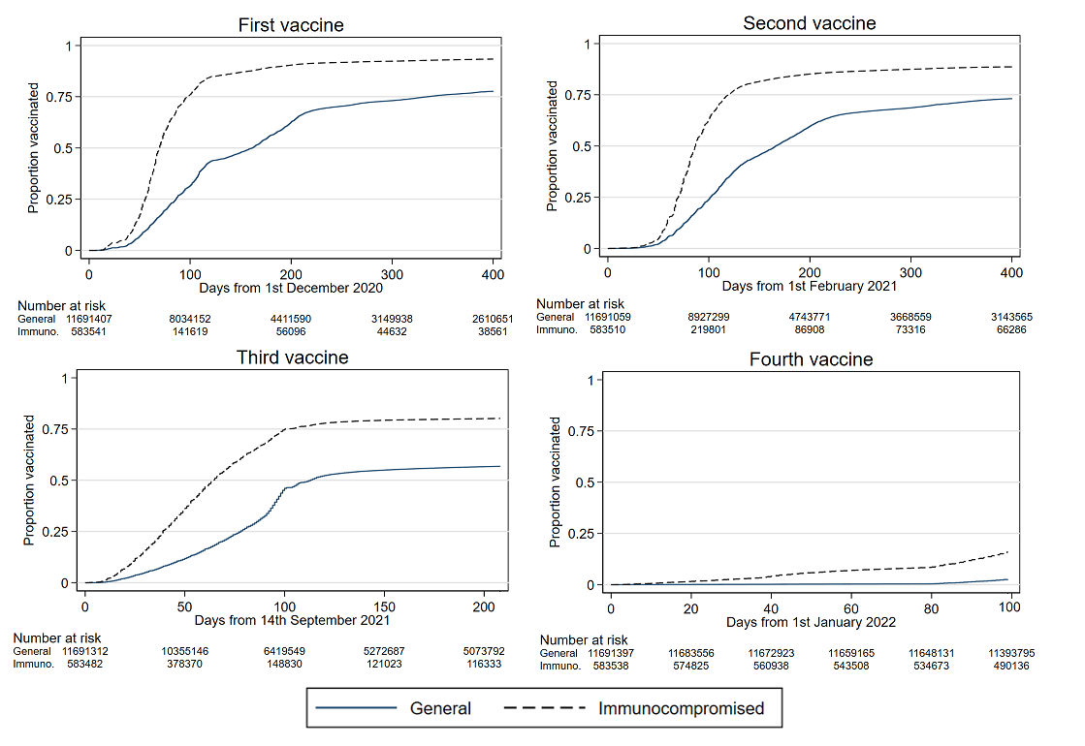

Supplementary Figure 2 – Kaplan-Meier curves of first to fourth COVID-19 vaccine uptake in the immunocompromised and general population among people aged 60 and above.

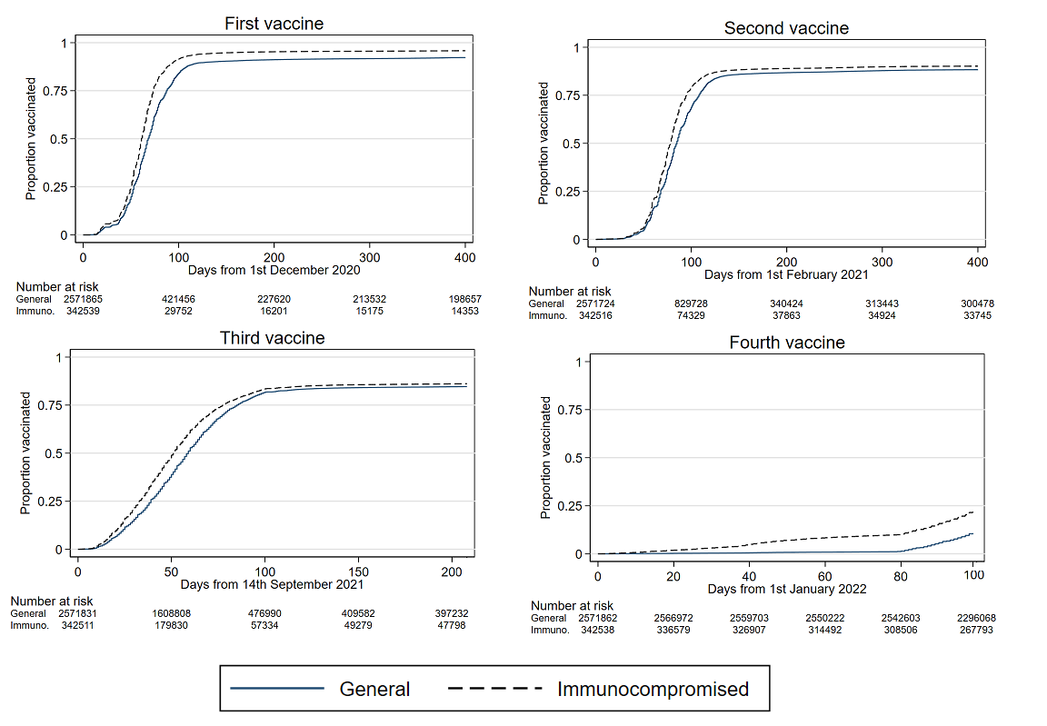

Supplementary Figure 3 –COVID-19 vaccine uptake by dose in the general and immunocompromised population
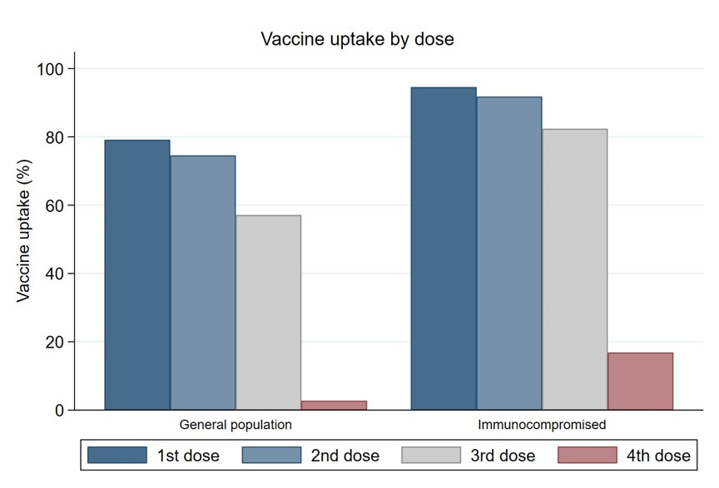
Supplementary Figure 4 – COVID-19 vaccine uptake by dose and vaccine types in the immunocompromised population
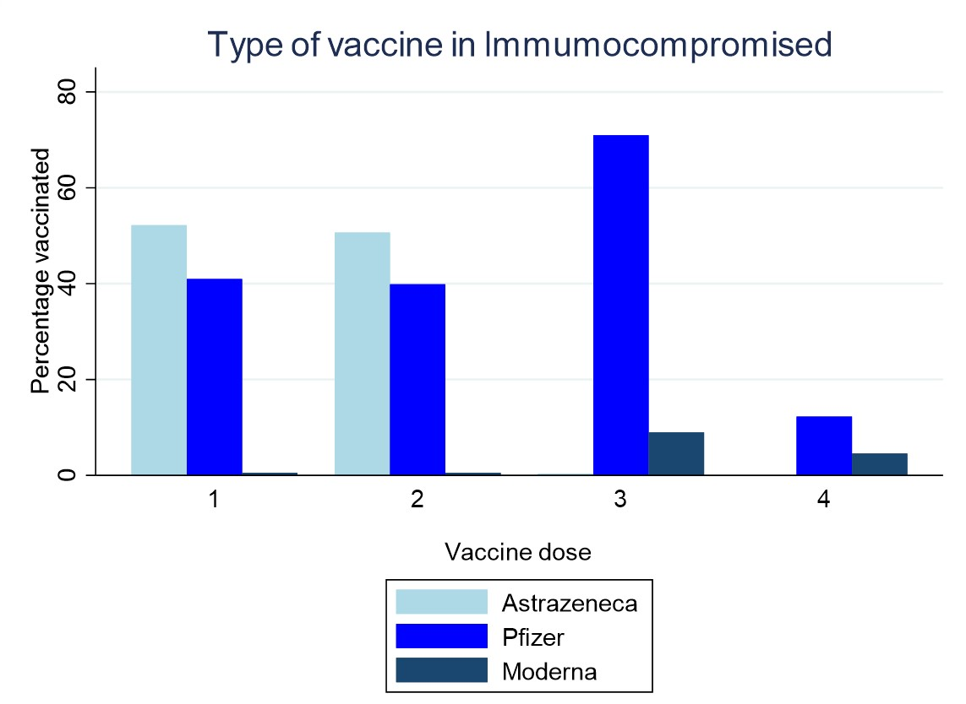

Supplementary Figure 5 – COVID-19 vaccine uptake by dose and subgroups in the immunocompromised population
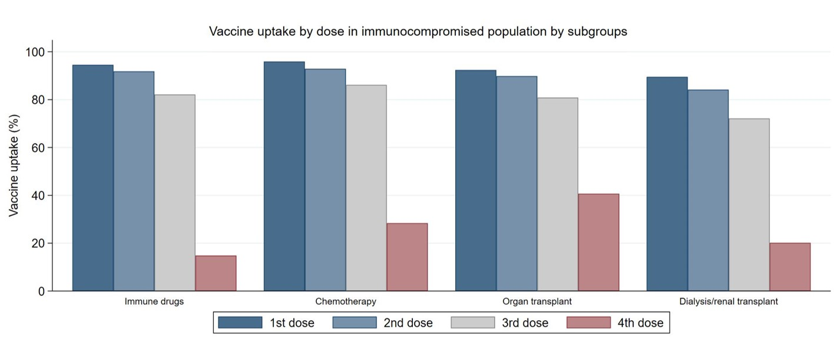

Supplementary Figure 6 – COVID-19 vaccine uptake by dose and ethnicity in the immunocompromised population
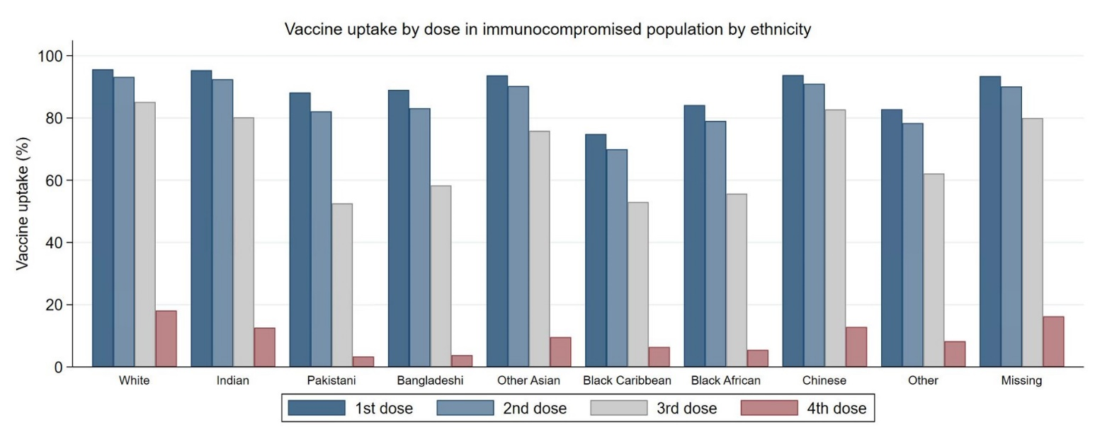

Supplementary Figure 7 – COVID-19 vaccine uptake by dose and deprivation quintile in the immunocompromised population
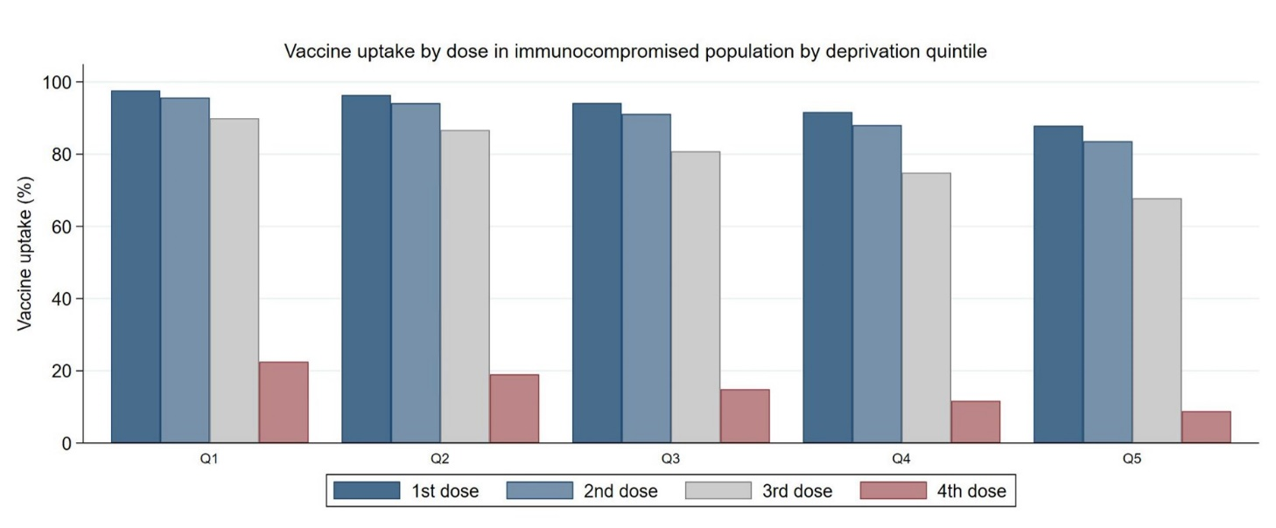
Note: Q1 to Q5 indicates quintiles of Townsend, from the most affluent (Q1) to the most deprived (Q5).

Supplementary Figure 8 – Adjusted vaccine effectiveness against COVID-19-realted hospitalisation by vaccine types in the immunocompromised population
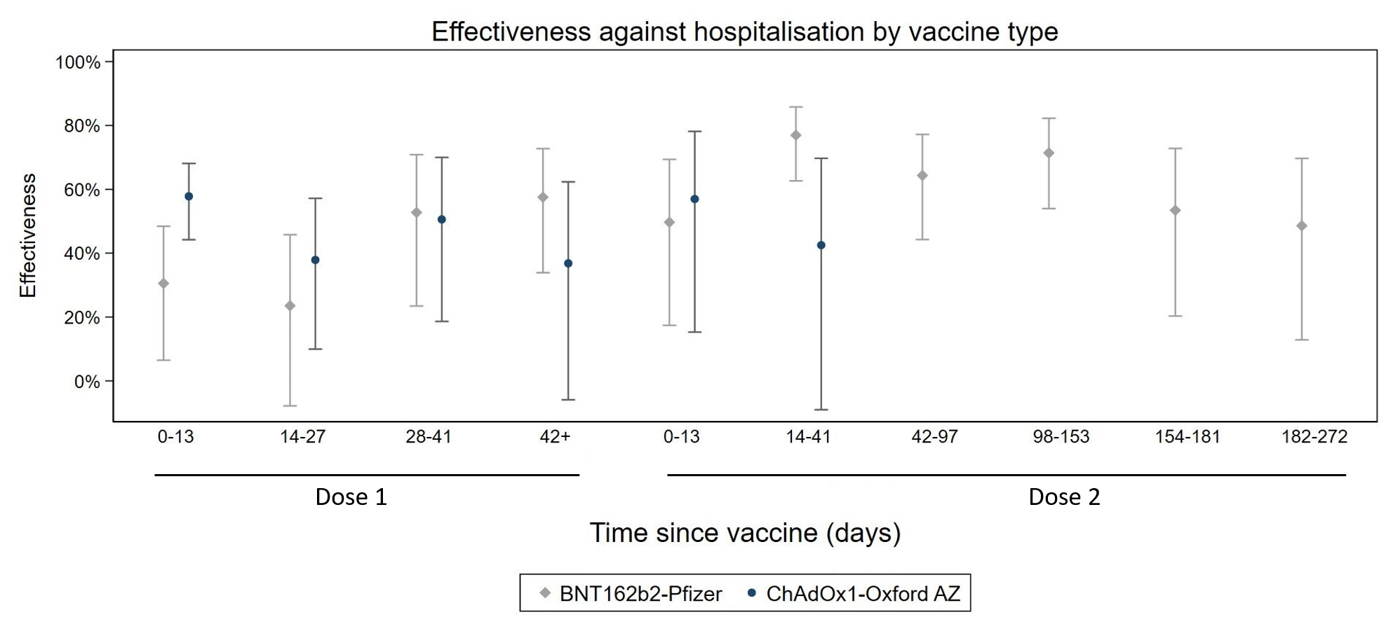
Note: Effectiveness by vaccine types was only estimated for risk against hospitalisation for ChAdOx1 (Oxford-AstraZeneca) and BNT162b2 (Pfizer) due to insufficient numbers or models not converging for other types of vaccine and outcomes; models were adjusted for ethnicity, Townsend, prior-COVID-19 infection, BMI, region, QCVOID comorbidities.

Supplementary Figure 9 – Adjusted vaccine effectiveness against COVID-19-realted hospitalisation in the immunocompromised population by periods of different dominant variant in the UK
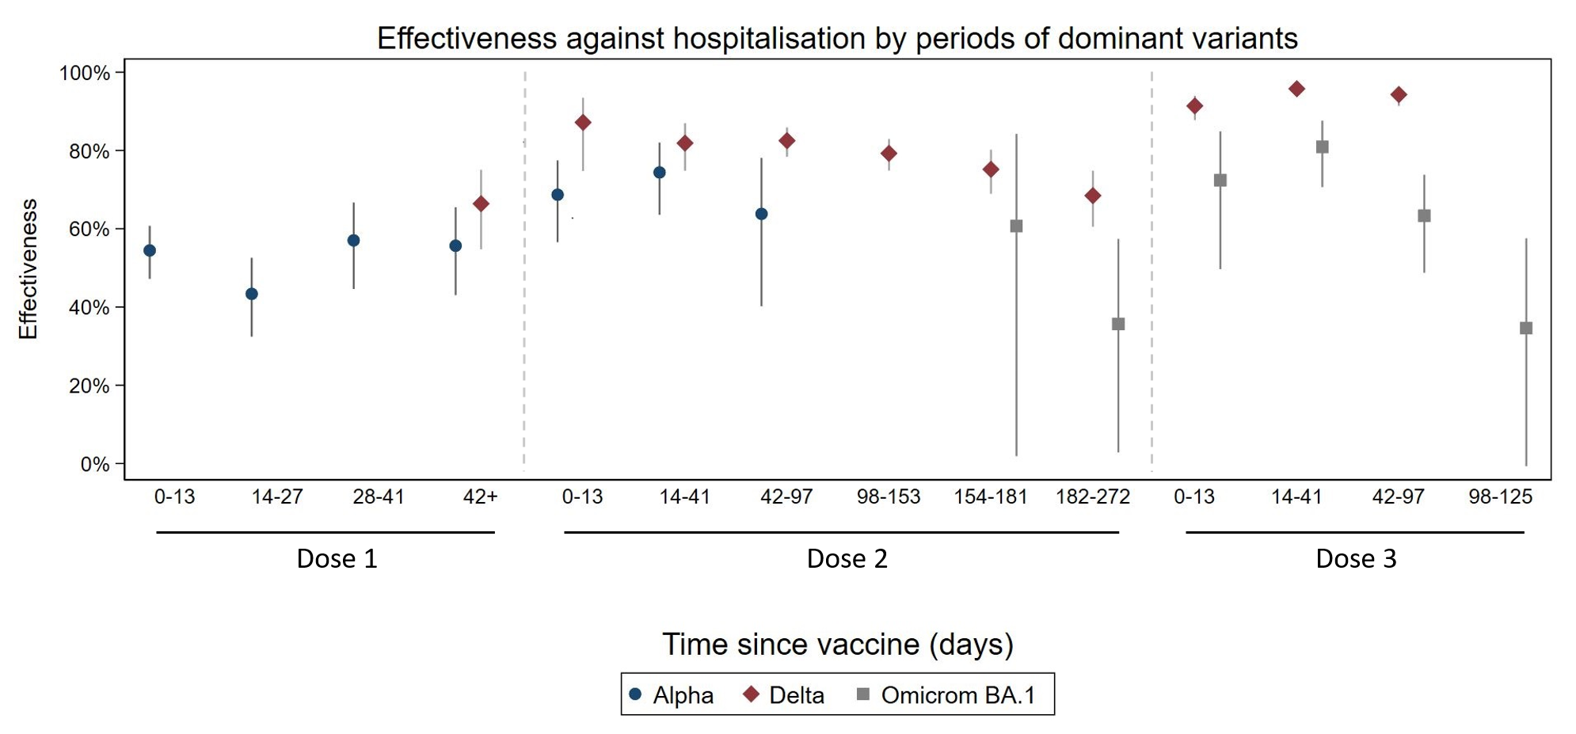
Note: Effectiveness by periods of different dominant variant in the UK was only estimated for risk against hospitalisation and due to insufficient numbers or models not converging in other outcomes; models were adjusted for ethnicity, Townsend, prior-COVID-19 infection, BMI, region, QCVOID comorbidities.

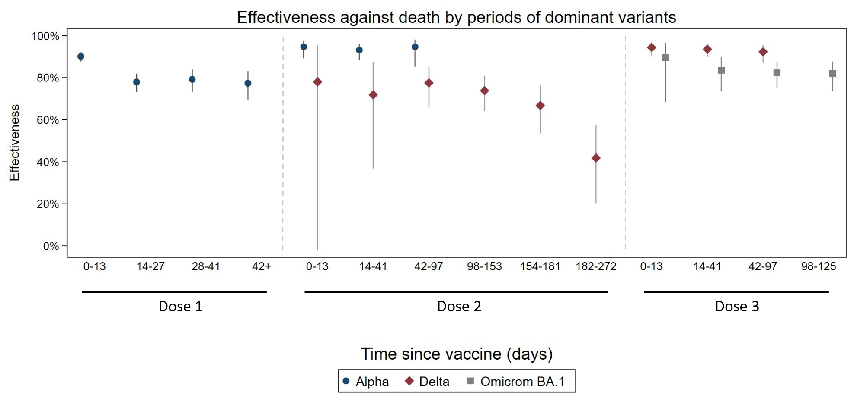Supplementary Figure 10 – Adjusted vaccine effectiveness against COVID-19-realted death in the immunocompromised population by periods of different dominant variant in the UK

Note: Effectiveness by periods of different dominant variant in the UK was only estimated for risk against hospitalisation and due to insufficient numbers or models not converging in other outcomes; models were adjusted for ethnicity, Townsend, prior-COVID-19 infection, BMI, region, QCVOID comorbidities.

Supplementary Figure 11 – Risk of serious outcomes following a first dose of ChAdOX1 or BNT162b2 vaccine in immunocompromised people relative to people who are not immunocompromised
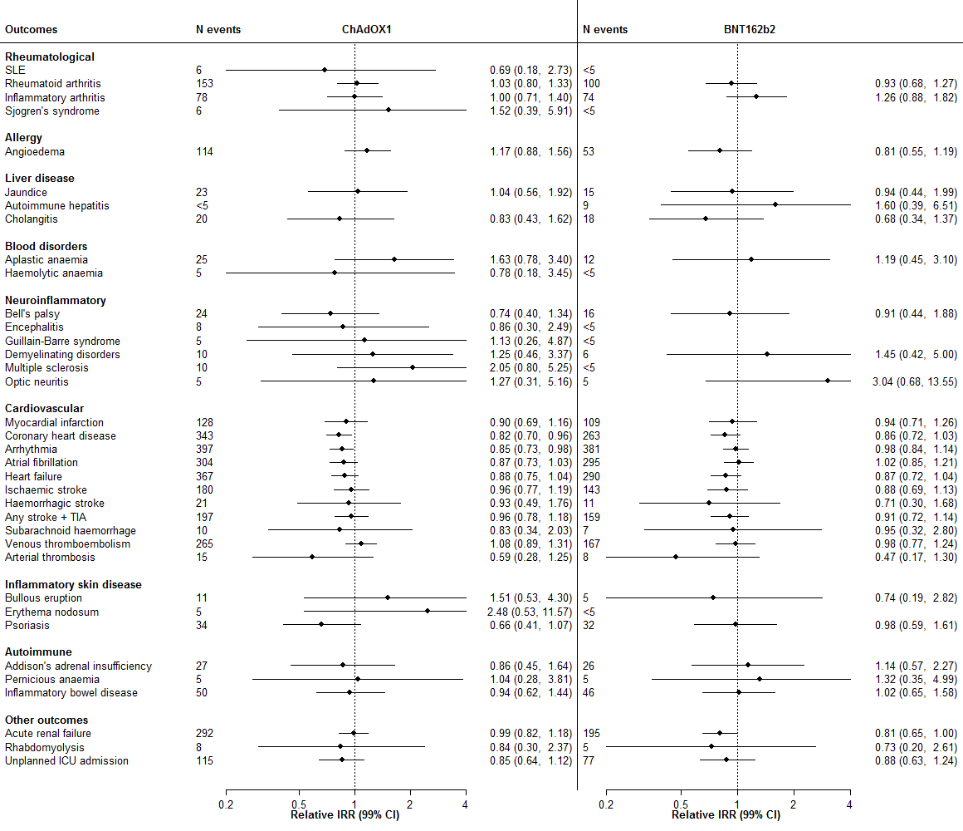
Note: N = number of events in the 1-28 days following vaccine dose in immunocompromised people; Relative incidence rate ratios (IRR 99% CI) in the 1-28 days following vaccination are presented for pre-specified outcomes only where there were at least five events following a second dose in immunocompromised people. A relative IRR of 1 indicates no difference in risk between immunocompromised people and non-immunocompromised people.

Supplementary Figure 12 – Risk of serious outcomes following a second dose of ChAdOX1 or BNT162b2 vaccine in immunocompromised people relative to people who are not immunocompromised
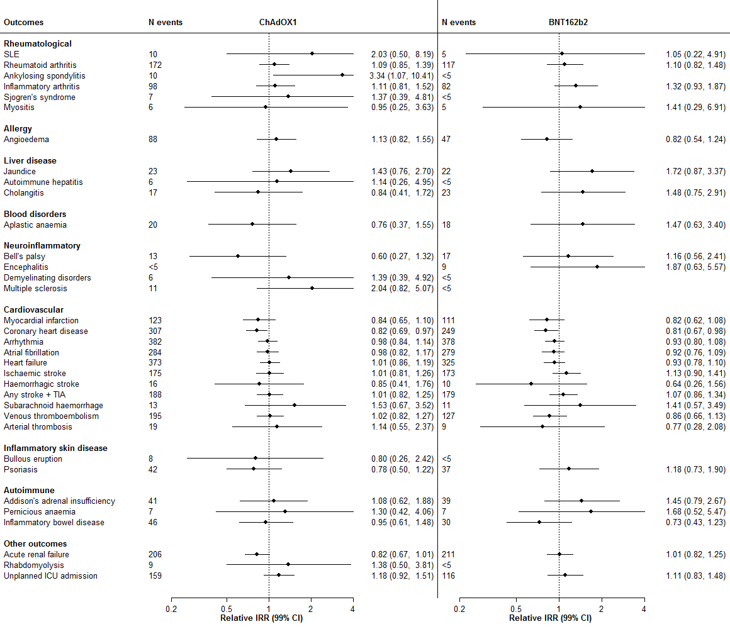

Note: N = number of events in the 1-28 days following vaccine dose in immunocompromised people; Relative incidence rate ratios (IRR 99% CI) in the 1-28 days following vaccination are presented for pre-specified outcomes only where there were at least five events following a third dose in immunocompromised people. A relative IRR of 1 indicates no difference in risk between immunocompromised people and non-immunocompromised people.

Supplementary Figure 13 – Risk of serious outcomes following a third dose of BNT162b2 or mRNA-1273 vaccine in immunocompromised people relative to people who are not immunocompromised
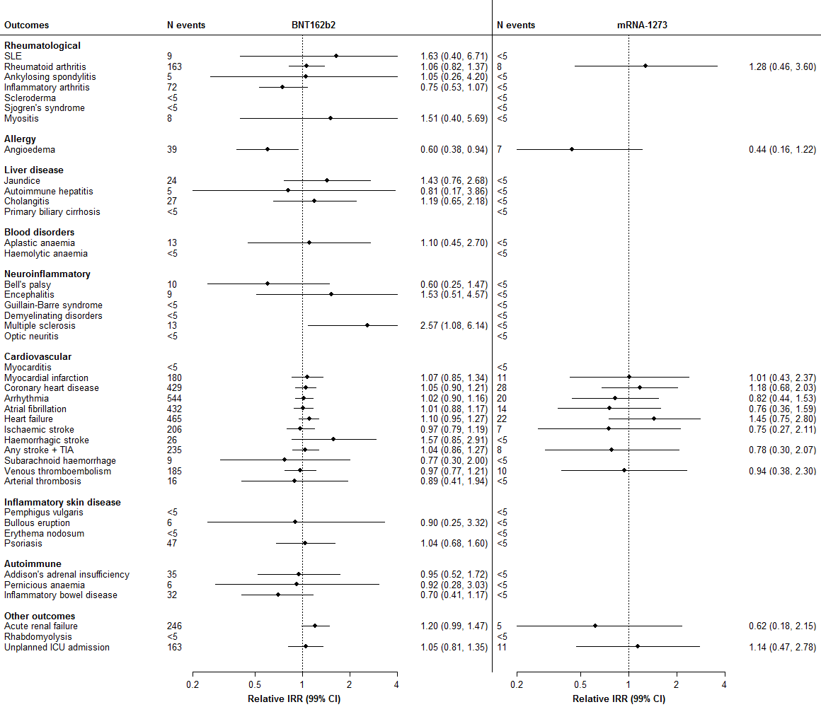

Note: N = number of events in the 1-28 days following vaccine dose in immunocompromised people; Relative incidence rate ratios (IRR 99% CI) in the 1-28 days following vaccination are presented for pre-specified outcomes only where there were at least five events following a third dose in immunocompromised people. A relative IRR of 1 indicates no difference in risk between immunocompromised people and non-immunocompromised people.
Supplementary Table 1 – Multivariable Cox regression analyses of COVID-19 vaccine uptake in the immunocompromised population
 | Cox proportional hazards with 95% CI of vaccination across all doses
 | Dose 1 | Dose 2 | Dose 3 | Dose 4
Age | 1.03 (1.03 - 1.03) | 1.02 (1.02 - 1.02) | 1.02 (1.02 - 1.02) | 1 (1 - 1)
Sex (ref. Male) | 0.94 (0.94 - 0.95) | 0.96 (0.95 - 0.96) | 1.01 (1 - 1.01) | 0.98 (0.97 - 0.99)
BMI (ref. Normal)
underweight | 0.85 (0.84 - 0.87) | 0.86 (0.84 - 0.87) | 0.78 (0.77 - 0.79) | 0.96 (0.94 - 0.97)
overweight | 1.01 (1 - 1.02) | 1.06 (1.05 - 1.07) | 1.09 (1.08 - 1.09) | 0.99 (0.98 - 0.99)
obese | 0.98 (0.97 - 0.99) | 1.07 (1.06 - 1.08) | 1.08 (1.07 - 1.09) | 0.96 (0.95 - 0.97)
severely obese | 0.98 (0.97 - 0.99) | 1.1 (1.09 - 1.11) | 1.08 (1.07 - 1.09) | 0.94 (0.94 - 0.95)
missing | 0.96 (0.95 - 0.97) | 0.98 (0.97 - 0.98) | 0.96 (0.95 - 0.97) | 0.96 (0.95 - 0.97)
Deprivation quintile
(ref. Q 1 [most affluent])
Q 2 | 0.95 (0.94 - 0.96) | 0.95 (0.94 - 0.96) | 0.92 (0.91 - 0.93) | 0.97 (0.97 - 0.98)
Q 3 | 0.89 (0.89 - 0.9) | 0.9 (0.89 - 0.9) | 0.84 (0.83 - 0.84) | 0.95 (0.94 - 0.96)
Q 4 | 0.84 (0.83 - 0.84) | 0.85 (0.84 - 0.86) | 0.77 (0.76 - 0.77) | 0.93 (0.93 - 0.94)
Q 5 (most deprived) | 0.78 (0.77 - 0.79) | 0.8 (0.79 - 0.8) | 0.71 (0.71 - 0.72) | 0.92 (0.91 - 0.93)
Region of England
(ref. London)
East Midlands | 0.99 (0.97 - 1.01) | 0.99 (0.98 - 1.01) | 0.95 (0.93 - 0.97) | 0.99 (0.98 - 1.01)
East of England | 1 (0.98 - 1.01) | 1.05 (1.04 - 1.07) | 0.97 (0.96 - 0.99) | 0.99 (0.98 - 1.01)
North East | 0.99 (0.97 - 1.01) | 1.04 (1.03 - 1.06) | 0.97 (0.96 - 0.99) | 0.97 (0.96 - 0.99)
North West | 1 (0.99 - 1.01) | 1.03 (1.02 - 1.03) | 0.95 (0.94 - 0.96) | 0.99 (0.98 - 1)
South Central | 1.01 (1 - 1.03) | 1.03 (1.02 - 1.04) | 1 (0.99 - 1.01) | 1.01 (1 - 1.02)
South East | 0.95 (0.94 - 0.96) | 0.99 (0.98 - 1) | 0.94 (0.93 - 0.95) | 0.99 (0.98 - 1)
South West | 1.03 (1.02 - 1.04) | 1.01 (0.99 - 1.02) | 1.01 (1 - 1.02) | 1.04 (1.03 - 1.05)
West Midlands | 0.99 (0.98 - 1) | 1.02 (1.01 - 1.03) | 0.96 (0.95 - 0.97) | 0.99 (0.98 - 1)
Yorkshire & Humber | 1.01 (0.99 - 1.02) | 1.08 (1.07 - 1.1) | 1.01 (1 - 1.03) | 0.97 (0.96 - 0.99)
Ethnicity (ref. White)
Indian | 1.02 (1 - 1.04) | 1.01 (0.99 - 1.03) | 0.98 (0.96 - 1) | 0.96 (0.94 - 0.98)
Pakistani | 0.78 (0.76 - 0.79) | 0.78 (0.77 - 0.8) | 0.67 (0.65 - 0.68) | 0.92 (0.9 - 0.94)
Chinese | 0.94 (0.91 - 0.97) | 0.92 (0.89 - 0.94) | 0.82 (0.8 - 0.84) | 0.95 (0.92 - 0.97)
Bangladeshi | 0.97 (0.94 - 0.99) | 0.97 (0.95 - 1) | 0.93 (0.91 - 0.96) | 0.95 (0.93 - 0.97)
Other Asian | 0.55 (0.54 - 0.57) | 0.64 (0.63 - 0.66) | 0.62 (0.6 - 0.63) | 0.89 (0.87 - 0.92)
Black Caribbean | 0.75 (0.73 - 0.77) | 0.8 (0.78 - 0.83) | 0.72 (0.7 - 0.74) | 0.92 (0.9 - 0.95)
Black African | 0.87 (0.83 - 0.92) | 0.92 (0.87 - 0.97) | 0.98 (0.93 - 1.03) | 0.95 (0.9 - 1)
Other | 0.78 (0.77 - 0.8) | 0.82 (0.8 - 0.83) | 0.79 (0.78 - 0.81) | 0.95 (0.93 - 0.97)
Not recorded | 0.91 (0.91 - 0.92) | 0.92 (0.91 - 0.92) | 0.9 (0.9 - 0.91) | 0.98 (0.98 - 0.99)

Note: Q1 to Q5 indicates quintiles of Townsend, from the most affluent (Q1) to the most deprived (Q5); Models were adjusted for QCVOID comorbidities.

Supplementary Table 2 – Adjusted vaccine effectiveness against COVID-19 outcomes in the immunocompromised population by vaccine types (A) and periods of different dominant variants in the UK (B)
A.
 | COVID-19-related hospitalisation
 | ChAdOx1 (Oxford-AstraZeneca) |  |  | BNT162b2 (Pfizer)
 | VE | 95%CI |  | VE | 95%CI
No vaccine | 0 | 0 | 0 | 0 | 0 | 0
1st dose (days after)
0-13 | 0.58 | 0.44 | 0.68 | 0.31 | 0.06 | 0.48
14-27 | 0.38 | 0.1 | 0.57 | 0.24 | -0.08 | 0.46
28-41 | 0.51 | 0.19 | 0.7 | 0.53 | 0.23 | 0.71
42+ | 0.37 | -0.06 | 0.62 | 0.58 | 0.34 | 0.73
2nd dose (days after)
0-13 days | 0.57 | 0.15 | 0.78 | 0.5 | 0.17 | 0.69
14-41 | 0.43 | -0.09 | 0.7 | 0.77 | 0.63 | 0.86
42-97 | 0.31 | -0.33 | 0.64 | 0.64 | 0.44 | 0.77
98-153 | ─ | ─ | ─ | 0.71 | 0.54 | 0.82
154-181 | ─ | ─ | ─ | 0.53 | 0.2 | 0.73
182-272 | ─ | ─ | ─ | 0.49 | 0.13 | 0.7
Note: Effectiveness by vaccine types was only estimated for risk against hospitalisation due to insufficient numbers or models not converging in other outcomes; models were adjusted for ethnicity, Townsend, prior-COVID-19 infection, BMI, region, QCVOID comorbidities; VE: vaccine effectiveness = (1-odds ratio)*100; ─: no data points due to insufficient numbers
B.
 | COVID-19-related hospitalisation |  |  |  |  |  |  |  |  | COVID-19-related death
 | Alpha dominant |  |  | Delta dominant |  |  | Omicrom BA.1 dominant |  |  |  | Alpha dominant |  |  | Delta dominant |  |  | Omicrom BA.1 dominant
 | VE | 95%CI |  | VE | 95%CI |  | VE | 95%CI |  |  | VE | 95%CI |  | VE | 95%CI |  | VE | 95%CI
No vaccine | 0 | 0 | 0 | 0 | 0 | 0 | 0 | 0 | 0 |  | 0 | 0 | 0 | 0 | 0 | 0 | 0 | 0 | 0
1st dose (days after)
0-13 | 0.54 | 0.47 | 0.61 | ─ | ─ | ─ | ─ | ─ | ─ |  | 0.9 | 0.88 | 0.92 | ─ | ─ | ─ | ─ | ─ | ─
14-27 | 0.43 | 0.32 | 0.53 | ─ | ─ | ─ | ─ | ─ | ─ |  | 0.78 | 0.73 | 0.82 | ─ | ─ | ─ | ─ | ─ | ─
28-41 | 0.57 | 0.45 | 0.67 | ─ | ─ | ─ | ─ | ─ | ─ |  | 0.79 | 0.73 | 0.84 | ─ | ─ | ─ | ─ | ─ | ─
42+ | 0.56 | 0.43 | 0.65 | 0.66 | 0.55 | 0.75 | ─ | ─ | ─ |  | 0.77 | 0.7 | 0.83 | ─ | ─ | ─ | ─ | ─ | ─
2nd dose (days after)
0-13 days | 0.69 | 0.57 | 0.77 | 0.87 | 0.75 | 0.93 | ─ | ─ | ─ |  | 0.95 | 0.89 | 0.97 | 0.78 | -0.02 | 0.95 | ─ | ─ | ─
14-41 | 0.74 | 0.64 | 0.82 | 0.82 | 0.75 | 0.87 | ─ | ─ | ─ |  | 0.93 | 0.88 | 0.96 | 0.72 | 0.37 | 0.87 | ─ | ─ | ─
42-97 | 0.64 | 0.4 | 0.78 | 0.83 | 0.78 | 0.86 | ─ | ─ | ─ |  | 0.95 | 0.85 | 0.98 | 0.78 | 0.66 | 0.85 | ─ | ─ | ─
98-153 | ─ | ─ | ─ | 0.79 | 0.75 | 0.83 | ─ | ─ | ─ |  | ─ | ─ | ─ | 0.74 | 0.64 | 0.81 | ─ | ─ | ─
154-181 | ─ | ─ | ─ | 0.75 | 0.69 | 0.8 | 0.36 | 0.03 | 0.57 |  | ─ | ─ | ─ | 0.67 | 0.53 | 0.76 | ─ | ─ | ─
182-272 | ─ | ─ | ─ | 0.68 | 0.61 | 0.75 | 0.41 | -0.23 | 0.72 |  | ─ | ─ | ─ | 0.42 | 0.2 | 0.58 | ─ | ─ | ─
3rd dose (days after)
0-13 days | ─ | ─ | ─ | 0.91 | 0.88 | 0.94 | 0.72 | 0.5 | 0.85 |  | ─ | ─ | ─ | 0.94 | 0.9 | 0.97 | 0.9 | 0.68 | 0.97
14-41 | ─ | ─ | ─ | 0.96 | 0.94 | 0.97 | 0.81 | 0.71 | 0.88 |  | ─ | ─ | ─ | 0.94 | 0.9 | 0.96 | 0.83 | 0.73 | 0.9
42-97 | ─ | ─ | ─ | 0.94 | 0.91 | 0.96 | 0.63 | 0.49 | 0.74 |  | ─ | ─ | ─ | 0.92 | 0.87 | 0.95 | 0.82 | 0.75 | 0.88
98-125 | ─ | ─ | ─ | ─ | ─ | ─ | 0.35 | -0.01 | 0.58 |  | ─ | ─ | ─ | ─ | ─ | ─ | 0.82 | 0.74 | 0.88
126-153 | ─ | ─ | ─ | ─ | ─ | ─ | ─ | ─ | ─ |  | ─ | ─ | ─ | ─ | ─ | ─ | 0.81 | 0.71 | 0.87

Note: Effectiveness by periods of different dominant variant in the UK was only estimated for risk against hospitalisation and death due to insufficient numbers or models not converging in other outcomes; models were adjusted for ethnicity, Townsend, prior-COVID-19 infection, BMI, region, QCVOID comorbidities; VE: vaccine effectiveness = (1-odds ratio)*100; ─: no data points due to insufficient numbers
Supplementary Table 3 – Demographic characteristics of the immunocompromised population according COVID-19 outcomes (n=583,541)
 | COVID-19 outcomes
 | Hospitalisations | Death | ICU admission
Total, N (%) | 17,817 (3.1) | 5,478 (0.9) | 1,249 (0.2)
Immunocompromised conditions (%)
Transplant | 811 (4.6) | 193 (3.5) | 78 (6.2)
Dialysis or renal transplant | 1108 (6.2) | 298 (5.4) | 131 (10.5)
Immune-modifying drugs | 15964 (89.6) | 4860 (88.7) | 1096 (87.8)
Chemotherapy | 1757 (9.9) | 749 (13.7) | 63 (5.0)
Age, years mean (SD) | 67.8 (16.1) | 76.9 (12.0) | 60.8 (13.2)
Female sex (%) | 8590 (48.2) | 2390 (43.6) | 494 (39.6)
BMI, kg/m² mean(SD) | 29.5 (6.7) | 28.0 (6.5) | 31.6 (6.8)
Townsend quintile of deprivation (%)
Q 1 (most affluent) | 3840 (21.6) | 1388 (25.3) | 230 (18.4)
Q 2 | 3792 (21.3) | 1262 (23.0) | 233 (18.7)
Q 3 | 3678 (20.6) | 1122 (20.5) | 249 (19.9)
Q 4 | 3501 (19.6) | 1005 (18.3) | 268 (21.5)
Q 5 (most deprived) | 2894 (16.2) | 681 (12.4) | 263 (21.1)
Ethnicity (%)
White | 12913 (72.5) | 4004 (73.1) | 781 (62.5)
Indian | 486 (2.7) | 113 (2.1) | 52 (4.2)
Pakistani | 523 (2.9) | 113 (2.1) | 51 (4.1)
Bangladeshi | 257 (1.4) | 61 (1.1) | 33 (2.6)
Other Asian | 273 (1.5) | 50 (0.9) | 47 (3.8)
Black Caribbean | 323 (1.8) | 86 (1.6) | 32 (2.6)
Black African | 342 (1.9) | 67 (1.2) | 50 (4.0)
Chinese | 38 (0.2) | 10 (0.2) | 4 (0.3)
Other | 461 (2.6) | 93 (1.7) | 54 (4.3)
Not recorded | 2201 (12.4) | 881 (16.1) | 145 (11.6)

