Supplementary information for：
Toward a solid microneedle patch for rapid and enhanced local analgesic action
Yue Liu^{1,2}, Ze Qiang Zhao^{1,2}, Ling Liang^{1,2}, Li Yue Jing^{1,2}, Jianhao Wang^{3*}, Yun Dai^{4*}, Bo Zhi Chen^{1*}, Xin Dong Guo^{1*}

¹State Key Laboratory of Organic-Inorganic Composites, Beijing University of Chemical Technology, Beijing 100029, China.
²Beijing Laboratory of Biomedical Materials, College of Materials Science and Engineering, Beijing University of Chemical Technology, Beijing 100029, China.
³School of Pharmacy, Changzhou University, Changzhou, Jiangsu 213164, China.
⁴Department of Endoscopy Center, The First Affiliated Hospital of Xiamen University, Xiamen 361000, China.
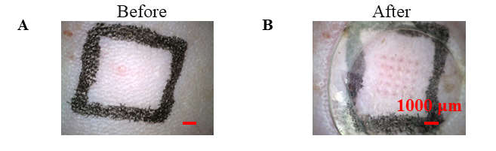
Fig. S1 MNs were inserted into the back of the rat. (A) Before insertion. (B) After insertion.

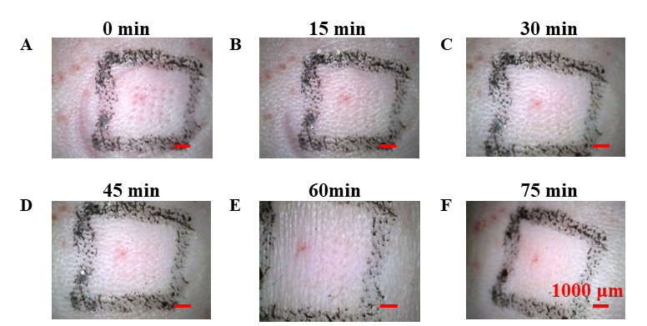
Fig. S2 The healing of micropores was observed with a hand-held microscope. The healing of MNs micropores in (A) 0 min, (B) 15 min,(C) 30 min,(D) 45 min,(E) 60 min, (F) 75 min.

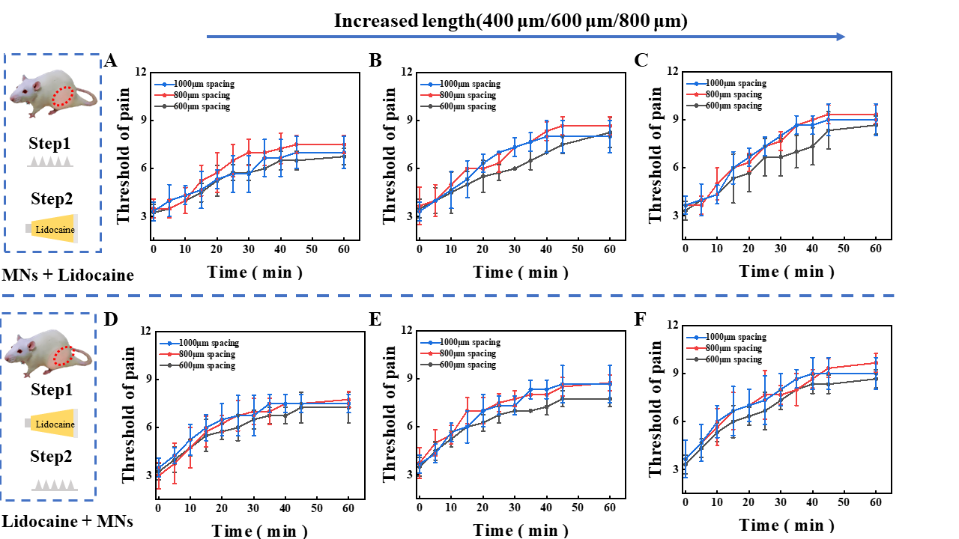
Fig. S3 Threshold of pain of different spacing MNs. MNs followed by lidocaine cream, length (A) 400 μm, (B) 600 μm, (C) 800 μm. Lidocaine cream followed by MNs, length (D) 400 μm, (E) 600 μm, (F) 800 μm.

