Supplementary information
Additional file 1: Fig. S1. Flow-chart of the study (SCI: Spinal Cord Injury)
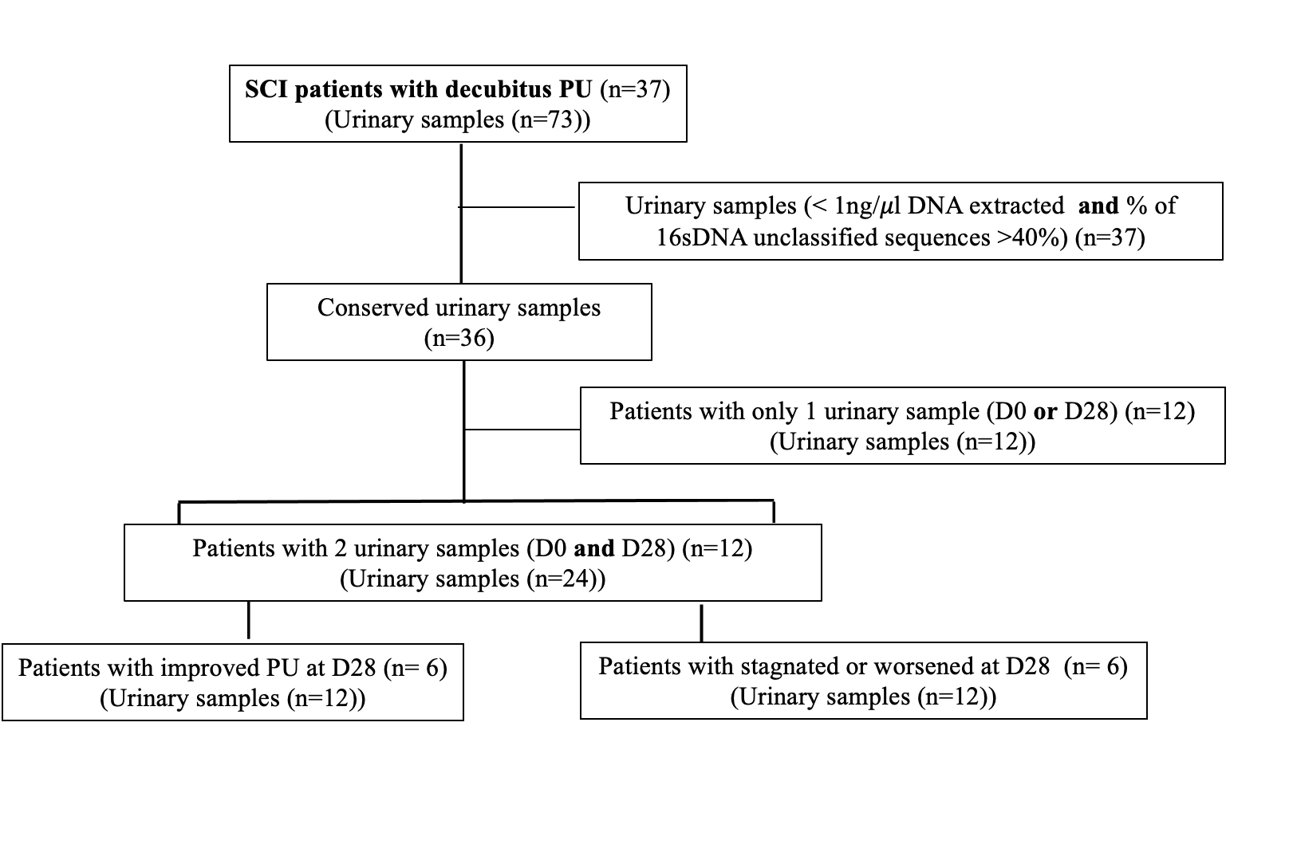

Fig. S2. Microbiota composition of the urine samples of SCI patients with PU according to the wound evolution. 1) Comparison of urinary microbiota composition of patients with improved or stagnated/worsened evolution of their wounds at admission (D0). 2) Comparison of urinary microbiota composition of patients with improved or stagnated/worsened evolution after 28 days (Visit D28). 3) Global comparison of urinary microbiota according to the wound evolution at D28.
Additional file 2:
Table S1. Main data from DNA extraction from urinary samples obtained from included SCI patients and the clinical evolution of their pressure ulcers at D28. Only samples in green-colored cells were analyzed.
Sample | DNA quantity (ng/µL) | % Classified | Sample (D28) | DNA quantity (ng/µL) | % Classified | PU status at D28
C01P01-D0 | 30.56 | 0.7
C01P03-D0 | 245.48 | 0.89 | C01P03-D28 | 54.76 | 0.91 | Stagnated/Worsened
C01P04-D0 | 28.57 | 0.93 | C01P04-D28 | 63.94 | 0.94 | Stagnated/Worsened
C01P05-D0 | 0.19 | 0.85 | C01P05-D28 | 0.01 | 0.97
C01P06-D0 | 0.09 | 0.81 | C01P06-D28 | 43.35 | 0.92
C01P07-D0 | 27.5 | 0.77 | C01P07-D28 | 24.45 | 0.79 | Stagnated/Worsened
C01P08-D0 | -0.01 | 0.79 | C01P08-D28 | 0.39 | 0.78
C01P10-D0 | 0.95 | 0.89 | C01P10-D28 | 10.16 | 0.81
C01P12-D0 | 244.63 | 0.76 | C01P12-D28 | 47.09 | 0.76 | Improved
C01P013-D0 | -0.01 | 0.72 | C01P013-D28 | 0.03 | 0.05
C01P014-D0 | -0.01 | 0.89 | C01P014-D28 | 1.1 | 0.82
C01P015-D0 | 25.04 | 0.66 | C01P015-D28 | 4.52 | 0.88 | Improved
C01P016-D0 | 0.02 | 0.89 | C01P016-D28 | 0 | 0.9
C01P017-D0 | 0.89 |  | C01P017-D28 | 0.06
C01P018-D0 | 1.01 |  | C01P018-D28 | 9.45
C01P020-D0 | 0.13 | 0.81 | C01P020-D28 | 93.91 | 0.85
C01P021-D0 | 2.31 |  | C01P021-D28 | 1.01
C01P023-D0 | 71.4 | 0.89 | C01P023-D28 | -0.02 | 0.73
C01P024-D0 | 1.13 | 0.87 | C01P024-D28 | 0.14 | 0.97
C01P025-D0 | 41.97 | 0.64 | C01P025-D28 | 232.66 | 0.63 | Stagnated/Worsened
C01P029-D0 | 4.97 | 0.9 | C01P029-D28 | 41.55 | 0.89 | Stagnated/Worsened
C01P030-D0 | 10.73 | 0.69 | C01P030-D28 | 164.84 | 0.71 | Improved
C01P031-D0 | 288.6 | 0.92 | C01P031-D28 | 0 | 0.87
C01P035-D0 | -0.01 | 0.74 | C01P035-D28 | 5.96 | 0.93
C01P036-D0 | 83.94 | 0.89 | C01P036-D28 | 0.39 | 0.15
C01P037-D0 | 0.18 |  | C01P037-D28 | 1.61
C01P038-D0 | 1.12 | 0.6 | C01P038-D28 | 6.73 | 0.69 | Improved
C01P040-D0 | 0.79 | 0.9 | C01P040-D28 | 0.01 | 0.9
C01P041-D0 | 91.69 | 0.6 | C01P041-D28 | 354.16 | 0.68 | Improved
C01P042-D0 | 0.1 | 0.78 | C01P042-D28 | -0.01 | 0.91
C01P043-D0 | 0 | 0.96 | C01P043-D28 | -0.01 | 0.87
C01P044-D0 | 5.95 | 0.92 | C01P044-D28 | 40.49 | 0.92 | Stagnated/Worsened
C01P045-D0 | 0.71 |  | C01P045-D28 | 0.15
C01P046-D0 | 0.09 | 0.87 | C01P046-D28 | -0.02 | 0.81
C01P047-D0 | -0.03 | 0.93 | C01P047-D28 | 6.07 | 0.94
C01P048-D0 | 86.68 | 0.89 | C01P048-D28 | 5.31 | 0.77 | Improved
C01P049-D0 | 0.01 | 0.88 | C01P049-D28 | 105.21 | 0.92

Table S2. Comparison of phyla detected in urinary microbiota of SCI patients with pressure ulcers (PU) and according to wound evolution at D28 (Improved vs Stagnated/Worsened).
 | Evolution of PU at D28:
 | Improved |  | Stagnated/worsened |  | p | Log(FC)
 | Mean | SD | Mean | SD
Bacteroidota | 390.67 | 703.78 | 2.5 | 5.17 | 0.001 | -6.075
Fusobacteriota | 0 | 0 | 6.83 | 14.43 | 0.187 | 3.697
Firmicutes | 19,540.33 | 10,784.77 | 5,225.5 | 6,938.17 | 0.247 | -1,744
Proteobacteria | 13,160.67 | 14,391.31 | 30,279.67 | 12,900.3 | 0.247 | 1.152
Actinobacteriota | 6,484.33 | 3,724.06 | 4,061.33 | 6,263.32 | 0.679 | -0.596
Cyanobacteria | 0.17 | 0.41 | 0 | 0 | NA | NA
Verrucomicrobiota | 0 | 0 | 0 | 0 | NA | NA
Campilobacterota | 0 | 0 | 0 | 0 | NA | NA
SD Standard deviation; NA Not applicable; log(FC) Log(Full of the Change)

