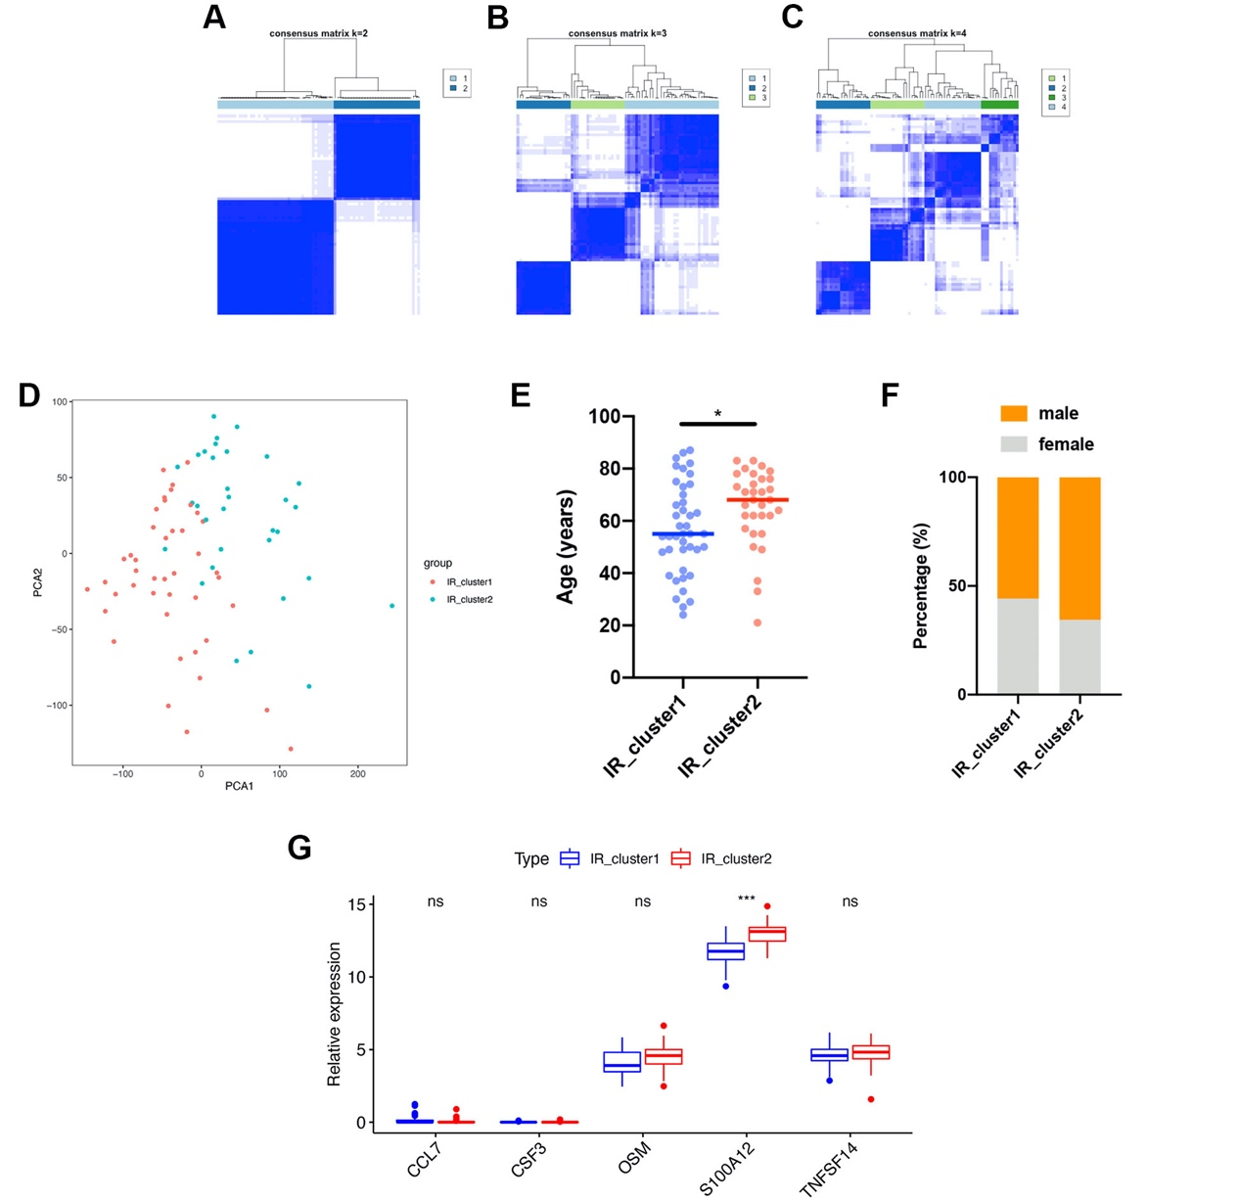FIGURE S1
(A-C) Unsupervised clustering of 42 IR genes and consensus matrices for k = 2-4. (D) Principal component analysis for the transcriptome profiles of two IR patterns, showing a remarkable difference on transcriptome profiles between two distinct IR clusters. (E) The differences in age between the two IR patterns in training cohort (Mann-Whitney U test). (F) The differences in sex proportions between the two IR clusters in training cohort (Chi-square test). (G) Expression levels of proinflammatory cytokine genes between two IR patterns in training cohort (Mann-Whitney U test). The upper and lower ends of the boxes represented interquartile range of values. The lines in the boxes represented median value, and dots showed outliers. The asterisks represented the statistical P value (*P < 0.05; **P < 0.01; ***P < 0.001; ns, no significance).
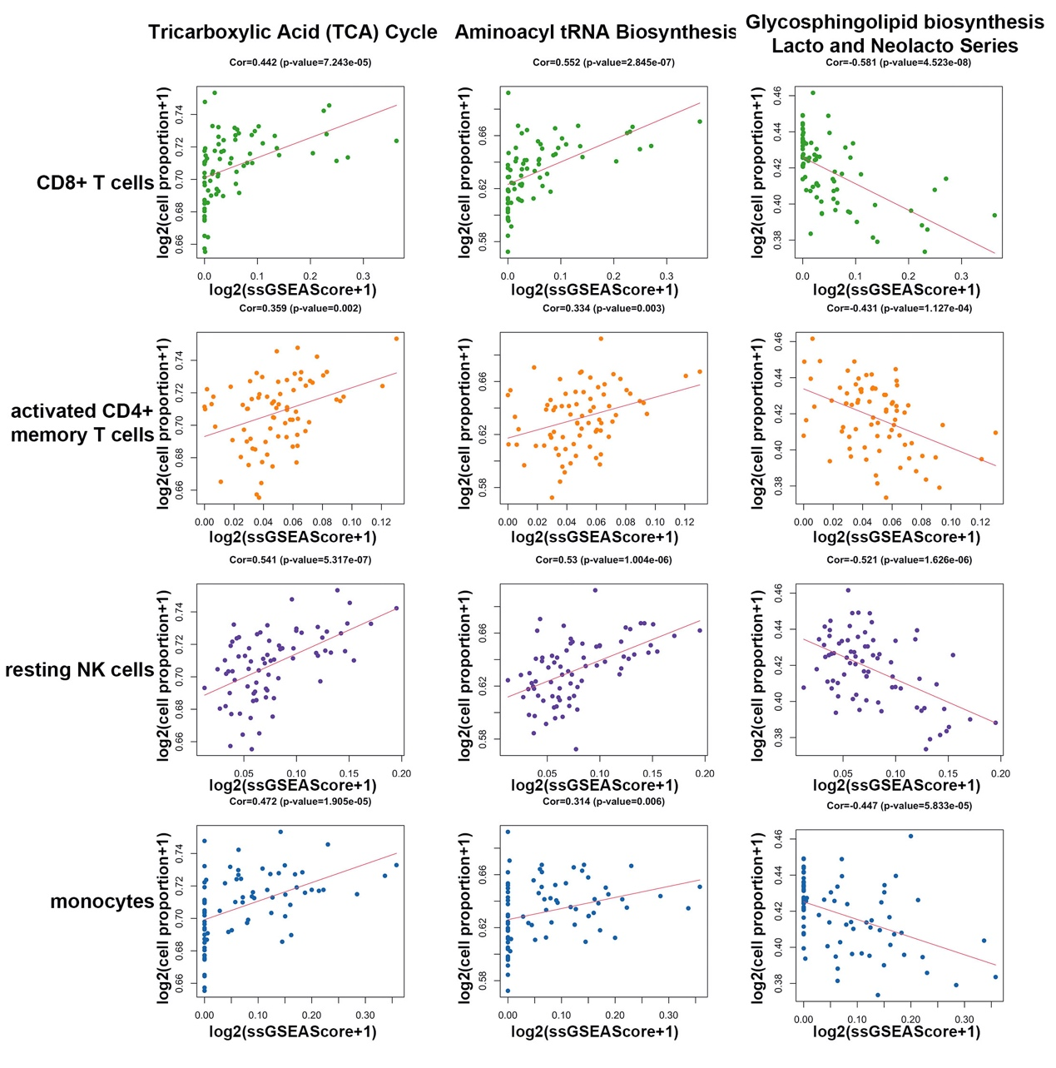
FIGURE S2
Correlation analysis between immune cell infiltration and cellular metabolic pathway enrichment. The correlation coefficient and p value of Spearman correlation analysis were presented at the top of each graph.
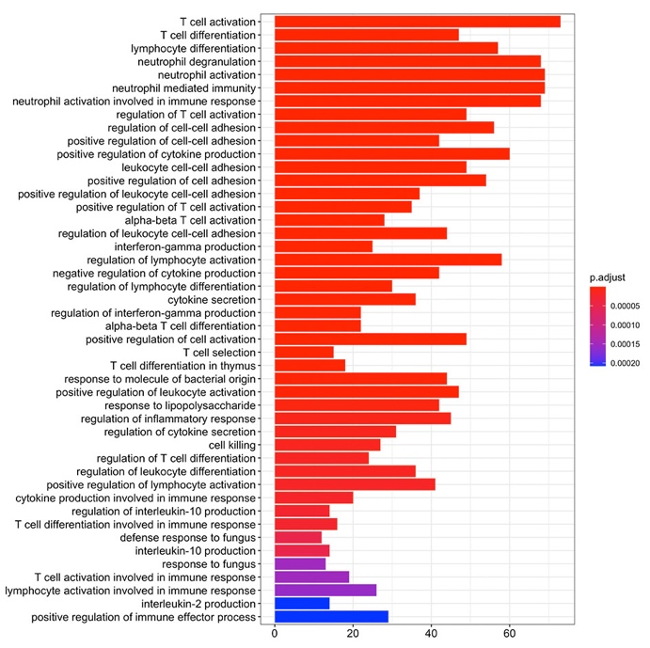
FIGURE S3
Functional annotation for IR phenotype associated genes through GO enrichment analysis. The x axis indicates the number of genes enriched within each GO term. The color depth of the bars represented the adjust p value of each GO term enriched.

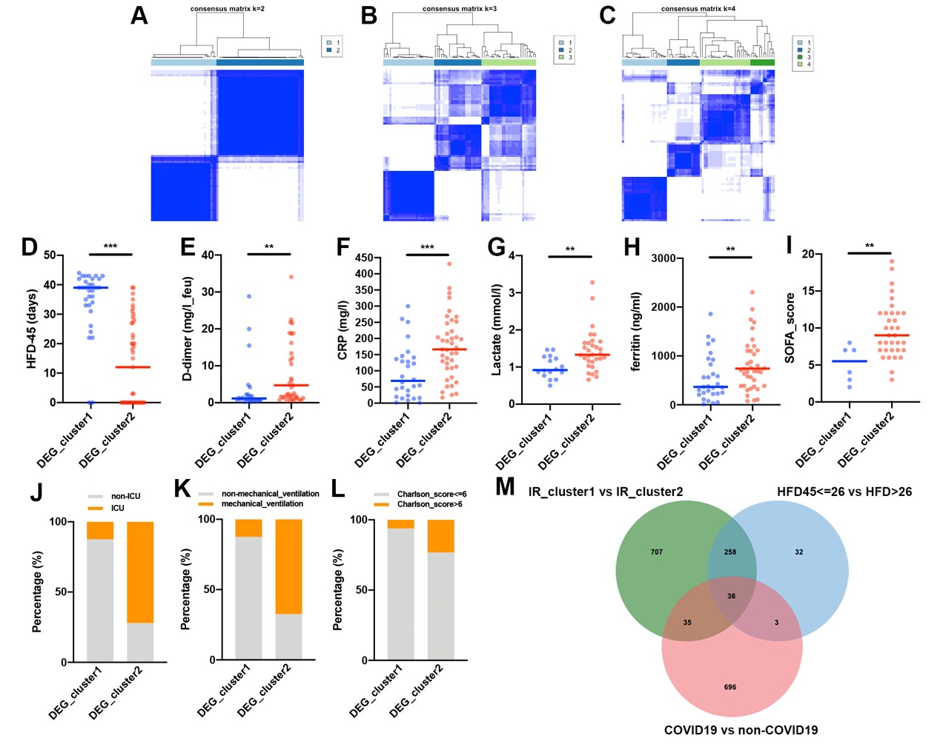FIGURE S4
(A-C) Unsupervised clustering of 1036 IR phenotype-related genes in training cohort and consensus matrices for k = 2-4. (D) Differences in HFD-45 between the two DEG clusters in training cohort (Mann-Whitney U test). (E-H) Differences in the concentrations of D-dimer (E), CRP (F), lactate (G), and ferritin (H) between the two DEG clusters in training cohort (Mann-Whitney U test). (I) Differences in the SOFA scores between the two DEG clusters in training cohort (unpaired t test). (J-L) Differences in the proportions of ICU (J), mechanical ventilation (K), and Charlson score > 6 (L) between the two DEG clusters in training cohort (Chi-square test). (M) Overlap analysis of the DE genes extracted from comparison between IR_cluster1 and IR_cluster2, COVID-19 and non-COVID-19 patients, HFD45 <= 26 and HFD45 >26 was shown in venn diagram. The asterisks represented the statistical P value (*P < 0.05; **P < 0.01; ***P < 0.001; ns, no significance).

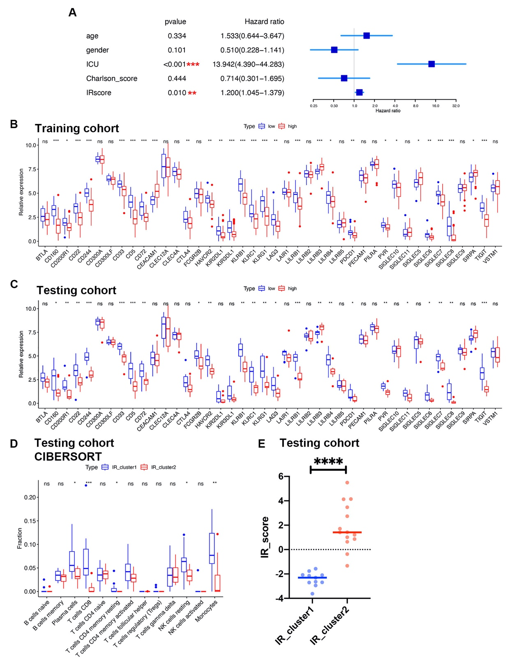FIGURE S5
(A) Forest plot displaying the multivariate Cox regression analysis results of IRscore in training cohort. (B) Expression levels of 42 IR genes between patients with the high and low IRscore in training cohort (Mann-Whitney U test). The upper and lower ends of the boxes represented interquartile range of values. The lines in the boxes represented median value, and dots showed outliers. (C) Expression levels of 42 IR genes between patients with the high and low IRscore in testing cohort (Mann-Whitney U test). The upper and lower ends of the boxes represented interquartile range of values. The lines in the boxes represented median value, and dots showed outliers. (D) The abundance of immune cells calculated by CIBERSORT between distinct IR patterns in testing cohort (Mann-Whitney U test). (E) Differences in the IRscore between the IR patterns in testing cohort (Mann-Whitney U test). The asterisks represented the statistical P value (*P < 0.05; **P < 0.01; ***P < 0.001; ns, no significance).

