Extended Data Figures
Figure 1. Macroinvertebrate’s response to channelization is dependent on riparian degradation and agricultural cover.
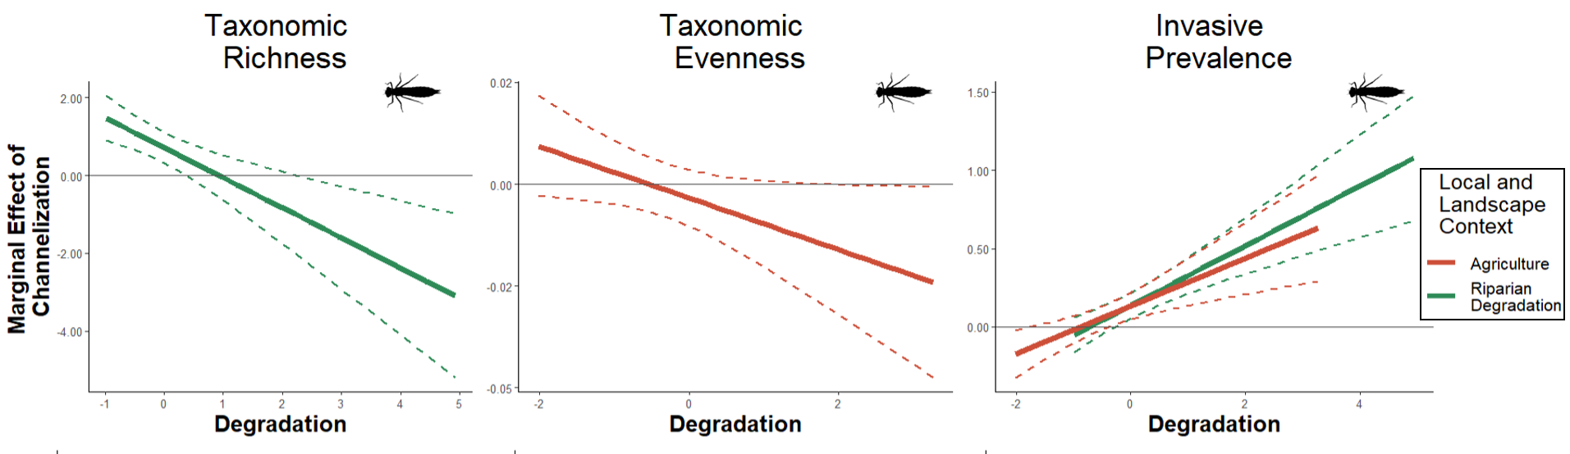
Figure 2. Functional traits relation to axis 1 (Ship traffic) in the full dataset, and highly degraded landscapes (i.e. the top 25% of sites with urban or agricultural cover).
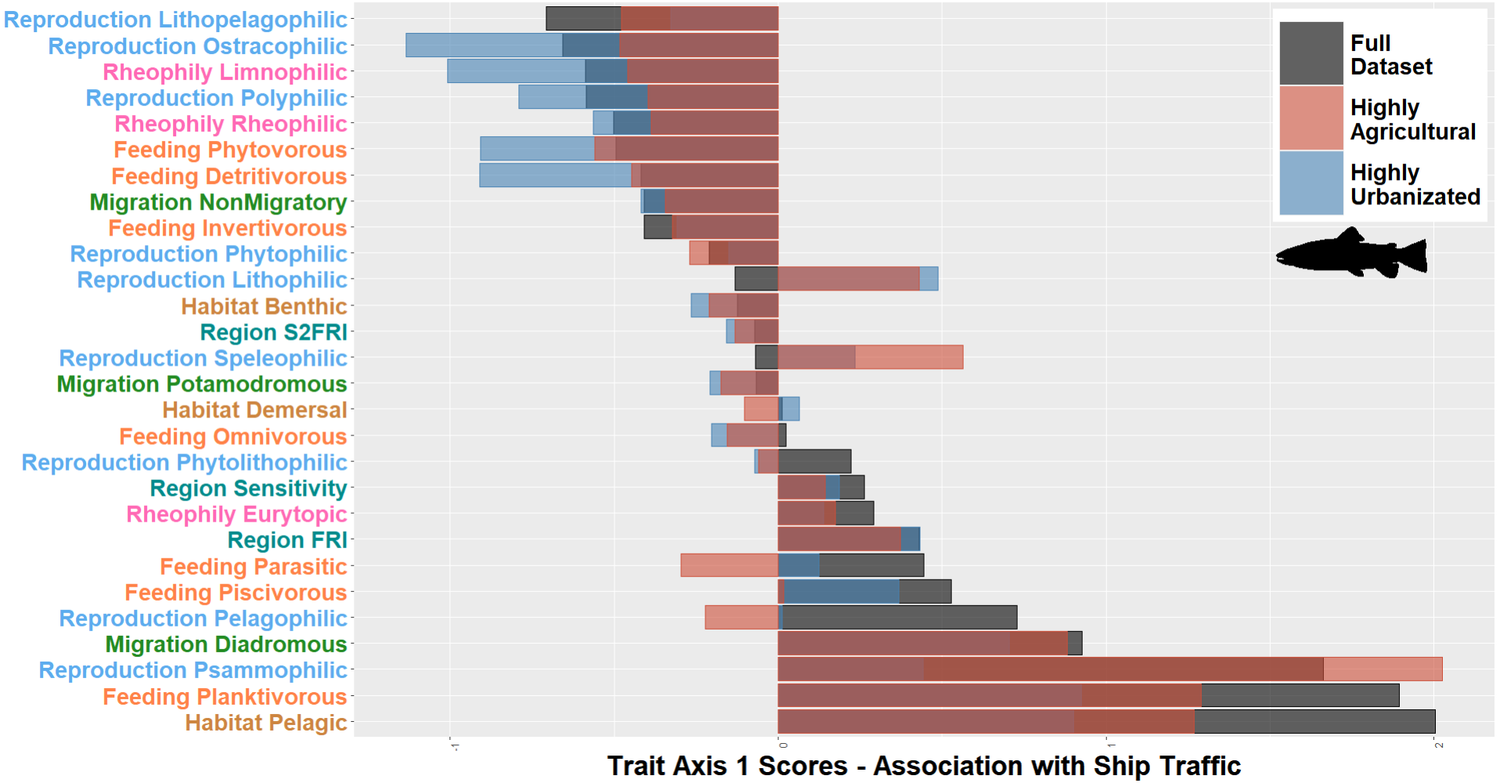
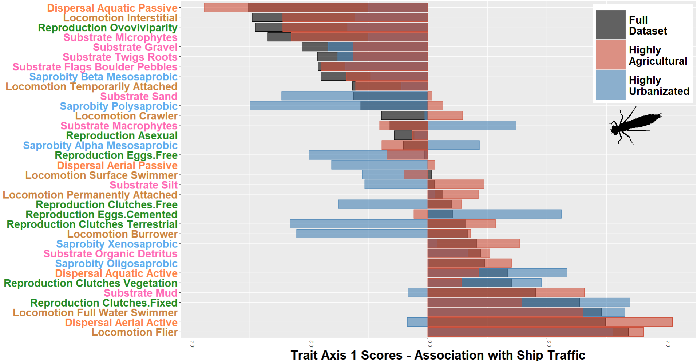

Figure 3. Follow-up analysis to show relationships between taxonomic evenness and the abundance and occurrences of rare species in fish and macroinvertebrates. A rare species was deemed as it’s abundance accounting for less than 25% of the total community abundance. Code for this figure and the analyses behind it are provided in Supplemental File 2.
