Supplementary Figure Legends

Supplementary Figure 1. Correlation analysis of the quality control (QC) samples.

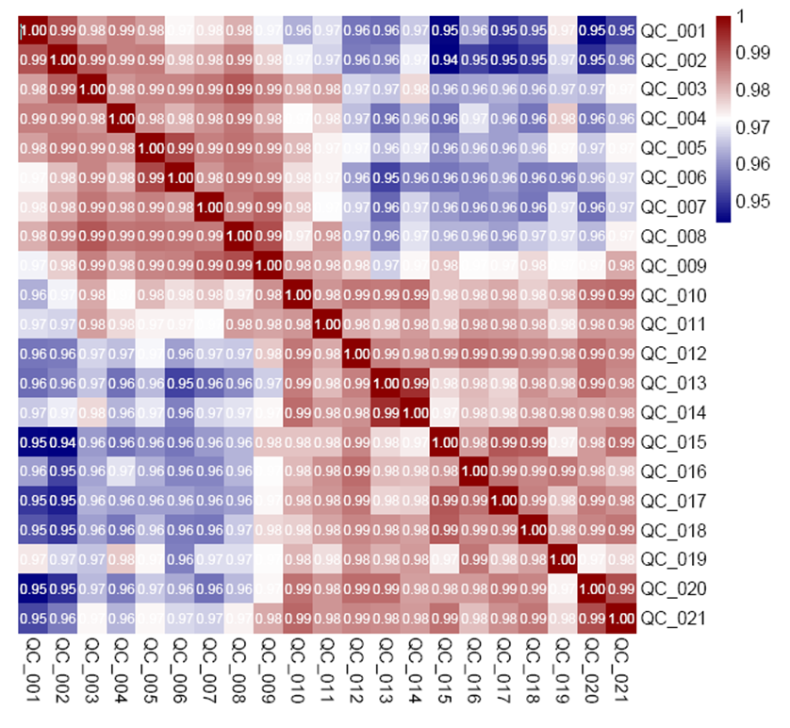

Supplementary Figure 2. Serum lipid mediator difference between health children and adults. A) Volcano plot of lipid mediators, comparing the fold change ( adults vs. children) to the P value (Student’s t-test); B) OPLS-DA score plots showed a partial between health children and adults; C). VIP scores of the lipid mediators. VIP larger than 1 highlights the most relevant indicators for distinguishing the healthy children and adults; 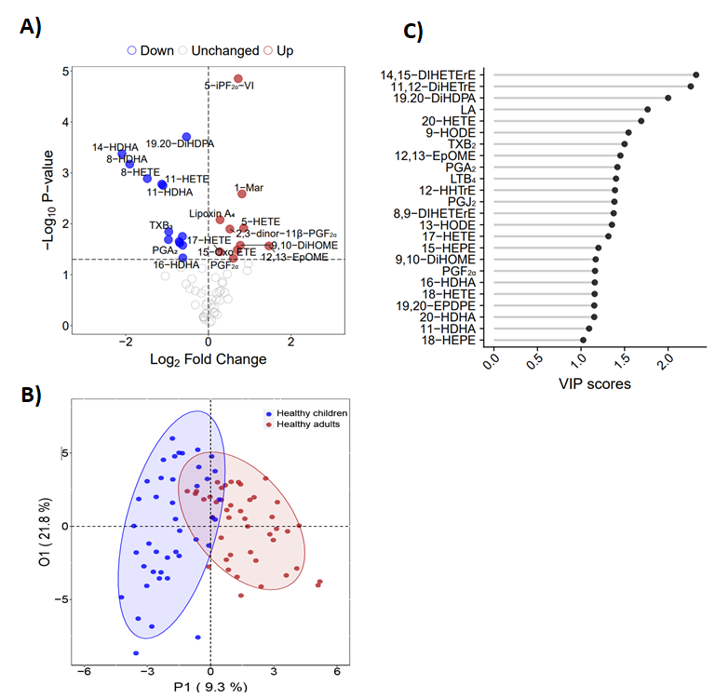

Supplementary Figure 3. Pathway analysis highlighting those biosynthetic pathways linked with lipid mediators associated with the difference between health children vs. health adults (P<0.05). PLA2, phospholipase A2: CYP: Cytochrome P450; COX: cyclooxygenase; 5-LOX, 5-lipoxygenase. sEH, soluble epoxide hydrolase.
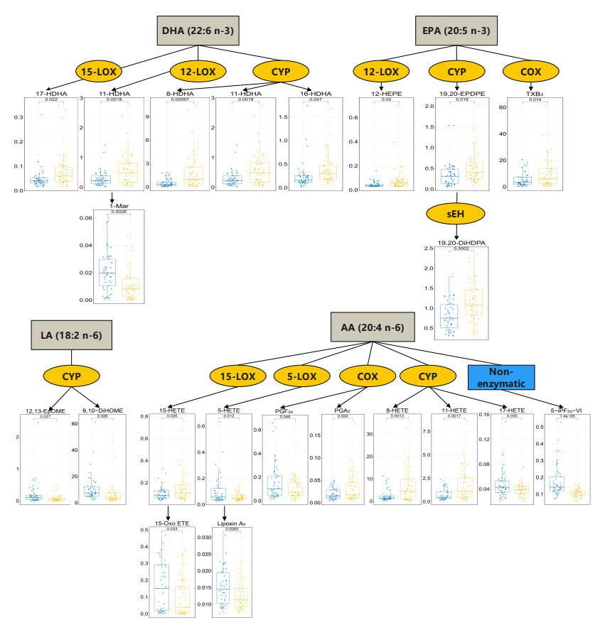

Supplementary Tables

Supplementary Table1. Health adult characteristics

Health Adult(n=45)
Age(years) | 39.09(14.84)
Gender
Male | 18(40%)
Female | 27(60%)

Supplementary Table 2. Lipid mediator profiling of H1N1 and healthy children by LC-MS/MS in human serum.

Lipid mediator (ng/mL) | H1N1 (n=44) | Healthy (n=44) | Pval*
14,15-DIHETErE | 0.62 ± 0.2 | 0.44 ± 0.13 | 1.91E-06
11,12-DiHETrE | 300.88 ± 104.07 | 219.16 ± 80.77 | 9.88E-05
PGF_{2α} | 42.68 ± 44.57 | 105.43 ± 88.67 | 1.02E-04
PGD₂ | 27.6 ± 1.3 | 30.18 ± 3.95 | 1.56E-04
TXB₂ | 4.19 ± 9.15 | 17 ± 19.14 | 1.96E-04
PGJ₂ | 14.06 ± 11.48 | 32.79 ± 28.78 | 2.11E-04
20-HETE | 137.41 ± 130.2 | 53.99 ± 54.98 | 2.45E-04
PGA₂ | 11.75 ± 11.9 | 32.17 ± 32.29 | 2.78E-04
12-HHTrE | 2.94 ± 6.21 | 12.28 ± 14.87 | 3.51E-04
TXB₃ | 3.47 ± 4.38 | 10.2 ± 11.84 | 9.37E-04
LA | 1283.43 ± 1084.12 | 684.49 ± 597.86 | 2.10E-03
8,9-DIHETErE | 42.59 ± 11.78 | 35.67 ± 9.82 | 3.77E-03
19.20-DiHDPA | 1.53 ± 0.7 | 1.16 ± 0.49 | 4.96E-03
11-HETE | 0.79 ± 1.07 | 1.66 ± 1.68 | 5.00E-03
LTB₄ | 55.04 ± 60.69 | 110.13 ± 121.14 | 9.62E-03
12,13-EpOME | 153.64 ± 163.3 | 77 ± 106.52 | 1.13E-02
6-keto-PGF_{1α} | 15.6 ± 2.6 | 17.55 ± 4.66 | 1.93E-02
11-HEPE | 50.93 ± 32.23 | 72.88 ± 53.06 | 2.30E-02
17-HETE | 45.82 ± 14.51 | 39.36 ± 11.38 | 2.33E-02
15-HETE | 107.01 ± 52.66 | 162.97 ± 152.85 | 2.72E-02
15-keto-PGE₂ | 30.7 ± 19.52 | 57.6 ± 79.34 | 3.59E-02
14-HDHA | 6.99 ± 10.22 | 3.56 ± 4.61 | 4.73E-02
8-HDHA | 3.75 ± 5.46 | 1.94 ± 2.51 | 5.06E-02
13-HDHA | 22.11 ± 3.23 | 25.21 ± 10.71 | 7.48E-02
5,6-DiHETrE | 97.35 ± 32.24 | 110.68 ± 40.65 | 9.47E-02
13,14-dihydro-15-keto PGF_{2α} | 38.3 ± 64.71 | 21.46 ± 13.15 | 9.75E-02
2,3-dinor-11β-PGF_{2α} | 36.39 ± 37.11 | 26.22 ± 16.95 | 1.04E-01
11-HDHA | 0.92 ± 1.1 | 0.62 ± 0.61 | 1.17E-01
RvD1 | 10.54 ± 3.87 | 13.24 ± 11.53 | 1.52E-01
14(15)-EET | 185.06 ± 161.99 | 135.02 ± 168.68 | 1.62E-01
18-HEPE | 37.28 ± 3.25 | 38.78 ± 6.83 | 1.96E-01
PGB₂ | 33.03 ± 11.44 | 36.95 ± 16.95 | 2.11E-01
1-Mar | 17.17 ± 24.39 | 12.07 ± 12.69 | 2.25E-01
20-HDHA | 1.27 ± 1.47 | 0.97 ± 0.66 | 2.32E-01
16-HETE | 1.19 ± 0.74 | 1.45 ± 1.21 | 2.36E-01
18-HETE | 0.64 ± 0.46 | 0.54 ± 0.44 | 2.97E-01
16-HDHA | 0.32 ± 0.22 | 0.38 ± 0.32 | 3.19E-01
5-HEPE | 224.05 ± 127.9 | 258.65 ± 194.36 | 3.31E-01
9,10-DiHOME | 5.13 ± 2.99 | 6.4 ± 8.19 | 3.43E-01
9-HETE | 76.52 ± 46.78 | 95.59 ± 122.72 | 3.45E-01
5,15-DiHETE | 37.88 ± 8.79 | 39.51 ± 7.21 | 3.46E-01
12-HETE | 1.16 ± 1.22 | 1.62 ± 3.09 | 3.65E-01
19,20-EPDEP-2 | 0.62 ± 0.25 | 0.68 ± 0.36 | 3.73E-01
5,6-DiHETE | 69.76 ± 20.14 | 66.77 ± 13.29 | 4.15E-01
8(9)-EET | 32.88 ± 5.55 | 31.85 ± 6.59 | 4.35E-01
5(6)-EET | 223.2 ± 220.61 | 189.22 ± 188.21 | 4.41E-01
7-HDHA | 18.52 ± 2.74 | 19.16 ± 5.37 | 4.91E-01
19,20-EPDPE | 0.48 ± 0.3 | 0.53 ± 0.41 | 5.59E-01
9-HODE | 2.9 ± 1.42 | 2.68 ± 2.1 | 5.59E-01
8-HETE | 8.43 ± 12.89 | 7.19 ± 8.44 | 5.96E-01
13-HODE | 1.91 ± 1.45 | 1.74 ± 1.69 | 6.13E-01
12,13-DiHOME | 5.45 ± 3.57 | 5.93 ± 5.32 | 6.26E-01
4-HDHA | 31.14 ± 7.51 | 32.03 ± 10.19 | 6.44E-01
12-HEPE | 99.18 ± 105.28 | 88.4 ± 115.57 | 6.51E-01
17-HDHA | 75.57 ± 49.65 | 81.64 ± 76.35 | 6.62E-01
13-HOTrE | 144.16 ± 73.08 | 137.02 ± 93.97 | 6.94E-01
15-HEPE | 135.22 ± 100.16 | 142.8 ± 145.13 | 7.78E-01
15-Oxo ETE | 102.9 ± 109.8 | 96.99 ± 112.19 | 8.04E-01
5-HETE | 56.07 ± 24.91 | 57.4 ± 28.49 | 8.18E-01
ARA | 1.41 ± 1.68 | 1.49 ± 1.85 | 8.30E-01
5-iPF_{2α}-VI | 2.12 ± 0.6 | 2.15 ± 0.49 | 8.48E-01
16(17)-EpDPE | 20.71 ± 4.16 | 20.55 ± 4.21 | 8.60E-01
Lipoxin A₄ | 12.61 ± 4.16 | 12.51 ± 3.91 | 9.06E-01
DHA | 4.97 ± 5.05 | 4.87 ± 5.45 | 9.33E-01
Data are means ± SD.

Supplementary Table 3. Lipid mediator profiling of H1N1 and recovered children by LC-MS/MS in human serum (n=33)

Lipid mediator (ng/mL) | H1N1 | Recovery | Pval
Lipoxin A₄ | 13.25 ± 4.41 | 13.16 ± 4.11 | 9.42E-01
PGD₂ | 27.71 ± 1.31 | 29.02 ± 3.35 | 3.34E-02
PGF_{2α} | 50.74 ± 46.81 | 114.81 ± 246.77 | 1.46E-01
TXB₂ | 6.38 ± 10.79 | 11.94 ± 14.05 | 5.55E-02
RvD1 | 10.14 ± 3.81 | 9.42 ± 2.54 | 3.94E-01
LA | 1051.93 ± 673.19 | 512.03 ± 398.47 | 3.65E-04
9,10-DiHOME | 5.78 ± 7.26 | 3.51 ± 2.93 | 9.85E-02
12,13-DiHOME | 6.57 ± 7.92 | 5.13 ± 4.73 | 3.30E-01
9-HODE | 2.98 ± 1.54 | 1.9 ± 1.48 | 5.97E-03
13-HODE | 2.11 ± 1.82 | 1.2 ± 0.97 | 1.29E-02
ARA | 1.23 ± 1.75 | 1.53 ± 2.9 | 6.16E-01
5-HETE | 59.63 ± 32.07 | 47.48 ± 21.15 | 9.00E-02
12-HETE | 1.19 ± 1.28 | 1.08 ± 1.58 | 7.20E-01
15-HETE | 118.96 ± 60.67 | 136.85 ± 109.43 | 3.39E-01
11,12-DiHETrE | 295.59 ± 108.44 | 176.19 ± 85.32 | 3.35E-05
20-HETE | 140.18 ± 137.27 | 43.05 ± 55.87 | 1.07E-03
5(6)-EET | 190.15 ± 173.73 | 187.07 ± 175.04 | 9.45E-01
5,15-DiHETE | 38.8 ± 9.48 | 39.02 ± 6.08 | 9.15E-01
5,6-DiHETE | 69.06 ± 19.17 | 63.29 ± 11.44 | 1.45E-01
5,6-DiHETrE | 108.75 ± 59.88 | 111.69 ± 48.66 | 8.29E-01
8(9)-EET | 32.22 ± 4.63 | 32.03 ± 7.26 | 8.92E-01
8-HETE | 9.85 ± 14.82 | 6.85 ± 8.6 | 2.76E-01
LTB₄ | 50.66 ± 63.08 | 16.79 ± 24.87 | 3.79E-03
DHA | 4.06 ± 4.61 | 3.32 ± 4.34 | 5.02E-01
17-HDHA | 71.01 ± 45.27 | 56.63 ± 37.72 | 1.14E-01
14-HDHA | 6.38 ± 10.91 | 3.98 ± 4.52 | 2.41E-01
7-HDHA | 18.54 ± 3.27 | 17.14 ± 2.39 | 7.14E-02
4-HDHA | 30.94 ± 7.93 | 29.05 ± 7.68 | 3.26E-01
13-HDHA | 21.6 ± 2.21 | 21.98 ± 3.68 | 5.98E-01
8-HDHA | 3.34 ± 5.76 | 2.31 ± 2.74 | 3.43E-01
1-Mar | 19.16 ± 28.87 | 13.8 ± 12.53 | 2.33E-01
16(17)-EpDPE | 20.16 ± 2.36 | 20.16 ± 3.53 | 9.93E-01
18-HEPE | 37.19 ± 3.36 | 35.49 ± 2.97 | 2.39E-02
15-HEPE | 129 ± 107.97 | 80.75 ± 55.6 | 2.03E-02
12-HEPE | 89.13 ± 84.03 | 66.96 ± 48.81 | 1.80E-01
5-HEPE | 222.17 ± 112.88 | 225.01 ± 217.39 | 9.33E-01
11-HEPE | 49.88 ± 30.38 | 56.3 ± 49.43 | 5.36E-01
18-HETE | 0.67 ± 0.47 | 0.5 ± 0.31 | 5.15E-02
19.20-DiHDPA | 1.49 ± 0.82 | 0.75 ± 0.41 | 3.75E-05
16-HETE | 1.26 ± 0.79 | 1.31 ± 0.95 | 8.05E-01
15-keto-PGE₂ | 32.18 ± 21.6 | 64.66 ± 161.9 | 2.65E-01
PGA₂ | 14.05 ± 12.81 | 26.34 ± 35.18 | 5.68E-02
PGB₂ | 33.46 ± 9.16 | 35.91 ± 18.65 | 4.60E-01
6-keto-PGF_{1α} | 15.77 ± 2.56 | 19.99 ± 13.37 | 7.21E-02
2,3-dinor-11β-PGF_{2α} | 34.91 ± 36.72 | 31.21 ± 18.34 | 6.09E-01
5-iPF_{2α}-VI | 2.04 ± 0.46 | 2.13 ± 0.51 | 5.21E-01
9-HETE | 77.56 ± 48.37 | 72.12 ± 65.53 | 6.56E-01
12-HHTrE | 4.23 ± 7.11 | 7.47 ± 8.73 | 7.91E-02
13-HOTrE | 145.96 ± 98.06 | 104.92 ± 56.67 | 1.63E-02
20-HDHA | 1.37 ± 1.64 | 0.8 ± 0.7 | 6.25E-02
11-HETE | 1.08 ± 1.33 | 1.68 ± 2.28 | 1.74E-01
16-HDHA | 0.31 ± 0.25 | 0.25 ± 0.16 | 2.72E-01
11-HDHA | 0.88 ± 1.13 | 0.46 ± 0.4 | 5.02E-02
19,20-EPDPE | 0.43 ± 0.22 | 0.33 ± 0.18 | 3.71E-02
19,20-EPDEP-2 | 0.62 ± 0.28 | 0.54 ± 0.25 | 2.36E-01
TXB₃ | 4.47 ± 4.85 | 10.15 ± 12.04 | 1.87E-02
13,14-dihydro-15-keto PGF_{2α} | 40.82 ± 72.3 | 15.57 ± 14.53 | 5.90E-02
12,13-EpOME | 145.19 ± 167.81 | 55.14 ± 104.87 | 1.52E-02
17-HETE | 48.06 ± 15.75 | 35.78 ± 9.79 | 5.85E-04
14,15-DIHETErE | 0.61 ± 0.2 | 0.38 ± 0.16 | 1.54E-05
8,9-DIHETErE | 42.69 ± 11.77 | 33.3 ± 9.65 | 9.14E-04
PGJ₂ | 15.94 ± 12.56 | 28.97 ± 36.42 | 4.87E-02
15-Oxo ETE | 117.66 ± 111.07 | 123.24 ± 101.12 | 7.71E-01
14(15)-EET | 195.28 ± 156.74 | 169.03 ± 157.23 | 5.18E-01
Data are means ± SD.

Supplementary Table 4. Lipid mediator profiling of healthy children and adults by LC-MS/MS in human serum.

Lipid mediator (ng/mL) | Healthy Adult (n=45) | Healthy Children (n=44) | Pval
Lipoxin A₄ | 15.2 ± 5.34 | 12.51 ± 3.91 | 8.33E-03
PGD₂ | 29.56 ± 1.92 | 30.18 ± 3.95 | 3.56E-01
PGF_{2α} | 160.19 ± 158.07 | 105.43 ± 88.67 | 4.77E-02
TXB₂ | 10.73 ± 12.13 | 17 ± 19.14 | 7.20E-02
RvD1 | 12.44 ± 12.44 | 13.24 ± 11.53 | 7.55E-01
LA | 841.73 ± 547.5 | 684.49 ± 597.86 | 2.02E-01
9,10-DiHOME | 10.92 ± 10.49 | 6.4 ± 8.19 | 2.64E-02
12,13-DiHOME | 8.13 ± 6.92 | 5.93 ± 5.32 | 9.73E-02
9-HODE | 2.97 ± 2.41 | 2.68 ± 2.1 | 5.45E-01
13-HODE | 1.92 ± 1.21 | 1.74 ± 1.69 | 5.62E-01
ARA | 1.72 ± 2.36 | 1.49 ± 1.85 | 6.04E-01
5-HETE | 103.7 ± 115.73 | 57.4 ± 28.49 | 1.22E-02
12-HETE | 0.79 ± 1.3 | 1.62 ± 3.09 | 1.06E-01
15-HETE | 105.81 ± 61.39 | 162.97 ± 152.85 | 2.64E-02
11,12-DiHETrE | 222.73 ± 99.99 | 219.16 ± 80.77 | 8.54E-01
20-HETE | 105.67 ± 172.21 | 53.99 ± 54.98 | 6.10E-02
5(6)-EET | 173.4 ± 152.24 | 189.22 ± 188.21 | 6.67E-01
5,15-DiHETE | 38.72 ± 5.87 | 39.51 ± 7.21 | 5.72E-01
5,6-DiHETE | 69.98 ± 20.35 | 66.77 ± 13.29 | 3.81E-01
5,6-DiHETrE | 98.48 ± 53.45 | 110.68 ± 40.65 | 2.30E-01
8(9)-EET | 30.31 ± 4.42 | 31.85 ± 6.59 | 2.02E-01
8-HETE | 2.58 ± 2.81 | 7.19 ± 8.44 | 1.29E-03
LTB₄ | 116.25 ± 124.54 | 110.13 ± 121.14 | 8.16E-01
DHA | 6.76 ± 10.76 | 4.87 ± 5.45 | 3.00E-01
17-HDHA | 49.99 ± 46.17 | 81.64 ± 76.35 | 2.22E-02
14-HDHA | 0.84 ± 0.9 | 3.56 ± 4.61 | 4.20E-04
7-HDHA | 21.91 ± 16.97 | 19.16 ± 5.37 | 3.06E-01
4-HDHA | 38.47 ± 32.77 | 32.03 ± 10.19 | 2.15E-01
13-HDHA | 24.01 ± 9.6 | 25.21 ± 10.71 | 5.82E-01
8-HDHA | 0.52 ± 0.52 | 1.94 ± 2.51 | 6.71E-04
1-Mar | 21.19 ± 14.82 | 12.07 ± 12.69 | 2.59E-03
16(17)-EpDPE | 21.65 ± 5.65 | 20.55 ± 4.21 | 3.05E-01
18-HEPE | 44.55 ± 30.96 | 38.78 ± 6.83 | 2.29E-01
15-HEPE | 131.26 ± 118.35 | 142.8 ± 145.13 | 6.85E-01
12-HEPE | 45.17 ± 24.55 | 88.4 ± 115.57 | 2.05E-02
5-HEPE | 207.81 ± 180.63 | 258.65 ± 194.36 | 2.08E-01
11-HEPE | 67.87 ± 62.1 | 72.88 ± 53.06 | 6.84E-01
18-HETE | 0.65 ± 0.62 | 0.54 ± 0.44 | 3.20E-01
19.20-DiHDPA | 0.8 ± 0.35 | 1.16 ± 0.49 | 1.96E-04
16-HETE | 1.09 ± 0.86 | 1.45 ± 1.21 | 1.21E-01
15-keto-PGE₂ | 110.33 ± 183.32 | 57.6 ± 79.34 | 8.27E-02
PGA₂ | 19.88 ± 12.86 | 32.17 ± 32.29 | 2.38E-02
PGB₂ | 46.7 ± 39.75 | 36.95 ± 16.95 | 1.37E-01
6-keto-PGF_{1α} | 16.8 ± 3.38 | 17.55 ± 4.66 | 3.92E-01
2,3-dinor-11β-PGF_{2α} | 37.54 ± 24.2 | 26.22 ± 16.95 | 1.27E-02
5-iPF_{2α}-VI | 3.54 ± 1.87 | 2.15 ± 0.49 | 1.41E-05
9-HETE | 65.74 ± 57.32 | 95.59 ± 122.72 | 1.52E-01
12-HHTrE | 7.28 ± 7.94 | 12.28 ± 14.87 | 5.50E-02
13-HOTrE | 150.61 ± 74.44 | 137.02 ± 93.97 | 4.56E-01
20-HDHA | 0.71 ± 1.15 | 0.97 ± 0.66 | 1.89E-01
11-HETE | 0.76 ± 0.62 | 1.66 ± 1.68 | 1.66E-03
16-HDHA | 0.25 ± 0.3 | 0.38 ± 0.32 | 4.67E-02
11-HDHA | 0.29 ± 0.27 | 0.62 ± 0.61 | 1.76E-03
19,20-EPDPE | 0.34 ± 0.31 | 0.53 ± 0.41 | 1.77E-02
19,20-EPDEP-2 | 0.89 ± 1.1 | 0.68 ± 0.36 | 2.24E-01
TXB₃ | 5.24 ± 5.16 | 10.2 ± 11.84 | 1.43E-02
13,14-dihydro-15-keto PGF_{2α} | 27.17 ± 22.47 | 21.46 ± 13.15 | 1.47E-01
12,13-EpOME | 212.17 ± 383.77 | 77 ± 106.52 | 2.73E-02
17-HETE | 47.62 ± 23 | 39.36 ± 11.38 | 3.55E-02
14,15-DIHETErE | 0.49 ± 0.19 | 0.44 ± 0.13 | 1.14E-01
8,9-DIHETErE | 32.09 ± 8.72 | 35.67 ± 9.82 | 7.48E-02
PGJ₂ | 23.45 ± 13.96 | 32.79 ± 28.78 | 5.92E-02
15-Oxo ETE | 157.13 ± 145.86 | 96.99 ± 112.19 | 3.26E-02
14(15)-EET | 108.41 ± 113.58 | 135.02 ± 168.68 | 3.90E-01
Data are means ± SD.

