Supplementary Information

Carrier-free low molecular weight heparin and lipid conjugate-based nano-anticoagulant with an albumin shuttling effect

Jae-Hyeon Lee^{1¶}, Hansol Lim^{2¶}, Gaeun Ma², Minho Seo¹, Jun-Hyuck Lee², Seong-Bin Yang², Han-Gil Jeong³, Seho Kweon⁴*, Jooho Park²*

¹Department of Biomedical Chemistry, College of Biomedical and Health Science, Konkuk University, Republic of Korea ²Department of Applied Life Science, BK21 Program, Konkuk University, Chungju 27478, Republic of Korea, ³Department of Neurology, Seoul National University Bundang Hospital, Seoul National University College of Medicine, Seongnam-si, 08826, Republic of Korea. ⁴Department of Molecular Medicine and Biopharmaceutical Science, Graduate School of Convergence Science and Technology, Seoul National University, Seoul 08826, Republic of Korea
¶These authors contributed equally to this work
*Corresponding author:
Jooho Park (Phone) +82-43-843-3574, (E-mail) pkjhdn@kku.ac.kr
Seho Kweon (Phone) +82-61-450-6063, (E-mail) sayhokweon@snu.ac.kr

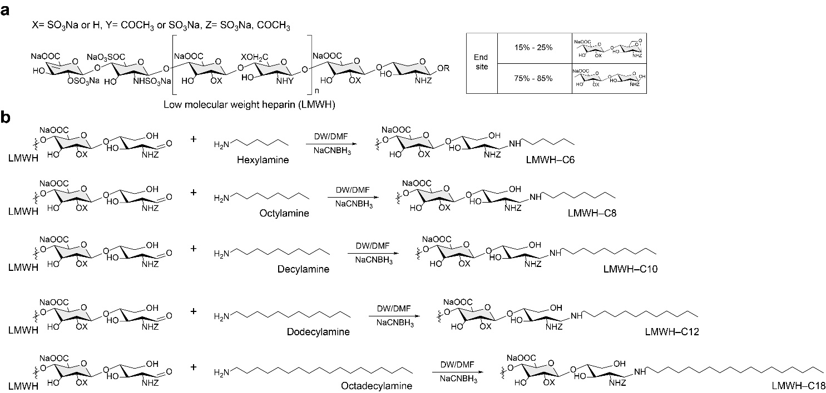
Supplementary Fig. 1 | a, b Schematic structure of low molecular weight heparin (LMWH) (a) and synthesis of LMWH conjugation with fatty amines (b): [LMWH–hexylamine (LMWH–C6), LMWH–octylamine (LMWH–C8), LMWH–decylamine (LMWH–C10), LMWH–dodecylamine (LMWH–C12), and LMWH–octadecylamine (LMWH–C18, LMHO)]

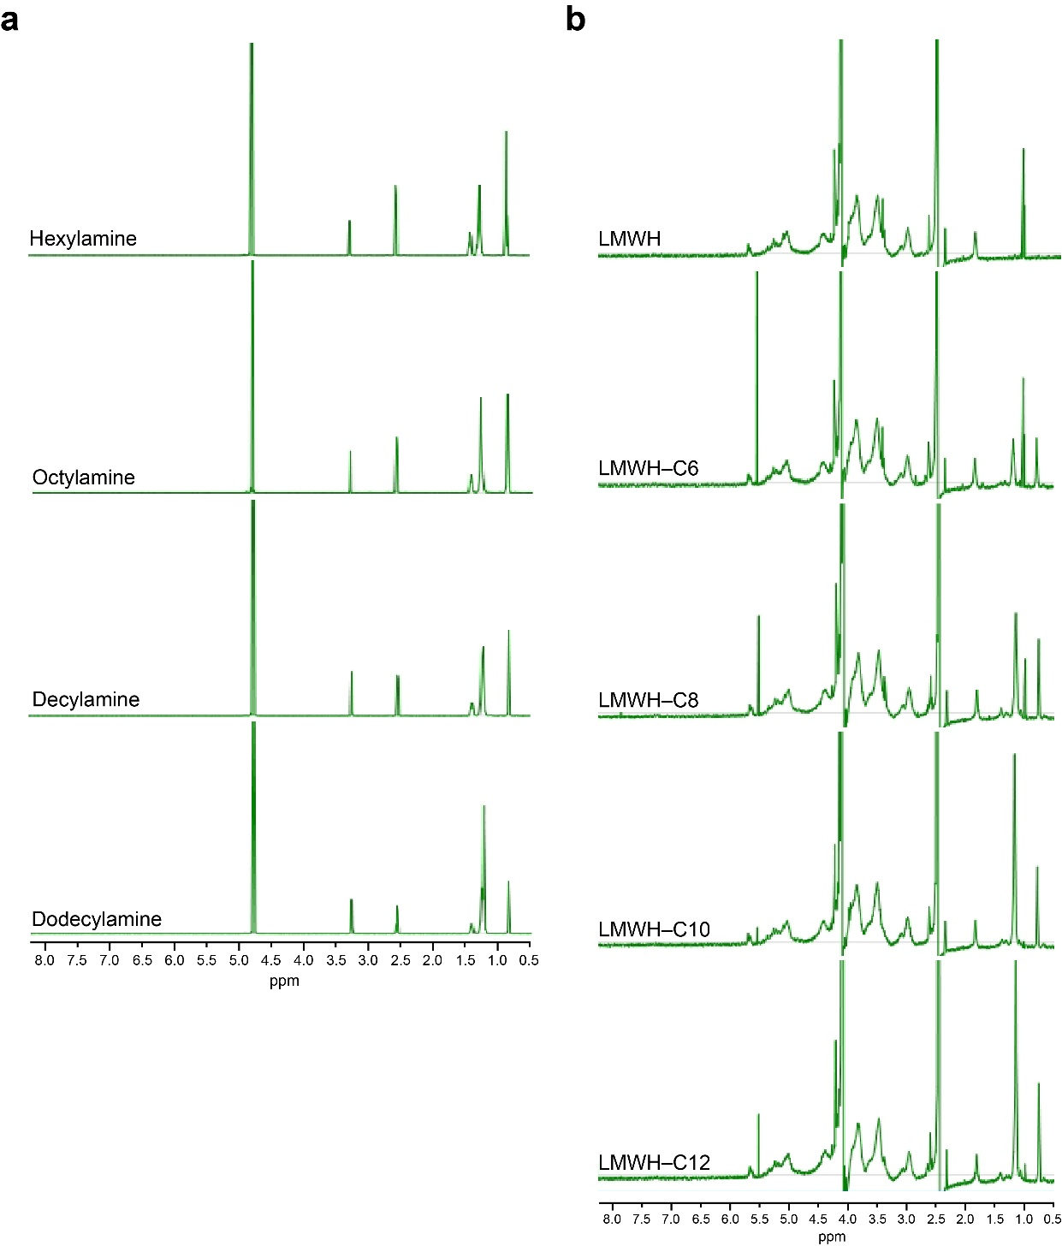
Supplementary Fig. 2 | a, b 1D ¹H-NMR results of fatty amines (hexylamine, octylamine, decylamine, and dodecylamine) (a) and the LMWH–lipid conjugates after conjugation on the reducing sugar end of LMWH (b).

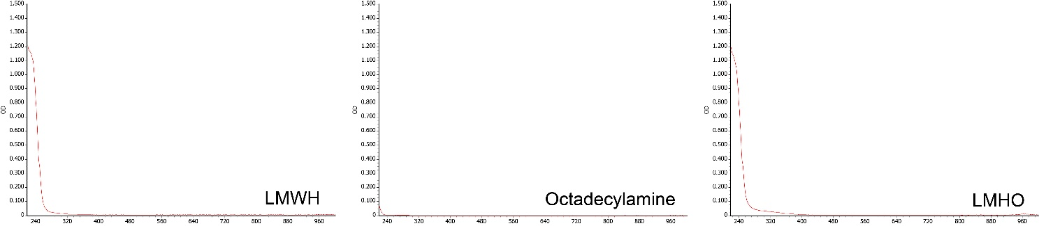
Supplementary Fig. 3 | UV-vis spectroscopic analysis of low molecular weight heparin (LMWH), octadecylamine, and LMHO.

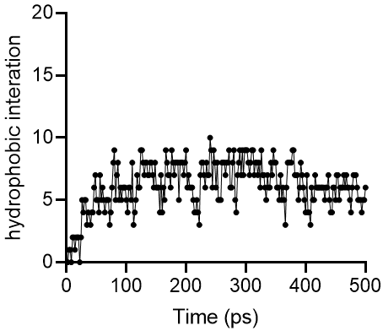
Supplementary Fig. 4 | The number of hydrophobic interaction bonds calculated from molecular dynamic (MD) simulations for self-assembly LMHO nanoparticle.

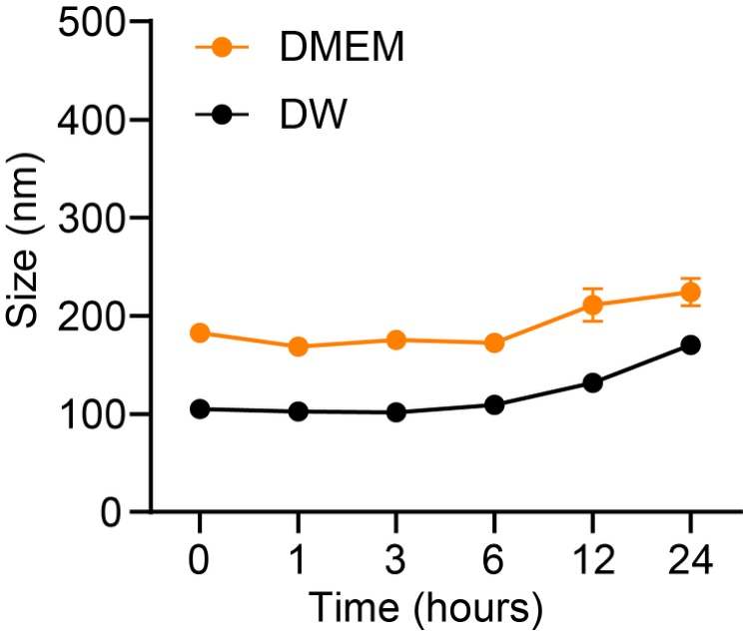
Supplementary Fig. 5 | The stability of LMHO nanoparticles in DMEM and distilled water (DW) for a duration of 24 hours (n = 3).

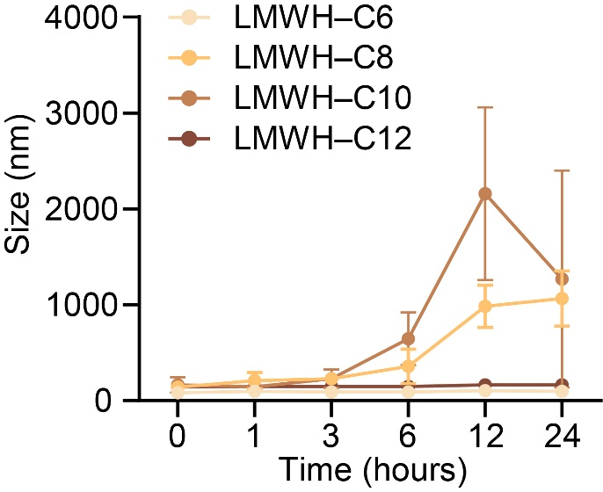
Supplementary Fig. 6 | The stability of LMWH–lipid conjugates (LMWH–C6, LMWH–C8, LMWH–C10, and LMWH–C12) nanoparticles in serum for a duration of 24 hours (n = 3).

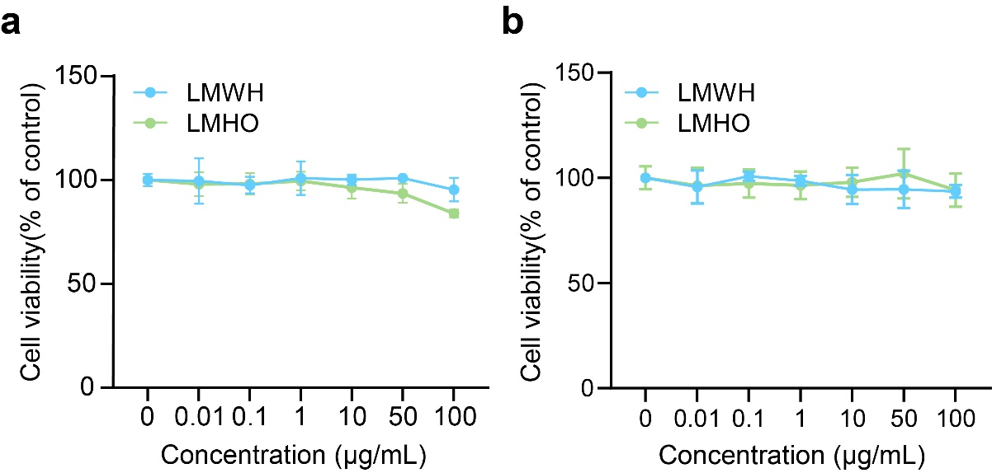
Supplementary Fig. 7 | a, b The cytotoxic effects of LMWH and LMHO with the concentration range of 0.01-100 µg/mL (n = 6) on MRC-5 (MRC-5 cells were fibroblast cells isolated from lung tissue of a 14-week-old male embryo of Caucasian origin) (a) and MDCK (MDCK cells were isolated from normal kidney tissue from a normal, adult, female cocker spaniel) (b).

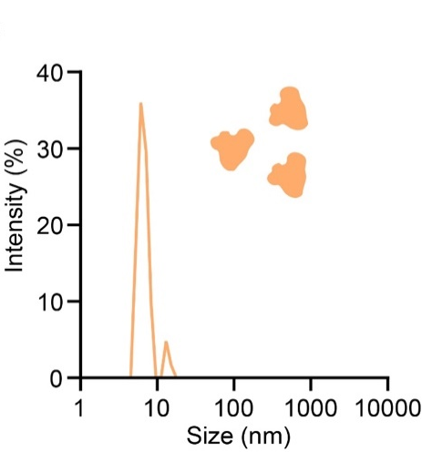
Supplementary Fig. 8 | The particle size distribution of human serum albumin (HSA) in aqueous condition using Dynamic Light Scattering (DLS).

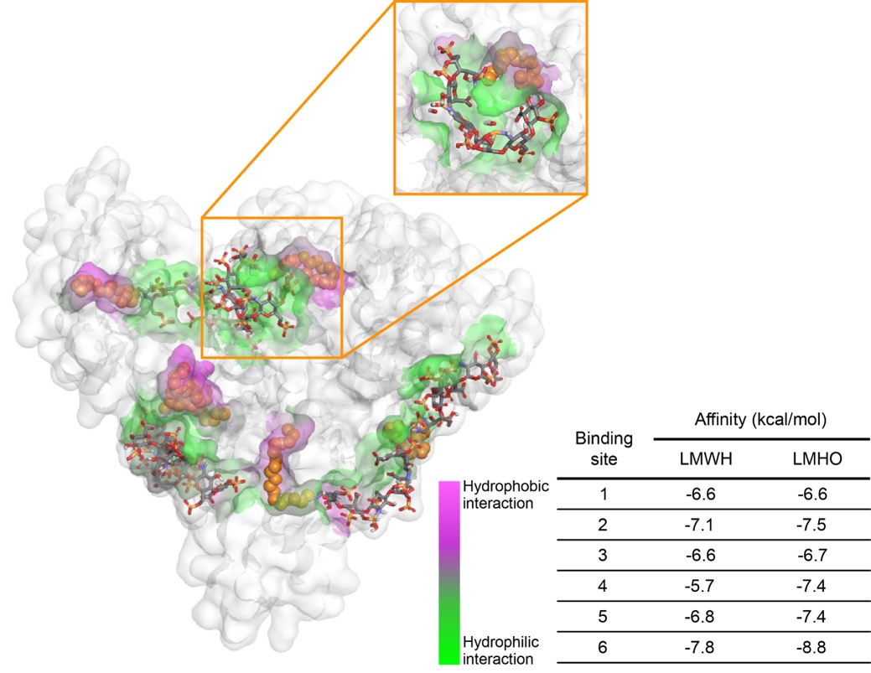
Supplementary Fig. 9 | The stability and interaction characteristics of LMWH and LMHO molecules after albumin sequential docking simulation with human serum albumin.

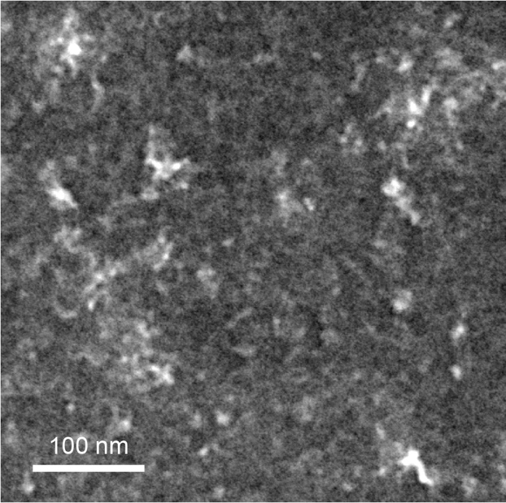
Supplementary Fig. 10 | The transmission electron microscopy (TEM) image of human serum albumin.

Supplementary Table 1. Pharmacokinetic parameters of LMHO and LMHO through the time course of anti-Xa activity measured in the rat plasma (n = 3).
 | Administration  route | Dose  (mg/kg) | AUC_{0-inf}  (h·µg·mL⁻¹) | CL  (mL·h⁻¹) | t_{1/2}  (h)
LMWH | Intravenous | 5 | 33.06 ± 3.84 | 38.16 ± 4.51 | 2.15 ± 0.89
LMHO | intravenous | 5 | 334.15 ± 159.48 | 4.33 ± 1.93 | 41.17 ± 19.15
*AUC; area under the curve, CL; clearance, t_{1/2}; half life; Data are presented as mean ± S.D.

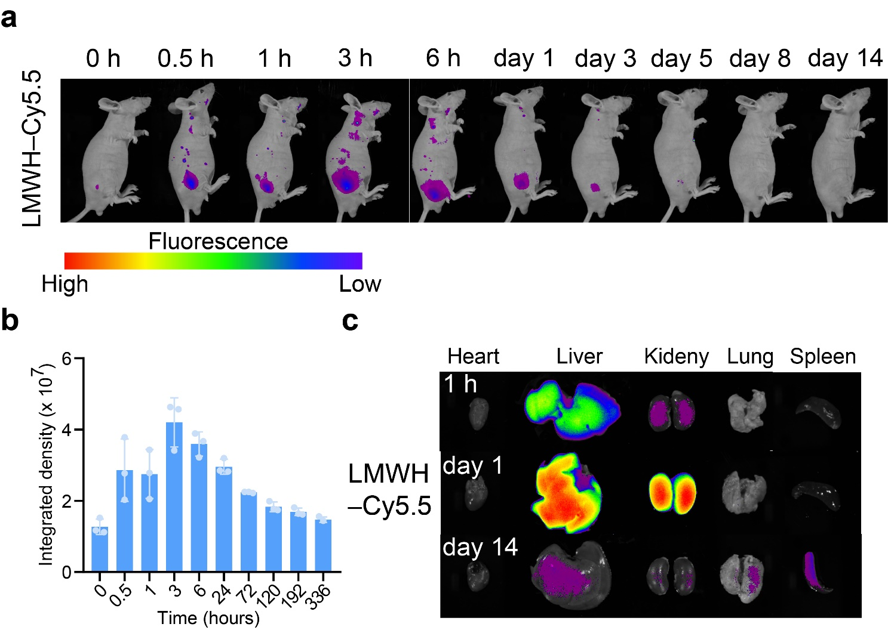
Supplementary Fig. 11 | Biodistribution of low-molecular-weight heparin (LMWH). a, b In vivo biodistribution of Cy5.5-labeled LMWH in BALC/c nude mice after subcutaneous administration (a) and the integrated density of each time point (b) (n = 3). c Fluorescence analysis of LMWH–Cy5.5 distributed in organs (the heart, liver, kidney, lung, and spleen) at 1 h, day 1, and day 14.

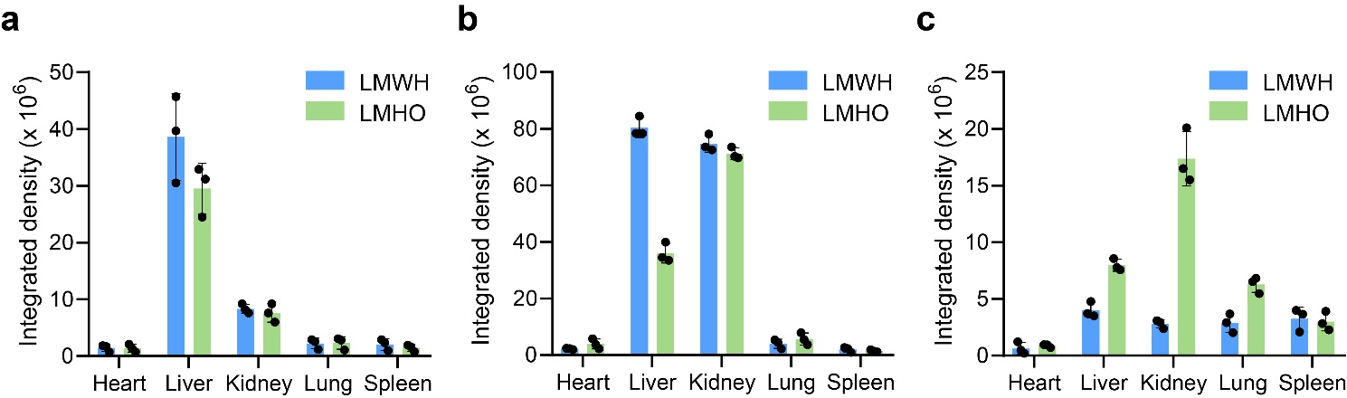
Supplementary Fig. 12 | a-c Quantification of fluorescence in major organs (the heart, liver, kidney, lung, and spleen) over time for Cy5.5-labeled LMWH and LMHO biodistribution at 1 h (a) day 1 (b), and day 14 (c) (n = 3).

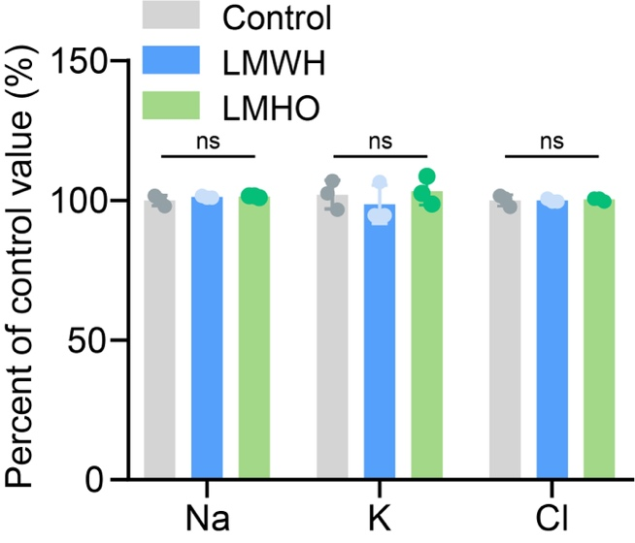
Supplementary Fig. 13 | Electrolyte (Na, K, Cl) percentage in serum versus control value as renal function parameters (n = 3).

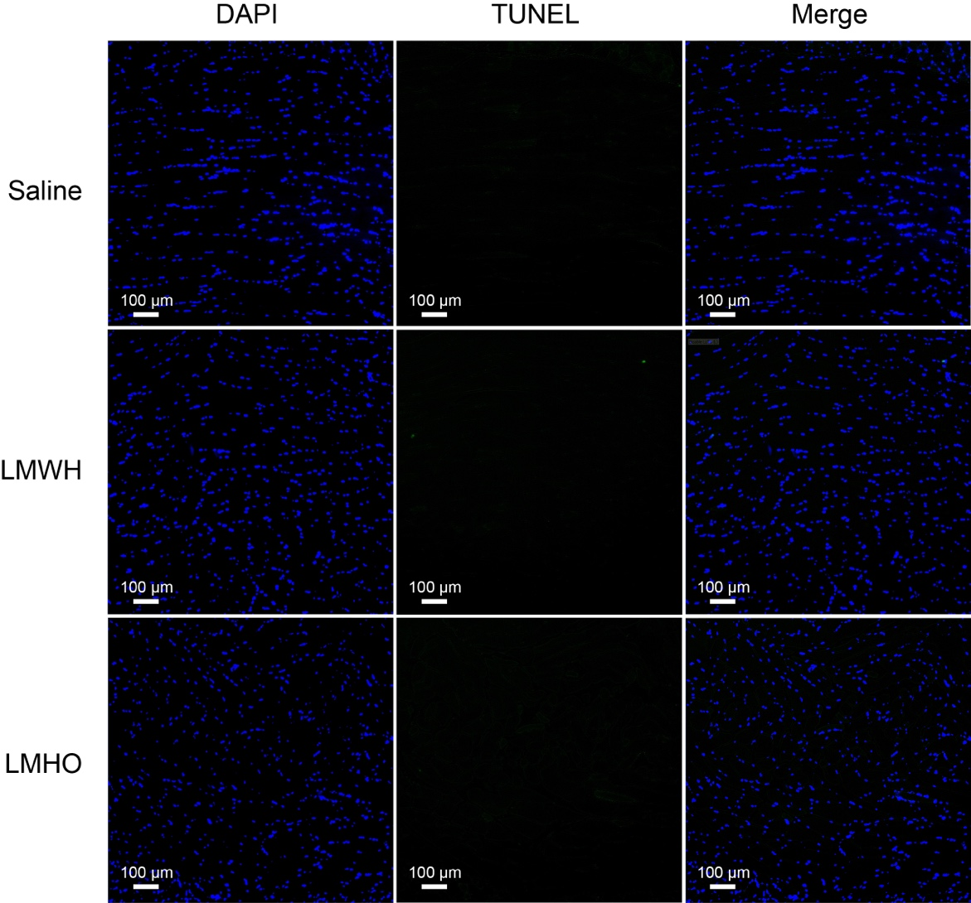
Supplementary Fig. 14 | Histological TUNEL staining on injection site tissues in BALB/c mice following saline, LMWH, and LMHO treatment.

