Supplementary Information
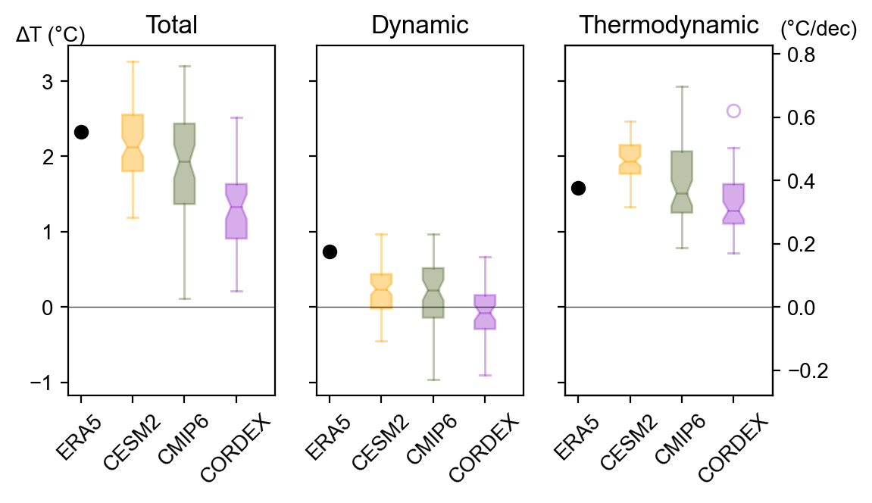
SFig. 1: As Fig. 3, but showing data for the full CORDEX (n=49) and CMIP6 (n=43) model ensembles rather than subsets with near-ERA5 background warming. We use a very long pre-industrial control simulation from CESM2 to train the statistical model for the dynamical adjustment, and additionally show results for a single-model ensemble of transient climate simulations, the CESM2 Large Ensemble (n=89) here.
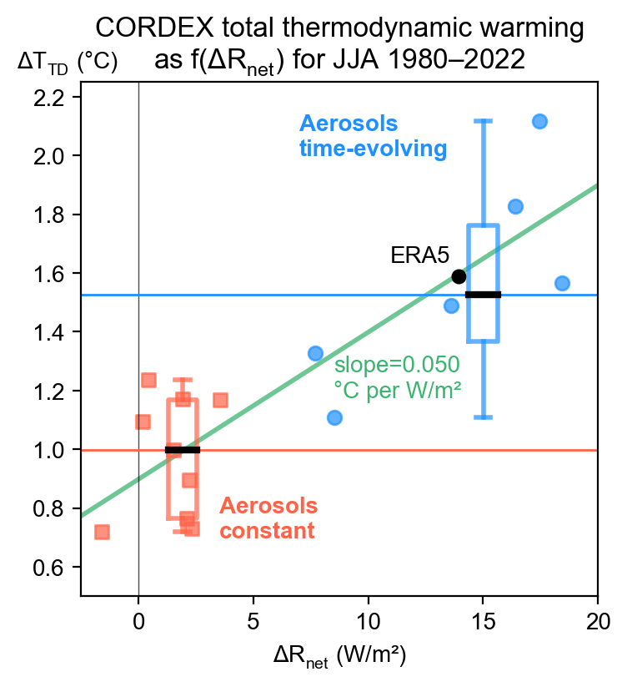
SFig. 2: As Fig. 4a, but using the total instead of regional thermodynamic warming. The resulting slope is nearly identical, and the intercept is not close to zero but rather roughly corresponds to the mean background warming.
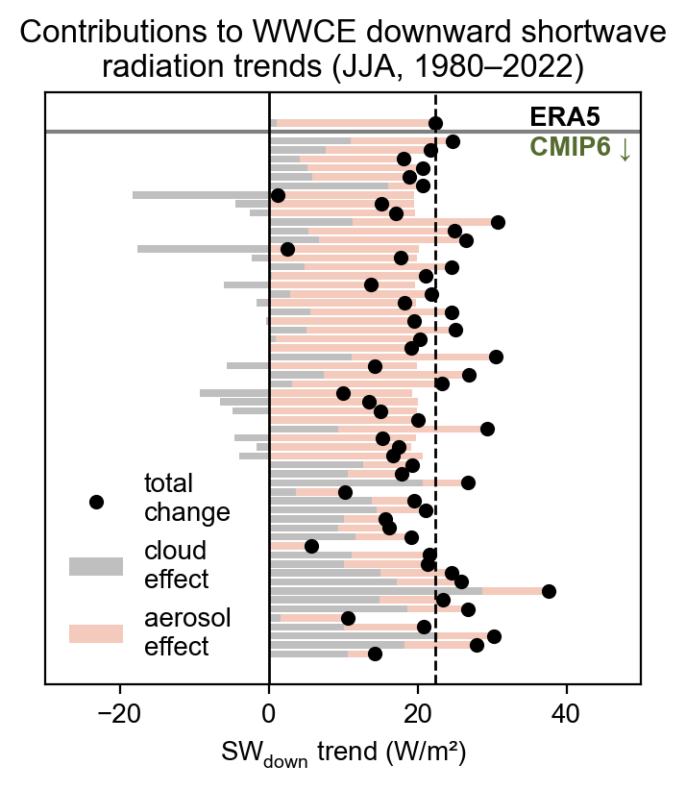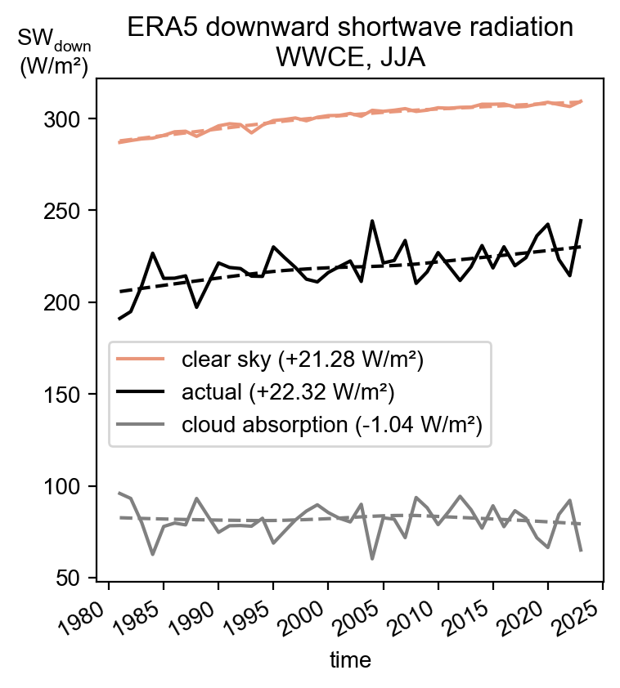
a b
SFig. 3: Effects of clouds and aerosol concentrations on shortwave radiation trends. a Clear-sky and actual shortwave downward radiation from ERA5, and also showing the difference of these variables, i.e. the radiation absorbed or scattered by clouds. Clear-sky radiation trends are, by definition, unaffected by changes in cloudiness, and thus indicate changes in atmospheric radiation attenuation that are in turn largely driven by aerosol emissions. The numbers shown in the legend correspond to linear trends calculated across the 1980–2022 period. b Condensed information obtained from the timeseries in (a) for ERA5 and analogously obtained contributions for all CMIP6 simulations (n=43).

Text describing SFig. 3
We extend our analysis by considering the clear-sky shortwave radiation of ERA5, which is a hypothetical quantity that expresses the amount of shortwave radiation that would reach Earth’s surface without clouds but otherwise unchanged conditions (e.g., air temperature and humidity). The difference of this variable and the actual shortwave radiation thus indicates the attenuation by clouds (gray line in SFig. 3a), which exhibits a linear trend of about -1.0 W/m² throughout the analysis period. In other words, less attenuation by clouds strengthens the incoming shortwave radiation at the surface, but this is far surpassed by the clear-sky contribution of +21.3 W/m². Fluctuations in the solar “constant” are comparatively small (e.g., Gueymard, 2018), such that changes in atmospheric transmittance must drive the strong increase in clear-sky shortwave radiation. In the case of (central) Europe, aerosols have been identified as the main factor, and hence the shortwave forcing is of predominantly anthropogenic origin (Wild et al., 2021).

We repeat the same analysis for CMIP6 models with clear-sky shortwave radiation available, and find that most simulations also reveal a primarily aerosol-enabled increase in downward shortwave radiation (light red bars in SFig. 3b), although cloud contributions are frequently stronger than in ERA5 (gray bars in SFig. 3b)
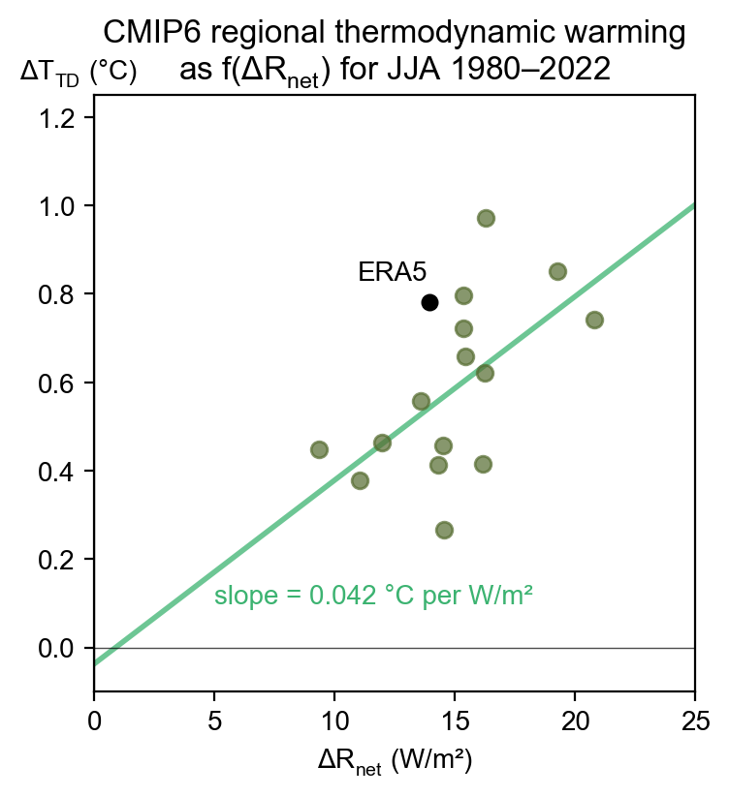
SFig. 4: As Fig. 4a but for the CMIP6 subset with near-ERA5 1980-2022 background warming.

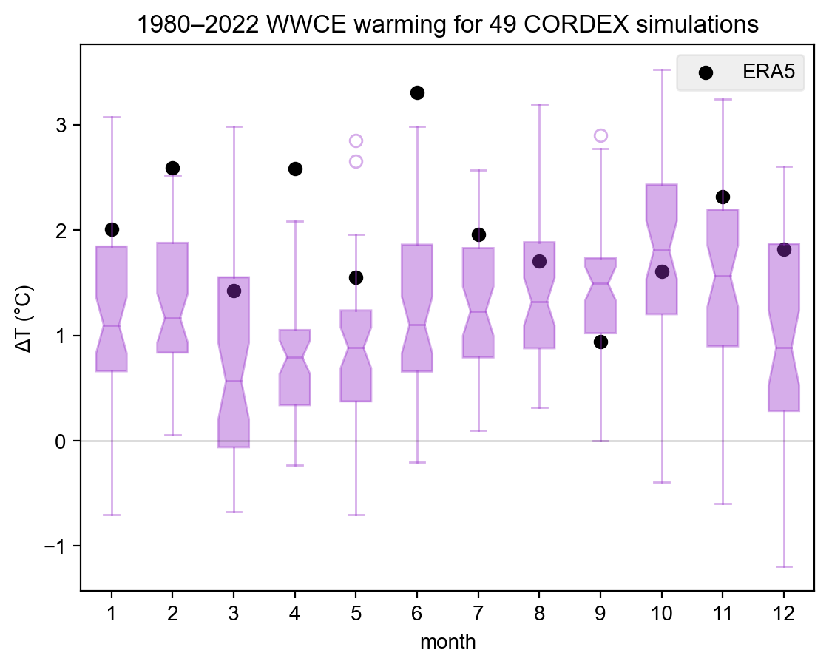
SFig. 5: Total 1980–2022 warming in WWCE per month for the EURO-CORDEX simulations used throughout the manuscript and ERA5, determined from linear trends.

