Genetically divergent shallow and mesophotic Stephanocoenia intersepta coral populations across Florida Keys National Marine Sanctuary
Ryan J. Eckert¹* (ORCID 0000-0002-3010-9395), Alexis B. Sturm¹ (ORCID 0000-0003-2153-7811), Ashley M. Carreiro¹ (ORCID 0000-0001-7204-8239), Allison M. Klein¹, Joshua D. Voss¹ (ORCID 0000-0002-0653-2767)
¹Harbor Branch Oceanographic Institute, Florida Atlantic University, Fort Pierce, Florida, USA
*ryan.j.eckert@gmail.com

SUPPLEMENTARY INFORMATION
Supplementary Table S1. Stephanocoenia intersepta sampling data.
Site | Depth  zone | Sampling  depth (m) | Average  depth (m) | N
Upper Keys | Shallow | 18.3–28.3 | 23.6 | 30
 | Mesophotic | 41.8–45.4 | 43.9 | 30
Lower Keys | Shallow | 17.1–19.2 | 18.0 | 30
 | Mesophotic | 31.4–35.1 | 32.8 | 30
Tortugas Bank | Shallow | 14.6–29.9 | 21.1 | 30
 | Mesophotic | 30.2–35.1 | 32.0 | 25
Riley's Hump | Shallow | 25.3–28 | 26.4 | 30
 | Mesophotic | 30.8–37.5 | 33.2 | 15

Supplementary Table S2. Distance-based redundancy analyses. Variance partition and analysis of variance outputs for environmental variables tested in dbRDA for S. intersepta genetic variation and in hospite Symbiodiniaceae ITS2 type profile community structure.
 |  | Variance partition |  |  |  | ANOVA
Organism | Variable | df | R² | Adjusted R² |  | SS | F | p-value
S. intersepta | Depth (m) | 1 | 0.01954 | 0.01504 |  | 0.3136 | 4.3445 | 0.001
 | Primary productivity (g m⁻³⁻d⁻¹) | 1 | 0.00579 | 0.00123 |  | 0.093 | 1.2702 | 0.04
 | Global | 2 | 0.02569 | 0.01671 |  | 0.4123 | 2.8611 | 0.001
Symbiodiniaceae | Depth (m) | 2 | 0.07981 | 0.07557 |  | 7.312 | 18.821 | 0.001
 | Current velocity (m s⁻¹) | 2 | 0.03670 | 0.03226 |  | 3.362 | 8.2665 | 0.001
 | Light (E m⁻² yr⁻¹) | 2 | 0.01925 | 0.01473 |  | 1.764 | 4.2594 | 0.001
 | Global | 3 | 0.14886 | 0.13295 |  | 12.608 | 11.437 | 0.001
df = degrees of freedom; R = correlation coefficient; SS = sum of squares; F = F-statistic
Supplementary Table S3. Average recent migration rates by source/sink depth zones.
Dataset | Mean m | SD | SEM
Global | 3.74 | 4.73 | 0.63
Mesophotic Sources | 5.52 | 5.90 | 1.11
Shallow Sources | 1.96 | 2.04 | 0539
Mesophotic Sinks | 3.50 | 5.70 | 1.08
Shallow Sink | 3.99 | 3.60 | 0.68
Mesophotic → Shallow | 4.89 | 3.93 | 0.98
Mesophotic → Mesophotic | 6.37 | 7.93 | 2.29
Shallow → Mesophotic | 1.35 | 0.86 | 0.22
Shallow → Shallow | 2.78 | 2.83 | 0.80

Supplementary Table S4. Test results from PERMANOVA (9,999 permutations) of Symbiodiniaceae ITS2 type profiles. Pairwise comparisons FDR corrected.
Test | Comparison | Pseudo-F | R² | p-value
Overall | Depth | 16.141 | 0.0586 | 0.0001
 | Site | 8.474 | 0.0923 | 0.0001
 | Depth:Site | 7.629 | 0.0831 | 0.0001
Site | Riley's Hump vs Tortugas Bank | 7.607 | 0.0720 | 0.0002
 | Riley's Hump vs Lower Keys | 11.696 | 0.1029 | 0.0002
 | Riley's Hump vs Upper Keys | 9.258 | 0.0825 | 0.0002
 | Tortugas Bank vs Lower Keys | 2.446 | 0.0214 | 0.0334
 | Tortugas Bank vs Upper Keys | 4.427 | 0.0377 | 0.0017
 | Lower Keys vs Upper Keys | 9.015 | 0.0715 | 0.0002
Site:Depth | Riley's Hump Shallow vs Riley's Hump Mesophotic | 1.851 | 0.041 | ns
 | Riley's Hump Shallow vs Tortugas Bank Shallow | 7.430 | 0.114 | 0.0002
 | Riley's Hump Shallow vs Tortugas Bank Mesophotic | 8.640 | 0.140 | 0.0002
 | Riley's Hump Shallow vs Lower Keys Shallow | 15.489 | 0.214 | 0.0002
 | Riley's Hump Shallow vs Lower Keys Mesophotic | 13.467 | 0.188 | 0.0002
 | Riley's Hump Shallow vs Upper Keys Shallow | 13.585 | 0.190 | 0.0002
 | Riley's Hump Shallow vs Upper Keys Mesophotic | 6.845 | 0.106 | 0.0005
 | Riley's Hump Mesophotic vs Tortugas Bank Shallow | 4.482 | 0.094 | 0.0011
 | Riley's Hump Mesophotic vs Tortugas Bank Mesophotic | 3.196 | 0.078 | 0.0272
 | Riley's Hump Mesophotic vs Lower Keys Shallow | 10.357 | 0.198 | 0.0002
 | Riley's Hump Mesophotic vs Lower Keys Mesophotic | 5.584 | 0.115 | 0.0033
 | Riley's Hump Mesophotic vs Upper Keys Shallow | 7.007 | 0.140 | 0.0005
 | Riley's Hump Mesophotic vs Upper Keys Mesophotic | 1.342 | 0.030 | ns
 | Tortugas Bank Shallow vs Tortugas Bank Mesophotic | 7.456 | 0.123 | 0.0004
 | Tortugas Bank Shallow vs Lower Keys Shallow | 6.042 | 0.096 | 0.0011
 | Tortugas Bank Shallow vs Lower Keys Mesophotic | 9.729 | 0.144 | 0.0002
 | Tortugas Bank Shallow vs Upper Keys Shallow | 9.906 | 0.146 | 0.0002
 | Tortugas Bank Shallow vs Upper Keys Mesophotic | 9.477 | 0.140 | 0.0002
 | Tortugas Bank Mesophotic vs Lower Keys Shallow | 16.781 | 0.244 | 0.0002
 | Tortugas Bank Mesophotic vs Lower Keys Mesophotic | 1.193 | 0.022 | ns
 | Tortugas Bank Mesophotic vs Upper Keys Shallow | 3.741 | 0.066 | 0.0147
 | Tortugas Bank Mesophotic vs Upper Keys Mesophotic | 3.855 | 0.068 | 0.0258
 | Lower Keys Shallow vs Lower Keys Mesophotic | 21.369 | 0.273 | 0.0002
 | Lower Keys Shallow vs Upper Keys Shallow | 20.115 | 0.261 | 0.0002
 | Lower Keys Shallow vs Upper Keys Mesophotic | 21.339 | 0.272 | 0.0002
 | Lower Keys Mesophotic vs Upper Keys Shallow | 4.919 | 0.078 | 0.0060
 | Lower Keys Mesophotic vs Upper Keys Mesophotic | 9.149 | 0.136 | 0.0006
 | Upper Keys Shallow vs Upper Keys Mesophotic | 10.593 | 0.154 | 0.0002
ns = non-significant p-value
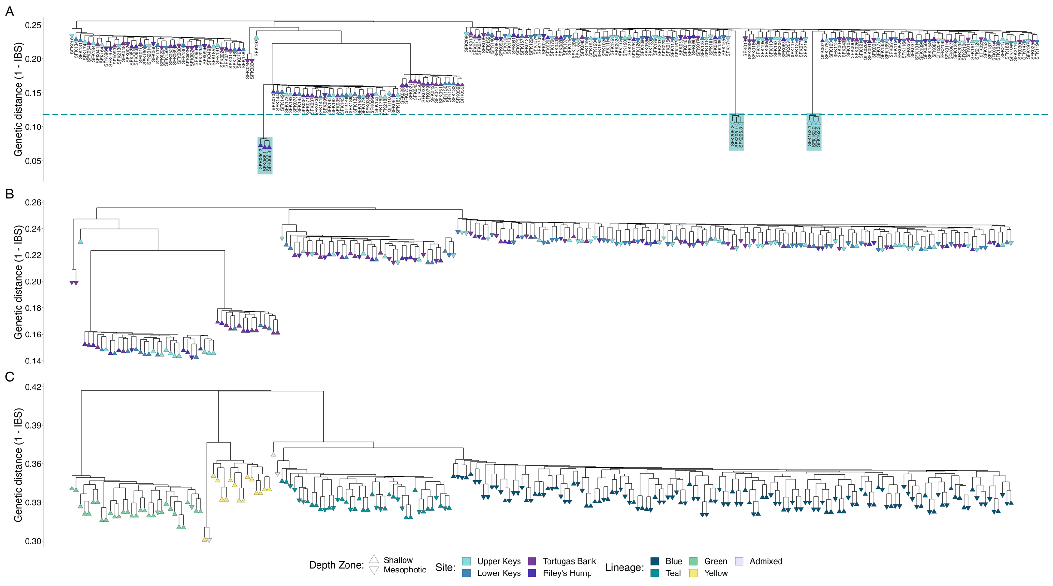
Supplementary Figure S1. Stephanocoenia intersepta cluster dendrograms. A) Hierarchical clustering of samples based on genetic distance (identity-by-state) including technical triplicate samples (red boxes) to establish a baseline for clonality (red dashed line). B) Hierarchical clustering of samples without technical replicates. C) Hierarchical clustering of samples in (B) based on IBS from common SNPs among lineages, colored by lineage assignment from ngsadmix.

