Quantifying future changes of flood hazards within the Broadland catchment in the UK
Ross Gudde¹ • Yi He¹ (yi.he@uea.ac.uk) • Ulysse Pasquier² • Nicole Forstenhäusler ¹ • Ciar Noble³ • Qianyu Zha ¹
¹ Tyndall Centre for Climate Change Research, School of Environmental Sciences, University of East Anglia, Norwich Research Park, Norwich NR4 7TJ, UK
² Climate and Ecosystem Sciences Division, Lawrence Berkeley National Laboratory, 1 Cyclotron Road, Berkeley, CA 94720, USA
³ School of Environmental Sciences, University of East Anglia, Norwich Research Park, Norwich NR4 7TJ, UK

Appendix A – Supplementary Tables and Figures
Table A1. Modelled flood scenarios. Abbreviations are as follows: sea level (SL), sea level rise (SLR) and river discharge (RD).
Type of event | Year | Sea level (SL) | River discharge (RD)
1:100 storm surge and river base flow | 1990 | 1:100 storm surge | 5th percentile 1990 RD
1:100 storm surge and river base flow | 2030 | 95th percentile SLR and 1:100 storm surge | 5th percentile 2030 RD
1:100 storm surge and river base flow | 2070 | 95th percentile SLR and 1:100 storm surge | 5th percentile 2070 RD
1:100 river peak flow and base tide. | 1990 | Mean SL and no storm surge | 95th percentile RD and 1:100 RD event
1:100 river peak flow and base tide. | 2030 | Mean SL and no storm surge. | 95th percentile RD and 1:100 RD event
1:100 river peak flow and base tide. | 2070 | Mean SL and no storm surge. | 95th percentile RD and 1:100 RD event
1:10,000 compound event | 1990 | 1:100 storm surge | 95th percentile RD and 1:100 RD event
1:10,000 compound event | 2030 | 95th percentile SLR and 1:100 storm surge | 95th percentile RD and 1:100 RD event
1:10,000 compound event | 2070 | 95th percentile SLR and 1:100 storm surge | 95th percentile 2070 RD and 1:100 RD event

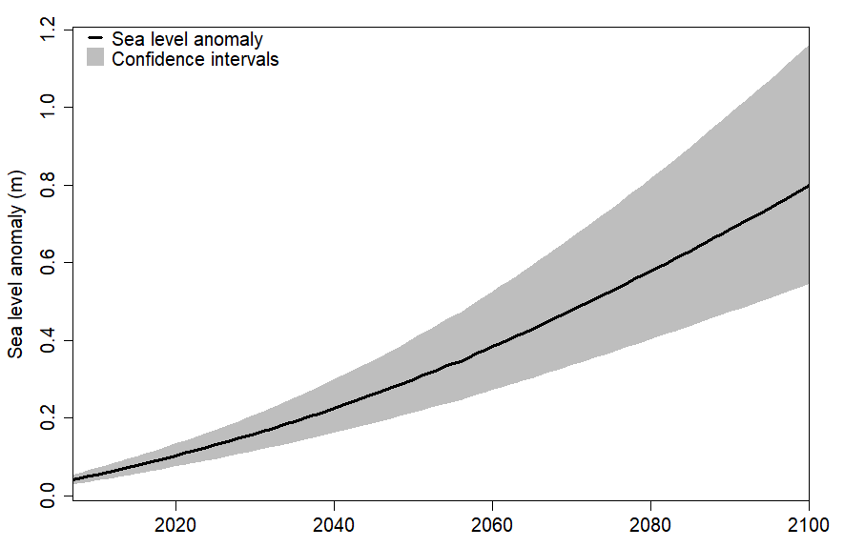
Figure A1. UKCP18 projected sea level rise from 2007-2100 at Lowestoft tide gauge. Confidence intervals (grey) represent the 5th to 95th percentile of data.

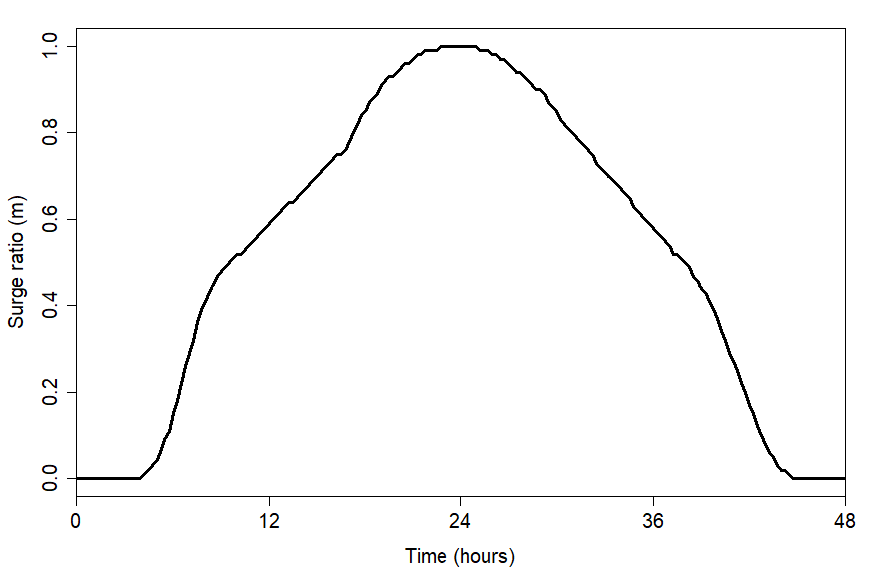
Figure A2. Normalised surge profile at Lowestoft tide gauge obtained from the Environment Agency (2011) practical guidance for coastal design sea levels.
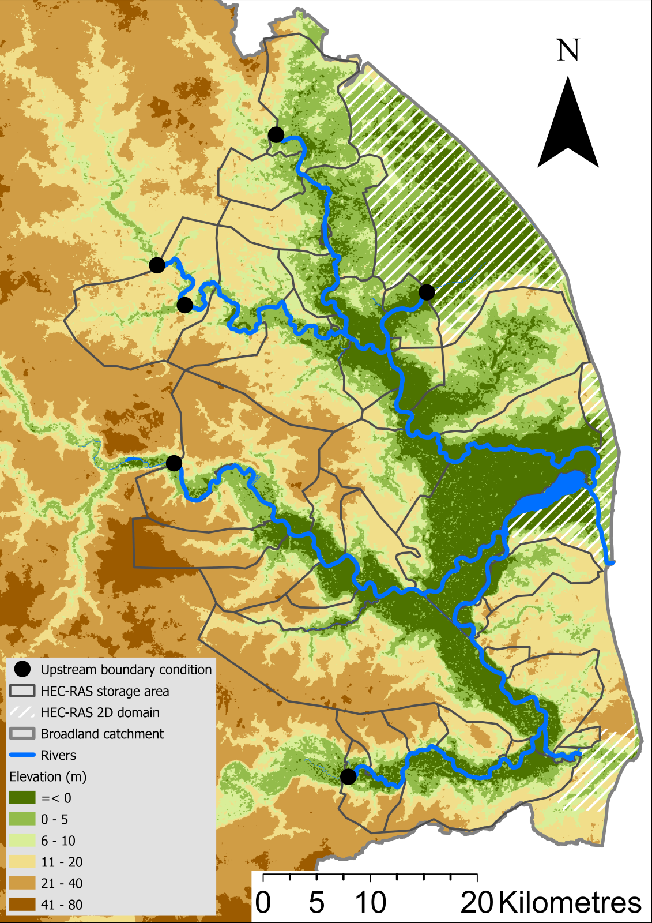
Figure A3. Model domain and structure of the 1D-2D integrated HEC-RAS hydraulic model.
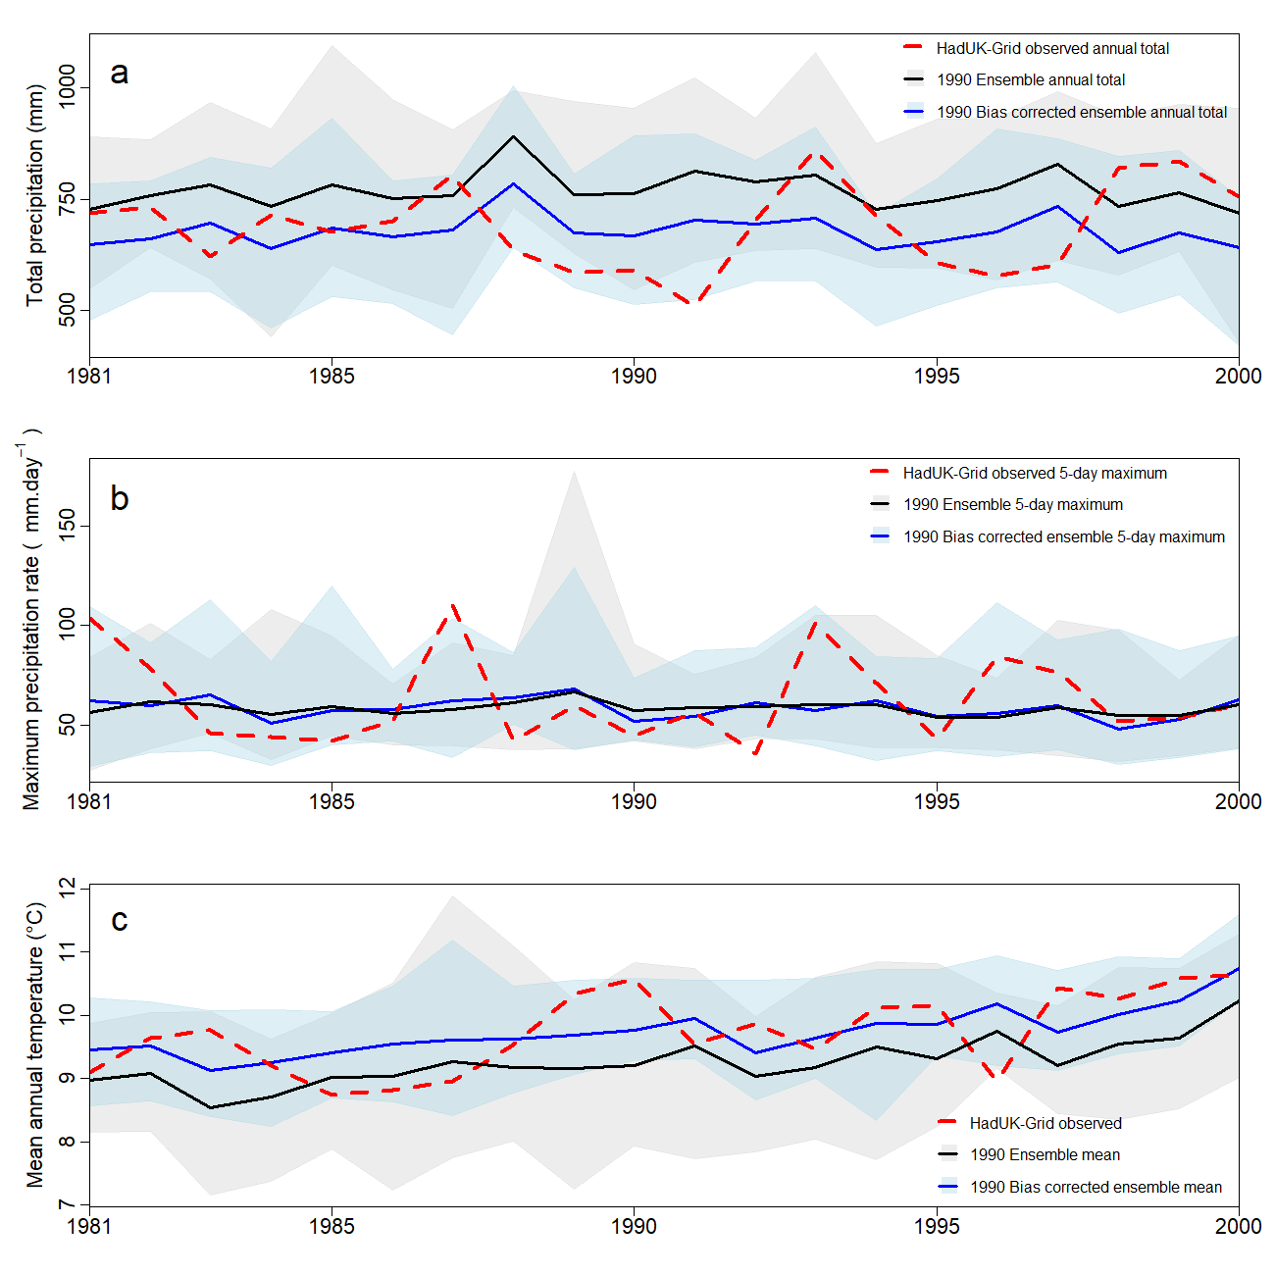
Figure A4. Annual variation of the HadUK-Grid observations (red), and the raw (black) and bias corrected (blue) CPM data in the baseline period within catchment 34003 (Bure). The grey and blue shaded areas represent the ranges of the 12 ensemble members from the raw and bias corrected data, respectively. (a) total precipitation (mm); (b) 5-day maximum precipitation rate (mm.day⁻¹); and (c) mean temperature (°C).

