Supplementary materials for “Protocol of the Comparison of Intravesical Therapy and Surgery as Treatment Options (CISTO) Study: a pragmatic, prospective multicenter observational cohort study of recurrent high-grade non-muscle invasive bladder cancer”

1. Supplementary Figure 1.
2. Supplementary Table 1.

Supplemental Figure 1. CISTO Study sites. A map of the 36 sites participating in the CISTO Study.
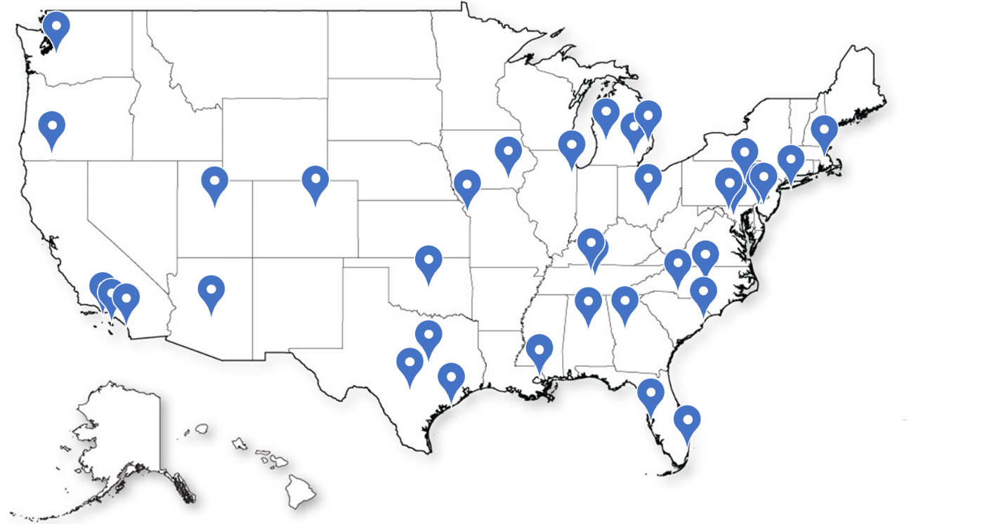
Supplemental Table 1. Candidate baseline variables to be included in TMLE models.
Variable | Variable Specification
Age | Age at enrollment as continuous and categorical variable
Gender | Male, female, other
Race/ethnicity | Non-Hispanic White vs. all other racial/ethnic groupings
Comorbid health conditions | Enumerated comorbidities; ECOG performance status; PROMIS Emotional Distress-Anxiety/Depression – Short Forms 4a
Smoking history | Pack-years; categorized as active, former, never
Cancer severity  Stage  Cancer histology  Multifocality  Size | Tumor stage classification (T2 or T3)  Urothelial vs. mixed histology with atypical variant  Unifocal or multifocal tumor  Largest diameter (cm)
Caregiver status | Partnered vs. unpartnered
Social determinants of health | Area Deprivation Index based on ZIP Code(41); Employment Status; Combined Family Income; Education Level;  Health Care / Prescription Drug Coverage
Rurality | Rural-Urban Commuting Area (RUCA) code based on ZIP code(42)
Patient preferences | Preferences for health states relevant to NMIBC
Health literacy | Single Item Literacy Screener (SILS)(43)
Baseline QOL | Baseline EORTC QLQ-C30(22) and BCI(25)
ECOG: Eastern Cooperative Oncology Group
TMLE: targeted maximum likelihood estimation; ECOG: Eastern Cooperative Oncology Group; PROMIS: Patient Reported Outcome Measurement Information System, NMIBC: non-muscle-invasive bladder cancer; QOL: quality of life; EORTC QLQ-C30: European Organisation for Research and Treatment of Cancer Core Quality of Life; BCI: Bladder Cancer Index.

