Table S1 Clinical data of HS ILAE type 1 and no-HS patients
Sample | Age at surgery(years) | Gender | First year of age(years) | AEDs | ILAE classification | RNA-Seq
I1 | 24 | M | 9 | PHB LEV VPA | I | Y
I2 | 29 | M | 9 | CBZ LTG | I | Y
I3 | 29 | F | 4 | VPA LEV TPM | I | Y
I4 | 7 | F | 4 | LEV CBZ LTG | I | N
I5 | 9 | M | 1 | LEV CBZ LTG | I | N
I6 | 24 | F | 4 | LEV LTG | 1 | N
I7 | 14 | M | 5 | CBZ LTG | 1 | N
C1 | 27 | M | 22 | PHB LEV VPA | No-HS | Y
C2 | 31 | M | 29 | OXC VPA TPM | No-HS | Y
C3 | 30 | F | 27 | PHB LEV VPA | No-HS | Y
C4 | 46 | M | 36 | PHB LEV | No-HS | N
C5 | 26 | F | 18 | CBZ TPM | No-HS | N
C6 | 26 | F | 11 | CBZ VPA | No-HS | N
C7 | 51 | F | 27 | OXC VPA TPM | No-HS | N

Table S2 Primer sequences of the quantitative real-time reverse transcription polymerase chain reaction (RT-qPCR) for validation of circRNA and related mRNA.
 | Primers | Primer Sequences
1 | FYN-F | TGGAGGTGTGAACTCTTCGTC
1 | FYN-R | TCTGTCCGTGCTTCATAGTCA
2 | SELENBP1-F | ACCCAGGGAAGAGATCGTCTA
2 | SELENBP1-R | ACTTGGGGTCAACATCCACAG
3 | GRIPAP1-F | GGACAAACAACTACCAGCTTTCA
3 | GRIPAP1-R | GCGACCTTCTGTCGAAGACT
4 | hsa_circ_0025349-F | GCGAACATGCTTCCGAAGAT
4 | hsa_circ_0025349-R | TGACCAGCCTCAACTCCAAA
5 | hsa_circ_0002405-F | ACTCCTGTACCAGTCCTACAA
5 | hsa_circ_0002405-R | GACGATTGAGGTCCTTTGGA
6 | hsa_circ_0004805-F | AGAGACTGCTTTTGAGTGACA
6 | hsa_circ_0004805-R | TGCAGAAAAGCCTTCCACTG
7 | hsa_circ_0032254-F | GAAATCATCAATTACCGAGATTCC
7 | hsa_circ_0032254-R | GAAGGAGTAGTGCTGAGGGAGG
8 | hsa_circ_0032875-F | CAGCGACTCTGAGGAGGAACA
8 | hsa_circ_0032875-R | CCTGCCTCTTTTCCACAGAAAC
9 | GAPDH-F | GGAGCGAGATCCCTCCAAAAT
9 | GAPDH-R | GGCTGTTGTCATACTTCTCATGG

Fig. S1 Immunohistochemical NeuN staining of ILAE-1 and no-HS group. A. Low-magnification view of the ILAE-1 group showing neuronal loss in the CA4 and CA1 regions; High-magnification view of the ILAE-1 group in CA4 (A1) and CA1 (A2) ; B. Low-magnification view of the no-HS group showing no neuronal loss in the CA4 and CA1 ; High-magnification view of the no-HS group in CA4 (B1) and CA1 (B2). Scale bars = 3 mm (A、B) and 200 µm (A1, A2, B1, B2). C. Comparison of neuronal density between the HS ILAE type 1 and No-HS groups

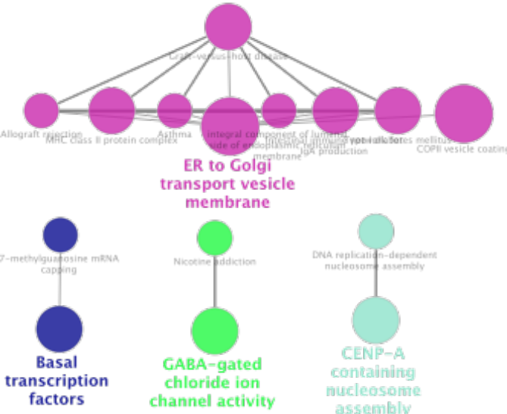
Fig. S2 Use of ClueGO/CluePedia to analyse the interaction networks of enriched biologic processes. Multiple color dots indicate that it revolves around multiple biologic processes. The GO term/pathway network connectivity defined by edges and functional clusters on genes shared between terms (kappa score ≥ 0.4) and displaying pathways only with p≤ 0.05.

