Supporting Information for
Enzyme-Instructed Peptide Self-Assembly as A Cell Membrane Lichen Activating Macrophage-Mediated Cancer Immunotherapy

Weiqi Zhang, Yinghua Zeng, Qiuqun Xiao, Yuanyuan Wu, Jiale Liu, Haocheng Wang, Yuting Luo, Jie Zhan*, Ning Liao*, Yanbin Cai*

*Corresponding author: zhanjie0507@smu.edu.cn (J. Zhan); drningliao@163.com (N. Liao); skyer1@smu.edu.cn (Y. Cai)

Supplementary materials
- Materials
Fmoc-amino acids, Fmoc-OSu, o-benzotriazol-1-yl-N,N,N’,N’-tetramethyluronium hexafluorophosphate (HBTU), dichloromethane (DCM), trifluoroacetic acid (TFA), trimethylsilane (TIS) and 2-chlorotrityl chloride resin were obtained from GL Biochem (Shanghai, China). Methanol (MeOH), β-Alanine, NBD-CI, HCI, Cy5.5-NHS, and K₂CO₃ were acquired from Macklin (Shanghai, China). Mouse IgG1 isotype control (clone MOPC-21) and anti-mouse CD24 (clone M1/69) were purchased from BioXcell. N,N-Diisopropylethylamine (DIPEA), hydrazine hydrate and Fmoc-Lys(Dde)-OH were obtained from ACMEC (Shanghai, China). NHS-PEG2000-Mal was acquired from Ruixibio (Xi’an, China).
2. Synthesis of NBD-β-ala-OH
A mixture of 540 mg β-alanine and 1.38 g K₂CO₃ was dissolved in 50 mL of methanol and a small amount of water. The solution was stirred until completely dissolved. Subsequently, 1g (5 mmol, 1 eq) of NBD-Cl was dissolved in 20 mL of methanol and slowly injected into the reaction flask via syringe. The reaction proceeded overnight at room temperature. After completion of the reaction, the methanol was removed by rotary evaporation under vacuum. The remaining aqueous solution was adjusted to pH 1-2 with 2 M HCl and then filtered to collect the brownish-yellow solid precipitate, which was the product NBD-β-ala-OH. This could be directly used in solid-phase peptide synthesis reactions.
3. Synthesis of Pep-PEG (NBD), Pep-PEG (Cy5.5), SAMI (NBD), SAMI (Cy5.5)
Pep-PEG (NBD, NBD-FFVLK(PEG₂₀₀₀)-AWSATWSNpYWRH), Pep-PEG (Cy5.5, Cy5.5-FFVLK(PEG₂₀₀₀)-AWSATWSNpYWRH), SAMI (NBD, NBD-FFVLK(PEG₂₀₀₀)-AWSATWSNYWRH), and SAMI (Cy5.5, Cy5.5-FFVLK(PEG₂₀₀₀)-AWSATWSNYWRH) were synthesized according to published methods. In brief, typical Fmoc solid-phase peptide synthesis protocols were utilized with the appropriate N-Fmoc and 2-chlorotrityl resin to synthesize Pep-PEG (NBD), Pep-PEG (Cy5.5), SAMI (NBD), and SAMI (Cy5.5), employing protected amino acids with suitable side chain protection. First, the C-terminus of the first amino acid was activated and coupled to the 2-chlorotrityl resin. After washing with DCM and DMF, the Fmoc protecting group was cleaved with 20 % piperidine in DMF. For better coupling of the next amino acid to the free amine, the coupling reagent HBTU was required. Repeat the Fmoc-cleaved and amino acid-added steps until the coupling of NBD-β-ala-OH or Cy5.5-NHS to the last amino acid. The added amino acid K was Fmoc-Lys(Dde)-OH, followed by cleavage of the Dde protecting group with 2 % hydrazine in DMF. NHS-PEG₂₀₀₀-Mal was then coupled like an amino acid. Excess reagents were removed by washing 5 times with DMF and 5 times with DCM. The peptide derivatives were then cleaved from the resin with 95 % TFA containing 2.5 % H₂O and 2.5 % TIS, and the mixture was rotary evaporated. The peptides were precipitated with anhydrous ether and the products collected. Purification by high performance liquid chromatography (HPLC) using MeOH/H₂O (0.05 % TFA) as the eluent provided the pure peptides.
4. Synthesis of PAC-SABIs (NBD) and PAC-SABIs (Cy5.5)
The synthesis of PAC-SABIs (NBD) and PAC-SABIs (Cy5.5) was achieved through nucleophilic addition between the maleimide group exposed on the peptides and the thiol group present on the anti-CD24 monoclonal antibody (mAb). Specifically, Pep-PEG (NBD) and Pep-PEG (Cy5.5) obtained in the previous step were dissolved in 0.01 M PBS buffer (pH 7.4) and induced to form a stabilized micellar structure by ultrasonic shaking. Further, we added anti-CD24 mAb into the mixed solution system in different mAb to peptide ratios. The mixture was gently shaken. The reaction mixtures were stirred at room temperature under light protection for 24 h to allow the coupling reaction to proceed. The resulting PAC-SABIs (NBD) and PAC-SABIs (Cy5.5) were stored in PBS (pH=7.4) at 4 °C for subsequent experiments.

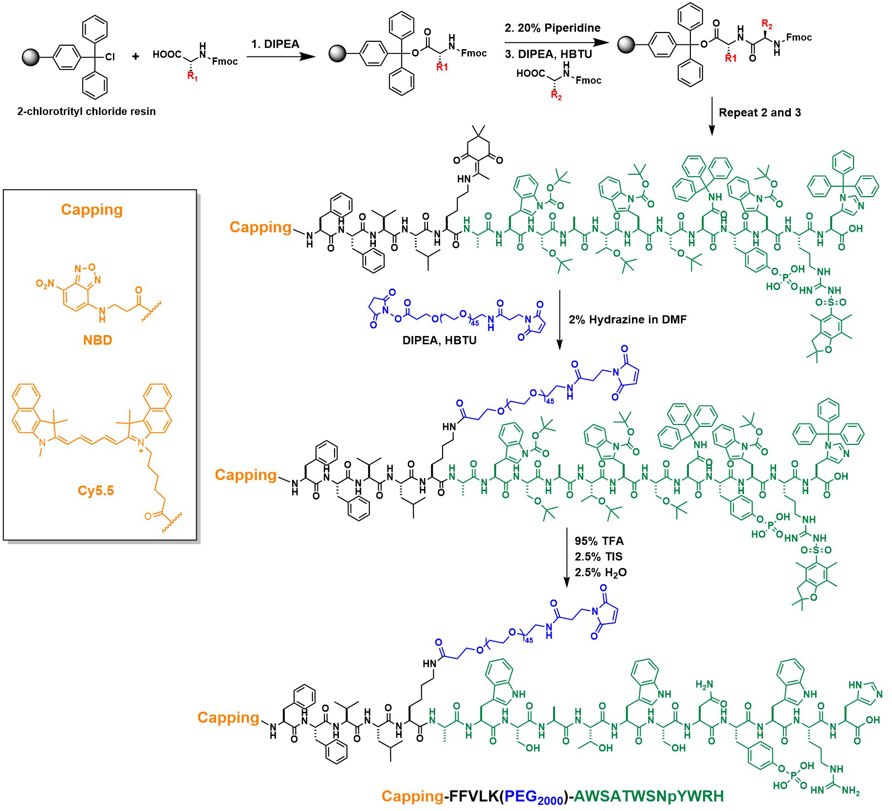
Scheme S1. The synthetic route for Pep-PEG.

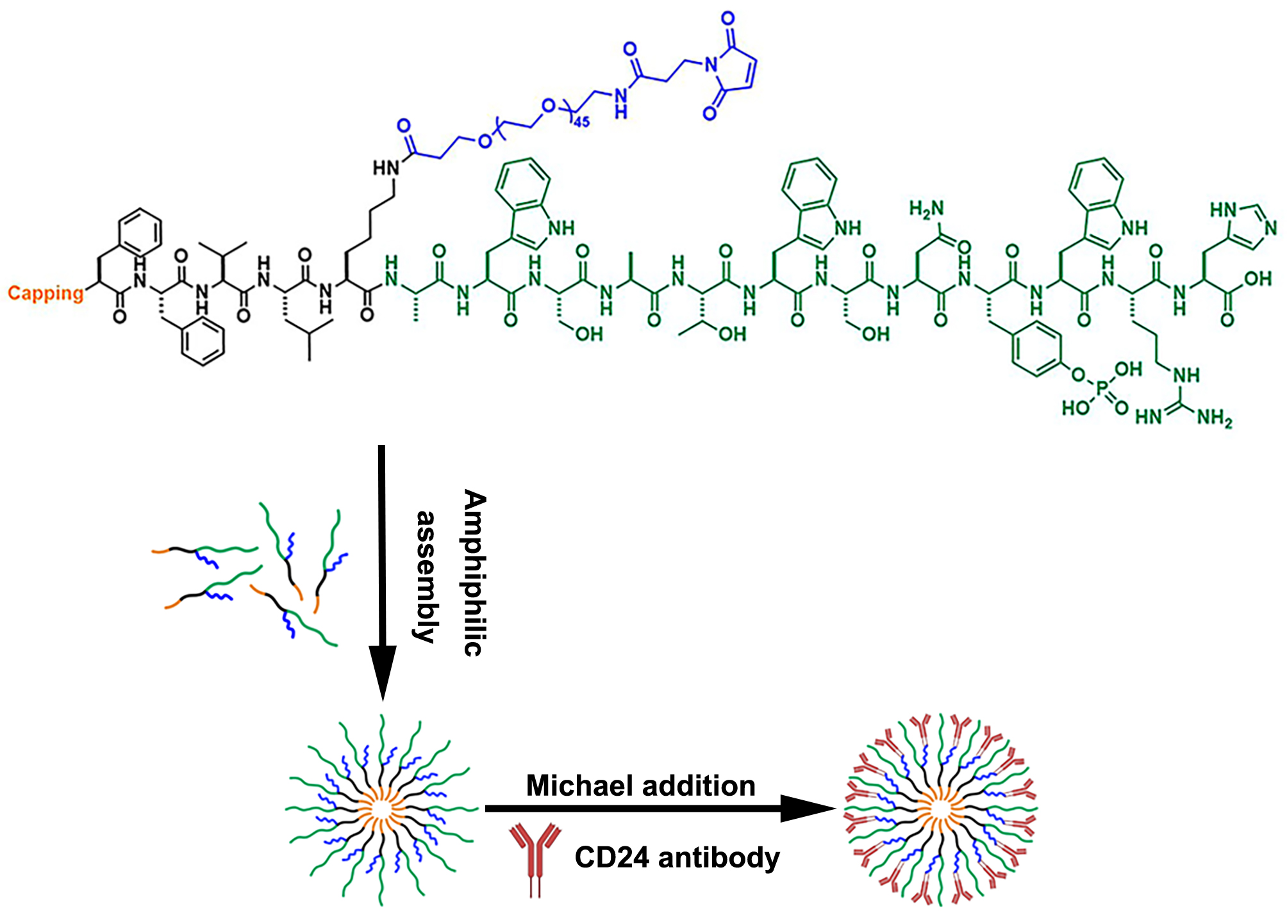
Scheme S2. The synthetic route for PAC-SABI.

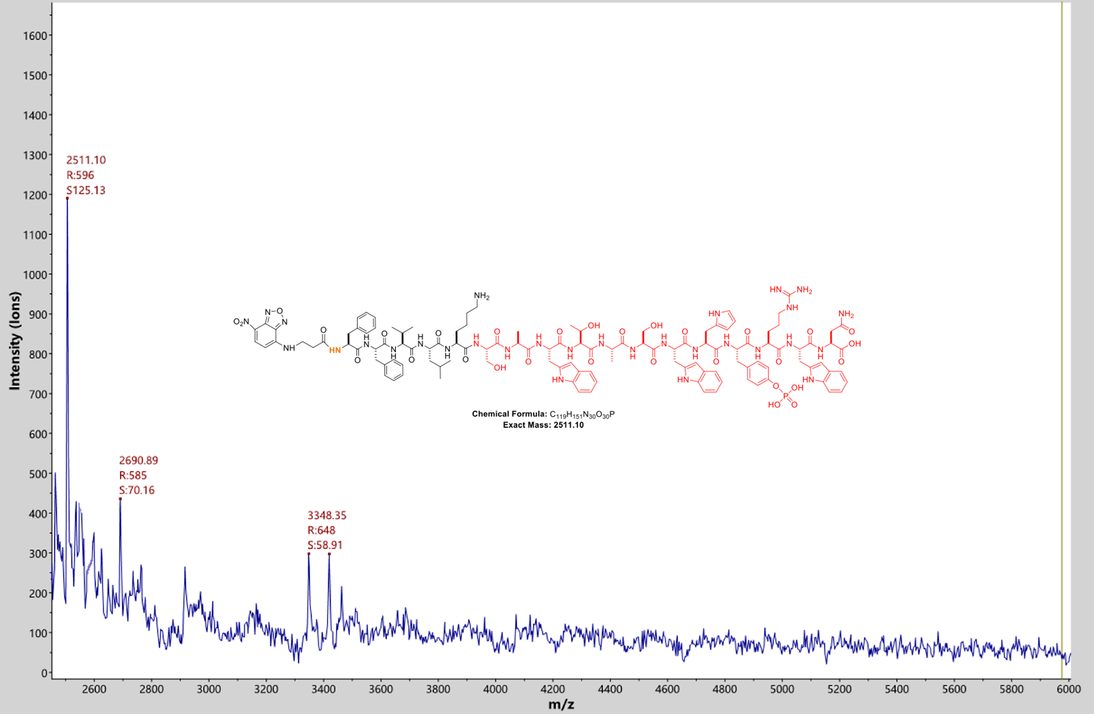
Figure S1. MALDI-TOF mass spectrometry of Pep (NBD).

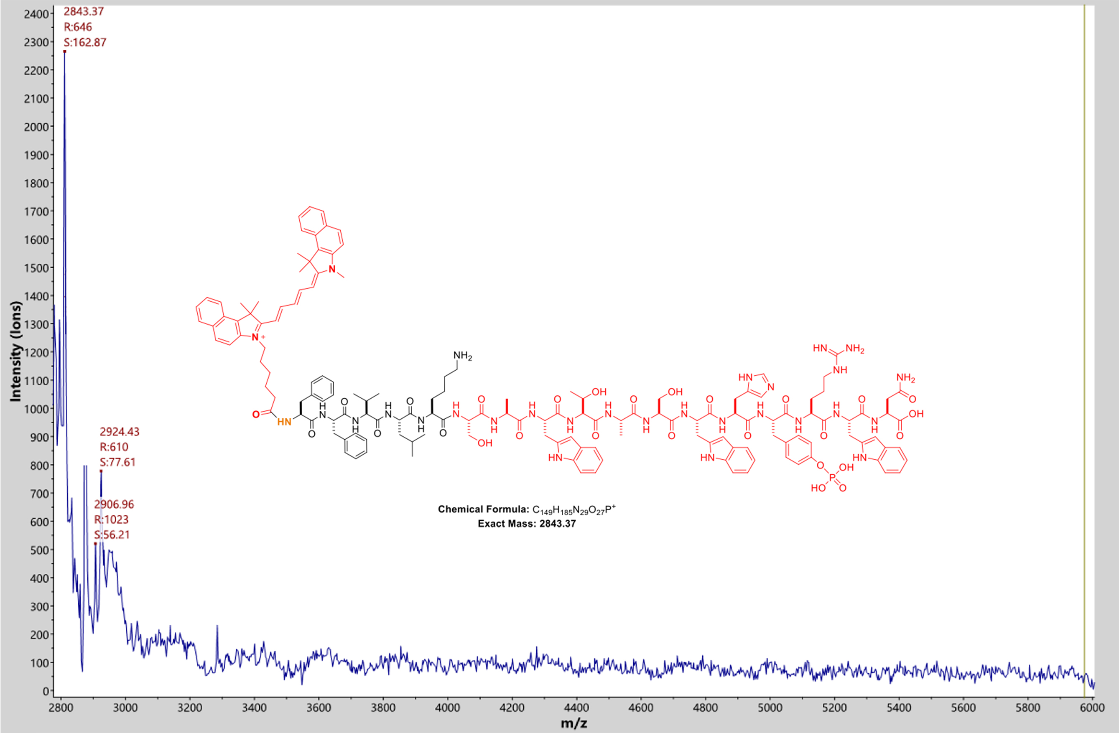
Figure S2. MALDI-TOF mass spectrometry of Pep (Cy5.5).

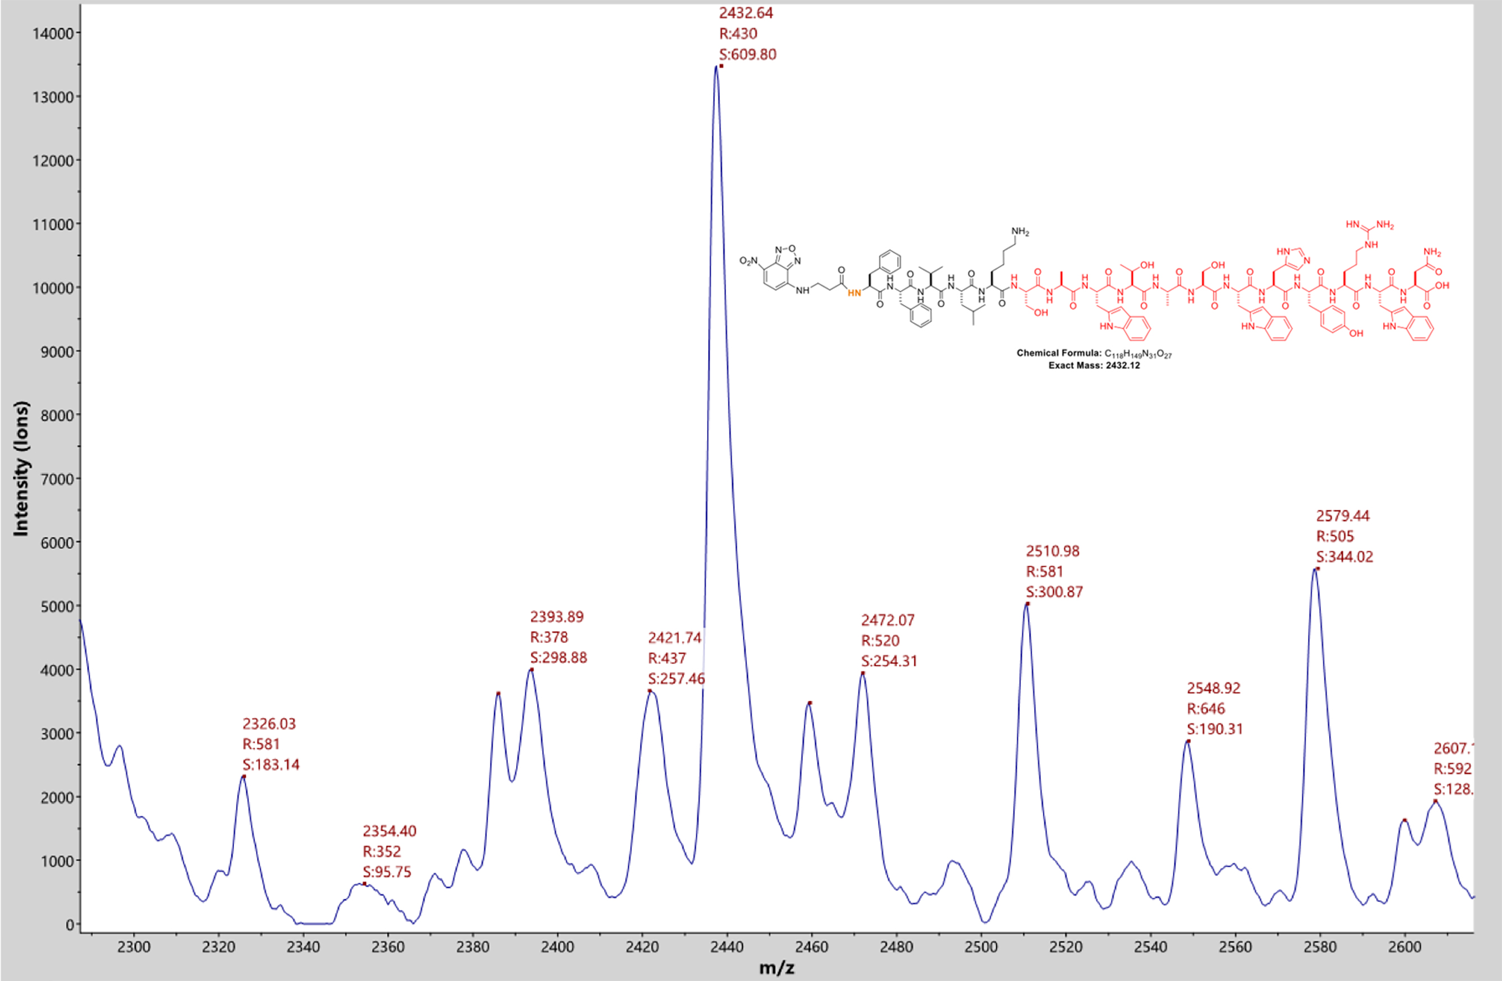
Figure S3. MALDI-TOF mass spectrometry of P2 (NBD).

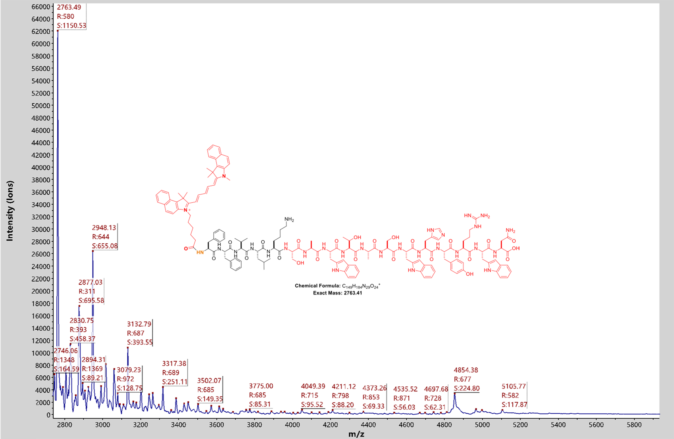
Figure S4. MALDI-TOF mass spectrometry of P2 (Cy5.5).

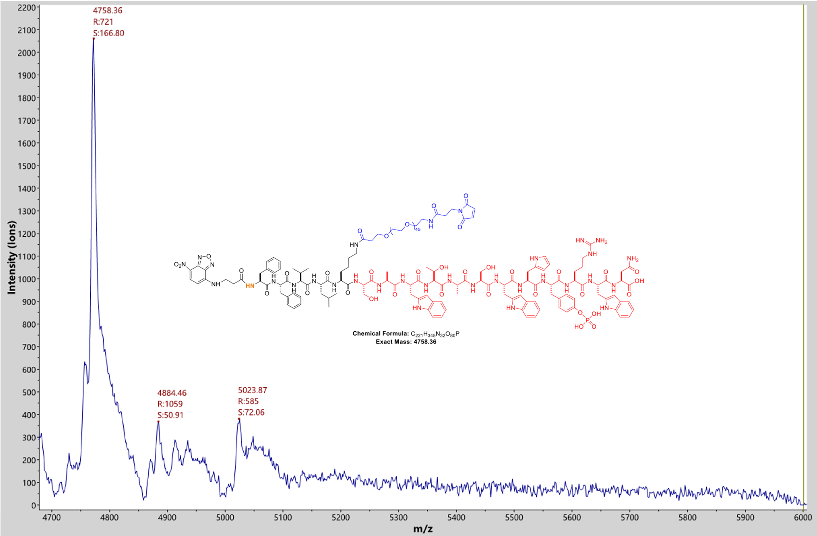
Figure S5. MALDI-TOF mass spectrometry of Pep-PEG (NBD).

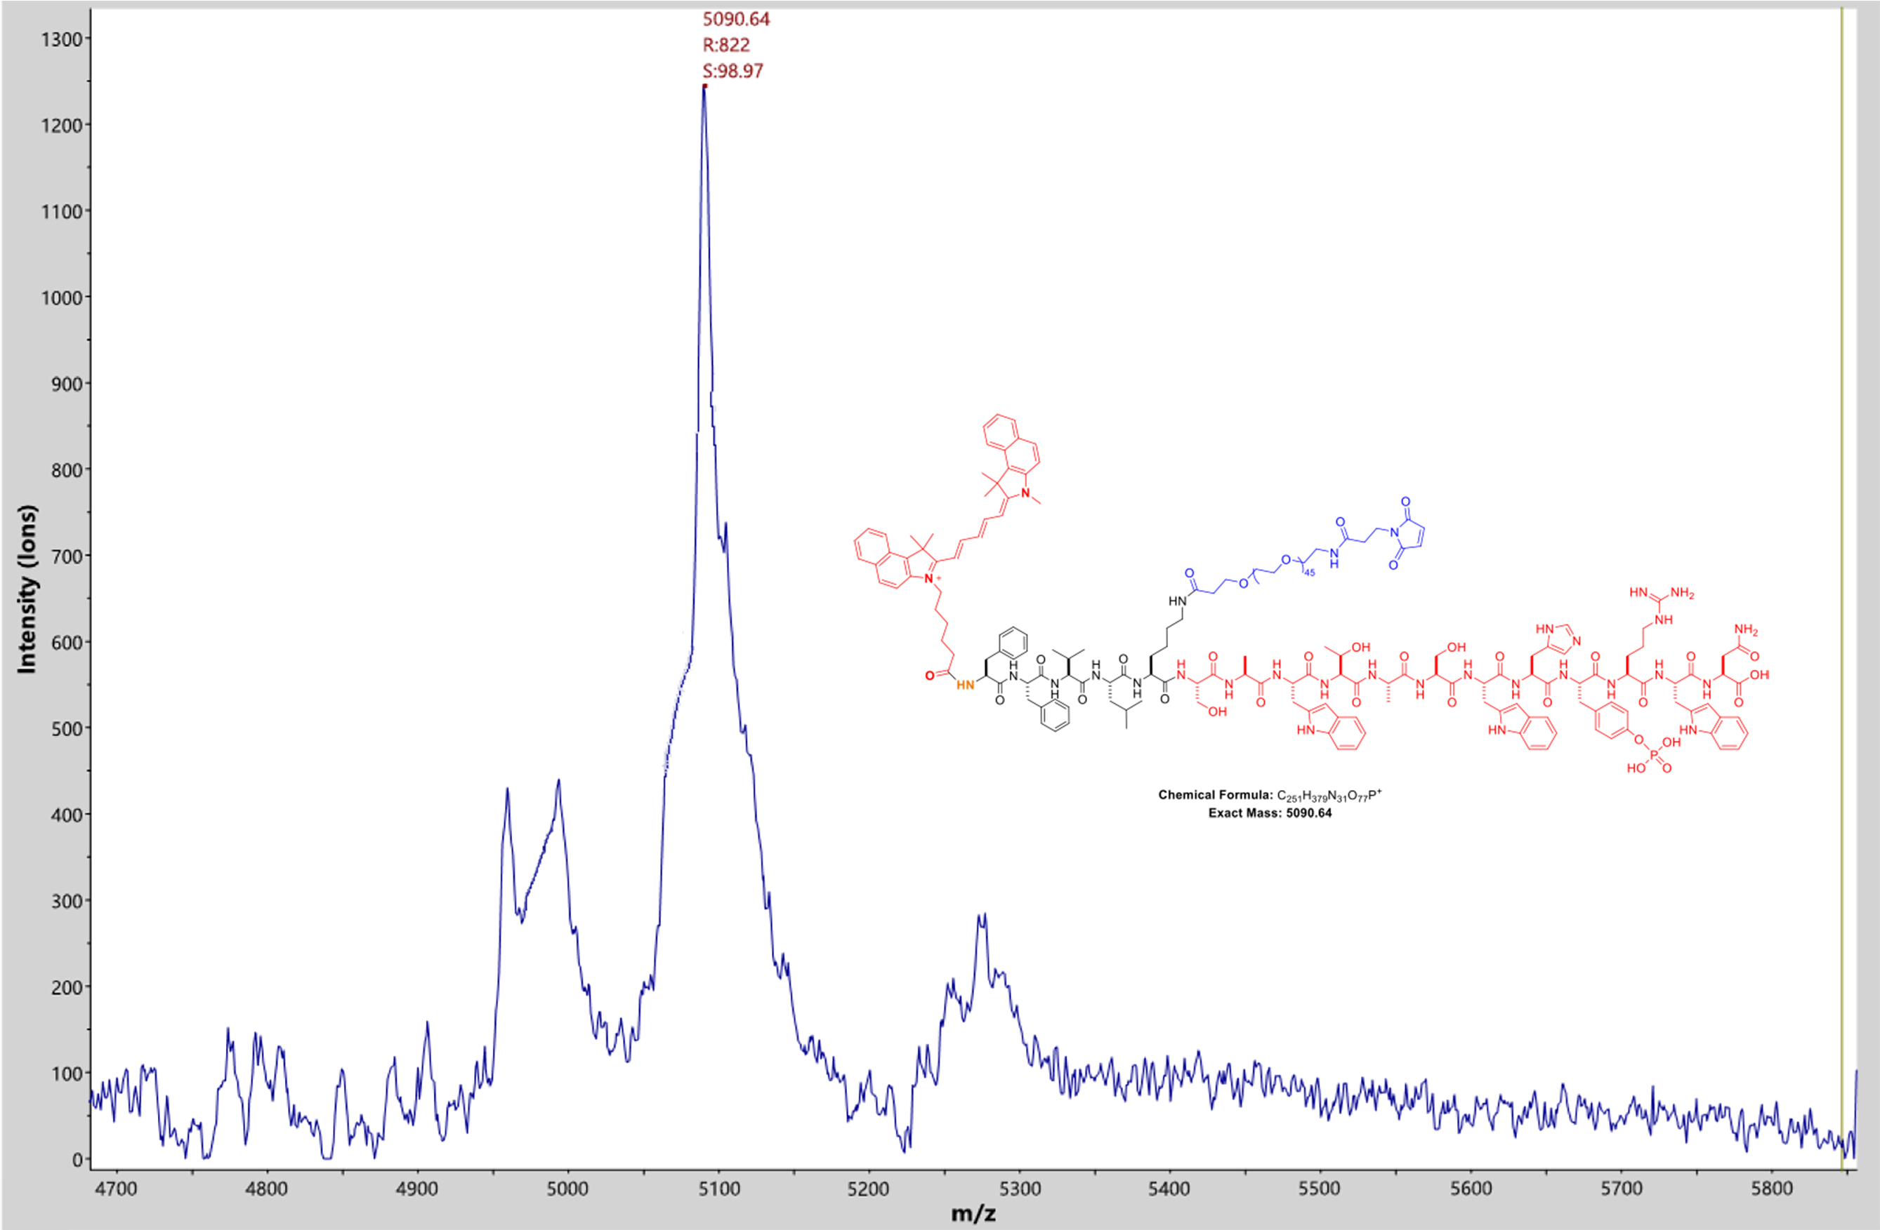
Figure S6. MALDI-TOF mass spectrometry of Pep-PEG (Cy5.5).

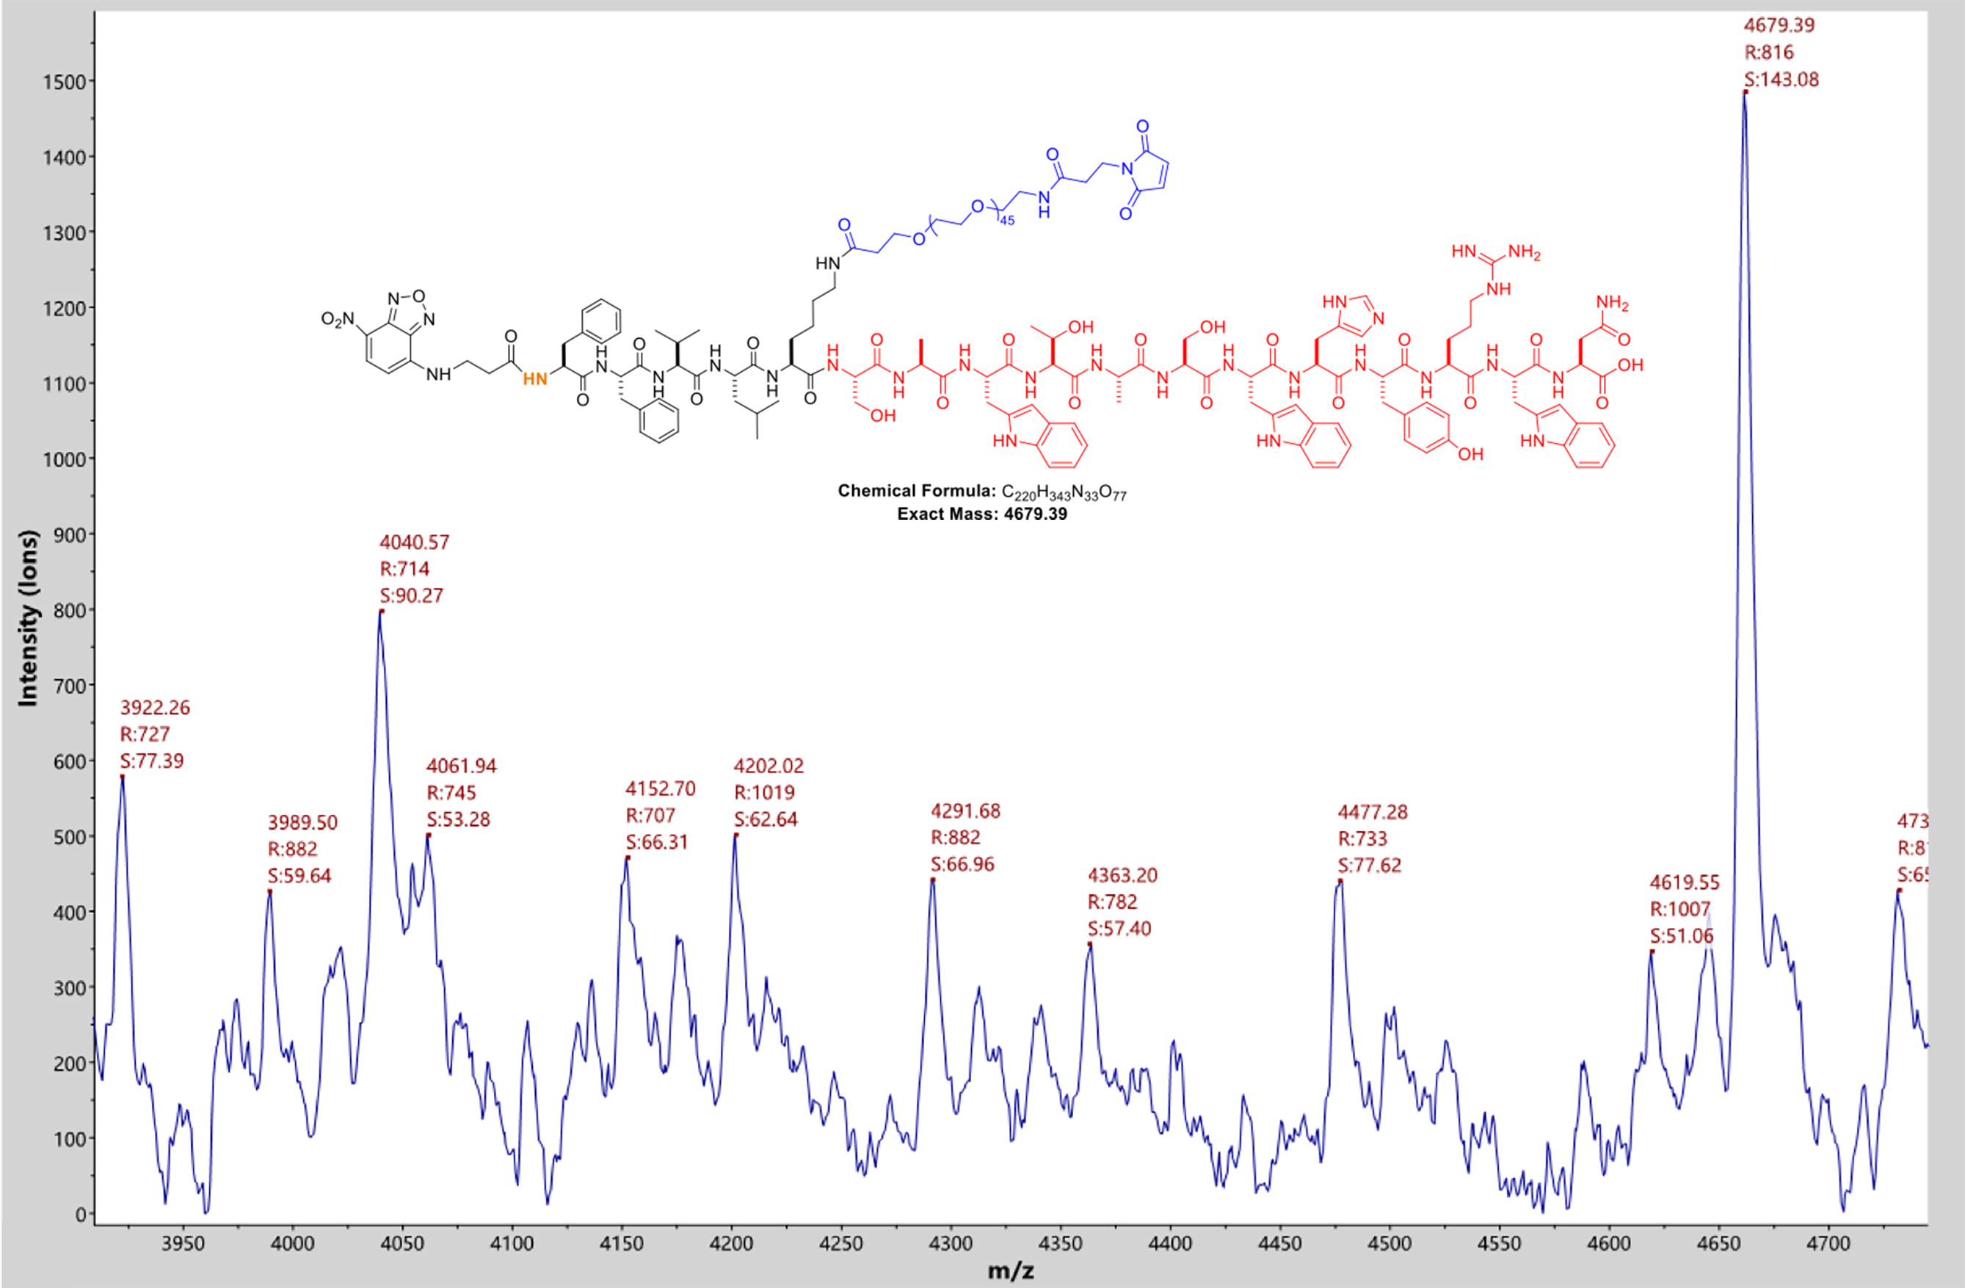
Figure S7. MALDI-TOF mass spectrometry of SAMI (NBD).

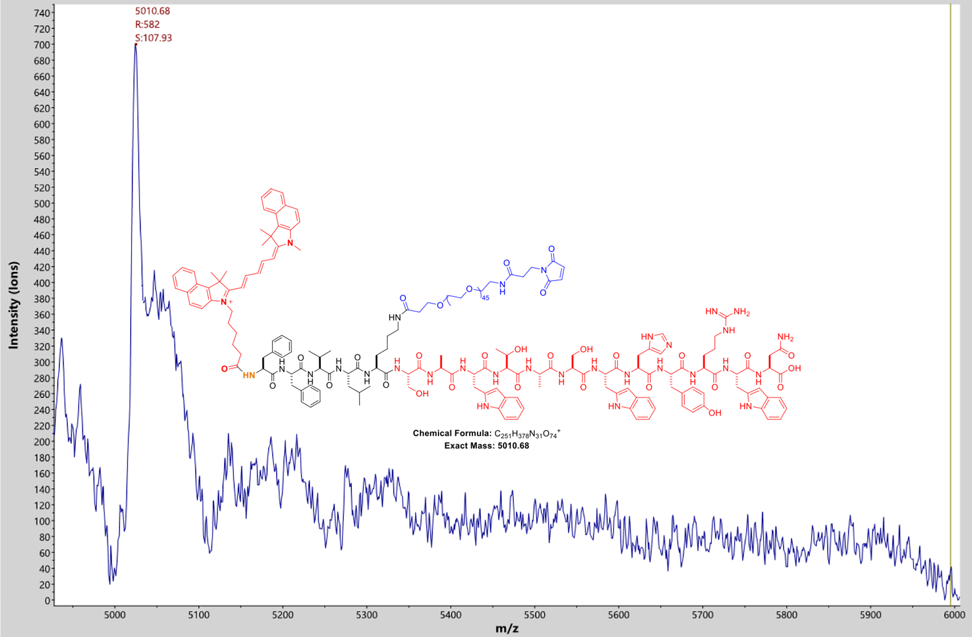
Figure S8. MALDI-TOF mass spectrometry of SAMI (Cy5.5).

mAb:peptide (w/w) | Zeta potential (mV)
1: 1 | -14.3 ± 0.6
1: 5 | -12.3 ± 0.7
1: 10 | -11.7 ± 0.8
1: 20 | -11.7 ± 1.2
1: 30 | -11.5 ± 0.6
1: 40 | -11.3 ± 0.4
1: 50 | -11.1 ± 0.7
Table S1. Zeta potential of PAC-SABIs with different ratio of anti-CD24 mAb to Peptide.

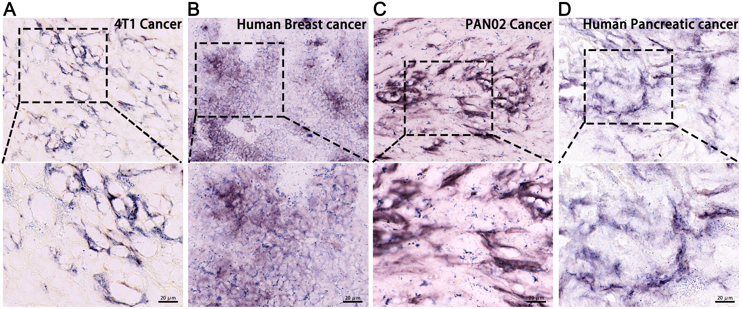
Figure S9. The expression of alkaline phosphatase (ALP) in tissue sections of 4T1 cancer, human breast cancer, PAN02 cancer, and human pancreatic cancer was detected by using the BCIP/NBT color development kit, as per manufacturer’s instructions. Scale bar: 20 μm.

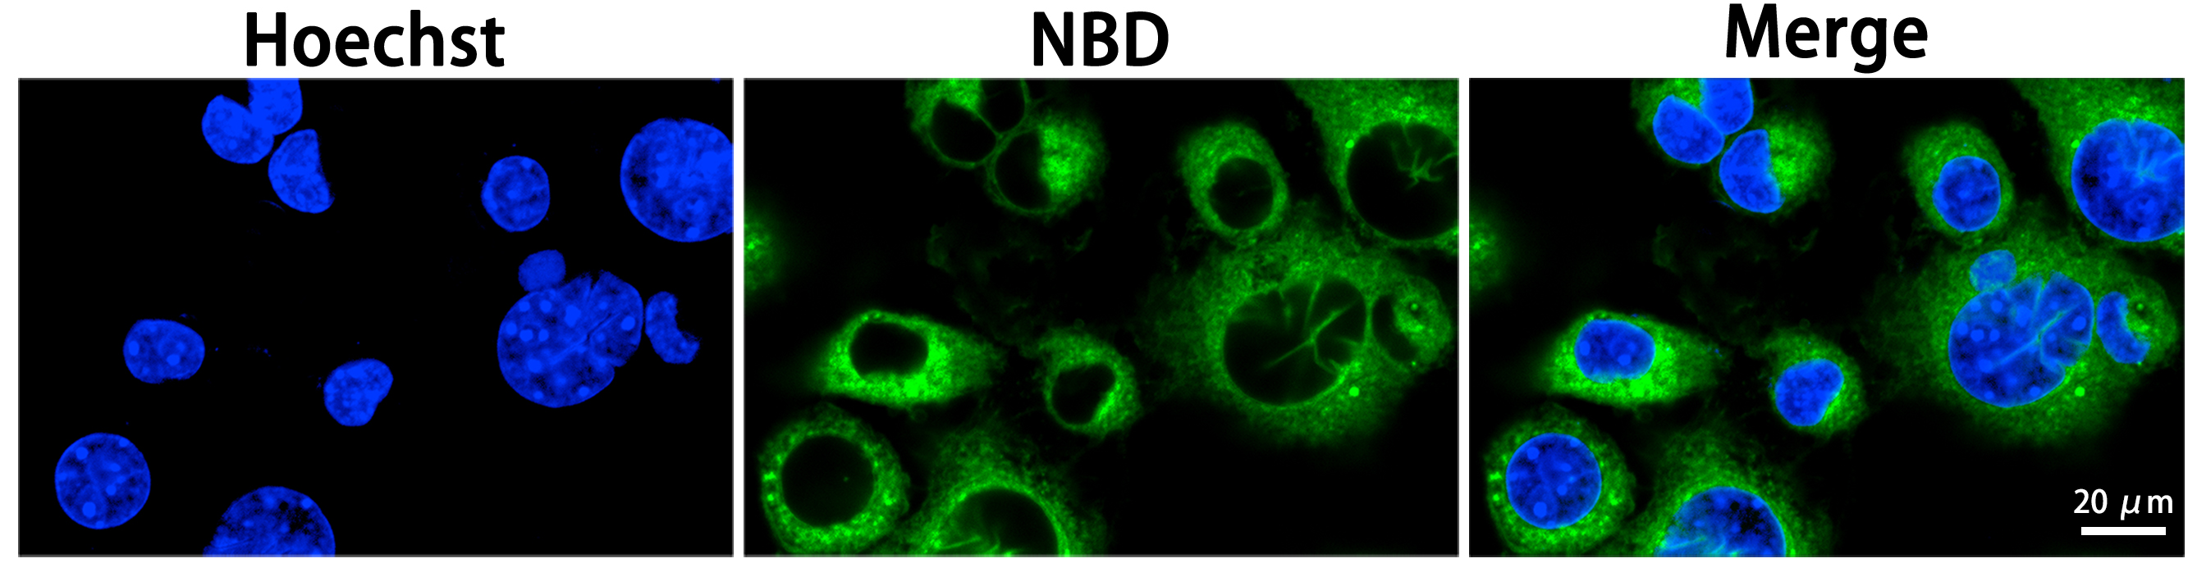
Figure S10. Confocal laser scanning microscopy (CLSM) images of 4T1 cells treated with NBD-labeled SAMIs for 120 min. Scale bar: 20 μm.

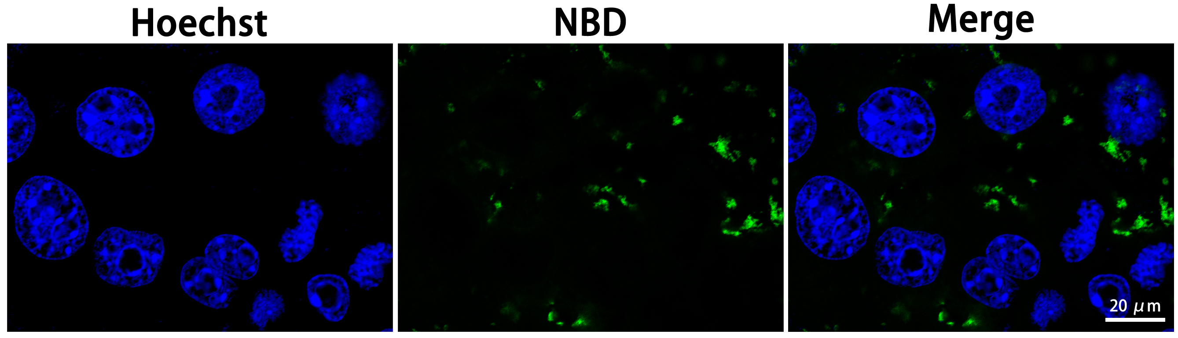
Figure S11. CLSM images of anti-CD24 mAb pre-blocked 4T1 cells treated with NBD-labeled PAC-SABIs for 120 min. Scale bar: 20 μm.

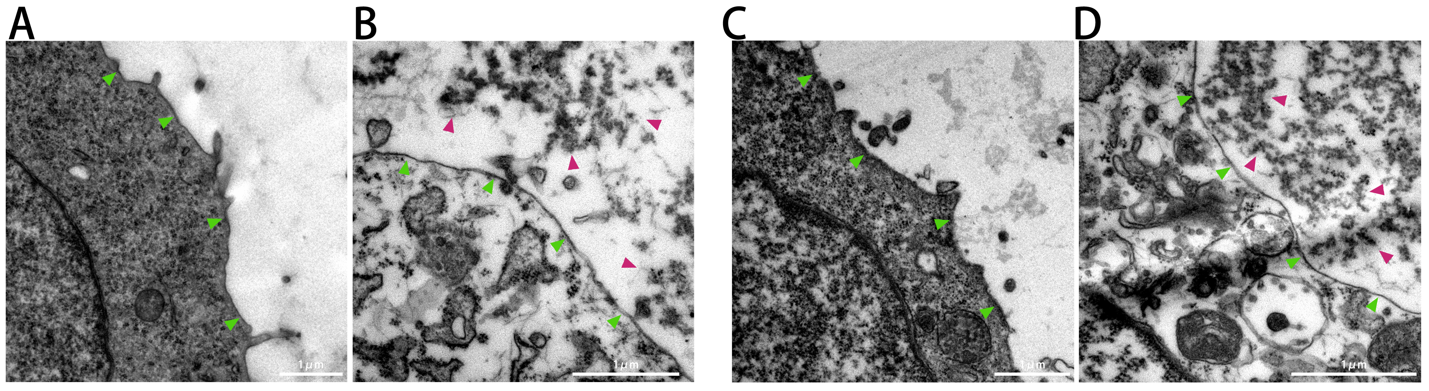
Figure S12. Transmission electron microscope (TEM) images of A) untreated 4T1 cell, B) PAC-SABI-treated 4T1 cell, C) untreated PAN02 cell, D) PAC-SABI-treated PAN02 cell. The green arrows point to cell membrane; The red arrows point to nanofibers of PAC-SABIs. Scale bar: 1 μm.

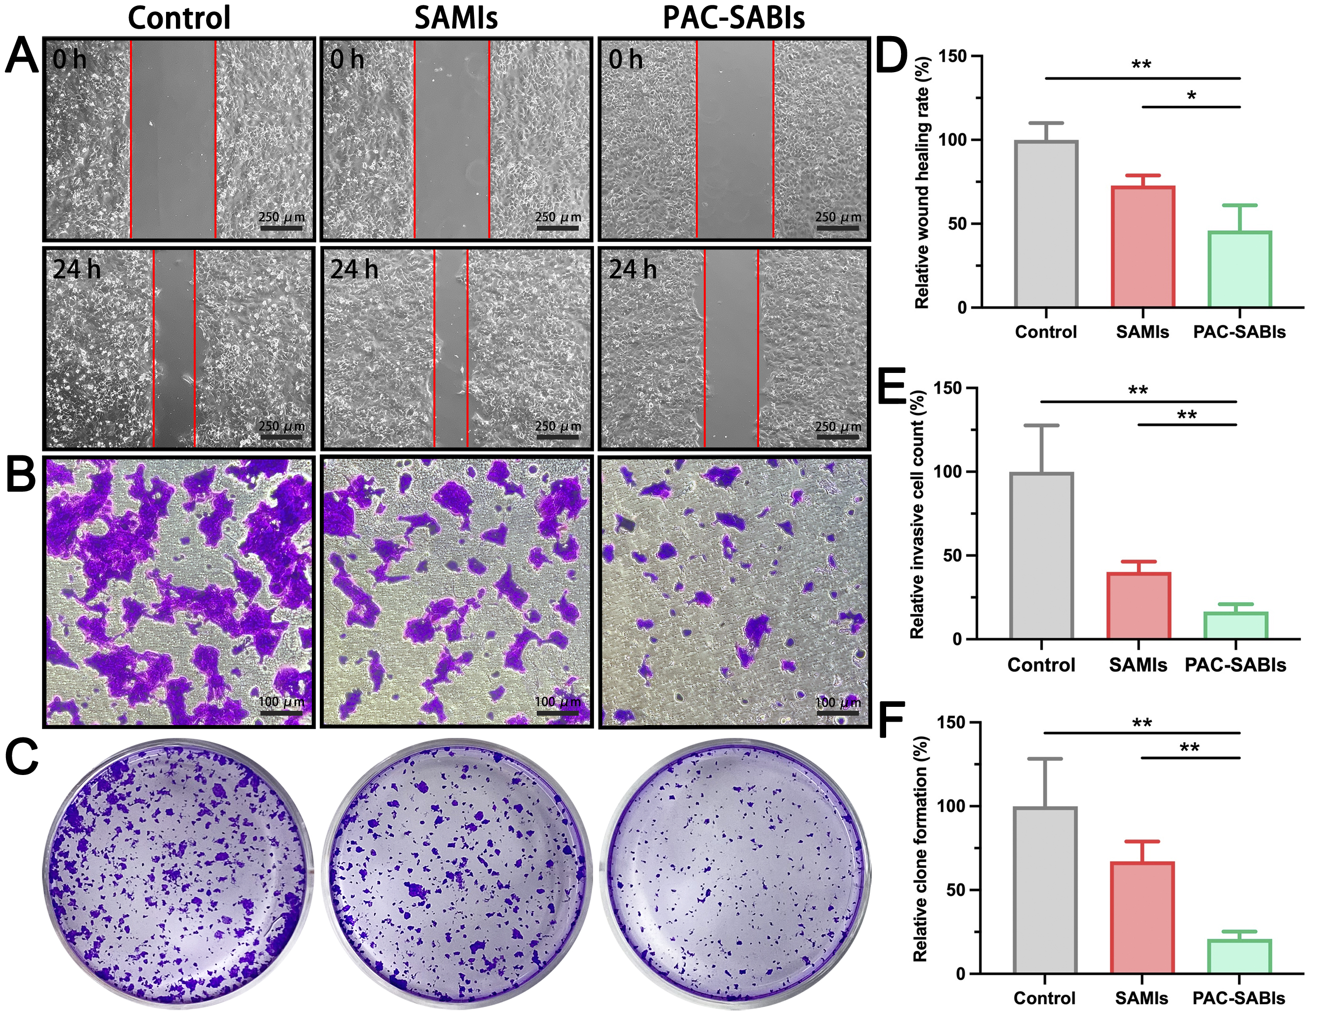
Figure S13. Wound healing, cell invasion, and Clone formation assays of 4T1 cells. A) Representative microscopy image of a wound healing experiment of 4T1 cells treated with PBS, SAMIs and PAC-SABIs. Red areas indicate no migrated cells. Scale bar: 250 μm. B) Representative microscopy images of migrated 4T1 cells treated with PBS, SAMIs and PAC-SABIs in a Transwell invasion assay. Scale bar: 100 μm. C) Representative bright field images of 4T1 cell Clone formation. D) Quantitative analysis of the wound healing rate. The error bars represent the mean ± S.E.M. (n = 3 independent experiments; *P = 0.05, **P = 0.01). E) Quantitative analysis of the invasion rate. The error bars represent the mean ± S.E.M. (n = 3 independent experiments; **P = 0.01). F) Quantitative analysis of Clone formation rate. The error bars represent the mean ± S.E.M. (n = 3 independent experiments; **P = 0.01).

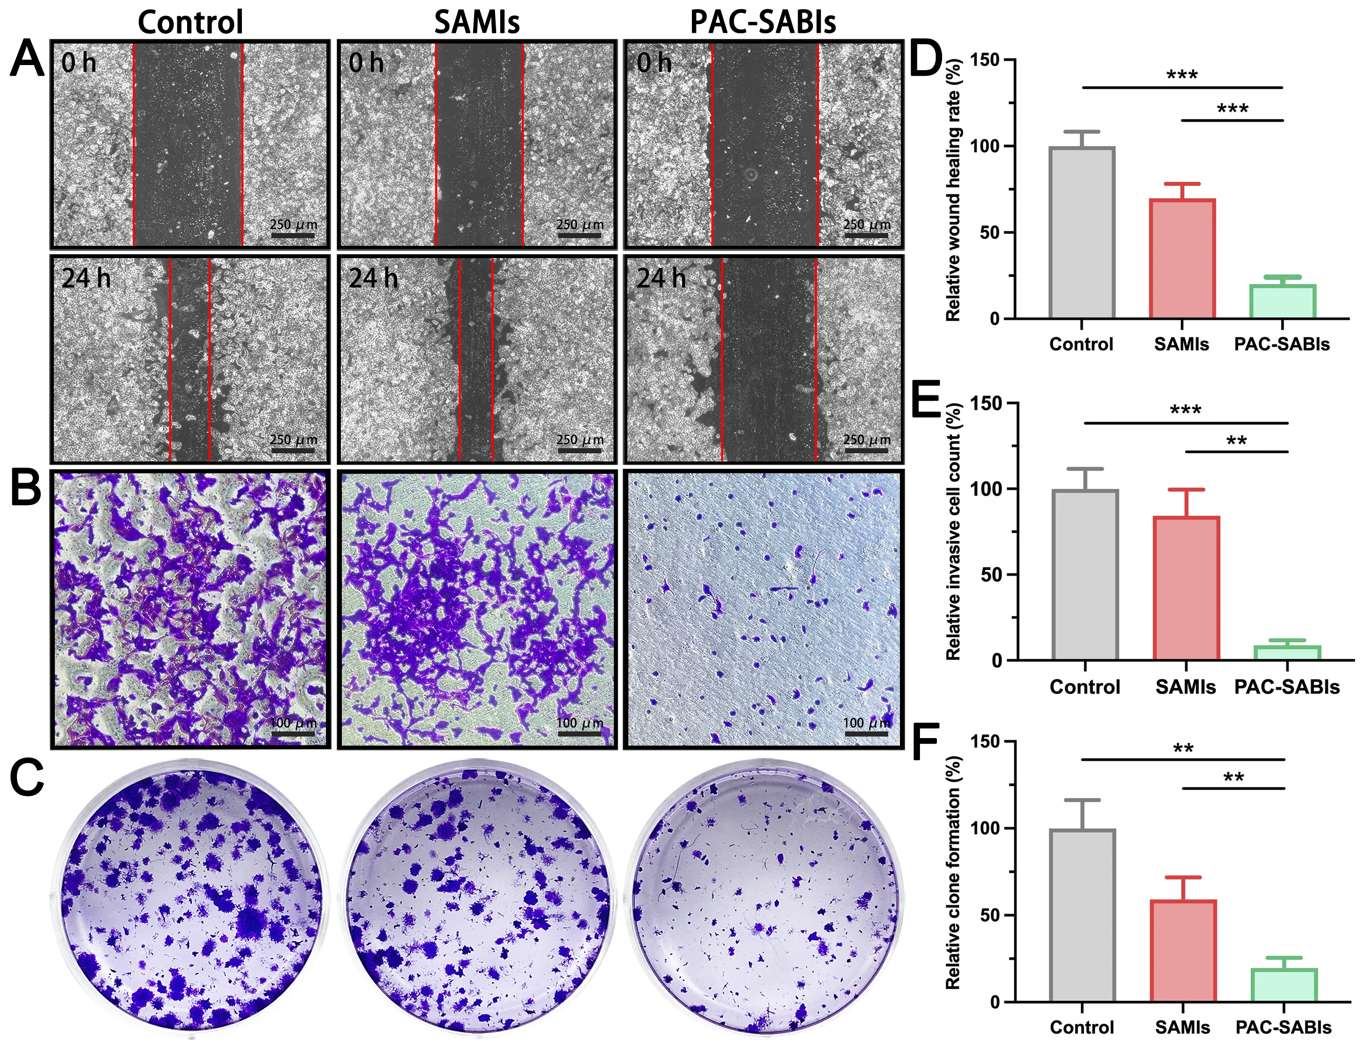
Figure S14. Wound healing, cell invasion, and Clone formation assays of PAN02 cells. A) Representative microscopy image of a wound healing experiment of PAN02 cells treated with PBS, SAMIs and PAC-SABIs. Red areas indicate no migrated cells. Scale bar: 250 μm. B) Representative microscopy images of migrated PAN02 cells treated with PBS, SAMIs and PAC-SABIs in a Transwell invasion assay. Scale bar: 100 μm. C) Representative bright field images of PAN02 cell Clone formation. D) Quantitative analysis of the wound healing rate. The error bars represent the mean ± S.E.M. (n = 3 independent experiments; ***P = 0.001). E) Quantitative analysis of the invasion rate. The error bars represent the mean ± S.E.M. (n = 3 independent experiments; **P = 0.01, ***P = 0.001). F) Quantitative analysis of Clone formation rate. The error bars represent the mean ± S.E.M. (n = 3 independent experiments; **P = 0.01).

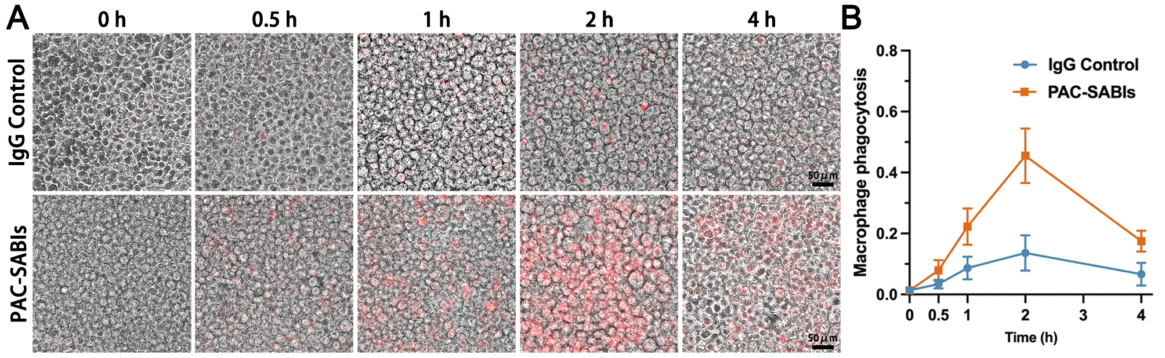
Figure S15. Promotion of phagocytic clearance of cancer cells via PAC-SABIs treatment in vitro. A) Phagocytosis images of pHrodo-red⁺ over time (hours). Scale bar: 50 μm. B) Phagocytosis of PAN02 cells, in the presence of IgG control or PAC-SABIs. The error bars represent the mean ± S.E.M. (n = 3 independent experiments).

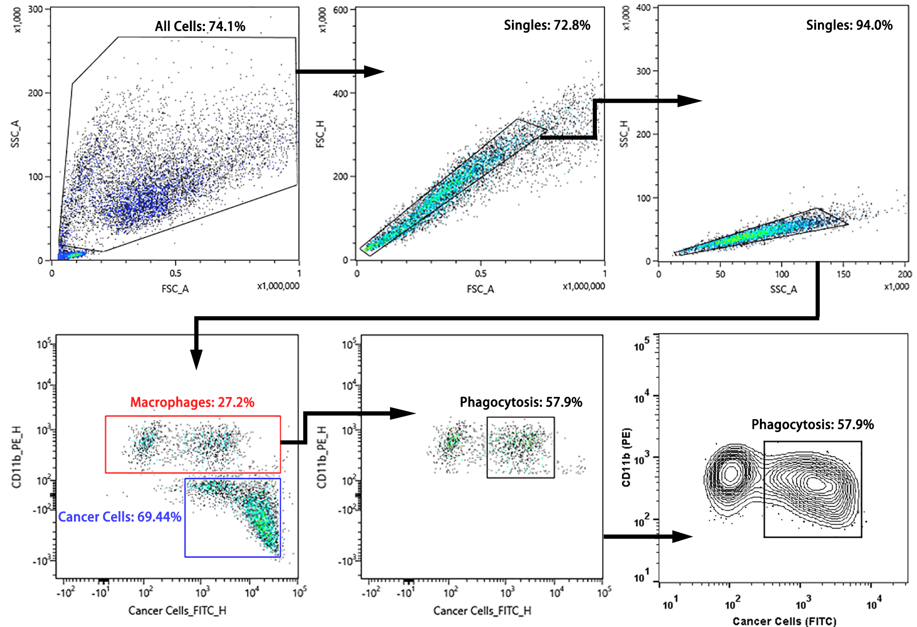Figure S16. Gating strategy used for the evaluation of macrophage phagocytosis.

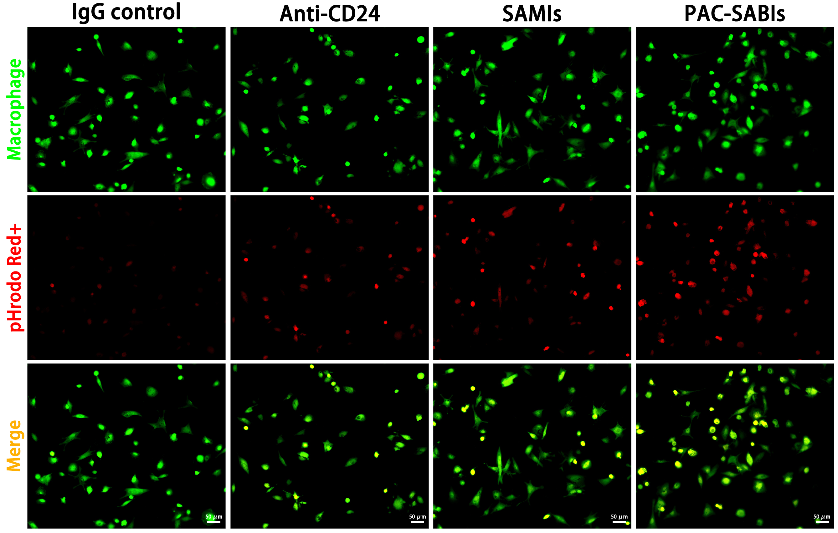
Figure S17. Representative CLSM images of in vitro phagocytosis of MDA-MB-231 cells (pHrodo-red⁺, red) by human THP-1 monocytes derived macrophages (Calcein, AM; green) in the presence of IgG control, anti-CD24 mAb, SAMIs and PAC-SABIs after 120 min of co-culture. Scale bar: 50 μm.

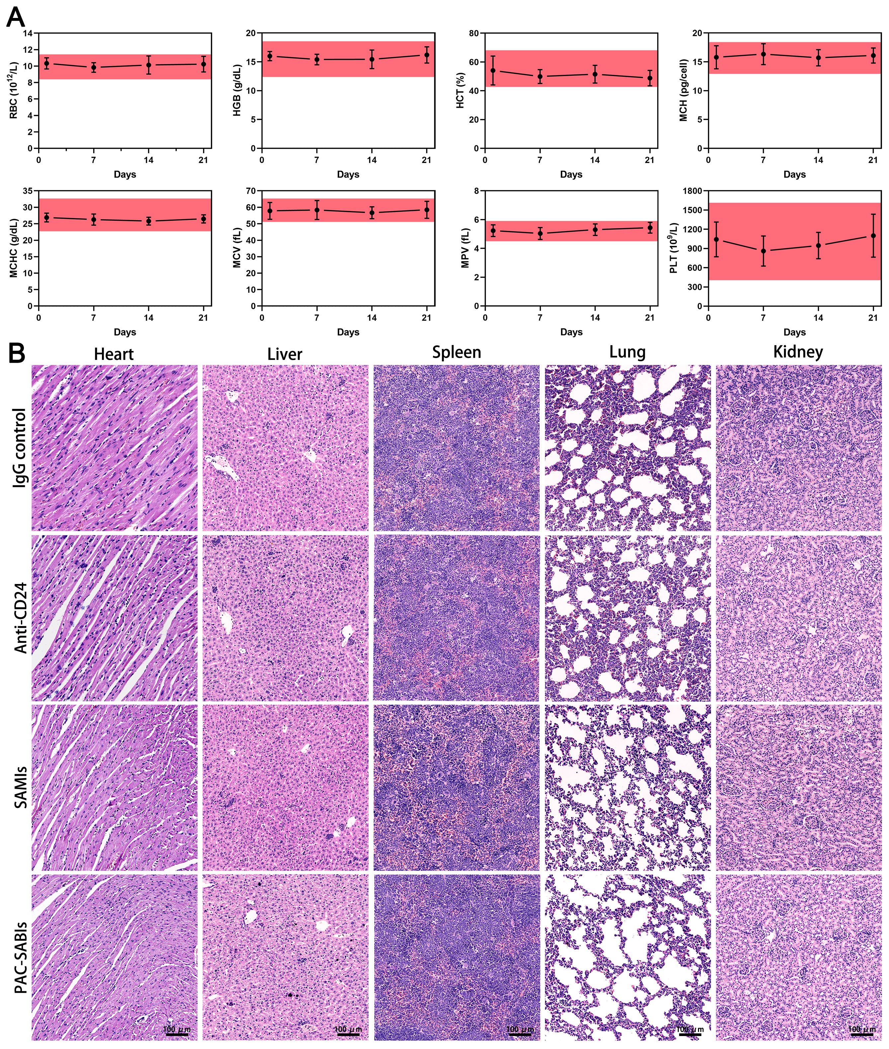
Figure S18. Complete blood count analyses and H&E staining. A) Complete blood count analyses including red blood cells (RBC), hemoglobin (HGB), hematocrit (HCT), mean corpuscular hemoglobin (MCH), mean corpuscular hemoglobin concentration (MCHC), mean corpuscular volume (MCV), mean platelet volume (MPV), platelet (PLT) after PAC-SABIs treatment. The error bars represent the mean ± S.E.M. (n = 3). B) H&E stained sections of major organs (heart, liver, spleen, lungs, and kidneys) from each treatment group. Scale bar: 100 μm.

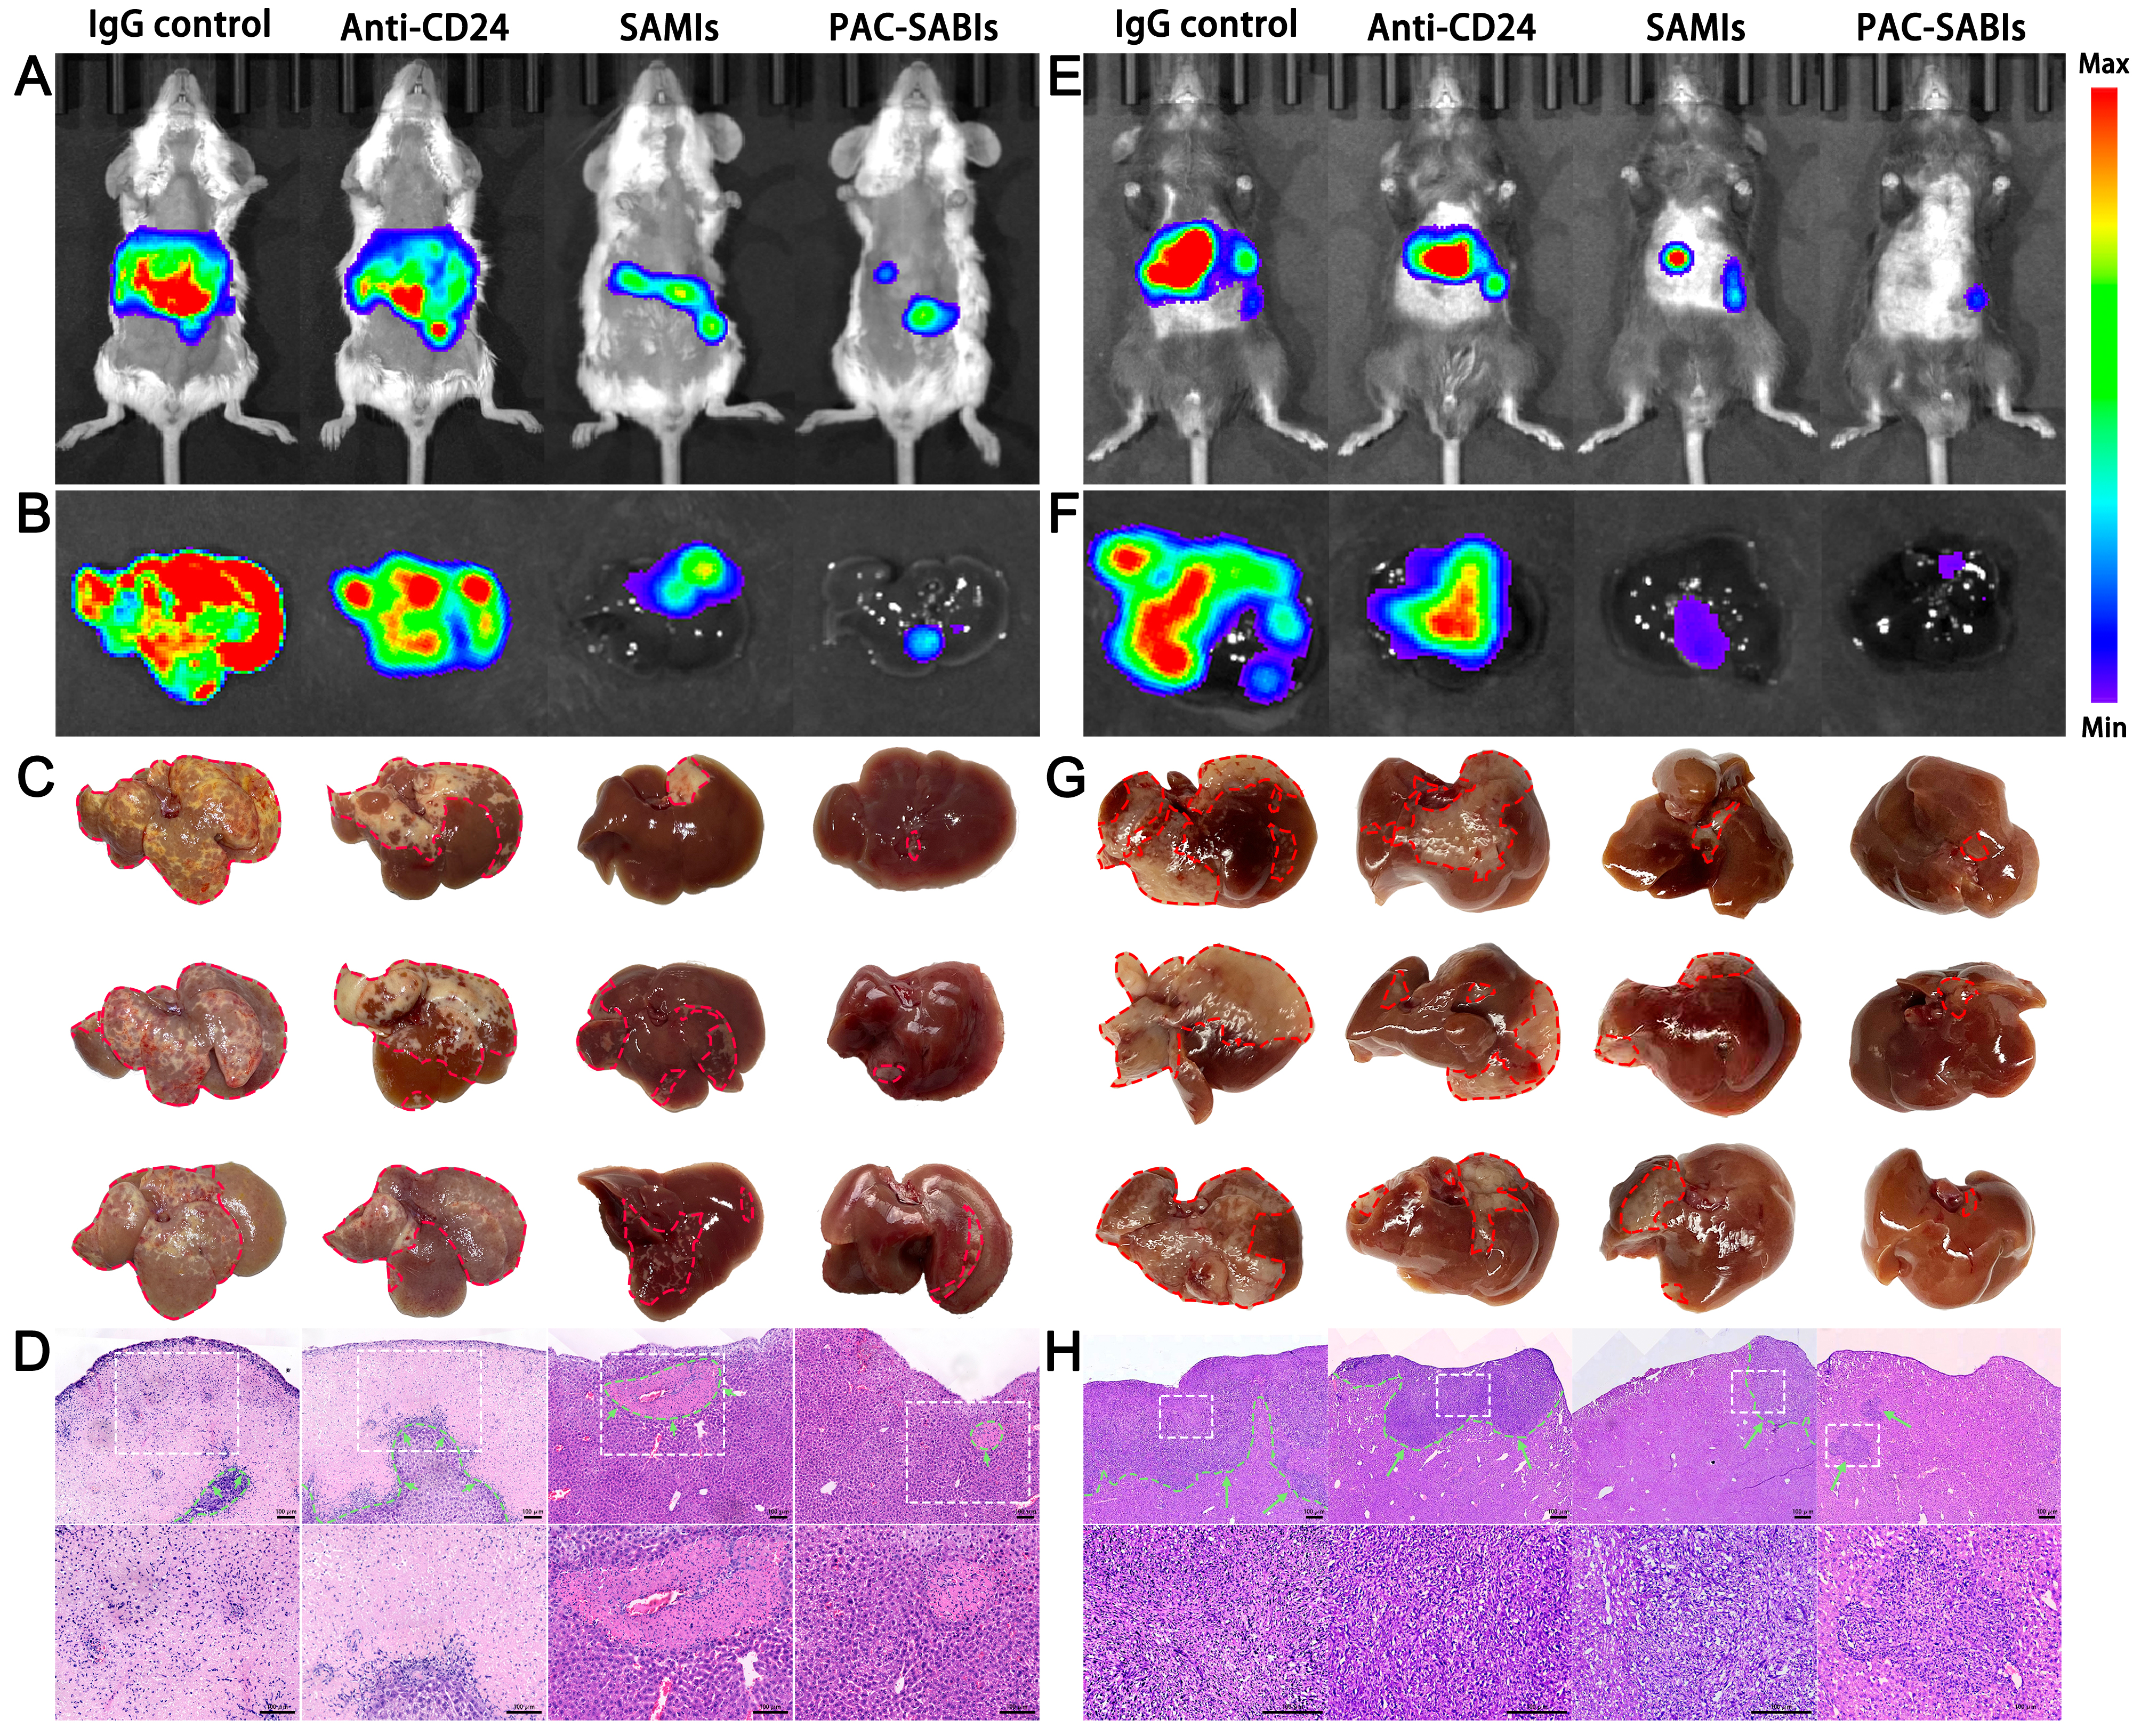
Figure S19. Inhibition on breast and pancreatic cancer liver metastasis in vivo. A) Representative in vivo bioluminescence imaging (BLI) of mice bearing 4T1 liver metastasis receiving different treatments. B) Representative ex vivo BLI of isolated livers in each treatment group. C) Bright field images of the 4T1 liver metastasis in each treatment group. D) Representative H&E stained sections of the 4T1 liver metastasis in each treatment group. The green areas and arrows point to the liver metastases. Scale bar: 100 μm. E) Representative in vivo BLI of mice bearing PAN02 liver metastasis receiving different treatments. F) Representative ex vivo BLI of isolated livers in each treatment group. C) Bright field images of the PAN02 liver metastasis in each treatment group. D) Representative H&E stained sections of the PAN02 liver metastasis in each treatment group. The green areas and arrows point to the liver metastases. Scale bar: 100 μm.

