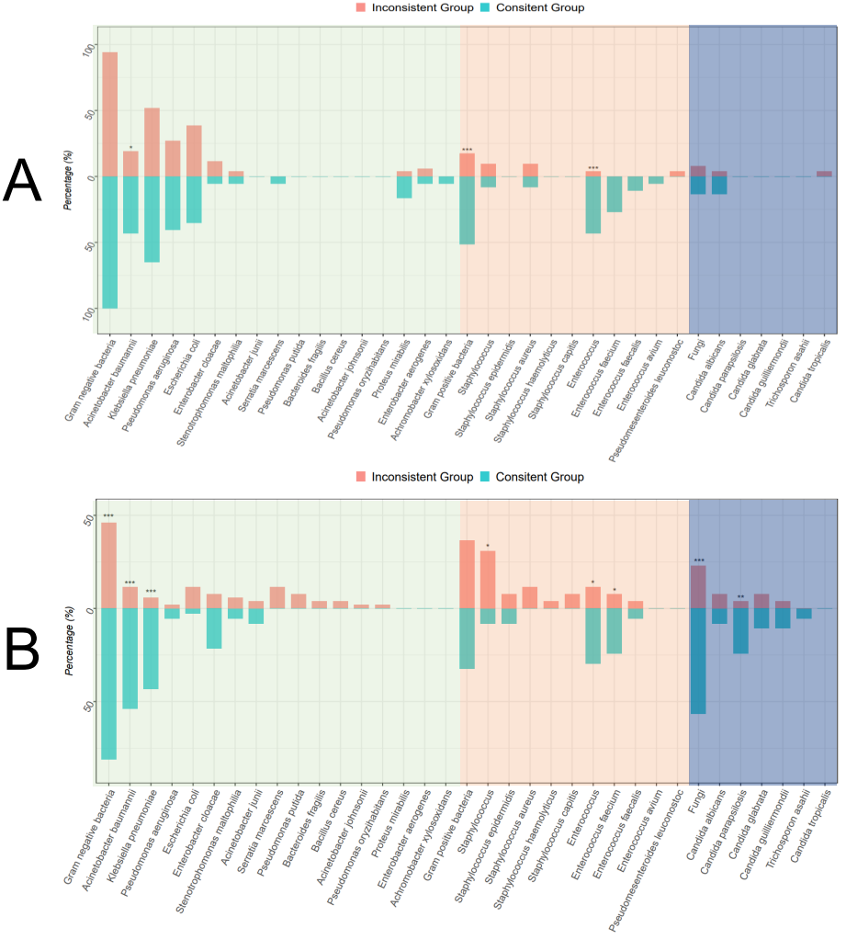
Fig. S1 - Distribution of microorganisms isolated from cultures sampled in critically ill gastrointestinal fistula patients with bloodstream infection. (A) Microorganisms isolated from abdominal drain cultures. (B) Microorganisms isolated from blood cultures. Microorganisms were clustered into Gram negative bacteria，Gram positive bacteria and fungi, which were distinguished by background colors of light green, light orange and light blue, respectively, in part A and B. Data were expressed as percentage and χ2-test was use for differences analysis. *P < 0.05, **P < 0.01, ***P < 0.001.

