Supplementary material for a publication in Environmental Monitoring and Assessment

Citizen Scientists’ Engagement in Flood Risk-Related Data Collection: A case study in Bui River Basin, Vietnam
Huan N. Tran*, Martine Rutten, Rajaram Prajapati, Ha T. Tran, Sudeep Duwal, Dung T. Nguyen, Jeffrey C. Davids, Konrad Miegel
* corresponding author
Email: huan.tran@uni-rosock.de
Affiliations: Faculty of Agricultural and Environmental Sciences, University of Rostock, Rostock, Germany

List of Contents
Supplementary material S1 Low-cost rain gauges
Supplementary material S2 Flood marks in floodplain area
Supplementary material S3 List of Participants (Excel file)
Supplementary material S4 List of flood data collection (Excel file)
Supplementary material S5 Hazard Data Collection and Analysis (Excel file)
Supplementary material S6 Exposure Collection (Excel file)
Supplementary material S7 Flood vulnerability Data Collection and Analysis (Excel file)

S 1 – Low-cost rain gauges
The low-cost rain gauge was constructed using 1.5 to 2-liter soda bottles, concrete, and rulers, following a design inspired by David et al. (2019). Due to the rarity of uniform-diameter bottles in Vietnam, the majority of S4W rain gauges were fashioned from bottles with non-uniform diameters. Rainfall collected from these non-uniform diameter bottles was found to exceed that collected from bottles with uniform diameters by 5% to 20%. For a tutorial video demonstrating the construction of the S4W rain gauge in Vietnam, please refer to the following YouTube link (https://bit.ly/3sciMeg).
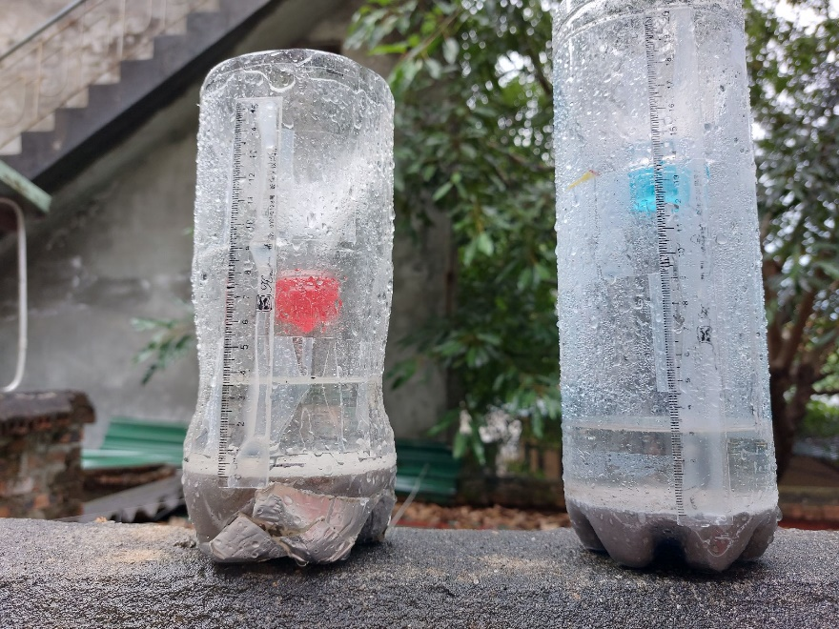

Fig. S1 The rainfall in the ununiform and uniform diameter of the rain gauge were 38 and 32 mm, respectively on 12 May 2022 at Xuan Mai commune, Chuong My district, Hanoi city

S 2- Flood mark in floodplain area
Fig. S2 Flood mark at Xuan Linh hamlet, Thuy Xuan Tien commune, Chuong My, District, Hanoi in 2018 flood (Flooding depth: 2.5 m, Lat/ Long: 20.880, 105.562); Surveying date: Jan 04th, 2022) Link: https://bit.ly/3qEQB7r

