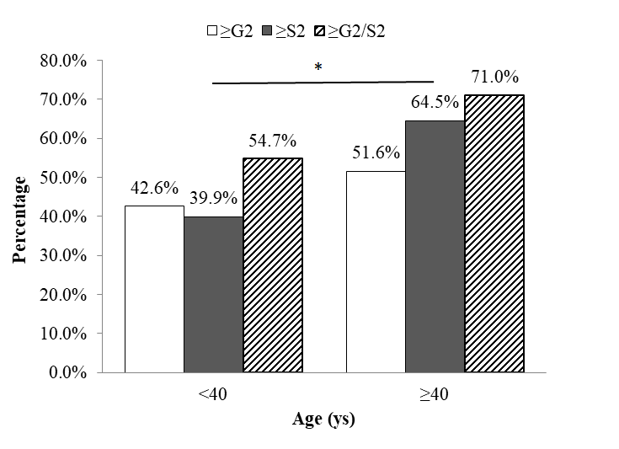
Supplementary figure 1. Significant liver histopathology in HBeAg-postive CHB patients in different age groups.*p<0.05

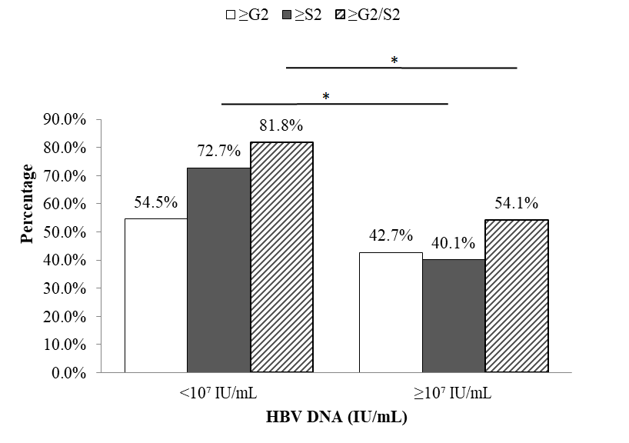
Supplementary figure 2. Significant liver histopathology in HBeAg-postive CHB patients in different HBV DNA groups. *p<0.05

