Genome-wide Identification and Characterization of Wall-associated Kinases, Molecular Docking and Polysaccharide Elicitation of Monoterpenoid Indole Alkaloids in Micro-propagated Catharanthus roseus
- Jawad Ahmed^{a,b}, Yasar Sajjadª, Aasia Latifª, Muhammad Huzafa^{c}, Chen Situ ^{b}, Raza Ahmadª, Muhammad Maroof Shahª, Amjad Hassanª*
ªDepartment of Biotechnology, COMSATS University Islamabad, Abbottabad Campus, 22044, Pakistan
^{b}Institute for Global Food Security, School of Biological Sciences, Queens University Belfast, BT9 5DL, United Kingdom
^{c}Department of Plant Sciences, Quaid-e-Azam University Islamabad, Pakistan
*Correspondence:
Prof. Dr. Amjad Hassan, Department of Biotechnology, COMSATS University Islamabad, Abbottabad Campus, 22044, Pakistan, amjadhassan@cuiatd.edu.pk
Table S1. The sequence of primers of selected genes
Gene (Accession Number) | Primer |  | Sequence (5´-3´) | Product size
TDC (MG748691) | Forward | CTTACCTCCCCGAACCACTT |  | 200
 | Reverse | ATTTCTAATTCGGTGGCGGC
SLS (KF415117) | Forward | ACCCACTCCAGCAAATACCA |  | 166
 | Reverse | CAAAAGCCGGCAACATTGAC
STR (X53602) | Forward | TCCTATGCTCCGAATGCCTT |  | 173
 | Reverse | TTCTCTGGATCGGTGCTGTT
SGD (AF112888) | Forward | AGAGCTCTTGTAGGAAGCCG |  | 206
 | Reverse | CGCACTTCCTTCCCATCAAC
DAT (AF053307) | Forward | TTTACGAAAATCCCGACGGC |  | 249
 | Reverse | TGCCAACAGTTACCCGTTTG
HL1 (MF770512) | Forward | AAGAGAAACTGAAGGGCGGA |  | 227
 | Reverse | AACCAACAACCTCGAGCAAC
PRX1 (AM236087) | Forward | TCAGCAGGCTTTCAGGATCA |  | 244
 | Reverse | TGCGAGTGAAGTTAGGAGGG
ORCA3 (AJ251249) | Forward | CGGAAAGCTGTCAGGAGGAT |  | 193
 | Reverse | GCATCCTCAGGTGTCTCGTA
WRKY1 (HQ646368) | Forward | TGCCGAACTCTCCGTACAAA |  | 162
 | Reverse | TACTTGACCCCTGCCGATTT
WAK-02 | Forward | ACTGGAGAGAGGGCACTTTC |  | 197
 | Reverse | GGCCTTTCCCCAGATTTCAC
WAK-03 | Forward | ATGTCTGCCGGGTTTTCAAG
 | Reverse | TCCTCCCATCGCCTTCAAAT
WAK-04 | Forward | TTTCGGTGTGGGTTGTTGTC |  | 245
 | Reverse | CCTCATCGCAGCTCAAGTTC
WAK-05 | Forward | TCCAATGCCTCGCTAGTCAT |  | 192
 | Reverse | GCCGACAAGAACAGCTGAAA
WAK-06 | Forward | ATTCTGCTGCTTCTCCTCCA |  | 158
 | Reverse | TCCGAGTGTTCCTTGTACCA
WAK-09 | Forward | GCTACTAACGGGCAAGCTTC |  | 199
 | Reverse | GGTTGGCCTATCTTCCCCTT
WAK-11 | Forward | AAACGAGCAAAACCCGGAAA |  | 235
 | Reverse | CAATTCTAAGGCGACGGAGC
WAK-13 | Forward | TCCTCTGTTAGCCATCCGAA |  | 178
 | Reverse | CTTGAGCAGTTTCAGCAGCA
WAK-18 | Forward | GGCGGCTTGTTCAAACTGTA |  | 247
 | Reverse | AGGGCTACAGTGGCTTGAAT
WAK-19 | Forward | CCCACTGTTGTTTTCCTCCG |  | 213
 | Reverse | ATCCTTTTCCTCCAGCTGCT
WAK-22 | Forward | CCATGATTCAGGGCCATTGG |  | 186
 | Reverse | CTTCCAGTGCCGATCTTGTG
WAK-29 | Forward | TTTGCGAGCGATTTCCAGAG |  | 212
 | Reverse | ATAAGGAGGCGTCACACCAA
WAK-32 | Forward | ATCAGAACGCCGCAATTTCA |  | 187
 | Reverse | AGCTGCAAGGGTCAAAGAGA
WAK-33 | Forward | TGCCTGGTTTTGTCTTTGCA |  | 191
 | Reverse | AGCCTGAACCTAAGCCAACT
WAK-34 | Forward | AGAGACCAAGCAGCGAAGTA |  | 172
 | Reverse | CCACAGGTATCATTGCAGCC
WAK-36 | Forward | CGTTGGATTGGCTGTATGGG |  | 188
 | Reverse | CCTTCTTCCTCTGCTCGTCA
RSP9 (AJ749993) | Forward | TCAATCCACCATGCCAGAGT |  | 162
 | Reverse | TCTCTTCACTCTGCCAGGAC

Table S2: Binding affinity (kcal/mol) of putative CrWAKs against tri galacturonic acid and chitosan
Proteins | Pose | Chitosan | Tri-galacturonic acid
CrWAK-01 | 1  2  3  4  5 | -11.1  -10.8  -10.7  -10.1  -10 | -8.8  -8.8  -8.8  -8.6  -8.6
CrWAK-02 | 1  2  3  4  5 | -8.1  -8.1  -8.1  -8  -7.8 | -7.7  -7.6  -7.6  -7.6  -7.5
CrWAK-03 | 1  2  3  4  5 | -9.2  -9.1  -8.8  -8.6  -8.6 | -9.3  -9.3  -9.1  -8.9  -8.8
CrWAK-04 | 1  2  3  4  5 | -11.4  -11.3  -11.1  -10.7  -10.4 | -11.8  -11.4  -11.2  -10.5  -10.5
CrWAK-05 | 1  2  3  4  5 | -11.2  -11  -11  -10.9  -10.9 | -11.6  -11.4  -11.1  -11  -10.7
CrWAK-06 | 1  2  3  4  5 | -11.2  -10.3  -10.1  -10  -9.2 | -11.9  -10.6  -10.6  -10.5  -10.4
CrWAK-07 | 1  2  3  4  5 | -11.1  -10.4  -10.2  -9.9  -9.7 | -11.2  -11.1  -10.8  -10.2  -9.5
CrWAK-08 | 1  2  3  4  5 | -11.4  -11.1  -11.1  -10.9  -10.6 | -11.7  -10  -9.6  -9.5  -9.5
CrWAK-09 | 1  2  3  4  5 | -10.9  -10.8  -10.2  -10.1  -9.9 | -11.3  -10.9  -10.9  -10.8  -10.5
CrWAK-10 | 1  2  3  4  5 | -10.9  -10.9  -10.8  -10.4  -10 | -11.4  -11.1  -10.8  -9.8  -9.8
CrWAK-11 | 1  2  3  4  5 | -10.7  -10.6  -10.3  -9.5  -9.2 | -11.2  -10.6  -10.5  -10.2  -10
CrWAK-12 | 1  2  3  4  5 | -11  -9.9  -9.8  -9.4  -9.2 | -11.3  -11.2  -10.3  -10.3  -10.2
CrWAK-13 | 1  2  3  4  5 | -10.9  -10.7  -10.6  -10.5  -9.7 | -8.7  -8.3  -8.1  -8  -8
CrWAK-14 | 1  2  3  4  5 | -8.8  -8.7  -8.5  -8.5  -8.4 | -11.2  -9.9  -9.7  -9.2  -9.1
CrWAK-15 | 1  2  3  4  5 | -10.3  -9  -8.9  -8.8  -8.6 | -11.9  -11.6  -10  -10  -9.8
CrWAK-16 | 1  2  3  4  5 | -10.6  -10.6  -10.6  -10.5  -10.4 | -11.2  -11  -10.5  -10.5  -10.3
CrWAK-17 | 1  2  3  4  5 | -10.9  -10.9  -10.6  -10.5  -10.1 | -9.2  -9.2  -9.1  -9.1  -8.8
CrWAK-18 | 1  2  3  4  5 | -11.6  -11.6  -11.5  -11.5  -11.2 | -12  -11.8  -11.6  -11.4  -11.2
CrWAK-19 | 1  2  3  4  5 | -11.6  -10.5  -10.3  -10  -9.1 | -10.9  -10.9  -10.3  -10.3  -9.3
CrWAK-20 | 1  2  3  4  5 | -10.8  -10.7  -10.4  -10  -9.9 | -11.2  -10.8  -10.8  -10.4  -9.9
CrWAK-21 | 1  2  3  4  5 | -10.6  -10.4  -10.4  -10  -10 | -11.1  -10.5  -10  -9.9  -9.6
CrWAK-22 | 1  2  3  4  5 | -10.5  -10.5  -10.3  -9.6  -9.5 | -12.6  -12.4  -11  -10.7  -10.5
CrWAK-23 | 1  2  3  4  5 | -9.9  -9.4  -9.3  -9.2  -9.2 | -9.3  -9.3  -9  -8.8  -8.8
CrWAK-24 | 1  2  3  4  5 | -10.7  -10.6  -10.4  -10  -10 | -8.7  -8.4  -8.4  -8.3  -8.2
CrWAK-25 | 1  2  3  4  5 | -11  -10.7  -10.5  -10  -9.9 | -11.5  -10.9  -10.5  -10.5  -10.3
CrWAK-26 | 1  2  3  4  5 | -11  -10.9  -10.2  -8.7  -8.6 | -9.1  -8.3  -8.2  -8.2  -8.1
CrWAK-27 | 1  2  3  4  5 | -11  -11  -10.9  -10.5  -10.3 | -8.9  -8.8  -8.8  -8.5  -8.4
CrWAK-28 | 1  2  3  4  5 | -10.8  -10.7  -10.4  -10.1  -10.1 | -10.2  -10.1  -10.1  -9.9  -9.9
CrWAK-29 | 1  2  3  4  5 | -9.9  -9.8  -9.7  -9.5  -9.3 | -9.8  -9.8  -9.6  -9.3  -9.2
CrWAK-30 | 1  2  3  4  5 | -10  -9.9  -9.6  -9.6  -9.4 | -9.6  -9.6  -9.1  -8.8  -8.8
CrWAK-31 | 1  2  3  4  5 | -11.3  -11.2  -11.1  -10.3  -10 | -11.9  -10.3  -9.4  -9.2  -9
CrWAK-32 | 1  2  3  4  5 | -11.3  -11.1  -10.5  -9.2  -9.1 | -11.8  -10.6  -9.8  -9.7  -9.6
CrWAK-33 | 1  2  3  4  5 | -11.3  -11.1  -11  -10.3  -9.9 | -11.3  -10.1  -8.8  -8.7  -8.6
CrWAK-34 | 1  2  3  4  5 | -7.9  -7.7  -7.6  -7.6  -7.5 | -7.8  -7.4  -7.4  -7.3  -7.3
CrWAK-35 | 1  2  3  4  5 | -11.3  -11.1  -11  -10.2  -9.9 | -11.3  -11.1  -9.9  -9.7  -9.6
CrWAK-36 | 1  2  3  4  5 | -9.2  -9  -9  -9  -8.9 | -9.5  -9.5  -9.3  -9  -8.8
CrWAK-37 | 1  2  3  4  5 | -9.7  -9.5  -9.5  -9.3  -9.3 | -9.7  -9.6  -9.6  -9.4  -9.4

Figure S1:Predicted Structures of Putative CrWAK1
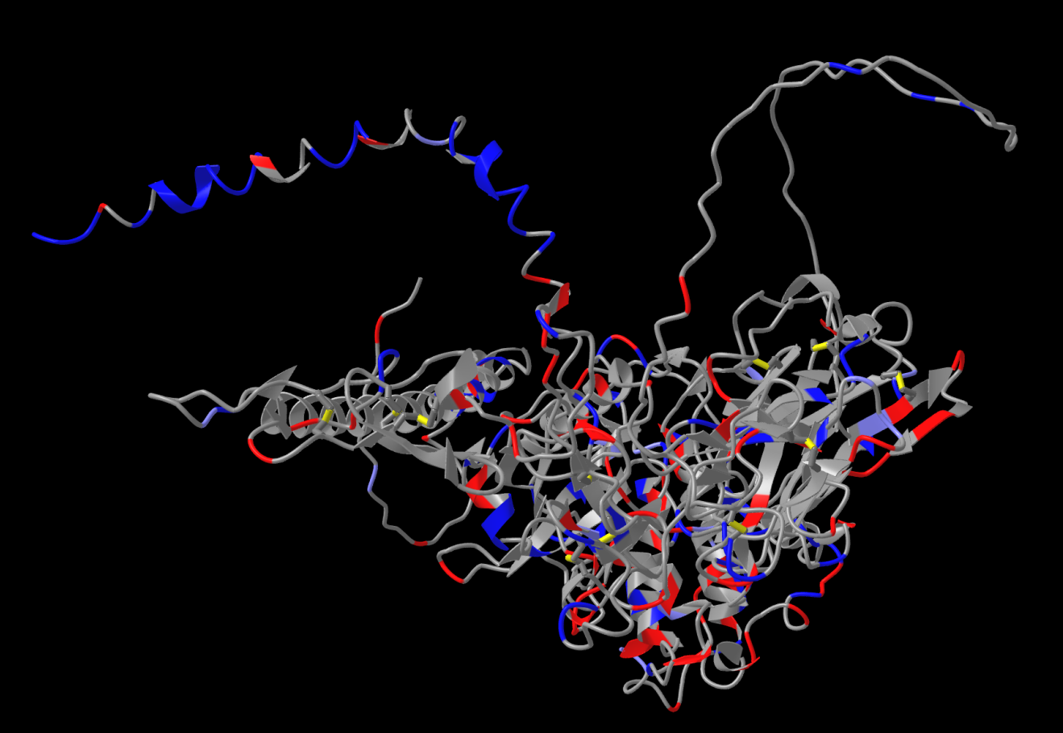

Figure S2: Predicted Structures of Putative CrWAK2
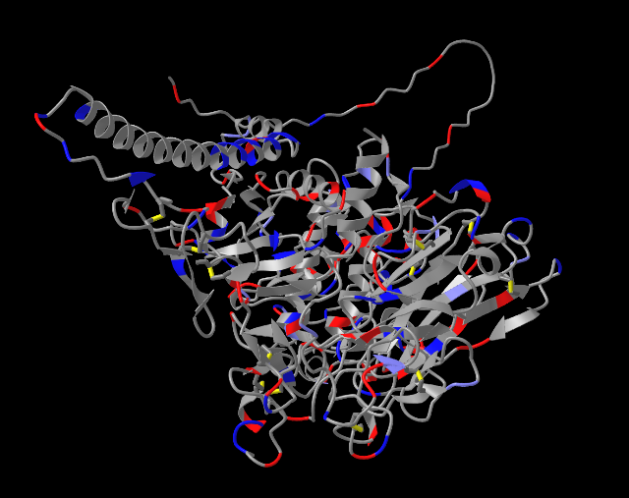

Figure S3: Predicted Structures of Putative CrWAK3
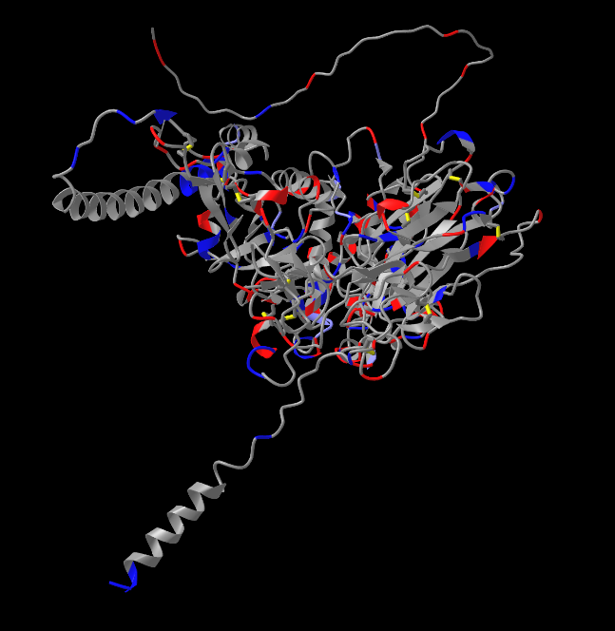

Figure S4: Predicted Structures of Putative CrWAK4
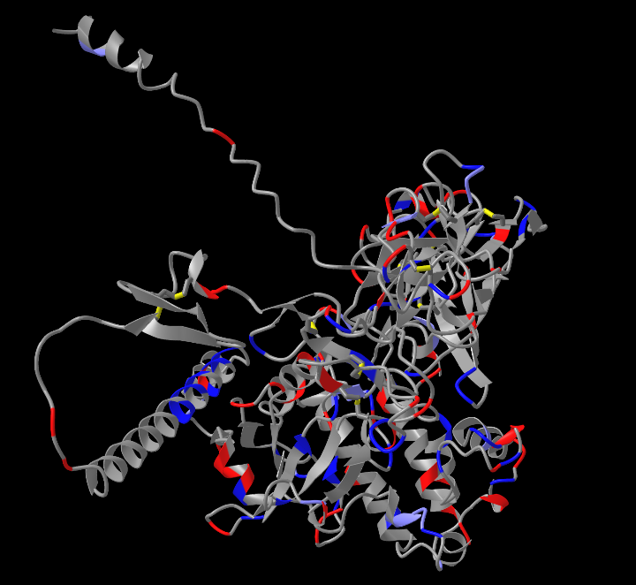

Figure S5: Predicted Structures of Putative CrWAK5
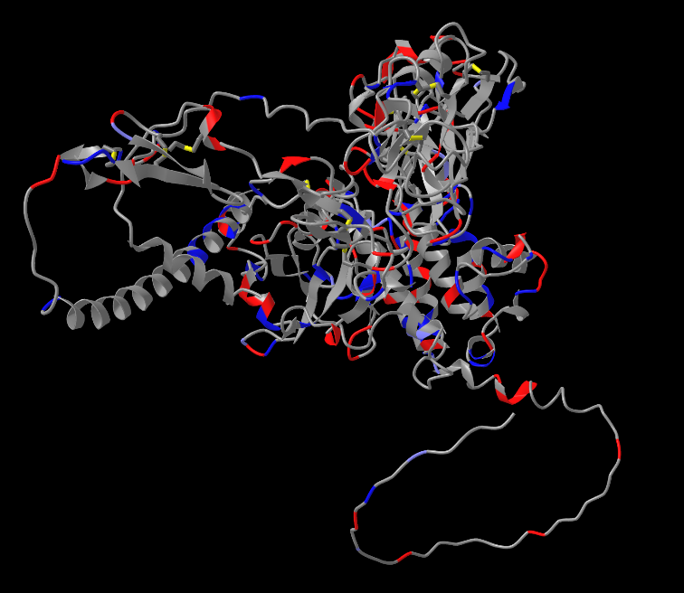

Figure S6: Predicted Structures of Putative CrWAK6
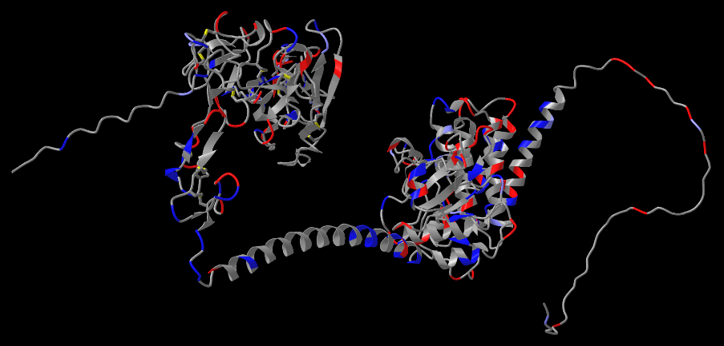

Figure S7: Predicted Structures of Putative CrWAK7
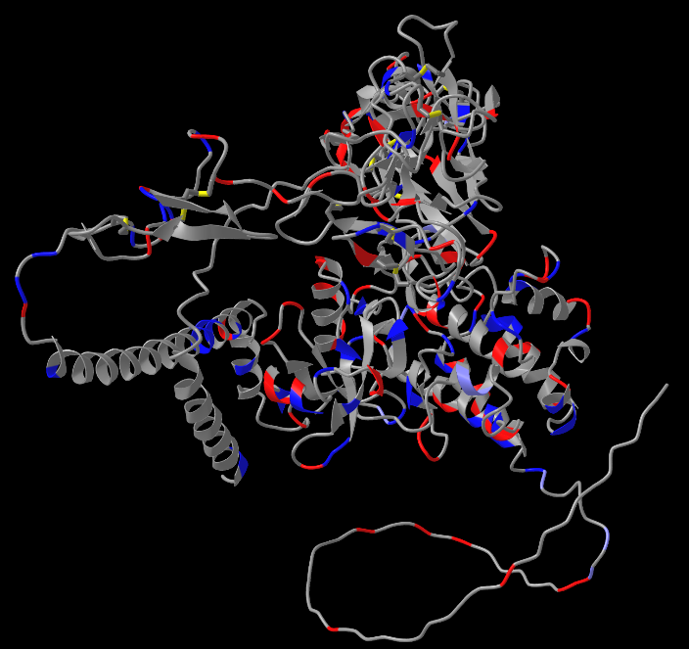

Figure S8: Predicted Structures of Putative CrWAK8
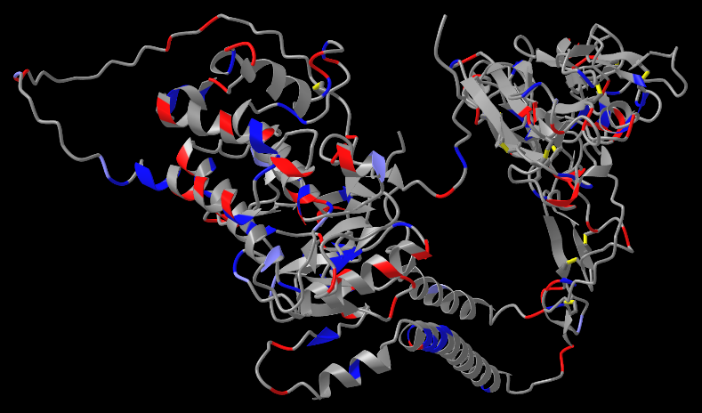

Figure S9: Predicted Structures of Putative CrWAK9
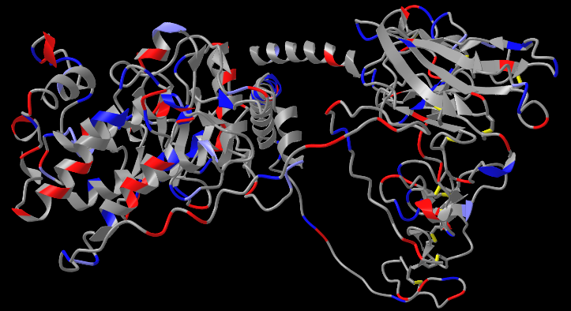

Figure S10: Predicted Structures of Putative CrWAK10
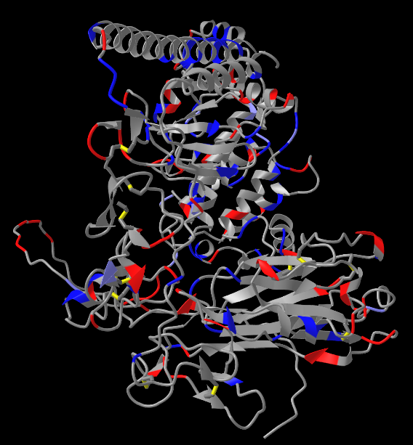

Figure S11: Predicted Structures of Putative CrWAK11
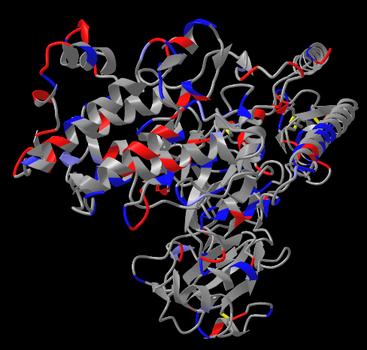

Figure S12: Predicted Structures of Putative CrWAK12
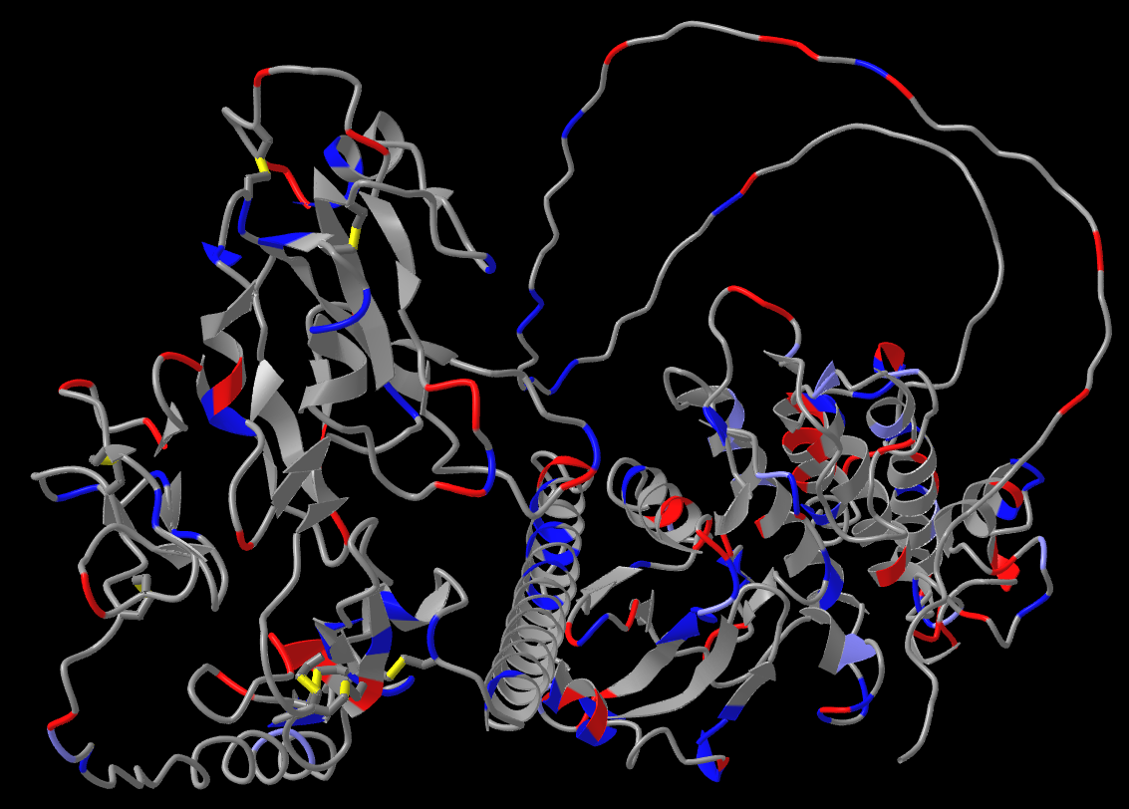

Figure S13: Predicted Structures of Putative CrWAK13
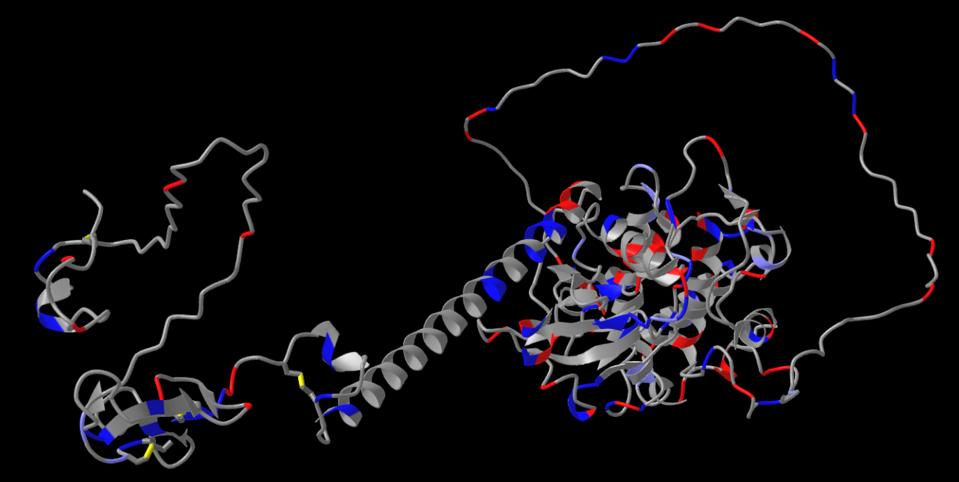

Figure S14: Predicted Structures of Putative CrWAK14
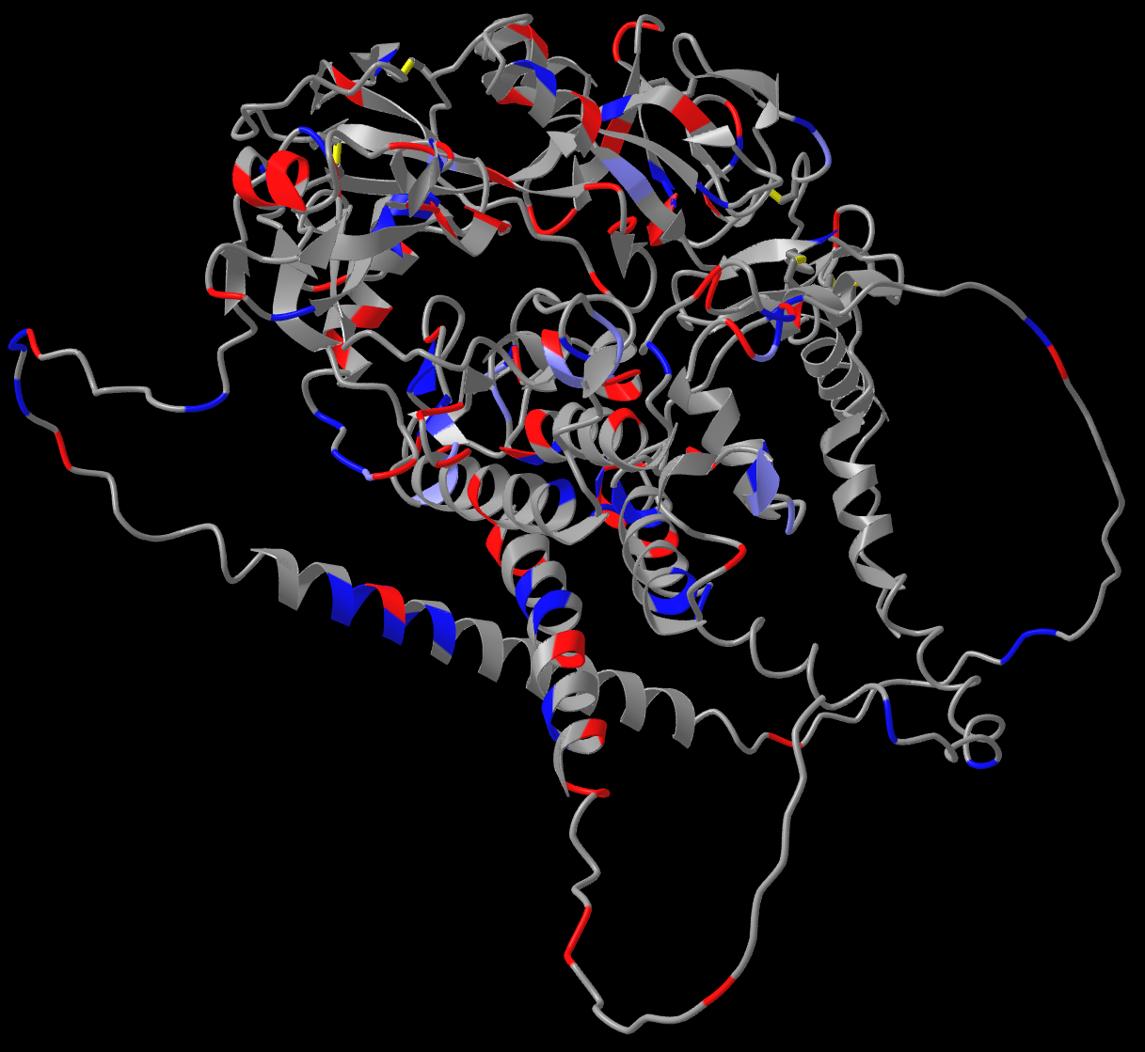

Figure S15: Predicted Structures of Putative CrWAK15
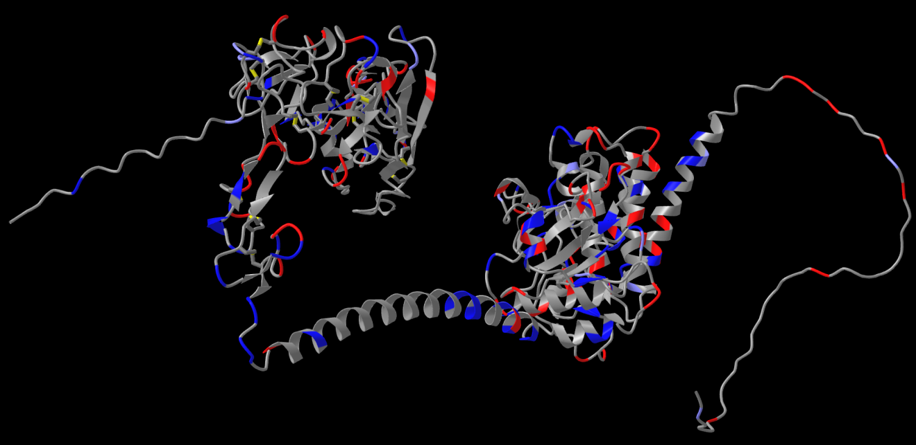

Figure S16: Predicted Structures of Putative CrWAK16
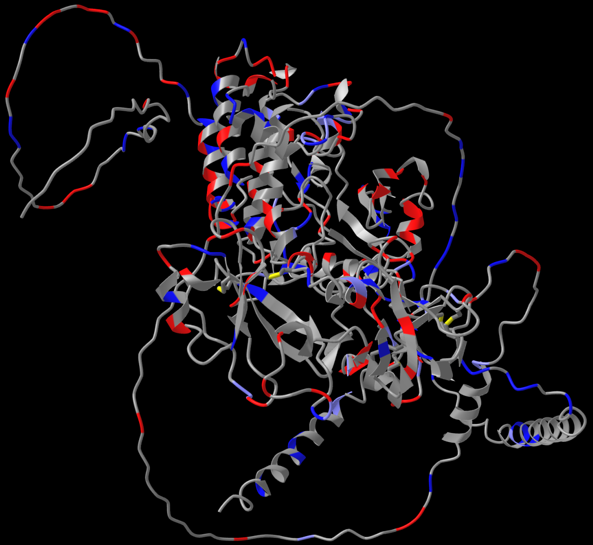

Figure S17: Predicted Structures of Putative CrWAK17
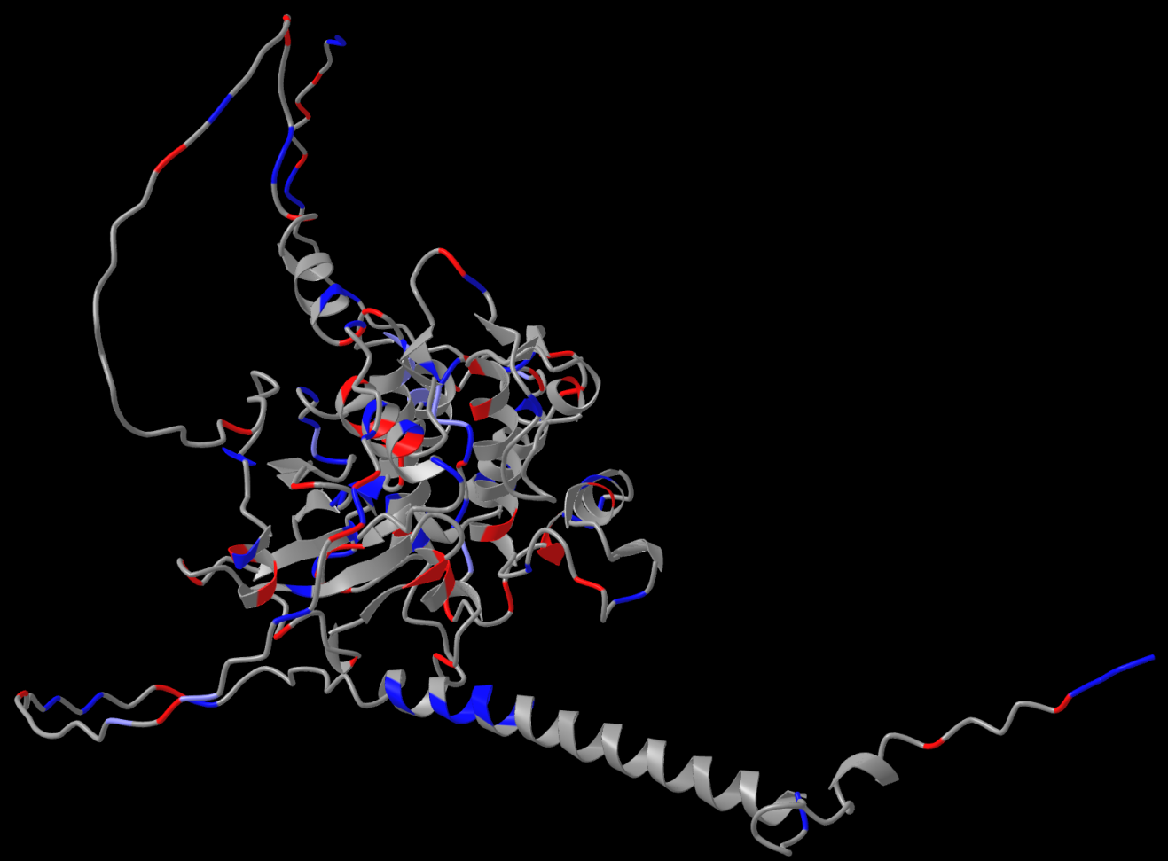

Figure S18: Predicted Structures of Putative CrWAK18
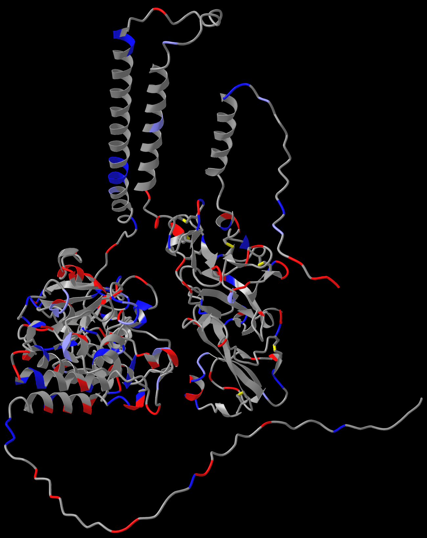

Figure S19: Predicted Structures of Putative CrWAK19
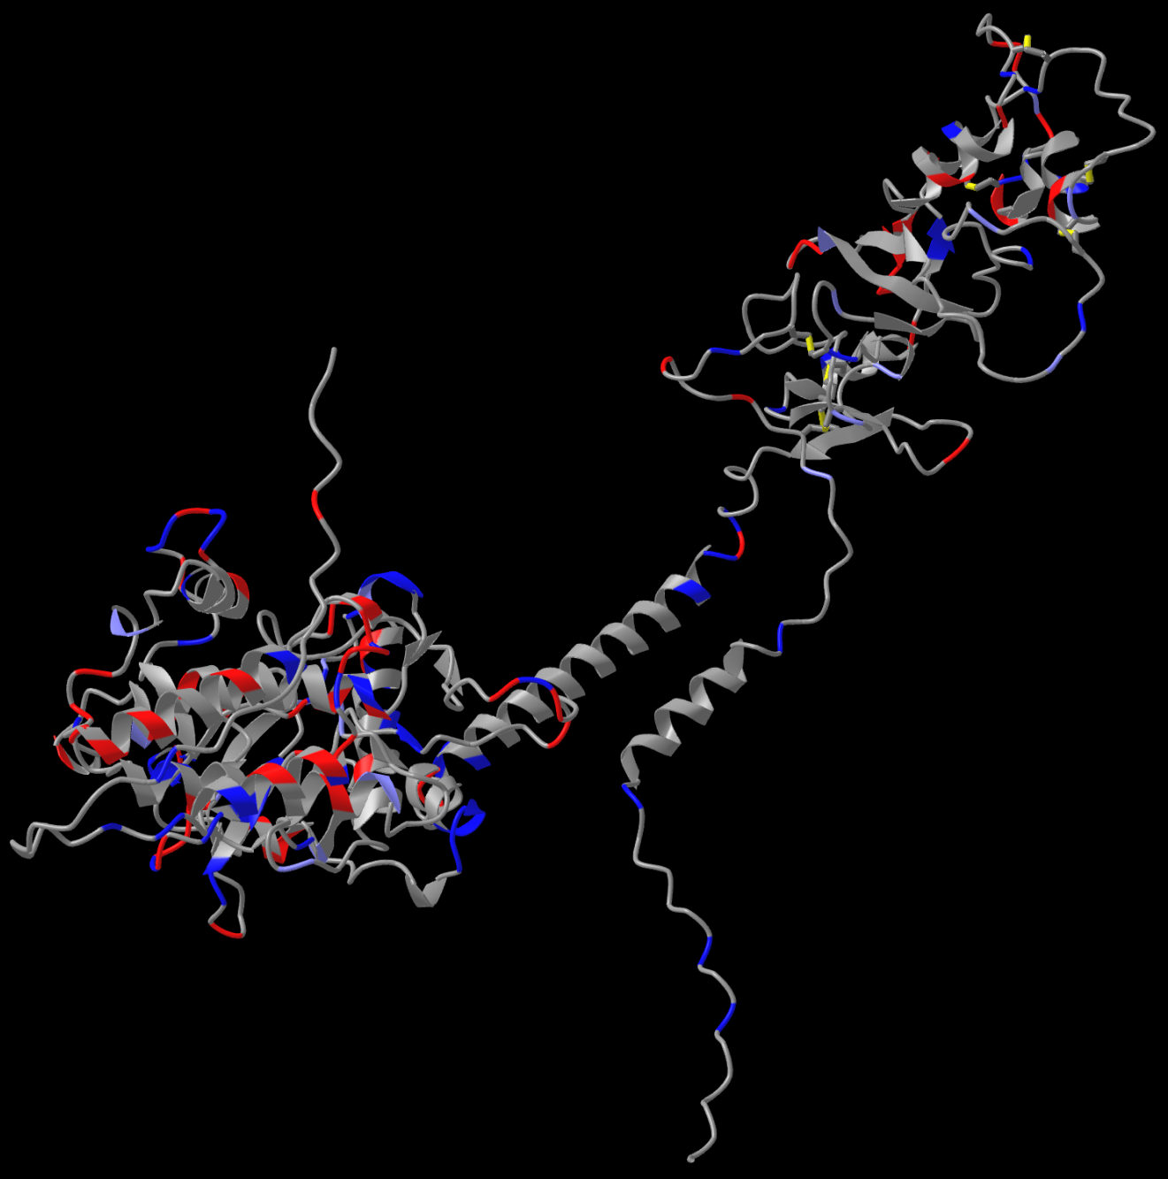

Figure S20: Predicted Structures of Putative CrWAK20
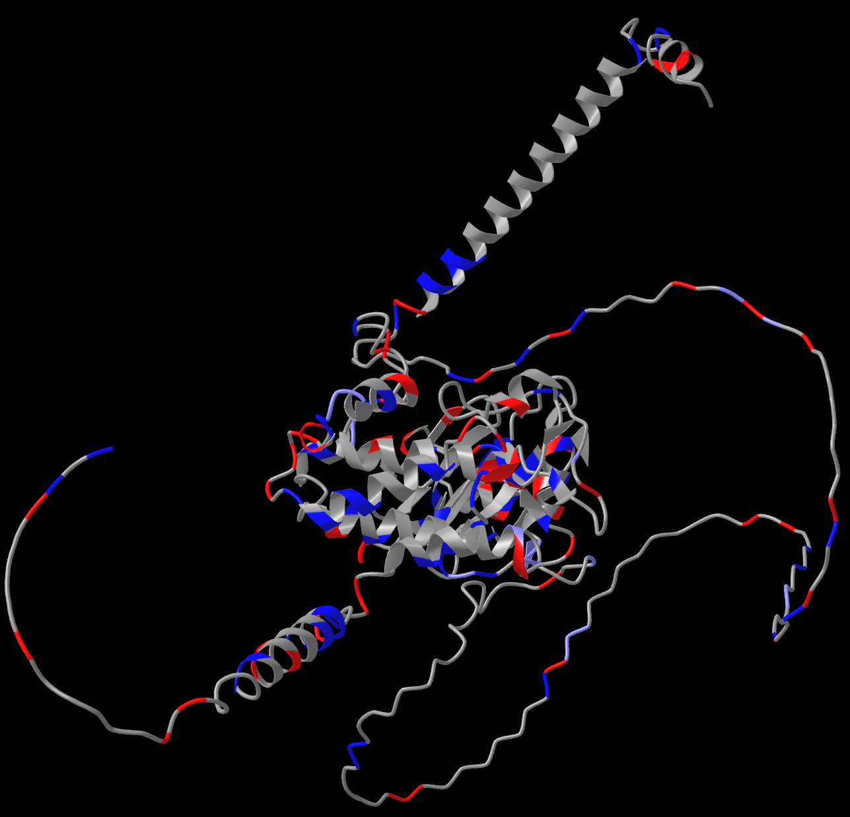

Figure S21: Predicted Structures of Putative CrWAK21
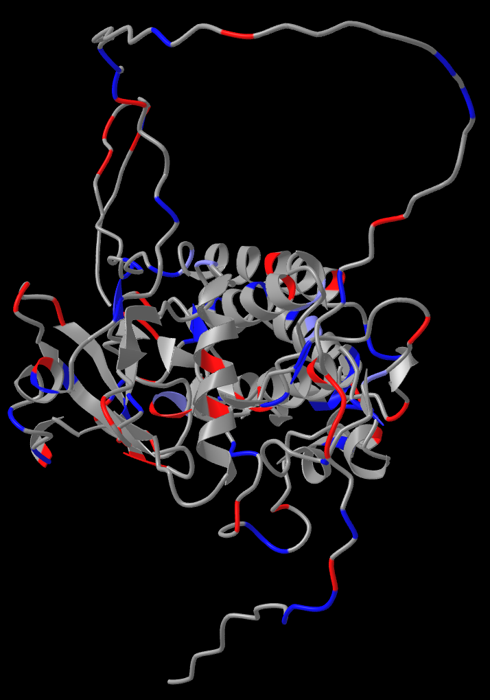
Figure S22: Predicted Structures of Putative CrWAK22
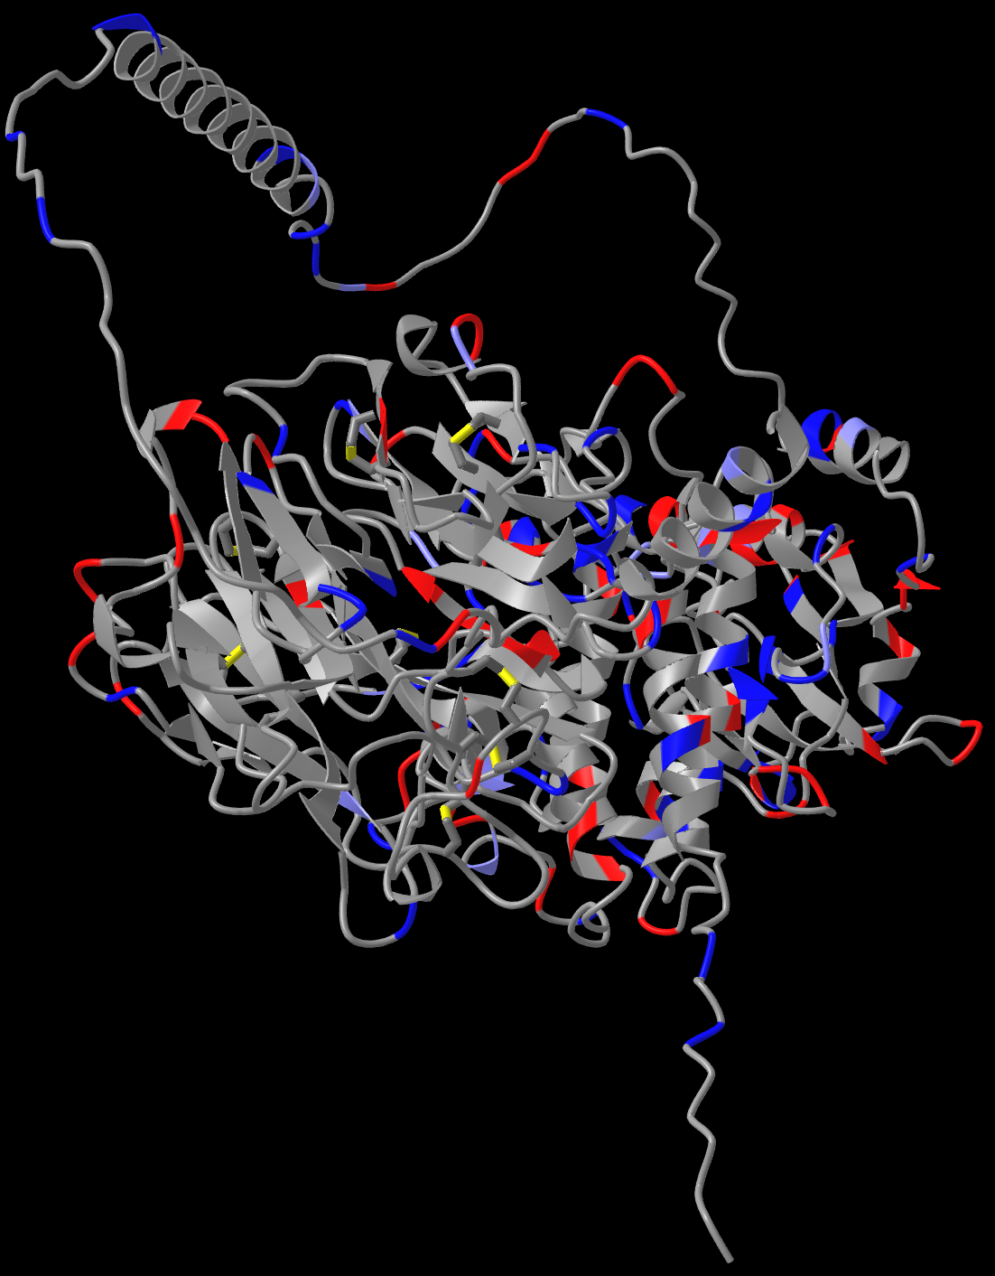

Figure S23: Predicted Structures of Putative CrWAK23
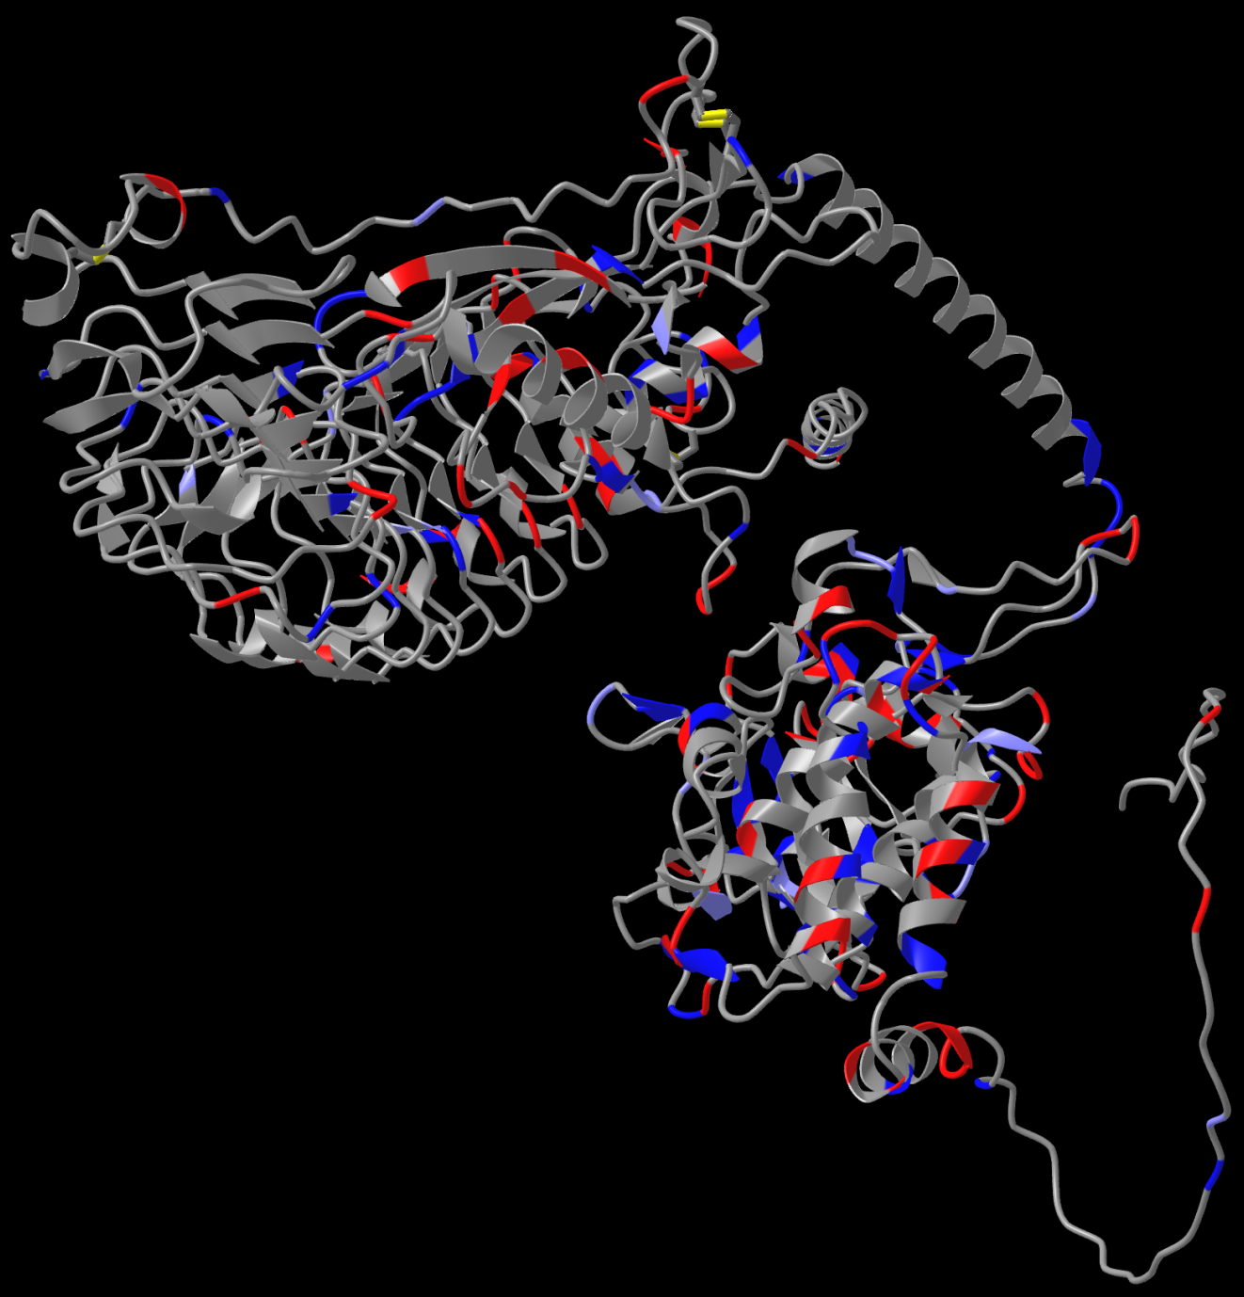
Figure S24: Predicted Structures of Putative CrWAK24
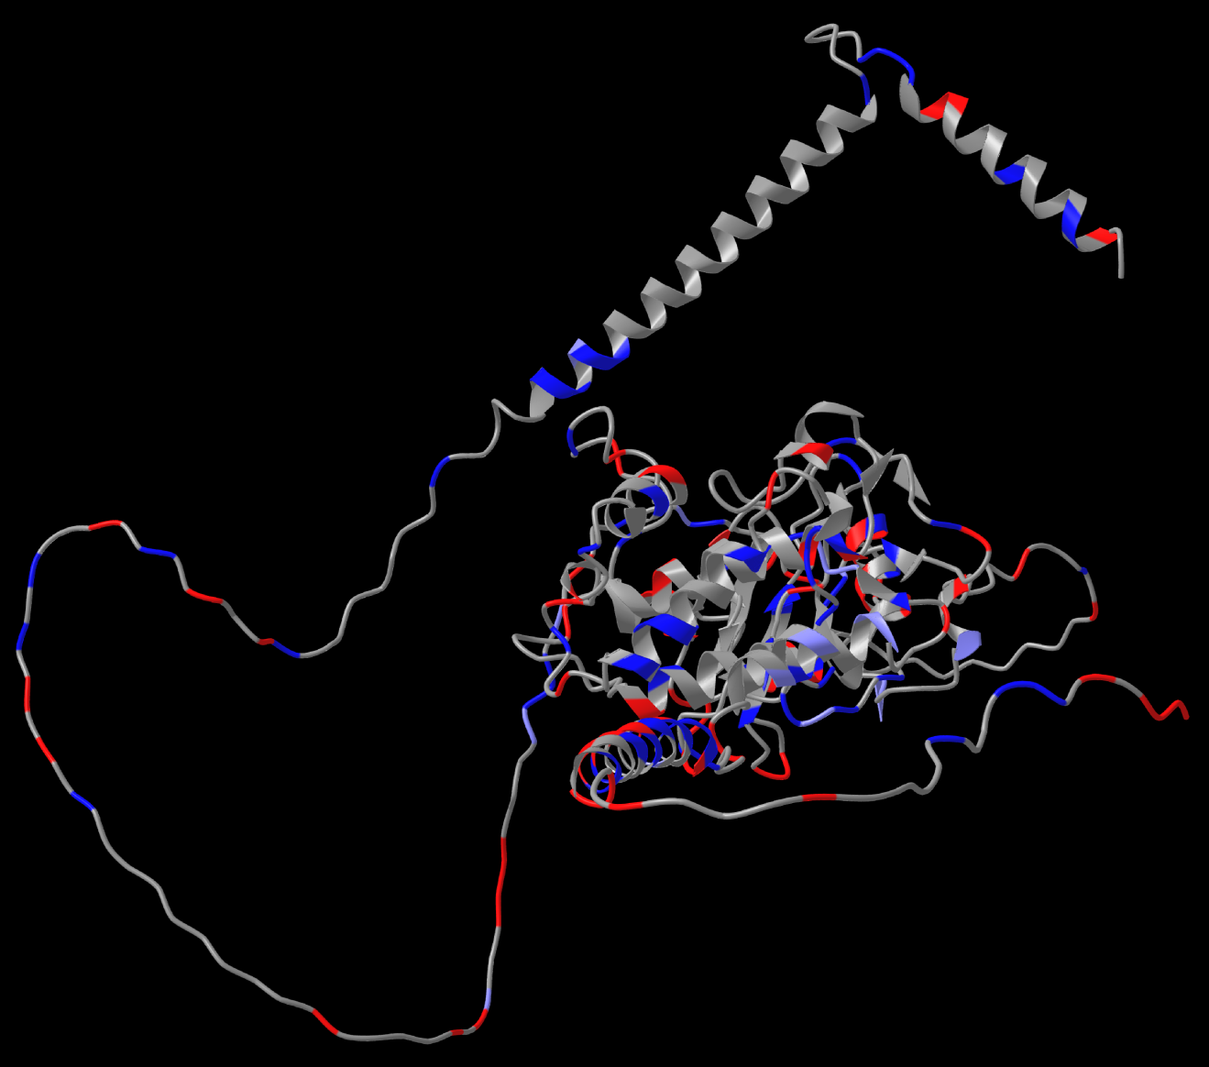

Figure S25: Predicted Structures of Putative CrWAK25
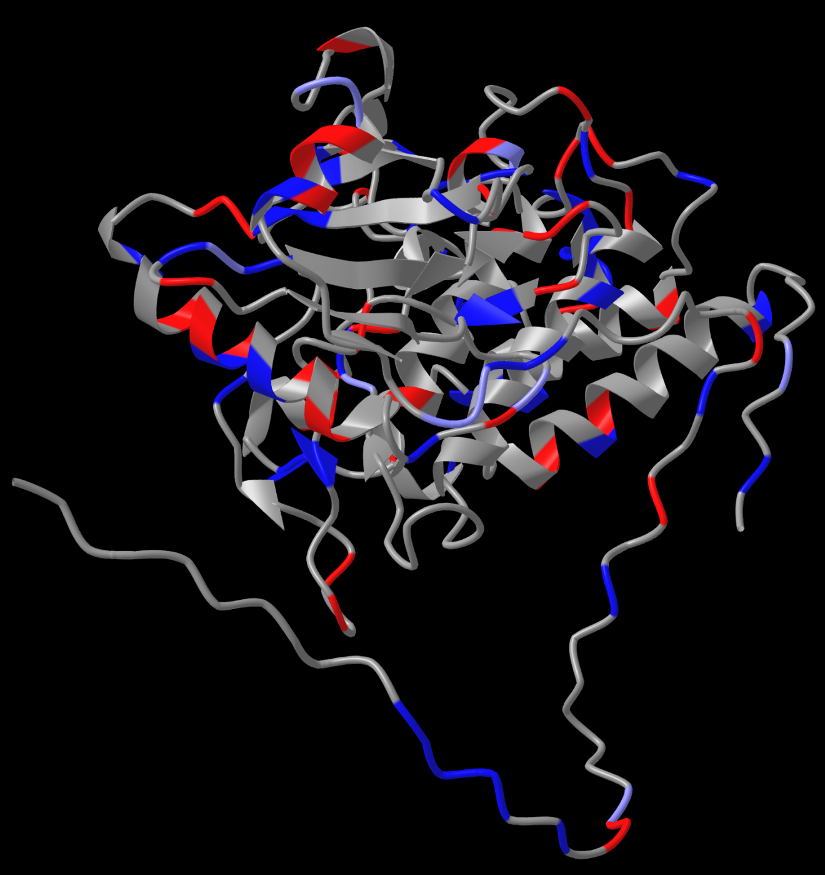

Figure S26: Predicted Structures of Putative CrWAK26
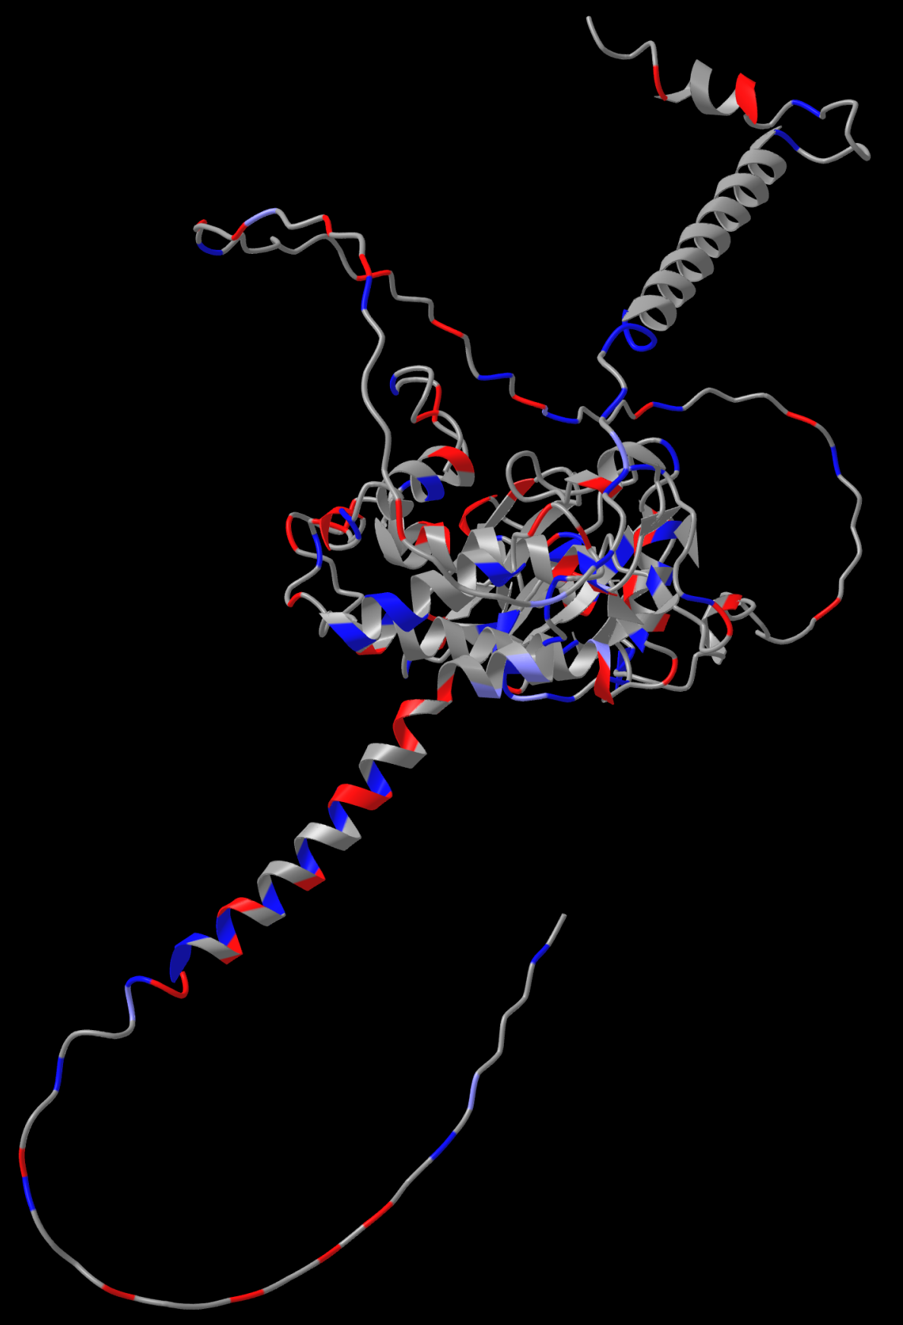

Figure S27: Predicted Structures of Putative CrWAK27
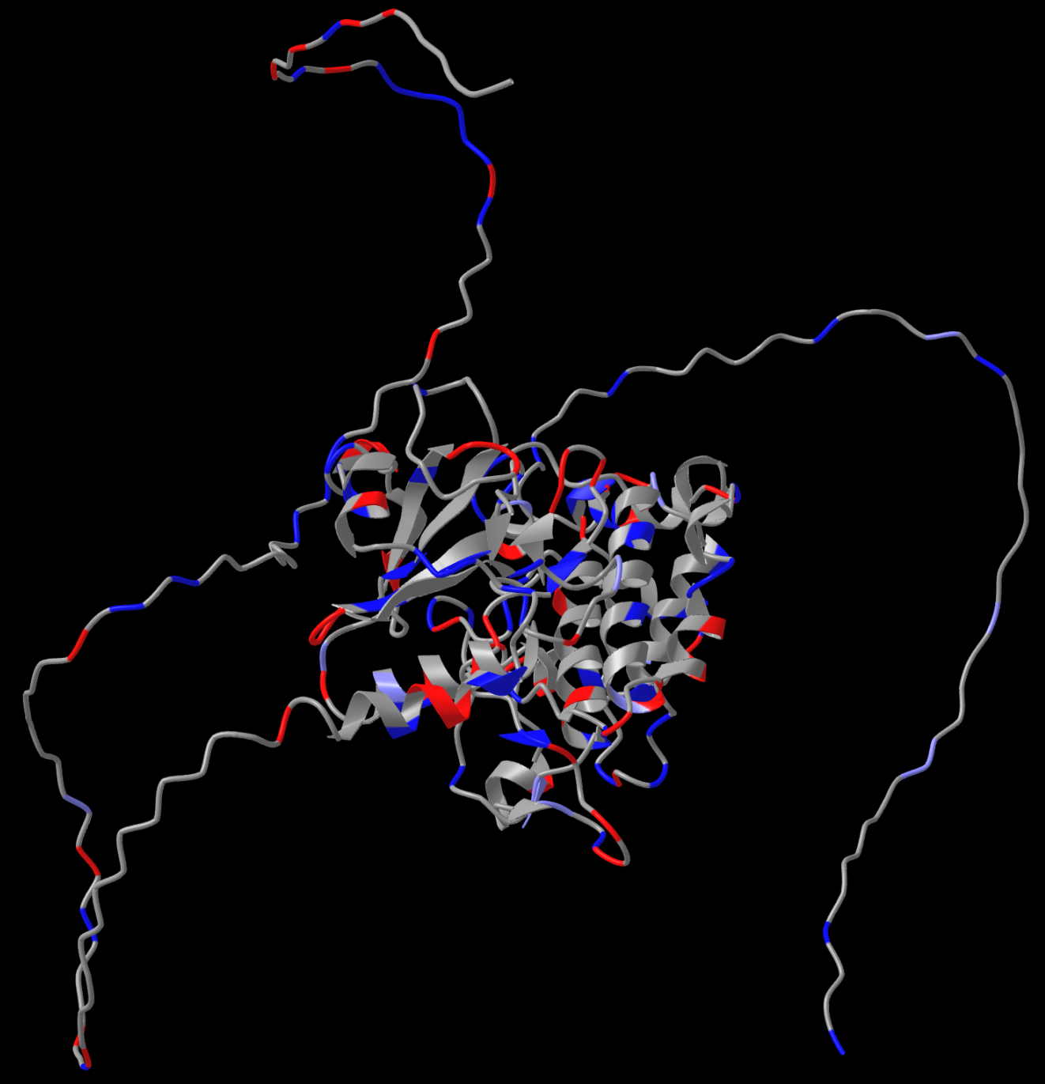

Figure S28: Predicted Structures of Putative CrWAK28
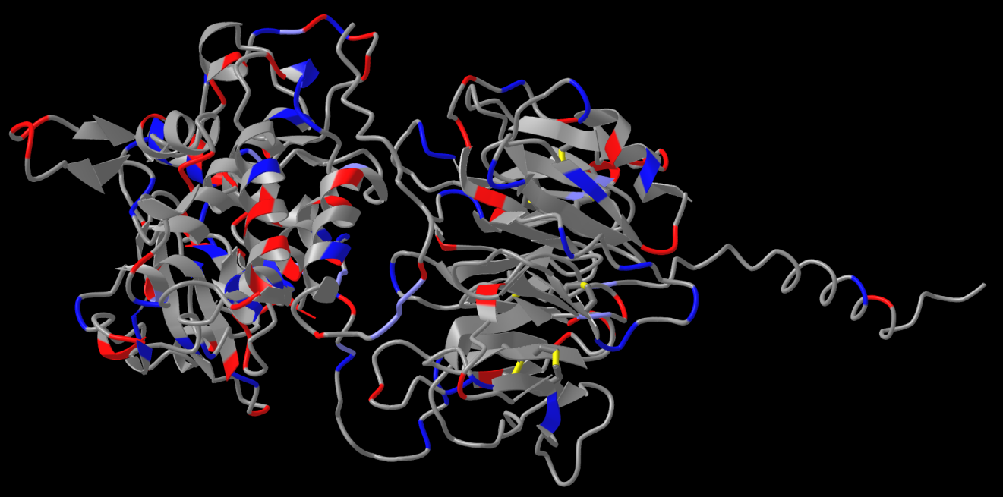

Figure S29: Predicted Structures of Putative CrWAK29
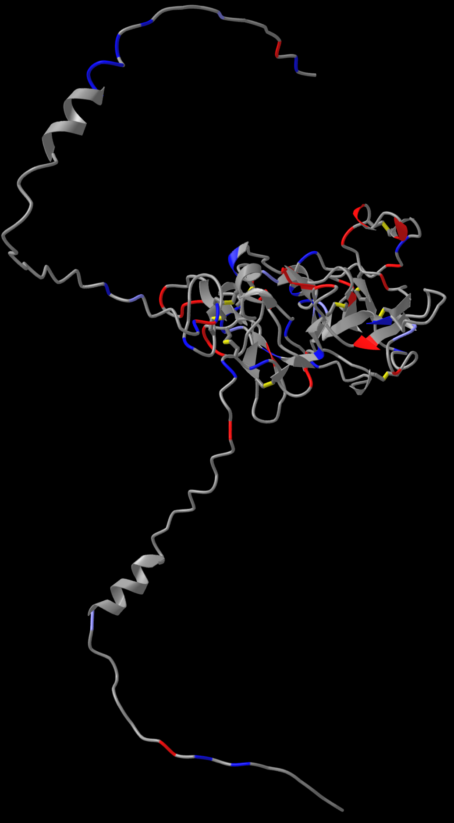
Figure S30: Predicted Structures of Putative CrWAK30
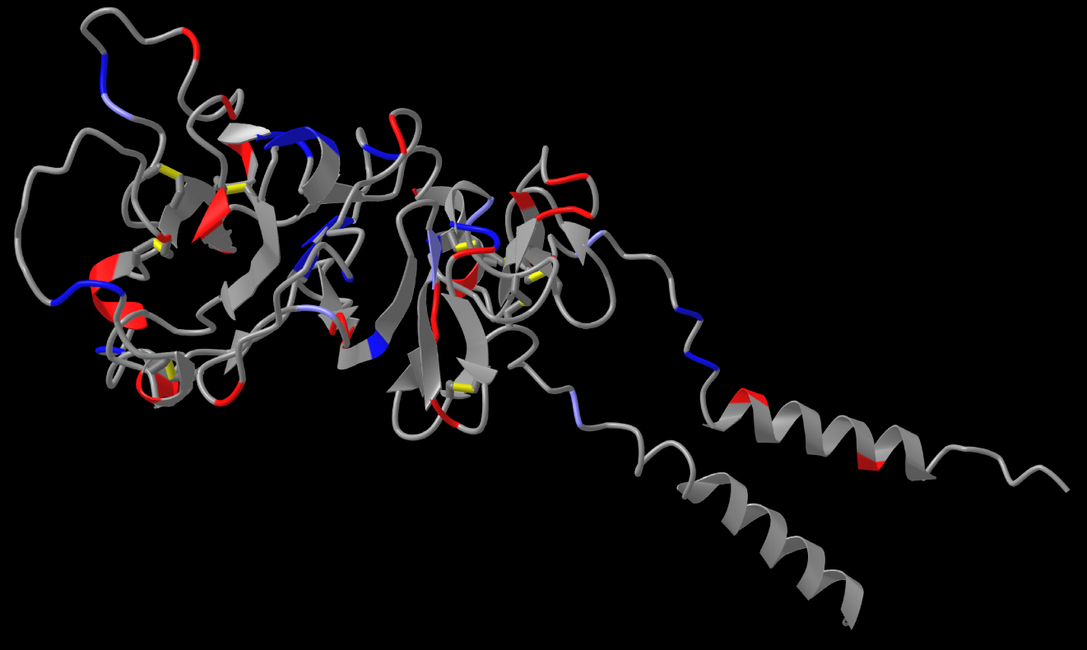

Figure S31: Predicted Structures of Putative CrWAK31
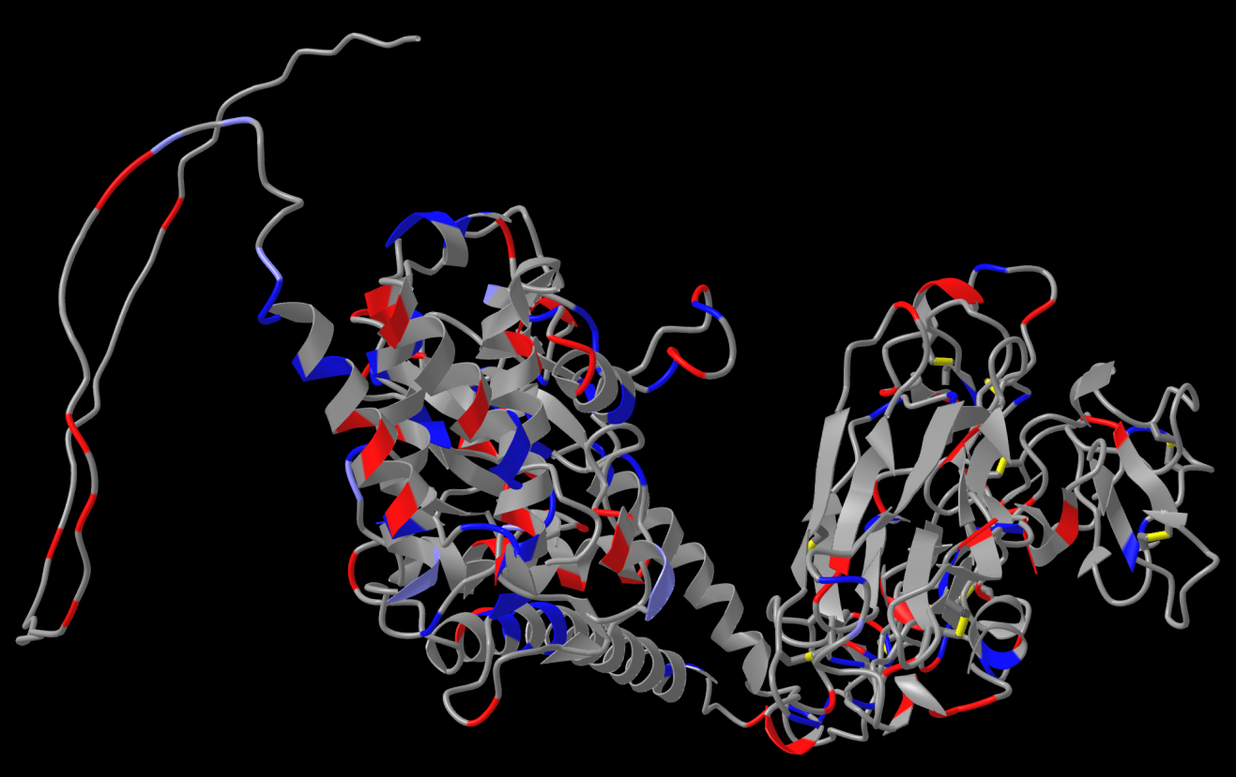

Figure S32: Predicted Structures of Putative CrWAK32
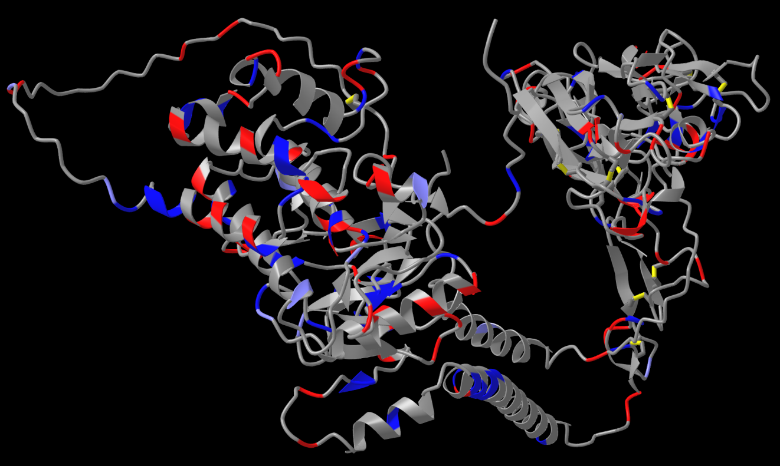

Figure S33: Predicted Structures of Putative CrWAK33
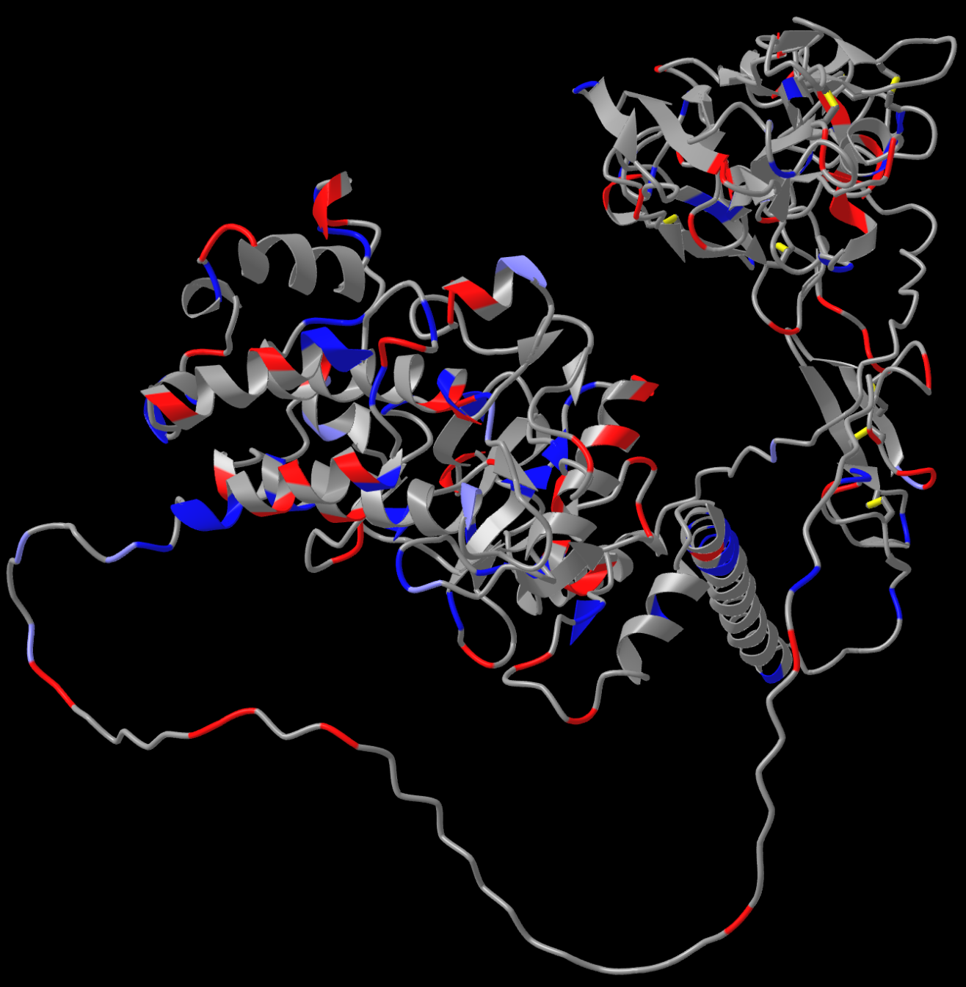

Figure S34: Predicted Structures of Putative CrWAK34
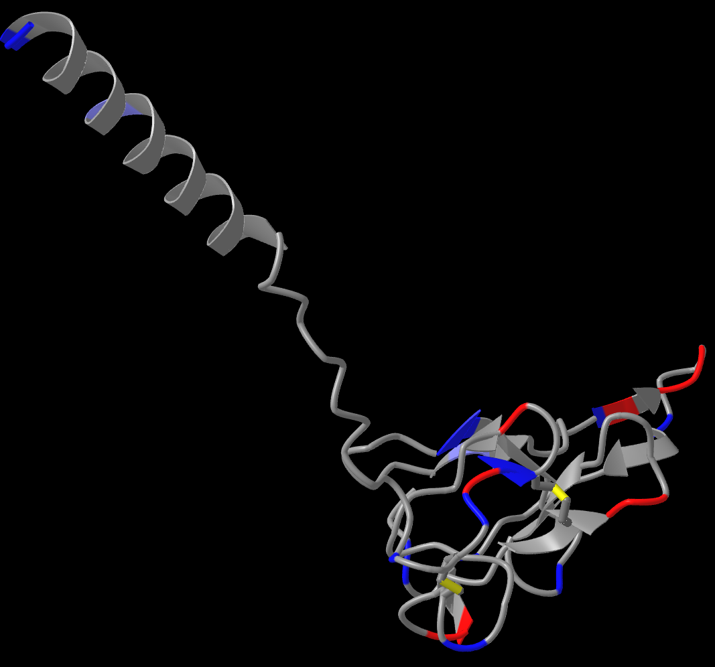

Figure S35: Predicted Structures of Putative CrWAK35
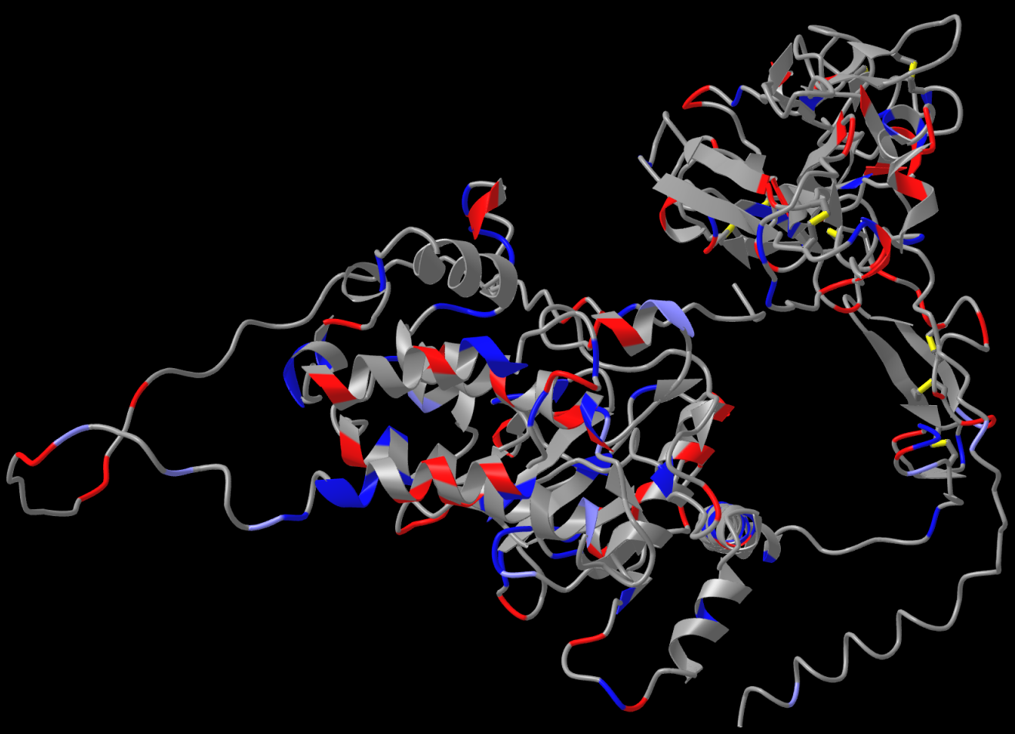

Figure S36: Predicted Structures of Putative CrWAK36
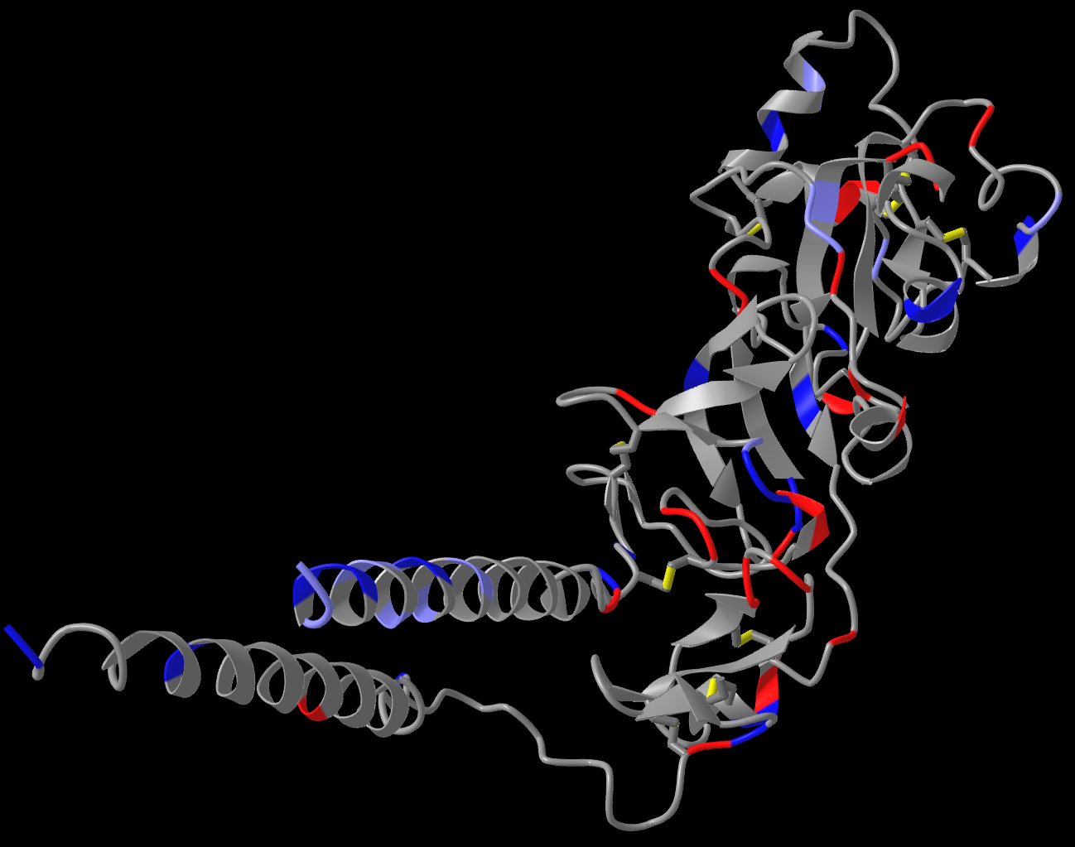

Figure S37: Predicted Structures of Putative CrWAK37
