Dynamical relationship between Indian summer monsoon rainfall and South Asian High in seasonal coupled models
G. Sripathi¹, Dandi. A. Ramu², T. S. Saikrishna¹, K.K. Osuri¹, A.S. Rao³

¹Department of Earth and Atmospheric Sciences, National Institute of Technology Rourkela, Odisha - 769 008, India
²Central University of Hyderabad, Hyderabad, Telangana, 500 046 India
³ Indian Institute of Tropical Meteorology, Pune, Maharastra 411 008, India

G. Sripathi (https://orcid.org/0009-0006-7946-8352)
Dandi.A. Ramu (https://orcid.org/0000-0002-9004-0158)
T. S. Saikrishna (https://orcid.org/0000-0002-6713-2628)
K.K.Osuri (https://orcid.org/0000-0001-9088-9656)
A.S.Rao (https://orcid.org/0000-0001-6460-5672 )

Submitting to Climate Dynamics

*Corresponding Author: Dr. Krishna Kishore Osuri
Assistant Professor,
Department of Earth and Atmospheric Sciences,
NIT Rourkela,
Email: osurikishore@gmail.com

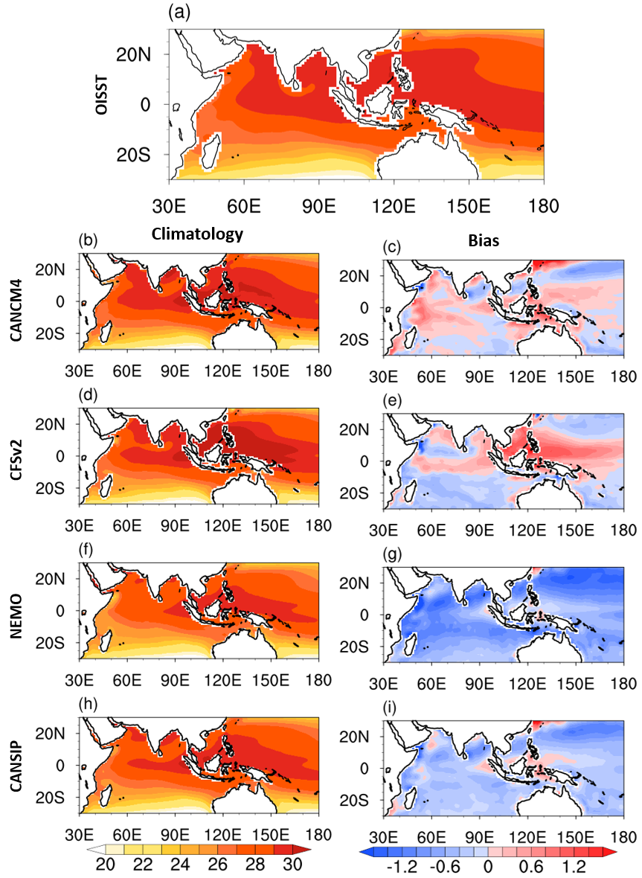
Figure S1: Spatial distributions of climatological JJA mean sea surface temperatures (shaded, ⁰ C) for a) observation, b) CANCM4, d) CFSv2, f) NEMO, h) CANSIP and wind bias for c) CANCM4, e) CFSv2, g) NEMO and i) CANSIP over the Asian region.

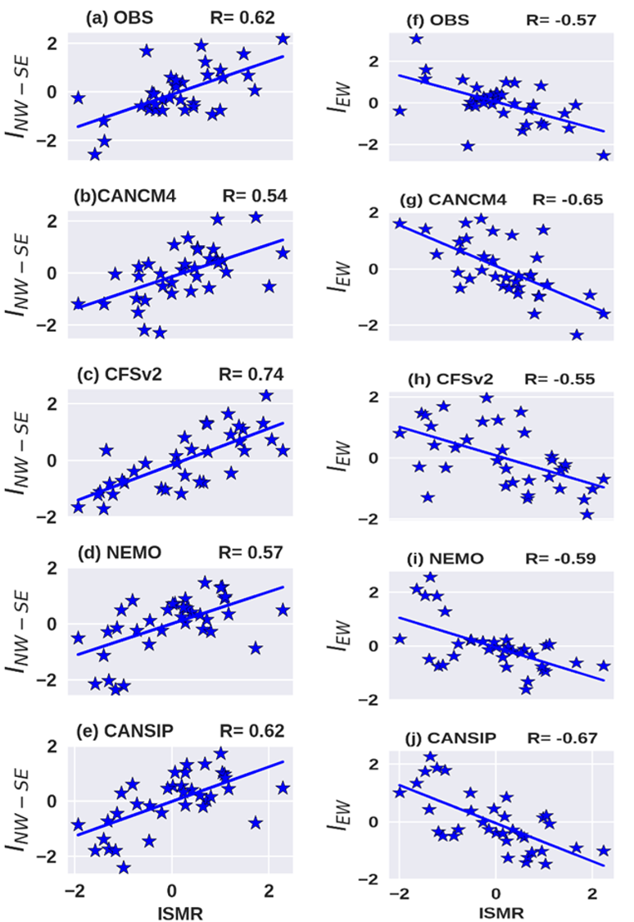
Figure S2: Scatter plot between I_{NW-SE} and ISMR for a) observation, b) CANCM4, c) CFSv2, d) NEMO, e) CANSIP and I_{EW} (Zonal shift) and ISMR region for f) observation, g) CANCM4, h) CFSv2, i) NEMO, j) CANSIP in JJA.

