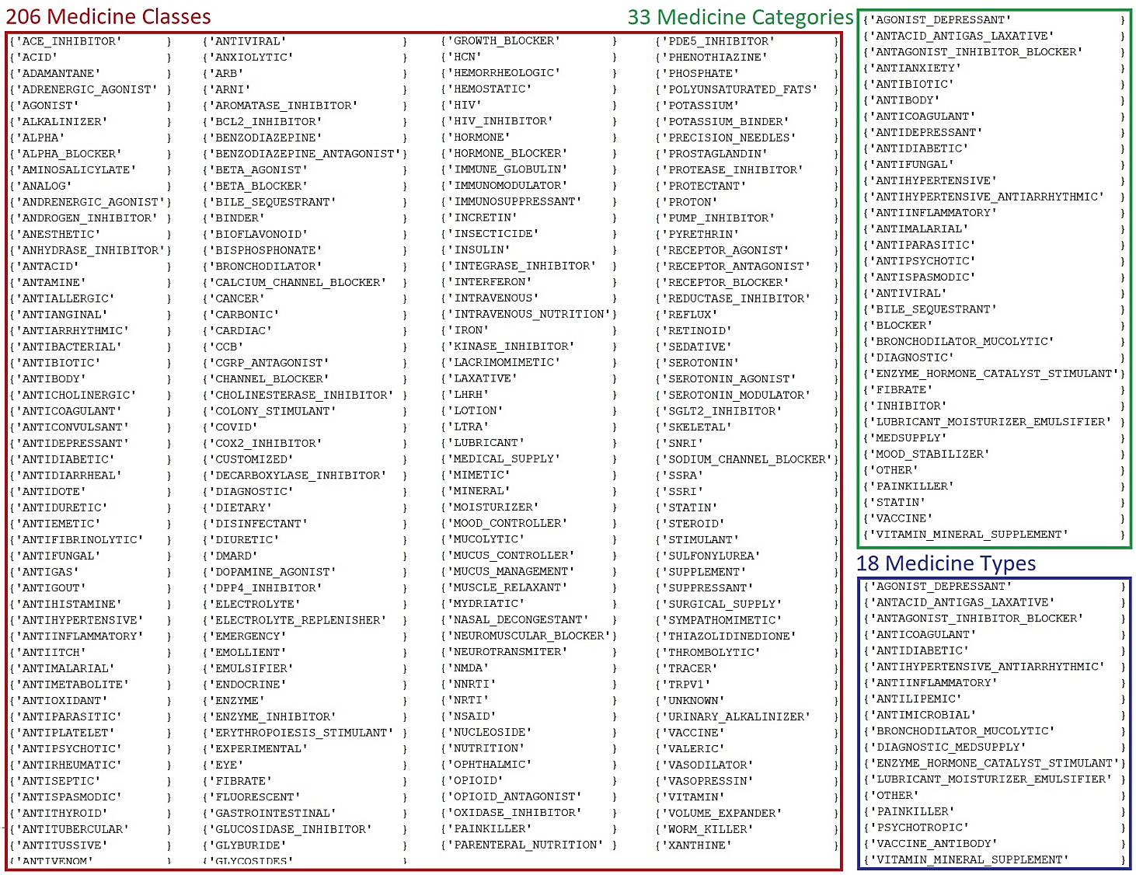
Figure S1. Lists of unique classes, categories, and types of medicines administered to 10k+ patients throughout their hospitalization

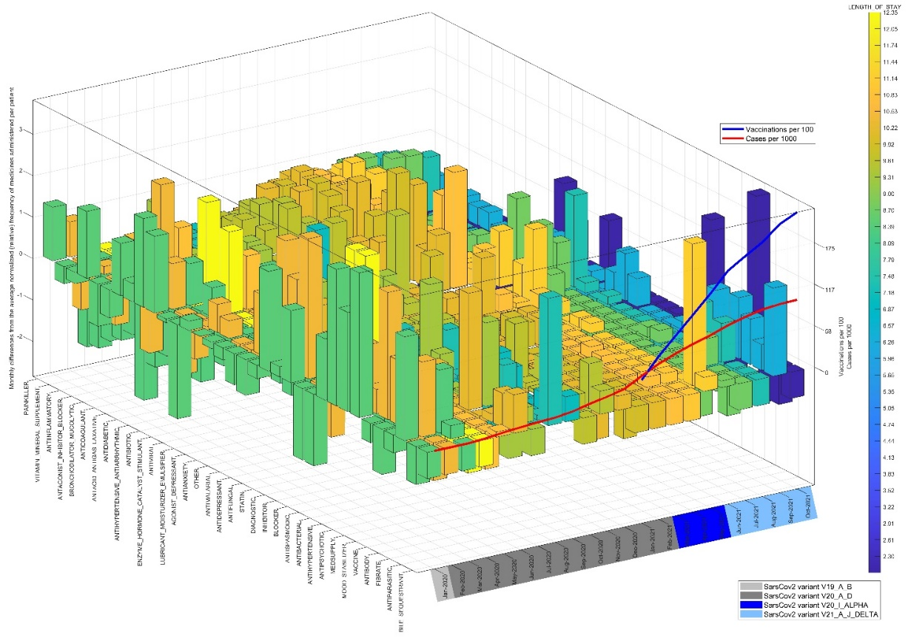
Figure S2. Monthly differences from the average per-patient frequencies of administered medicines of different categories along the COVID-19 Pandemic timeline in the UAE, cross-correlated with the average monthly patients' duration of hospital stay [days]. Medicine categories are ordered by the average frequency of administration to the SARS-COV-2-positive, hospitalized patients. Bar heights reflect the differences from the whole-period averages of per-patient administered categories of medicines, color-coded according to the monthly average duration of hospital stay. The COVID-19 timeline in the UAE is depicted by the continuous red/blue lines reflecting cumulative monthly cases-per-1000/vaccinations-per-100 and the dominant SARS-COV-2 variant in the UAE for each month.

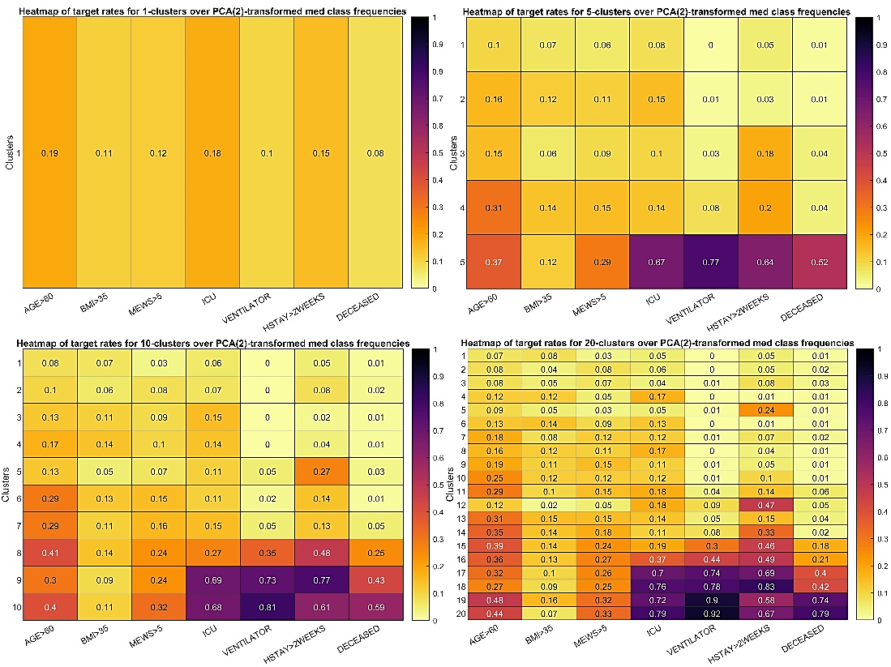
Figure S3. Heat-maps of disease management KPI target probabilities for an incremental number of clusters over PCA-transformed med class frequencies. The top-left plot for just a single cluster was added to inform the prior-average probability of targets.

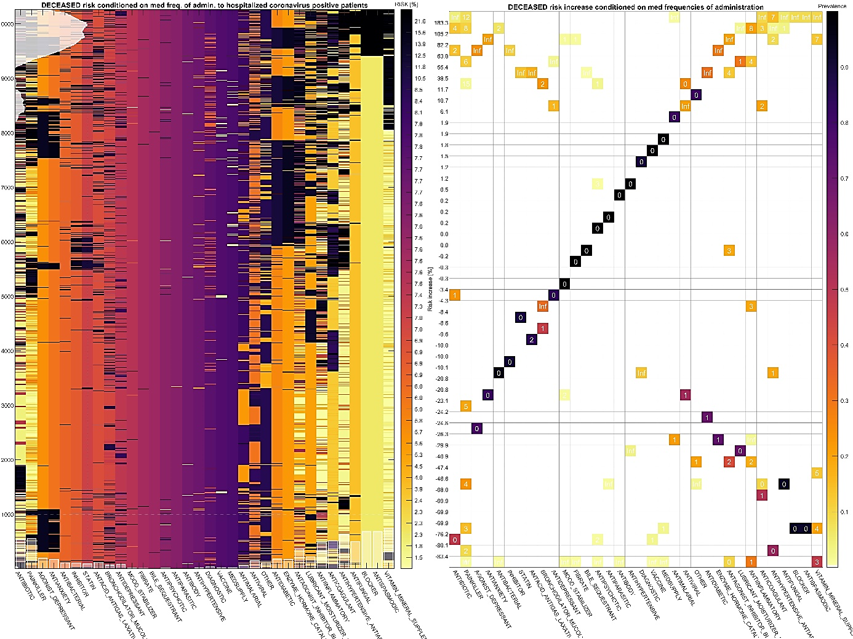
Figure S4. Deceased-Meds Clustergram. Heatmap of the death risk for hospitalized COVID-19-positive patients (rows) as a function of the optimally binned frequency of administered medicine categories (columns) both independently ordered by the hierarchical clustering to minimize the difference between the neighboring risk (to clump similar risk color together). The color bar illustrates the range of probability of death conditioned on the binned frequency of administered med. categories for different patients. Semi-transparent bar charts on the left and bottom left indicate the post-clustered groups of elevated death risk density and the AUC-measured individual predictive power of the overlaid frequency of med categories. The right-hand chart attempts to disambiguate how the med frequencies were binned and by how much the death risk increases /reduces for the corresponding binned frequency intervals, additionally colored by their probability of occurrence.

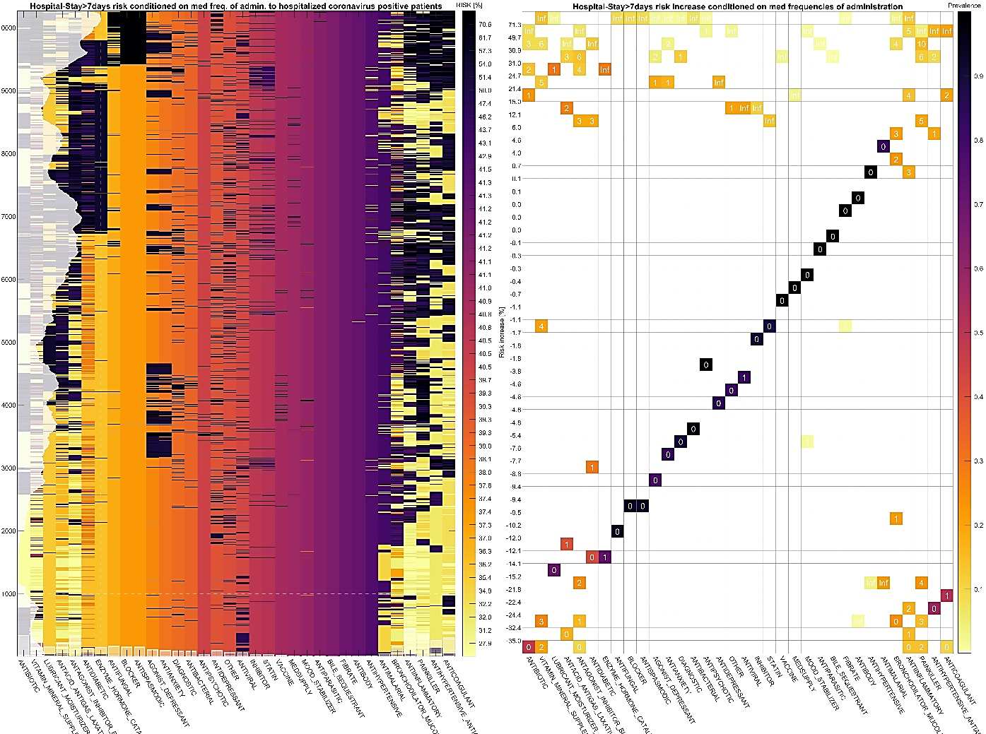
Figure S5. Hospitalization-Meds Clustergram. Heatmap of the risk of staying hospitalized above 7 days for COVID-19-positive patients (rows) as a function of the optimally binned frequency of administered medicine categories (columns) both independently ordered by the hierarchical clustering to minimize the difference between the neighboring risk (to clump similar risk color together). The color bar illustrates the range of probability of hospitalization longer than 7 days conditioned on the binned frequency of administered med. categories for different patients. Semi-transparent bar charts on the left and bottom-left indicate the post-clustered groups of elevated hospitalization rate and the AUC-measured individual predictive power of the overlaid med-frequency features. The right-hand chart how med. category frequencies were binned and by how much the risk of hospitalization over 7 days increases/reduces for the corresponding binned frequency intervals, additionally colored by their probability of occurrence.

