Supporting Information
Triggering Triplet Excitons of Carbon Nanodots for Multicolor Phosphorescence in Aqueous Solution

Ya-Chuan Liang^{2,3}, Qing Cao¹, Yuan Deng¹, Yong Wang¹, Shi-Yu Song¹, Wen-Bo Zhao¹, Lin Dong¹, Kai-Kai Liu¹* and Chong-Xin Shan¹*

¹ Henan Key Laboratory of Diamond Optoelectronic Material and Devices, School of Physics and Microelectronics, Zhengzhou University, Zhengzhou 450001, China.
² School of Electronics and Information, Zhengzhou University of Light Industry, Zhengzhou 450002, China.
³ Academy for Quantum Science and Technology, Zhengzhou University of Light Industry, Zhengzhou 450002, China.
E-mail: liukaikai@zzu.edu.cn. cxshan@zzu.edu.cn.

Phosphorescence quantum yield measurement. The phosphorescence quantum yield (QY) of the CNDs@silica was measured by FLS980 spectrometer with a calibrated integrating sphere, and the obtained photoluminescence QY is absolute QYs. In principle, the photoluminescence QY can be expressed by the following equation:
$$η=\frac{ε}{α}=\frac{\int_{390}^{750}{L_{emission}}}{\int{E_{reference}}-\int{E_{sample}}}=\frac{number of emitted photons}{number of absorbed photons}$$
where η is the photoluminescence QY, ε is the emitted photons of the sample that collected by the integrating sphere in the range of 390-750 nm, α is the photons absorbed by the sample. L_{emission} is the net photoluminescence of the sample. E_{reference} is the absorption spectrum of the reference in the sphere. E_{sample} is the absorption spectrum of the sample and reference. The total quantum yield (QY) of the B-CNDs@silica and G-CNDs@silica are 14.53 % and 12.31 %, respectively. The QY of the sample includes phosphorescence and fluorescence QYs. According to the measured luminescence spectrum, the proportion of phosphorescence QY is about 81.5 % for B-CNDs@silica and 69.9 % for G-CNDs@silica in the total QY, thus the phosphorescence QY of the B-CNDs@silica and G-CNDs@silica are about 11.8 % and 8.6 %, respectively. The red phosphorescence is achieved through FRET process between phosphorescence CNDs and RhB and the calculated luminescence QY of CNDs@silica in the range of 390-750 nm is about 25.21 % based on above equation. The proportion of phosphorescence is about 46 % in the total luminescence intensity, thus the phosphorescence QY is about 11.6 %. The photoluminescence QY of the RhB in aqueous solution is 31 %, and Förster resonant energy transfer efficiency between CNDs and RhB is 99.2 %. So, the phosphorescence QY of R-CNDs@silica is 3.56 %.
Cellular Toxicity Test. In order to assess cellular toxicity, CHO-K1 cells (1000 cells/200 μL) were cultured in 96-well plates in an incubator for 24 h (37 °C, 5 % CO₂). After that, the cultured medium was replaced by fresh medium, which contained the three kinds of CNDs@silica with different concentrations (0, 25, 50, 100 and 200 μg/mL). The microplate reader was used to monitor absorbance at 490 nm and the corresponding cell viability was evaluated according to the following equation:
Cell Viability (%) = OD_{Treated}/OD_{Control}
Mice. Kunming mice were purchased from Vital River Laboratory Animal Technology Co. Ltd (Beijing, China). All mice maintained in a specific pathogen-free facility. Animal welfare and experimental procedures were carried out in accordance with national and institutional guidelines for animal care and were approved by the Ethics Committee of Zhengzhou University.

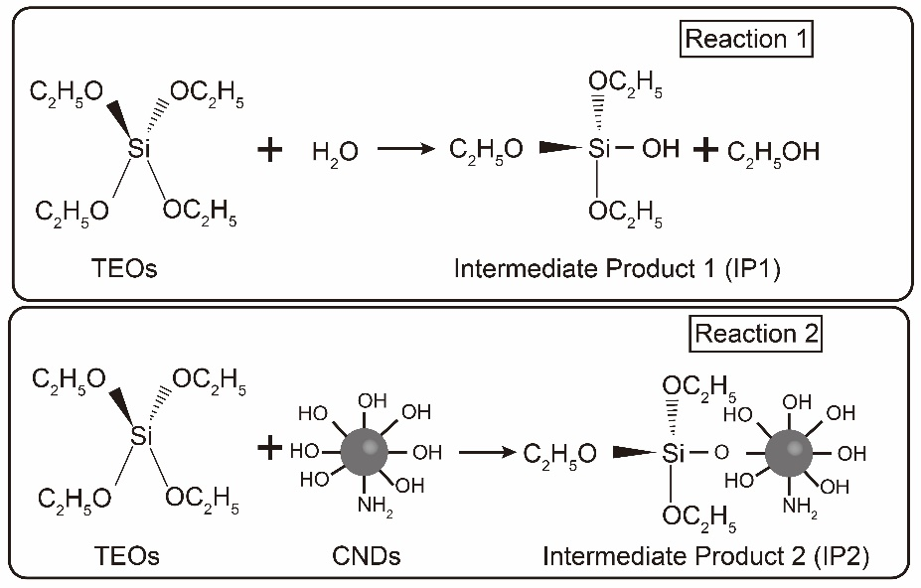
Figure S1. The silica encapsulation mechanism of the CNDs.
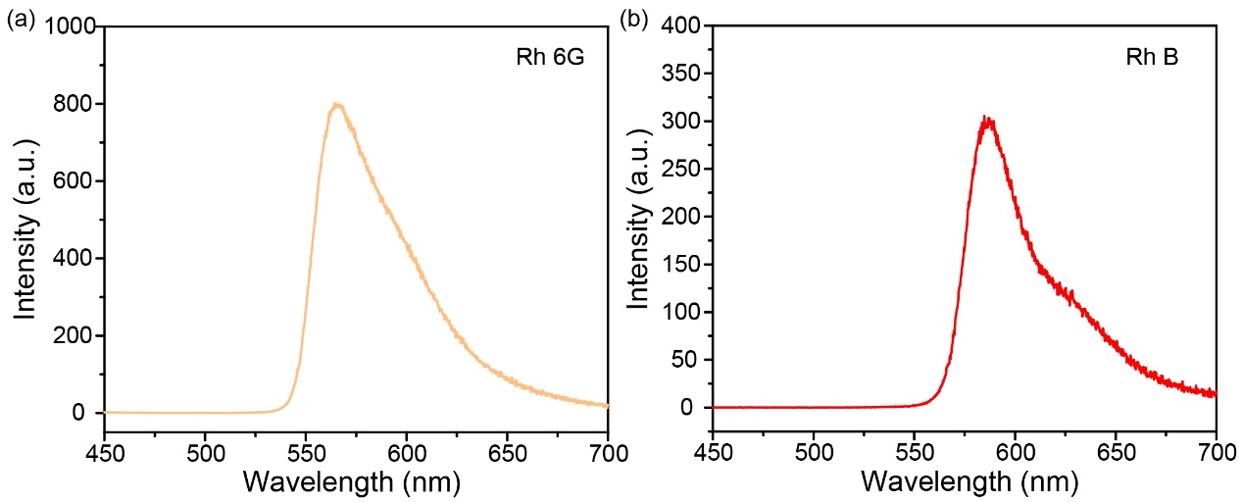 Figure S2. The fluorescence spectra of rhodamine 6G (Rh6G) (a) and rhodamine B (RhB) (b).

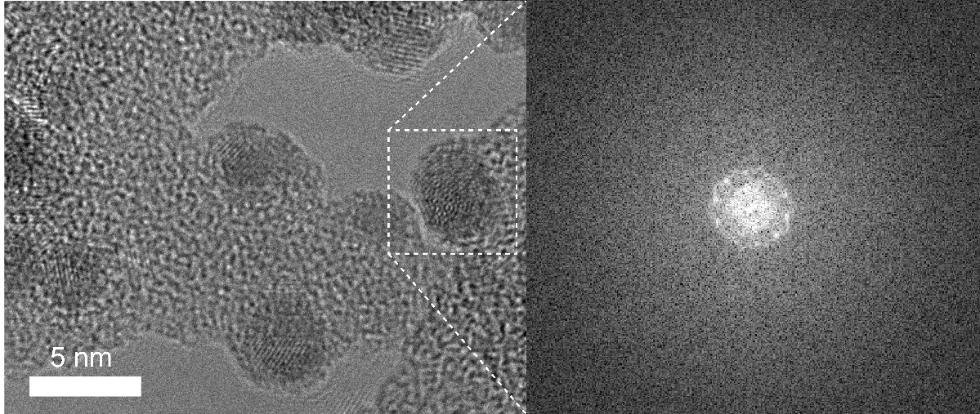
Figure S3. High resolution TEM image and selected-area diffraction image of the CNDs@silica.

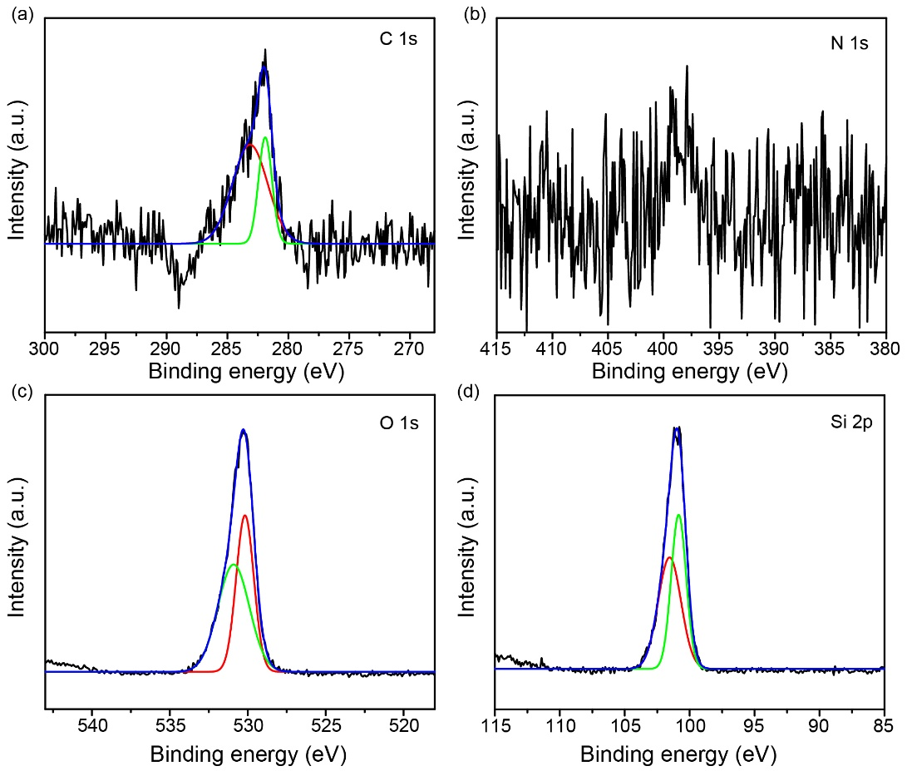
Figure S4. The high resolution XPS spectra of C 1s, N 1s, O 1s and Si 2p of the B-CNDs@silica.

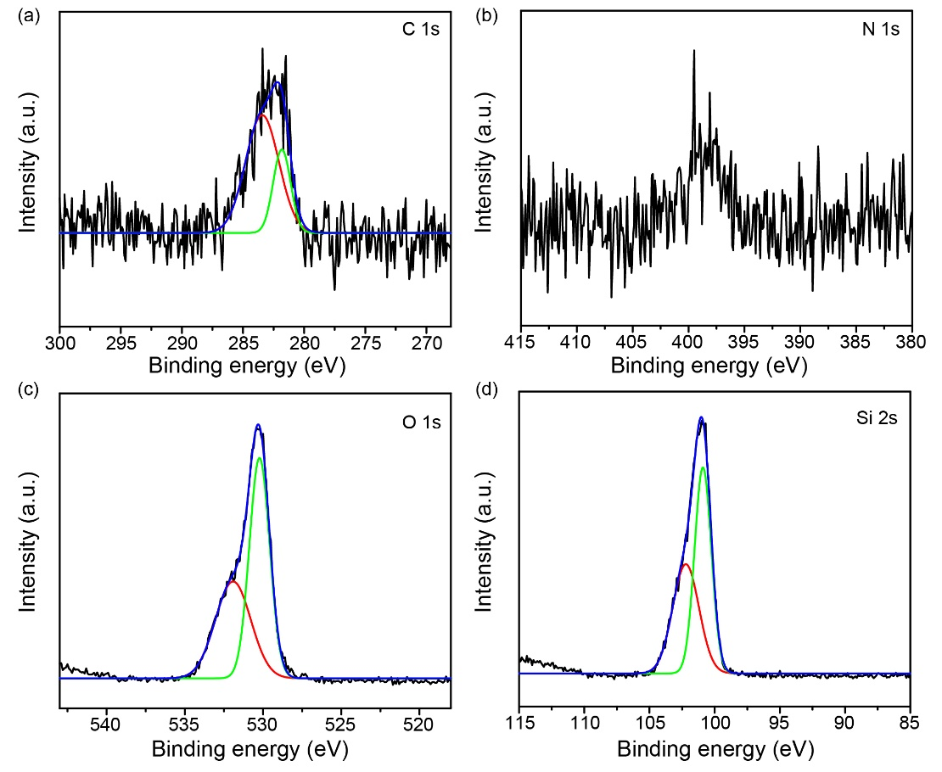
Figure S5. The high resolution XPS spectra of C 1s, N 1s, O 1s and Si 2p of the G-CNDs@silica.

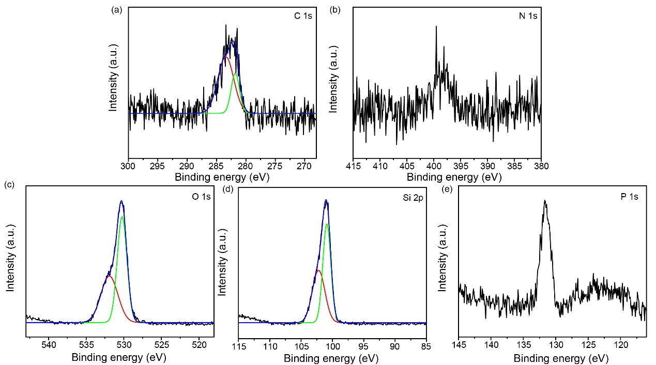
Figure S6. The high resolution XPS spectra of C 1s, N 1s, O 1s, Si 2p and P 1s of the R-CNDs@silica.
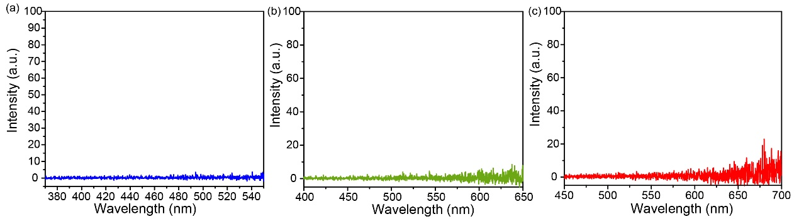
Figure S7. The phosphorescence spectra of three kinds of samples (blue, green and red) before encapsulating silica.
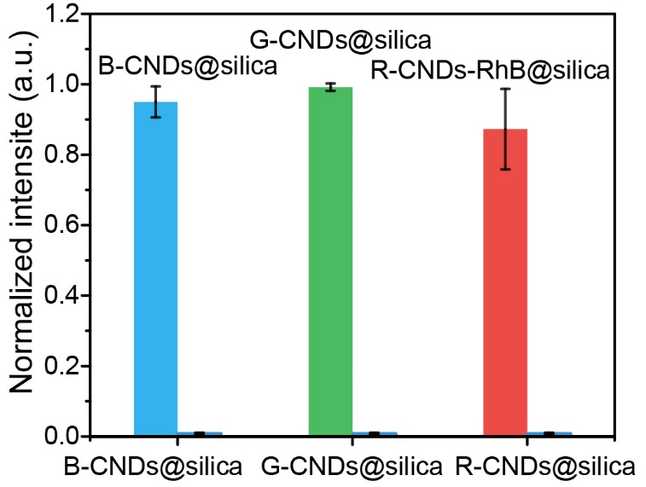
Figure S8. Normalized phosphorescence intensity of the CNDs before and after encapsulating with silica.
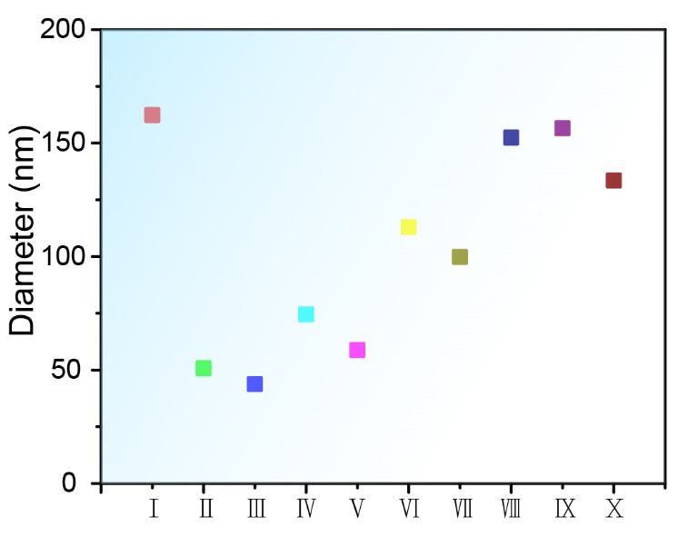
Figure S9. Hydrodynamic diameters of as-prepared samples measured by dynamic light scattering method.
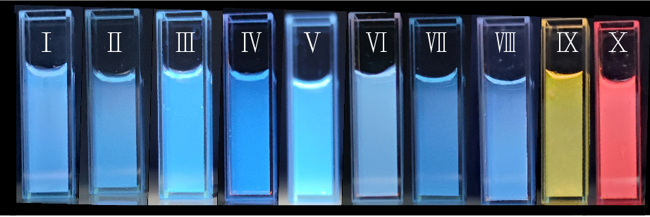
Figure S10. The fluorescence images of ten kinds of CNDs@silica.

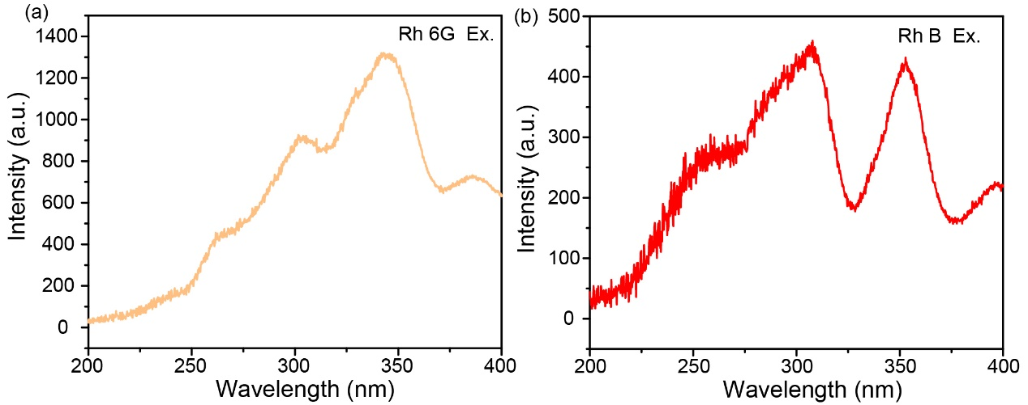
Figure S11. The excitation spectra of RhB and Rh6G.

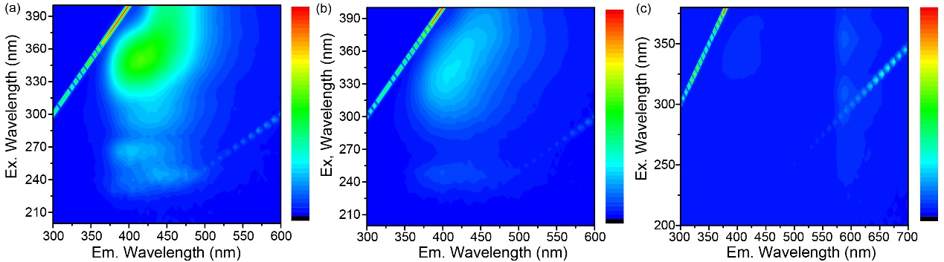 Figure S12. The fluorescence excitation-emission contour plots of B-CNDs@silica (a), G-CNDs@silica (b) and R-CNDs-RhB@silica (c).

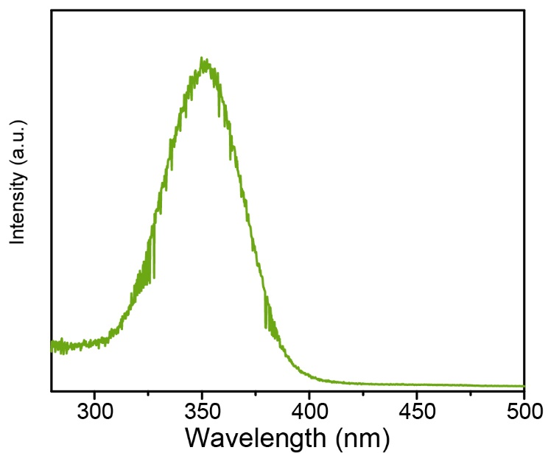
Figure S13. The phosphorescence excitation spectrum of green phosphorescence CNDs.

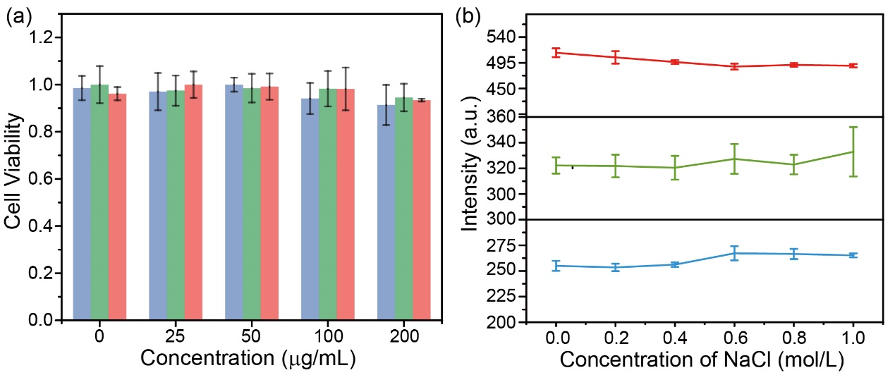
Figure S14. (a) The cell viability of the CHO-K1 cells after incubating with the three samples for 24 h. (b) The phosphorescence intensity of the three samples at sodium chloride with different concentrations.

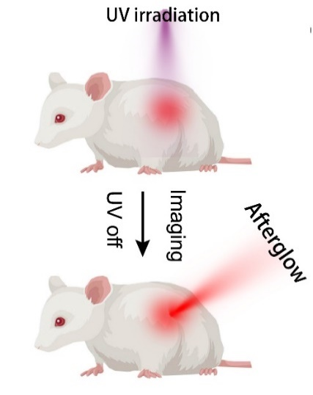
Figure S15. Schematic illustration of in vivo phosphorescence imaging.
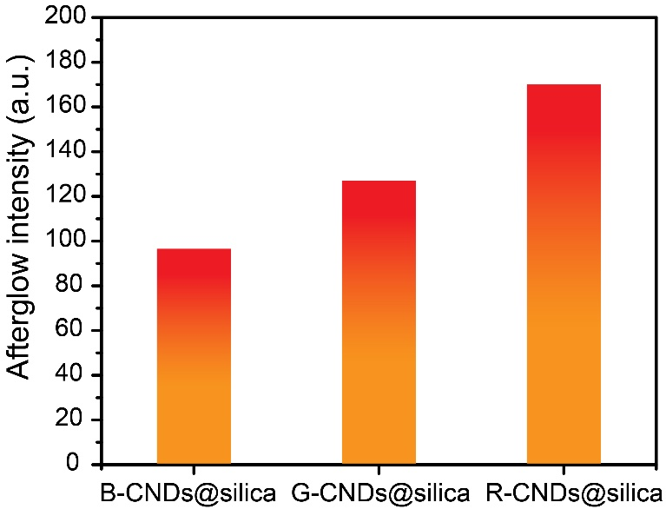
Figure S16. The quantification of phosphorescence intensities of the signal regions.

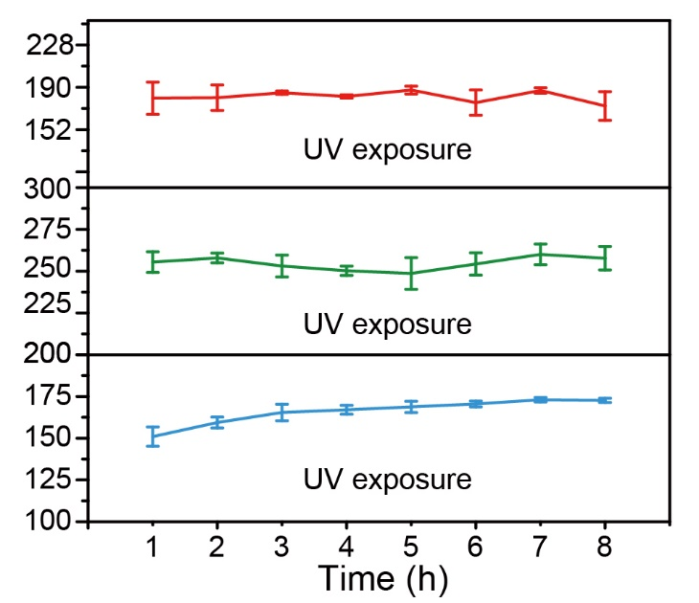
Figure S17. The phosphorescence intensity of blue, green and red samples after UV illumination for 8 hours.

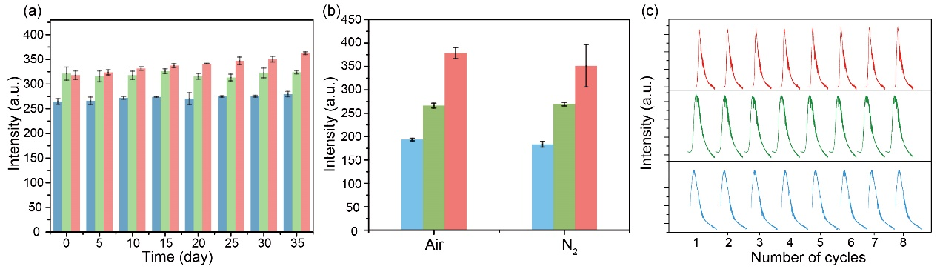
Figure S18. (a) The phosphorescence intensity of the three samples versus time at ambient. (b) The phosphorescence intensity of the three samples purged with air or nitrogen. (c) The phosphorescence intensity of the three samples as a function of the cycle number of illuminations.
Table S1. Dynamic photophysical parameters of B-CNDs@silica, G-CNDs@silica and R-CNDs-RhB@silica. 