Supplementary materials
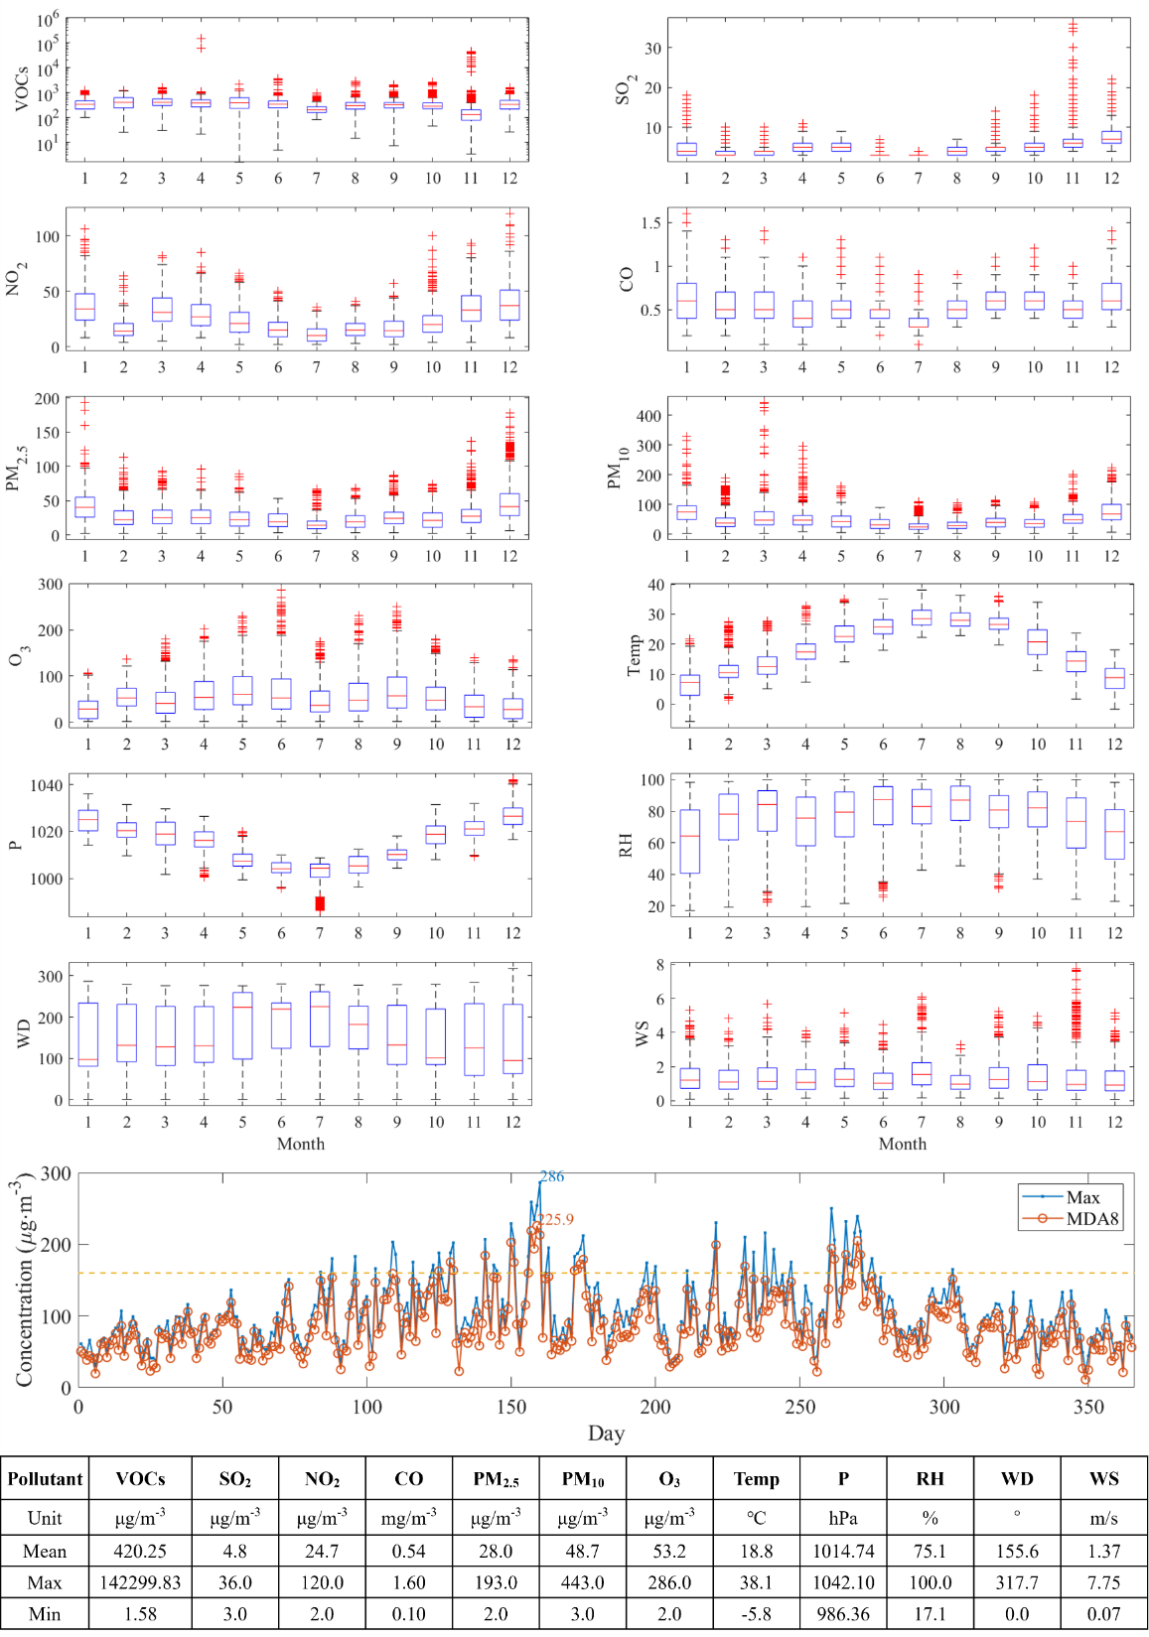
Figure S1. Monthly distribution of hourly pollutants and meteorological elements

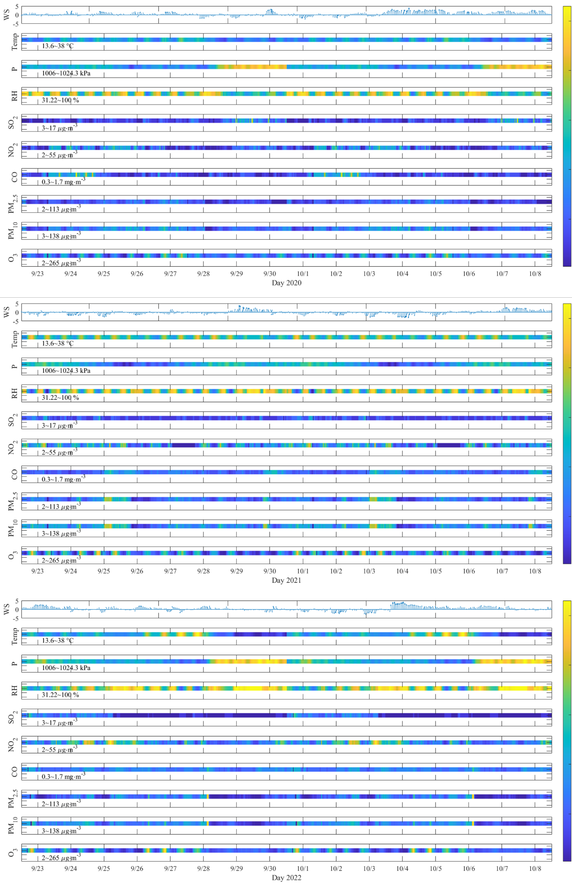
Figure S2. Daily and monthly distribution of maximum and MDA8 concentration of O₃

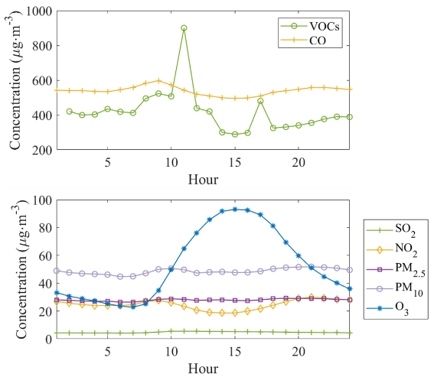
Figure S3. Hourly distribution of pollutants

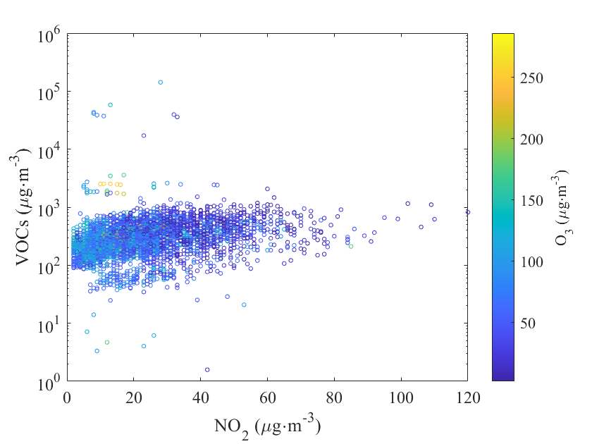
Figure S4. Daytime distribution among VOCs, NO₂ and O₃
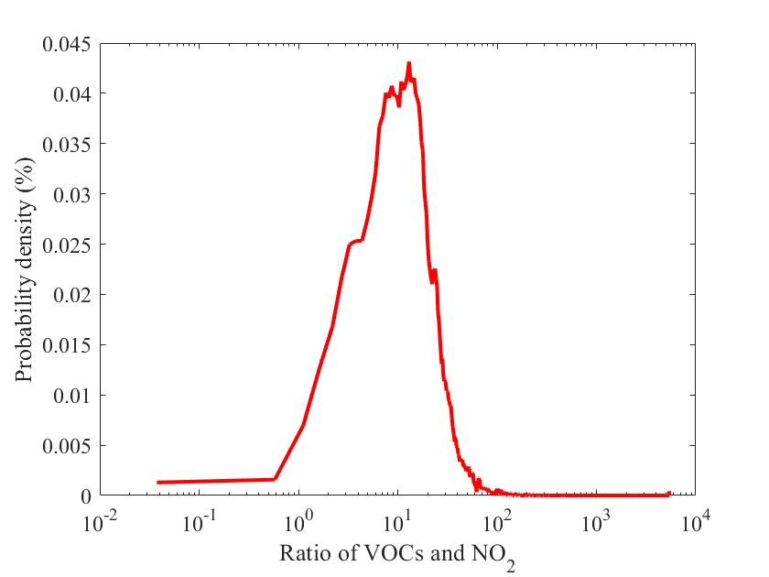
Figure S5. The probability distribution of the ratio of VOCs and NO₂

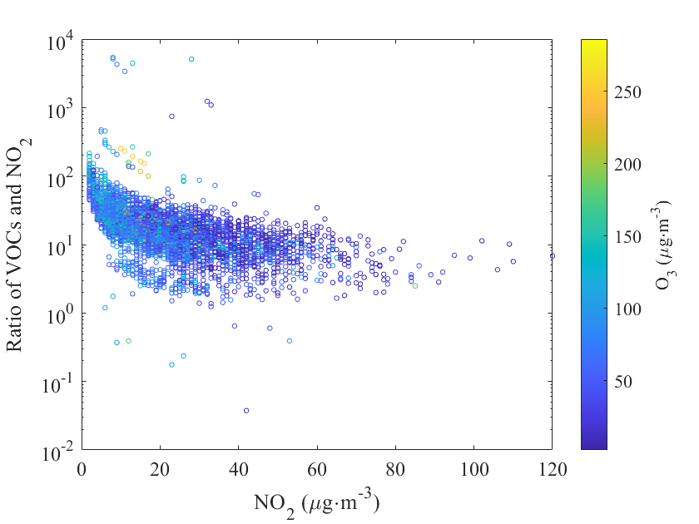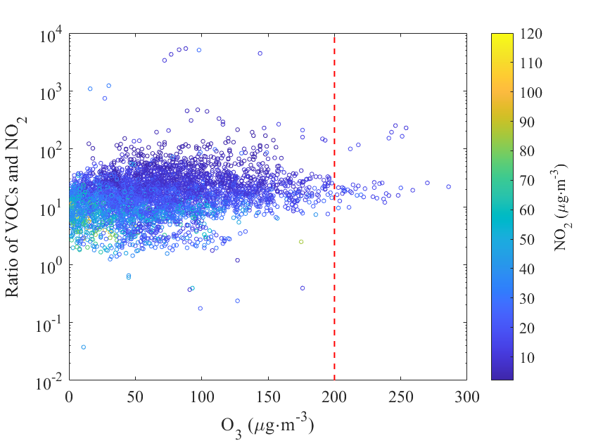
Figure S6. The distribution of the ratio of VOCs and NO₂ to NO₂ and O₃ in 2021

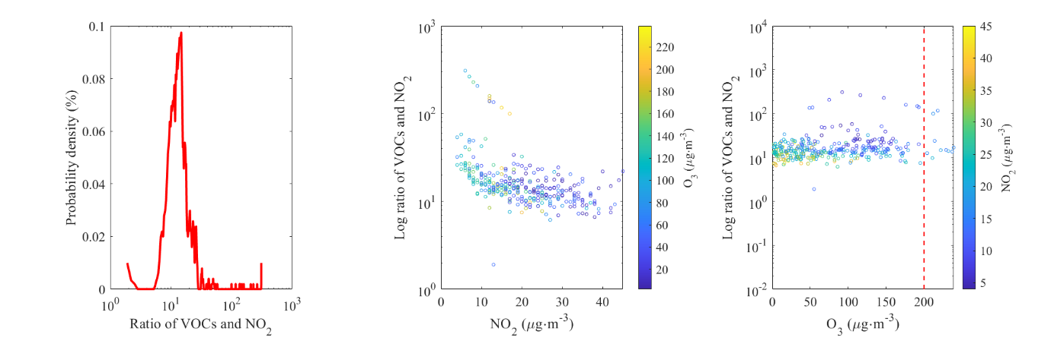
Figure S7. The distribution of the ratio of VOCs and NO₂ to NO₂ and O₃ during corresponding period in 2021

