Table S1: In-situ water parameters statistical table by wetland strata
 | Mean | Std.Dev. | Std.Error | Median | Minimum | Maximum
DRM (n=10)
Conductivity | 0.185 | 0.001 | 0 | 0.185 | 0.184 | 0.188
Turbidity | 20.043 | 10.585 | 3.347 | 17.426 | 6.675 | 33.741
Temperature | 17.415 | 0.116 | 0.037 | 17.378 | 17.277 | 17.607
pH | 8.693 | 0.056 | 0.018 | 8.685 | 8.587 | 8.798
Depth | 1.132 | 0.336 | 0.106 | 1.053 | 0.769 | 1.681
TOC | 0.716 | 0.318 | 0.1 | 0.841 | -0.043 | 0.973
Gravel | 0.088 | 0.109 | 0.035 | 0.028 | 0 | 0.306
Sand | 0.419 | 0.165 | 0.052 | 0.434 | 0.101 | 0.619
Fine Sand | 0.366 | 0.193 | 0.061 | 0.33 | 0.131 | 0.714
Silt | 0.128 | 0.068 | 0.021 | 0.117 | 0.026 | 0.231
GRASS (n=10)
Conductivity | 0.199 | 0.004 | 0.001 | 0.198 | 0.195 | 0.205
Turbidity | 16.009 | 10.258 | 3.244 | 11.764 | 5.247 | 39.69
Temperature | 19.627 | 0.162 | 0.051 | 19.669 | 19.334 | 19.819
pH | 8.542 | 0.231 | 0.073 | 8.611 | 8.109 | 8.891
Depth | 1.035 | 0.291 | 0.092 | 1.034 | 0.707 | 1.502
TOC | 1.17 | 0.497 | 0.157 | 0.959 | 0.798 | 2.435
Gravel | 0.09 | 0.048 | 0.015 | 0.078 | 0.017 | 0.186
Sand | 0.503 | 0.059 | 0.019 | 0.528 | 0.403 | 0.567
Fine Sand | 0.238 | 0.04 | 0.013 | 0.23 | 0.174 | 0.307
Silt | 0.169 | 0.03 | 0.01 | 0.164 | 0.128 | 0.229
PECHE (n=10)
Conductivity | 0.193 | 0.006 | 0.002 | 0.195 | 0.177 | 0.197
Turbidity | 26.555 | 10.295 | 3.256 | 25.392 | 9.32 | 48.452
Temperature | 19.279 | 0.241 | 0.076 | 19.318 | 18.937 | 19.816
pH | 8.385 | 0.096 | 0.03 | 8.393 | 8.242 | 8.585
Depth | 1.507 | 0.61 | 0.193 | 1.365 | 1.008 | 3.193
TOC | 0.966 | 0.192 | 0.061 | 0.967 | 0.72 | 1.241
Gravel | 0.009 | 0.012 | 0.004 | 0.005 | 0 | 0.04
Sand | 0.345 | 0.081 | 0.025 | 0.342 | 0.253 | 0.487
Fine Sand | 0.332 | 0.068 | 0.022 | 0.315 | 0.265 | 0.466
Silt | 0.313 | 0.101 | 0.032 | 0.326 | 0.117 | 0.458
RIVER CANARD (n=10)
Conductivity | 0.204 | 0.001 | 0 | 0.205 | 0.202 | 0.205
Turbidity | 31.935 | 25.054 | 7.923 | 21.504 | 6.38 | 73.754
Temperature | 20.034 | 0.112 | 0.037 | 20.01 | 19.876 | 20.2
pH | 8.664 | 0.151 | 0.05 | 8.693 | 8.336 | 8.817
Depth | 1.581 | 0.479 | 0.151 | 1.792 | 0.601 | 2.145
TOC | 0.858 | 0.128 | 0.043 | 0.823 | 0.709 | 1.06
Gravel | 0.059 | 0.05 | 0.017 | 0.038 | 0.006 | 0.163
Sand | 0.354 | 0.051 | 0.017 | 0.347 | 0.295 | 0.439
Fine Sand | 0.461 | 0.075 | 0.025 | 0.461 | 0.334 | 0.587
Silt | 0.127 | 0.028 | 0.009 | 0.126 | 0.083 | 0.172
TC (n=9)
Conductivity | 0.198 | 0.002 | 0 | 0.197 | 0.196 | 0.2
Turbidity | 20.976 | 14.233 | 4.744 | 19.695 | 8.376 | 53.003
Temperature | 18.615 | 0.09 | 0.029 | 18.62 | 18.481 | 18.745
pH | 8.489 | 0.147 | 0.046 | 8.56 | 8.253 | 8.671
Depth | 1.581 | 0.479 | 0.151 | 1.792 | 0.601 | 2.145
TOC | 0.952 | 0.316 | 0.1 | 0.926 | 0.43 | 1.643
Gravel | 0.021 | 0.033 | 0.011 | 0.011 | 0 | 0.11
Sand | 0.289 | 0.114 | 0.036 | 0.263 | 0.156 | 0.487
Fine Sand | 0.55 | 0.187 | 0.059 | 0.575 | 0.224 | 0.813
Silt | 0.141 | 0.09 | 0.028 | 0.115 | 0.026 | 0.345

Table S2: In-situ water parameters statistical table of tributary wetlands by position strata

RC – UPSTREAM (n=5)
Conductivity | 0.199 | 0.001 | 0 | 0.199 | 0.198 | 0.2
Turbidity | 43.08 | 29.934 | 13.387 | 43.159 | 12.344 | 73.754
Temperature | 18.541 | 0.047 | 0.021 | 18.539 | 18.481 | 18.605
pH | 8.379 | 0.125 | 0.056 | 8.347 | 8.253 | 8.567
Depth | 1.292 | 0.52 | 0.232 | 1.214 | 0.601 | 1.807
TOC | 1.03 | 0.438 | 0.196 | 1.021 | 0.43 | 1.643
Gravel | 0.033 | 0.045 | 0.02 | 0.024 | 0 | 0.11
Sand | 0.317 | 0.142 | 0.064 | 0.273 | 0.161 | 0.487
Fine Sand | 0.474 | 0.235 | 0.105 | 0.435 | 0.224 | 0.813
Silt | 0.176 | 0.12 | 0.054 | 0.179 | 0.026 | 0.345
RC – DOWNSTREAM (n=5)
Conductivity | 0.196 | 0.001 | 0 | 0.196 | 0.196 | 0.197
Turbidity | 20.789 | 14.346 | 6.416 | 19.872 | 6.38 | 43.481
Temperature | 18.689 | 0.049 | 0.022 | 18.697 | 18.635 | 18.745
pH | 8.599 | 0.049 | 0.022 | 8.574 | 8.554 | 8.671
Depth | 1.871 | 0.191 | 0.085 | 1.896 | 1.625 | 2.145
TOC | 0.874 | 0.132 | 0.059 | 0.878 | 0.685 | 1.033
Gravel | 0.009 | 0.009 | 0.004 | 0.004 | 0.001 | 0.02
Sand | 0.26 | 0.084 | 0.037 | 0.252 | 0.156 | 0.356
Fine Sand | 0.625 | 0.095 | 0.043 | 0.625 | 0.505 | 0.724
Silt | 0.105 | 0.024 | 0.011 | 0.103 | 0.075 | 0.137
RC – TRIBUTARY (n=5)
Conductivity | 0.268 | 0.053 | 0.024 | 0.266 | 0.2 | 0.349
Turbidity | 19.657 | 10.532 | 4.71 | 19.141 | 9.451 | 33.015
Temperature | 19.218 | 0.218 | 0.098 | 19.151 | 18.965 | 19.513
pH | 8.453 | 0.132 | 0.059 | 8.468 | 8.264 | 8.596
Depth | 0.973 | 0.45 | 0.201 | 0.823 | 0.456 | 1.446
TOC | 1.302 | 0.645 | 0.288 | 1.714 | 0.394 | 1.828
Gravel | 0.177 | 0.229 | 0.103 | 0.026 | 0.007 | 0.517
Sand | 0.33 | 0.101 | 0.045 | 0.35 | 0.222 | 0.457
Fine Sand | 0.439 | 0.301 | 0.135 | 0.475 | 0.095 | 0.743
Silt | 0.053 | 0.037 | 0.016 | 0.041 | 0.015 | 0.112
TC – UPSTREAM (n=5)
Conductivity | 0.205 | 0 | 0 | 0.205 | 0.205 | 0.205
Turbidity | 13.493 | 6.602 | 3.301 | 11.453 | 8.376 | 22.688
Temperature | 19.953 | 0.08 | 0.04 | 19.935 | 19.876 | 20.064
pH | 8.585 | 0.193 | 0.097 | 8.604 | 8.336 | 8.797
Depth | 1.163 | 0.499 | 0.25 | 1.122 | 0.601 | 1.805
TOC | 0.898 | 0.121 | 0.06 | 0.885 | 0.777 | 1.045
Gravel | 0.058 | 0.027 | 0.014 | 0.055 | 0.034 | 0.091
Sand | 0.373 | 0.035 | 0.018 | 0.362 | 0.347 | 0.422
Fine Sand | 0.426 | 0.073 | 0.036 | 0.435 | 0.334 | 0.502
Silt | 0.142 | 0.025 | 0.013 | 0.139 | 0.117 | 0.172
TC – DOWNSTREAM (n=5)
Conductivity | 0.204 | 0.001 | 0 | 0.204 | 0.202 | 0.205
Turbidity | 26.962 | 16.482 | 7.371 | 21.731 | 9.313 | 53.003
Temperature | 20.099 | 0.092 | 0.041 | 20.138 | 19.994 | 20.2
pH | 8.727 | 0.08 | 0.036 | 8.749 | 8.608 | 8.817
Depth | 1.871 | 0.191 | 0.085 | 1.896 | 1.625 | 2.145
TOC | 0.825 | 0.137 | 0.061 | 0.774 | 0.709 | 1.06
Gravel | 0.059 | 0.067 | 0.03 | 0.021 | 0.006 | 0.163
Sand | 0.339 | 0.059 | 0.026 | 0.316 | 0.295 | 0.439
Fine Sand | 0.488 | 0.072 | 0.032 | 0.465 | 0.402 | 0.587
Silt | 0.115 | 0.025 | 0.011 | 0.117 | 0.083 | 0.147
TC – TRIBUTARY (n=5)
Conductivity | 0.257 | 0.017 | 0.008 | 0.261 | 0.238 | 0.279
Turbidity | 20.506 | 0.322 | 0.144 | 1.39 | 0.002 | 0.586
Temperature | 20.506 | 0.279 | 0.125 | 20.358 | 20.26 | 20.824
pH | 8.759 | 0.322 | 0.144 | 8.608 | 8.416 | 9.152
Depth | 0.659 | 0.322 | 0.144 | 0.503 | 0.354 | 1.097
TOC | 1.394 | 0.153 | 0.068 | 1.39 | 1.212 | 1.628
Gravel | 0.019 | 0.022 | 0.01 | 0.012 | 0.002 | 0.056
Sand | 0.288 | 0.172 | 0.077 | 0.22 | 0.171 | 0.586
Fine Sand | 0.493 | 0.154 | 0.069 | 0.538 | 0.28 | 0.672
Silt | 0.199 | 0.121 | 0.054 | 0.154 | 0.078 | 0.367

Table S3: Diversity measurements by strata

 | Shannon H’ | Richness (n) | Pielou J | EPT% | Turnover | Nestedness
Detroit River (n=50) | 1.764 | 13.22 | 0.69 | 7.17 | 0.736 | 0.264
Tributary Impacted (n=20) | 1.584 | 11.5 | 0.653 | 3.746 | 0.755 | 0.245
Non-impacted (n=30) | 1.885 | 14.367 | 0.715 | 10.595 | 0.755 | 0.245
Detroit River Marshes (DRM) (n=10) | 1.843 | 14.9 | 0.69 | 14.509 | 0.652 | 0.348
Grass Island (GI) (n=10) | 1.849 | 15.2 | 0.683 | 12.868 | 0.736 | 0.264
Peche Island (PI) (n=10) | 1.962 | 13 | 0.773 | 4.408 | 0.713 | 0.287
River Canard (RC) (n=10) | 1.625 | 11.8 | 0.663 | 5.61 | 0.808 | 0.192
Turkey Creek (TC) (n=10) | 1.543 | 11.2 | 0.643 | 1.883 | 0.723 | 0.277
RC – Tributary (n=5) | 1.49 | 9.8 | 0.745 | 7.57 | 0.926 | 0.074
RC – Downstream (n=5) | 1.611 | 11.8 | 0.658 | 3.822 | 0.428 | 0.572
RC – Upstream (n=5) | 1.64 | 11.8 | 0.668 | 7.398 | 0.715 | 0.285
TC – Tributary (n=5) | 2.09 | 16.4 | 0.75 | 11.271 | 0.712 | 0.288
TC – Downstream (n=5) | 1.639 | 11.6 | 0.669 | 2.545 | 0.735 | 0.265
TC – Upstream (n=5) | 1.447 | 10.8 | 0.617 | 1.221 | 0.735 | 0.265

TABLE S4: Permutation test for homogeneity of multivariate dispersions – between wetland comparisons

 | DRM | GRASS | PECHE | RIVER CANARD | TURKEY CREEK
DRM |  | 0.347000 | 0.449000 | 0.047000 | 0.392
GRASS | 0.354152 |  | 0.169000 | 0.009000 | 0.987
PECHE | 0.467824 | 0.184946 |  | 0.297000 | 0.179
RIVER CANARD | 0.036841 | 0.010353 | 0.316977 |  | 0.015
TURKEY CREEK | 0.381857 | 0.987035 | 0.198599 | 0.014013

Figure S1: Map of Peche Island sample sites
Figure S2: Map of Turkey Creek wetland and tributary sample sites
Figure S3: Map of Grass Island and Detroit River Marshes sample sites
Figure S4: Map of River Canard wetland and tributary sample sites

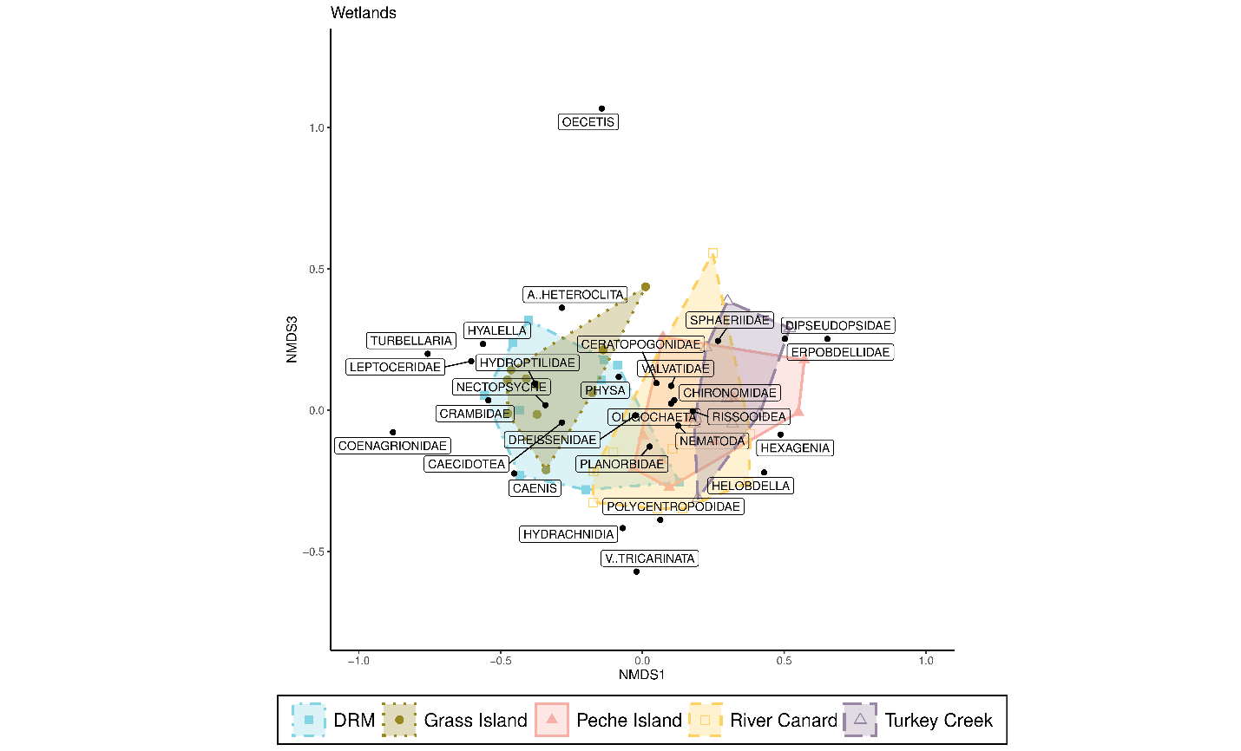
Figure S5: NMDS ordination of five Detroit River channel wetland benthic macroinvertebrate communities by wetland with species scores plotted on NMDS1-NMDS3

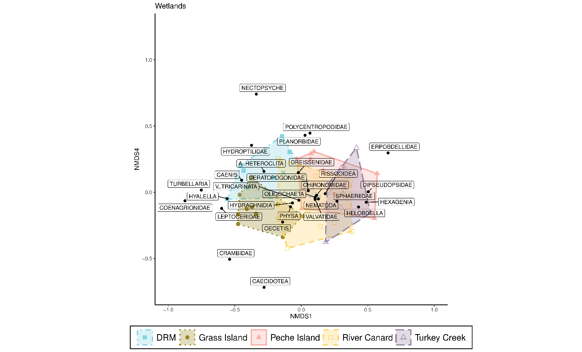
Figure S6: NMDS ordination of five Detroit River channel wetland benthic macroinvertebrate communities by wetland with species scores plotted on NMDS1-NMDS4

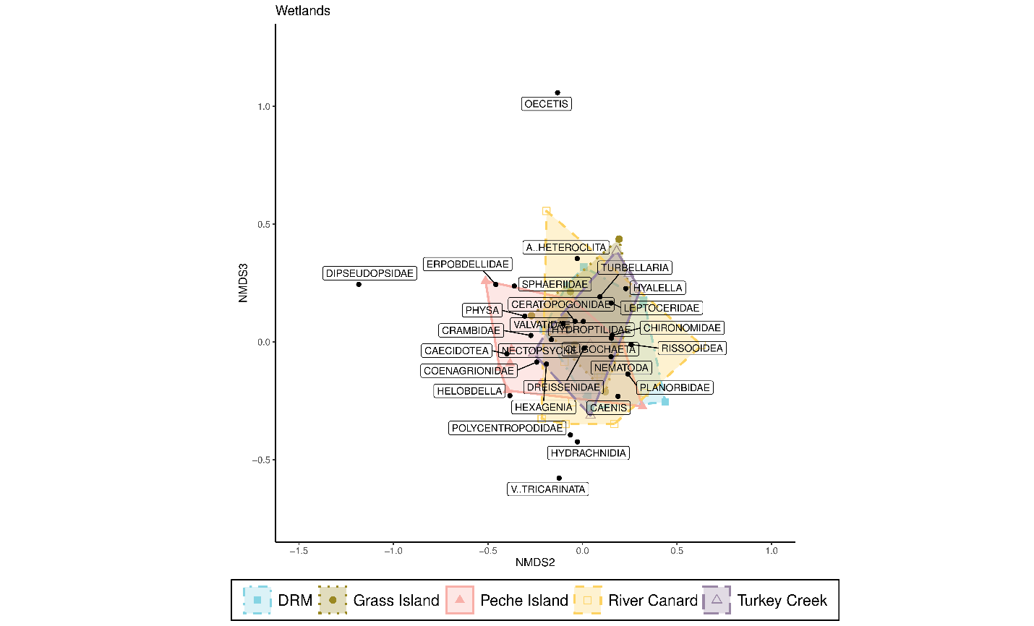
Figure S7: NMDS ordination of five Detroit River channel wetland benthic macroinvertebrate communities by wetland with species scores plotted on NMDS2-NMDS3

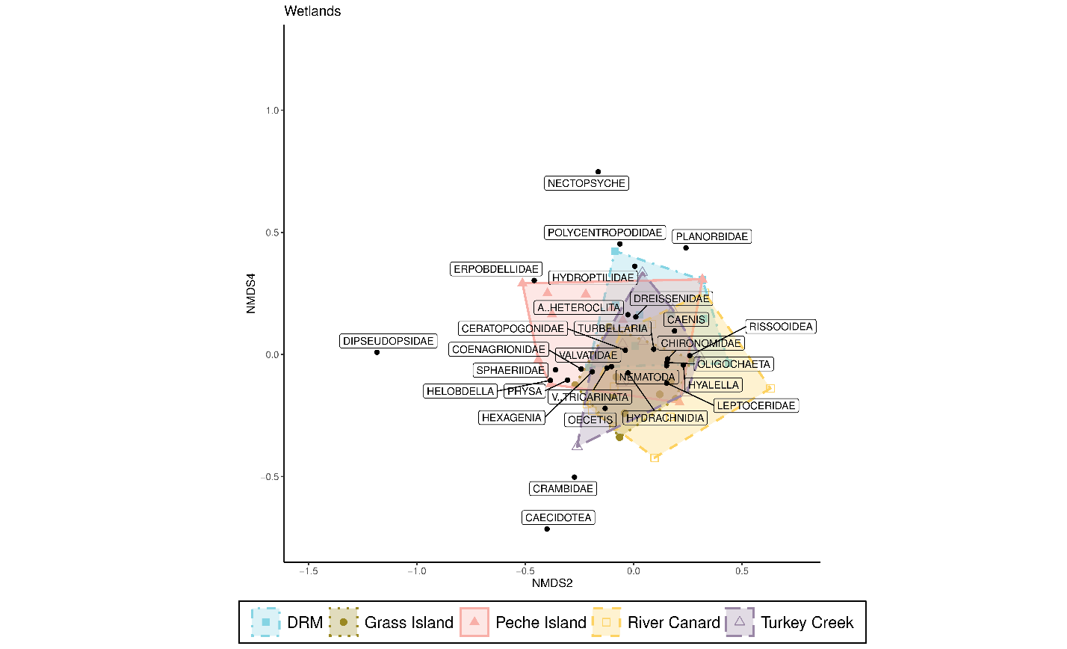
Figure S8: NMDS ordination of five Detroit River channel wetland benthic macroinvertebrate communities by wetland with species scores plotted on NMDS2-NMDS4
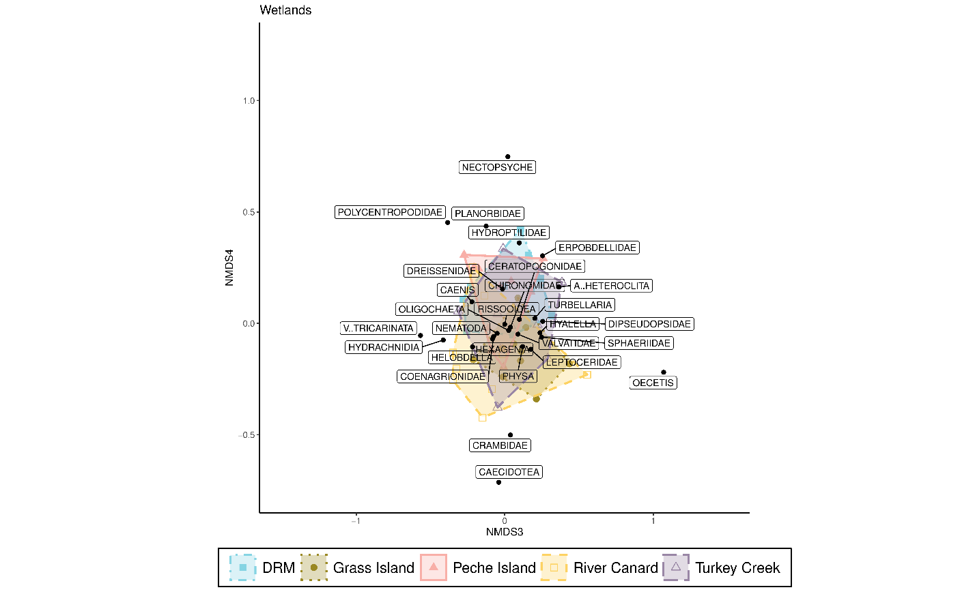
Figure S9: NMDS ordination of five Detroit River channel wetland benthic macroinvertebrate communities by wetland with species scores plotted on NMDS3-NMDS4

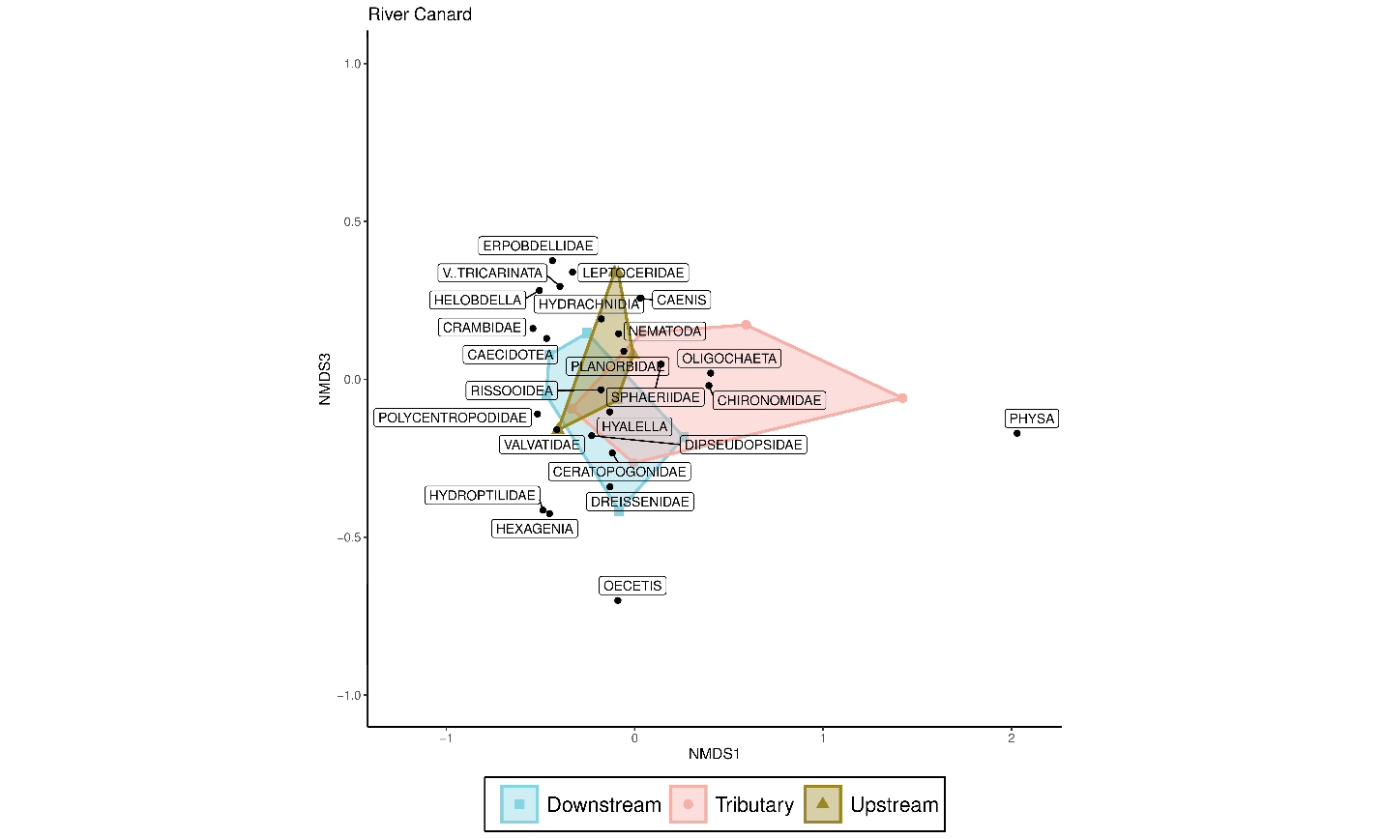
Figure S10: NMDS ordination of River Canard benthic macroinvertebrate communities by wetland with species scores plotted on NMD1-NMDS3
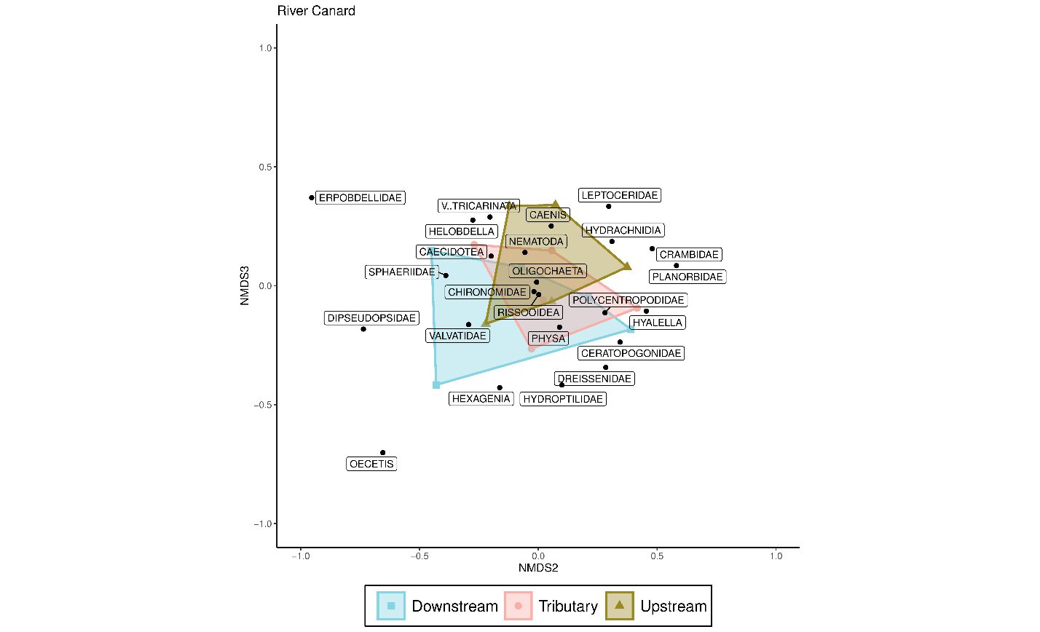
Figure S11: NMDS ordination of River Canard benthic macroinvertebrate communities by wetland with species scores plotted on NMD1-NMDS3
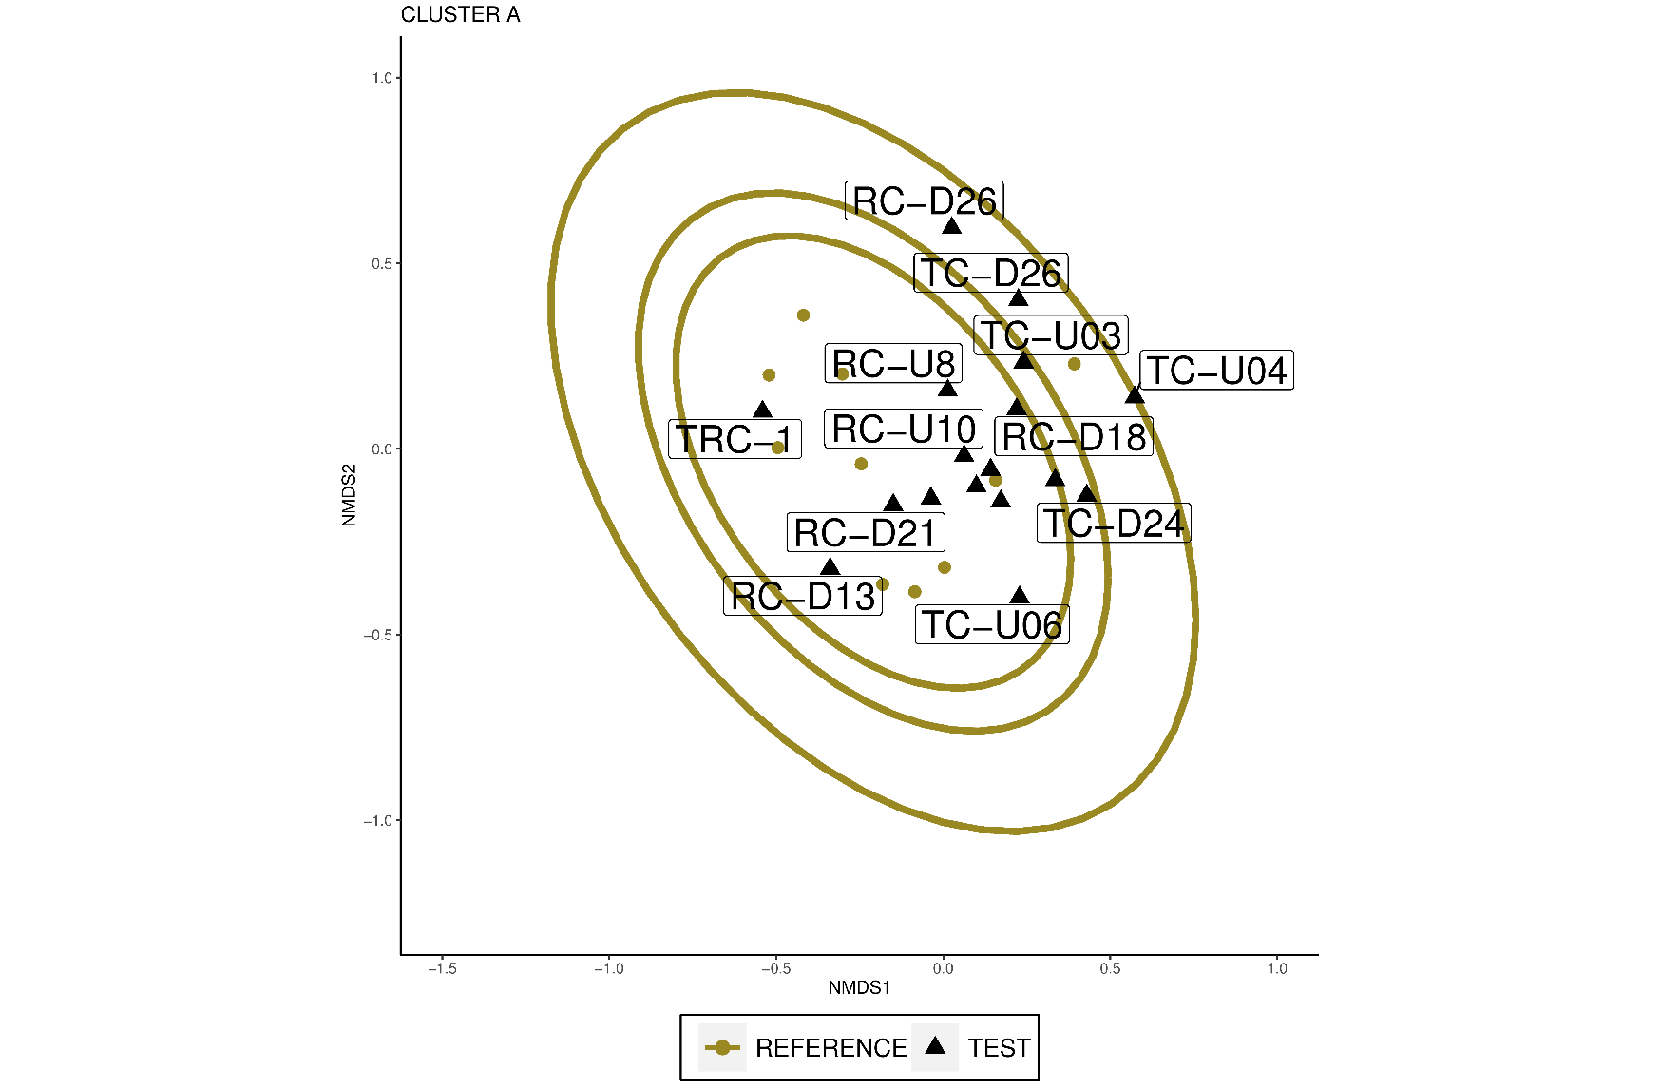
Figure S12: NMDS ordination of Sediment Habitat Group A with 90, 95, 99% confidence ellipses of reference sites plotted on NMD1-NMDS3

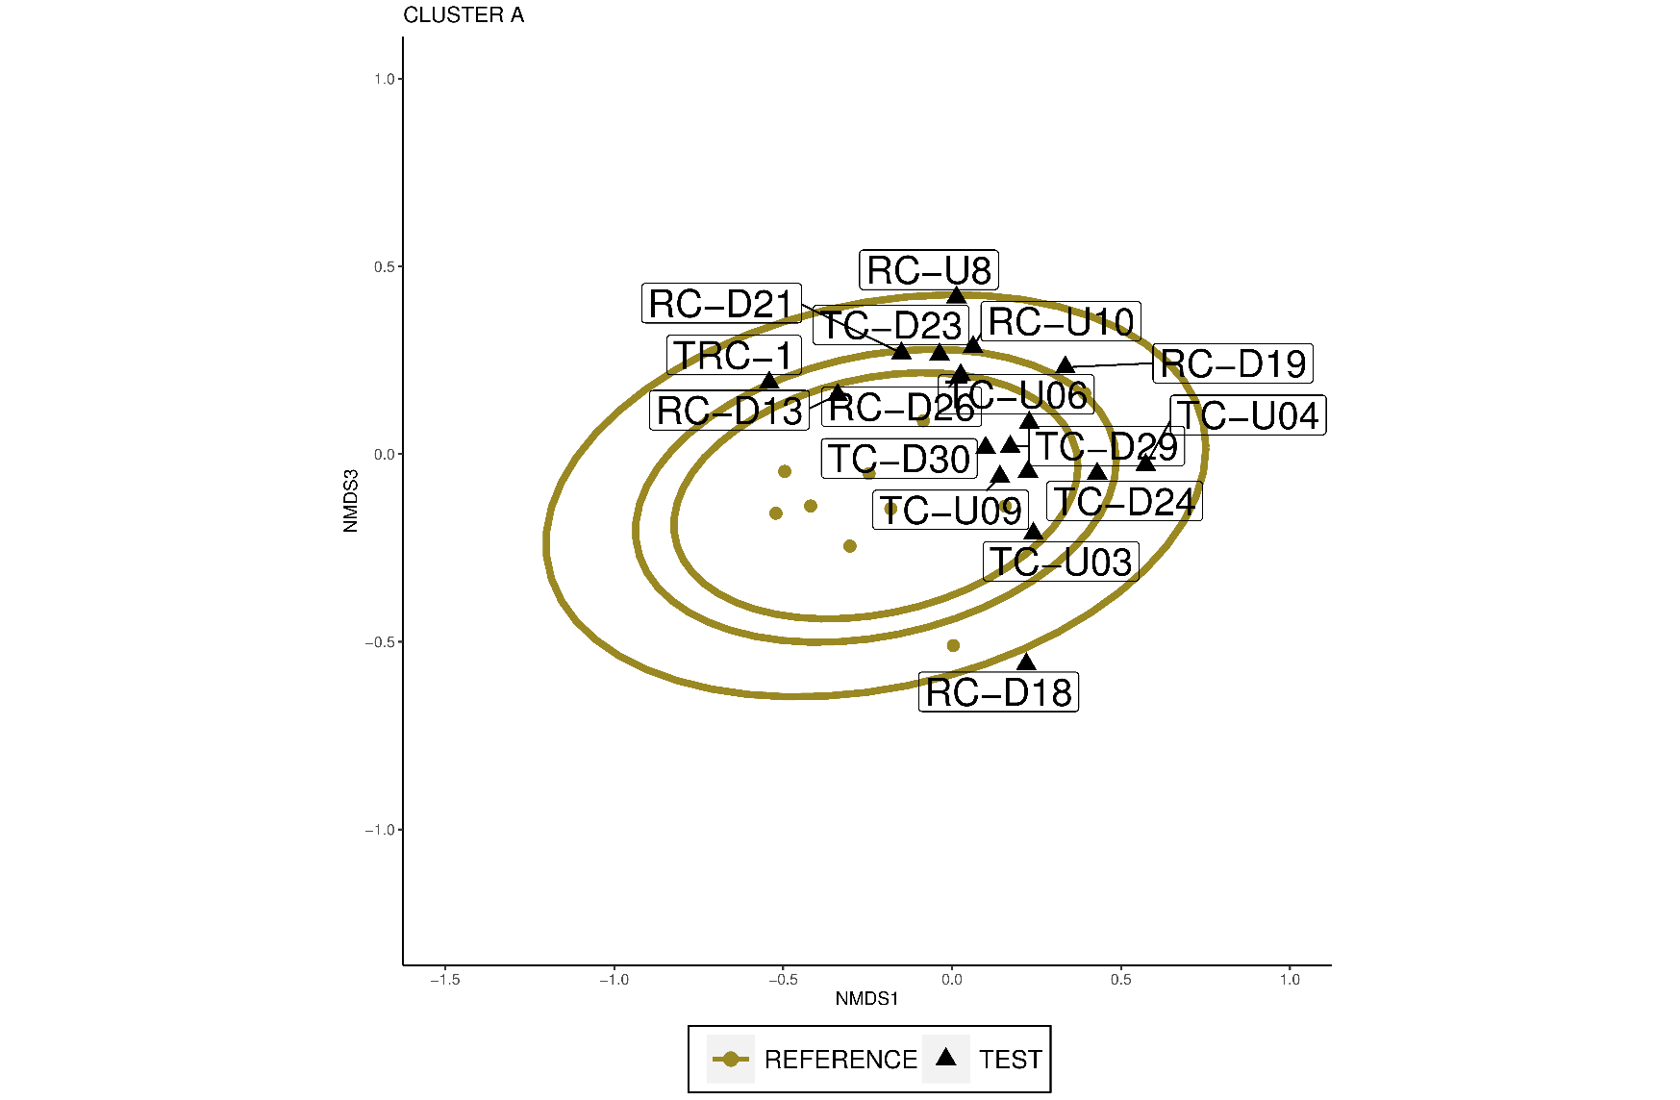
Figure S13: NMDS ordination of Sediment Habitat Group A with 90, 95, 99% confidence ellipses of reference sites plotted on NMD1-NMDS3

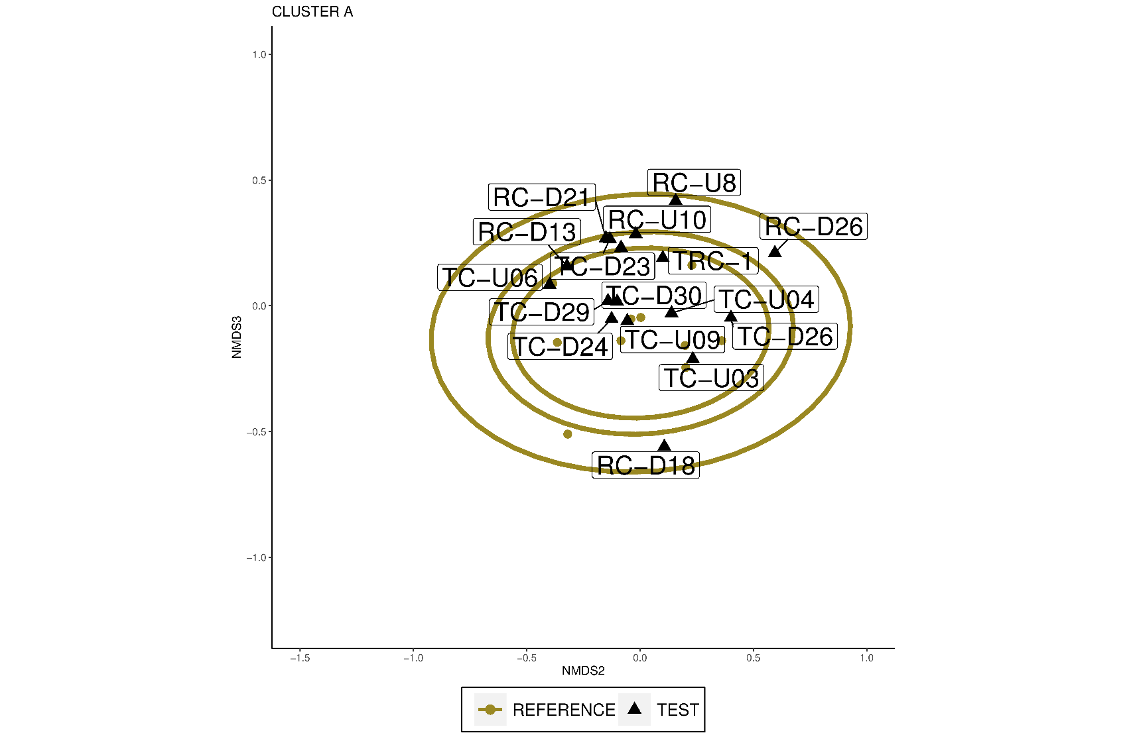
Figure S14: NMDS ordination of Sediment Habitat Group A with 90, 95, 99% confidence ellipses of reference sites plotted on NMD2-NMDS3.
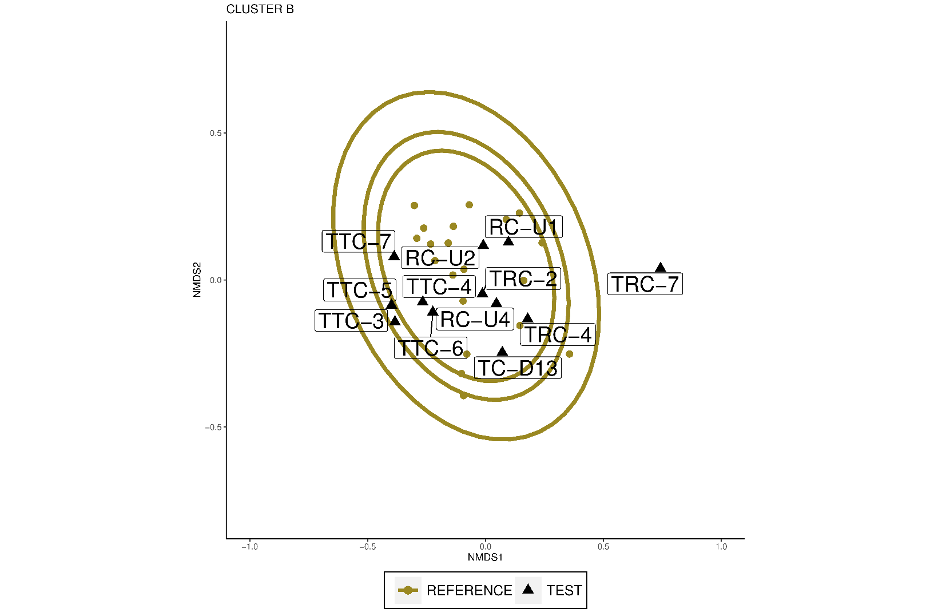

Figure S15: NMDS ordination of Sediment Habitat Group A with 90, 95, 99% confidence ellipses of reference sites plotted on NMD1-NMDS3

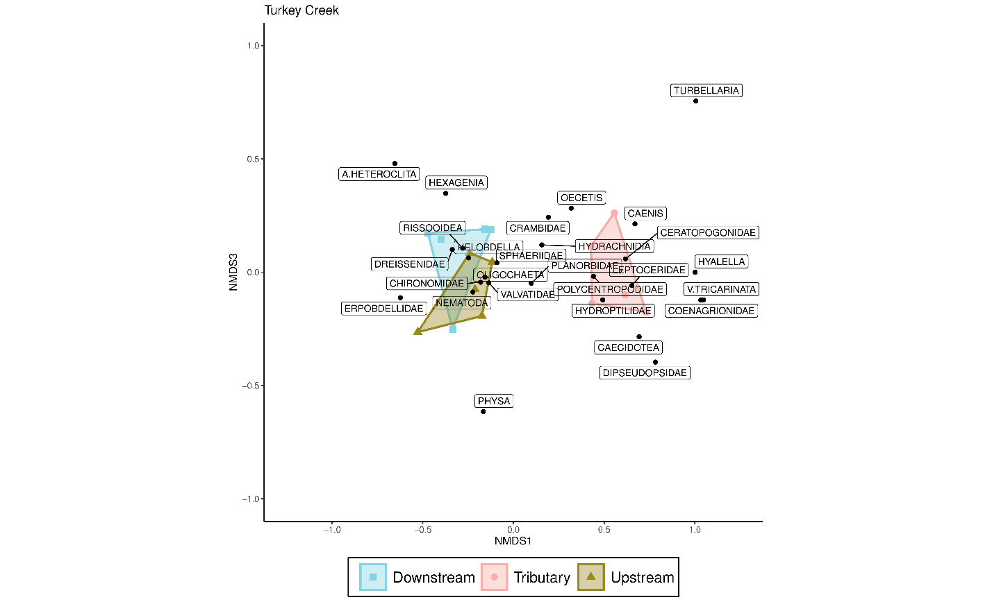
Figure S16: NMDS ordination of Turkey Creek benthic macroinvertebrate communities by wetland with species scores plotted on NMD1-NMDS3

