Supplementary Materials for

Geomagnetic paleointensity dating of mid-ocean ridge basalts from the neo-volcanic zone of the Central Indian Ridge

Yutaka Yoshimura¹, Masakazu Fujii^{2,3}

1. Division of Environmental Changes, Faculty of Social and Cultural Studies, Kyushu University, 744 Motooka, Fukuoka, 819-0395, Japan. (yoshimura.yutaka.36w@kyoto-u.jp)
2. National Institute of Polar Research, 10-3 Midori-cho, Tachikawa, Tokyo 190-8518, Japan. (fujii.masakazu@nipr.ac.jp)
3. The Graduate University for Advanced Studies, SOKENDAI, 10-3 Midori-cho, Tachikawa, Tokyo 190-8518, Japan.

Corresponding author: Yutaka Yoshimura

Supplementary Table
Table S1
Table S2
Table S3

Supplementary Figure
Figure S1
Figure S2
Figure S3
Figure S4
Figure S5
Figure S6
Figure S7

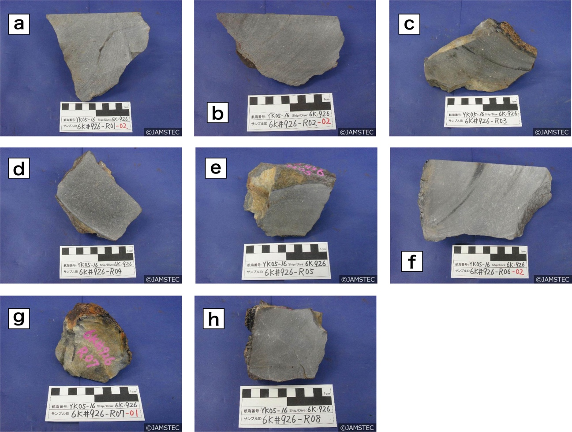

Figure S1. (a-h) Photographs of samples of studied volcanic rocks collected from the neo-volcanic zone of CIR-S2.

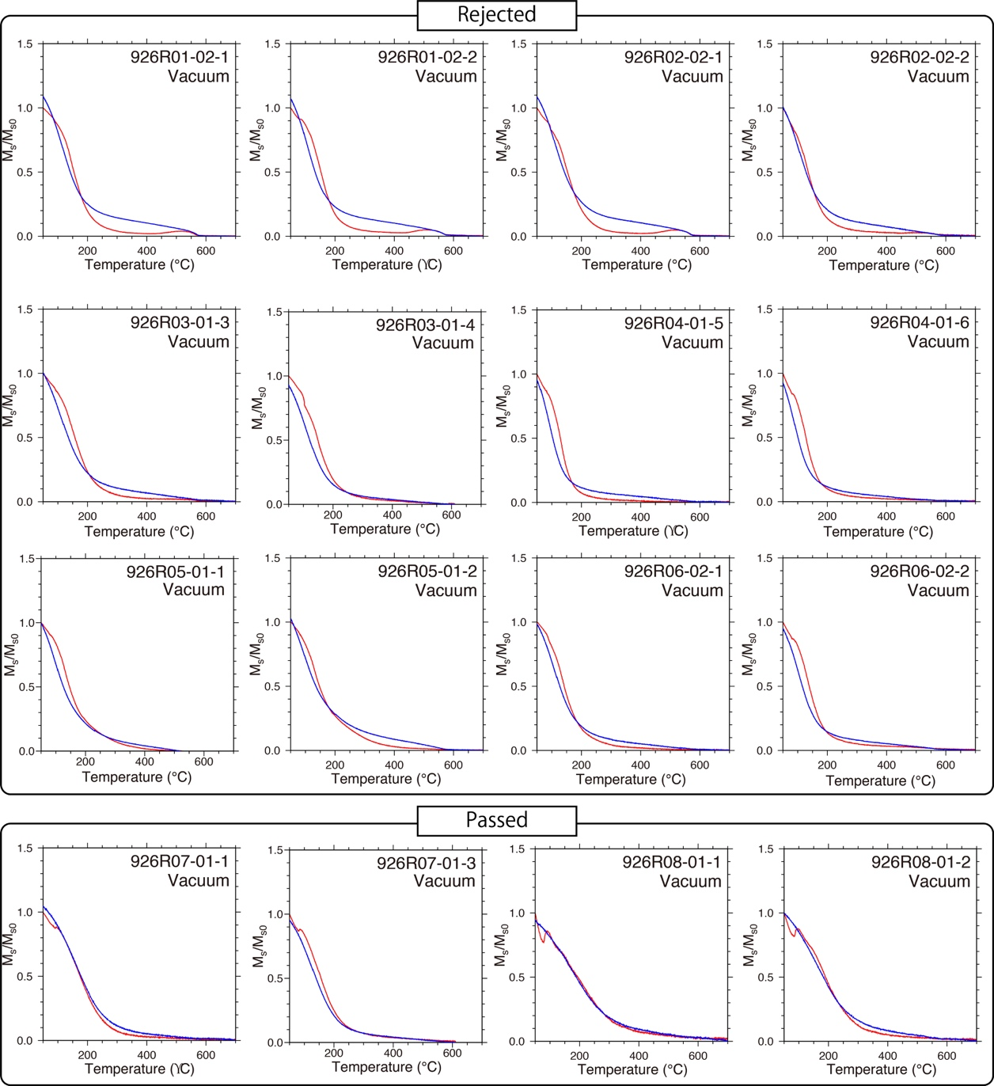
Figure S2. All results of thermomagnetic curves heated in vacuum (Red line: heating procedure, blue line: cooling procedure). The top panel shows the samples rejected by the statistical selection criteria of the Tsunakawa-Shaw method and the bottom panel shows those passed the criteria.

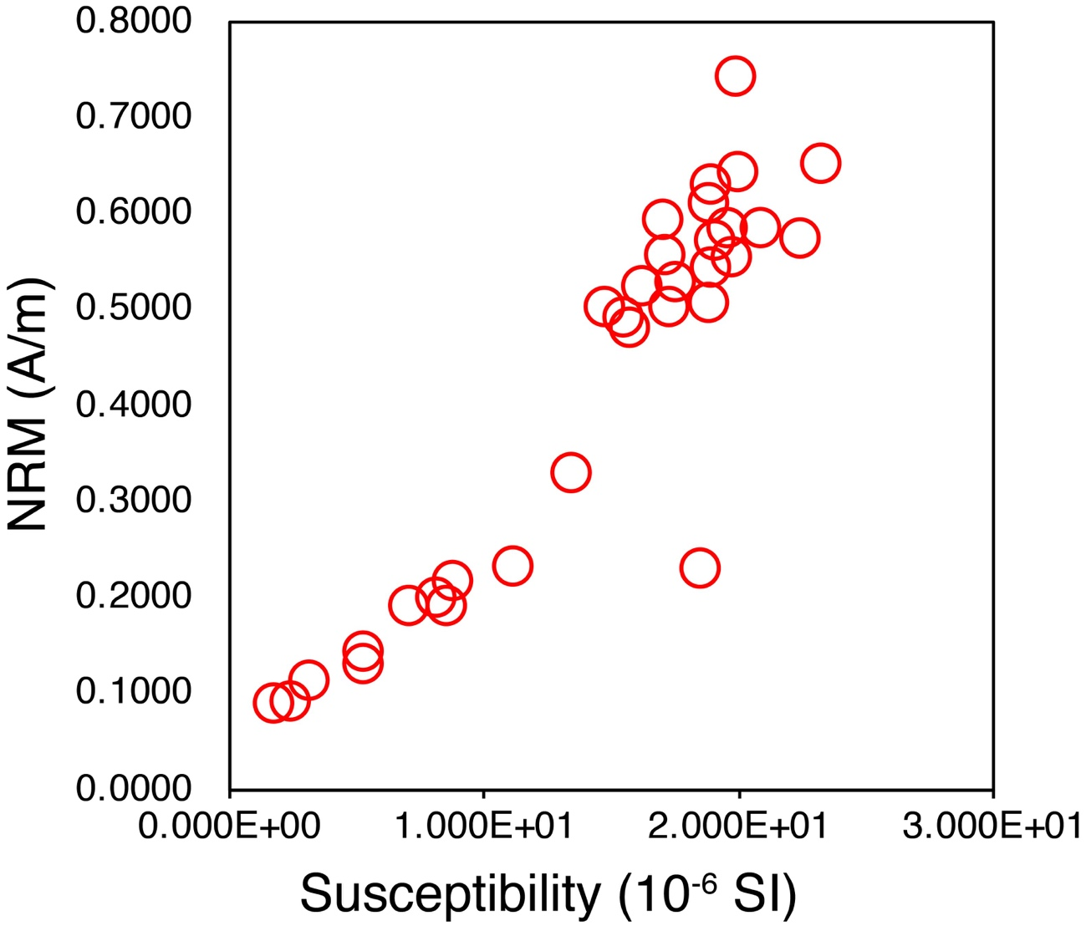
Figure S3. Magnetic susceptibility and volume-normalized NRM.

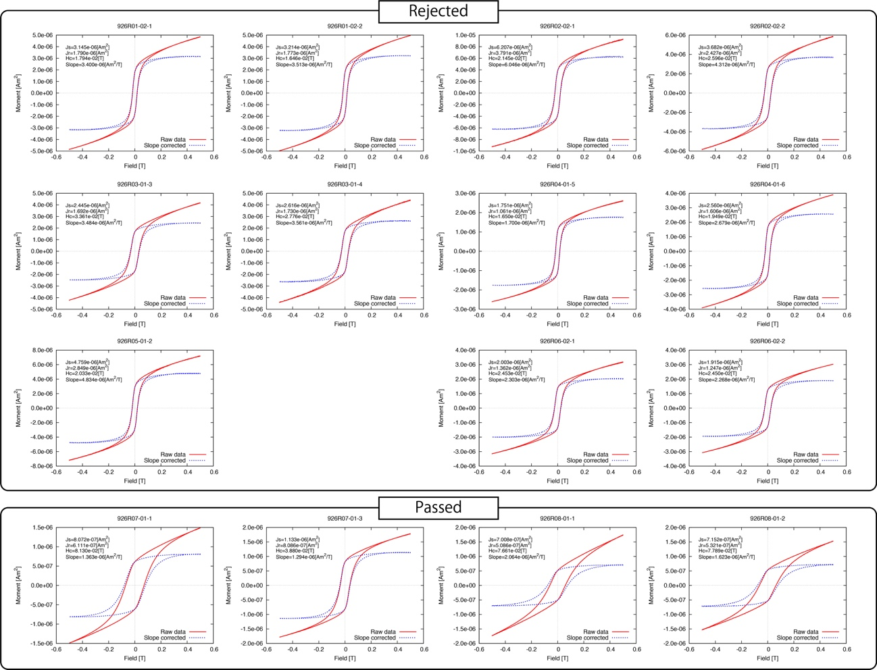
Figure S4. All Hysteresis loops before (red) and after (blue) paramagnetic correction, respectively. The top panel shows the samples rejected by the statistical selection criteria of the Tsunakawa-Shaw method and the bottom panel shows those passed the criteria.

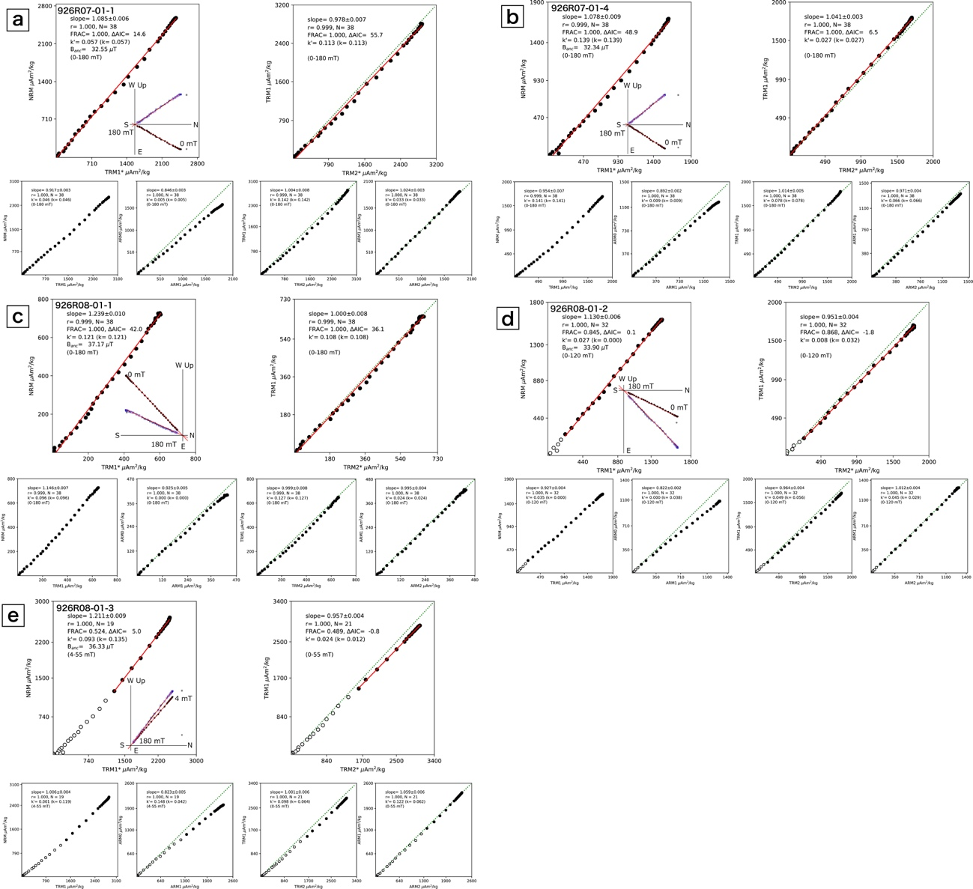
Figure S5. (a-e) The other accepted results of the Tsunakawa-Shaw paleointensity experiments.

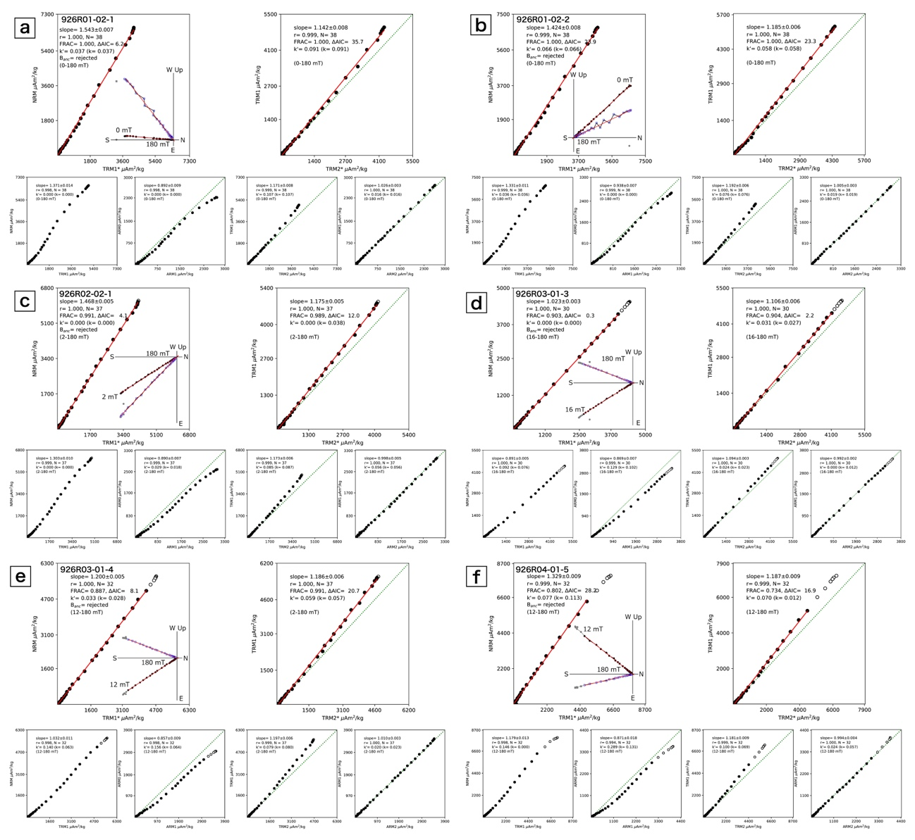
Figure S6. (a-k) The other rejected results of the Tsunakawa-Shaw paleointensity experiments.
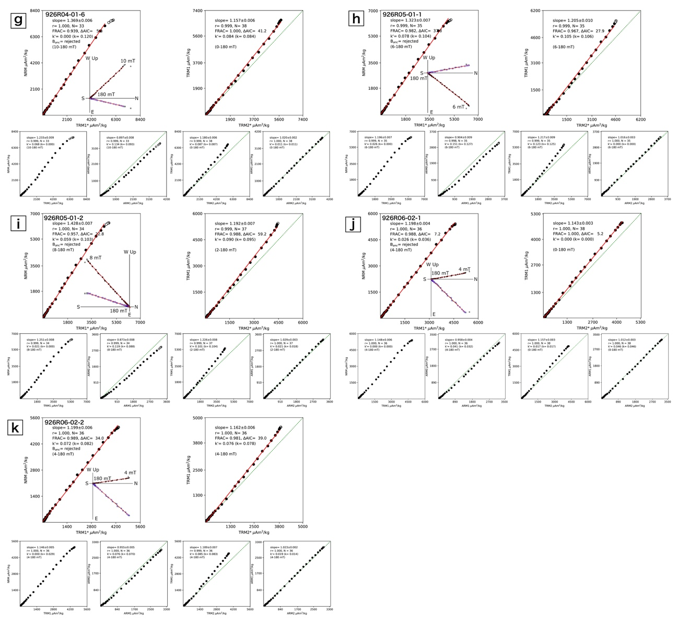
Figure S6. Continued.

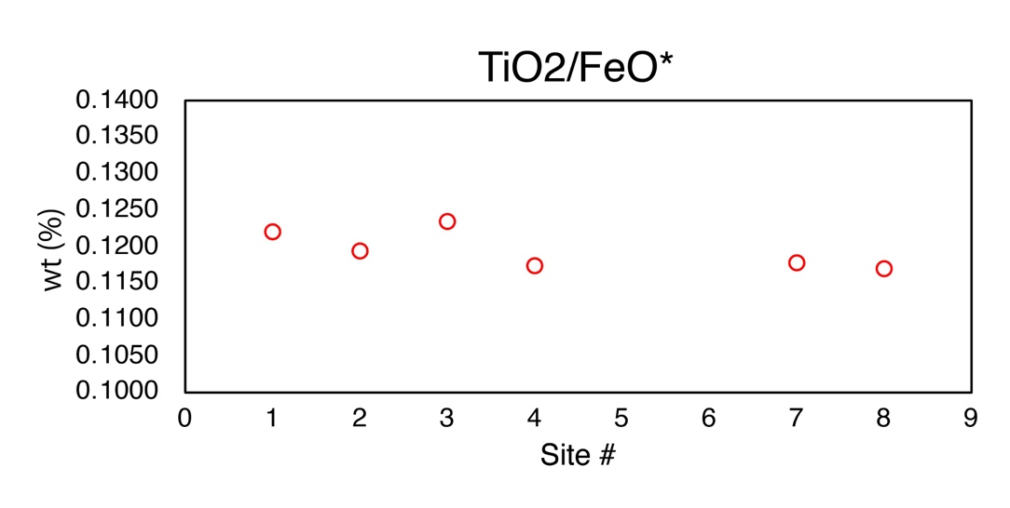
Figure S7. Variations of TiO₂ and FeO* contents of Sato et al. (2015) and Neo (2011) with site number of the conical cone in the CIR-S2. *Total Fe as FeO.

