Supplementary Table
Supplementary Table 1. The Relationship between ECI2 expression and clinicopathological features
Characteristics | ECI2 expression
Characteristics | n = 210 | Low | High | χ2 value | P value
Frequency | 210 | 152(72.4%) | 58(27.6%)
Gender |  |  |  | 0.281 | 0.353
Male | 122 | 90 | 32
Female | 88 | 62 | 26
Age（years） |  |  |  | 0.410 | 0.320
≤50 | 48 | 33 | 15
＞50 | 162 | 119 | 43
Tumor site |  |  |  | 0.473 | 0.298
colon | 138 | 102 | 36
Rectum | 72 | 50 | 22
Tumour size(diameter in cm) |  |  |  | 4.537 | 0.024
＜5 | 109 | 72 | 37
≥5 | 101 | 80 | 21
Differentiation |  |  |  | 4.711 | 0.095
Well | 12 | 6 | 6
Moderate | 147 | 105 | 42
Poor | 51 | 41 | 10
T stage |  |  |  | 10.872 | 0.004
T1-2 | 17 | 7 | 10
T3 | 116 | 83 | 33
T4 | 77 | 62 | 15
Lymph node staus |  |  |  | 210.000 | 0.000
Positive | 106 | 88 | 16
Negative | 104 | 64 | 42
Distant metastasis |  |  |  | 10.340 | 0.000
Yes | 24 | 24 | 0
No | 186 | 128 | 58
Vascular nerve invasion |  |  |  | 4.646 | 0.021
Positive | 63 | 52 | 11
Negative | 147 | 100 | 47
TNM classification |  |  |  | 29.139 | 0.000
Ⅰ | 11 | 3 | 8
Ⅱ | 92 | 57 | 35
Ⅲ | 83 | 68 | 15
Ⅳ | 24 | 24 | 0

Supplementary Table 2. Pearson correlation analysis between the expression levels of ECI2 and Clinicopathologic Features

Variables | ECI2 expression
Variables | Pearson correlation | P value
Gender | 0.037 | 0.598
Age | -0.044 | 0.524
Tumour size | -0.147 | 0.033
Differentiation | -0.140 | 0.043
Lymph node staus | -0.317 | 0.000
Distant metastasis | -0.222 | 0.001
TNM classification | -0.310 | 0.000

Supplementary Figure
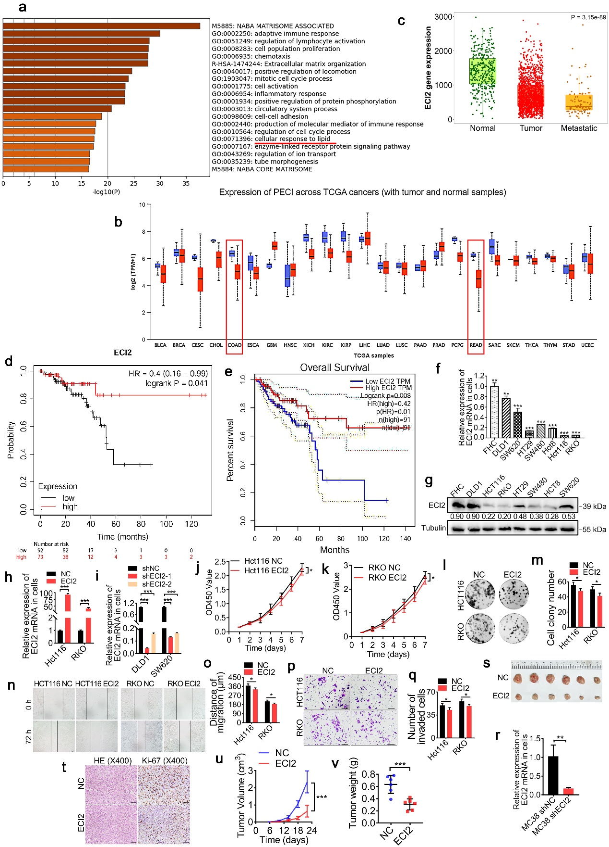
Supplementary Fig. 1. ECI2 predicts poor prognosis of CRC and inhibits CRC development through tumor cancer microenvironment
a, Enrichment of lipid metabolic pathways using TCGA database.
b, Aberrant expression of ECI2 in various tumors was analyzed using the TCGA database.
c, Analysis of differential expression of ECI2 in CRC tissues and metastatic tissues using Kaplan-Meier database.
(d, e) Survival prognosis of ECI2 in CRC patients was analyzed using Kaplan-Meier database (d) and GEPIA database (e).
(f, g) Detection of ECI2 expression in seven CRC cell lines and one normal colorectal epithelial cell (FHC) line using RT-qPCR (f) and western blotting (g).
(h, i) Application of RT-qPCR to verify the efficiency of overexpression (h) and silencing (i) of ECI2.
(j, k) CCK8 assay was applied to detect changes in proliferation of CRC cells HCT116 (j) and RKO (k) after overexpression of ECI2.
(l, m) Representative pictures (l) and quantification (m) of colony formation after overexpression of ECI2 in CRC cells were detected using colony formation assay (n = 3 biological replicates).
(n, o) Representative pictures (n) and quantification (o) of migration of CRC cells after overexpression of ECI2 were detected using a cellular wound healing assay (scale bar 100 μm, n = 3 biological replicates).
(p, q) Representative pictures (p) and quantification (q) of the invasion of CRC cells after overexpression of ECI2 detected using the Transwell invasion assay (scale bar 50 μm, n = 3 biological replicates).
r, Efficiency of mouse CRC cell line MC38 transfection with silencing ECI2 lentivirus was detected using RT-qPCR.
(s, t, u, v) Subcutaneous tumorigenic model of C57BL/6J mice constructed from CRC cells overexpressing ECI2 (22 days after cell injection, n = 6 biological replicates). s, Photograph of the tumor at the end of the experiment. t, Representative images of HE staining and ki-67 histochemical staining of the tumors (scale bar 20 μm). u, Volume of the tumor at the end of the experiment. v, Weight of the tumor at the end of the experiment.
Data are presented as mean ± s.d. (b, c, f, h, i, j, k, m, o, q, r, u, v). Statistical significance was determined by two-way ANOVA (j, k, u), two-tailed unpaired Student's t-test (b, c, f, h, i, m, o, q, r, v), or Kaplan-Meier method (d, e). Blotting experiments were repeated at least three biological replicates (g). Source data are provided as source data files. *p < 0.05; **p < 0.01; ***p < 0.001; ****p < 0.0001, and ns denotes no statistical difference.

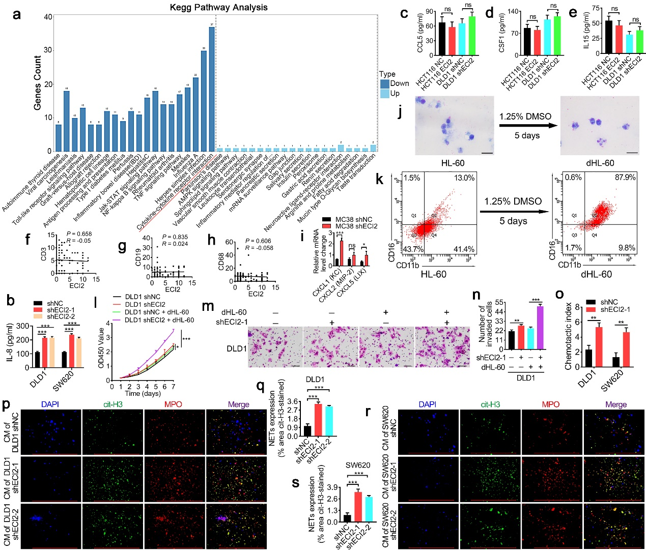
Supplementary Fig. 2. ECI2 inhibits IL-8 expression, neutrophil infiltration and NETs formation in CRC cells
a, RNA-seq followed by KEGG enrichment analysis of cells overexpressing ECI2.
b, Elisa was applied to detect changes in IL-8 content in CRC cells silencing ECI2 (n = 3 biological replicates).
(c, d, e) Elisa was applied to detect changes in the content of CCL5 (c), CSF1 (d) and IL15 (e) in CRC cells overexpressing or silencing ECI2, respectively (n = 3 biological replicates).
(f, g, h) Correlation between ECI2 and CD3-labeled T cells (f), CD19-labeled B cells (g), or CD68-labeled macrophages (h), respectively.
i, Expression of CXCL1 (KC), CXCL2 (MIP-2) and CXCL5 (LIX) in MC38 cells silenced with ECI2 was detected by RT-qPCR.
(j, k) HL-60 cells were cultured with 1.25% DMSO at 5% CO2 37°C for 5 days, and the efficiency of HL-60 differentiation into neutrophils was detected by using Giemsa staining (i) and flow cytometry (k) (dHL-60 surface markers were CD11b and CD16. Differentiated neutrophils were noted as dHL-60). Scale bar 10 μm.
(l, m, n) CRC cells silenced with ECI2 were co-cultured with dHL-60 for in vitro functional assays. l, CCK8 assay to detect the proliferation of CRC cells. (m, n) Representative pictures (m) and quantification (n) of the invasion of CRC cells detected using transwell invasion assay (scale bar 50 μm, n = 3 biological replicates).
o, Conditioned medium of CRC cells silencing ECI2 was used as an inducer to induce dHL-60 cell migration using the chemotaxis assay (n = 3 biological replicates).
(p, q, r, s) Representative pictures (p, r) and quantification (q, s) of NETs formation after silencing ECI2 in CRC cell-conditioned medium cultured with dHL-60 by applying immunofluorescence assay (scale bar 200 μm, n = 3 biological replicates).
Data are expressed as mean ± s.d. (b, c, d, e, i, l, n, o, q, s). Statistical significance was determined by two-way ANOVA (l) or two-tailed unpaired Student's t-test (b, c, d, e, i, n, o, q, s) or Correlation of Ozone correlations (f, g, h). Source data are provided as source data files. *p < 0.05; **p < 0.01; ***p < 0.001; ****p < 0.0001, and ns denotes no statistical difference.

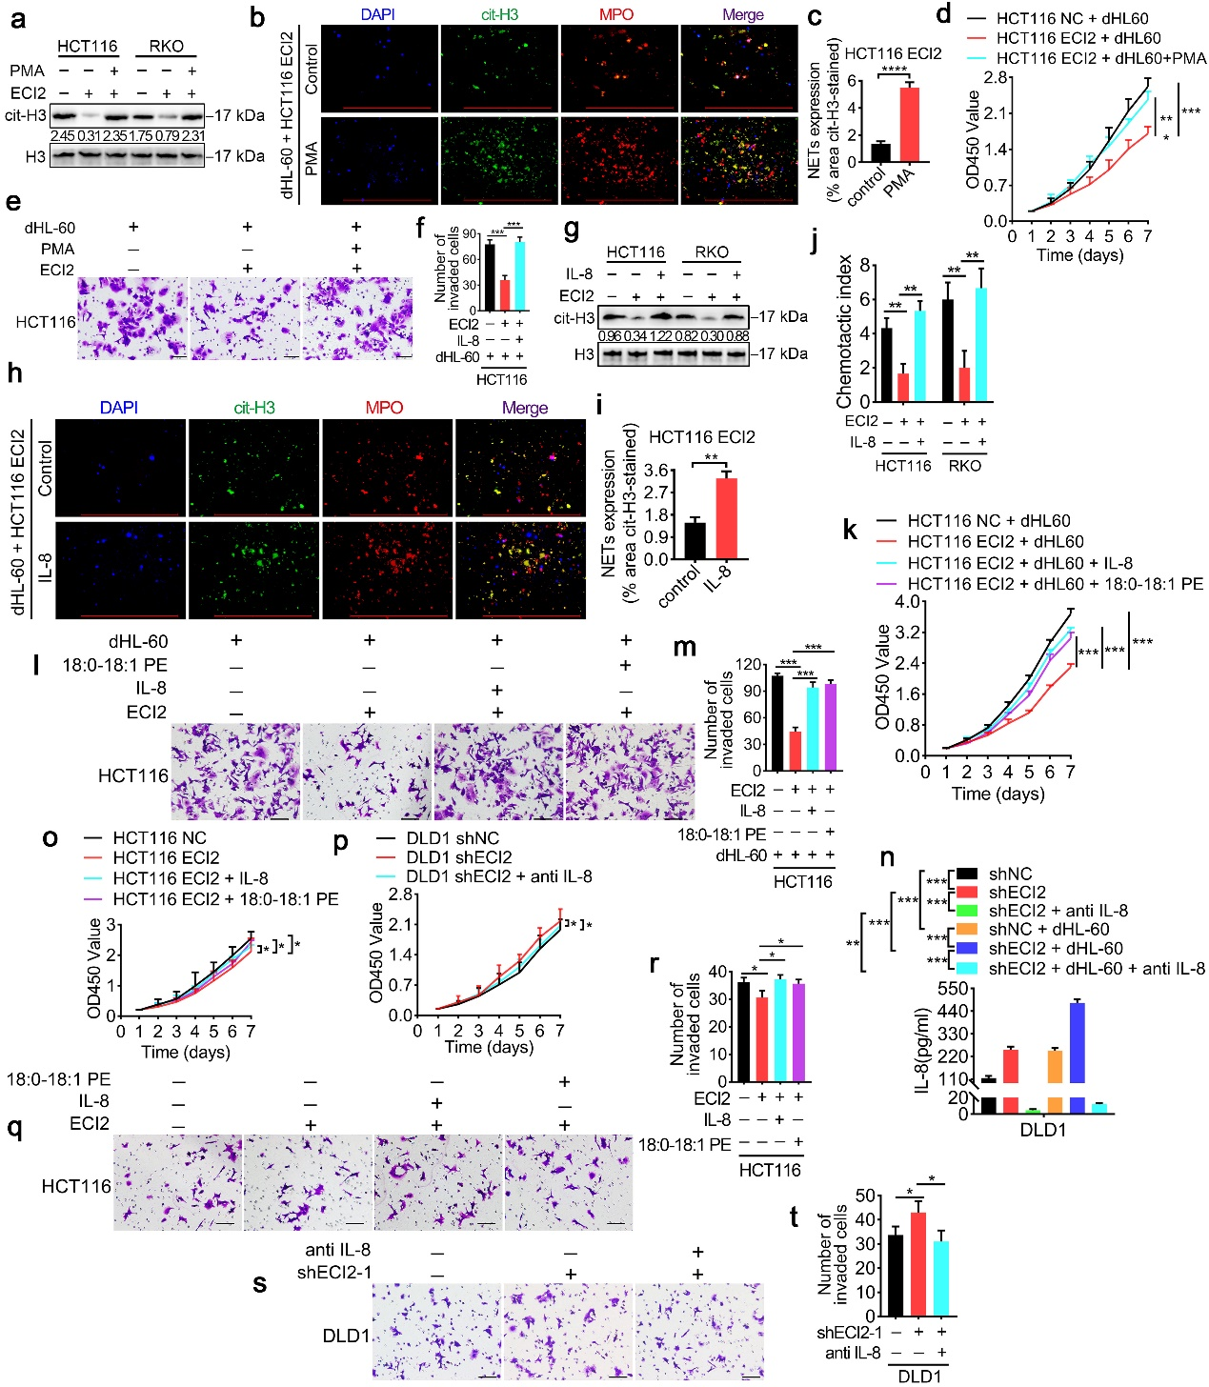
Supplementary Fig. 3. ECI2 inhibits NETs formation and CRC progression by reducing IL-8 and ether lipids
(a, b, c) CRC cells overexpressing ECI2 were co-cultured with dHL-60 with the addition of 25 ng/ml PMA and NETs formation was detected by applying western blotting (a) and immunofluorescence (b, c) (scale bar 200 μm, n = 3 biological replicates). c, Quantitative results of Figure b.
(d, e, f) CRC cells overexpressing ECI2 were added to 25 ng/ml PMA co-cultured with dHL-60 for in vitro functional assays. d, CCK8 assay to detect the proliferation of CRC cells. e, Transwell invasion assay to detect the invasion of CRC cells (scale bar of 50 μm, n = 3 biological replicates). f, Quantitative results for Figure e.
(g, h, i) Western blotting (g) and immunofluorescence (h, i) to detect NETs formation after co-culture of CRC cells overexpressing ECI2 plus recombinant IL-8 cytokine (100 ng/ml) with dHL-60 (scale bar 200 μm, n = 3 biological replicates). i, Quantitative results for Figure h.
j, CRC cells overexpressing ECI2 were cultured by addition of recombinant IL-8 cytokine (100 ng/ml), and cell supernatants were collected to induce dHL-60 cell migration in chemotaxis assay (n = 3 biological replicates).
(k, l, m) CRC cells overexpressing ECI2 were co-cultured with dHL-60 for in vitro functional assays after addition of recombinant IL-8 cytokine (100 ng/ml) or 18:0-18:1 PE (10 ug/ml). k, CCK8 assay to detect the proliferation of CRC cells. The CRC cell proliferation was detected by CCK8 assay. l, Transwell invasion assay to detect the invasion of CRC cells (scale bar 50 μm, n = 3 biological replicates). m, Quantitative results for Figure l.
n, Anti-IL-8 (500 ng/ml) was added to CRC cells silenced with ECI2 (with or without dHL-60 co-culture), and Elisa was applied to detect the level of IL-8 in the supernatant (n = 3 biological replicates).
(o, p, q, r, s, t) Recombinant IL-8 cytokines (100 ng/ml) or 18:0-18:1 PE (10 ug/ml) were added to CRC cells overexpressing ECI2 (o, q, r) or anti-IL-8 was added to ECI2-silenced CRC cells without co-culturing with neutrophil dHL-60 (p, s, t), for in vitro functional experiments. (o, p) CCK8 assay to detect the proliferation of CRC cells. (q, s) Transwell invasion assay to detect invasion of CRC cells (scale bar 50 μm, n = 3 biological replicates). r, Quantitative results of Figure q. t, Quantitative results of Figure s.
Data are expressed as mean ± s.d. (c, d, f, i, j, k, m, n, o, p, r, t). Statistical significance was determined by two-way ANOVA (d, k, o, p) or two-tailed unpaired Student's t-test (c, f, i, j, m, n, r, t). Blotting experiments were repeated at least three biological replicates (a, g). Source data are provided as source data files. *p < 0.05; **p < 0.01; ***p < 0.001; ****p < 0.0001, and ns denotes no statistical difference.
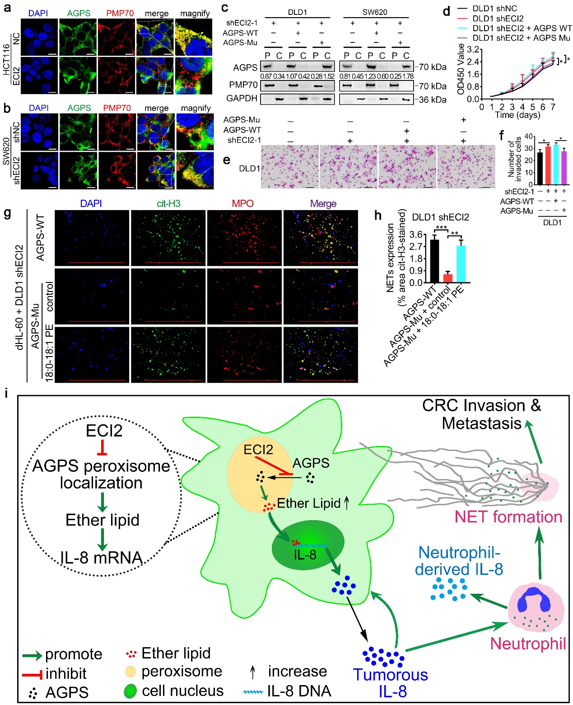
Supplementary Fig. 4. ECI2 inhibits ether lipid synthesis-mediated CRC development by inhibiting AGPS peroxisome localization
(a, b) Immunofluorescence detection of co-localization of AGPS and peroxisomal membrane marker PMP70 after overexpression (a) or silencing (b) of ECI2 (scale bar 10 μm).
c, CRC cells silenced with ECI2 were transfected with AGPS-Mu and AGPS-WT lentiviral vectors, respectively, and peroxisome isolation assay and western blotting assay were applied to detect the content of AGPS in peroxisome (P) and cytoplasm (C).
(d, e, f) CRC cells transfected with shECI2 and AGPS-WT or AGPS-Mu lentiviruses were subjected to in vitro functional assays without co-culture with dHL-60. d, CCK8 assay to detect the proliferation of CRC cells. e, Transwell invasion assay to detect the invasion of CRC cells (scale bar 50 μm, n = 3 biological replicates). f, Quantitative results for Figure e.
(g, h) Representative pictures (g) and quantification (h) of NETs formation after application of immunofluorescence for detection of NETs in CRC cells transfected with shECI2 and AGPS-WT or AGPS-Mu lentiviruses incubated with dHL-60 by addition of 18:0-18:1 PE (10 ug/ml) (scale bar 200 μm, n = 3 biological replicates).
i, Working model of ECI2 inhibition of CRC progression.
Data are expressed as mean ± s.d. (d, f, h). Statistical significance was determined by two-way ANOVA (d) or two-tailed unpaired Student's t-test (f, h). Blotting experiments were repeated at least three biological replicates (c). Source data are provided as source data files. *p < 0.05; **p < 0.01; ***p < 0.001; ****p < 0.0001, and ns denotes no statistical difference.

