Figure 1. The mRNA expression of GPCRs in breast tumors and normal tissues in GEPIA. red: tumor tissue, Green: normal tissue; Expression changes (down and upregulation) among fifty GPCRs. *P<0.05 and |Log1 (fold-change)| cutoff=1.

Figure 2A. Prognostic values of 50 GPCRs for overall survival (OS) and (2B) Association between Key GPCRs and clinical stages of breast cancer patients. The y axis: log2(TPM+1) (TPM: transcript per million).
Supplementary Table 1: Clinico pathological parameters of 50 selected GPCRs in human breast cancer patients.
 | TSHR | CASR | SMO | FSHR | LHCGR | CCKBR | PROKR2 | NMUR2
Age | ≤51> >51 (P=0.001) | ≤51> >51 (P=0.0204) | ≤51> >51 (P<0.0001) | ≤51= >51 (P<0.2558) | ≤51> >51 (P=0.0007) | ≤51> >51 (P<0.0001) | ≤51> >51 (P<0.0001) | ≤51> >51 (P=0.0320)
HER-2 | −<+ (P<0.0001) | + = −( P=0.6432) | +<−( P<0.0001) | +=−( P<0.1408) | +<− (P=0.0026) | +<− (P<0.0001) | +<− (P=0.0041) | +=− (P=0.5582)
PR | +<−(P<0.0001) | +=−(P=0.0687) | +<−( P<0.0001) | +=−( P=0.9528) | −<+ (P=0.0002) | +<−(P<0.0001) | +<−(P<0.0001) | −<+ (P<0.0001)
ER | + < −(P<0.0001) | + < −(P=0.0375) | −>+ ( P<0.0001) | −=+ ( P=0.5664) | −<+ (P<0.0001) | + < −(P<0.0001) | + < −(P<0.0001) | −<+ (P<0.0001)
Nodal status | +=−(P=0.1041) | +=−(P=0.7475) | −>+(P=0.0001) | −=+(P=0.4828) | +=−(P=0.7404) | −>+(P=0.0001) | +=−(P=0.0671) | +=−(P=0.1385)
P53 status | WT<mutated  (P<0.0001) | WT=mutated (P=0.4336) | WT<mutated ( P<0.0001) | WT=mutated (P=0.8220) | WT>mutated  (P=0.0017) | WT<mutated  (P<0.0001) | WT<mutated  (P<0.0001) | WT=mutated (P=0.1591)
SBR | SBR1=SBR2<SBR3 (P<0.0001) | SBR1=SBR2=SBR3/ SBR1<SBR3 (P=0.0170) | SBR1>SBR2=SBR3  (P<0.0001) | SBR1=SBR2=SBR3  (P=0.1132) | SBR1=SBR2>SBR3 (P<0.0001) | SBR1=SBR2<SBR3 (P<0.0001) | SBR1=SBR2<SBR3 (P<0.0001) | SBR1=SBR2>SBR3 (P=0.0485)
NPI | NPI1<NPI2=NPI3 (P=0.0002) | NPI1<NPI2=NPI3 (P=0.0077) | NPI1>NPI2>NPI3 (P<0.0001) | NPI1=NPI2=NPI3 (P=0.8145) | NPI1=NPI2=NPI3/NP1>NPI3 (P=0.0430) | NPI1<NPI2>NPI3 (P<0.0001) | NPI1<NPI2>NPI3 (P<0.0001) | NPI1=NPI2=NPI3 (P=0.1030)
TNBC status | Not TNBC<TNBC  (P<0.0001) | Not TNBC=TNBC(P=0.2636) | Not TNBC<TNBC(P<0.0001) | Not TNBC=TNBC(P=0.8195) | Not TNBC>TNBC  (P=0.0002) | Not TNBC<TNBC  (P<0.0001) | Not TNBC<TNBC  (P<0.0001) | Not TNBC>TNBC  (P<0.0001)
 | GPR149 | MAS1L | MAS1 | P2RY2 | P2RY8 | VIPR1 | BDKRB2 | GPR98
Age | ≤51 = >51 (P=0.3225) | ≤51> >51 (P=0.0005) | ≤51 = >51 (P=0.3835) | ≤51= >51 (P=0.3337) | ≤51> >51 (P<0.0001) | ≤51< >51 (P<0.0001) | ≤51= >51 (P=0.9689) | ≤51> <51 (P<0.0001)
HER-2 | +<−(P=0.0005) | +<−( P=0.0477) | +=−( P=0.0768) | −<+ (P<0.0001) | −<+ (P<0.0001) | −>+ (P<0.0001) | −<+ (P<0.0001) | −<+ (P<0.0001)
PR | +<−(P=0.0007) | + > − (P<0.0001) | +=−( P=0.1274) | −<+ (P<0.0001) | −>+ (P<0.0001) | −<+ (P<0.0001) | −<+ (P<0.0001) | −<+ (P<0.0001)
ER | + < −(P=0.0002) | + > − (P<0.0001) | −=+ ( P=0.0604) | −<+ (P<0.0001) | −>+ (P<0.0001) | −<+ (P<0.0001) | −<+ (P<0.0001) | −<+ (P<0.0001)
Nodal status | +=−(P=0.9477) | +=−(P=0.0723) | −=+(P=0.6004) | −<+ (P<0.0001) | −<+(P=0.0008) | −<+ (P=0.0110) | +=−(P=0.1570) | +=−(P=0.0812)
P53 status | WT=mutated  (P=0.0650) | WT>mutated (P<0.0001) | WT=mutated (P=0.2215) | WT>mutated (P=0.0002) | WT=mutated  (P=0.1420) | WT>mutated (P<0.0001) | WT=mutated  (P=0.0557) | WT>mutated (P<0.0001)
SBR | SBR1=SBR2=SBR3 (P=0.1908) | SBR1>SBR2>SBR3  (P<0.0001) | SBR1=SBR2=SBR3  (P=0.3730) | SBR1>SBR2>SBR3 (P<0.0001) | SBR1<SBR2<SBR3  (P<0.0001) | SBR1>SBR2>SBR3  (P<0.0001) | SBR1=SBR2=SBR3  (P=0.2495) | SBR1>SBR2>SBR3  (P<0.0001)
NPI | NPI1=NPI2=NPI3 (P=0.7469) | NPI1>NPI2>NPI3 (P<0.0001) | NPI1=NPI2=NPI3 (P=0.3664) | NPI1>NPI2=NPI3 (P<0.0001) | NPI1<NPI2=NPI3 (P<0.0001) | NPI1>NPI2=NPI3 (P<0.0001) | NPI1=NPI2=NPI3 (P=0.7989) | NPI1>NPI2=NPI3 (P<0.0001)
TNBC status | Not TNBC<TNBC  (P=0.0005) | Not TNBC>TNBC  (P<0.0001) | Not TNBC=TNBC(P=0.0586) | Not TNBC>TNBC  (P<0.0001) | Not TNBC<TNBC  (P<0.0001) | Not TNBC>TNBC  (P<0.0001) | Not TNBC>TNBC  (P<0.0001) | Not TNBC>TNBC  (P<0.0001)
 | GPR112 | BAI2 | BAI3 | LPHN1 | LPHN2 | LPHN3 | CELSR1 | CELSR2
Age | ≤51< >51 (P=0.0002) | ≤51< >51 (P=0.0022) | ≤51< >51 (P<0.0001) | ≤51< >51 (P=0.0008) | ≤51> >51 (P<0.0001) | ≤51> >51 (P=0.0073) | ≤51= >51 (P=0.4028) | ≤51> <51 (P<0.0001)
HER-2 | −>+(P=0.0096) | −>+ (P<0.0001) | −>+ (P<0.0001) | −>+ (P<0.0001) | −>+ (P<0.0001) | −>+ (P<0.0001) | −>+ (P<0.0001) | −>+ (P<0.0001)
PR | + = −(P=0.1893) | + > − (P<0.0001) | + > − (P<0.0001) | −<+ (P<0.0001) | −>+ (P<0.0001) | −<+ (P=0.0375) | −<+ (P<0.0001) | −<+ (P<0.0001)
ER | + = −(P=0.1279) | + > − (P<0.0001) | + > − (P<0.0001) | −<+ (P<0.0001) | −>+ (P<0.0001) | + = −(P=0.1387) | −<+ (P<0.0001) | −<+ (P<0.0001)
Nodal status | −=+(P=0.2247) | −>+(P=0.0127) | −>+(P=0.0083) | −=+(P=0.3483) | −>+(P=0.0372) | −=+ (P=0.1263) | +=−(P=0.8356) | +=−(P=0.3868)
P53 status | WT=mutated (P=0.5909) | WT>mutated (P<0.0001) | WT>mutated (P<0.0001) | WT>mutated (P<0.0001) | WT<mutated (P=0.0020) | WT=mutated (P=0.3472) | WT>mutated (P<0.0001) | WT>mutated (P<0.0001)
SBR | SBR1=SBR2>SBR3 (P=0.0017) | SBR1>SBR2>SBR3 (P<0.0001) | SBR1>SBR2>SBR3 (P<0.0001) | SBR1>SBR2>SBR3 (P<0.0001) | SBR1>SBR2>SBR3 (P<0.0001) | SBR1>SBR2>SBR3  (P<0.0001) | SBR1=SBR2=SBR3  (P=0.0643) | SBR1=SBR2>SBR3  (P<0.0001)
NPI | NPI1>NPI2=NPI3 (P=0.0044) | NPI1>NPI2>NPI3 (P<0.0001) | NPI1>NPI2>NPI3 (P<0.0001) | NPI1>NPI2=NPI3 (P<0.0001) | NPI1>NPI2>NPI3 (P<0.0001) | NPI1>NPI2>NPI3 (P<0.0001) | NPI1=NPI2=NPI3 (P=0.6219) | NPI1>NPI2>NPI3 (P<0.0001)
TNBC status | Not TNBC=TNBC(P=0.0937) | Not TNBC>TNBC  (P<0.0001) | Not TNBC>TNBC  (P<0.0001) | Not TNBC>TNBC  (P<0.0001) | Not TNBC<TNBC  (P<0.0001) | Not TNBC=TNBC(P=0.1315) | Not TNBC>TNBC  (P<0.0001) | Not TNBC>TNBC  (P<0.0001)
 | CELSR3 | GRM1 | GRM2 | GRM3 | GRM4 | GRM5 | GRM6 | GRM7
Age | ≤51= >51 (P=0.5280) | ≤51< >51 (P=0.0298) | ≤51< >51 (P=0.0437) | ≤51= >51 (P=0.2658) | ≤51< >51 (P<0.0001) | ≤51= >51 (P=0.3741) | ≤51> >51 (P=0.0008) | ≤51= >51 (P=0.6764)
HER-2 | −<+(P<0.0001) | + = −(P=0.2027) | + = −(P=0.8941) | + = −(P=0.2913) | −>+ (P<0.0001) | + = −(P=0.3120) | + = −(P=0.0796) | −>+ (P<0.0001)
PR | + <−(P=0.0114) | + = −(P=0.0738) | −>+ (P<0.0001) | −<+ (P<0.0001) | −<+ (P<0.0001) | + = −(P=0.3540) | −>+ (P<0.0001) | −<+ (P<0.0001)
ER | + = −(P=0.3308) | + = −(P=0.0682) | −>+ (P<0.0001) | −<+ (P<0.0001) | −<+ (P<0.0001) | + = −(P=0.1982) | −>+ (P<0.0001) | −<+ (P<0.0001)
Nodal status | −<+(P=0.0203) | −=+(P=0.3248) | −=+(P=0.1217) | −=+(P=0.0962) | −=+(P=0.8919) | −=+ (P=0.3062) | +=−(P=0.4413) | +=−(P=0.8052)
P53 status | WT=mutated (P=0.7477) | WT=mutated (P=0.0734) | WT<mutated (P<0.0001) | WT>mutated (P<0.0001) | WT>mutated (P<0.0001) | WT=mutated (P=0.2057) | WT<mutated (P<0.0001) | WT>mutated (P<0.0001)
SBR | SBR1<SBR2<SBR3 (P<0.0001) | SBR1=SBR2=SBR3  (P=0.1895) | SBR1>SBR2<SBR3 (P<0.0001) | SBR1<SBR2>SBR3 (P=0.0018) | SBR1=SBR2>SBR3 (P<0.0001) | SBR1=SBR2=SBR3  (P=0.6109) | SBR1=SBR2<SBR3  (P<0.0001) | SBR1>SBR2>SBR3  (P<0.0001)
NPI | NPI1<NPI2<NPI3 (P<0.0001) | NPI1=NPI2=NPI3 (P=0.1259) | NPI1=NPI2=NPI3 (P=0.6016) | NPI1=NPI2=NPI3 (P=0.8832) | NPI1>NPI2=NPI3 (P<0.0001) | NPI1=NPI2=NPI3 (P=0.5212) | NPI1<NPI2=NPI3 (P=0.0152) | NPI1>NPI2>NPI3 (P<0.0001)
TNBC status | Not TNBC=TNBC(P=0.6595) | Not TNBC=TNBC(P=0.6972) | Not TNBC<TNBC  (P<0.0001) | Not TNBC>TNBC  (P<0.0001) | Not TNBC>TNBC  (P<0.0001) | Not TNBC=TNBC(P=0.4303) | Not TNBC<TNBC  (P<0.0001) | Not TNBC>TNBC  (P<0.0001)
 | GRM8 | LPAR1 | LPAR2 | LPAR3 | LPAR4 | LPAR5 | LPAR6 | S1PR1
Age | ≤51< >51 (P<0.0001) | ≤51= >51 (P=0.1094) | ≤51> >51 (P<0.0001) | ≤51> >51 (P<0.0001) | ≤51> >51 (P=0.0275) | ≤51< >51(P<0.0001) | ≤51< >51 (P=0.0060) | ≤51< >51 (P=0.0012)
HER-2 | −<+(P=0.0116) | −>+(P=0.0103) | −<+ (P<0.0001) | −<+ (P=0.0022) | + = −(P=0.1499) | −=+(P=0.1849) | −>+(P=0.0071) | −>+(P=0.0007)
PR | + = −(P=0.4992) | −<+ (P<0.0001) | −>+ (P<0.0001) | −>+ (P<0.0001) | −<+ (P<0.0001) | −=+(P=0.4406) | −<+ (P<0.0001) | −<+ (P<0.0001)
ER | −<+ (P<0.0001) | −<+ (P<0.0001) | −>+ (P<0.0001) | −>+ (P<0.0001) | −<+ (P<0.0001) | −>+ (P<0.0001) | −<+ (P<0.0001) | −<+ (P<0.0001)
Nodal status | −=+(P=0.1590) | −>+(P=0.0309) | +>− (P=0.0065) | +=− (P=0.7246) | −=+(P=0.1667) | −=+(P=0.5184) | −>+(P=0.0120) | +=− (P=0.8910)
P53 status | WT>mutated (P=0.0224) | WT>mutated ( P<0.0001) | WT<mutated ( P<0.0001) | WT<mutated ( P<0.0001) | WT>mutated (P=0.0025) | WT=mutated ( P=0.2269) | WT>mutated ( P<0.0001) | WT>mutated ( P<0.0001)
SBR | SBR1=SBR2<SBR3 (P<0.0001) | SBR1>SBR2>SBR3 ( P<0.0001) | SBR1<SBR2<SBR3 ( P<0.0001) | SBR1>SBR2<SBR3 (P<0.0001) | SBR1>SBR2>SBR3 ( P<0.0001) | SBR1<SBR2<SBR3 ( P<0.0001) | SBR1>SBR2>SBR3 ( P<0.0001) | SBR1>SBR2>SBR3 ( P<0.0001)
NPI | NPI1<NPI2=NPI3 (P=0.0269) | NPI1>NPI2>NPI3 ( P<0.0001) | NPI1<NPI2<NPI3 ( P<0.0001) | NPI1<NPI2=NPI3 (P=0.0009) | NPI1>NPI2=NPI3 ( P<0.0001) | NPI1<NPI2=NPI3 ( P<0.0001) | NPI1>NPI2>NPI3 ( P<0.0001) | NPI1>NPI2>NPI3 ( P<0.0001)
TNBC status | Not TNBC>TNBC(P=0.0021) | Not TNBC>TNBC( P<0.0001) | Not TNBC<TNBC( P<0.0001) | Not TNBC<TNBC( P<0.0001) | Not TNBC>TNBC( P<0.0001) | Not TNBC=TNBC( P=0.1857) | Not TNBC>TNBC( P<0.0001) | Not TNBC>TNBC( P<0.0001)
 | S1PR2 | S1PR3 | S1PR4 | S1PR5 | CHRM1 | CHRM2 | CHRM3 | CHRM4
Age | ≤51> >51 (P<0.0001) | ≤51< >51 (P<0.0001) | ≤51> >51 (P<0.0001) | ≤51> >51 (P<0.0001) | ≤51= >51 (P=0.8062) | ≤51= >51(P=0.3831) | ≤51 > >51(P<0.0001) | ≤51> >51 (P=0.0056)
HER-2 | −<+ (P=0.0222) | −<+ (P<0.0001) | −<+ (P<0.0001) | −>+ (P=0.0055) | −<+ (P=0.0006) | −=+(P=0.1131) | −>+ (P<0.0001) | −>+ (P<0.0001)
PR | −>+ (P<0.0001) | −<+ (P<0.0001) | −>+ (P<0.0001) | −>+ (P<0.0001) | −>+ (P<0.0001) | −=+(P=0.3105) | −>+ (P<0.0001) | −<+ (P<0.0001)
ER | −>+ (P<0.0001) | −<+ (P<0.0001) | −>+ (P<0.0001) | −>+ (P<0.0001) | −>+ (P<0.0001) | −=+(P=0.0786) | −>+ (P<0.0001) | −<+ (P<0.0001)
Nodal status | −>+(P=0.0008) | −=+(P=0.8288) | +>− (P=0.0279) | +>− (P=0.0304) | +>− (P=0.0018) | −=+(P=0.5633) | −>+(P=0.0014) | +=− (P=0.1130)
P53 status | WT<mutated ( P<0.0001) | WT>mutated ( P=0.0001) | WT<mutated ( P=0.0012) | WT<mutated ( P<0.0001) | WT<mutated ( P<0.0001) | WT=mutated ( P=0.0961) | WT<mutated ( P<0.0001) | WT>mutated ( P=0.0043)
SBR | SBR1>SBR2<SBR3 (P<0.0001) | SBR1=SBR2>SBR3 ( P=0.0001) | SBR1=SBR2<SBR3 ( P<0.0001) | SBR1=SBR2<SBR3 (P=0.0002) | SBR1=SBR2>SBR3 ( P<0.0001) | SBR1=SBR2=SBR3 ( P=0.3081) | SBR1>SBR2<SBR3 ( P<0.0001) | SBR1=SBR2>SBR3 ( P<0.0001)
NPI | NPI1=NPI2=NPI3 (P=0.1503) | NPI1>NPI2=NPI3 ( P=0.0015) | NPI1<NPI2=NPI3 ( P<0.0001) | NPI1<NPI2=NPI3 ( P<0.0001) | NPI1>NPI2=NPI3 ( P<0.0001) | NPI1=NPI2=NPI3 ( P=0.6232) | NPI1<NPI2>NPI3 ( P<0.0001) | NPI1>NPI2>NPI3 ( P<0.0001)
TNBC status | Not TNBC<TNBC( P<0.0001) | Not TNBC>TNBC( P<0.0001) | Not TNBC<TNBC( P<0.0001) | Not TNBC<TNBC( P<0.0001) | Not TNBC<TNBC( P<0.0001) | Not TNBC=TNBC( P=0.1120) | Not TNBC<TNBC( P<0.0001) | Not TNBC>TNBC( P<0.0001)
 | CHRM5 | PTGFR |  | CHRM5 | PTGFR |  | CHRM5 | PTGFR
Age | ≤51= >51 (P=0.0750) | ≤51= >51 (P=0.4137) | Age | ≤51= >51 (P=0.0750) | ≤51= >51 (P=0.4137) | Age | ≤51= >51 (P=0.0750) | ≤51= >51 (P=0.4137)
HER-2 | −=+ (P=0.6349) | −>+ (P<0.0001) | HER-2 | −=+ (P=0.6349) | −>+ (P<0.0001) | HER-2 | −=+ (P=0.6349) | −>+ (P<0.0001)
PR | −=+ (P=0.4715) | −>+ (P<0.0001) | PR | −=+ (P=0.4715) | −>+ (P<0.0001) | PR | −=+ (P=0.4715) | −>+ (P<0.0001)
ER | −>+ (P=0.0140) | −>+ (P<0.0001) | ER | −>+ (P=0.0140) | −>+ (P<0.0001) | ER | −>+ (P=0.0140) | −>+ (P<0.0001)
Nodal status | −=+(P=0.5838) | +<− (P=0.0003) | Nodal status | −=+(P=0.5838) | +<− (P=0.0003) | Nodal status | −=+(P=0.5838) | +<− (P=0.0003)
P53 status | WT=mutated ( P=0.7167) | WT<mutated ( P=0.0427) | P53 status | WT=mutated ( P=0.7167) | WT<mutated ( P=0.0427) | P53 status | WT=mutated ( P=0.7167) | WT<mutated ( P=0.0427)
SBR | SBR1=SBR2>SBR3 ( P=0.0001) | SBR1>SBR2>SBR3 ( P<0.0001) | SBR | SBR1=SBR2>SBR3 ( P=0.0001) | SBR1>SBR2>SBR3 ( P<0.0001) | SBR | SBR1=SBR2>SBR3 ( P=0.0001) | SBR1>SBR2>SBR3 ( P<0.0001)
NPI | NPI1>NPI2=NPI3 ( P=0.0004) | NPI1>NPI2>NPI3 ( P<0.0001) | NPI | NPI1>NPI2=NPI3 ( P=0.0004) | NPI1>NPI2>NPI3 ( P<0.0001) | NPI | NPI1>NPI2=NPI3 ( P=0.0004) | NPI1>NPI2>NPI3 ( P<0.0001)
TNBC status | Not TNBC=TNBC( P=0.2188) | Not TNBC<TNBC( P<0.0001) | TNBC status | Not TNBC=TNBC( P=0.2188) | Not TNBC<TNBC( P<0.0001) | TNBC status | Not TNBC=TNBC( P=0.2188) | Not TNBC<TNBC( P<0.0001)

Supplementary Table 2. Putative Phosphorylation Motifs (Stringency Low) as Potential PKC Targets in GPCRs.
PTGFR
 | motif_gene_symbol | motif_name | score | protein | site | site_sequence
 | PRKCE | PKC epsilon | 0.4867 | PF2R | S62 | YQRFRQKsKASFLLL
 | PRKCZ | PKC zeta | 0.5215 |  | S62 | YQRFRQKsKASFLLL
 | PRKCA | PKCa/b/y | 0.4807 |  | S65 | FRQKSKAsFLLLASG
 | PRKCD | PKC delta | 0.4379 |  | S65 | FRQKSKAsFLLLASG
 | PRKCE | PKC epsilon | 0.5097 |  | S65 | FRQKSKAsFLLLASG
 | PRKCE | PKC epsilon | 0.4415 |  | T184 | YKIQASRtWCFYNTE
 | PRKCD | PKC delta | 0.4828 |  | T286 | SLETCETtLFALRMA
 | PRKCE | PKC epsilon | 0.5037 |  | T286 | SLETCETtLFALRMA
 | PRKCD | PKC delta | 0.4828 |  | S341 | ELSSIKNsLKVAAIS
 | PRKCE | PKC epsilon | 0.4082 |  | S341 | ELSSIKNsLKVAAIS
VIPR1
 | motif_gene_symbol | motif_name | score | protein | site | site_sequence
 | PRKCD | PKC delta | 0.3469 | VIPR1_HUMAN | T136 | ASLDEQQtMFYGSVK
 | PRKCE | PKC epsilon | 0.4644 |  | T136 | ASLDEQQtMFYGSVK
 | PRKCZ | PKC zeta | 0.5288 |  | T136 | ASLDEQQtMFYGSVK
 | PRKCE | PKC epsilon | 0.497 |  | S247 | LYTLLAVsFFSERKY
 | PRKCE | PKC epsilon | 0.4807 |  | T343 | YSRLARStLLLIPLF
ADGRB2
 | motif_gene_symbol | motif_name | score | protein | site | site_sequence
 | PRKCE | PKC epsilon | 0.4934 | AGRB2_HUMAN | S412 | ELQTKLCsMAACPVE
 | PRKCE | PKC epsilon | 0.5097 | AGRB2_HUMAN | T543 | DEYVMLMtWKKAAAG
 | PRKCA | PKC alpha/beta/gamma | 0.5187 | AGRB2_HUMAN | T649 | ILRNVTDtFKRATYV
 | PRKCA | PKC alpha/beta/gamma | 0.539 | AGRB2_HUMAN | T654 | TDTFKRAtYVPSADD
 | PRKCZ | PKC zeta | 0.5473 | AGRB2_HUMAN | S670 | QRFFQVVsFMVDAEN
 | PRKCA | PKC alpha/beta/gamma | 0.5362 | AGRB2_HUMAN | S715 | ALKAFQSsLIVTDNL
 | PRKCD | PKC delta | 0.4728 | AGRB2_HUMAN | S715 | ALKAFQSsLIVTDNL
 | PRKCA | PKC alpha/beta/gamma | 0.511 | AGRB2_HUMAN | T845 | TSRVMTVtVRPPTQP
 | PRKCD | PKC delta | 0.4901 | AGRB2_HUMAN | S1153 | SARNAMAsLWSSCVV
 | PRKCE | PKC epsilon | 0.4934 | AGRB2_HUMAN | S1275 | TGTLSRLsLDEDEEP
 | PRKCD | PKC delta | 0.495 | AGRB2_HUMAN | S1292 | CLVGPEGsLSFSPLP
 | PRKCA | PKC alpha/beta/gamma | 0.4902 | AGRB2_HUMAN | T1381 | PRARPEGtPRRAAKT
 | PRKCA | PKC alpha/beta/gamma | 0.511 | AGRB2_HUMAN | T1388 | TPRRAAKtVAHTEGY
 | PRKCE | PKC epsilon | 0.4208 | AGRB2_HUMAN | T1388 | TPRRAAKtVAHTEGY
 | PRKCA | PKC alpha/beta/gamma | 0.475 | AGRB2_HUMAN | S1458 | GSTMKMGsLERKKLR
 | PRKCZ | PKC zeta | 0.5373 | AGRB2_HUMAN | S1467 | ERKKLRYsDLDFEKV
 | PRKCA | PKC alpha/beta/gamma | 0.4888 | AGRB2_HUMAN | S1502 | FDRYRSQsTAKREKR
 | PRKCA | PKC alpha/beta/gamma | 0.3964 | AGRB2_HUMAN | T1503 | DRYRSQStAKREKRW
 | PRKCZ | PKC zeta | 0.5595 | AGRB2_HUMAN | T1503 | DRYRSQStAKREKRW
 | PRKCD | PKC delta | 0.3026 | AGRB2_HUMAN | S1511 | AKREKRWsVSSGGAA
 | PRKCE | PKC epsilon | 0.4275 | AGRB2_HUMAN | S1511 | AKREKRWsVSSGGAA
 | PRKCA | PKC alpha/beta/gamma | 0.539 | AGRB2_HUMAN | S1543 | SQHRRHQsWSTFKSM
 | PRKCA | PKC alpha/beta/gamma | 0.5245 | AGRB2_HUMAN | S1545 | HRRHQSWsTFKSMTL
 | PRKCZ | PKC zeta | 0.551 | AGRB2_HUMAN | S1545 | HRRHQSWsTFKSMTL
 | PRKCA | PKC alpha/beta/gamma | 0.4882 | AGRB2_HUMAN | T1546 | RRHQSWStFKSMTLG
 | PRKCE | PKC epsilon | 0.4541 | AGRB2_HUMAN | T1551 | WSTFKSMtLGSLPPK
 | PRKCA | PKC alpha/beta/gamma | 0.4957 | AGRB2_HUMAN | T1564 | PKPRERLtLHRAAAW
 | PRKCE | PKC epsilon | 0.4771 | AGRB2_HUMAN | T1564 | PKPRERLtLHRAAAW
CELSR1
 | motif_gene_symbol | motif_name | score | protein | site | site_sequence
 | PRKCD | PKC delta | 0.4923 | CELR1_HUMAN | T49 | FALRPGCtYAVGAAC
 | PRKCA | PKC alpha/beta/gamma | 0.5165 | CELR1_HUMAN | T237 | ARRARRGtSGRGSLK
 | PRKCD | PKC delta | 0.3442 | CELR1_HUMAN | T237 | ARRARRGtSGRGSLK
 | PRKCA | PKC alpha/beta/gamma | 0.4931 | CELR1_HUMAN | S238 | RRARRGTsGRGSLKF
 | PRKCA | PKC alpha/beta/gamma | 0.4449 | CELR1_HUMAN | S242 | RGTSGRGsLKFPMPN
 | PRKCD | PKC delta | 0.4728 | CELR1_HUMAN | S242 | RGTSGRGsLKFPMPN
 | PRKCZ | PKC zeta | 0.5573 | CELR1_HUMAN | S242 | RGTSGRGsLKFPMPN
 | PRKCD | PKC delta | 0.3642 | CELR1_HUMAN | S609 | YRLVDTAsTFLGGGS
 | PRKCE | PKC epsilon | 0.5037 | CELR1_HUMAN | S609 | YRLVDTAsTFLGGGS
 | PRKCE | PKC epsilon | 0.5097 | CELR1_HUMAN | T1469 | FHFTISLtFATQERN
 | PRKCD | PKC delta | 0.4863 | CELR1_HUMAN | S1591 | TQTGSKKsLDLTGPL
 | PRKCE | PKC epsilon | 0.5097 | CELR1_HUMAN | S1591 | TQTGSKKsLDLTGPL
 | PRKCE | PKC epsilon | 0.4667 | CELR1_HUMAN | S1726 | FRTRKEDsVLMEATS
 | PRKCA | PKC alpha/beta/gamma | 0.5353 | CELR1_HUMAN | S1832 | GASEDKVsVRRGFRG
 | PRKCD | PKC delta | 0.4801 | CELR1_HUMAN | S1832 | GASEDKVsVRRGFRG
 | PRKCE | PKC epsilon | 0.483 | CELR1_HUMAN | T2106 | PELFNCTtISFVDLR
 | PRKCD | PKC delta | 0.4679 | CELR1_HUMAN | T2147 | SATQHTGtLFGNDVR
 | PRKCE | PKC epsilon | 0.4578 | CELR1_HUMAN | T2147 | SATQHTGtLFGNDVR
 | PRKCD | PKC delta | 0.495 | CELR1_HUMAN | S2280 | FPRELESsVSFPADF
 | PRKCE | PKC epsilon | 0.4667 | CELR1_HUMAN | S2280 | FPRELESsVSFPADF
 | PRKCD | PKC delta | 0.4964 | CELR1_HUMAN | S2450 | CQCSHTAsFAVLMDI
 | PRKCA | PKC alpha/beta/gamma | 0.5263 | CELR1_HUMAN | S2637 | SVLSAKVsCQRKHHY
 | PRKCE | PKC epsilon | 0.506 | CELR1_HUMAN | S2817 | ELSLDEQsSSYASSH
 | PRKCE | PKC epsilon | 0.4934 | CELR1_HUMAN | S2867 | PAGWPDQsLAESDSE
 | PRKCA | PKC alpha/beta/gamma | 0.5205 | CELR1_HUMAN | T2945 | PLTLTEQtLKGRLRE
 | PRKCE | PKC epsilon | 0.4934 | CELR1_HUMAN | T2945 | PLTLTEQtLKGRLRE
 | PRKCD | PKC delta | 0.4449 | CELR1_HUMAN | S2968 | PTSSRTSsLGSGGPD
 | PRKCE | PKC epsilon | 0.4771 | CELR1_HUMAN | S2968 | PTSSRTSsLGSGGPD
ADGRL2
 | motif_gene_symbol | motif_name | score | protein | site | site_sequence
 | PRKCA | PKC alpha/beta/gamma | 0.5182 | AGRL2_HUMAN | T139 | YIFVCPGtLKAIVDS
 | PRKCE | PKC epsilon | 0.4644 | AGRL2_HUMAN | T301 | YTLRFEAtWETVYDK
 | PRKCE | PKC epsilon | 0.4993 | AGRL2_HUMAN | S339 | ESETGKNsIDYIYNT
 | PRKCE | PKC epsilon | 0.506 | AGRL2_HUMAN | S419 | ELFKTIIsTTSTTSQ
 | PRKCA | PKC alpha/beta/gamma | 0.5058 | AGRL2_HUMAN | T601 | KLQKREKtCRAYLKA
 | PRKCD | PKC delta | 0.4886 | AGRL2_HUMAN | T601 | KLQKREKtCRAYLKA
 | PRKCE | PKC epsilon | 0.483 | AGRL2_HUMAN | T601 | KLQKREKtCRAYLKA
 | PRKCA | PKC alpha/beta/gamma | 0.5052 | AGRL2_HUMAN | T703 | SIQLSANtVKQNSRN
 | PRKCA | PKC alpha/beta/gamma | 0.5043 | AGRL2_HUMAN | T733 | FLSTENAtIKLGADF
 | PRKCD | PKC delta | 0.4471 | AGRL2_HUMAN | T733 | FLSTENAtIKLGADF
 | PRKCE | PKC epsilon | 0.506 | AGRL2_HUMAN | T818 | DTNKTRTtCACSHLT
 | PRKCA | PKC alpha/beta/gamma | 0.5009 | AGRL2_HUMAN | T1022 | KMVKHSNtLKPDSSR
 | PRKCD | PKC delta | 0.4886 | AGRL2_HUMAN | S1102 | YGKCFRHsYCCGGLP
 | PRKCA | PKC alpha/beta/gamma | 0.5338 | AGRL2_HUMAN | S1116 | PTESPHSsVKASTTR
 | PRKCA | PKC alpha/beta/gamma | 0.5136 | AGRL2_HUMAN | S1120 | PHSSVKAsTTRTSAR
 | PRKCA | PKC alpha/beta/gamma | 0.4085 | AGRL2_HUMAN | T1121 | HSSVKAStTRTSARY
 | PRKCD | PKC delta | 0.495 | AGRL2_HUMAN | T1121 | HSSVKAStTRTSARY
 | PRKCD | PKC delta | 0.4323 | AGRL2_HUMAN | S1125 | KASTTRTsARYSSGT
 | PRKCE | PKC epsilon | 0.4897 | AGRL2_HUMAN | S1125 | KASTTRTsARYSSGT
 | PRKCA | PKC alpha/beta/gamma | 0.5236 | AGRL2_HUMAN | T1143 | IRRMWNDtVRKQSES
 | PRKCD | PKC delta | 0.488 | AGRL2_HUMAN | S1151 | VRKQSESsFISGDIN
 | PRKCE | PKC epsilon | 0.4082 | AGRL2_HUMAN | S1151 | VRKQSESsFISGDIN
 | PRKCD | PKC delta | 0.4028 | AGRL2_HUMAN | T1348 | KKVKSEGtDSYVSQL
 | PRKCE | PKC epsilon | 0.4505 | AGRL2_HUMAN | T1348 | KKVKSEGtDSYVSQL
ADGRL3
 | motif_gene_symbol | motif_name | score | protein | site | site_sequence
 | PRKCE | PKC epsilon | 0.4644 | AGRL3_HUMAN | T300 | YTLRIEGtWDTAYDK
 | PRKCE | PKC epsilon | 0.4474 | AGRL3_HUMAN | S351 | NTDQSKDsLVDVPFP
 | PRKCE | PKC epsilon | 0.4541 | AGRL3_HUMAN | S388 | NYHVVKYsLDFGPLD
 | PRKCE | PKC epsilon | 0.483 | AGRL3_HUMAN | S423 | DSELERPsVKDISTT
 | PRKCA | PKC alpha/beta/gamma | 0.4597 | AGRL3_HUMAN | T443 | GSTTTSTtLRTTTLS
 | PRKCD | PKC delta | 0.495 | AGRL3_HUMAN | T443 | GSTTTSTtLRTTTLS
 | PRKCE | PKC epsilon | 0.4771 | AGRL3_HUMAN | T443 | GSTTTSTtLRTTTLS
 | PRKCD | PKC delta | 0.495 | AGRL3_HUMAN | T448 | STTLRTTtLSPGRST
 | PRKCA | PKC alpha/beta/gamma | 0.4775 | AGRL3_HUMAN | S460 | RSTTPSVsGRRNRST
 | PRKCA | PKC alpha/beta/gamma | 0.5052 | AGRL3_HUMAN | T718 | TIQLSANtLKQNGRN
 | PRKCA | PKC alpha/beta/gamma | 0.5338 | AGRL3_HUMAN | S748 | YLSTENAsMKLGTEA
 | PRKCD | PKC delta | 0.4571 | AGRL3_HUMAN | S748 | YLSTENAsMKLGTEA
 | PRKCE | PKC epsilon | 0.506 | AGRL3_HUMAN | T816 | SYSKRTMtGYWSTQG
 | PRKCA | PKC alpha/beta/gamma | 0.4449 | AGRL3_HUMAN | S1122 | CLRTHCCsGKSTESS
 | PRKCD | PKC delta | 0.485 | AGRL3_HUMAN | S1129 | SGKSTESsIGSGKTS
 | PRKCE | PKC epsilon | 0.506 | AGRL3_HUMAN | S1129 | SGKSTESsIGSGKTS
 | PRKCA | PKC alpha/beta/gamma | 0.5159 | AGRL3_HUMAN | S1132 | STESSIGsGKTSGSR
 | PRKCA | PKC alpha/beta/gamma | 0.5236 | AGRL3_HUMAN | T1159 | IRRMWNDtVRKQSES
 | PRKCD | PKC delta | 0.488 | AGRL3_HUMAN | S1167 | VRKQSESsFITGDIN
 | PRKCE | PKC epsilon | 0.4082 | AGRL3_HUMAN | S1167 | VRKQSESsFITGDIN
 | PRKCZ | PKC zeta | 0.5092 | AGRL3_HUMAN | T1231 | RGYNHNEtALEKKIL
 | PRKCE | PKC epsilon | 0.4771 | AGRL3_HUMAN | T1362 | SLYTSMPtLAGVAAT
LPAR1
 | motif_gene_symbol | motif_name | score | protein | site | site_sequence
 | PRKCZ | PKC zeta | 0.5057 | LPAR1_HUMAN | S29 | PQCFYNEsIAFFYNR
 | PRKCA | PKC alpha/beta/gamma | 0.4625 | LPAR1_HUMAN | T236 | FGYVRQRtMRMSRHS
 | PRKCZ | PKC zeta | 0.535 | LPAR1_HUMAN | S255 | RNRDTMMsLLKTVVI
 | PRKCE | PKC epsilon | 0.4438 | LPAR1_HUMAN | S319 | SYRDKEMsATFRQIL
S1PR1
 | motif_gene_symbol | motif_name | score | protein | site | site_sequence
 | PRKCA | PKC alpha/beta/gamma | 0.5217 | S1PR1_HUMAN | T108 | NLLLSGAtTYKLTPA
 | PRKCD | PKC delta | 0.4449 | S1PR1_HUMAN | S123 | QWFLREGsMFVALSA
 | PRKCE | PKC epsilon | 0.4644 | S1PR1_HUMAN | S123 | QWFLREGsMFVALSA
 | PRKCZ | PKC zeta | 0.4992 | S1PR1_HUMAN | T145 | IAIERYItMLKMKLH
 | PRKCA | PKC alpha/beta/gamma | 0.2801 | S1PR1_HUMAN | T236 | RTRSRRLtFRKNISK
 | PRKCD | PKC delta | 0.4842 | S1PR1_HUMAN | T236 | RTRSRRLtFRKNISK
 | PRKCE | PKC epsilon | 0.5097 | S1PR1_HUMAN | T236 | RTRSRRLtFRKNISK
 | PRKCZ | PKC zeta | 0.5092 | S1PR1_HUMAN | T236 | RTRSRRLtFRKNISK
 | PRKCD | PKC delta | 0.4385 | S1PR1_HUMAN | S251 | ASRSSEKsLALLKTV
 | PRKCE | PKC epsilon | 0.4704 | S1PR1_HUMAN | S251 | ASRSSEKsLALLKTV

Supplementary Table 3. Active sites and nature of interactions between ligands and GPCRs.
No.1 The overall binding affinity observed between the ligands and PTGFR receptor
Sr.No | Phytocompound | Binding affinity Kcal/mol | 2D and 3D interactions with protein No. 1 PTGFR
1 | Ellagic acid | -7.2 | 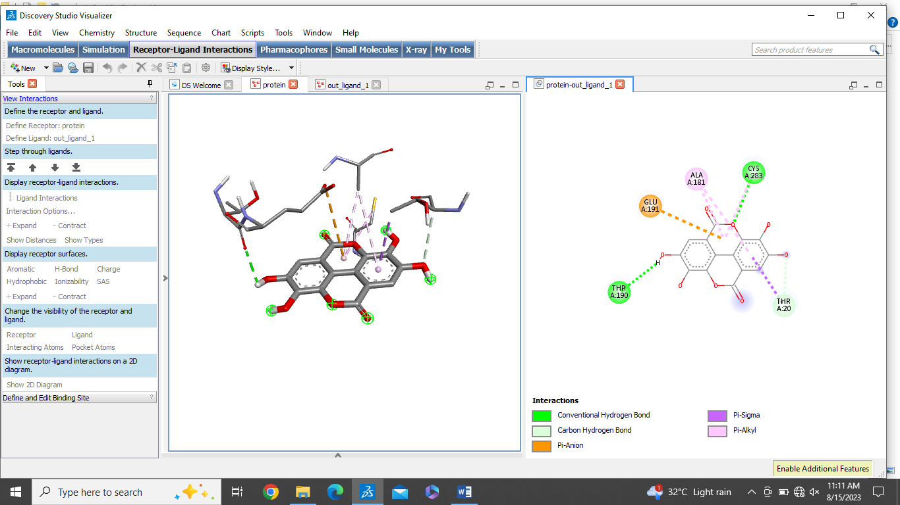
2 | Resveratrol | -6.4 | 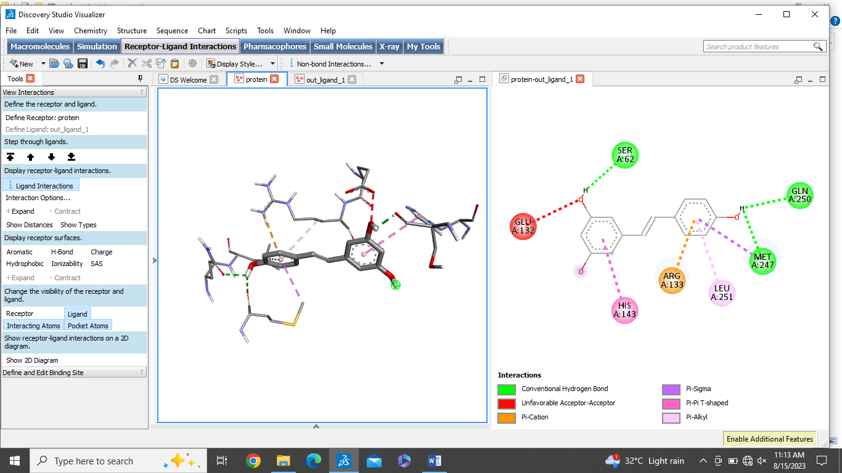
3 | Capsaicin | -6.0 | 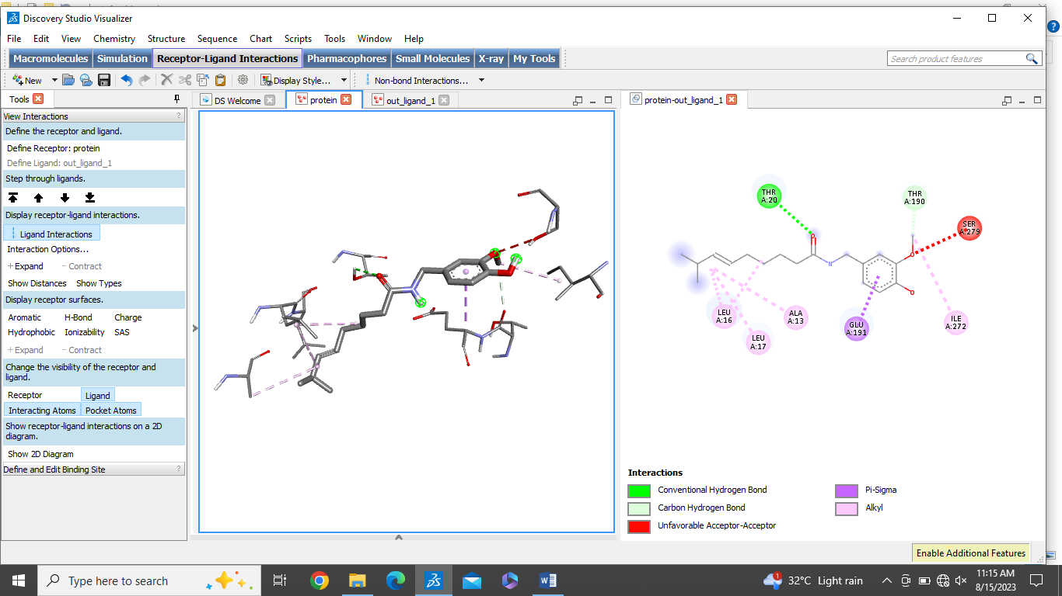
4 | Catechins | -7.2 | 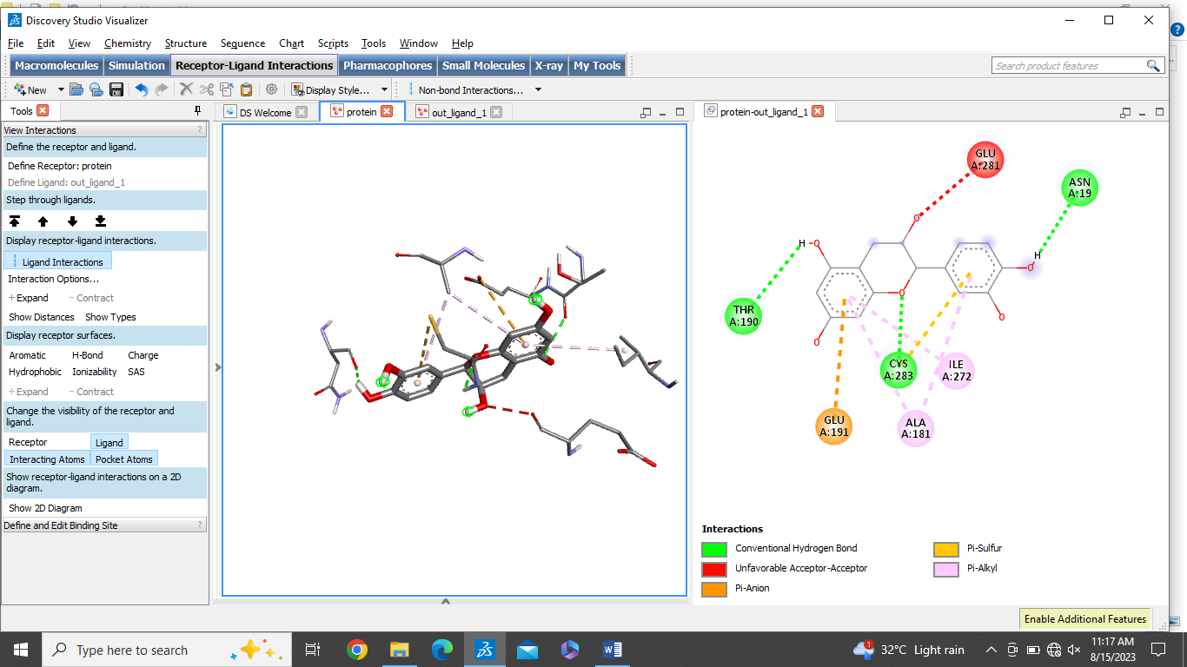
5 | Myricetin | -7.0 | 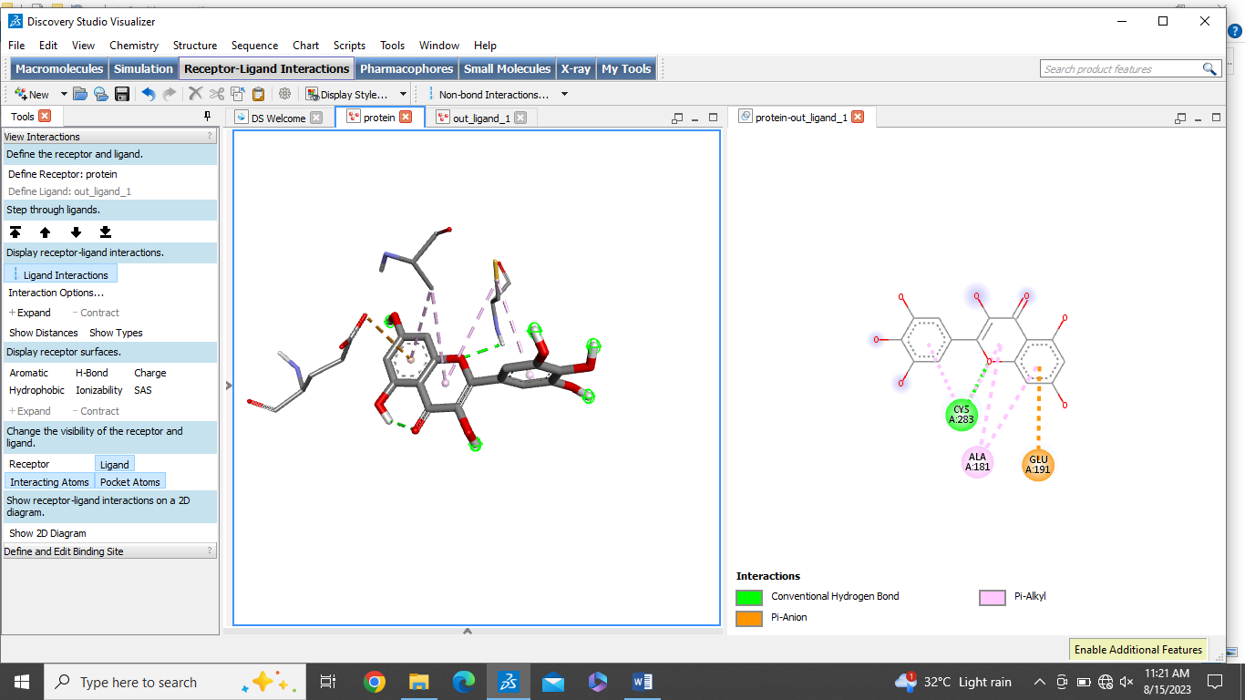
6 | Cucurbitacins | -8.3 | 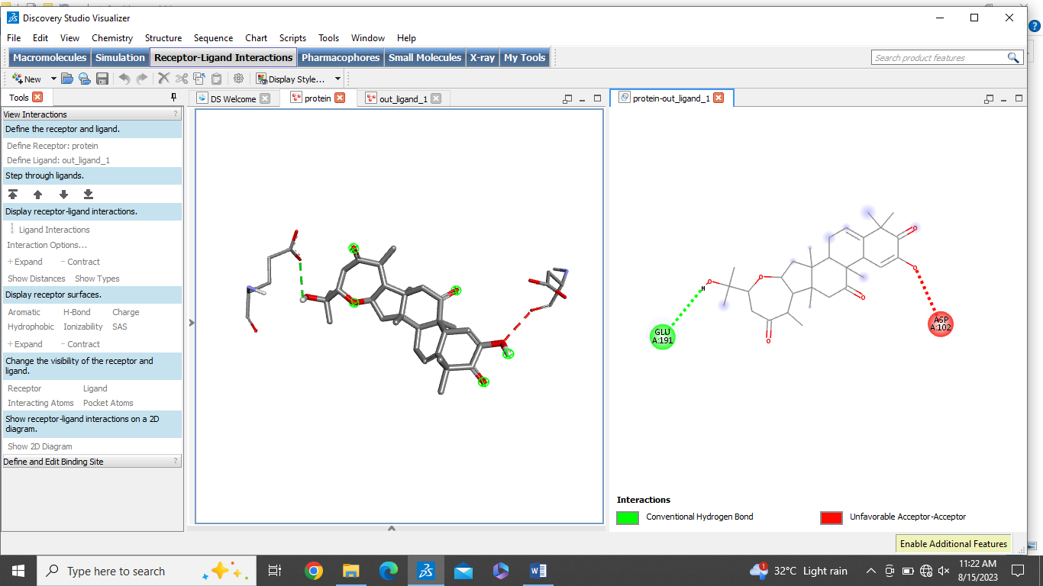
7 | Benzyl isothiocyanate | -4.6 | 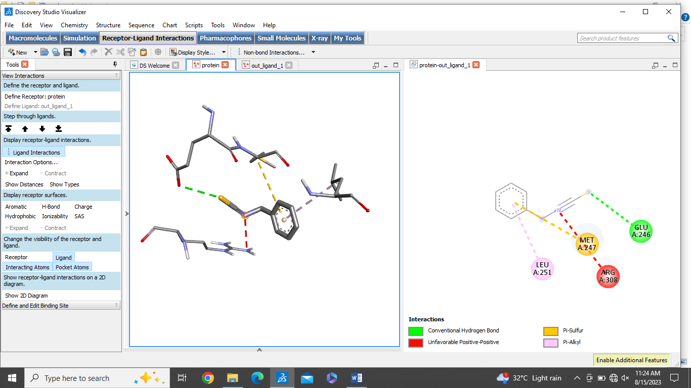
8 | Quercetin | -7.2 | 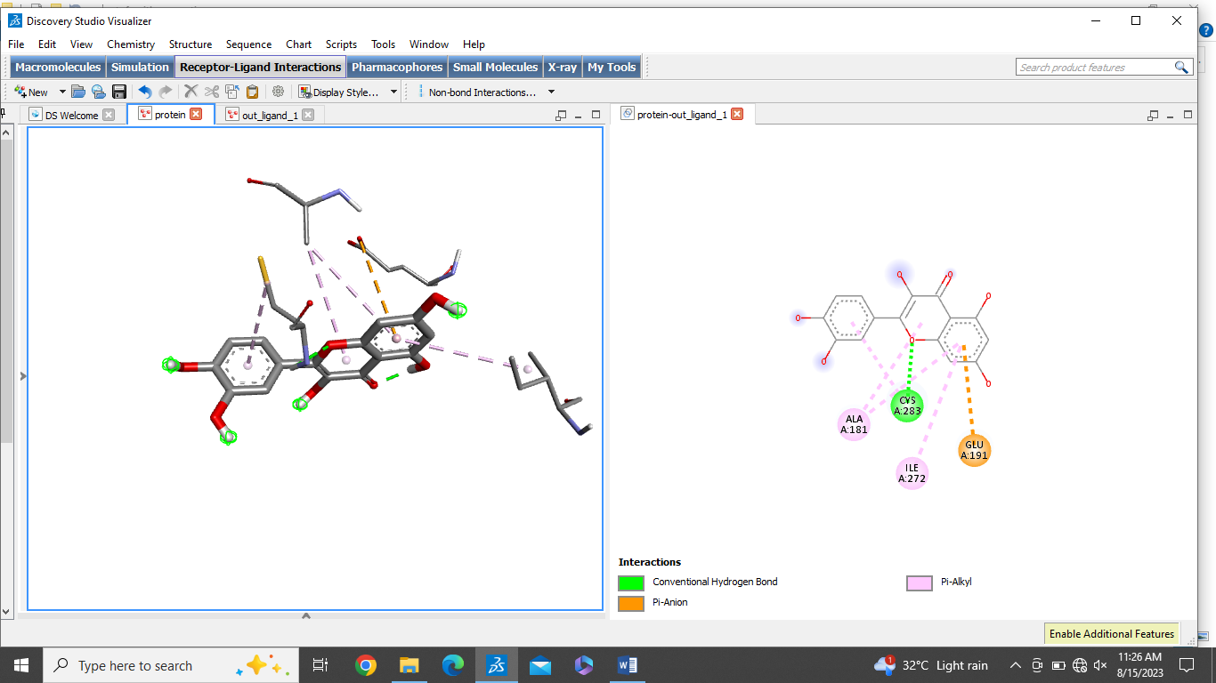
9 | Piperlongumine | -5.9 | 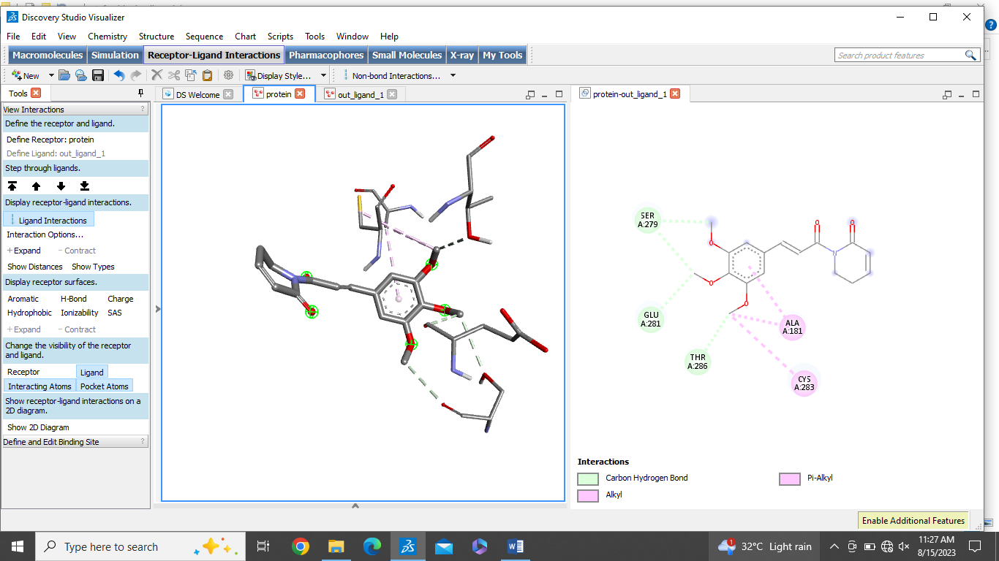
10 | Tilliroside | -8.2 | 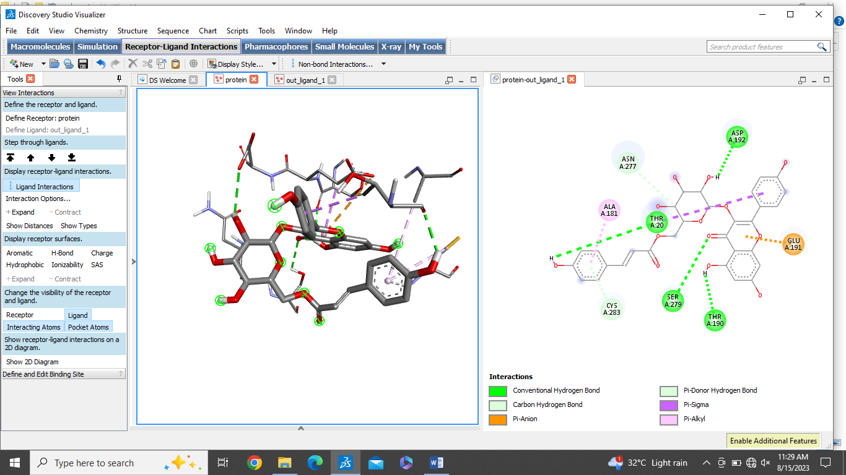
11 | Rutin | -9.1 | 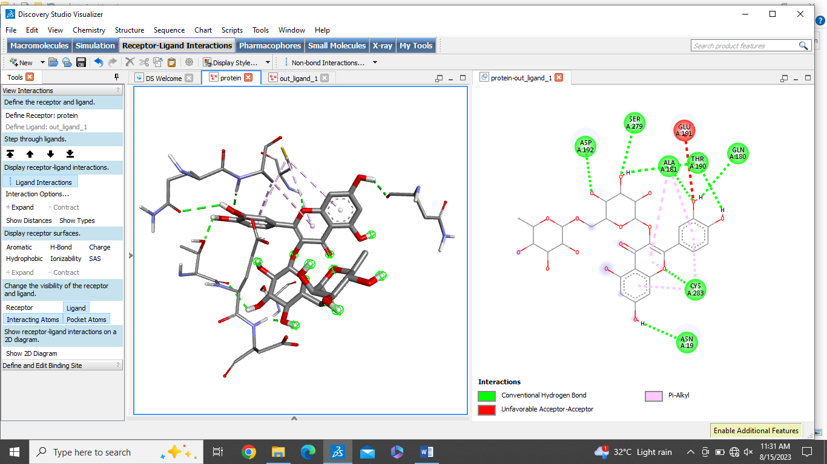
12 | Luteolin | -7.3 | 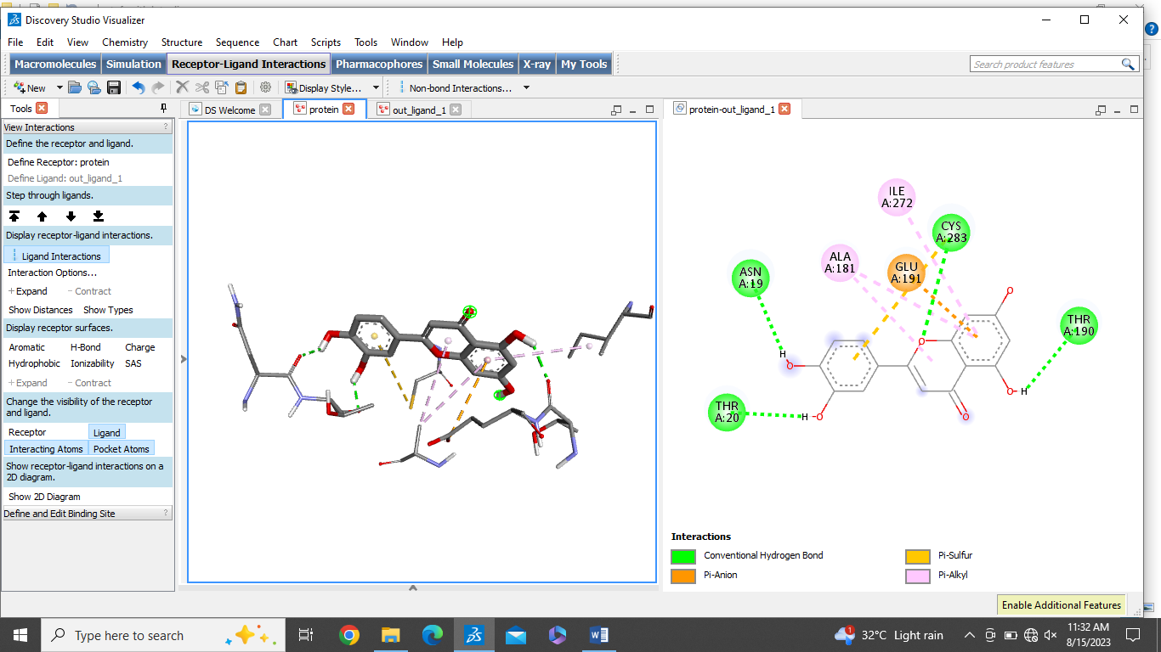
13 | Hyperoside | -7.7 | 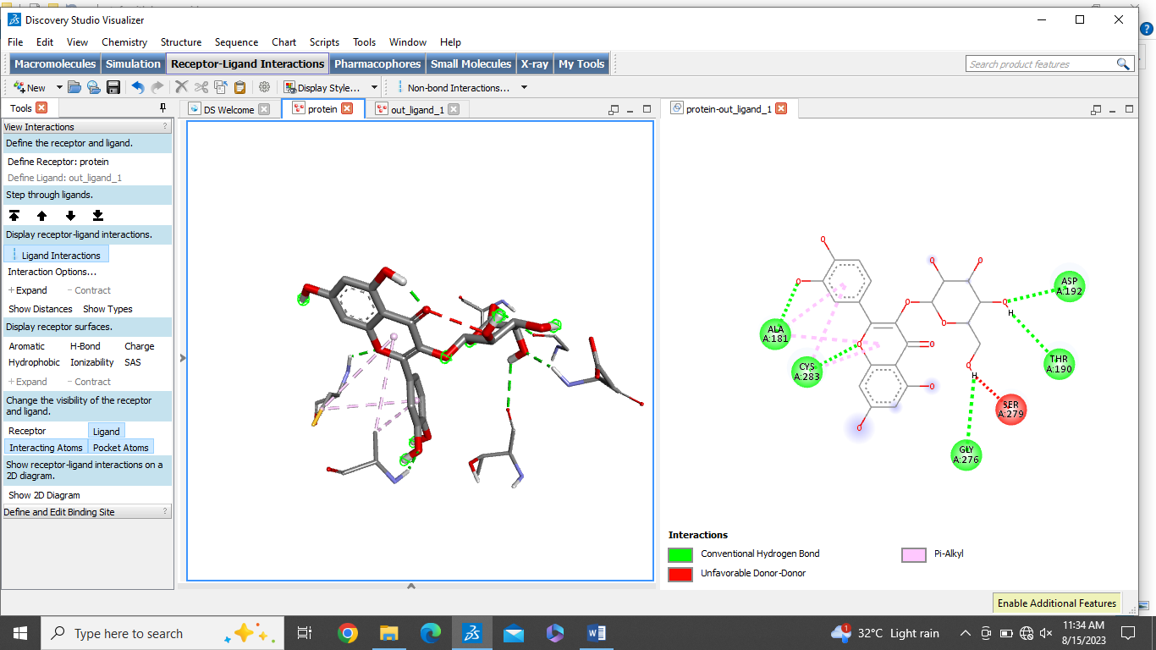
14 | Epicathechin | -7.2 | 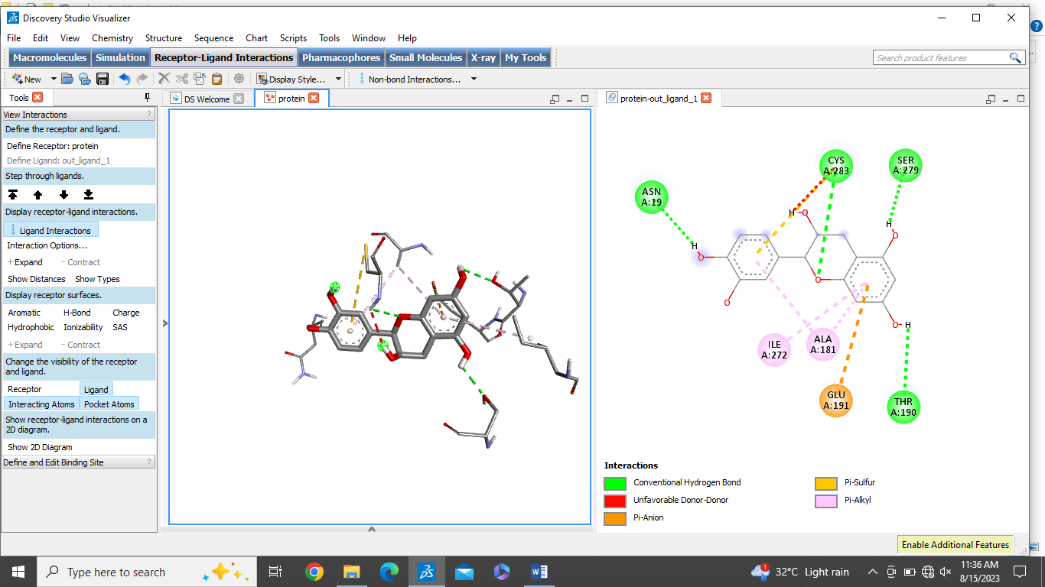  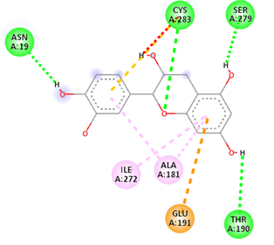

No.2 The overall binding affinity observed between the ligand and VIPR1 receptor.
Sr.No | Phytocompound | Binding affinity Kcal/mol | 2D and 3D interactions with Protein VIPR1
1 | Ellagic acid | -7.6 | 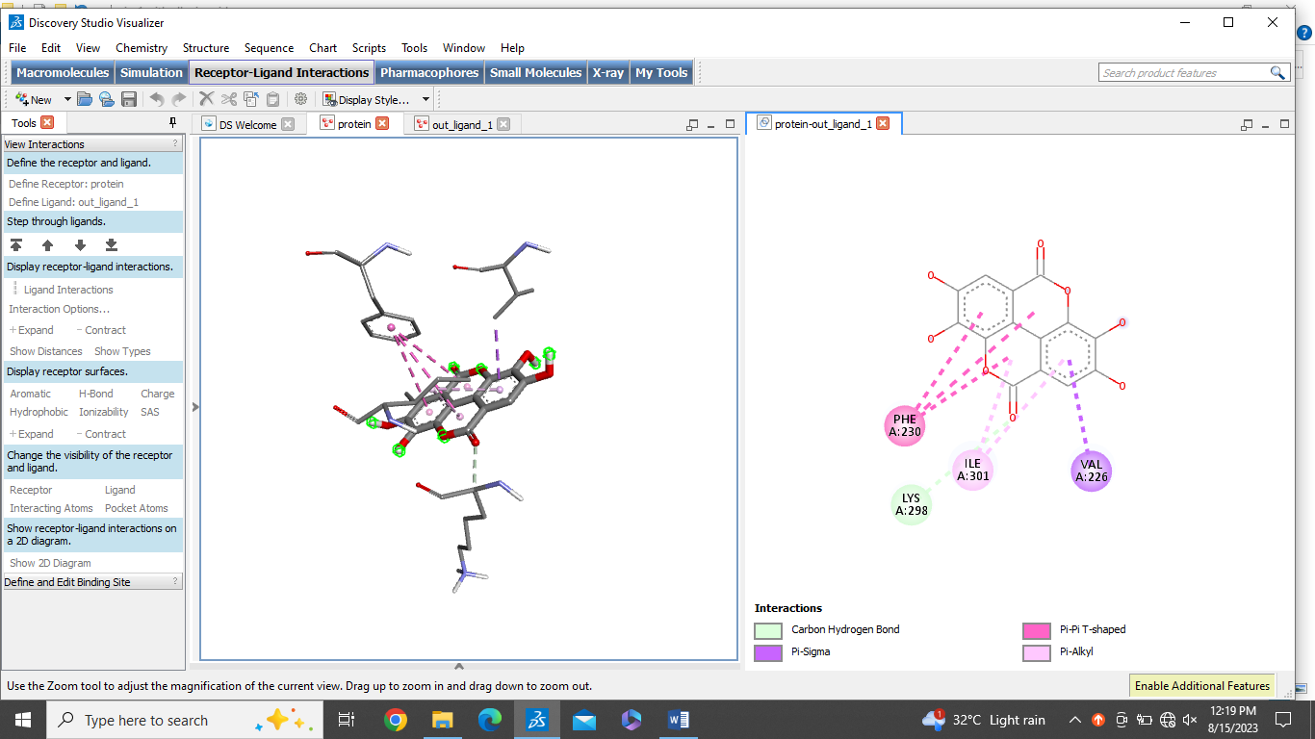
2 | Resveratrol | -6.9 | 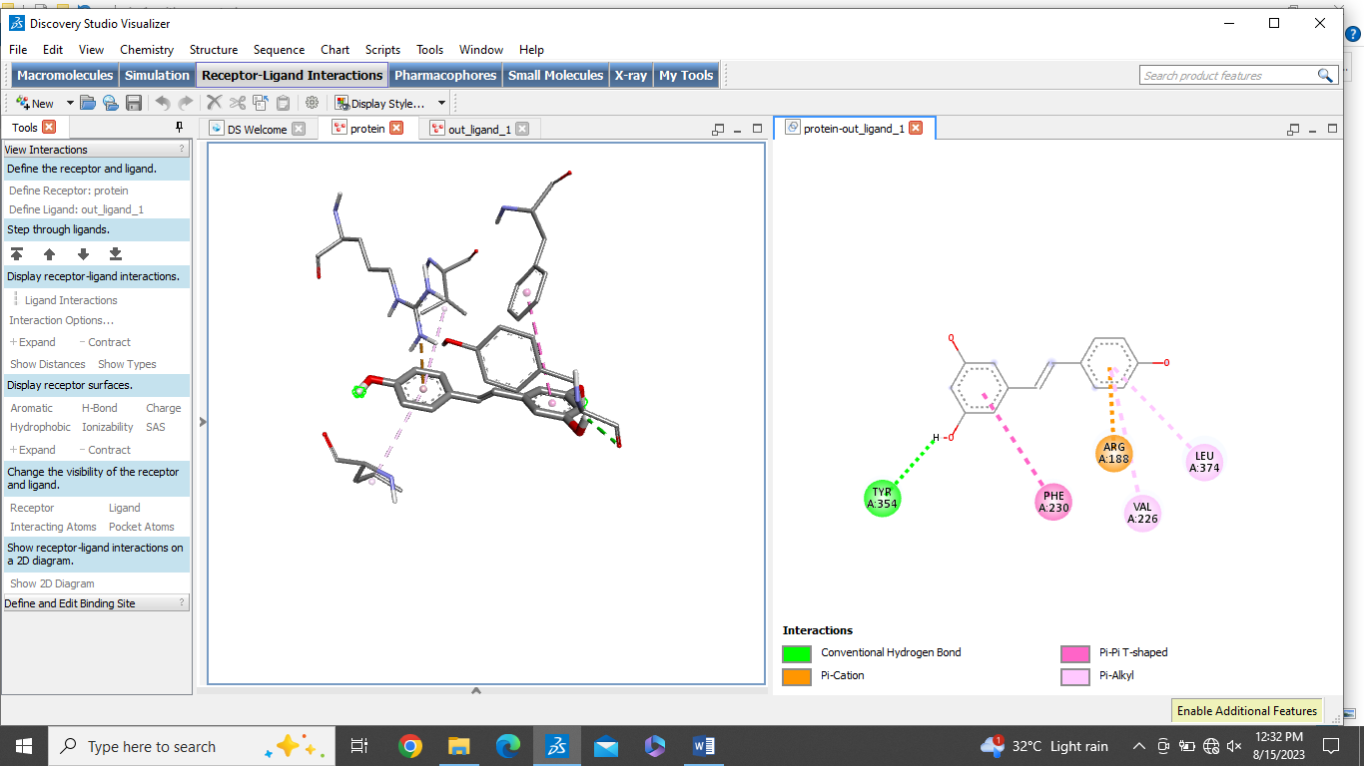
3 | Capsaicin | -6.9 | 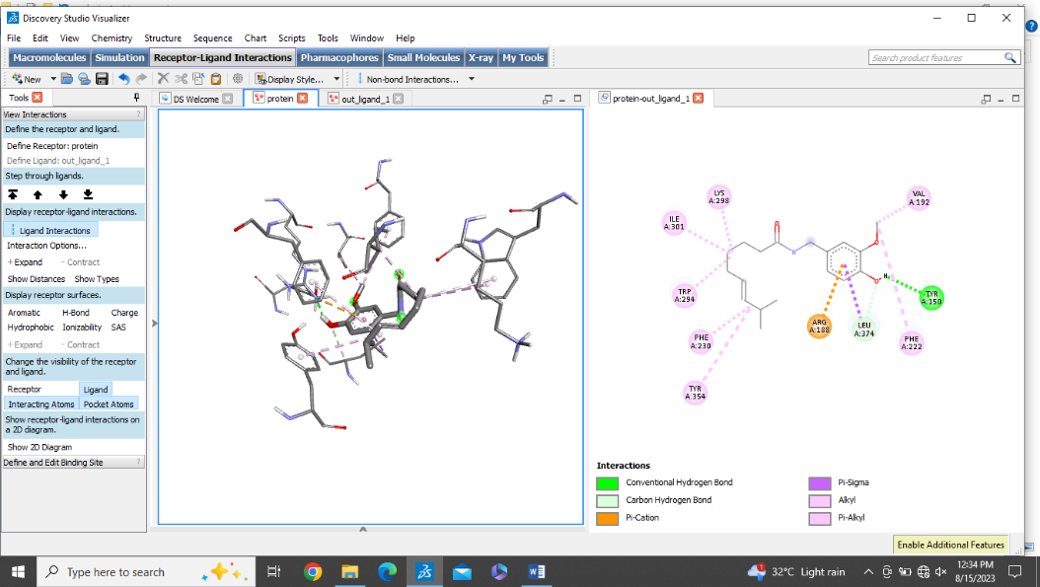
4 | Catechins | -9.2 | 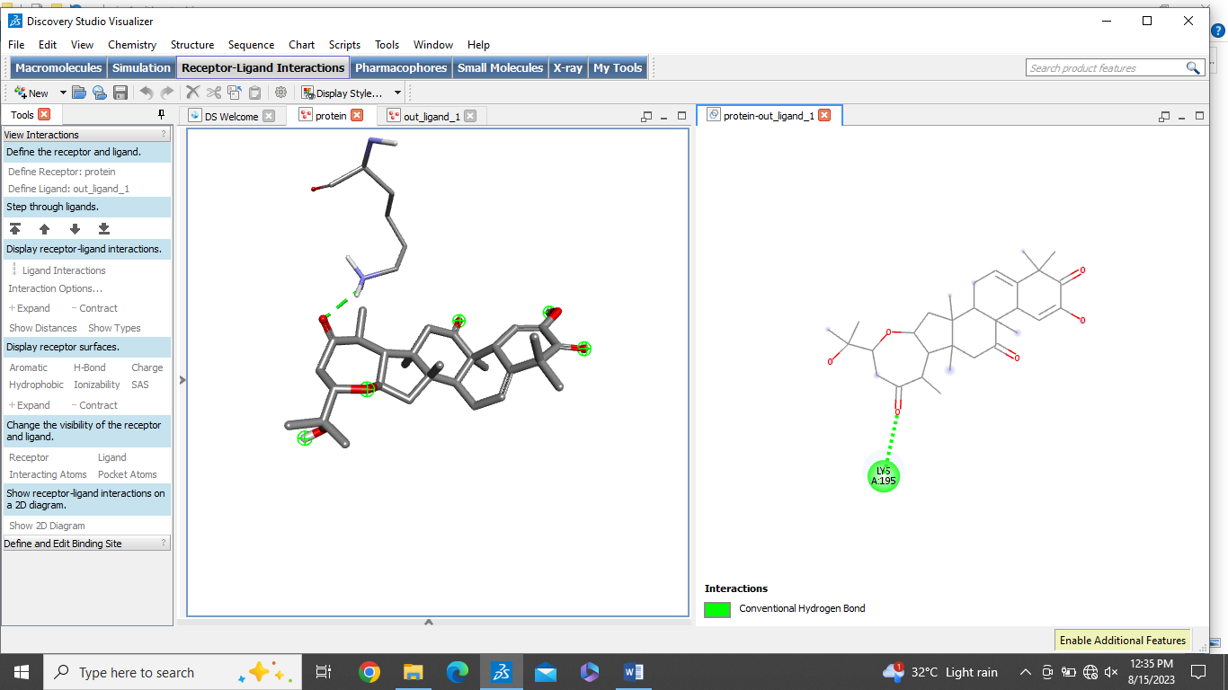
5 | Myricetin | -7.5 | 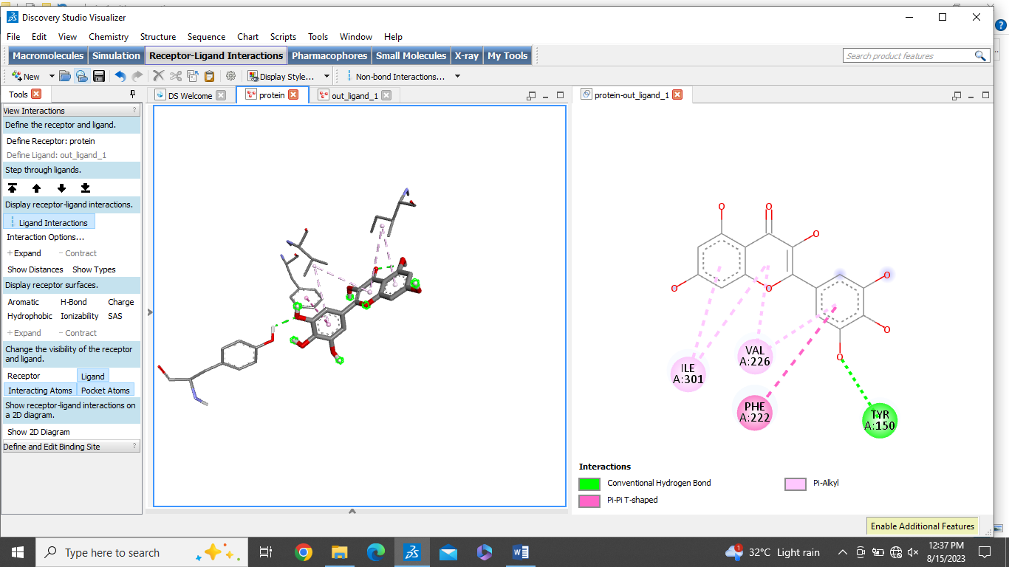
6 | Cucurbitacins | -9.7 | 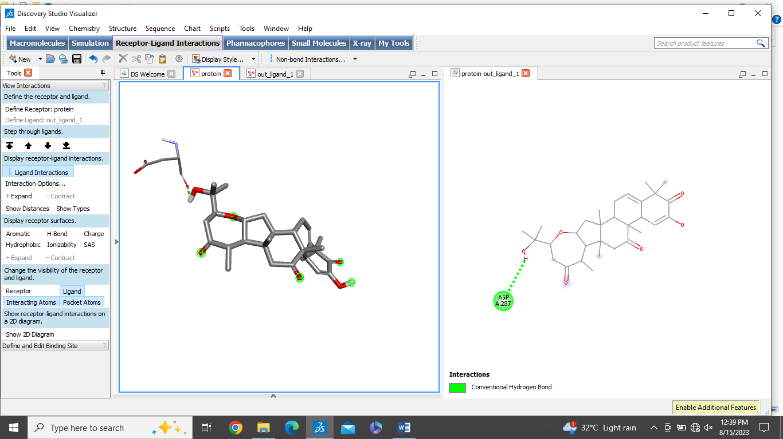
7 | Benzyl isothiocyanate | -4.7 | 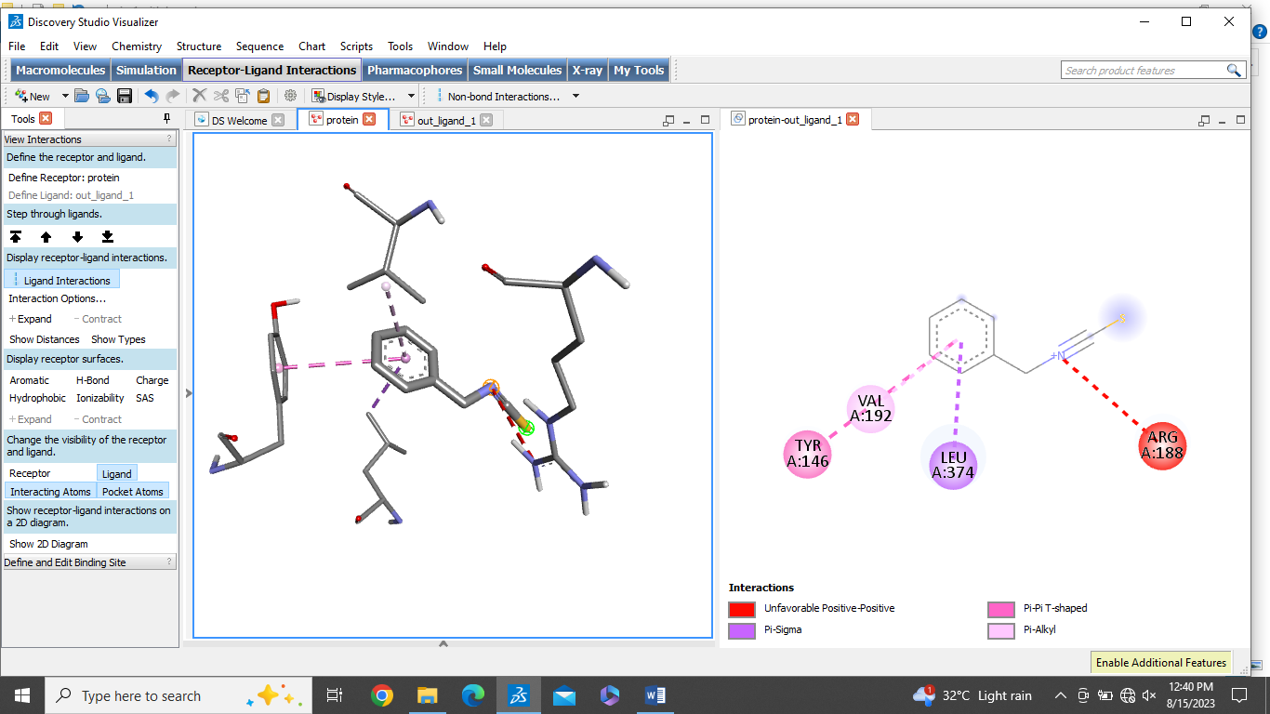
8 | Quercetin | -7.6 | 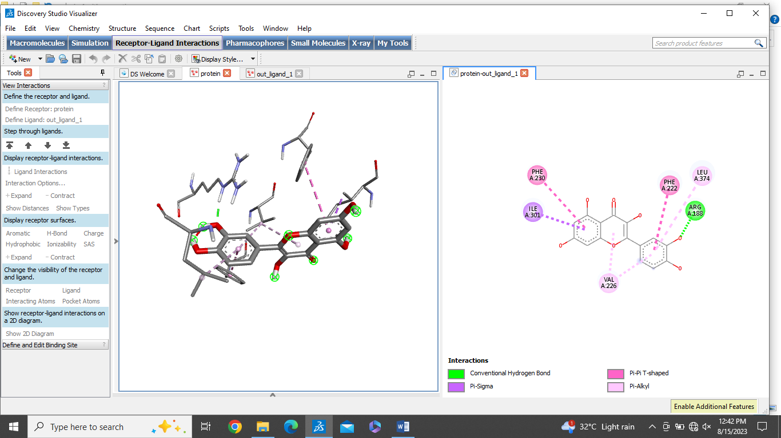
9 | Piperlongumine | -6.5 | 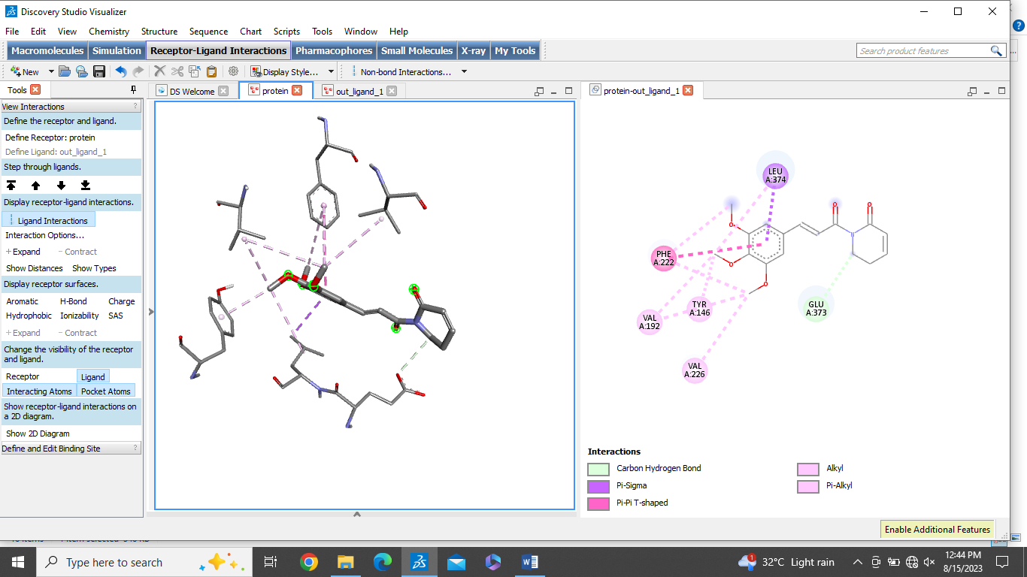
10 | Tilliroside | -8.6 | 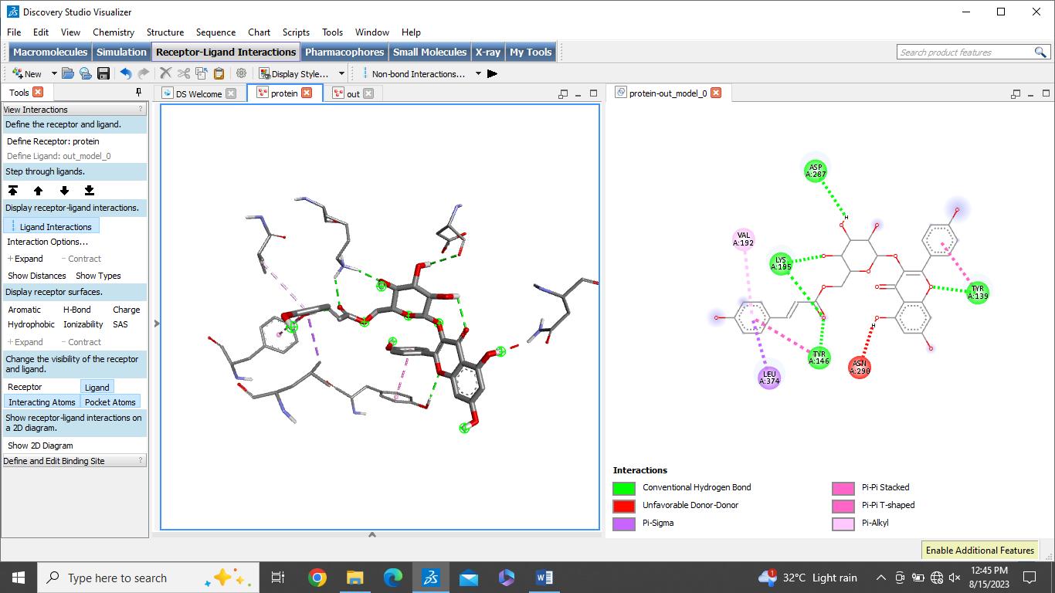
11 | Rutin | -8.0 | 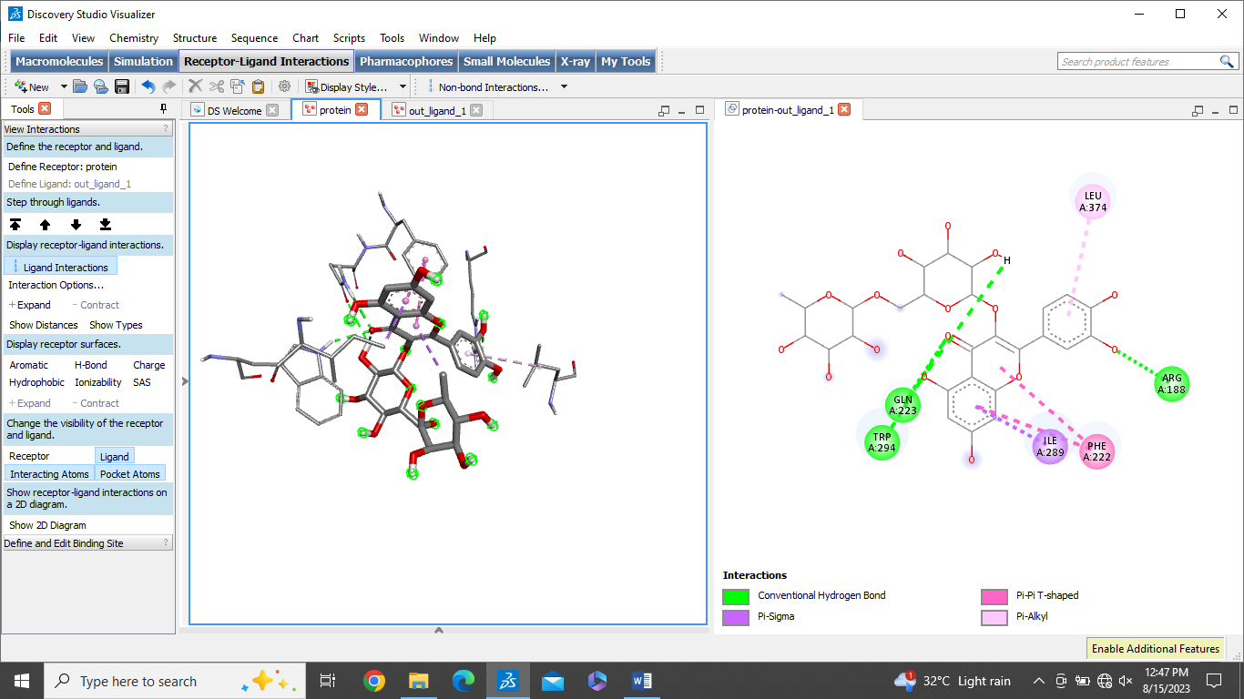
12 | Luteolin | -7.9 | 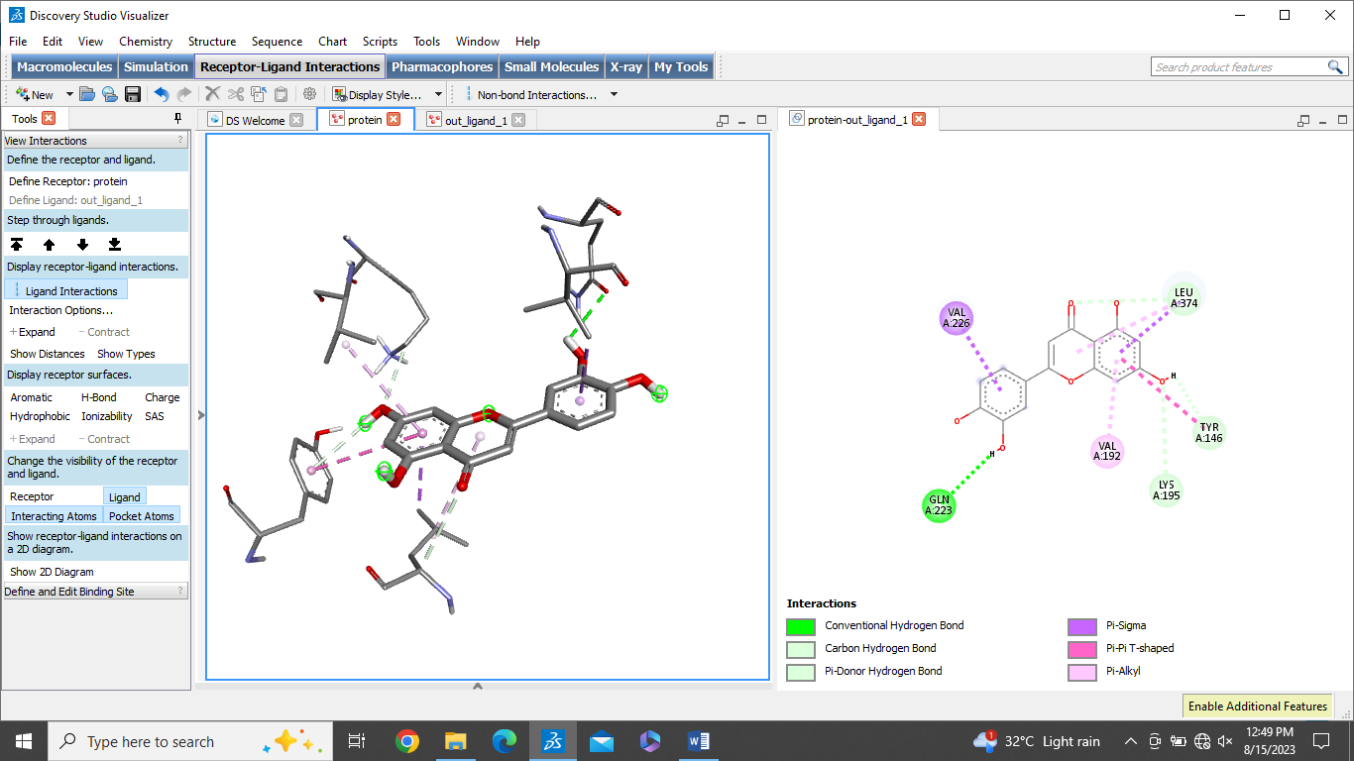
13 | Hyperoside | -8.4 | 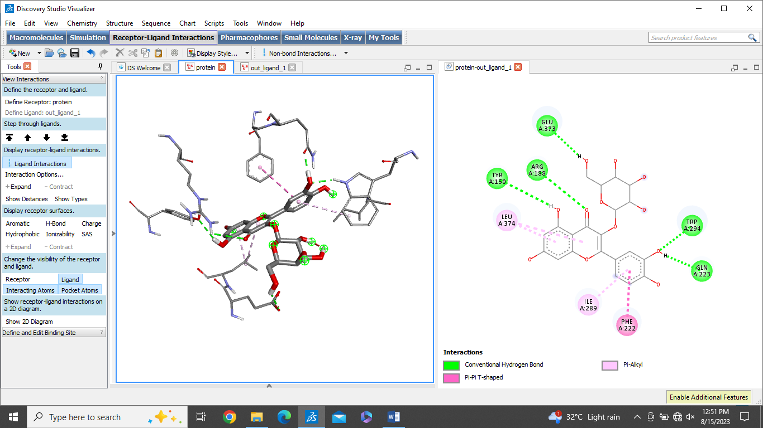
14 | Epicathechin | -7.2 | 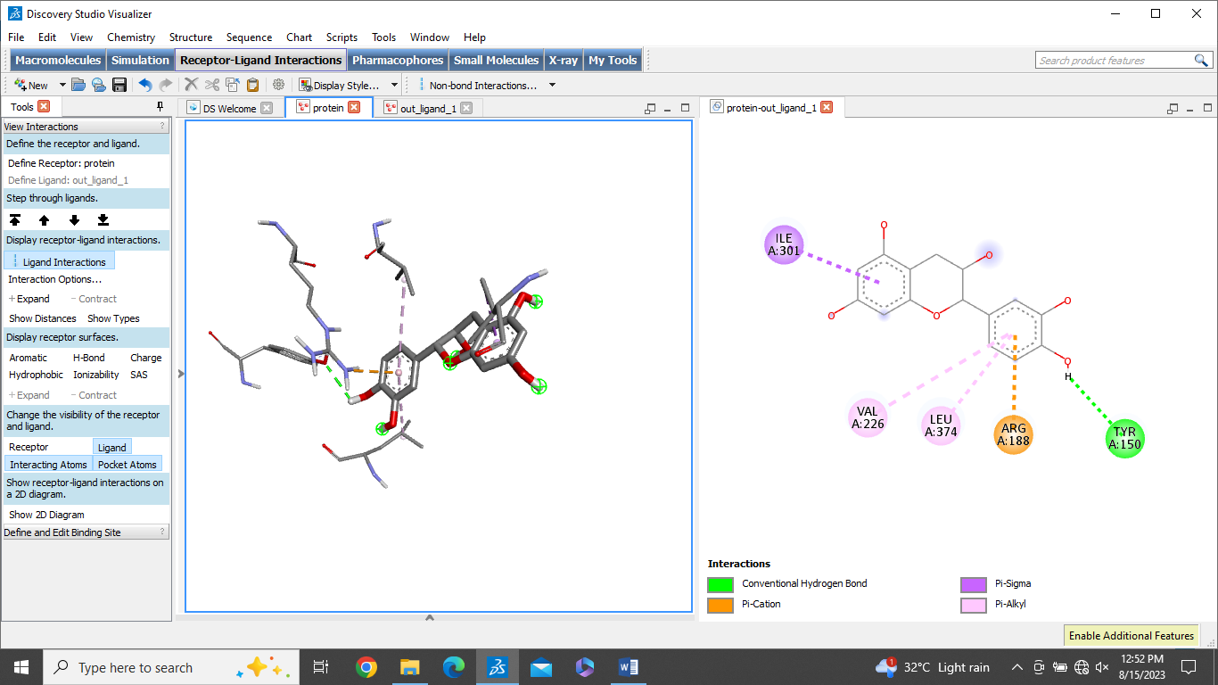

No.3. The overall binding affinity observed between the ligand and ADGRB2 receptor
Sr.No | Phytocompound | Binding affinity Kcal/mol | 2D and 3D interactions with Protein ADGRB2
1 | Ellagic acid | -7.0 | 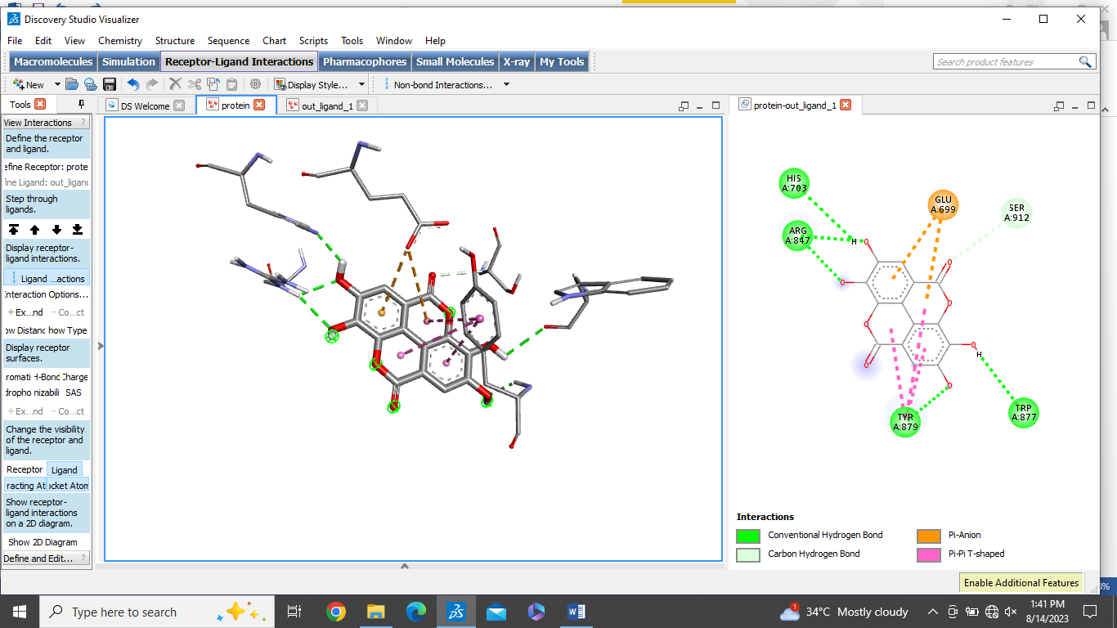  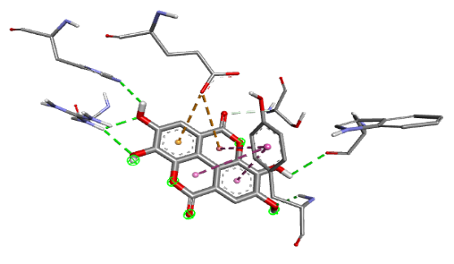
2 | Resveratrol | -6.5 | 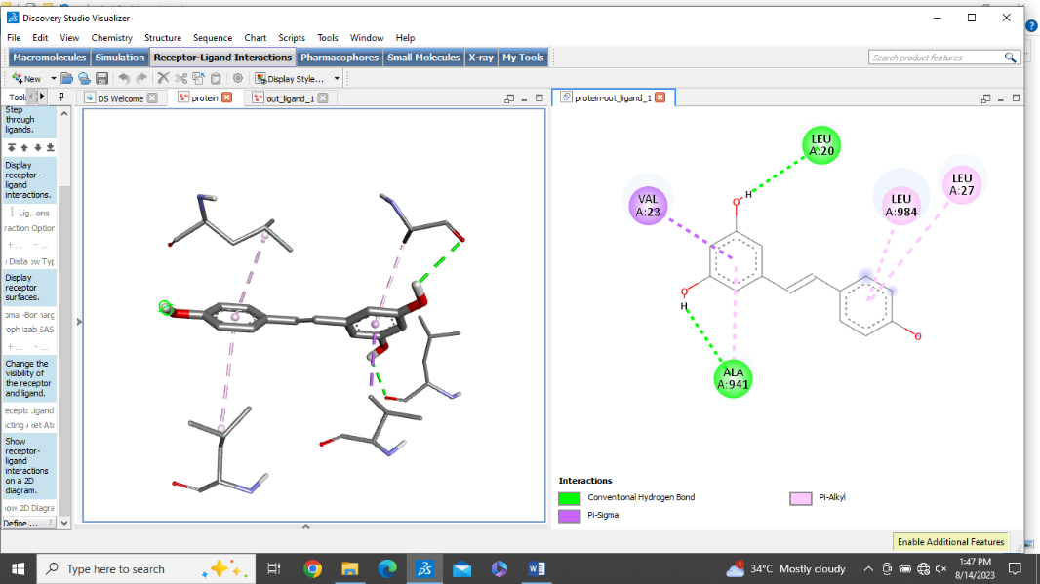
3 | Capsaicin | -6.1 | 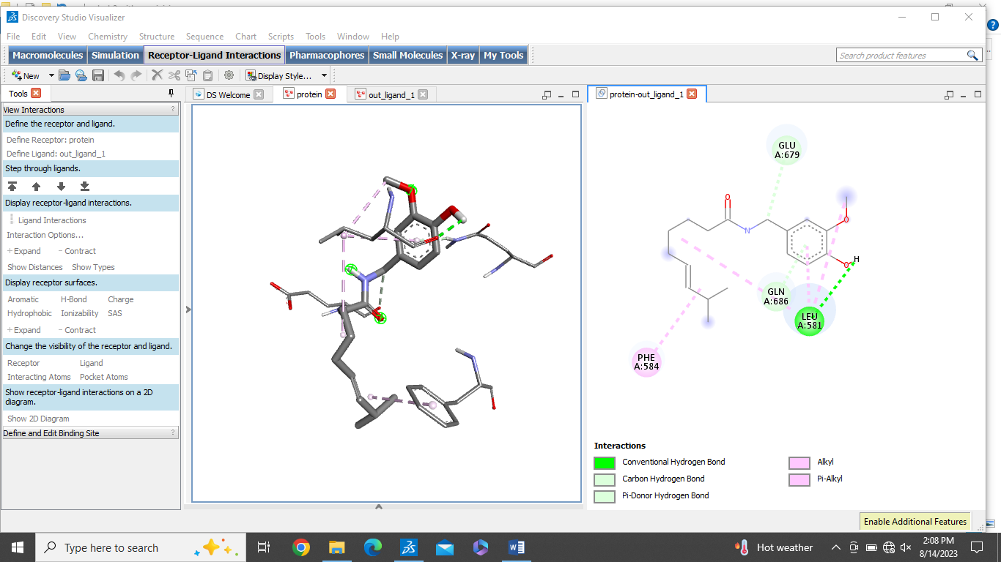
4 | Catechins | -6.9 | 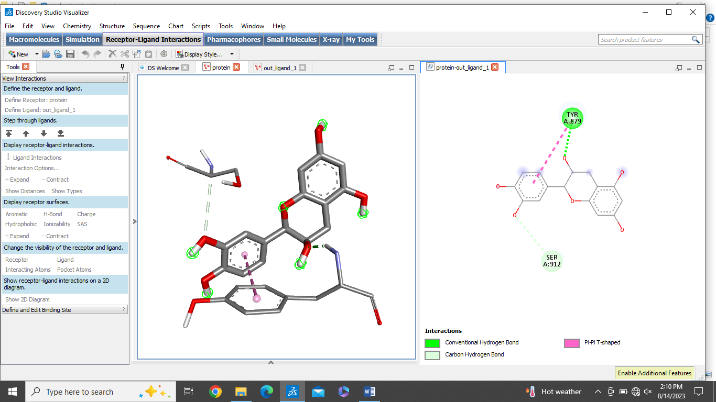
5 | Myricetin | -7.1 | 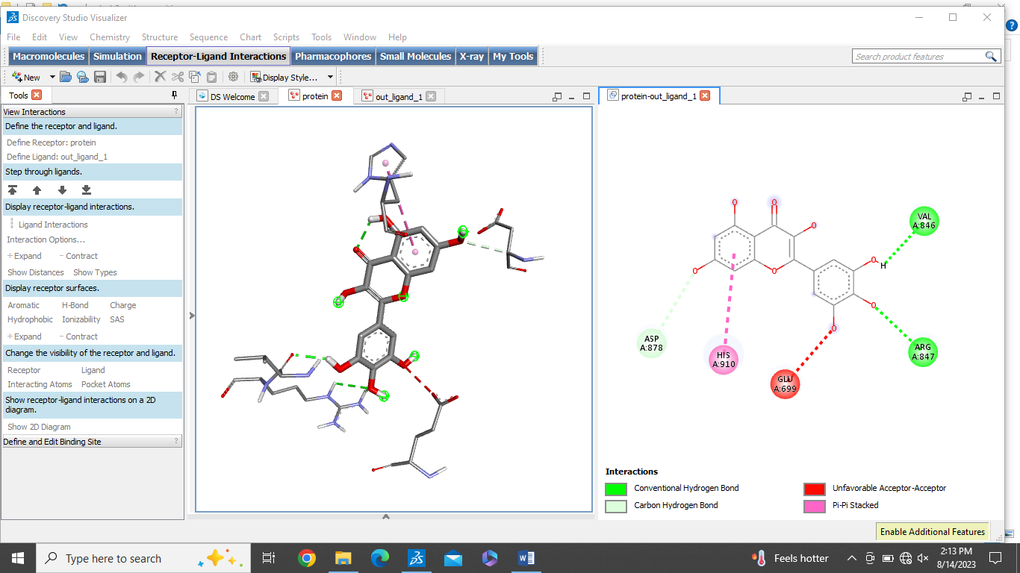
6 | Cucurbitacins | -8.5 | 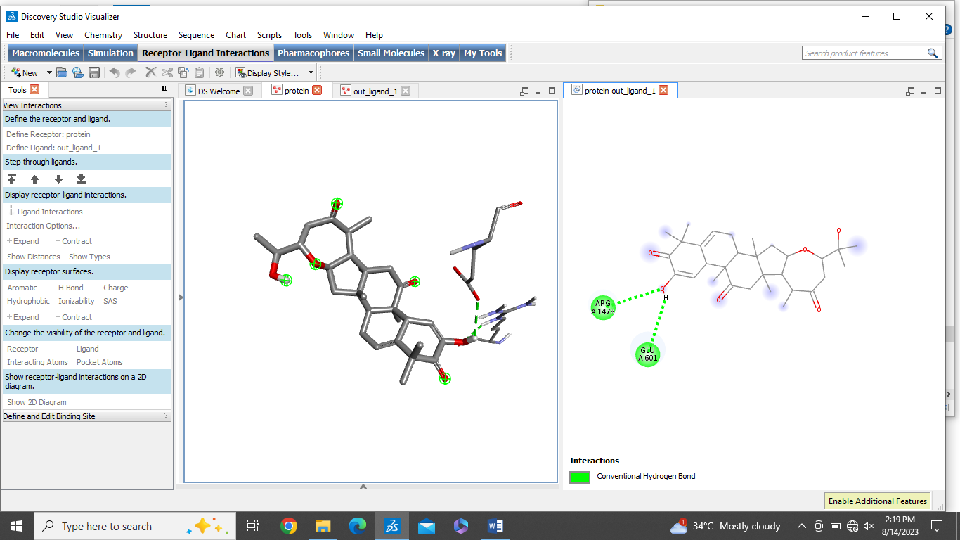
7 | Benzyl isothiocyanate | -4.5 | 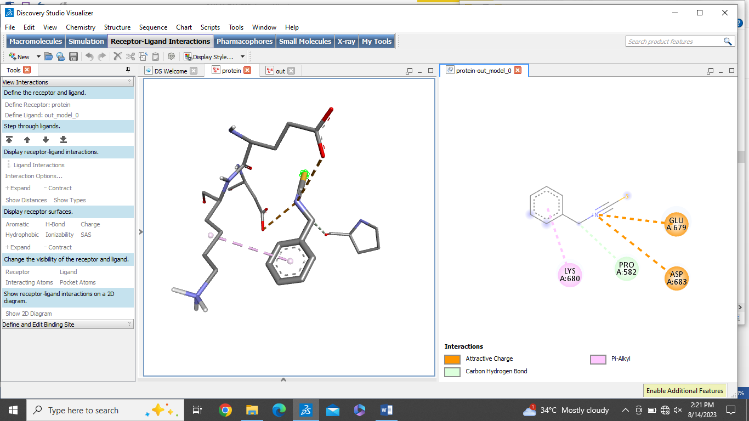
8 | Quercetin | -7.2 | 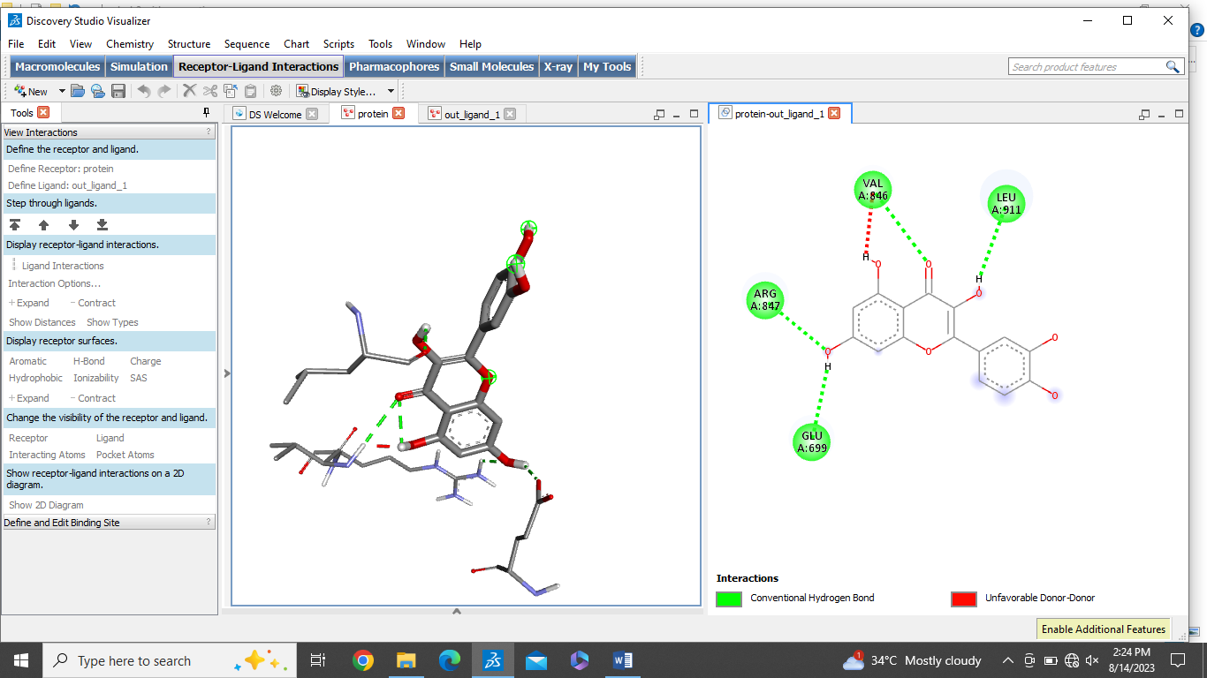
9 | Piperlongumine | -7.5 | 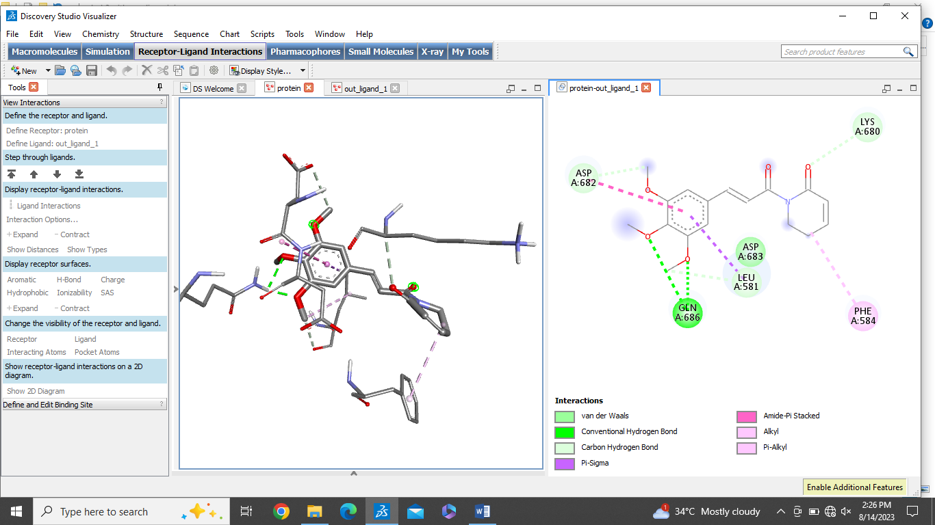
10 | Tilliroside | -7.6 | 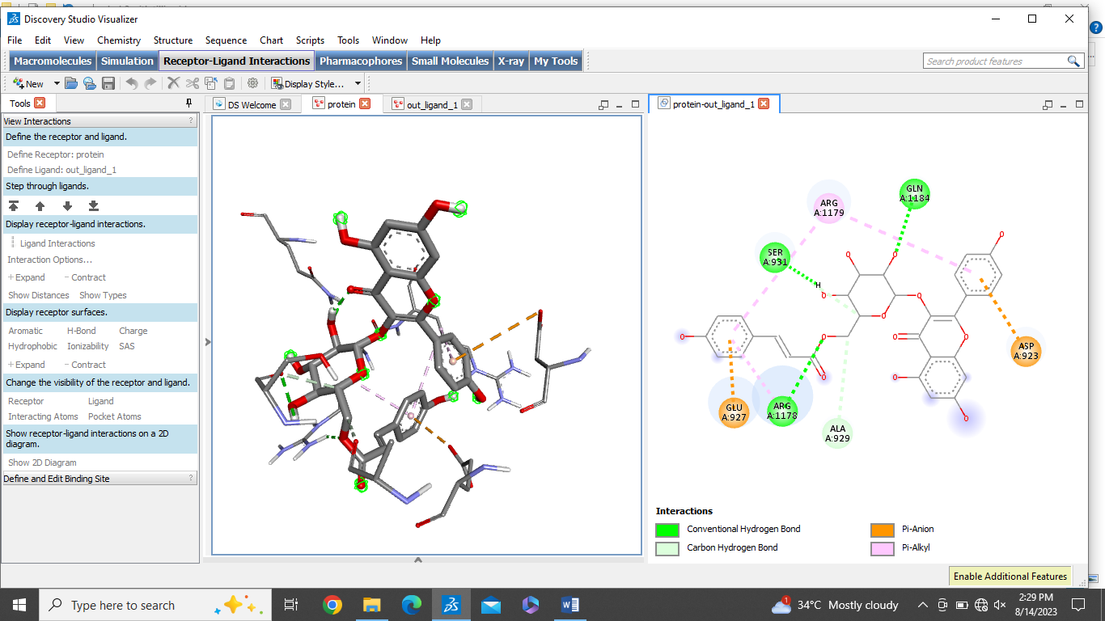
11 | Rutin | -8.2 | 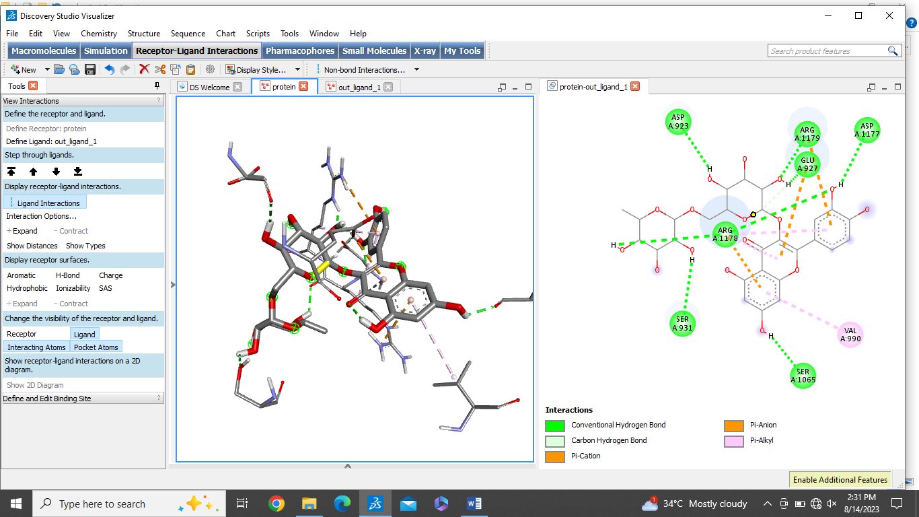
12 | Luteolin | -7.1 | 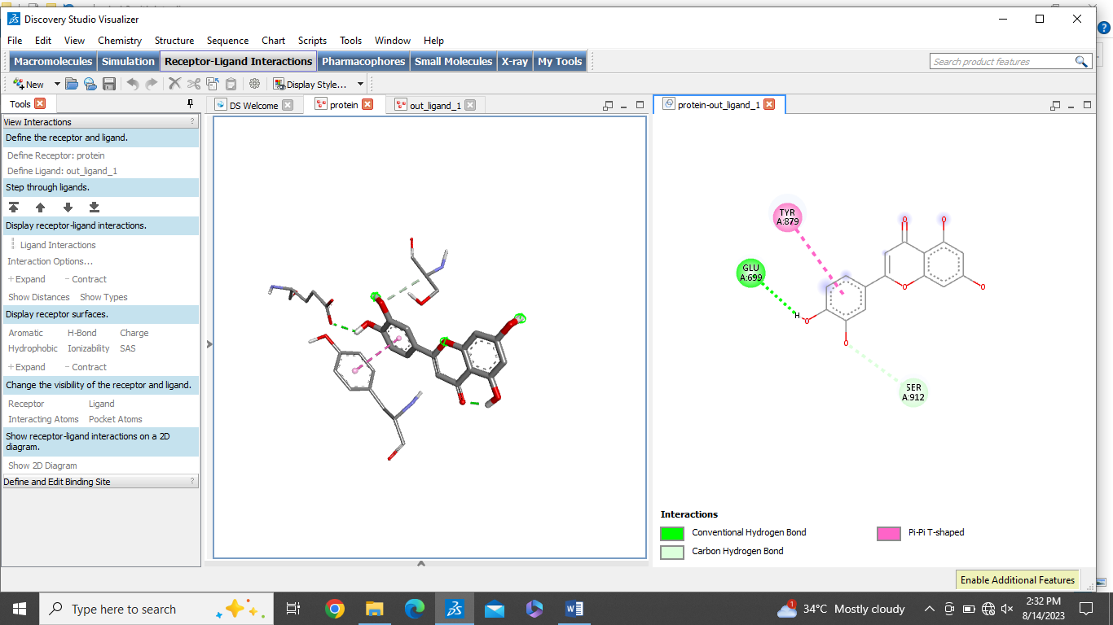
13 | Hyperoside | -7.4 | 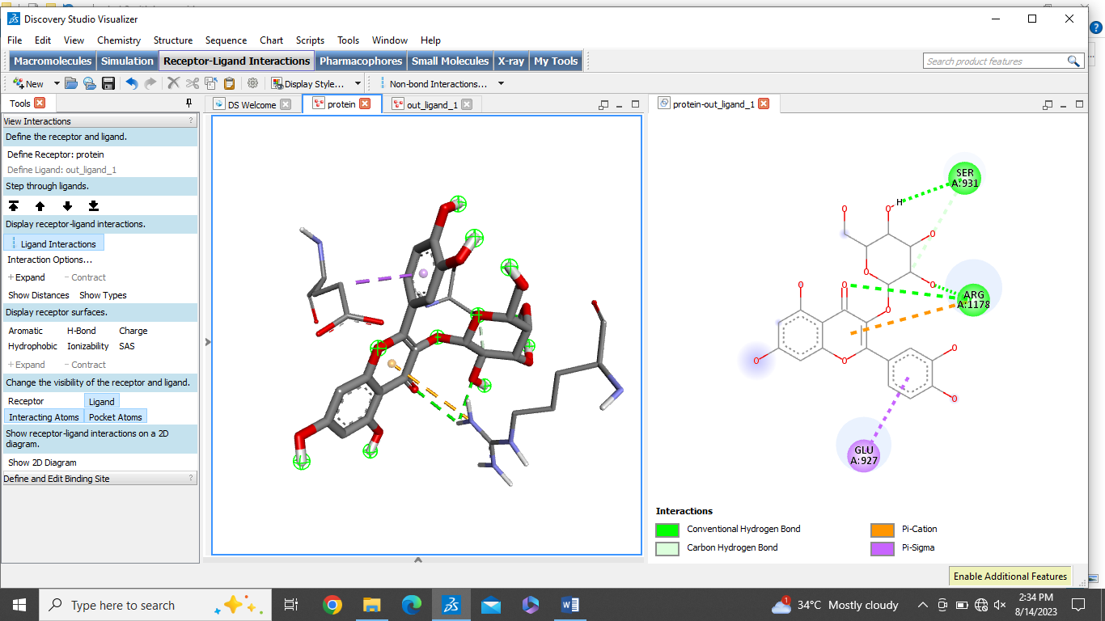
14 | Epicathechin | -7.6 | 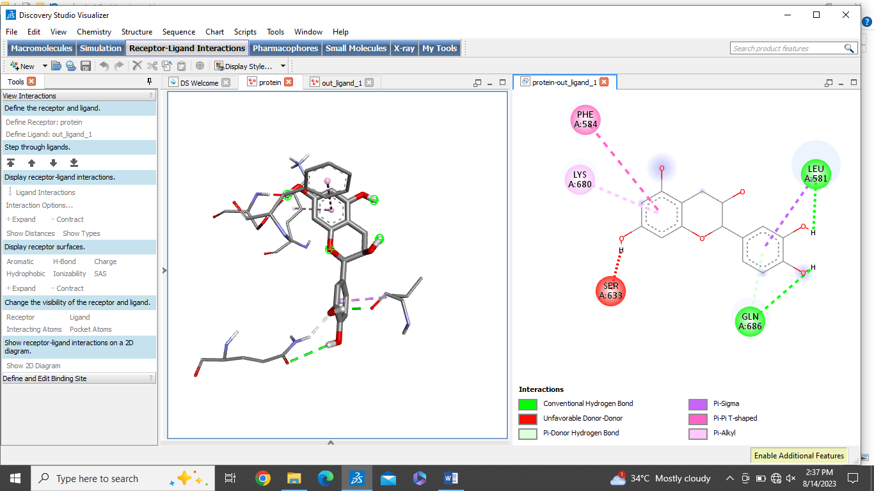

No. 4. The overall binding affinity observed between the ligand and CELSR1 receptor.
Sr.No | Phytocompound | Binding affinity Kcal/mol | 2D and 3D interactions with CELSR1
1 | Ellagic acid | -5.9 | 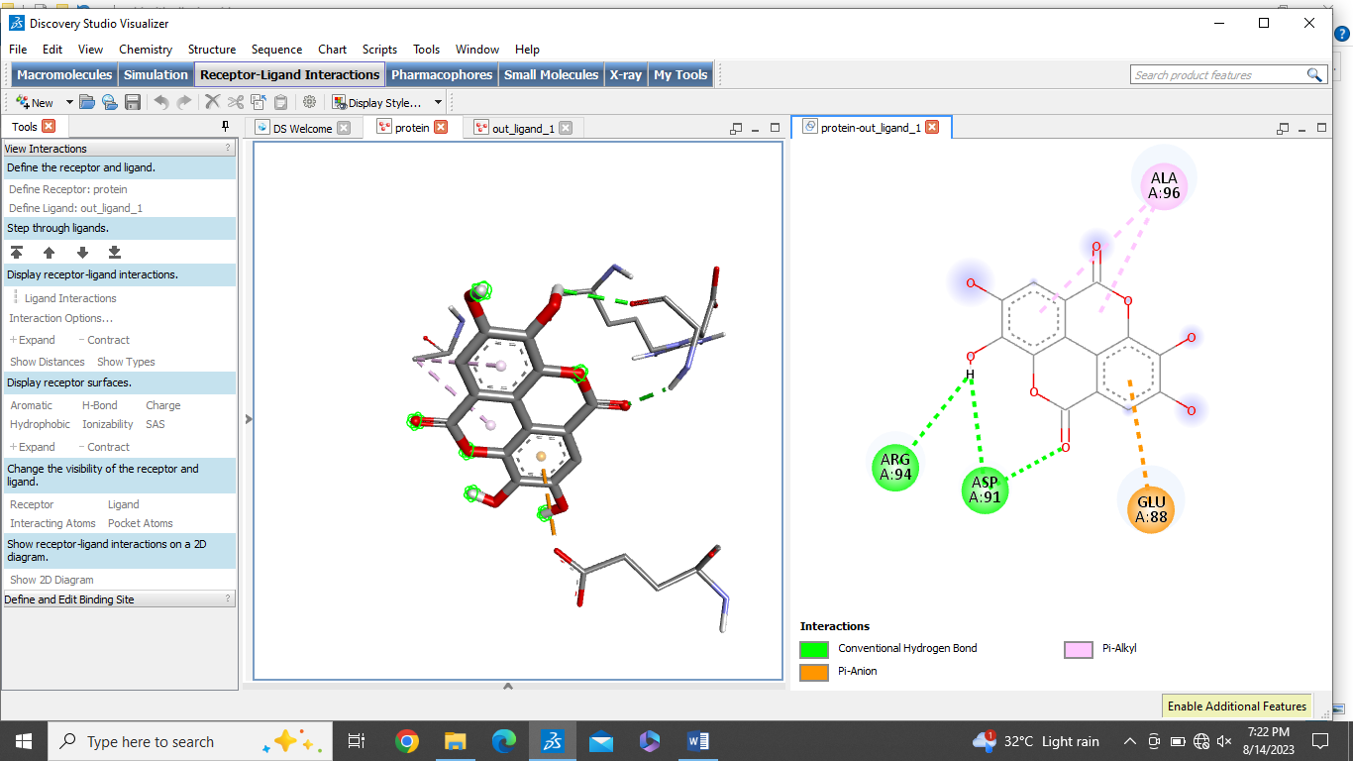
2 | Resveratrol | -5.0 | 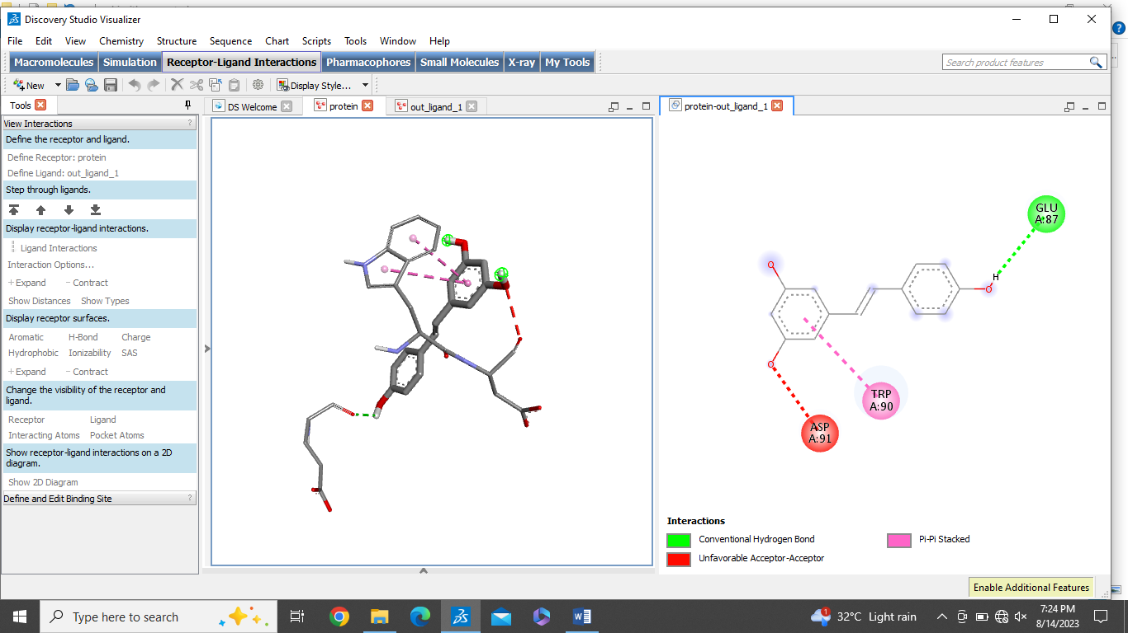
3 | Capsaicin | -5.0 | 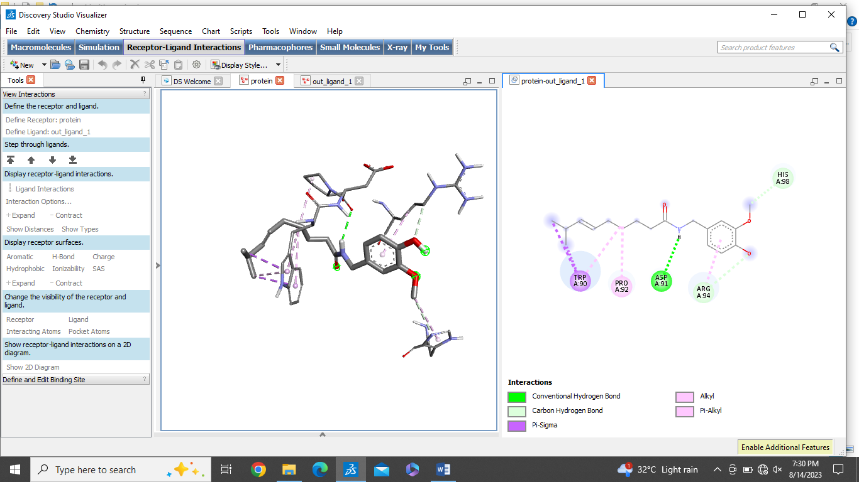
4 | Catechins | -6.0 | 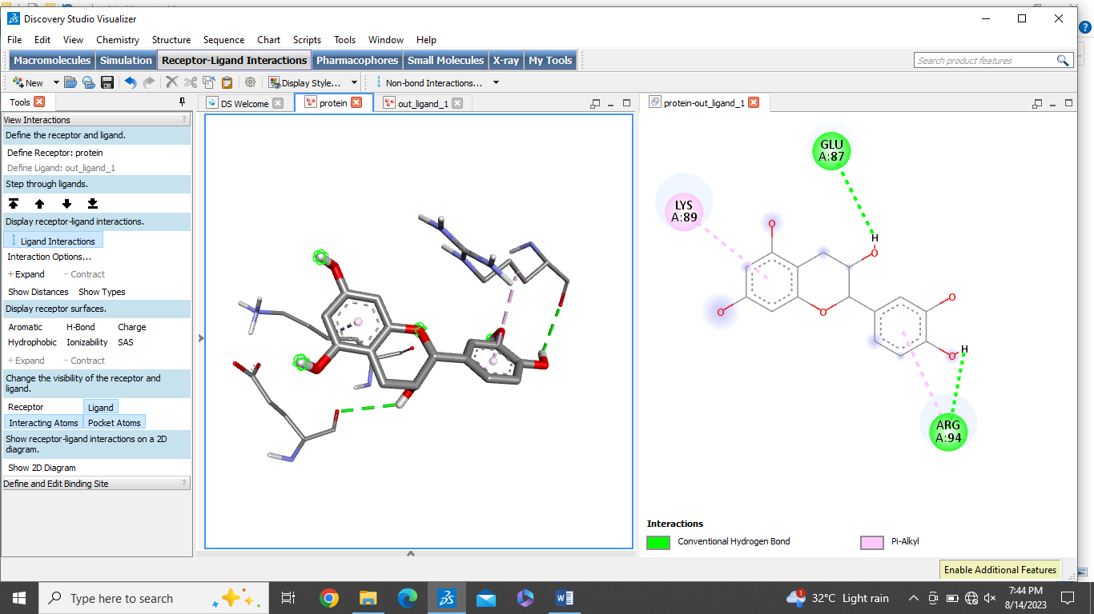
5 | Myricetin | -5.7 | 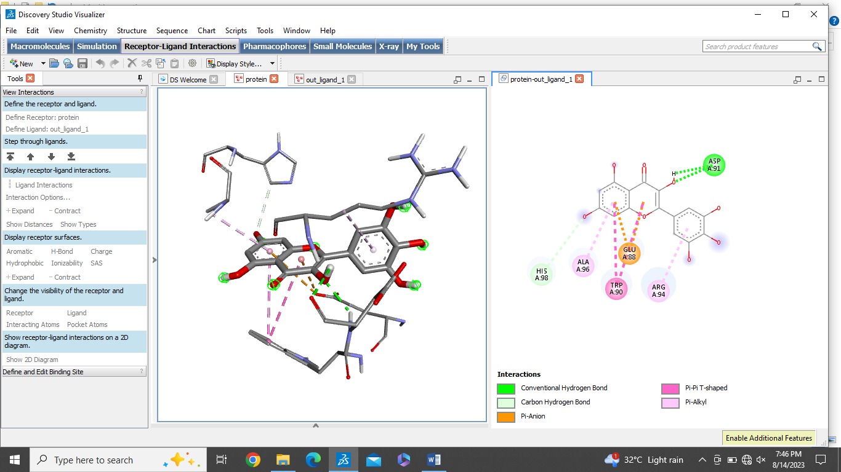
6 | Cucurbitacins | -6.7 | 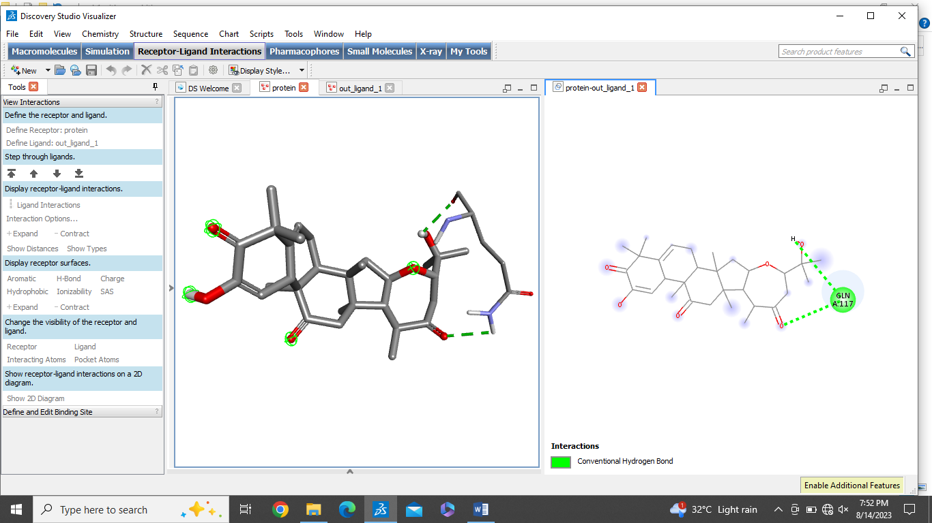
7 | Benzyl isothiocyanate | -3.1 | 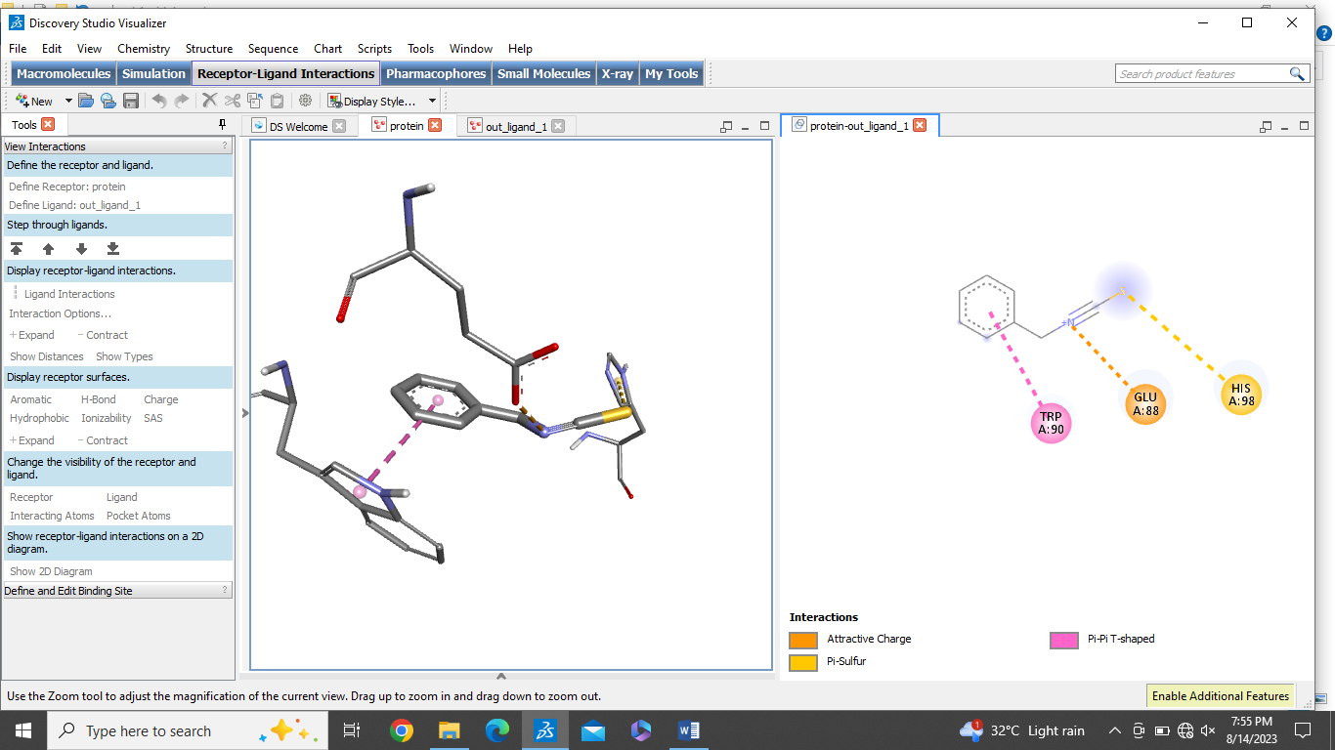
8 | Quercetin | -5.7 | 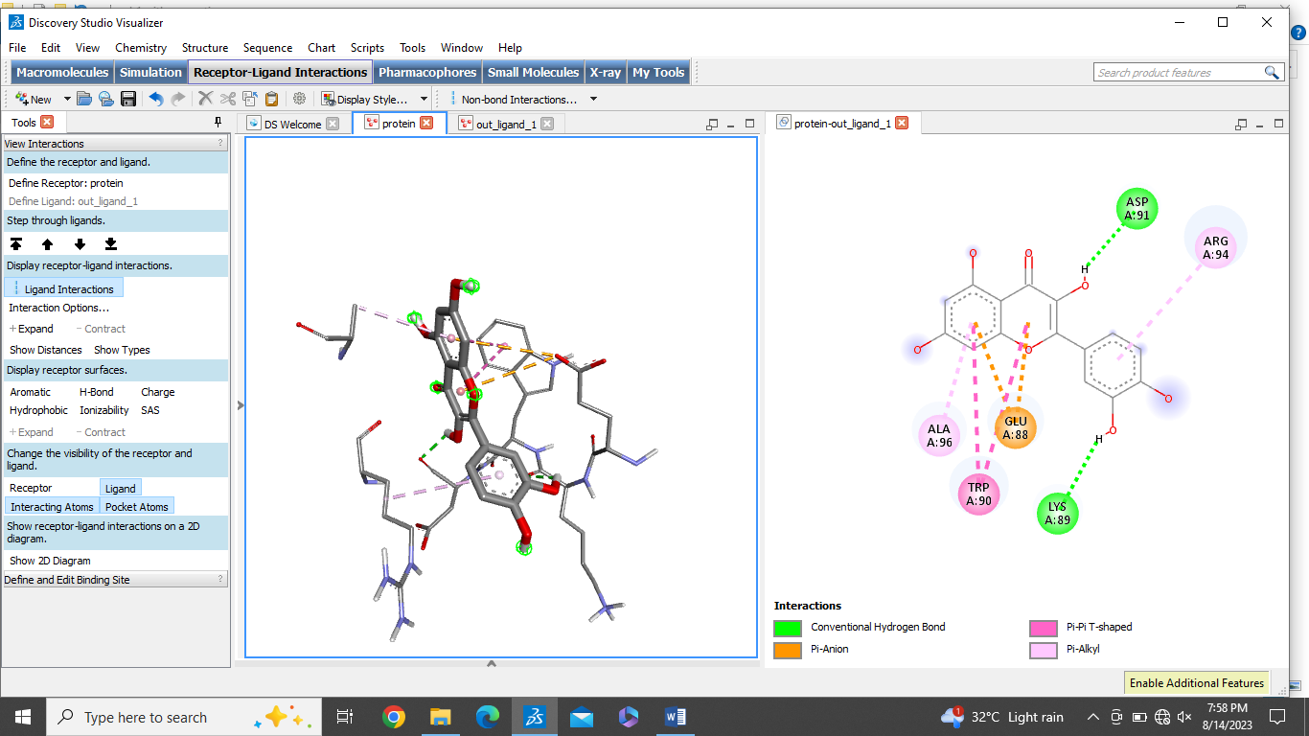
9 | Piperlongumine | -4.8 | 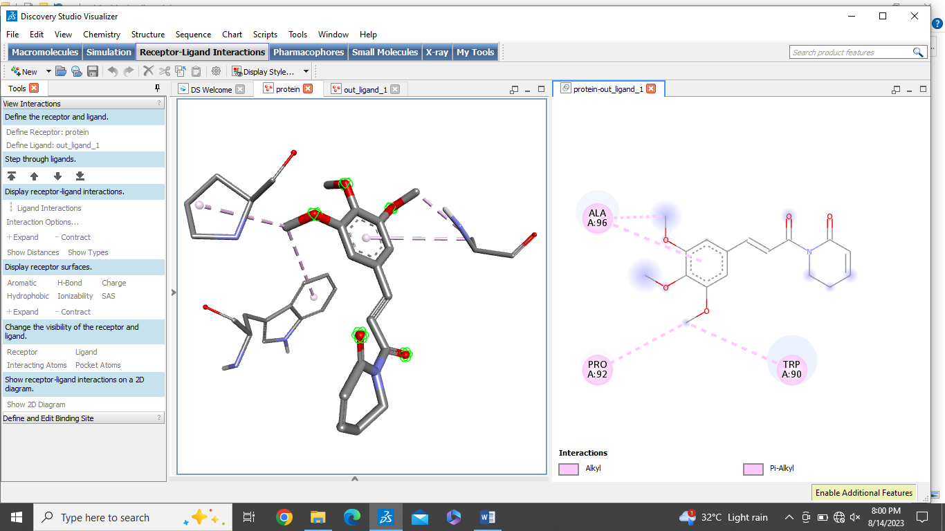
10 | Tilliroside | -6.0 | 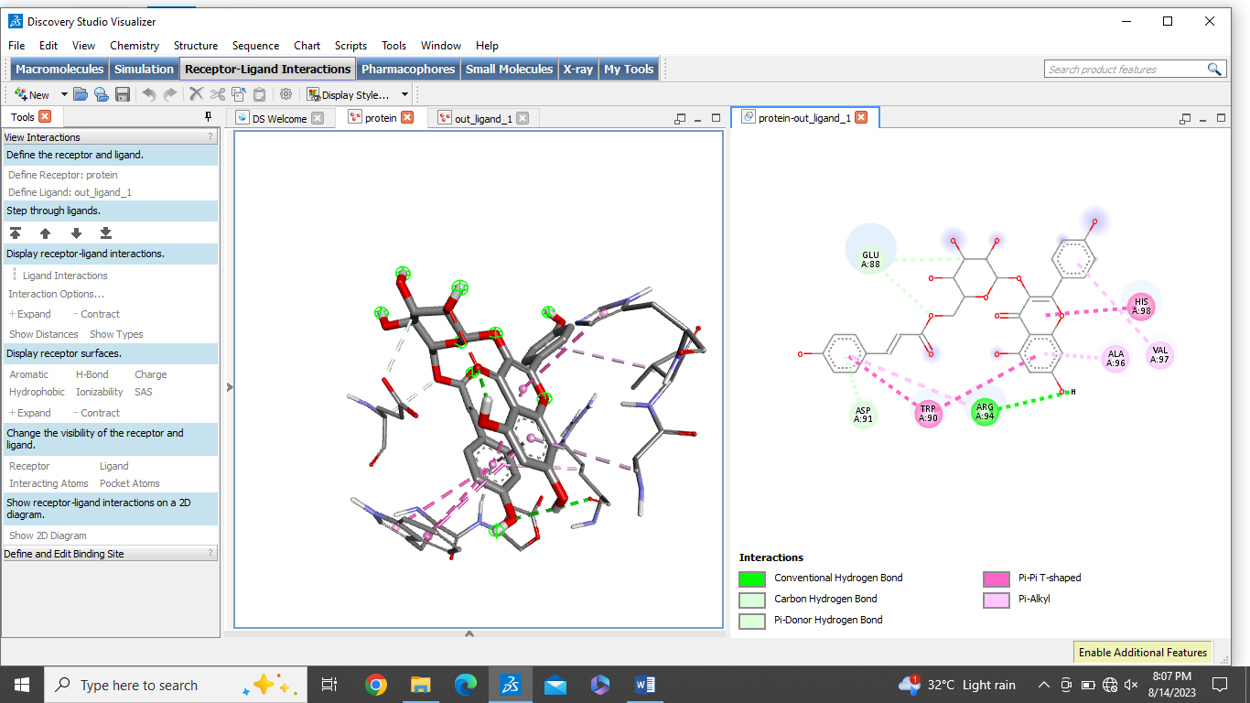
11 | Rutin | -6.5 | 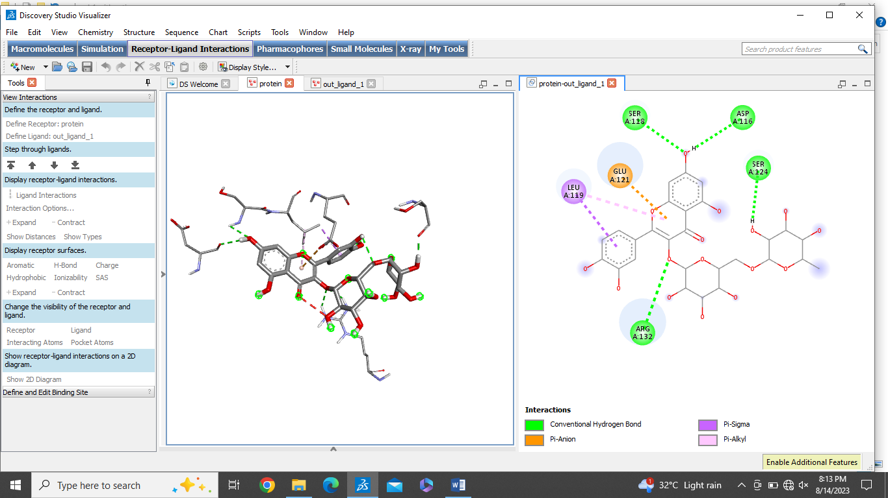
12 | Luteolin | -6.2 | 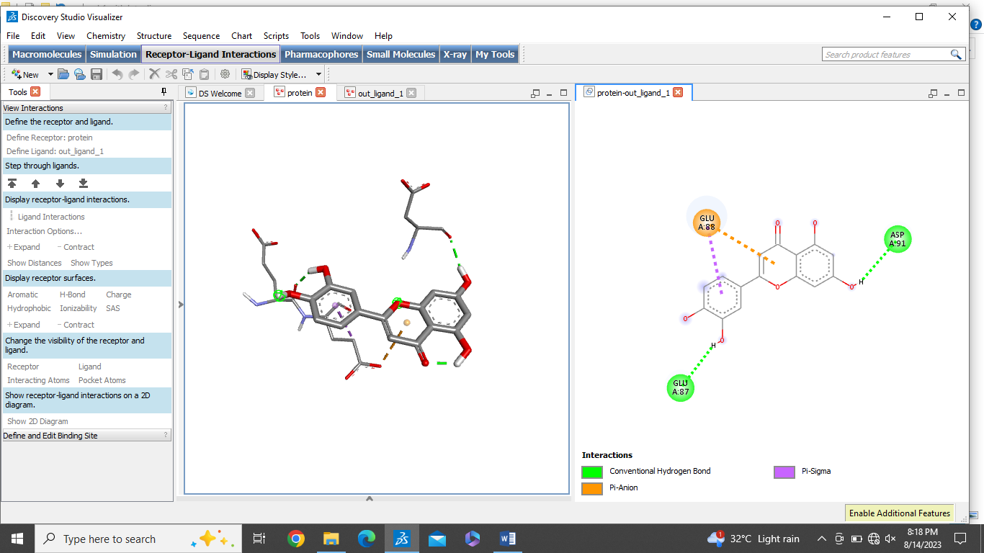
13 | Hyperoside | -5.7 | 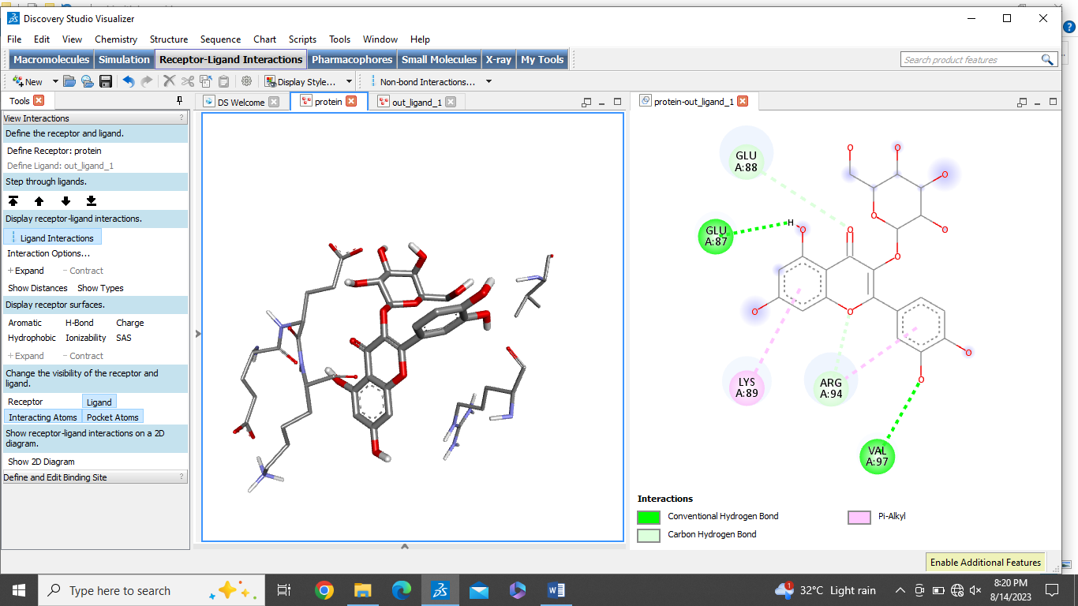
14 | Epicathechin | -6.0 | 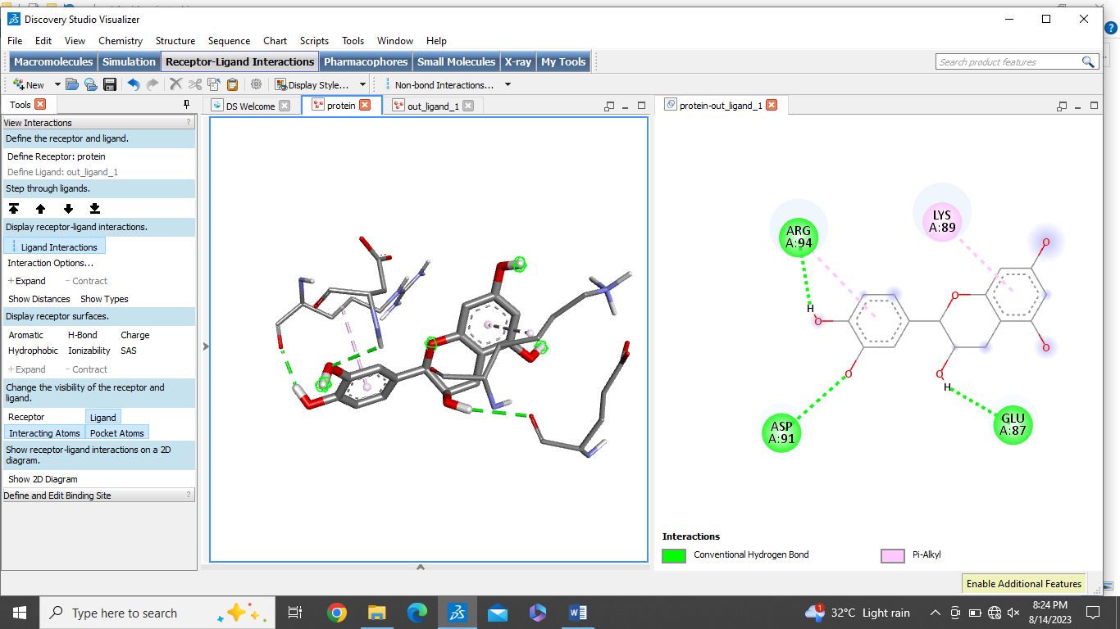

No.5. The overall binding affinity observed between the ligand and ADGRL2 receptor.
Sr.No | Phytocompound | Binding affinity Kcal/mol | 2D and 3D interactions with ADGRL2
1 | Ellagic acid | -8.4 | 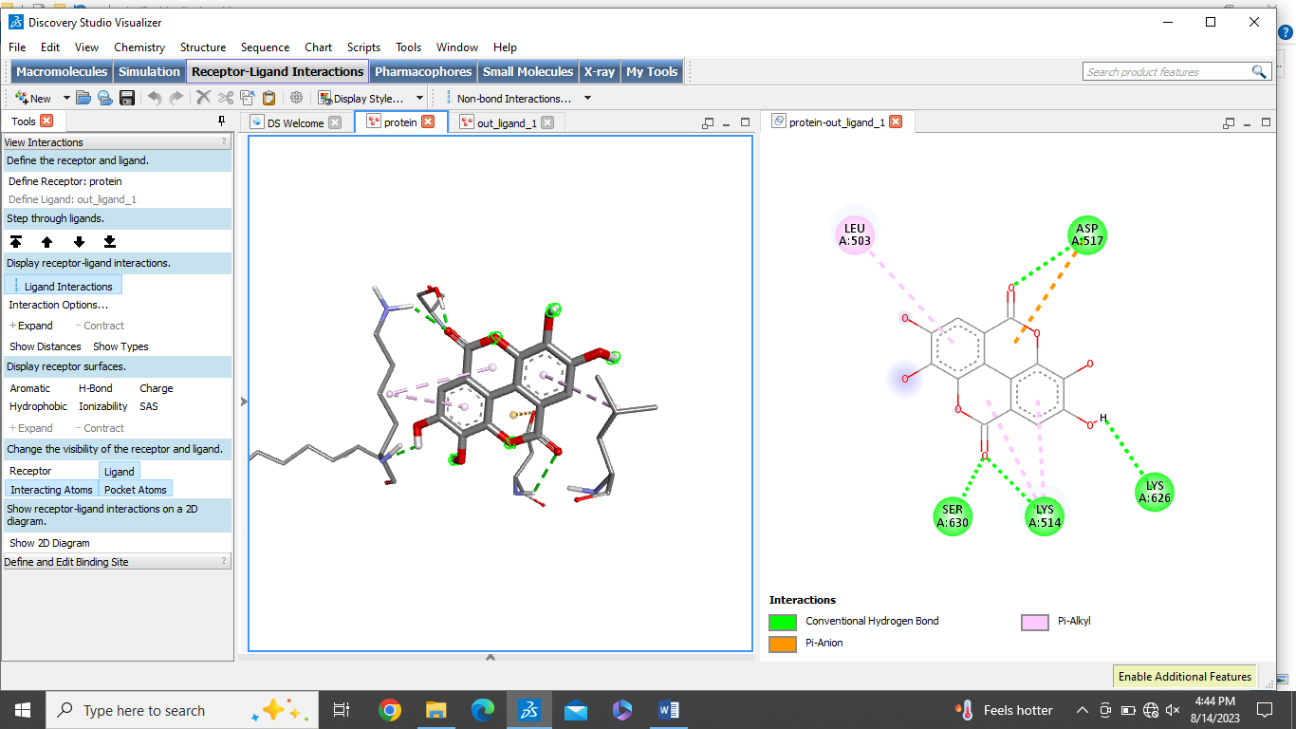  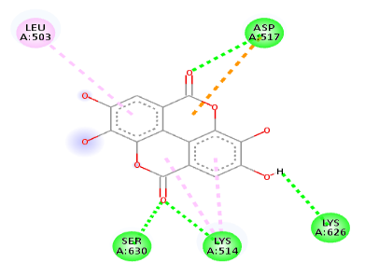
2 | Resveratrol | -7.1 | 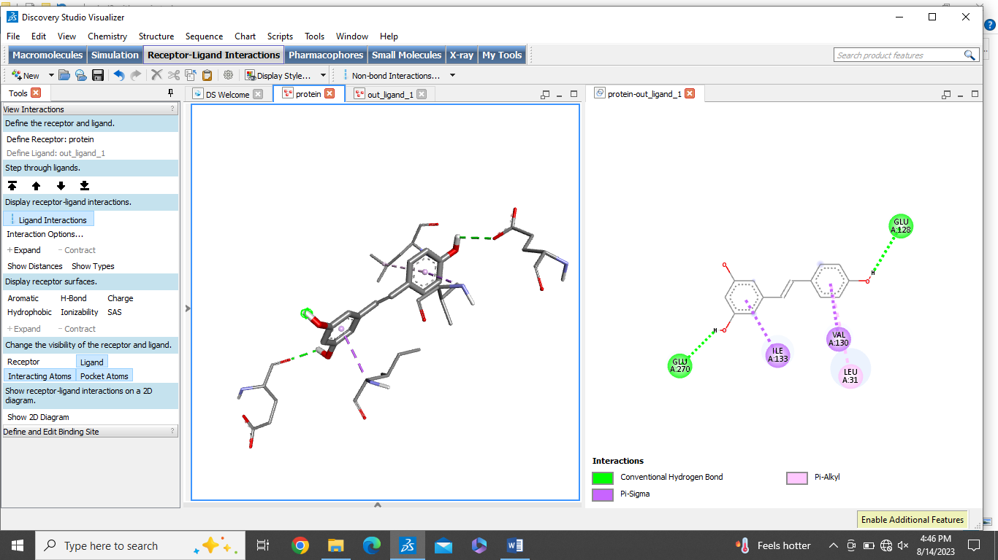
3 | Capsaicin | -6.7 | 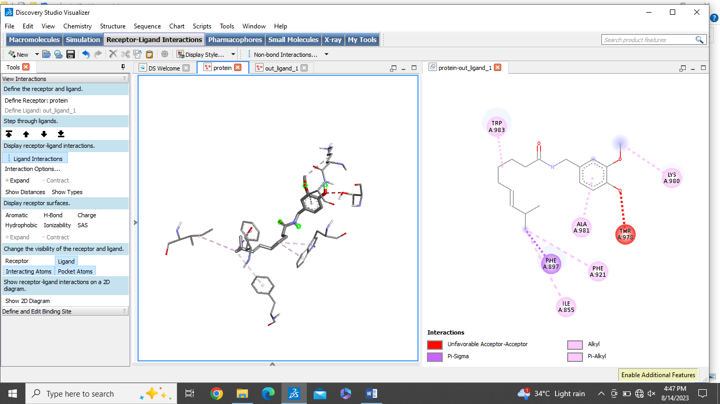
4 | Catechins | -7.2 | 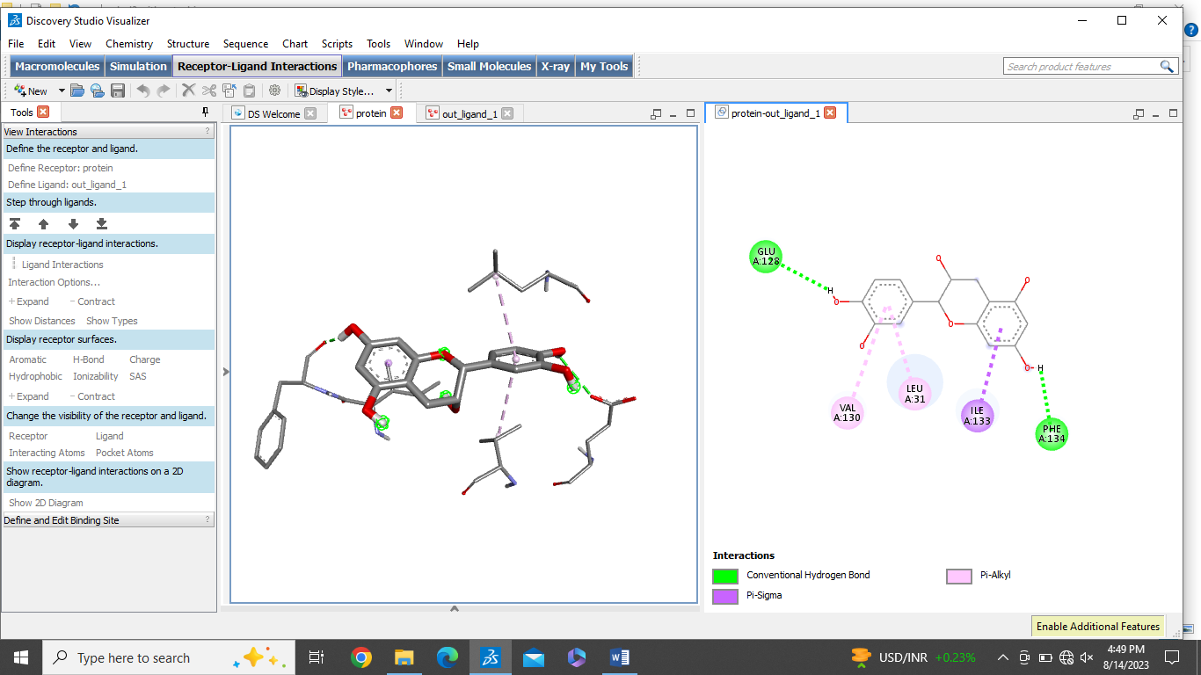
5 | Myricetin | -6.8 | 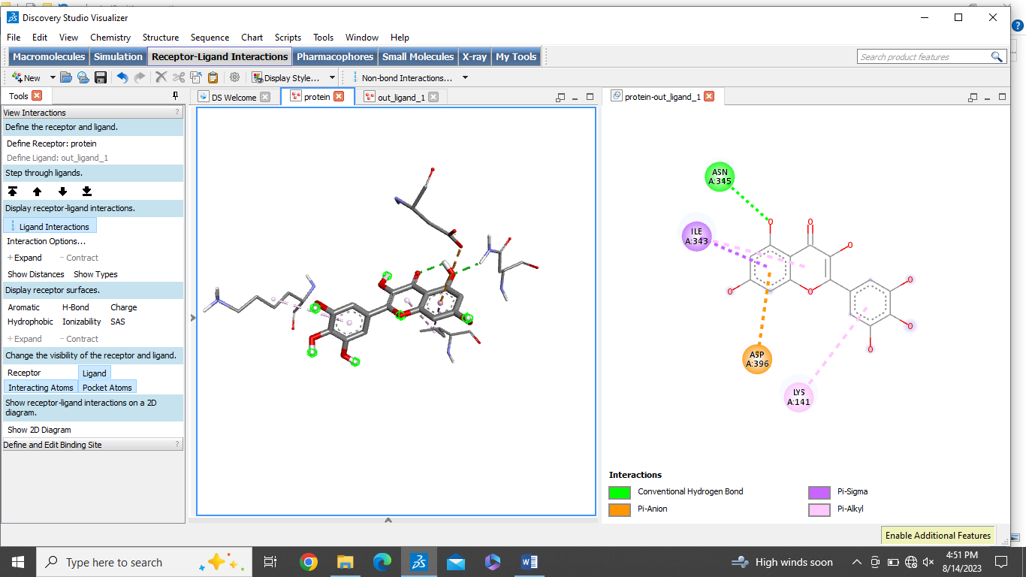
6 | Cucurbitacins | -8.6 | 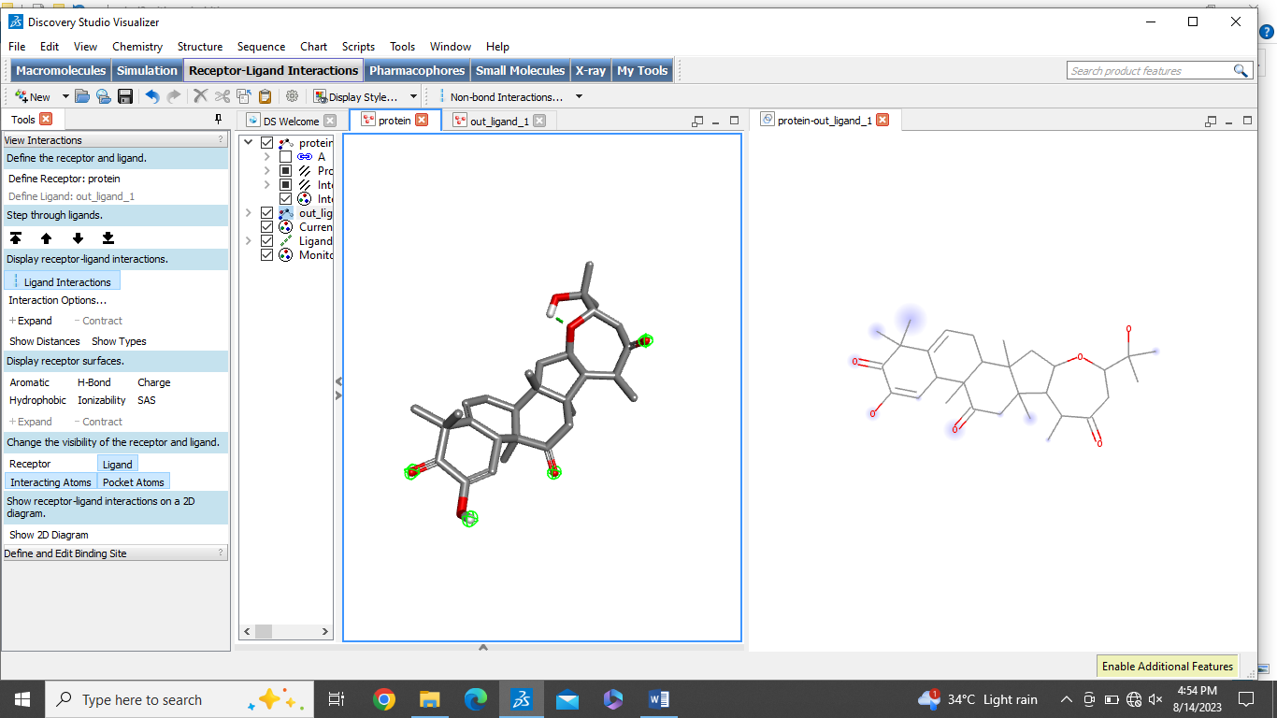
7 | Benzyl isothiocyanate | -4.9 | 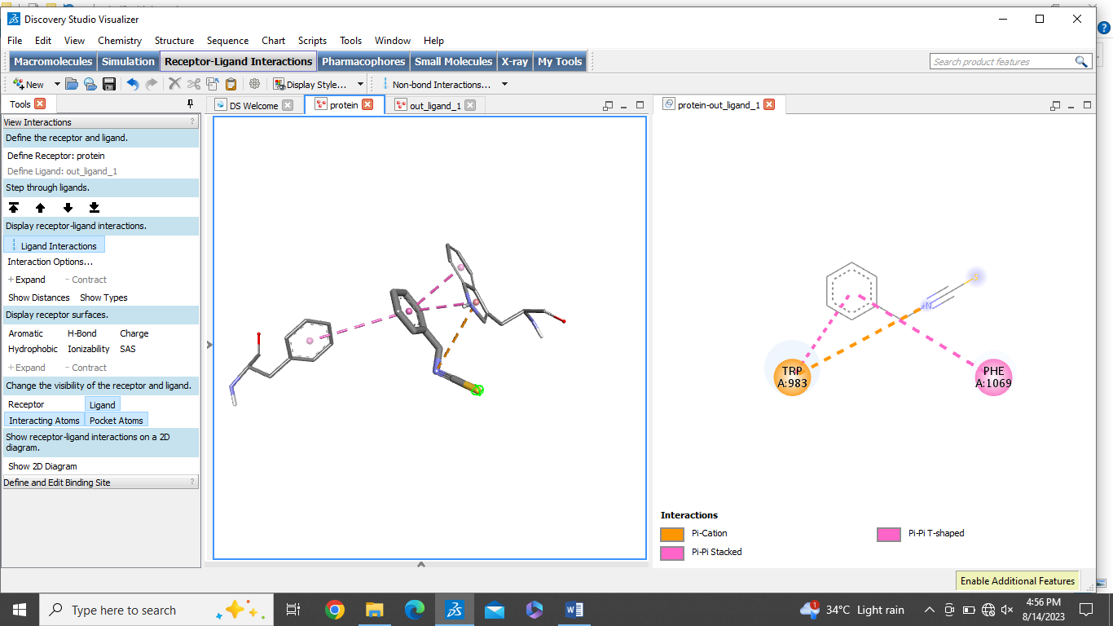
8 | Quercetin | -7.9 | 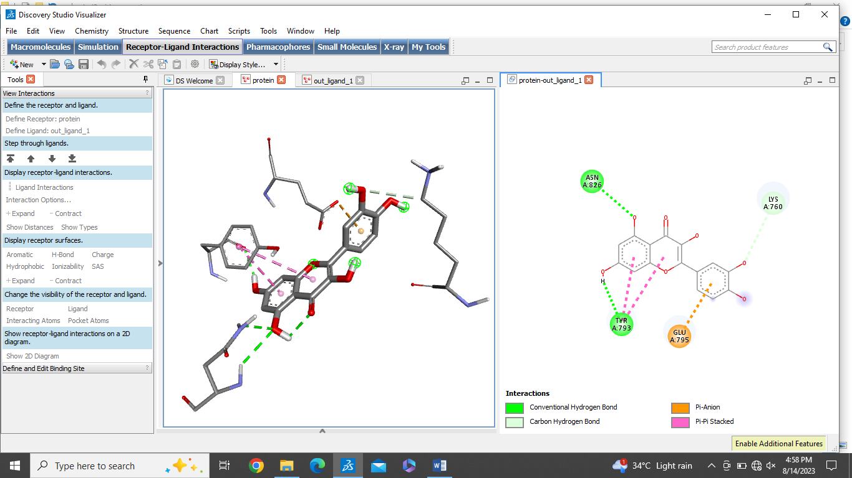  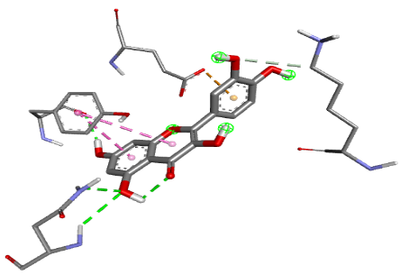
9 | Piperlongumine | -6.2 | 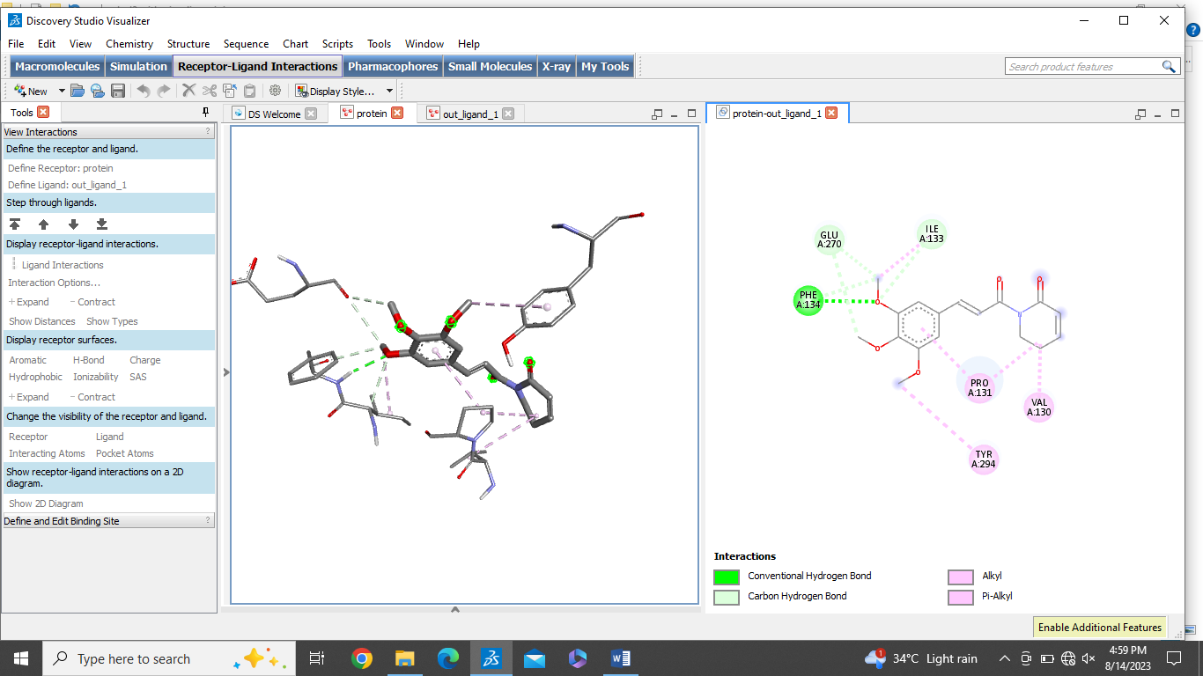
10 | Tilliroside | -8.2 | 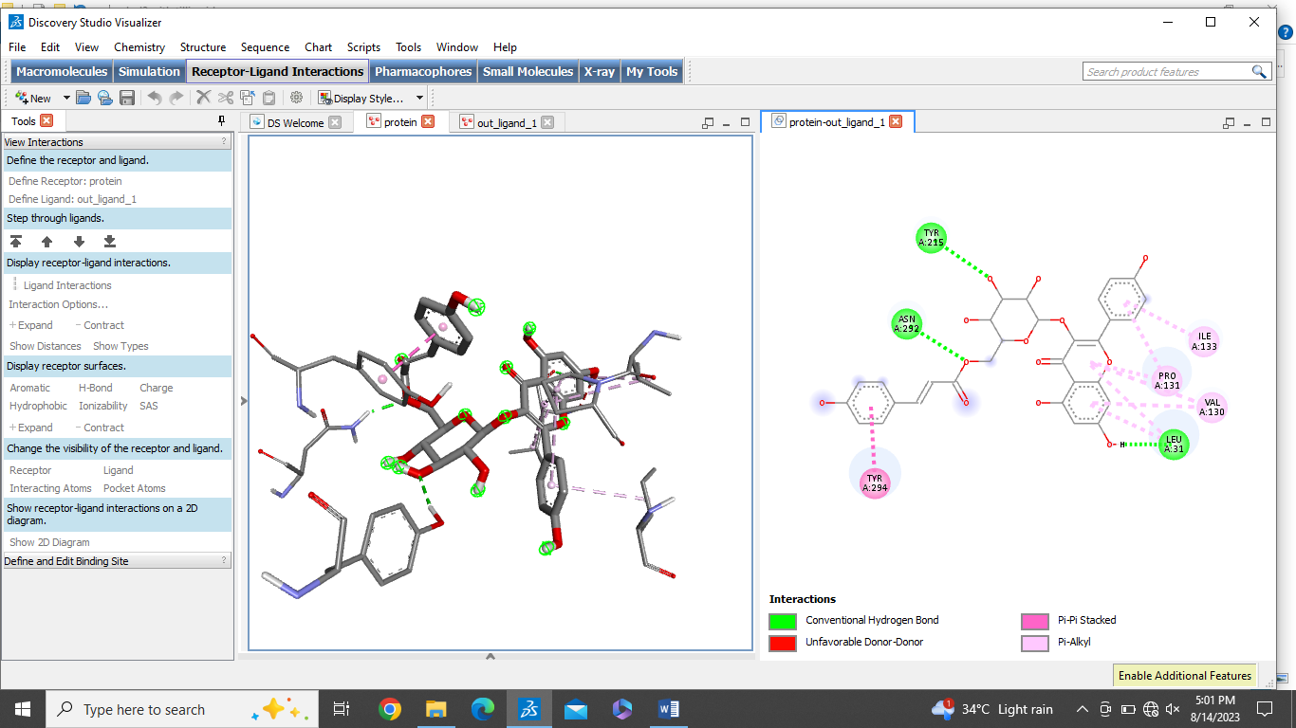
11 | Rutin | -7.9 | 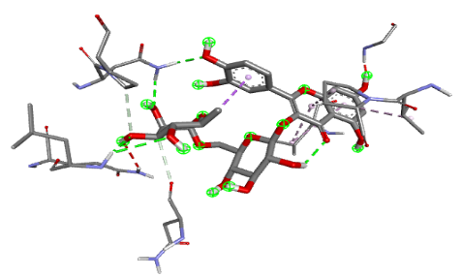  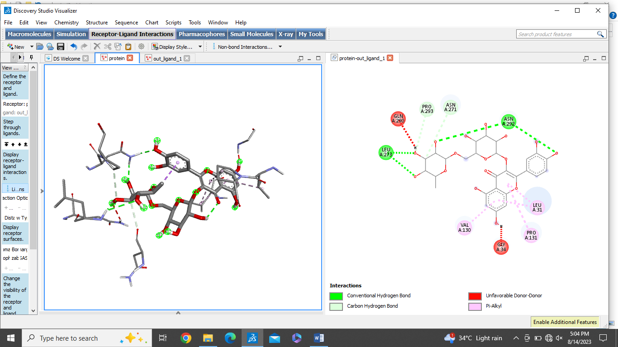
12 | Luteolin | -7.5 | 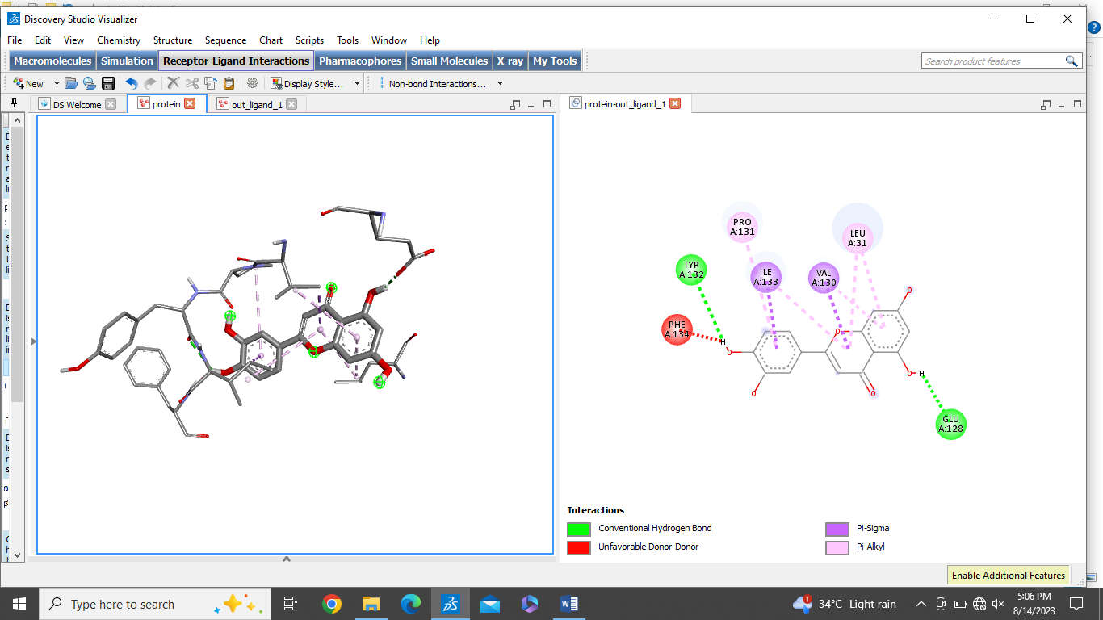
13 | Hyperoside | -7.6 | 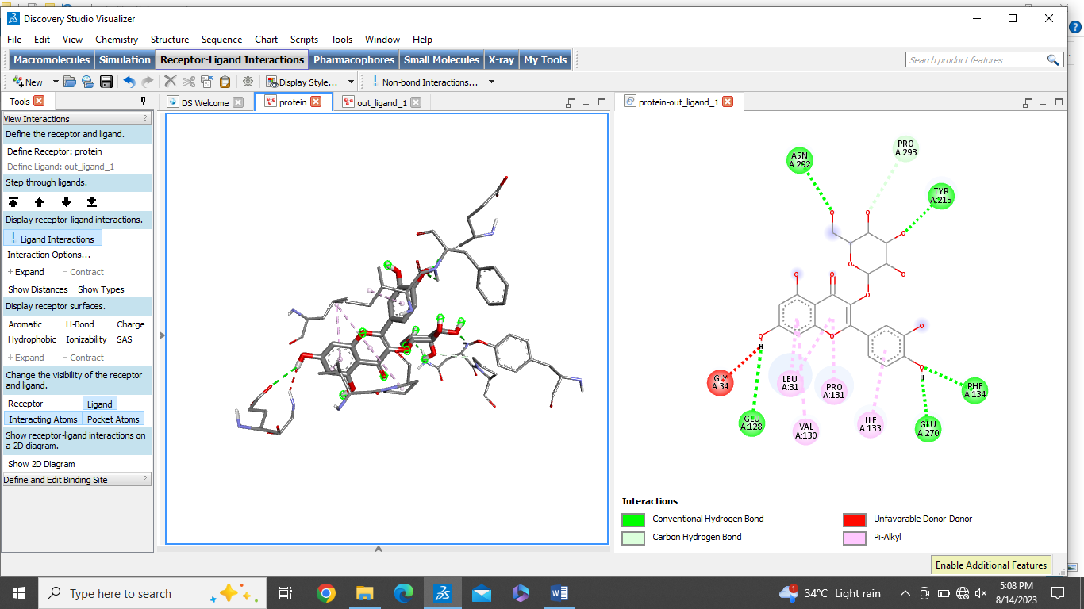
14 | Epicathechin | -7.2 | 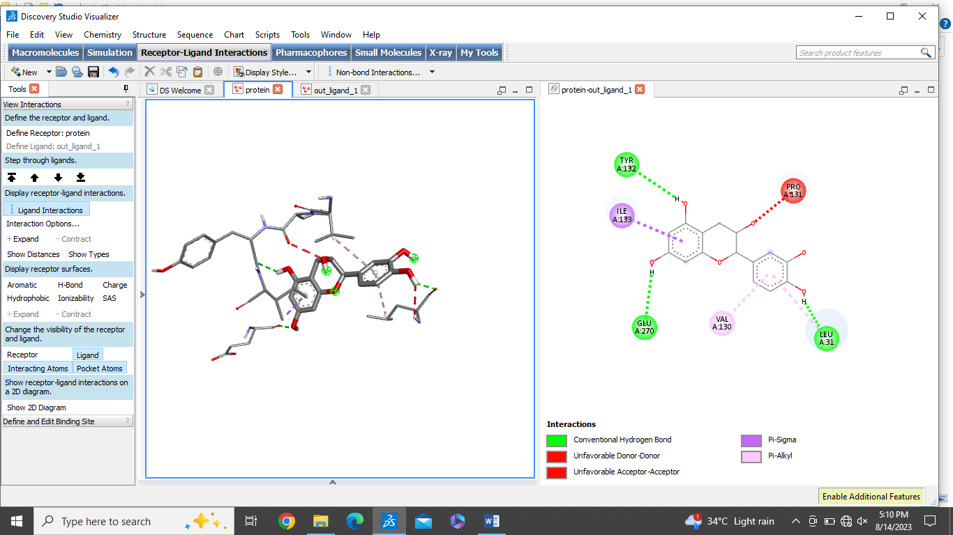

No.6 The overall binding affinity observed between the ligand and ADGRL3 receptor.
Sr.No | Phytocompound | Binding affinity Kcal/mol | 2D and 3D interactions with ADGRL3
1 | Ellagic acid | -7.5 | 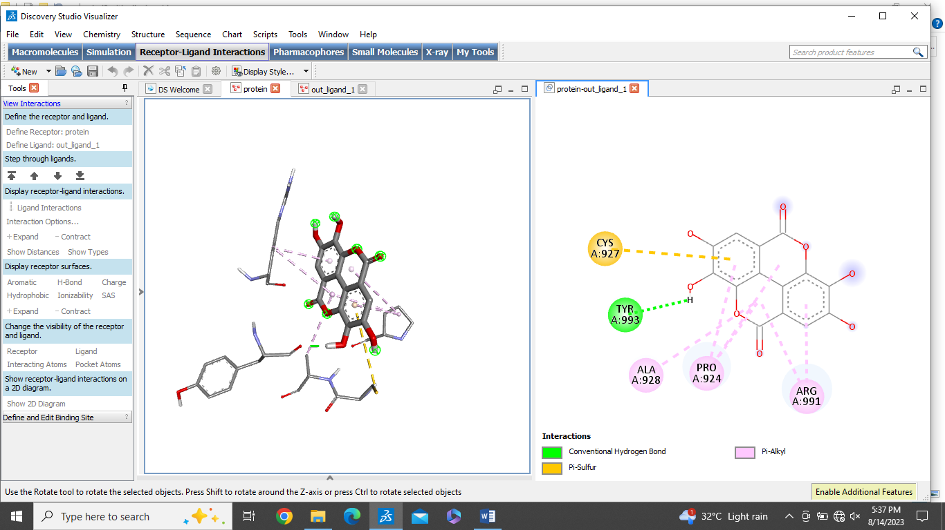
2 | Resveratrol | -6.5 | 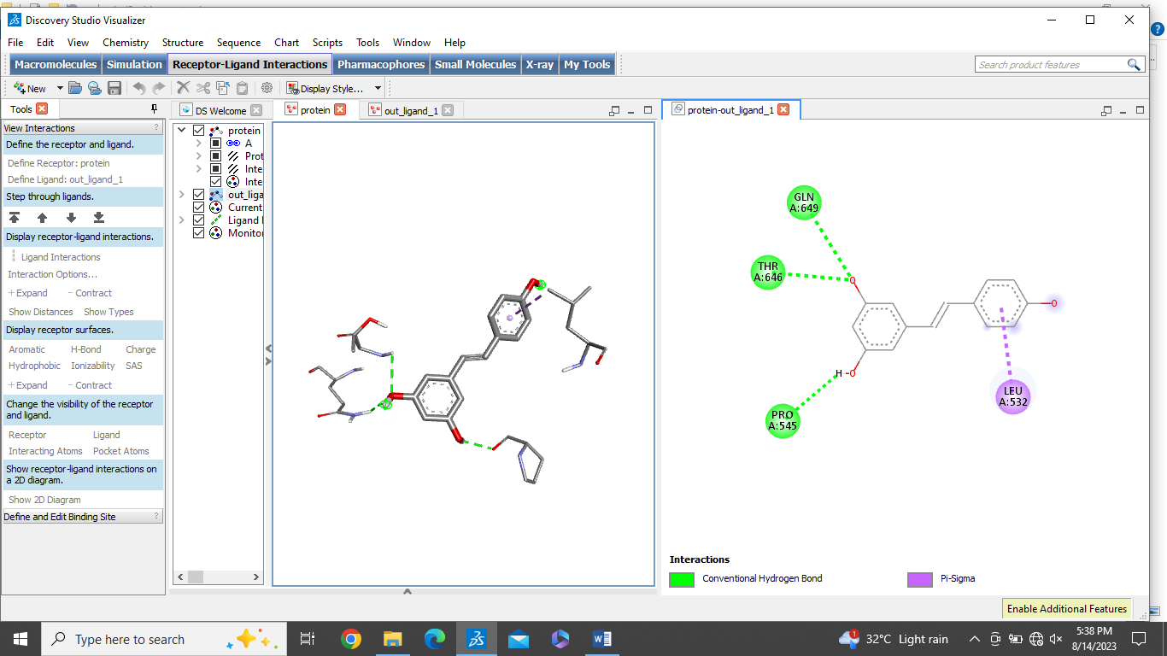
3 | Capsaicin | -4.9 | 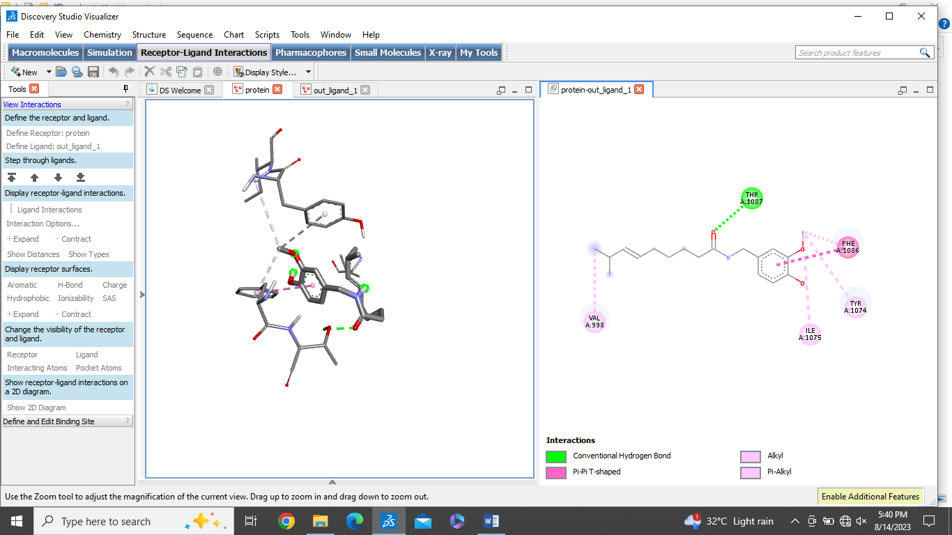
4 | Catechins | -7.7 | 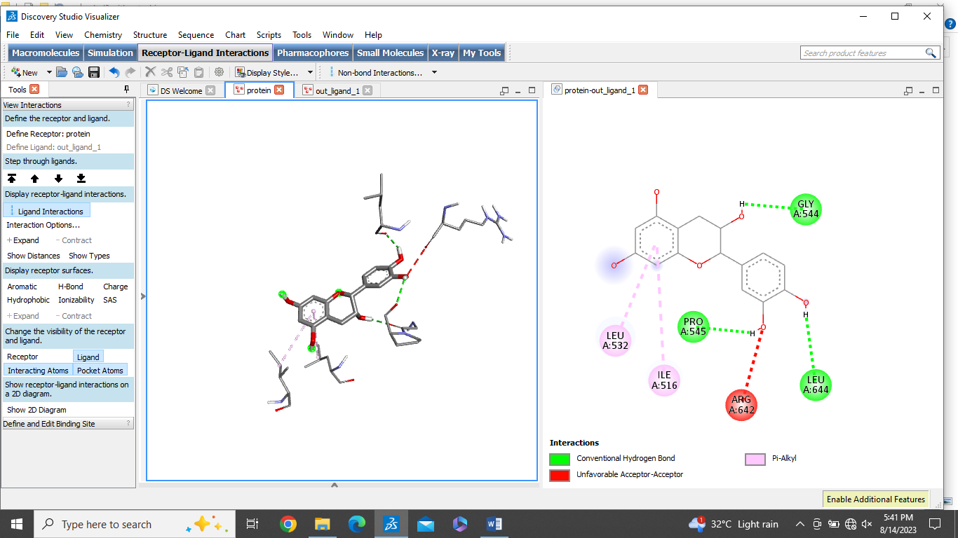
5 | Myricetin | -7.2 | 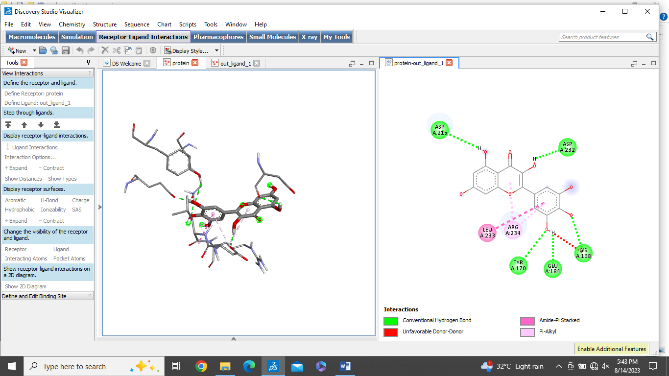
6 | Cucurbitacins | -9.2 | 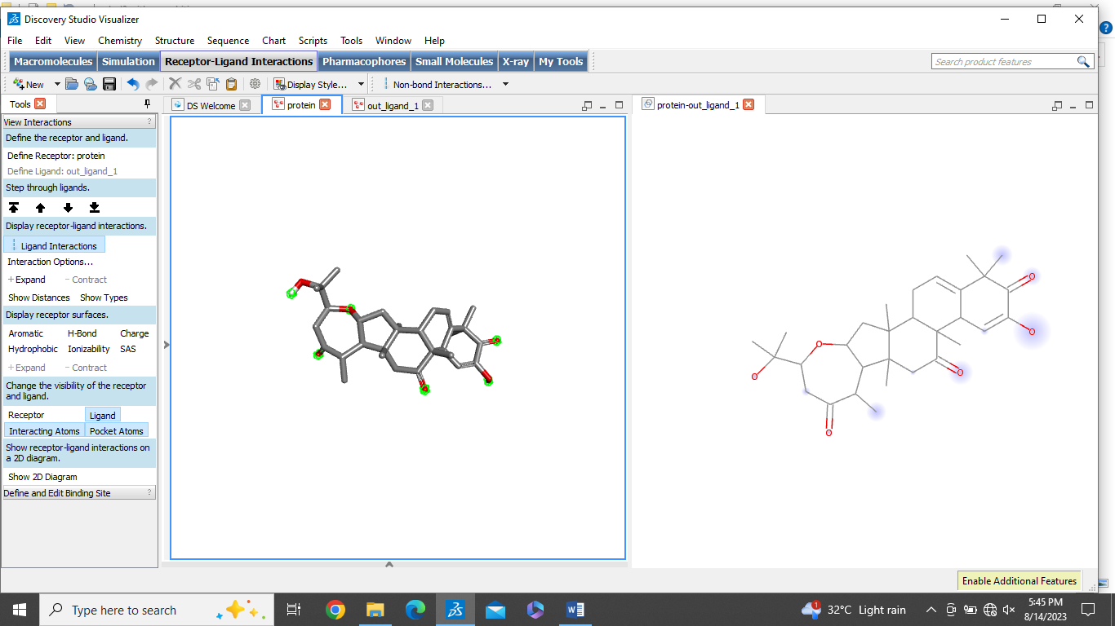
7 | Benzyl isothiocyanate | -4.7 | 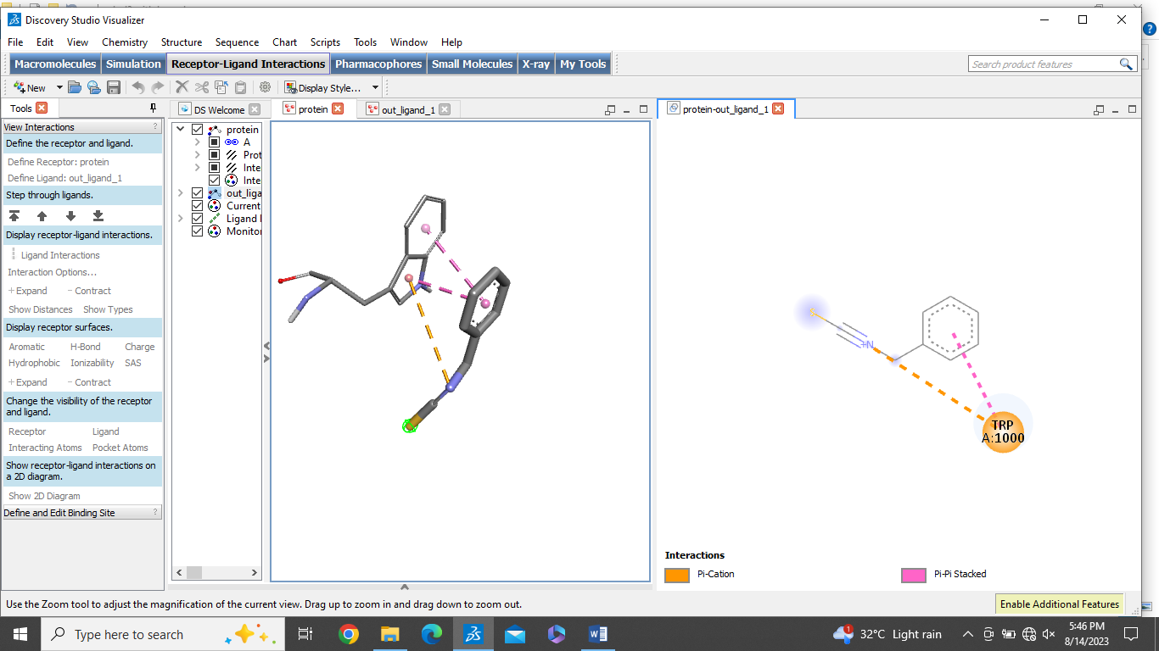
8 | Quercetin | -7.6 | 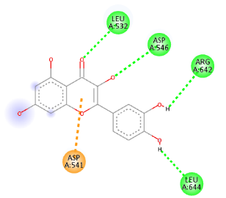  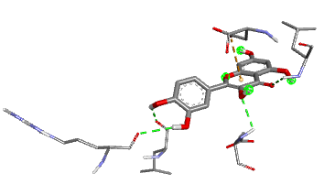
9 | Piperlongumine | -6.6 | 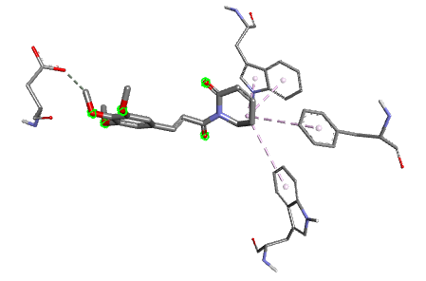  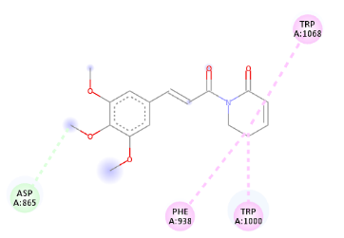
10 | Tilliroside | -7.6 | 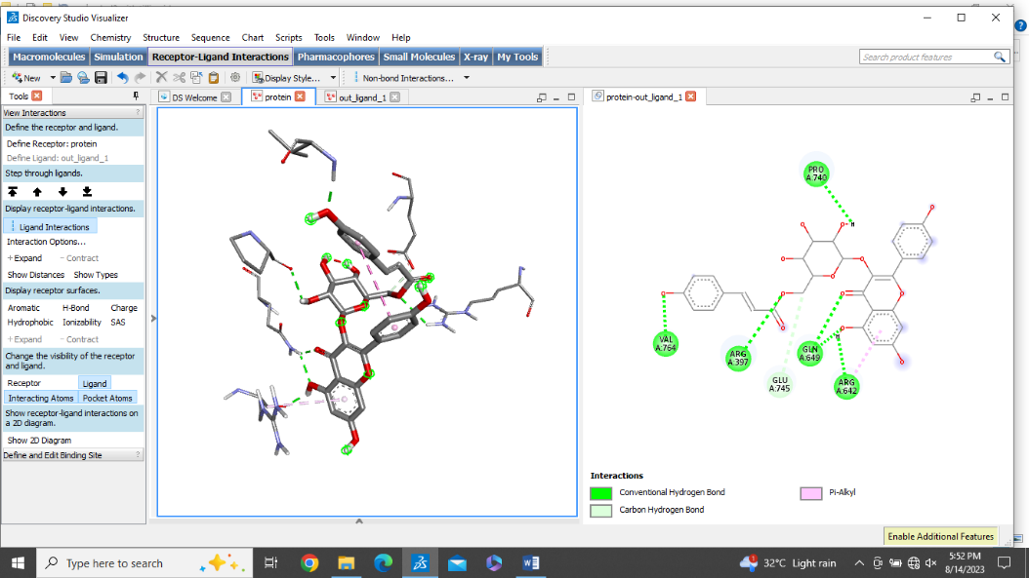  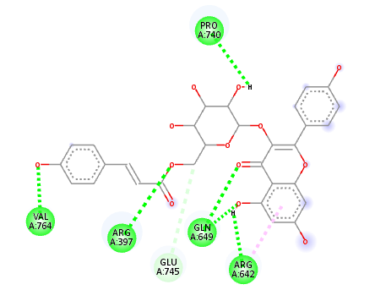
11 | Rutin | -8.0 | 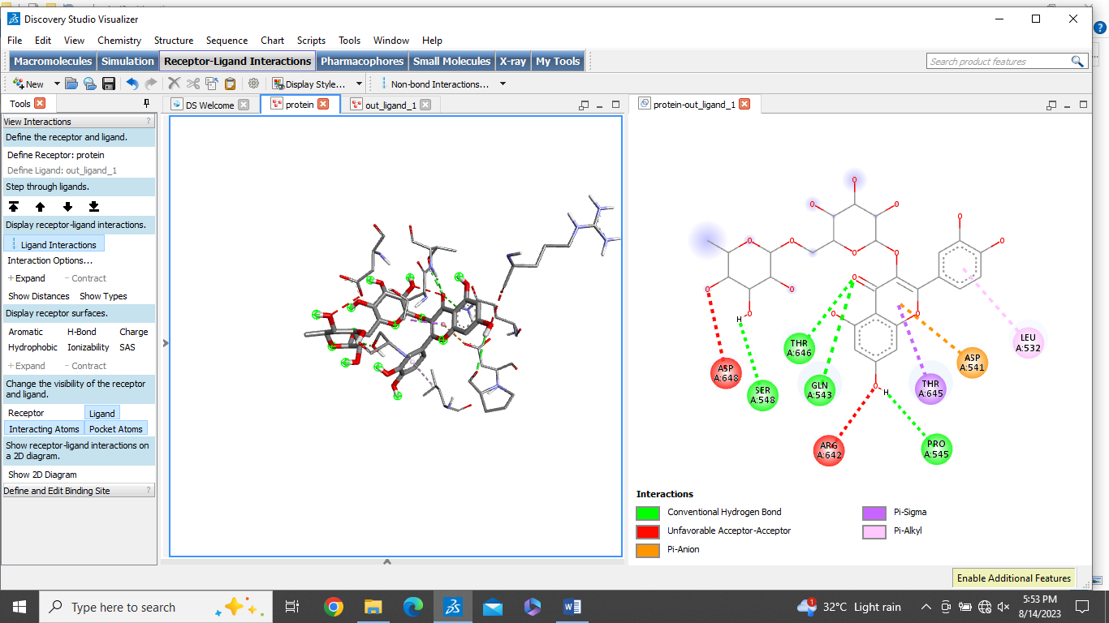
12 | Luteolin | -7.7 | 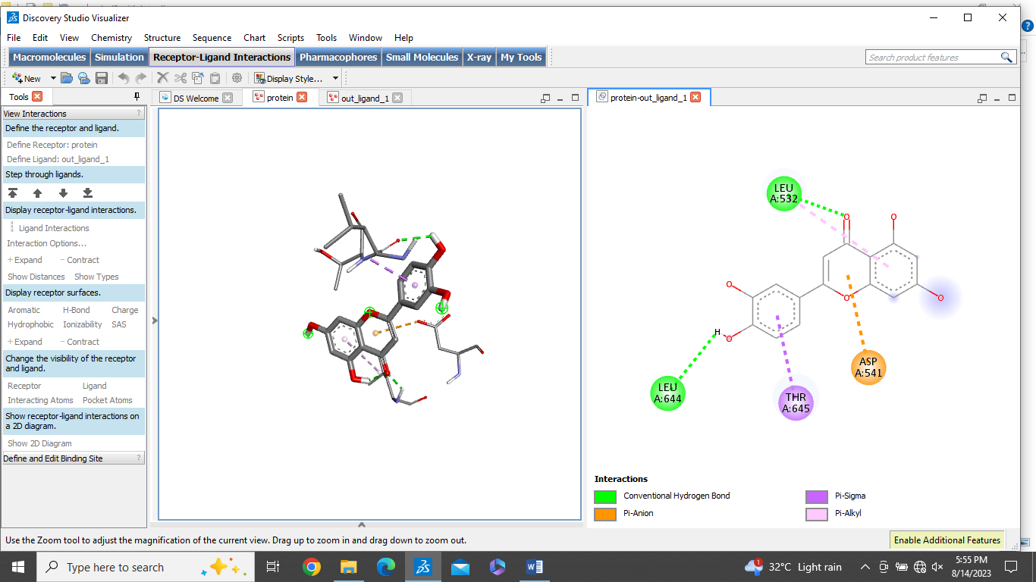
13 | Hyperoside | -7.2 | 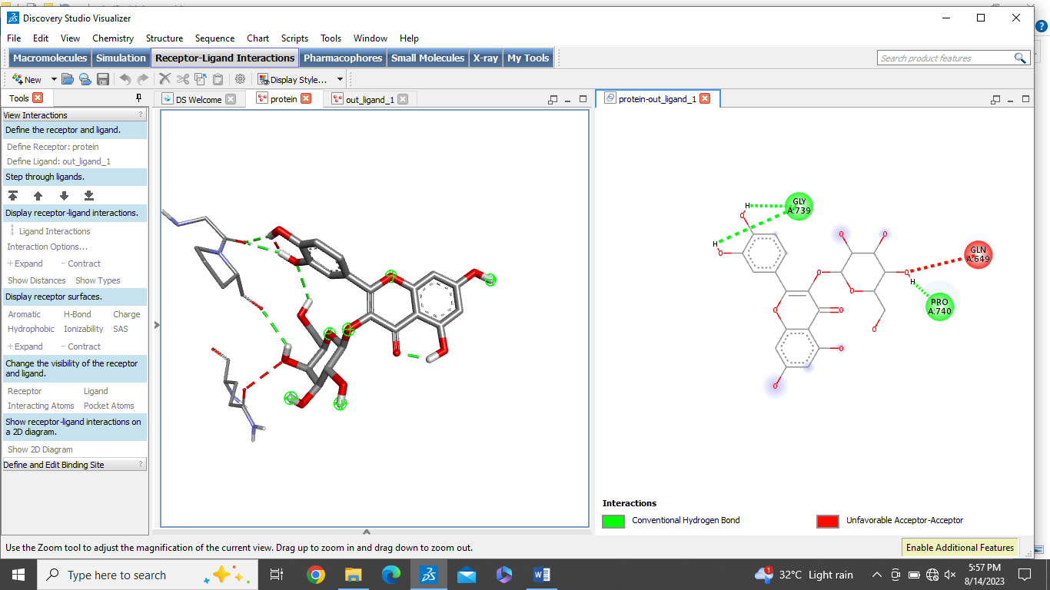
14 | Epicathechin | -7.7 | 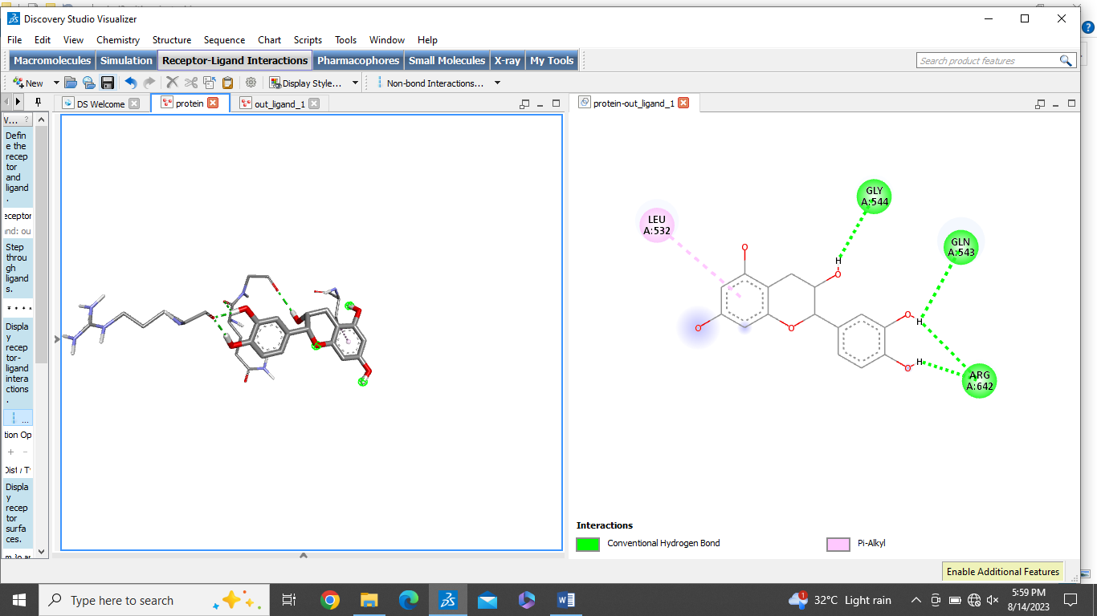

No. 7. The overall binding affinity observed between the ligand and LPAR1 receptor.
Sr.No | Phytocompound | Binding affinity Kcal/mol | 2D and 3D interactions with LPAR1
1 | Ellagic acid | -9.1 | 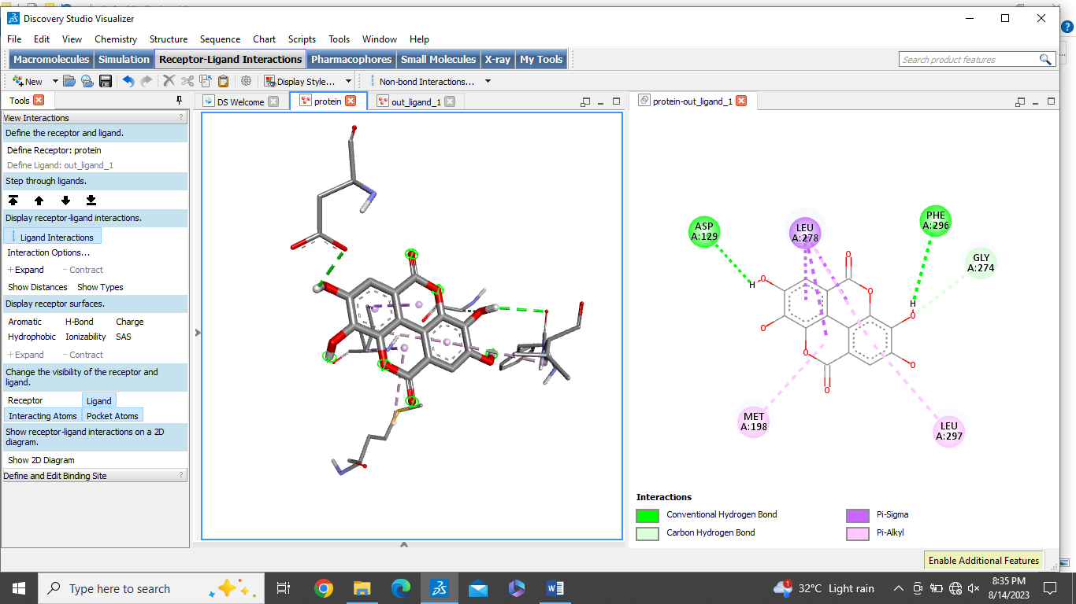
2 | Resveratrol | -6.8 | 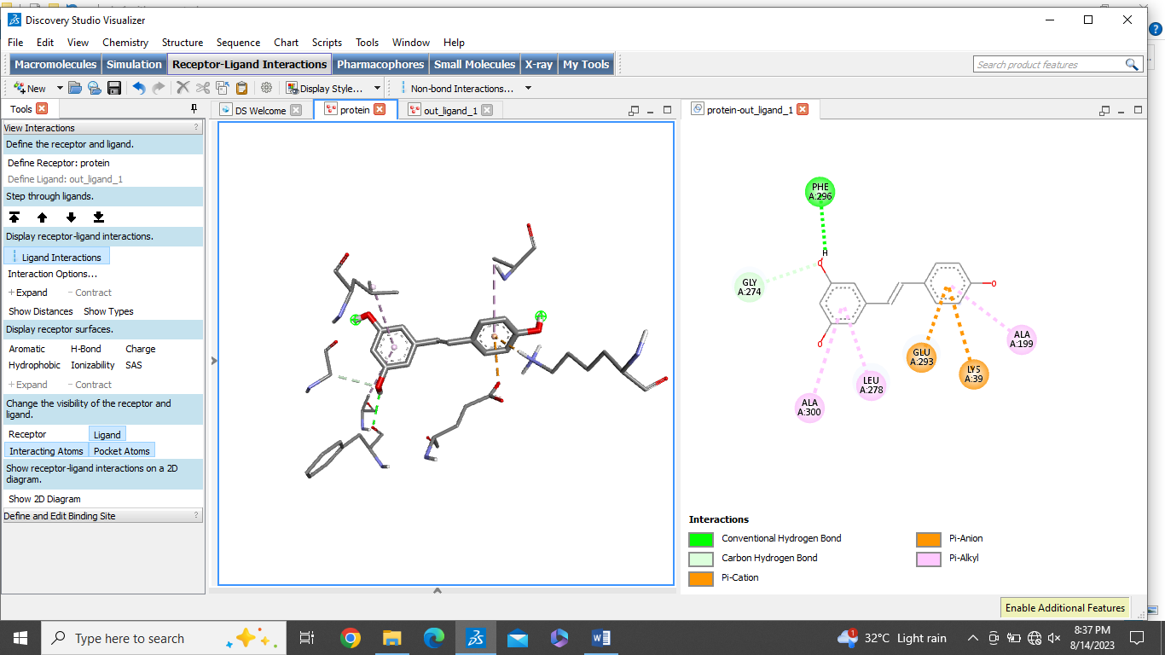
3 | Capsaicin | -6.4 | 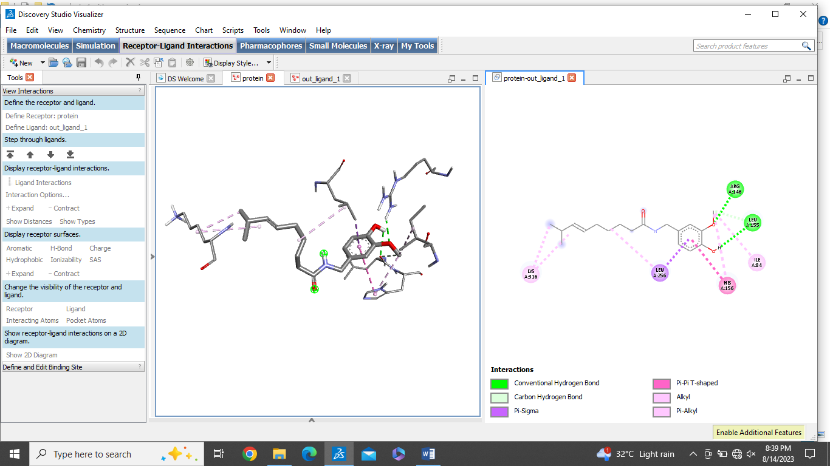
4 | Catechins | -7.8 | 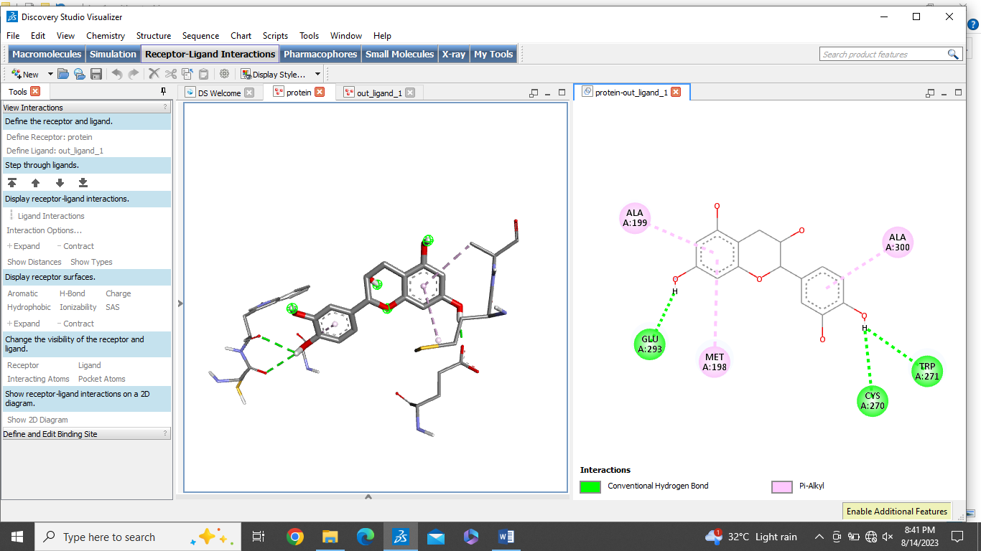
5 | Myricetin | -8.2 | 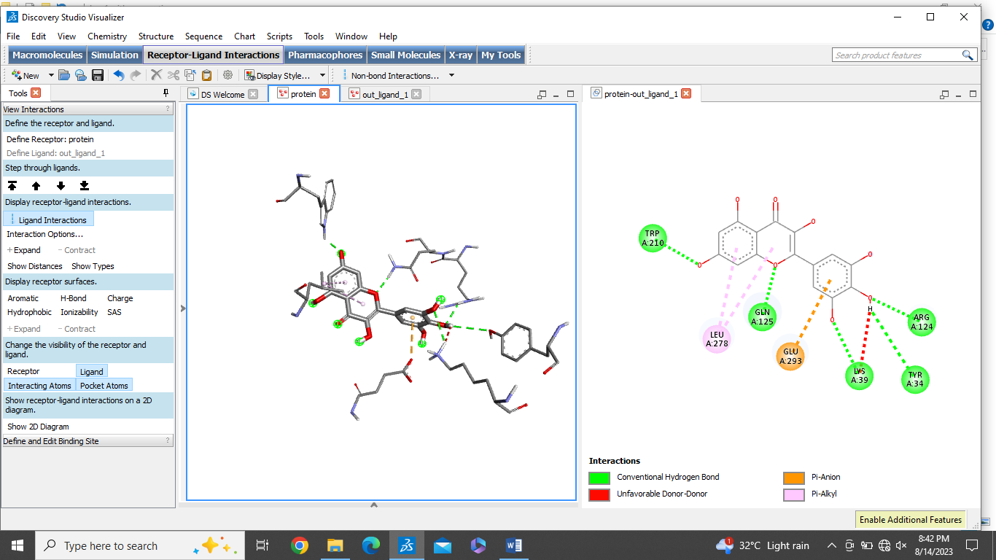
6 | Cucurbitacins | -7.8 | 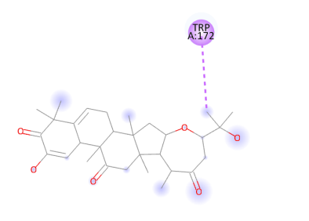  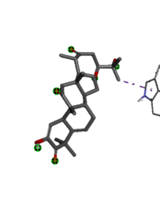
7 | Benzyl isothiocyanate | -5.1 | 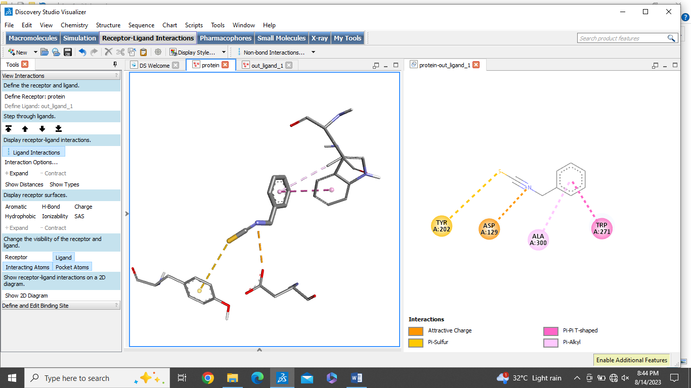
8 | Quercetin | -8.3 | 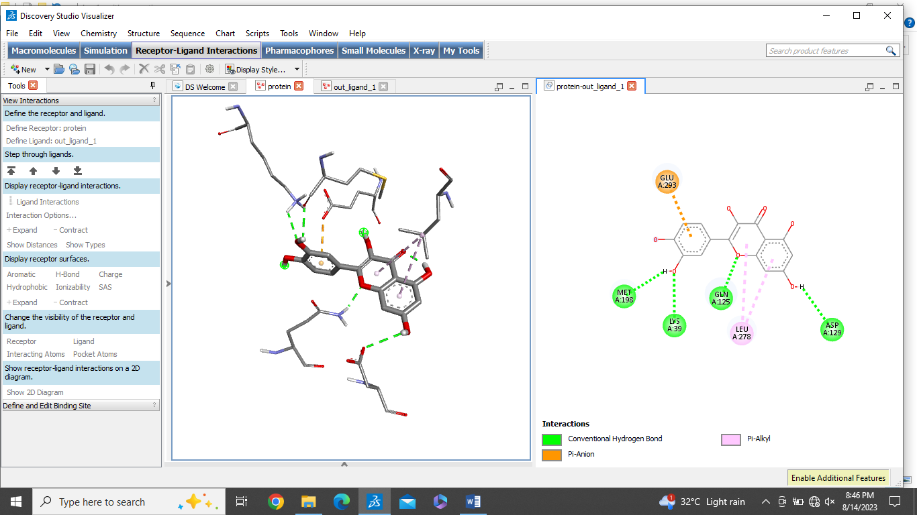
9 | Piperlongumine | -7.5 | 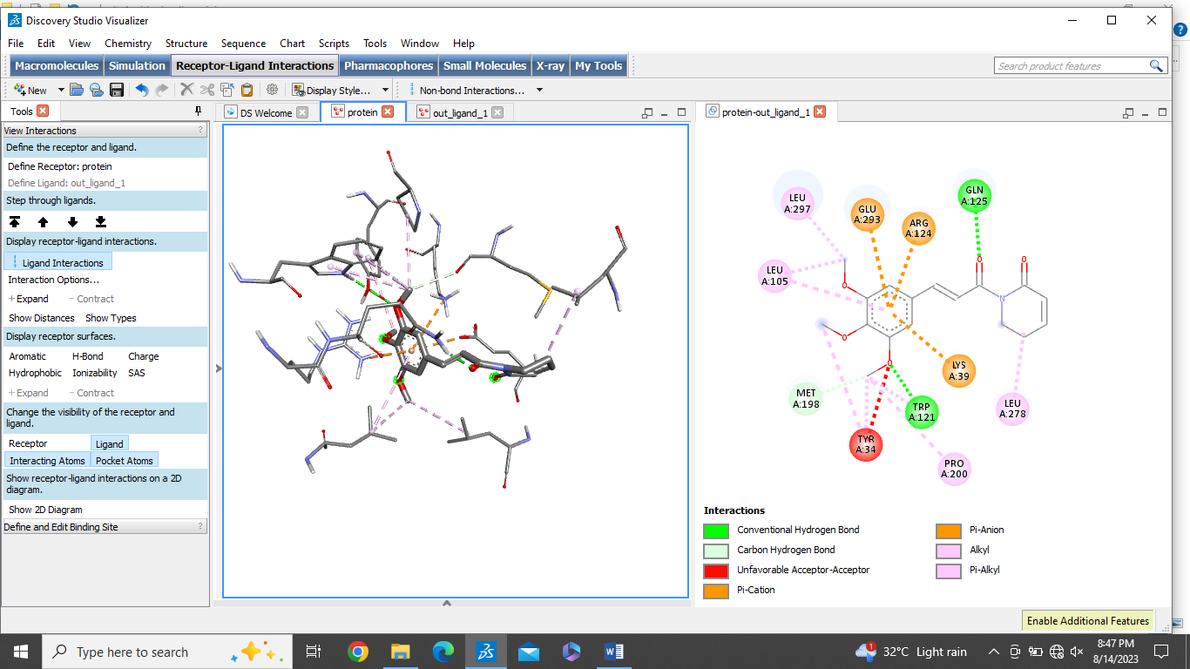
10 | Tilliroside | -7.6 | 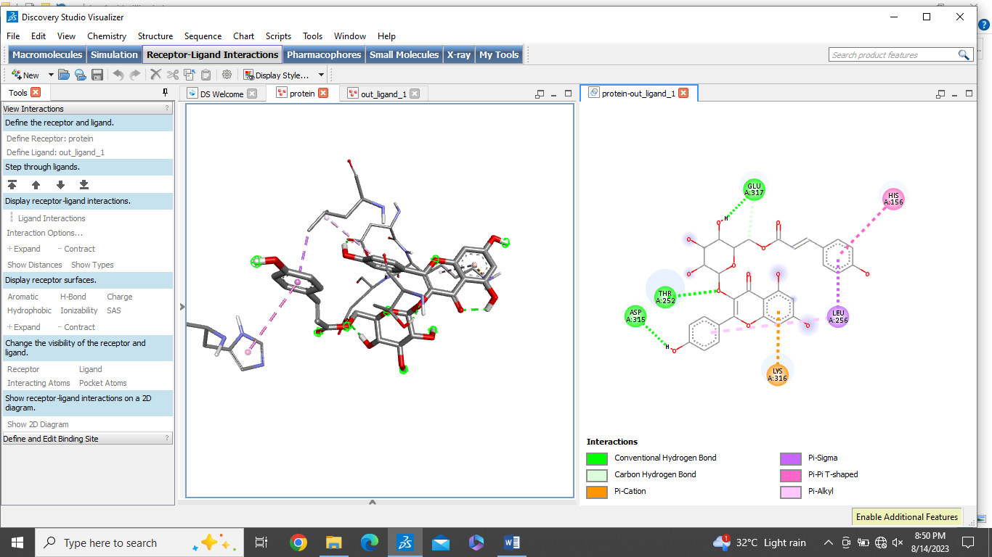
11 | Rutin | -7.1 | 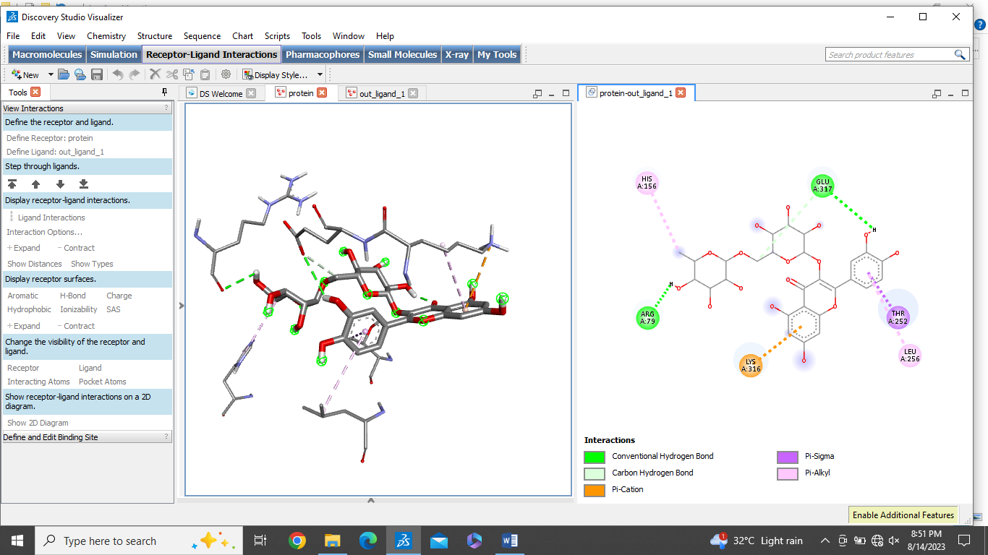
12 | Luteolin | -8.3 | 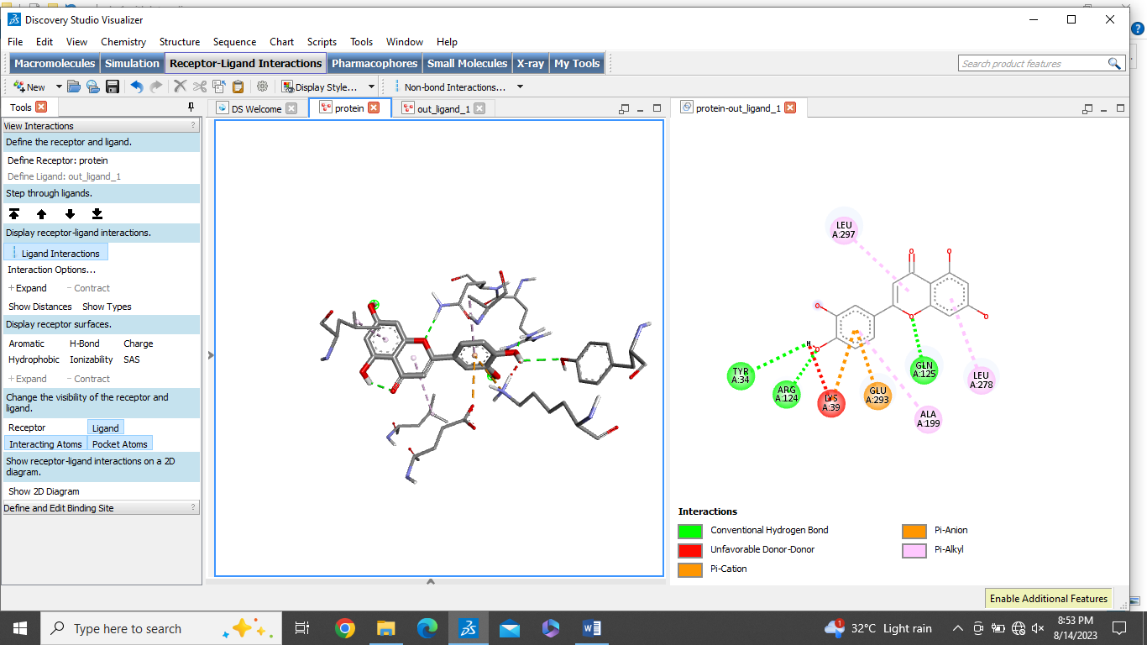
13 | Hyperoside | -6.9 | 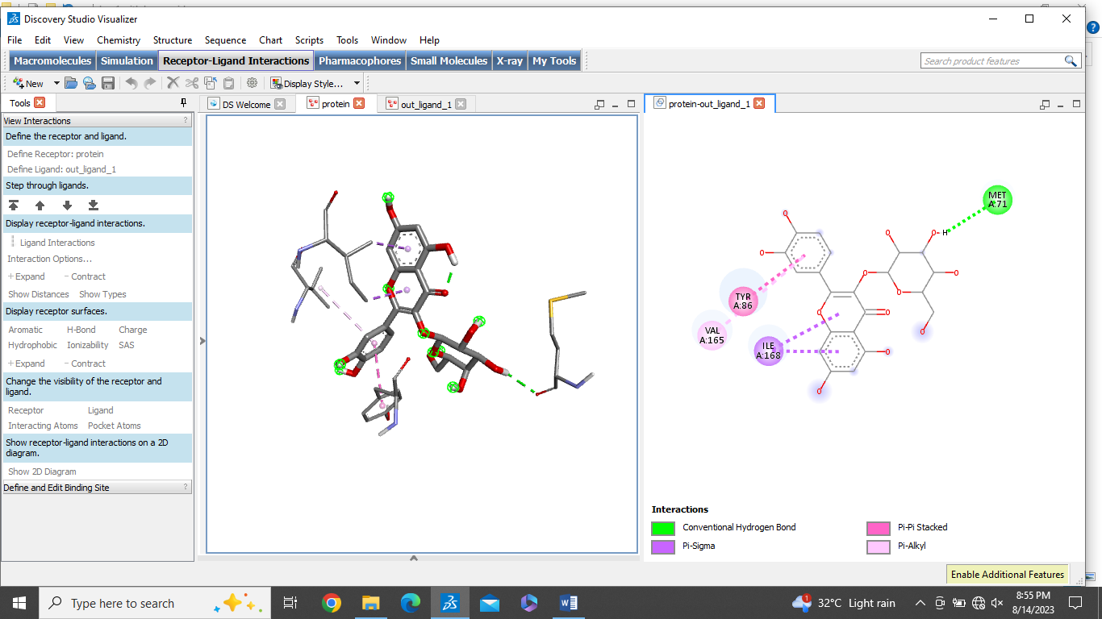
14 | Epicathechin | -5.1 | 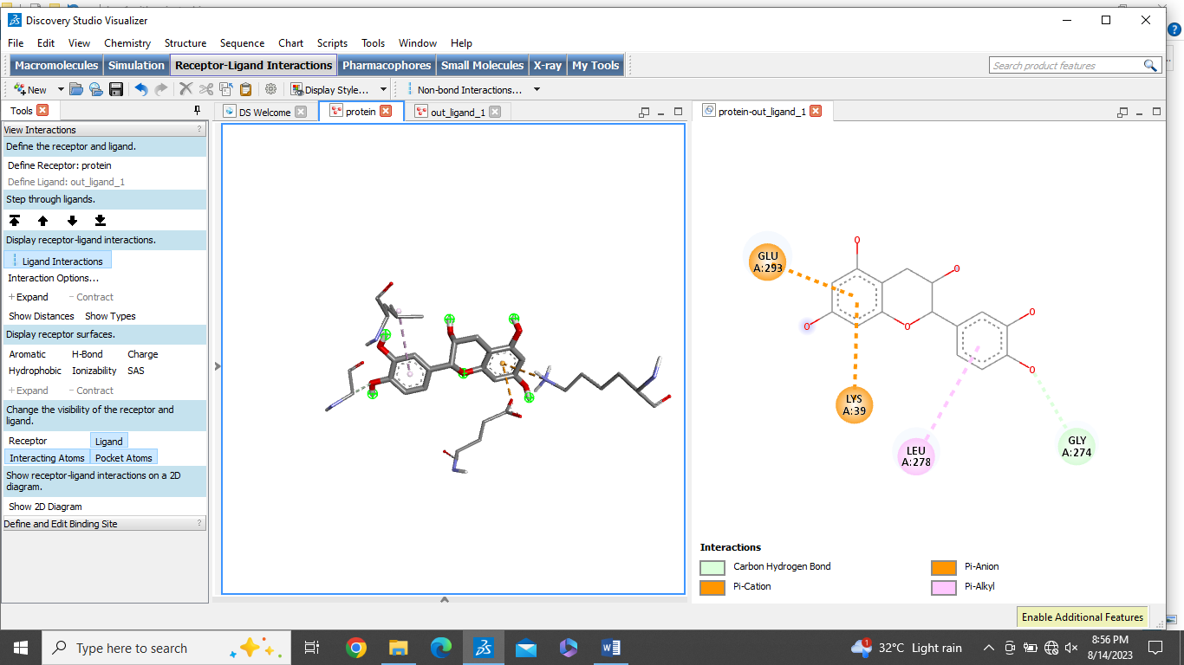

No. 8. The overall binding affinity observed between the ligand and S1PR1 receptor.
Sr.No | Phytocompound | Binding affinity Kcal/mol | 2D and 3D interactions with S1RP1
1 | Ellagic acid | -8.8 | 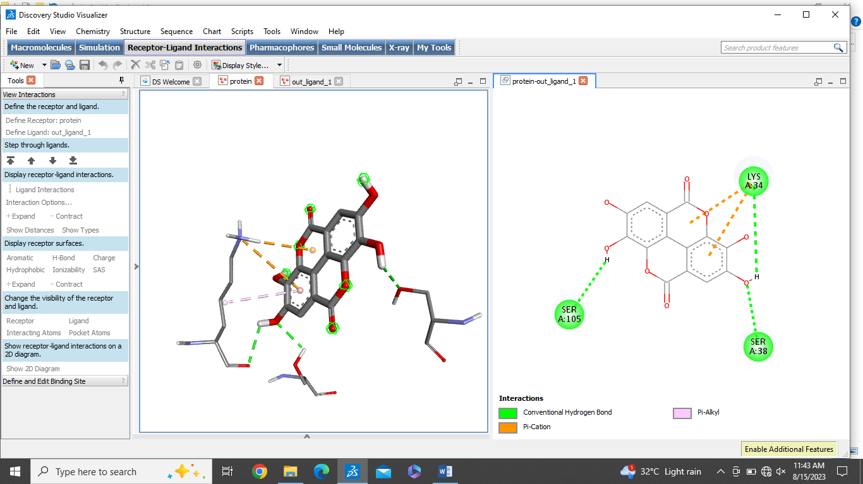
2 | Resveratrol | -7.6 | 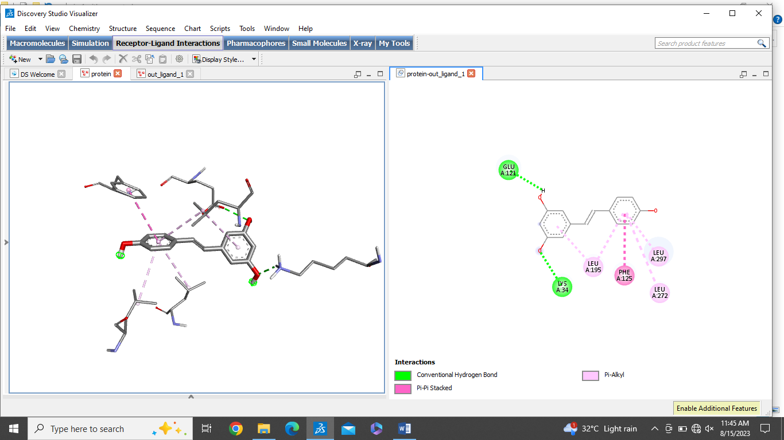
3 | Capsaicin | -6.4 | 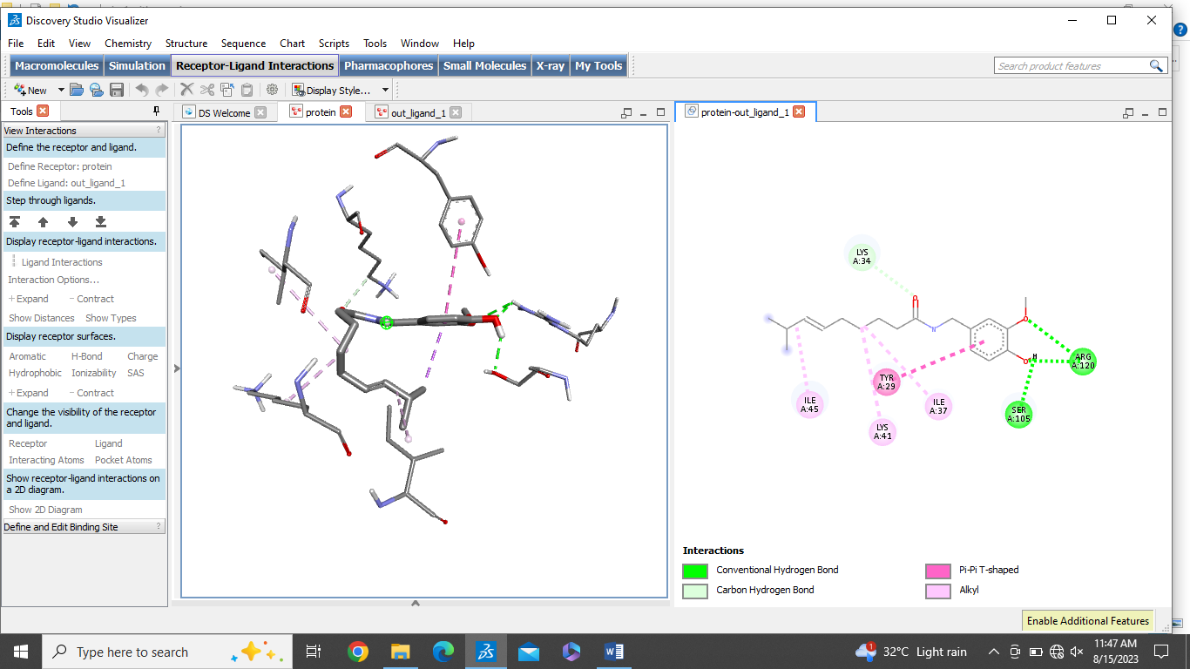
4 | Catechins | -8.1 | 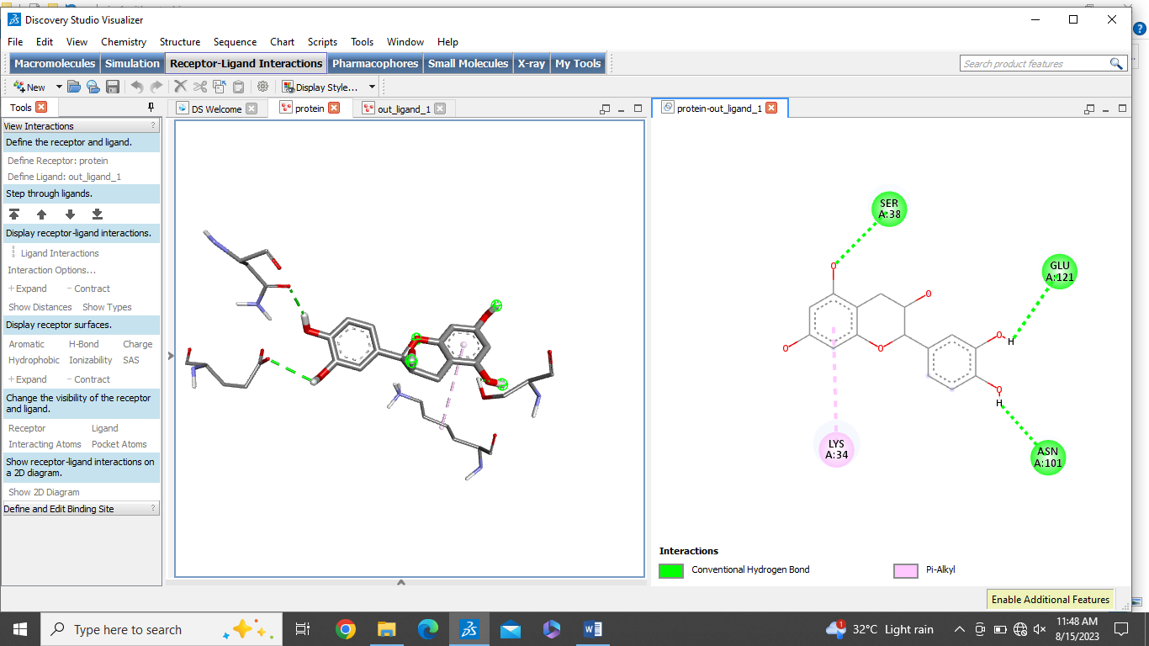
5 | Myricetin | -8.3 | 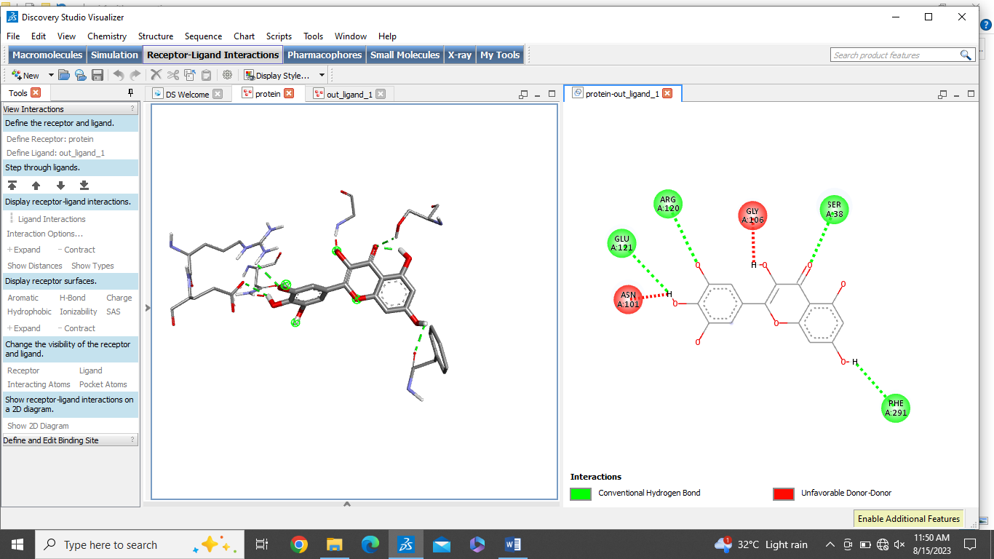
6 | Cucurbitacins | -8.0 | 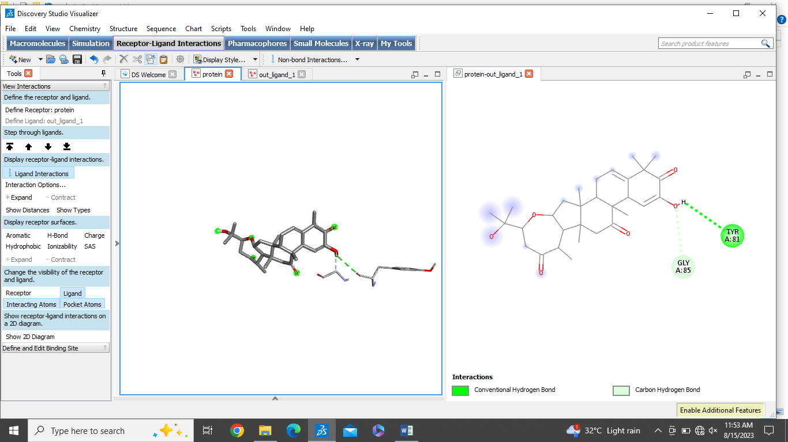
7 | Benzyl isothiocyanate | -4.5 | 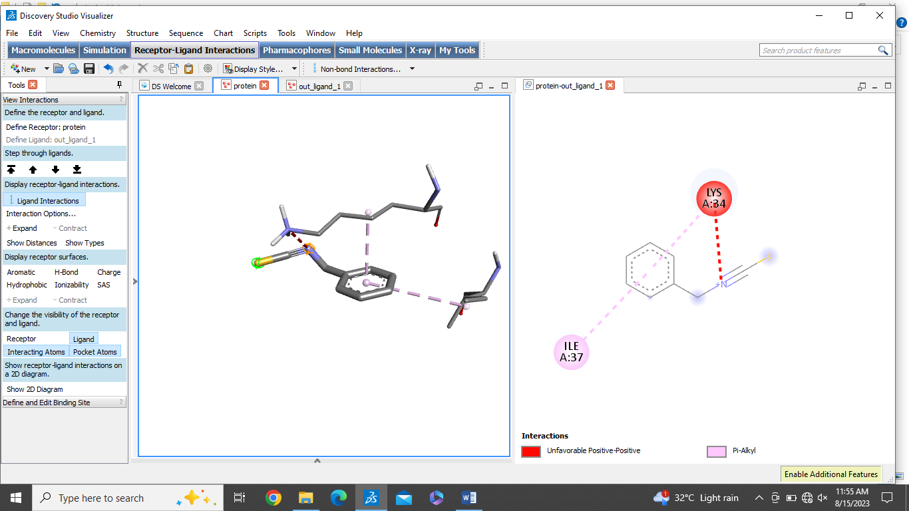
8 | Quercetin | -8.3 | 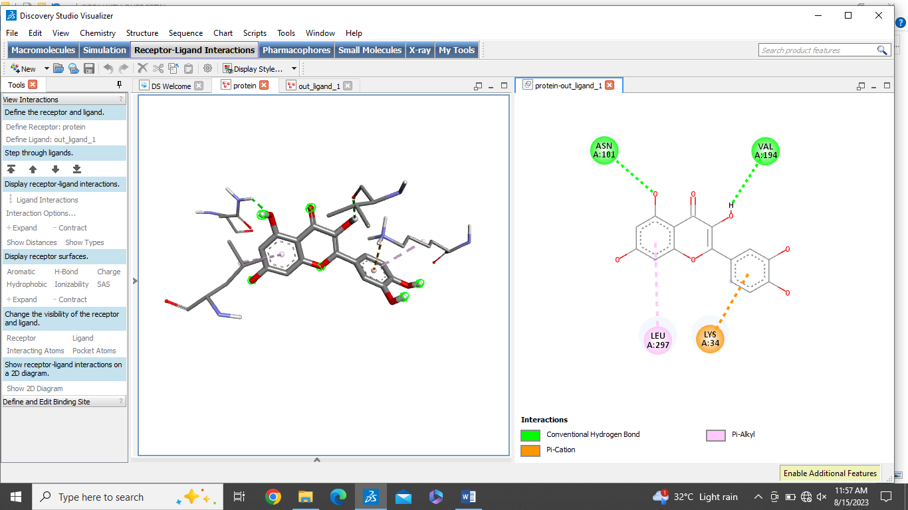
9 | Piperlongumine | -6.0 | 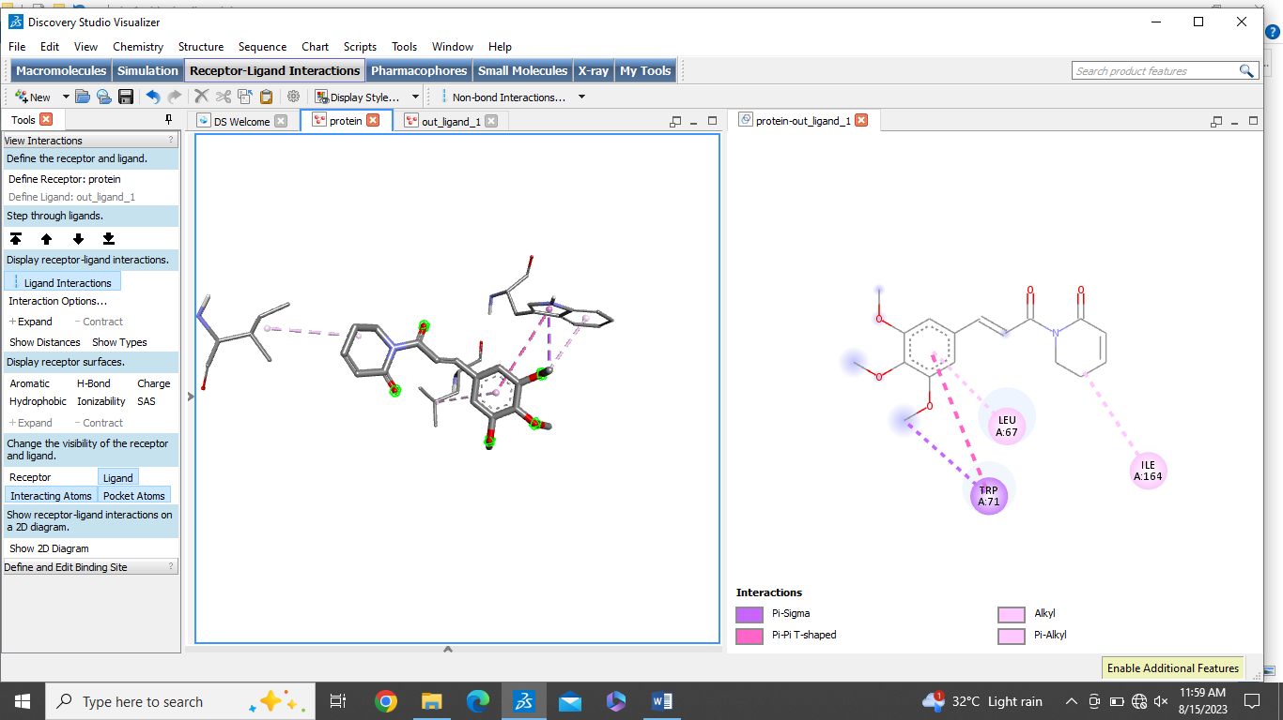
10 | Tilliroside | -9.7 | 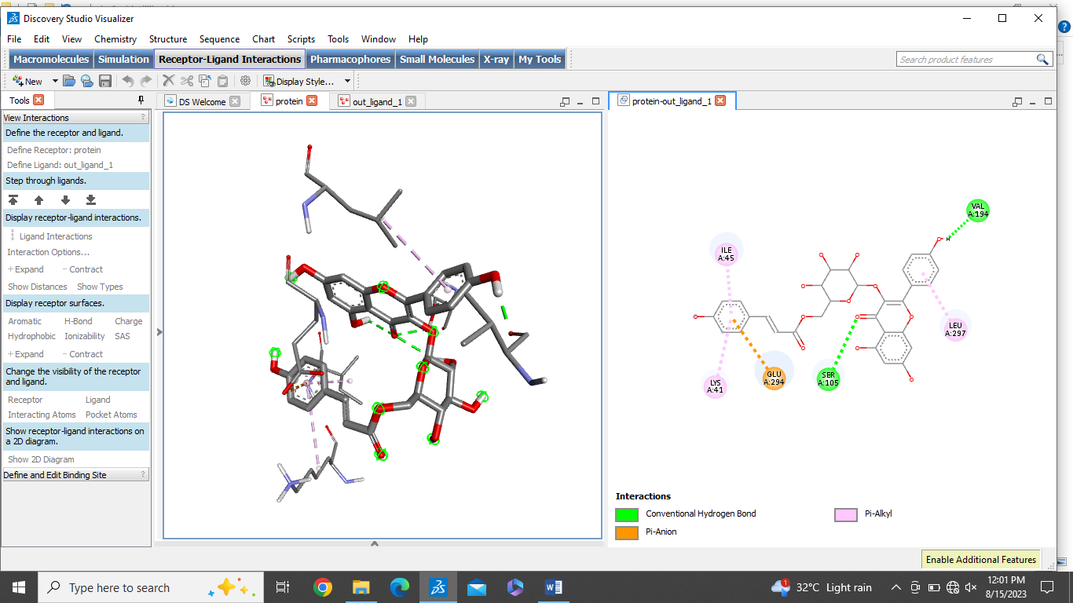
11 | Rutin | -7.2 | 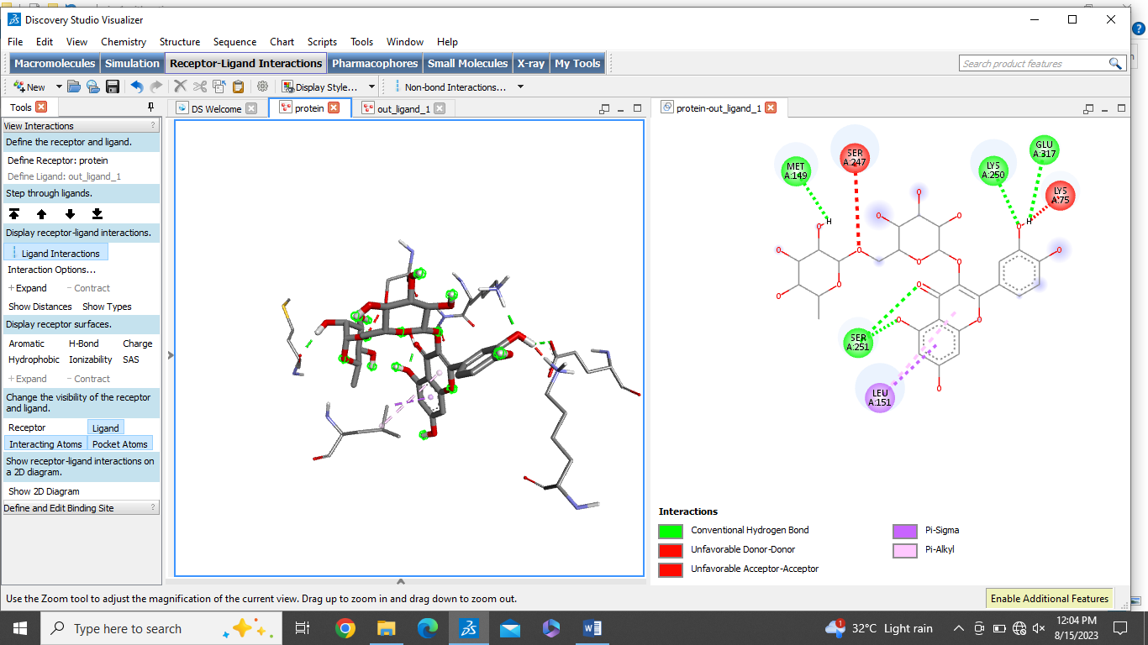
12 | Luteolin | -7.5 | 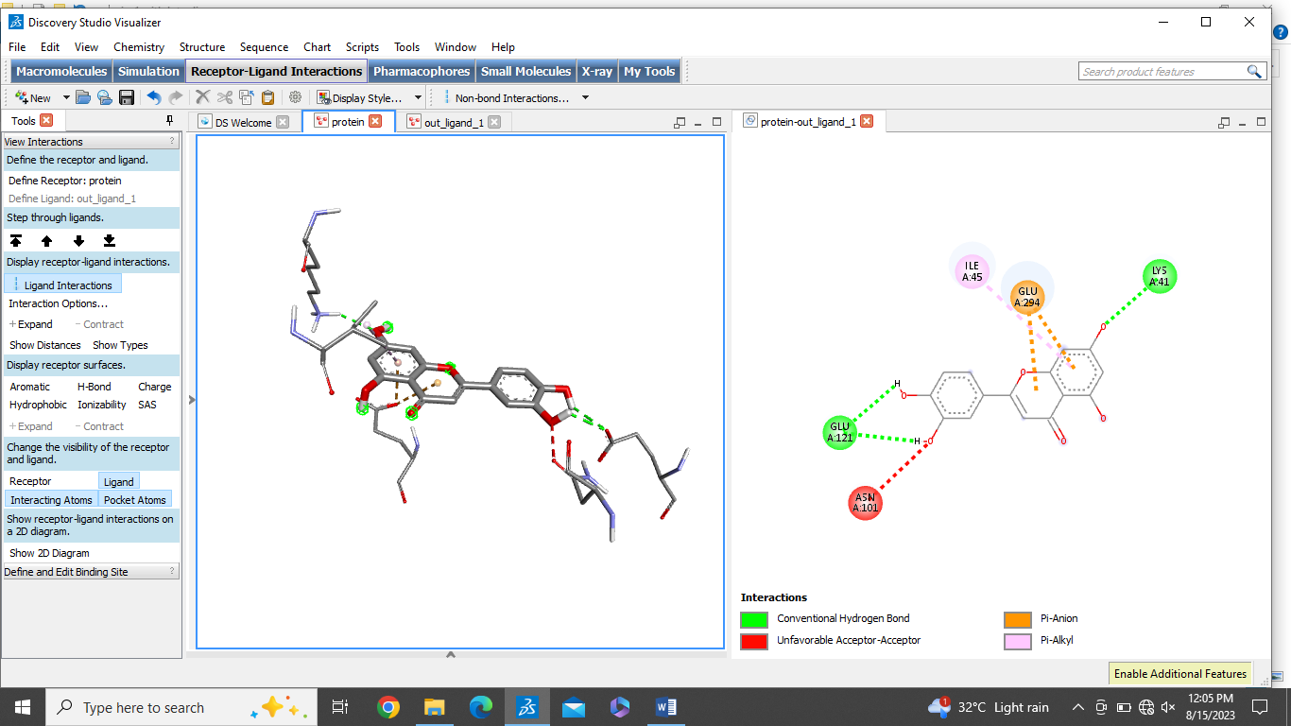
13 | Hyperoside | -6.4 | 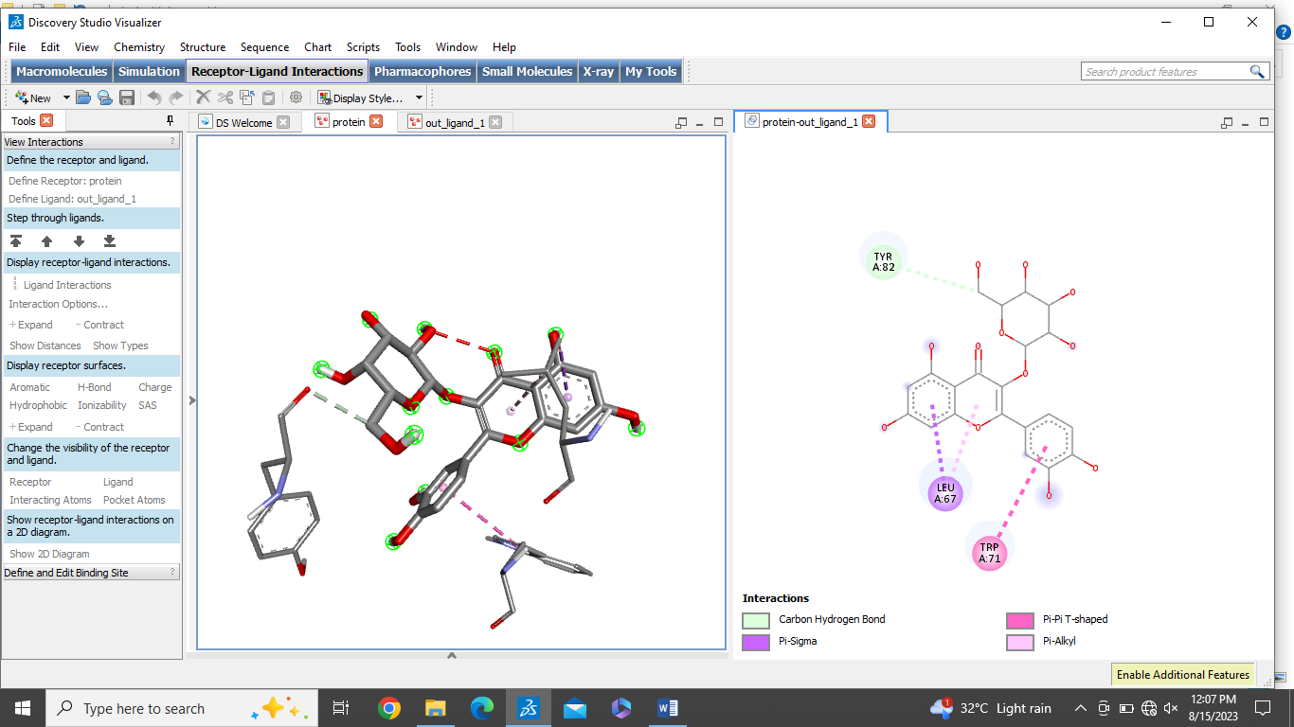
14 | Epicathechin | -8.1 | 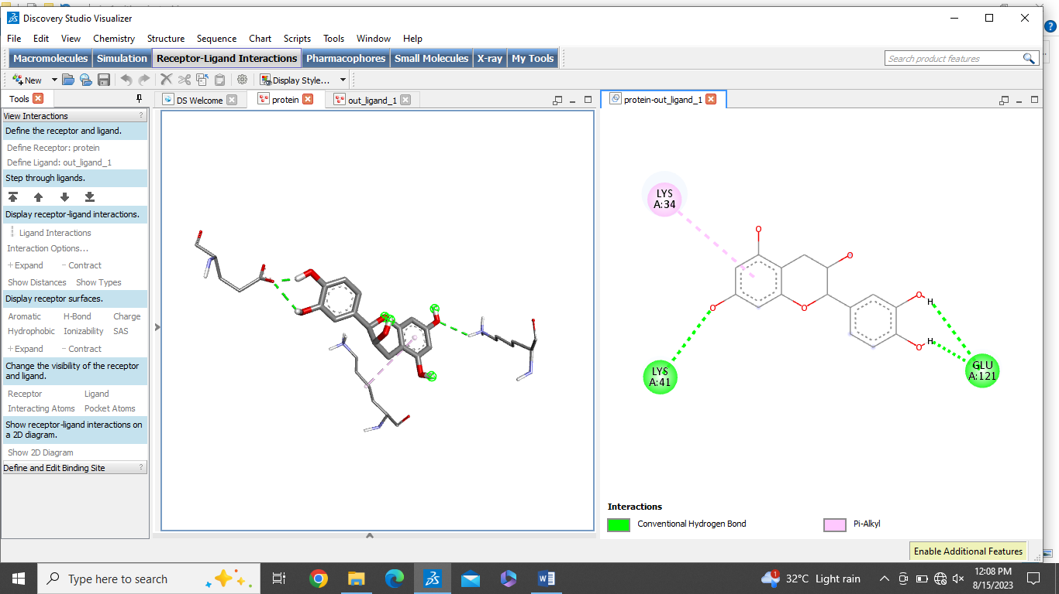

Type of interactions for docking analysis
C | Interactions
 | Conventional Hydrogen Bond
 | Carbon Hydrogen Bond
 | Pi-Anion/Pi-Cation
 | Pi-Sigma
 | Pi-Alkyl
 | Unfavorable Accceptor-Acceptor
 | Pi-Pi T-shaped
 | Pi-Sulfur
 | Alkyl
 | Pi-Donor Hydrogen Bond
 | Atrractive charge
 | Van der Waals
 | Amide-Pi-Stacked
 | Unfavorable Donor-Donor

