Supplementary 1
Table 1: Relative chlorophyll index before infestation
Variety | Relative chlorophyll index
Variety | Si+ | Si-
IAC91-1099 | 36,19 + 1,23 ns | 35,22 + 2,58 ns
SP80-3280 | 38,21 + 1,0 ns | 37,2 + 1,26 ns
Interactions | F | P
Variety | 1,0188 | 0,3195 ns
Si | 0,1400 | 0,7105 ns
Variety × Si | 0,0681 | 0,7956 ns

Supplementary 2
Table 1: Relative chlorophyll index after infestation
Variety | Relative chlorophyll index
Variety | Si+ | Si-
IAC91-1099 | 37,24 + 1,53 ns | 36,07 + 1,19 ns
SP80-3280 | 37,87 + 1,07 ns | 34,27 + 1,82 ns
Interactions | F | P
Variety | 0,166 | 0,686 ns
Si | 2,765 | 0,105 ns
Variety × Si | 0,717 | 0,403 ns

Supplementary 3
Calculation of jaw wear index. Blue line represents the measurement from the apex of the second tooth to the base of the mandible, and green line represents the measurement from the apex of the second tooth to its sclerotized base.
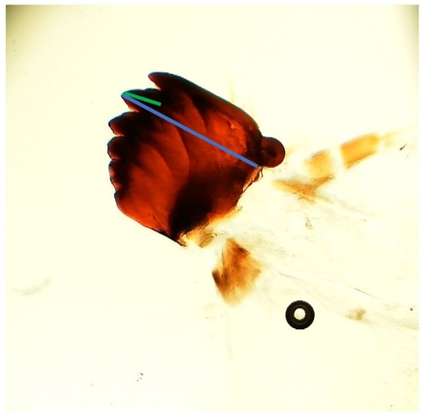
Figure: Calculation of jaw wear index

