SUPPLEMENTARY INFORMATION

Simple, sensitive, and cost-effective voltammetric determination of salbutamol at a pencil graphite electrode modified with Nafion and functionalized multi-walled carbon nanotubes

Didem Giray Dilgin^{1,}*, Kader Vural¹, Serkan Karakaya^{2,}*, Yusuf Dilgin²

¹Department of Secondary Science and Mathematics Education, Faculty of Education, Çanakkale Onsekiz Mart University, Çanakkale, Turkey
²Department of Chemistry, Faculty of Science and Art, Çanakkale Onsekiz Mart University, Çanakkale, Turkey

*Corresponding author:
didemgiray@comu.edu.tr
skarakaya@comu.edu.tr

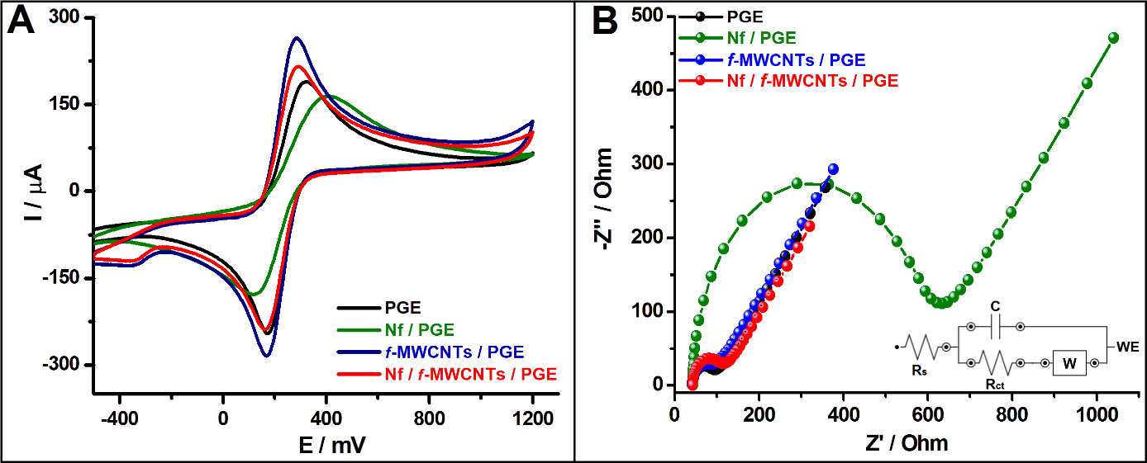
Fig. S1 (A) CVs (Potential scan range is -500 mV – +1200 mV at a scan rate of 50 mV/s) and (B) ICs (Frequency range: 1×10⁵ – 1×10⁻¹ Hz and the inside figure is electrochemical IS circuit model; W: Warburg impedance; R_{s}: Ohmic resistance; WE: Working electrode; C: Double layer capacitance) of 5.0 mM Fe(CN)₆^{3-/4-} + 0.10 M KCl recorded at bare PGE, Nf/PGE, f-MWCNTs/PGE and Nf/f-MWCNTs/PGE.

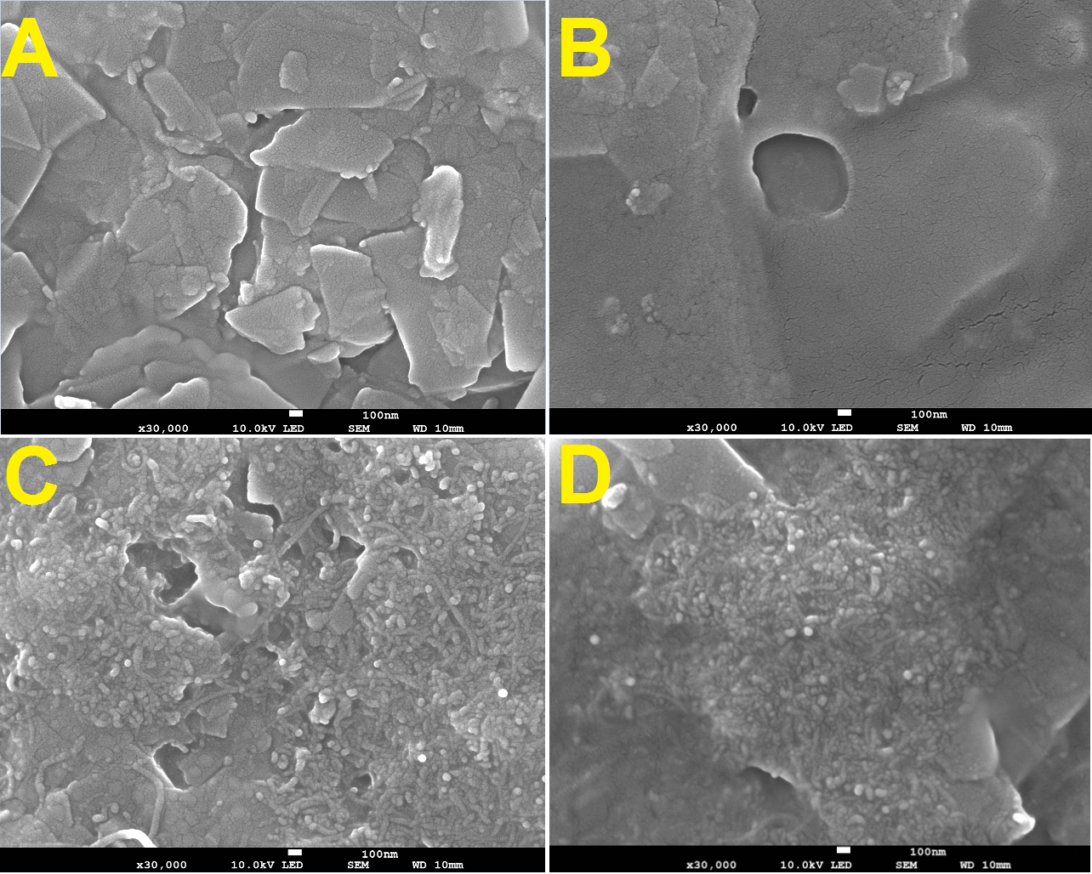
Fig. S2 SEM micrographs (30000 ×100 nm) recorded for (A) PGE, (B) Nf/PGE, (C) f-MWCNTs/PGE, and (D) Nf/f-MWCNTs/PGE.

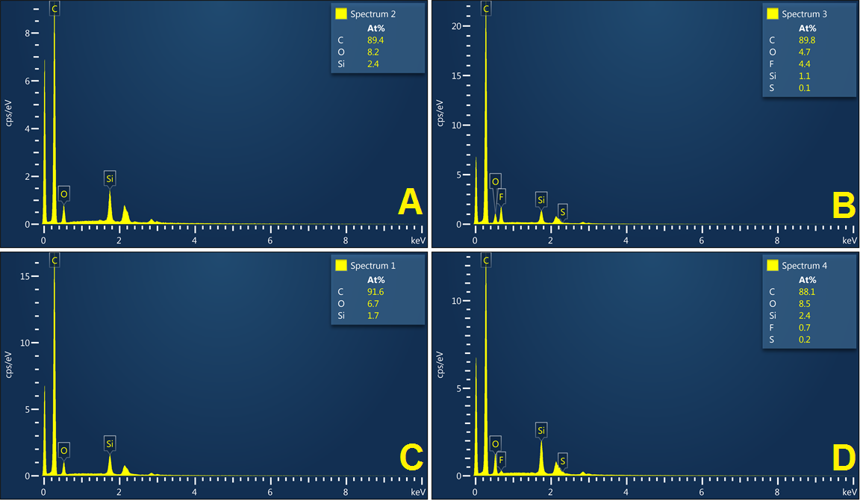
Fig. S3 EDX spectra recorded for (A) PGE, (B) Nf/PGE, (C) f-MWCNTs/PGE ve (D) Nf/f-MWCNTs/PGE.

Fig. S4 (A) DPVs of increased concentrations (0 → 150 µM) of SBT recorded at PGE under optimized conditions (v= 25 mV/s; t_{pulse}= 10 ms; E_{Step}= 10 mV; E_{Amp}= 150 mV), (B) the I(µA) vs. [SBT](µM) plots and (C) the calibration plots generated from the Fig. 5A.

Table S1. The effect of the interferences on the DPV response of SBT at Nf/f-MWCNTs/PGE (Stable concentration of SBT is 5.0 µM and n=3).
Interference | Fold | Percentage Change in DPV response (%) | SD (±)
Cu²⁺ | 5.0 | -5.32 | 1.32
Mg²⁺ | 5.0 | -4.61 | 2.03
Ca²⁺ | 5.0 | -3.67 | 1.25
K⁺ | 100 | +3.12 | 0.70
Cl⁻ | 100 | +1.20 | 0.68
Na⁺ | 100 | +2.77 | 1.70
SO₄²⁻ | 50 | +3.50 | 1.30
Fructose | 50 | -2.16 | 0.44
Glucose | 100 | -2.10 | 0.73
Maltose | 5.0 | -5.20 | 1.40
Mannose | 50 | -0.93 | 0.52
Sucrose | 100 | -5.23 | 1.67
Uric acid | 10 | -2.78 | 0.91
Ascorbic acid | 10 | -1.50 | 0.80
Dopamine | 2.5 | -2.64 | 0.53

